Cairo University SEM – team 14

Faculty of Engineering

Computer Engineering Department

CMP 202

***Introduction to database systems***

***Phase 1 report***

***Team number: 14***

Team members:

* Aisha Mousa 1 32
* Hady Maher 2 28
* Ibrahim Mahmoud 1 1
* Reem Ashraf 1 24

Contact info:

[remoash97@gmail.com](mailto:hadymaher311@gmail.com)

9/11/2017

***Course Center Website***

**ER diagram:**

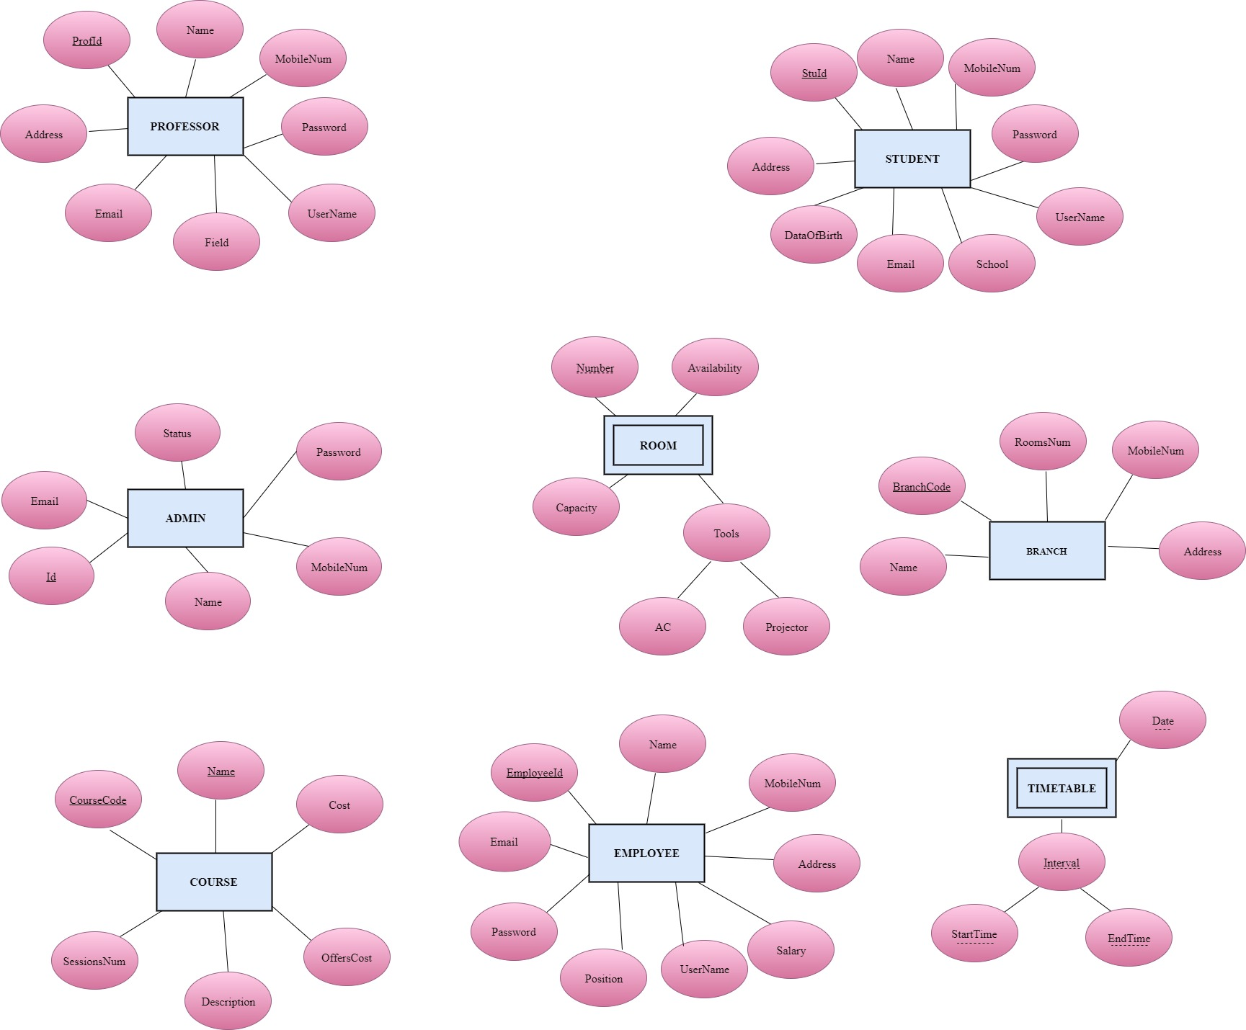

**Data restrictions:**

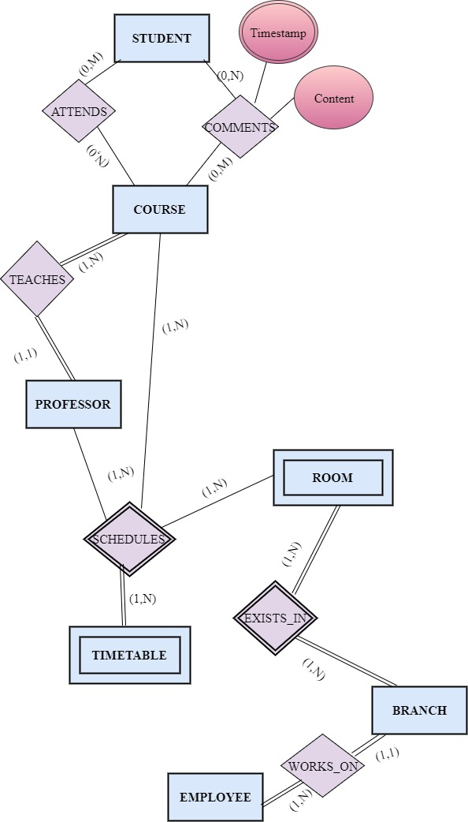

**Schema:**

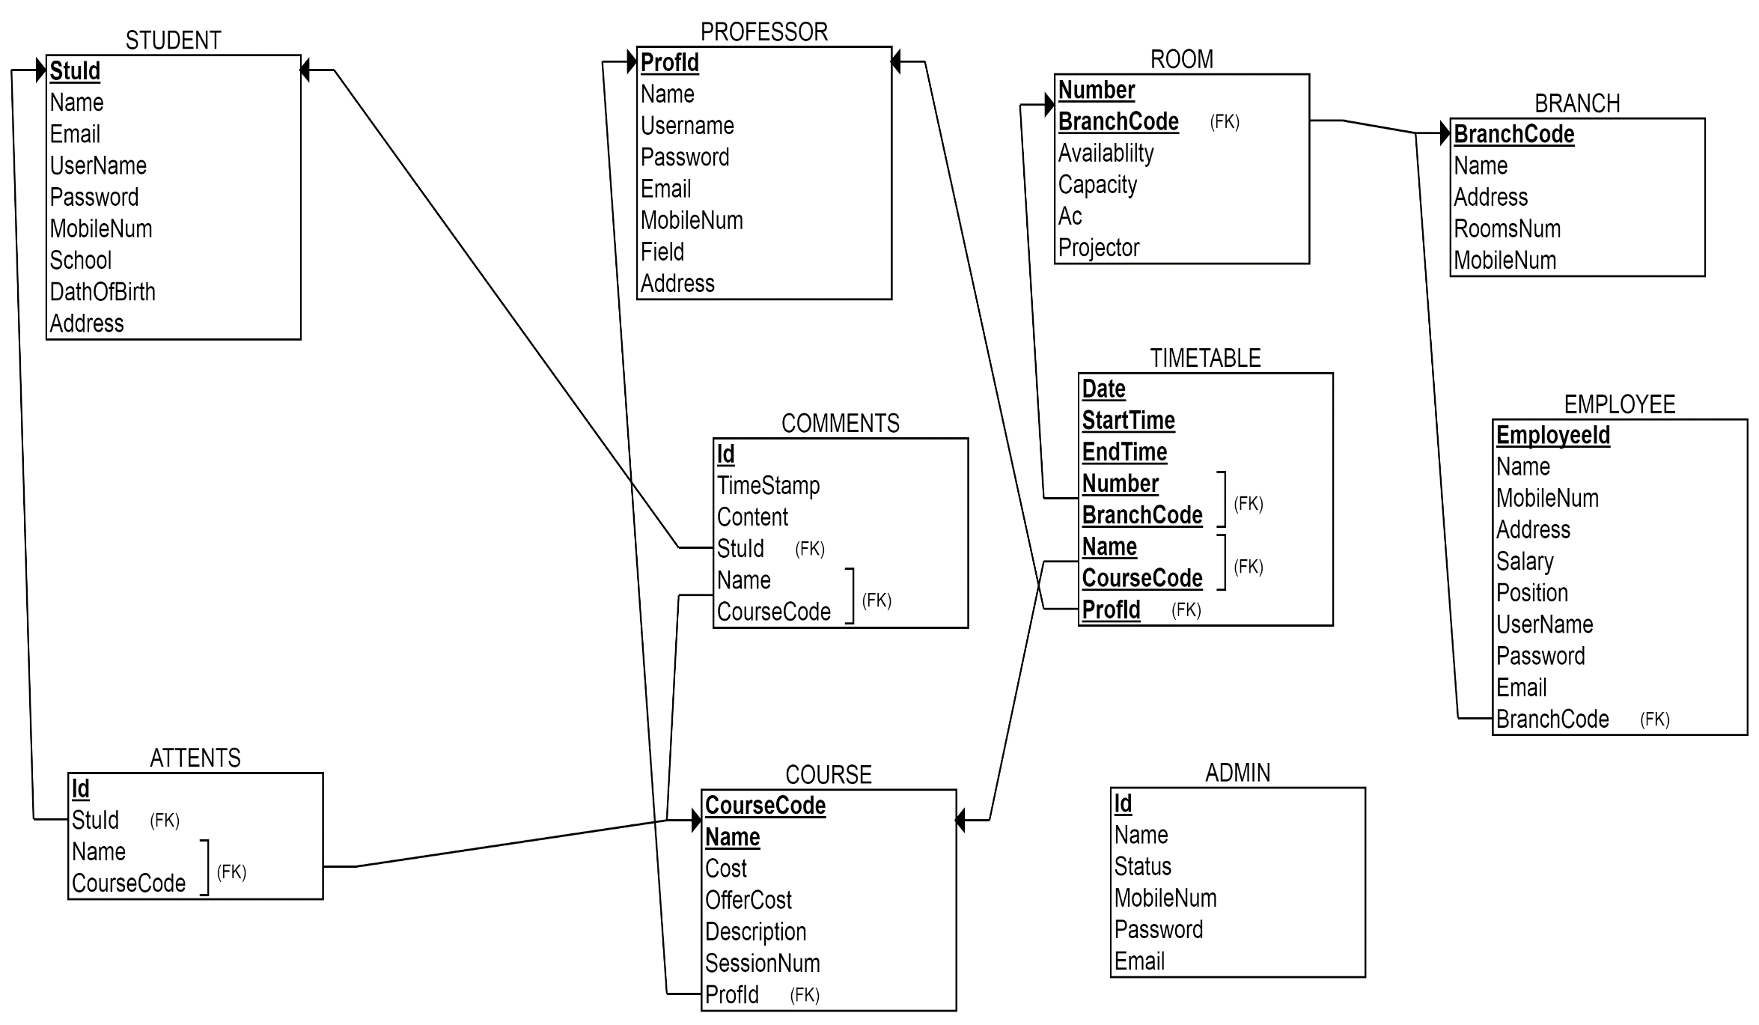

**Constrains:**

|  |  |  |  |  |  |  |
| --- | --- | --- | --- | --- | --- | --- |
|  | ENTITY INTEGRITY | | REFERENTIAL INTEGRITY | DOMAIN INTRGRITY | | |
| **Primary** | **Unique** | **Foreign** | **Not NULL** | **Default** | **Check** |
|  | **Student** | | | | | |
| StuId |  |  |  |  |  |  |
| Name |  |  |  |  |  |  |
| MobileNum |  |  |  |  |  |  |
| Password |  |  |  |  |  |  |
| Username |  |  |  |  |  |  |
| School |  |  |  |  |  |  |
| Email |  |  |  |  |  |  |
| DateOfBirth |  |  |  |  |  |  |
| Address |  |  |  |  |  |  |
|  | **Professor** | | | | | |
| ProfId |  |  |  |  |  |  |
| Name |  |  |  |  |  |  |
| MobileNum |  |  |  |  |  |  |
| Password |  |  |  |  |  |  |
| Username |  |  |  |  |  |  |
| Field |  |  |  |  |  |  |
| Email |  |  |  |  |  |  |
| Address |  |  |  |  |  |  |
|  | **Admin** | | | | | |
| Id |  |  |  |  |  |  |
| Name |  |  |  |  |  |  |
| MobileNum |  |  |  |  |  |  |
| Password |  |  |  |  |  |  |
| Status |  |  |  |  | **true** |  |
| Email |  |  |  |  |  |  |
|  | **Course** | | | | | |
| CourseCode |  |  |  |  |  |  |
| Name |  |  |  |  |  |  |
| Cost |  |  |  |  |  |  |
| OfferCost |  |  |  |  |  | **<= Cost** |
| Description |  |  |  |  |  |  |
| SessionsNum |  |  |  |  |  |  |
|  | **Employee** | | | | | |
| EmployeeId |  |  |  |  |  |  |
| Name |  |  |  |  |  |  |
| MobileNum |  |  |  |  |  |  |
| Address |  |  |  |  |  |  |
| Salary |  |  |  |  |  |  |
| Username |  |  |  |  |  |  |
| Position |  |  |  |  |  |  |
| Password |  |  |  |  |  |  |
| Email |  |  |  |  |  |  |
| BranchCode |  |  |  |  |  |  |
|  | **TimeTable** | | | | | |
| Date |  |  |  |  |  |  |
| StartTime |  |  |  |  |  |  |
| EndTime |  |  |  |  |  | **> StartTime** |
| RoomNumber |  |  |  |  |  |  |
| BranchCode |  |  |  |  |  |  |
| CourseName |  |  |  |  |  |  |
| CourseCode |  |  |  |  |  |  |
| ProfId |  |  |  |  |  |  |
|  | **Room** | | | | | |
| Number |  |  |  |  |  |  |
| BranchCode |  |  |  |  |  |  |
| Availability |  |  |  |  | **true** |  |
| Capacity |  |  |  |  |  |  |
| AC |  |  |  |  | **true** |  |
| Projector |  |  |  |  | **true** |  |
|  | **Branch** | | | | | |
| BranchCode |  |  |  |  |  |  |
| Name |  |  |  |  |  |  |
| Address |  |  |  |  |  |  |
| RoomsNum |  |  |  |  |  |  |
| MobileNum |  |  |  |  |  |  |
|  | **Comments** | | | | | |
| Id |  |  |  |  |  |  |
| TimeStamp |  |  |  |  |  |  |
| Content |  |  |  |  |  |  |
| StuId |  |  |  |  |  |  |
| CourseName |  |  |  |  |  |  |
| CourseCode |  |  |  |  |  |  |
|  | **Attends** | | | | | |
| Id |  |  |  |  |  |  |
| StuId |  |  |  |  |  |  |
| CourseName |  |  |  |  |  |  |
| CourseCode |  |  |  |  |  |  |