Supplementary Materials — Phase-Predictable Tidal-Sampling Bias of Sun-Synchronous Optical Satellites and Its Conversion into Waterline-DEM Errors over the Macrotidal Korean Coast
[Author name TBD]¹
First draft v0.1 — 2026-05-21
This document accompanies the main manuscript and contains all supplementary figures, the extended Table S1, and pointers to the public derived-data tables that support the reported statistics. Section, equation and figure numbers in the main manuscript are referenced by their numerical labels without an “S” prefix; entries in this document use the “S” prefix.

Table S1 — Stability regression coefficients
Regression coefficients of the closed-form model mean bias = β · A · ⟨cos θ⟩ (Equation 1 of the main text) when the 15 (site × sensor) sample is repartitioned by acquisition year, season, sensor, or via leave-one-site-out cross-validation. n is the number of (site × sensor) points contributing to each fit. The pooled bootstrap mean / 95 % CI is reported on the final row.

Table S1a — Annual partition
Year | n | Intercept (m) | Slope β | r | R² | p-value | SE(β) | RMSE (m) | MAE (m)
2020 | 9 | −0.154 | 1.625 | 0.920 | 0.846 | 0.0004 | 0.262 | 0.177 | 0.139
2021 | 9 | −0.165 | 1.718 | 0.939 | 0.882 | 0.0002 | 0.238 | 0.118 | 0.100
2022 | 13 | −0.173 | 1.517 | 0.948 | 0.900 | <0.0001 | 0.153 | 0.126 | 0.105
2023 | 13 | −0.200 | 1.316 | 0.974 | 0.949 | <0.0001 | 0.092 | 0.103 | 0.084
2024 | 13 | −0.203 | 1.345 | 0.920 | 0.847 | <0.0001 | 0.173 | 0.131 | 0.102

Table S1b — Seasonal partition (meteorological seasons, KST)
Season | n | Intercept (m) | Slope β | r | R² | p-value | SE(β) | RMSE (m) | MAE (m)
DJF | 14 | −0.116 | 1.491 | 0.971 | 0.943 | <0.0001 | 0.106 | 0.180 | 0.141
MAM | 12 | −0.084 | 1.138 | 0.992 | 0.984 | <0.0001 | 0.046 | 0.077 | 0.068
JJA | 12 | −0.269 | 0.809 | 0.919 | 0.845 | <0.0001 | 0.110 | 0.118 | 0.094
SON | 13 | −0.555 | 1.163 | 0.924 | 0.854 | <0.0001 | 0.145 | 0.245 | 0.188

Table S1c — Per-sensor fit
Sensor | n | Intercept (m) | Slope β | r | R² | p-value | SE(β) | RMSE (m) | MAE (m)
Landsat 8 | 5 | −0.044 | 1.734 | 0.993 | 0.986 | 0.0007 | 0.121 | 0.065 | 0.057
Landsat 9 | 5 | −0.063 | 2.007 | 0.998 | 0.996 | 0.0001 | 0.072 | 0.031 | 0.028
Sentinel-2 | 5 | −0.048 | 1.712 | 0.999 | 0.997 | <0.0001 | 0.053 | 0.025 | 0.020

Table S1d — Pooled bootstrap (n = 15; 2 000 resamples, seed = 42)
Parameter | Mean | Median | 95 % CI low | 95 % CI high
Slope β | 1.764 | 1.777 | 1.443 | 1.912
Intercept (m) | −0.070 | −0.059 | −0.212 | −0.029

Table S1e — Leave-one-site-out cross-validation (per-point residuals)
Held-out site | Sensor | A·⟨cos θ⟩ (m) | Measured bias (m) | Predicted bias (m) | Residual (m)
Ganghwa-do | L8 | −0.616 | −1.133 | −1.166 | +0.033
Ganghwa-do | L9 | −0.460 | −0.941 | −0.884 | −0.057
Ganghwa-do | S2 | −0.592 | −1.049 | −1.121 | +0.073
Garorim Bay | L8 | −0.720 | −1.205 | −1.377 | +0.172
Garorim Bay | L9 | −0.360 | −0.824 | −0.714 | −0.111
Garorim Bay | S2 | −0.452 | −0.798 | −0.884 | +0.085
Gomso Bay | L8 | −0.469 | −0.881 | −0.887 | +0.006
Gomso Bay | L9 | −0.406 | −0.860 | −0.775 | −0.085
Gomso Bay | S2 | −0.317 | −0.637 | −0.618 | −0.019
Hampyeong Bay | L8 | −0.313 | −0.684 | −0.604 | −0.080
Hampyeong Bay | L9 | −0.352 | −0.801 | −0.673 | −0.128
Hampyeong Bay | S2 | −0.270 | −0.516 | −0.528 | +0.012
Suncheon Bay | L8 | +0.160 | +0.287 | −0.020 | +0.307
Suncheon Bay | L9 | +0.221 | +0.390 | +0.065 | +0.325
Suncheon Bay | S2 | +0.203 | +0.312 | +0.040 | +0.273
LOO summary: Pearson r = 0.969, RMSE = 0.156 m, MAE = 0.118 m; sign-of-bias correct in 15 / 15 held-out points.

Table S2 — Robustness to amplitude definition and reference choice
Per-variant, per-sensor regression of the closed-form model mean bias = β · A · ⟨cos θ⟩ (main-text Equation 1) under the four amplitude / reference combinations described in main-text §4.7: (a) baseline (A = ½(HW−LW), KHOA hourly reference); (b) A = strict M₂ amplitude from a 5-year utide decomposition, KHOA observed reference; (c) A = M₂ amplitude with the reference replaced by the astronomical-only utide.reconstruct synthetic series; (d) FES2022b global ocean tide model used as both reference and satellite-overpass source, with A set to the site-specific mean half-range computed from the FES synthesis.

Table S2a — Pooled regression summary (n = 15)
Variant | β | 95 % CI | Intercept (m) | R² | LOO RMSE (m) | LOO Pearson r | Sign correct
(a) Baseline KHOA | 1.78 | [1.44, 1.92] | −0.057 | 0.980 | 0.16 | 0.969 | 15/15
(b) M₂ amplitude + KHOA | 1.87 | [1.50, 2.02] | −0.053 | 0.978 | 0.17 | 0.961 | 15/15
(c) M₂ amplitude + astro. ref. | 1.90 | [1.49, 2.06] | −0.042 | 0.974 | 0.17 | 0.964 | 15/15
(d) FES2022b global model | 1.70 | [1.42, 1.80] | +0.004 | 0.983 | 0.11 | 0.977 | 15/15

Table S2b — Per-sensor FES2022b values (variant d)
Site | Sensor | n | A (m, FES) | ⟨cos θ⟩ | A·⟨cos θ⟩ (m) | KHOA bias (m) | FES bias (m)
Ganghwa-do | L8 | 137 | 1.02 | −0.107 | −0.109 | −1.133 | −0.263
Ganghwa-do | L9 | 90 | 1.02 | −0.243 | −0.248 | −0.941 | −0.419
Ganghwa-do | S2 | 826 | 1.02 | −0.186 | −0.190 | −1.049 | −0.353
Garorim Bay | L8 | 129 | 2.16 | −0.143 | −0.309 | −1.205 | −0.632
Garorim Bay | L9 | 91 | 2.16 | −0.286 | −0.618 | −0.824 | −0.987
Garorim Bay | S2 | 1656 | 2.16 | −0.213 | −0.461 | −0.798 | −0.784
Gomso Bay | L8 | 203 | 1.28 | −0.233 | −0.299 | −0.881 | −0.547
Gomso Bay | L9 | 110 | 1.28 | −0.257 | −0.330 | −0.860 | −0.562
Gomso Bay | S2 | 187 | 1.28 | −0.345 | −0.444 | −0.637 | −0.643
Hampyeong Bay | L8 | 195 | 1.48 | −0.303 | −0.450 | −0.684 | −0.700
Hampyeong Bay | L9 | 119 | 1.48 | −0.251 | −0.373 | −0.801 | −0.660
Hampyeong Bay | S2 | 796 | 1.48 | −0.212 | −0.314 | −0.516 | −0.549
Suncheon Bay | L8 | 70 | 1.00 | +0.303 | +0.302 | +0.287 | +0.523
Suncheon Bay | L9 | 38 | 1.00 | +0.212 | +0.211 | +0.390 | +0.410
Suncheon Bay | S2 | 435 | 1.00 | +0.148 | +0.148 | +0.312 | +0.317
The FES2022b A is the mean half-range of the synthesised 5-year hourly series at each KHOA gauge coordinate, derived from the eight major constituents (M₂, S₂, K₁, O₁, N₂, P₁, K₂, Q₁); the systematic under-estimate at Ganghwa-do (FES 1.02 m vs KHOA 2.83 m for the M₂ component alone) reflects the inability of the 1/30° global grid to resolve within-bay tidal amplification, which is why the FES variant is used as a complementary astronomical reference rather than as a replacement for KHOA.

Supplementary Figures
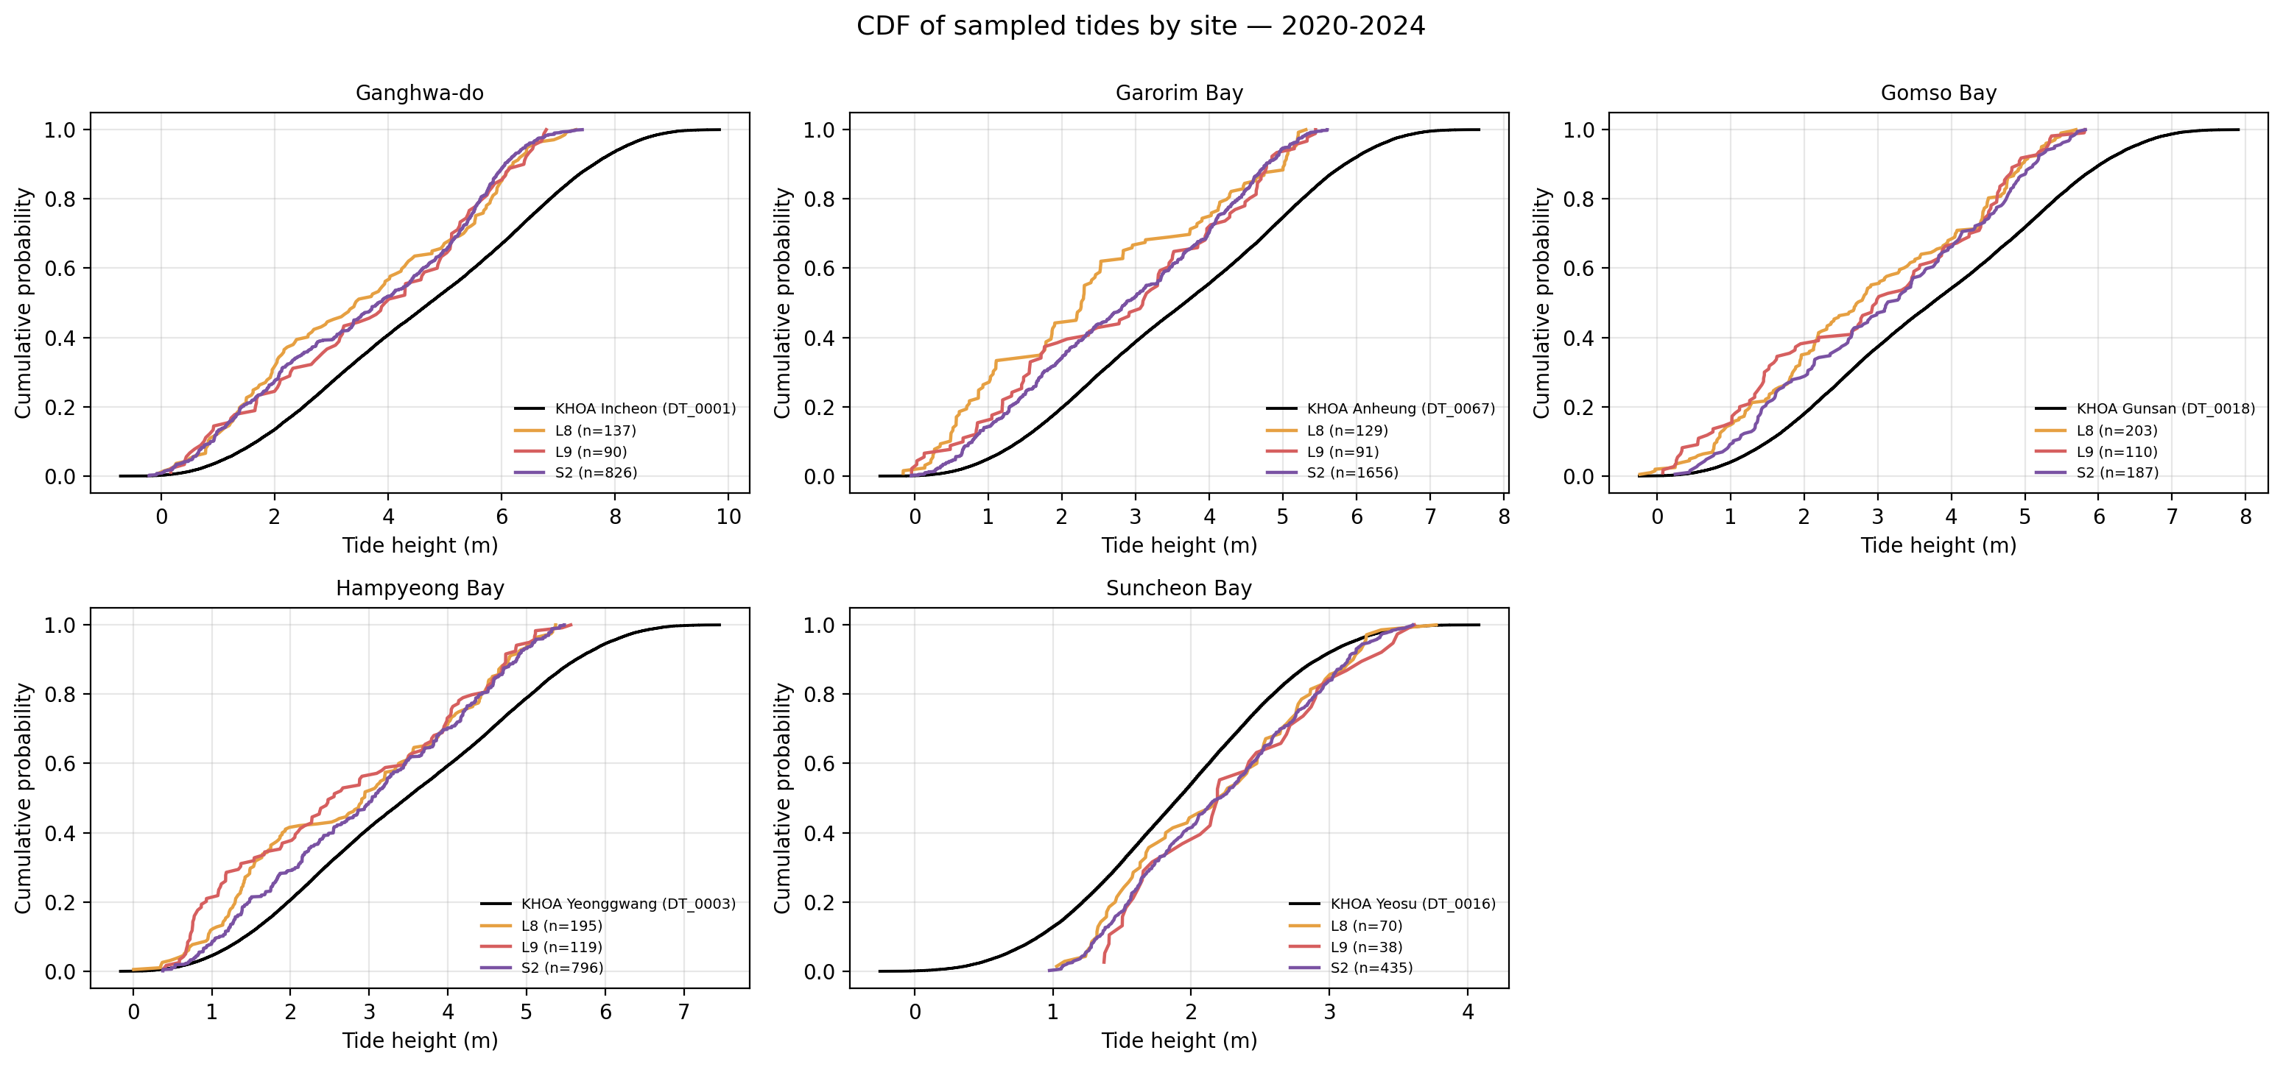
Figure S1. Cumulative distribution functions of satellite-sampled tide heights (coloured) versus the 5-year KHOA hourly reference (black) per site. Complements main-text Figure 2 (densities). The Kolmogorov–Smirnov gap between satellite and reference curves is largest at the high-tide tail on the four western sites and at the low-tide tail at Suncheon Bay.
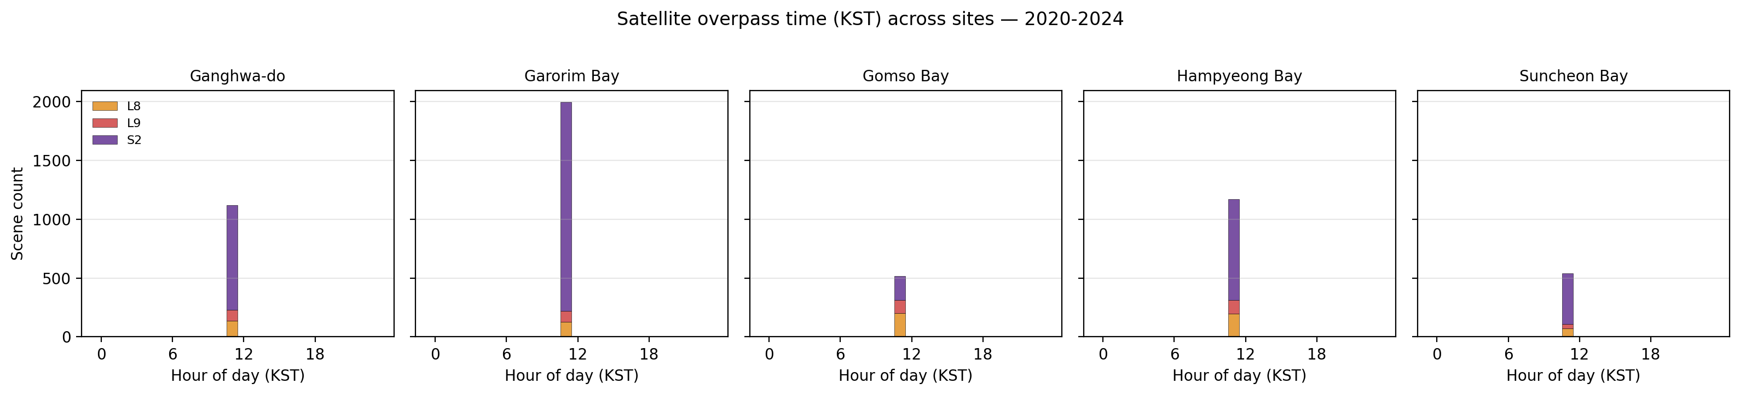
Figure S2. Hour-of-day (KST) histograms of satellite acquisition times across the five sites. Every histogram peaks at ≈ 11:00 KST regardless of site, confirming that the spread in tidal phase between sites (main-text Figure 4) arises entirely from the regional amphidromic structure and not from any difference in solar overpass time.
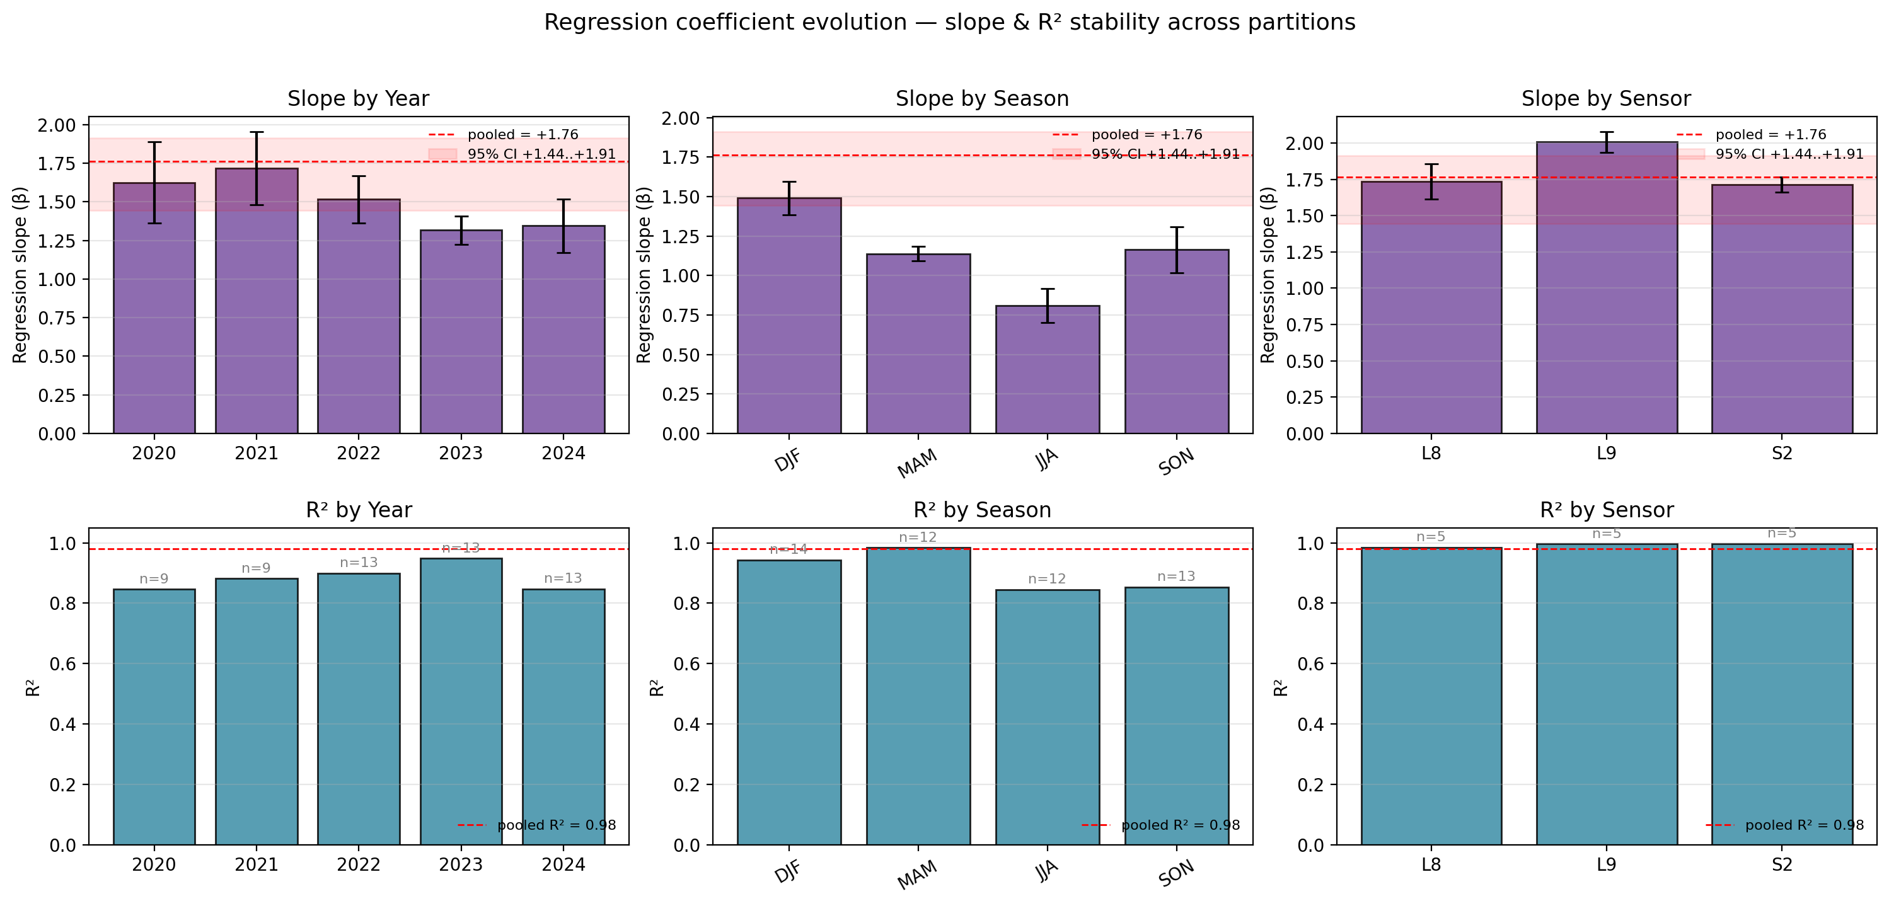
Figure S3. Stability of the regression coefficients (companion to main-text Figure 5): (top row) slope β by year / season / sensor with ±1 SE error bars; (bottom row) R² by the same partitions. The horizontal red band marks the pooled (n = 15) bootstrap 95 % CI of β. All partitions yield β within or near the pooled CI and R² ≥ 0.85, indicating that the regression is robust to year, season, and sensor and is not driven by a single subset of the data; the underlying per-(site × sensor) scatter is shown in Figure S4 and the numerical values in Table S1.
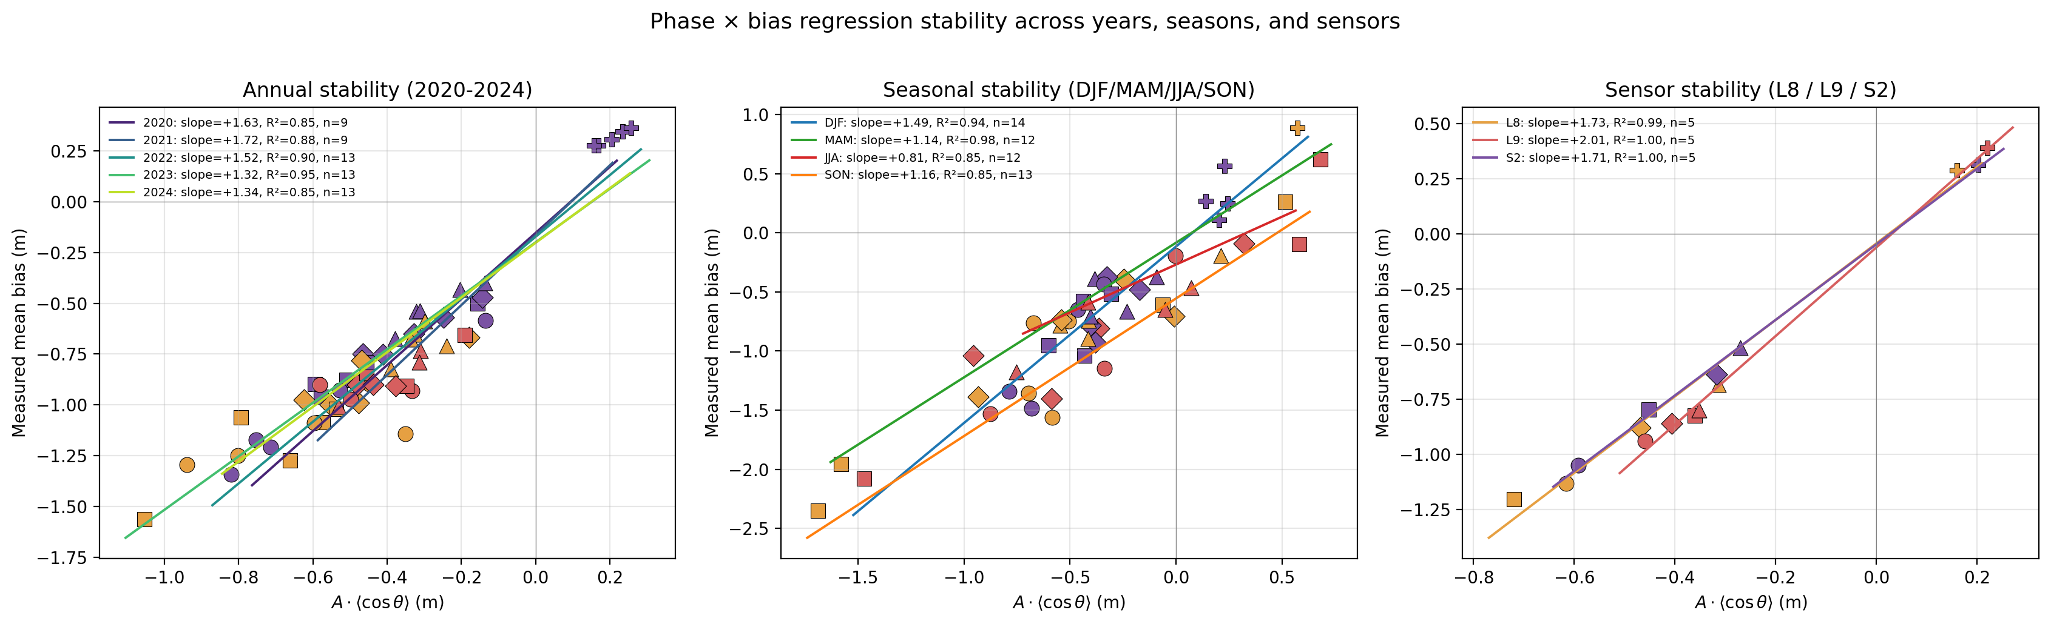
Figure S4. Scatter plots of measured mean bias vs the predictor A · ⟨cos θ⟩ partitioned by year (left), meteorological season (middle), or sensor (right), each overlaid with its OLS fit. Companion to Figure S3 (which summarises the slopes and R² as bars).
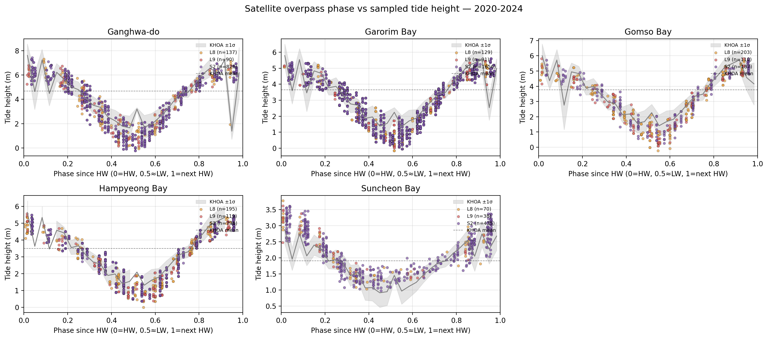
Figure S5. Per-site scatter of tide height versus normalised phase ϕ since the prior HW, with the KHOA-derived mean tide-vs-phase curve (grey band = ±1 σ) and the overall reference mean (dashed line). Satellite acquisitions (coloured by sensor) cluster around phases that, on the western sites, lie below the reference mean (negative bias); at Suncheon Bay they lie above it (positive bias).
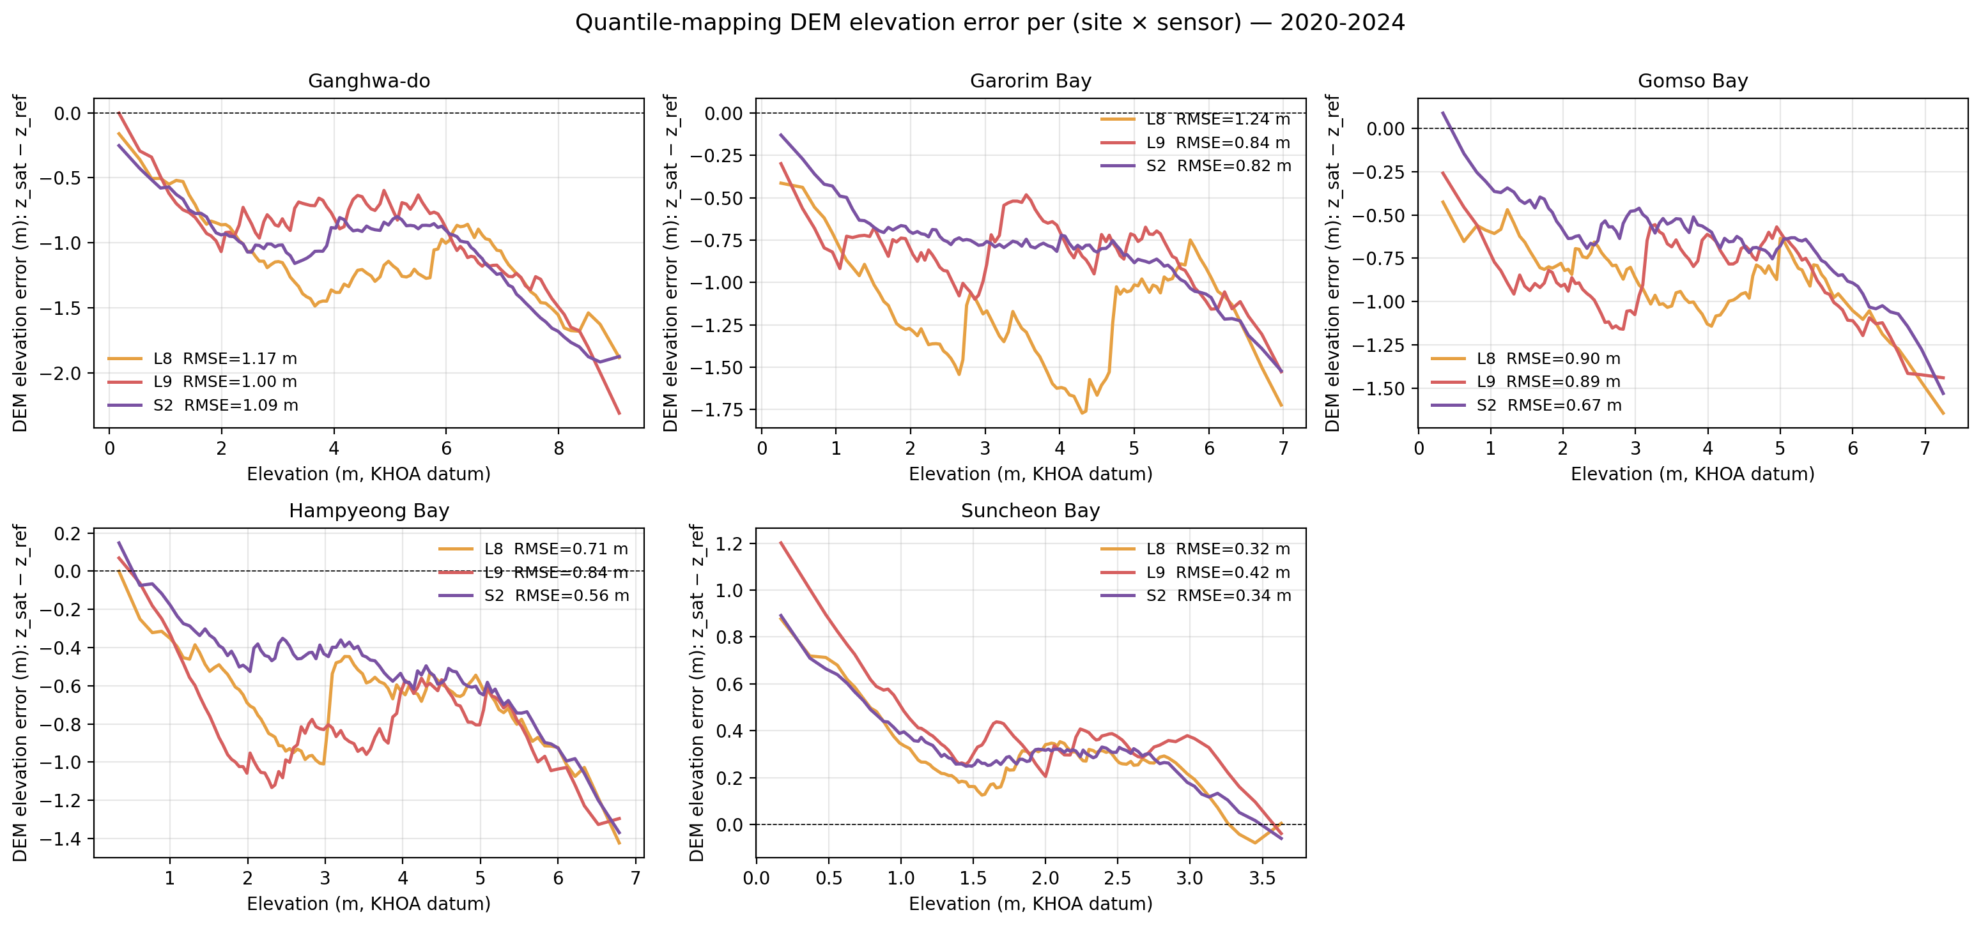
Figure S6. Elevation-domain DEM error: z_{sat}(p) − z_{ref}(p) as a function of reference elevation z_{ref}, for each site (panel) and sensor (colour). The Suncheon panel is mirror-symmetric to the western panels, confirming that the tide-domain bipolar bias maps directly into the elevation domain of the waterline DEM. This per-quantile error underlies the per-site truncation and RMSE summaries in main-text Figure 7.
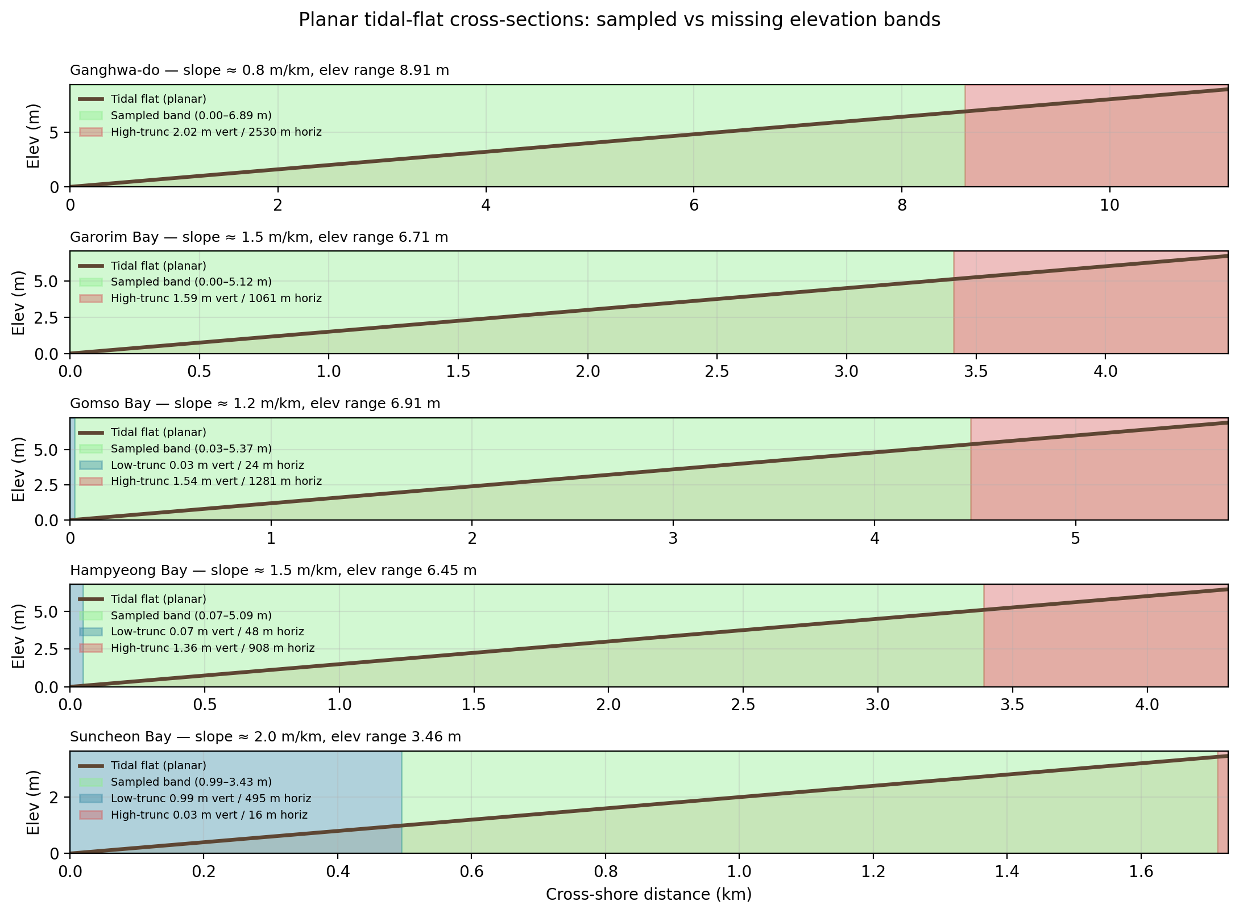
Figure S7. Schematic planar tidal-flat cross-sections per site (vertical exaggerated): brown line is the assumed planar tidal-flat surface; green shading is the elevation band sampled by satellites; red shading is the upper-tide truncation band; blue shading is the lower-tide truncation band. Annotated numbers give the vertical extent (m) and horizontal-equivalent width (m) of each band on the site-specific planar slope. Note the 2.5 km of horizontally missing upper-flat width on Ganghwa-do.
The four-variant robustness fit of Equation 1 of the main text (variants (a)–(d), including the FES2022b global-model variant) is summarised numerically in Table S2 above; a dedicated figure panel is omitted in this version because the per-variant β values, CIs, and LOO RMSEs are most compactly read from the table.

Pointers to public derived-data tables
The following CSV tables underlie the figures and Table S1 entries and will be released through the Zenodo-archived GitHub repository (tidalflat) at the DOI assigned upon acceptance:
File (under data/outputs/tables/) | Used in
phase_stability_annual.csv | Table S1a, Figure S3 (left), Figure S4
phase_stability_seasonal.csv | Table S1b, Figure S3 (middle), Figure S4
phase_stability_sensor.csv | Table S1c, Figure S3 (right), Figure S4
phase_stability_bootstrap.csv | Table S1d, main-text §4.3
phase_stability_loo.csv | Table S1e, main-text Figure 6
dem_error_stats.csv | Figure S6, main-text Figure 7
Static versions of these CSVs, together with the figure-generation scripts in scripts/demo_*.py, are version-controlled in the public GitHub repository.

