User Guide for KvApp

Haedong Kim

2022-04-01

## Getting Started

There are four associated files as shown in Figure 1 below: KvAppBeta, MyAppInstaller_mcr, MyAppInstaller_web, and splash.

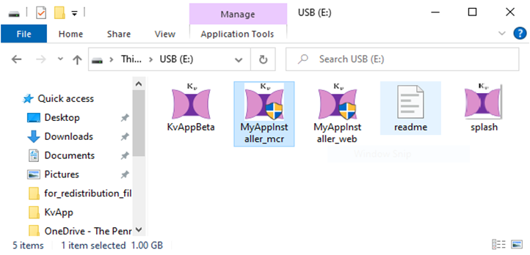

Figure 1. Consisting files of the applications

KvAppBeta is the file that runs the application, but you will get the error message in Figure 2 if the correct version of MATLAB is not installed on the machine.

Figure 2. Error message when the right version of MATLAB is not installed on the target

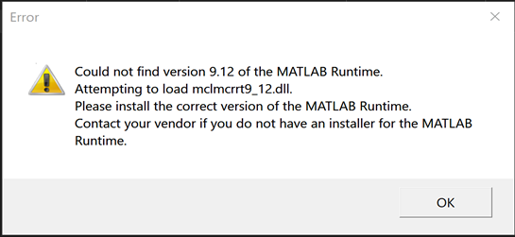

MyAppInstaller_web will install the packaged application and MATLAB Runtime from the Internet, which enables the application to run without having MATLAB installed. Your computer needs to be connected to the Internet to complete the installation. If the Internet connection is not available, MyAppInstaller_mcr will install the necessary programs locally. A few screenshots below in Figure 3 show the installation process. The other file splash is just an image file for the application icon.

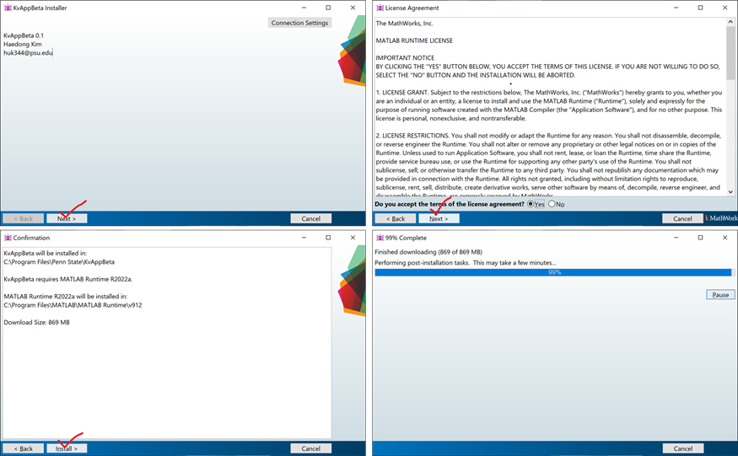

Figure 3. Screenshots of the installation process.

## Modules and Functions

KvApp consists of three modules, as shown in Figure 4: Experimental Protocol & Data, Computer Model, and Model Outputs & Kinetics Modeling Results.

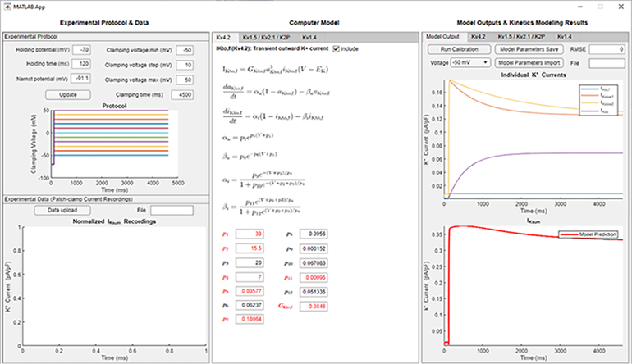

Figure 4. Startup window of KvApp.

The data to be investigated *in silico* should be stored in an Excel file, with the first column corresponding to time and the other columns normalized currents for voltage steps in increasing order. This is a default format when IKsum traces are transferred to a tabular format in ClampFit. Figure 5 is an example of IKsum recordings. To import a dataset, we need to specify the experimental protocol of the voltage-clamp method used to generate that dataset. If the defined protocol does not match the data, it will give an error or does not display the data correctly.

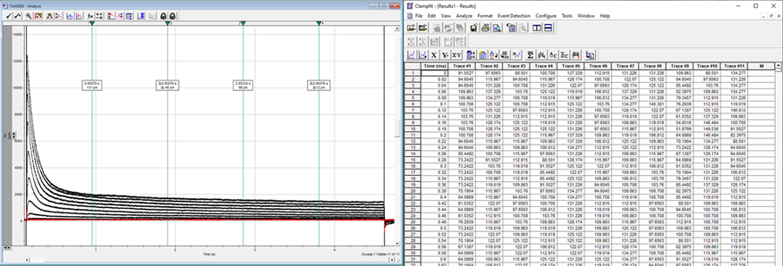

Figure 5. Example of raw IKsum data in ClampFit.

The Computer Model module shows equations and kinetics parameters of computers models of Kv isoforms separated by tabs. The Computer Model module shows equations and kinetics parameters of computers models of potassium isoforms, separated and grouped by tabs. The Kv4.2 model in the first tab is the only stand-alone model in which every kinetic variables and parameter are independent of other models. The second tab contains three closely connected models. Each model can be chosen to be or not be included in calculating the total potassium current by checking or unchecking the Include boxes. The kinetic parameters can be adjusted manually by entering the number in the corresponding box and pressing the enter/return key. Parameters in red are identified as having significant impacts on the model behavior.

These parameters in red can be calibrated automatically using the Turn Calibration button in the Model Output tab of the third module. This function calibrates the models by minimizing discrepancies between model prediction and experimental IKsum traces. The fitness of calibration results is visualized, and the drop-down button allows to select different voltage steps. The calibrated parameter values can be saved using the Model Parameters Save button in an Excel file. It is desirable to perform model calibration separately, utilizing more computing power and time for better results. Other tabs named after the Kv isoforms show kinetic variables such as steady states, time constants, and transition rates as shown on Figure 6.

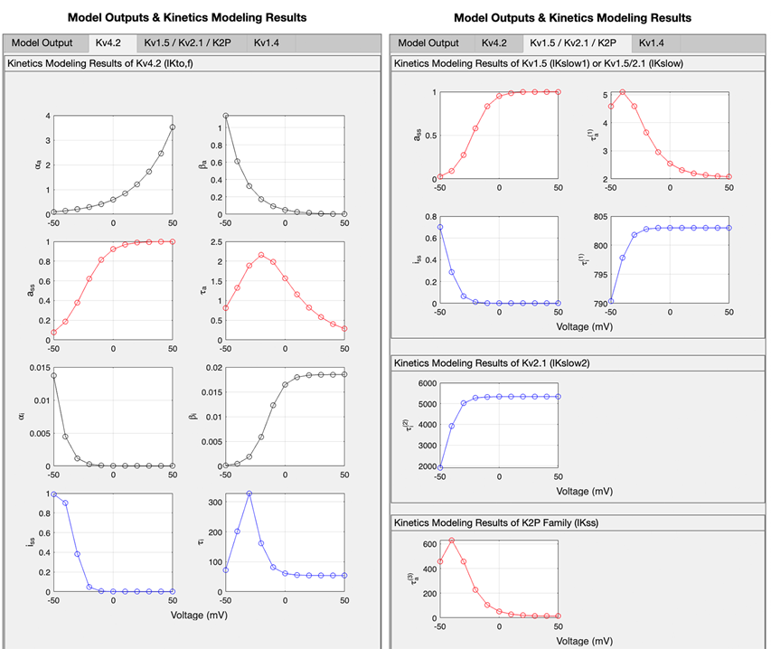

Figure 6. Kinetics modeling results.

## Example 1 – Calibration in the app

This section provides an example of using the calibration function. A data set will be used having voltage steps from -30 to 50 mV lasting 4.5 s from holding voltage -70 mV. The data is saved in the provided file, 15o27010.xlsx. First update the protocol accordingly and upload the data as in Figure 7. Uncheck the IKslow2 (Kv2.1) box to remove it for this data. Then import 15o27010.xlsx using Data Upload.

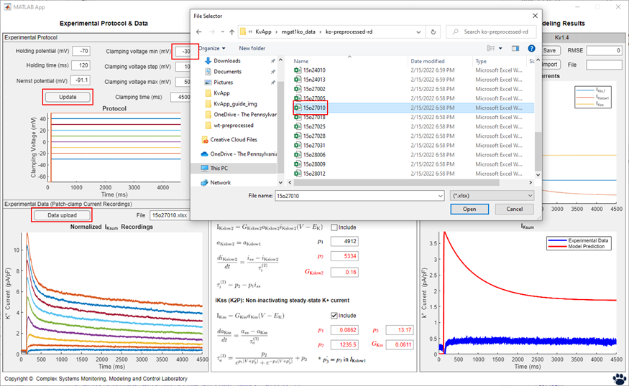

Figure 7. Data upload.

Discrepancies between the model prediction and exerrmental IKsum traces can be observed in the bottom right figure. To calibrate the models according to the data, click the Run Calibration button. It will change to a progress bar as in Figure 8.

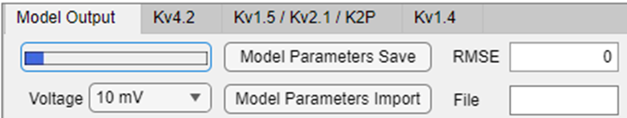

Figure 8. Run calibration.

Once the calibration is completed, the model outputs and kinetics are updated as in Figure9.

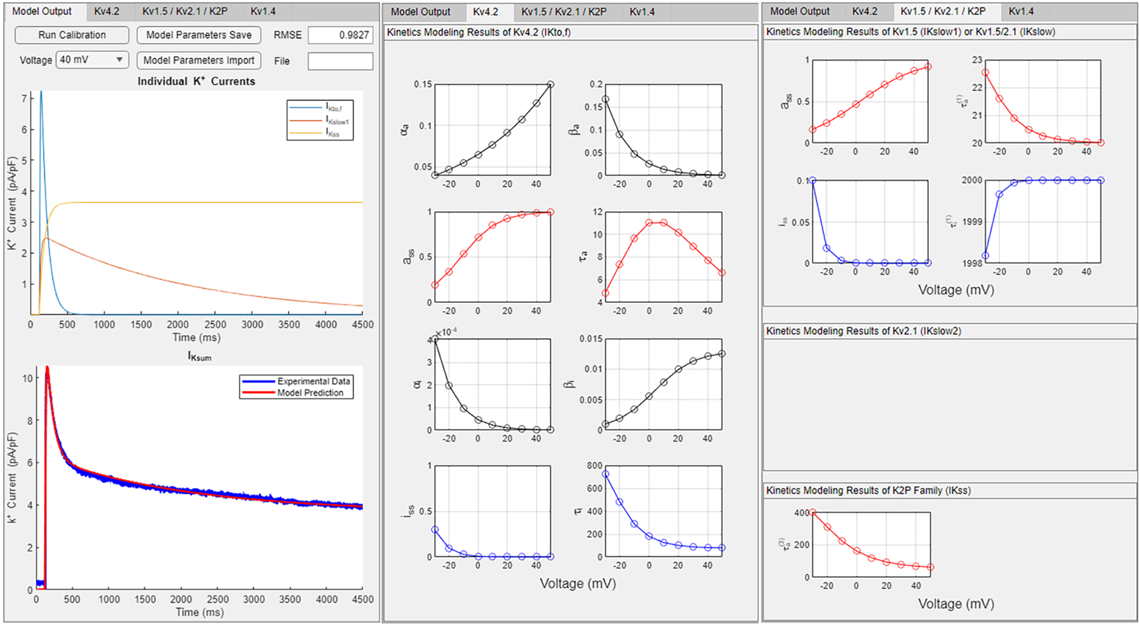

Figure 9. Calibration results. From left to right, current outputs and kinetics modeling.

## Example 2 – Import calibration parameters

This example illustrates how to use pre-calibrated parameters as opposed to Example 1, wherein the models are calibrated in the application. First update the protocol and exclude IKslow2 (Kv2.1) to import the same data used in Example 1, 15o27010.xlsx. Then import the calibrated parameters saved in 15o27010_param.xlsx using the Model Parameters Import button.