 | Verification Report |  |  | Written by | Reviewed by |  |  | Approved by
 |  |  |  | 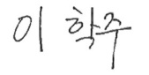 | 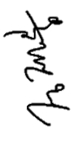 |  |  | 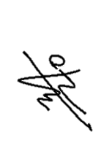
 |  |  |  | 2024/12/17 | 2024/12/17 |  |  | 2024/12/17
Document No. | CRD-0601-0434-241217-001
Product / Project | CU-SP1 (Semi-Automated External Defibrillator)  CU-SP1 AUTO (Automated External Defibrillator)
Related Models | CU-SP1, CU-SP1 PLUS, CU-SP1 AUTO
Title | SIT-DS-110_Threpy PIC_ Therapy PIC UART Data Reception Test
Verification Stage | □ Design and Development □ Design Change ■ Pre-Verification
Qualified  Verification Person | Department: R&D | Date | 2024.12.17 |  |  | Pages | 3
 | Name: Lee Hak Joo

■ Verification Method
1. Verification Items
SIT-ID | Verification Items
SIT-DS-110 | Therapy PIC UART Data Reception Test

2. Verification Purpose
- The Software Integration Test aims to verify the design specifications listed below.
Software Design | Software Design Definition
SDS-TP-008 | The response according to the Main ARM instruction is stored in the Main ARM transmit data and then transmitted to Main ARM.
Detailed Design Specification
- When data is stored in the Main ARM transmits data of the temporary variable, the Therapy PIC triggers a UART transmit interrupt to the Main ARM.
- Upon interrupt occurrence, Therapy PIC transmitted data of temporary variables is transmitted to Main ARM.
- Upon completion of transmission, clear the Therapy PIC transmission data.
- If data is not transmitted via Main ARM, attempt retry up to five times.
- The response is stored in the following transmitted data variable
Transmission Data (Tx) - Unsigned char / 8 bits / TxBuf[4]
- Response Classification
- Response according to the command
- HV_CTRL_BIT_CHARGE: Charge Progress of Electrical Energy
- HV_CTRL_BIT_DISCHARGE: External Discharge in Progress
- HV_CTRL_BIT_DISARM: Internal discharge in progress
- HV_CTRL_BIT_DEFI_MODE: Proceed in electric shock mode
File |  | Function | Reference Unit Test
main.c |  | main | SUT-TP-012
uart.c |  | RxISR | SUT-TP-013

3. Description of relevant functions
SIT-ID | Verification items | Pre-existing functionality
SIT-DS-110 | Therapy PIC UART Data Reception Test

4. Verification Method
4.1 [SIT-DS-110] Therapy PIC UART Data Reception Test
- [UART Data Reception Test] connects the UART pins of the PC and Therapy PIC to perform a UART data reception test.
When data is transmitted from PC to PC via Serial communication program on PC, the Therapy PIC receives the data via UART. The Therapy PIC analyzes the received data to confirm whether UART data reception was performed normally.
* Used PC Serial Communication Program: jwRsMonitor (open-source serial communication terminal program)
- Assign an arbitrary value to [Input Value] and perform [UART Data Reception Test].

4.1.1 Input Value
- Verify that the intended result is output by entering the Input Value in the table below.
- The input value is “PC UART transmitted data”.
Test Case | Input Value | Note
Case#1 | AAAA | Valid input value
Case#2 | BBBB | Valid input value
Case#3 | CCCC | Abnormal input value

4.1.2 Verification Method
(1) Connect the Therapy PIC to the PC and prepare a serial communication program for the PC.
(2) Input the PC UART transmission data ("AAAA" or "BBBB") into the PC Serial communication program and transmit it to the Device.
(3) When data is received from the Device via the Device's UART, it is stored in the UART received data.
(4) Analyze whether the received UART data matches the data transmitted from the PC.
(5) The UART data reception test results are confirmed through the LED output of the Device.
[Figure 1] Therapy PIC UART Data Reception Test Steps

4.1.3 Test Criteria
Classification | Detailed Criteria | Reference Value | Output
Normal packet communication | Data received via UART  It matches the data transmitted from PC | UART Received Data | i-Button Blue LED  Lighting on
Abnormal packet communication | Data received via UART does not match the data sent from the PC | UART Received Data | i-Button Red LED  Lighting on

5. Test Results
5.1 Therapy PIC UART Data Reception Test
Test Case | Input | Test Criteria | Test result | Result
#1 | AAAA | i-Button Blue LED Lighting on | 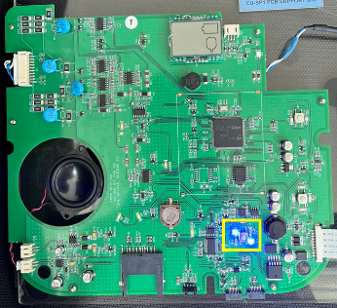 | PASS
#2 | BBBB | i-Button Blue LED Lighting on |  | PASS
#3 | CCCC | i-Button Red LED Lighting on | 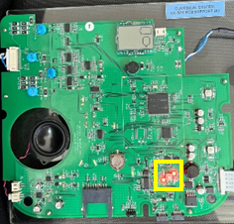 | PASS

6. Traceability Matrix
SIT ID | Design Element ID | Reference Unit Test
SIT-DS-110 | SDS-TP-008 | SUT-TP-012, SUT-TP-013

■ Conclusion
[SIT-DS-110] The Main ARM UART Data Reception Test was conducted over three Test Cases, confirming that all tests met the defined Test Criteria.

■ Attached Document

