 | Verification Report |  |  | Written by | Reviewed by |  |  | Approved by
 |  |  |  | 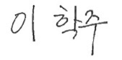 | 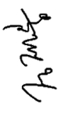 |  |  | 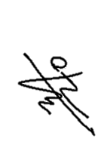
 |  |  |  | 2025/02/26 | 2025/02/26 |  |  | 2025/02/26
Form No. | CUP-731-07 (Rev.0)
Document No. | CRD-0601-0434-250226-003
Product / Project | CU-SP1 (Semi-Automated External Defibrillator)
Related Models | CU-SP1, CU-SP1 PLUS
Title | SST-019_Debug Port Security Test
Verification Stage | □ Design and Development □ Design Change ■ Pre-Verification
Qualified  Verification Person | Department: R&D | Date | 2025.02.26 |  |  | Pages | 7
 | Name: Lee Hak Joo

- Verification Method
- Test ID : SST-019
- Test Purpose
- This test aims to verify compliance with Device access restriction requirements for debugging ports (such as download JIGs) and security (blocking access in operational mode) specifications.

Software Requirements Specification (SRS)
SRS ID | Requirements
CBS-REQ-07 | Physical access to the device housing, internal circuitry, storage devices, etc., shall be protected by seals, locks, position sensors, etc., and warnings or operational restrictions shall be applied in case of unauthorized access.
CBS-REQ-08 | Debugging ports (such as UART, JTAG, etc.) must only allow sealed, deactivated, or access restricted by authentication, and access must be blocked except for maintenance purposes.

- Test Conditions
  - Test Sample Information
- Total EUT :5 EA
- Number of EUTs: 5 units (EUT #1 ~ EUT #5)
* The EUT quantity shall be determined based on "[CRD-0601-DP-PAR-01] Performance and Functional Test Report".

- Software Version
Main ARM | Main PIC | Therapy PIC | Remarks
2.03 | 1.33(2) | 1.00B

- Hardware Version
Main Board | Therapy Board | Remarks
2.01C | 1.41B

- Battery(CUSA1103BB)
Classification | Quantity | Type | State | Remarks
Battery #1 | 5EA | Long life battery  (CUSA1103BB) | Battery Level: FULL

- Test Method
- Verify the access control security function of the debugging port according to the Test Method below.
- The test is conducted on five EUTs respectively, and the results are captured for the physical model.
- The operating mode refers to Normal Operation Mode on the Device.
- CU-SP1 and CU-SP1 PLUS differ only in configurable energy output, and all other cybersecurity-related features are considered equivalent; therefore, the verification is conducted solely on CU-SP1.

- Verify the access control security function of the debugging ports (3 ports), when entering Normal Operation Mode. 1.1 Verify that the Device's debugging ports are properly blocked (screw check, sticker check).

- Test Criteria
Classfication | Detailed Creteria | Device operation
Blocking access to debugging port | It shall be ensured that access to the debugging port is disabled during Normal Operation Mode. | Verification of physical containment status

- Test Results
  - CU-SP1 / CU-SP1 PLUS
No | Device Operation | EUT #1 | EUT #2 | EUT #3 | EUT #4 | EUT #5
1 | It shall be ensured that access to the debugging port is disabled during Normal Operation Mode. | Pass | Pass | Pass | Pass | Pass

EUT | Verification results
EUT #1 | 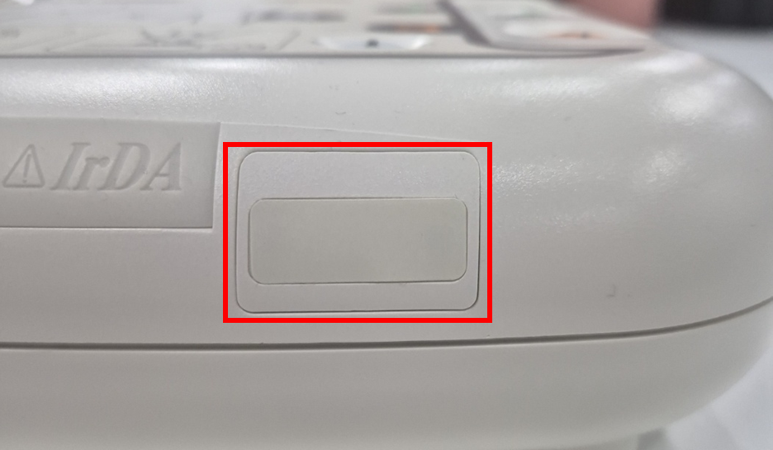
EUT #2 | 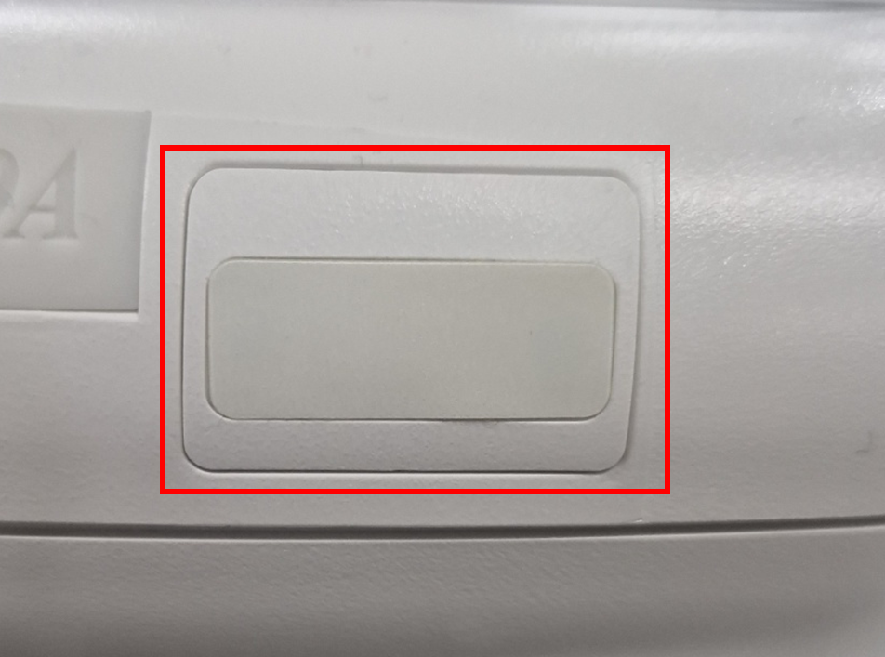
EUT #3 | 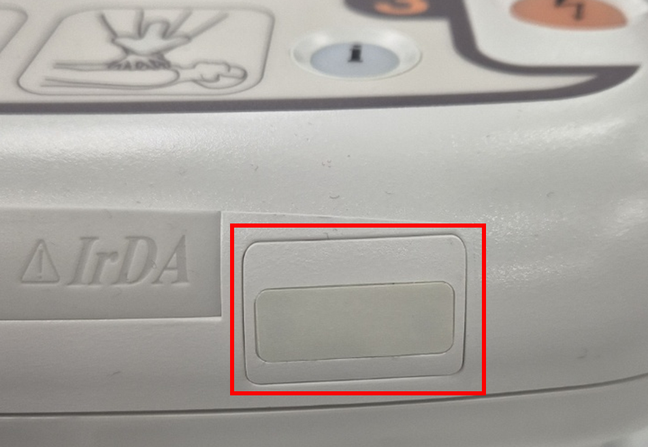
EUT #4 | 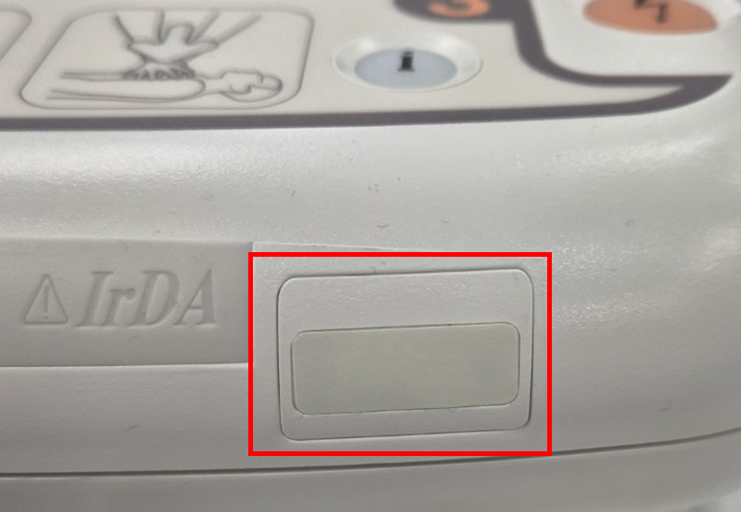
EUT #5 | 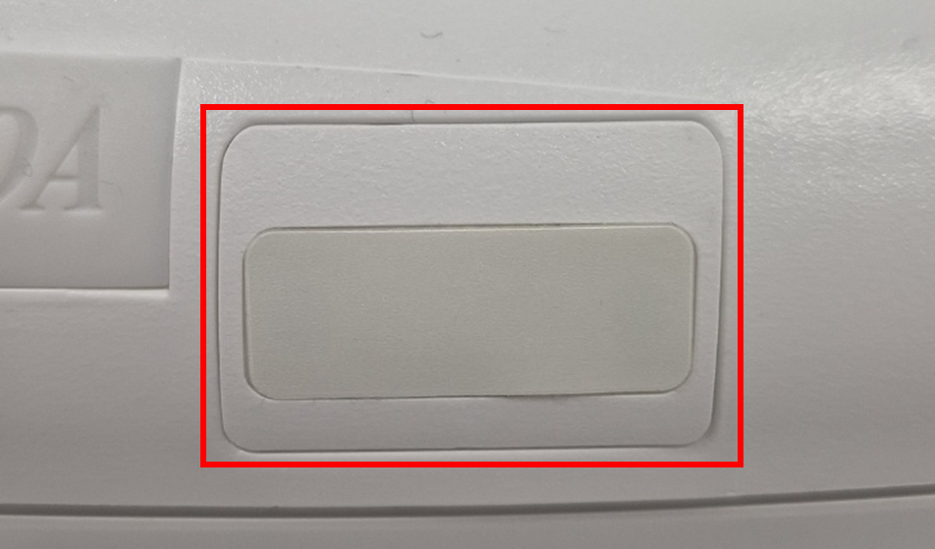

- Traceability Matrix
Test ID | Requirement ID | Remark
SST-019 | CBS-REQ-07, CBS-REQ-08

- Conclusion
- CU-SP1, CU-SP1 PLUS were repeatedly tested using five EUTs for the defined test criteria, and the results confirmed that the requirements were successfully met.
- Attached Document

