Internal development report: From Cartesian Probabilistic Projection Matching to Refactored Polar Common-Lines Formulations
Over the past several years, this project has evolved from a set of ideas and prototypes into a robust, high‑performance ab initio 3D reconstruction pipeline. This did not happen by accident, nor did it happen quickly. It required persistence, technical rigor, and a willingness to revisit and rethink earlier decisions when the data or the benchmarks told us we had more work to do.
I want this report to serve two purposes. First, it documents *how* we got here, so new developers can understand not just what the code does, but why it is structured the way it is. Second, it is meant as a genuine acknowledgment of the collective effort behind this work. The improvements described here—both in performance and robustness—are the result of sustained collaboration across algorithm design, numerical analysis, performance engineering, and debugging. This is exactly the kind of team effort that produces software we can trust and build on.
Why this matters (for new developers):
The Cartesian baseline described in this report is not "obsolete" code. It is the reference against which correctness and resolution are judged. Understanding it will make you far more effective when working on newer methods.
Why this matters (engineering):
Most of the speedups reported here did not come from changing the math, but from making data movement, memory ownership, and control flow explicit. These are recurring themes in high‑performance scientific software.
Why this matters (robustness):
Rare failures are often more important than average performance. Much of the refactoring effort focused on eliminating hidden assumptions that only surfaced under repeated runs or edge cases.

1. Background and baseline formulation
The original Cartesian implementation used throughout this project is based on probabilistic projection matching. This approach is well established, robust, and mathematically transparent, and it served as the reference baseline against which all subsequent developments were evaluated.
While reliable, the Cartesian probabilistic projection-matching pipeline is computationally expensive. Repeated FFTs, dense Cartesian grids, and repeated reference preparation lead to wall-clock times on the order of 4,000 seconds for the streptavidin ab initio 3D benchmark (Table 1).

2. Transition to polar common-lines methods
To address the computational limitations of the Cartesian formulation, the project explored a polar Fourier representation combined with common-lines geometry. This represents a conceptual shift from projection matching to line-based angular constraints, allowing the search problem to be expressed more efficiently.
The initial polar implementation demonstrated that this reformulation was sound: successful runs converged to resolutions comparable to the Cartesian baseline, while reducing execution time by approximately 40% on average (Table 1). However, this early implementation also revealed engineering and robustness issues, including rare convergence failures and sensitivity to bookkeeping and numerical edge cases.

3. Refactoring and stabilization
The refactoring phase focused on transforming the polar prototype into production-quality infrastructure. This involved extensive low-level optimization as well as disciplined memory and I/O management.
These changes eliminated duplicated work, removed unsafe numerical assumptions, and dramatically reduced overhead in reference preparation. As a result, the refactored polar implementation achieved a further ~30% reduction in execution time relative to the original polar code, while also significantly improving robustness across repeated runs.

4. Benchmarking results
Benchmarking was performed using streptavidin ab initio 3D reconstruction, with ten independent repeats for each method where applicable. Table 1 summarizes the execution times, and Figure 1 shows per-run variability.
The refactored polar implementation achieves more than a twofold speedup relative to the Cartesian probabilistic projection-matching baseline, without any systematic loss in reconstruction resolution.
Table 1. Execution times (seconds) for streptavidin ab initio 3D benchmarking.
Run | Cartesian (Prob. PM) | Polar (old) | Polar (refactored)
1 | 4050.3 | 2454.0 | 1883.3
2 | 4082.3 | 2453.2 | 1843.0
3 | 3926.6 | 2415.5 | 1872.7
4 | 3535.9 | 2443.1 | 1892.3
5 | 4033.2 | 2445.6 | 1883.7
6 | 3974.1 | 2469.0 | 1875.4
7 | 4026.2 | 2433.3 | 1850.4
8 | 4171.5 | 2438.3 | 1846.8
9 | 4230.9 |  | 1895.1
10 | 4007.5 | 2442.9 | 1875.5
Figure 1. Execution time per run for Cartesian and polar ab initio 3D implementations.
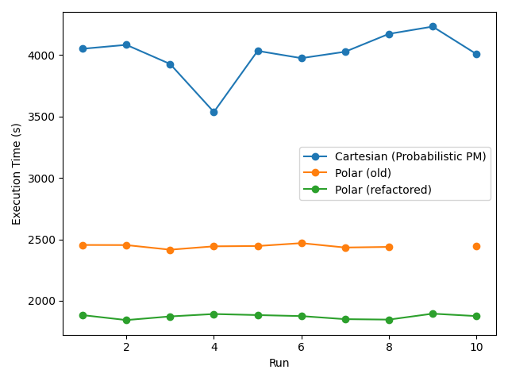

5. Lessons for developers
This development effort illustrates several key lessons for new contributors: algorithmic ideas must be validated through repeated benchmarking; performance and robustness are engineering outcomes; and refactoring is an essential step in turning a promising concept into reliable scientific software.
The improvements documented here are the result of sustained collaboration and careful technical work. The current codebase reflects that collective effort and provides a strong foundation for future development.

