**Points 4 Joe**

**All fonts & body background (gradient):**

body {

font-family: Arial, Helvetica, sans-serif;

margin: 0px;

overflow: hidden;

/* IE10+ */

background-image: -ms-linear-gradient(top, #FFFFFF 0%, #59779E 100%);

/* Mozilla Firefox */

background-image: -moz-linear-gradient(top, #FFFFFF 0%, #59779E 100%);

/* Opera */

background-image: -o-linear-gradient(top, #FFFFFF 0%, #59779E 100%);

/* Webkit (Safari/Chrome 10) */

background-image: -webkit-gradient(linear, left top, left bottom, color-stop(0, #FFFFFF), color-stop(100, #59779E));

/* Webkit (Chrome 11+) */

background-image: -webkit-linear-gradient(top, #FFFFFF 0%, #59779E 100%);

/* W3C Markup */

background-image: linear-gradient(to bottom, #FFFFFF 0%, #59779E 100%);

}

SIMPLE logo should have a margin on top (same size as on bottom)

Margin on the sides of main working window should be at least 50 pixels

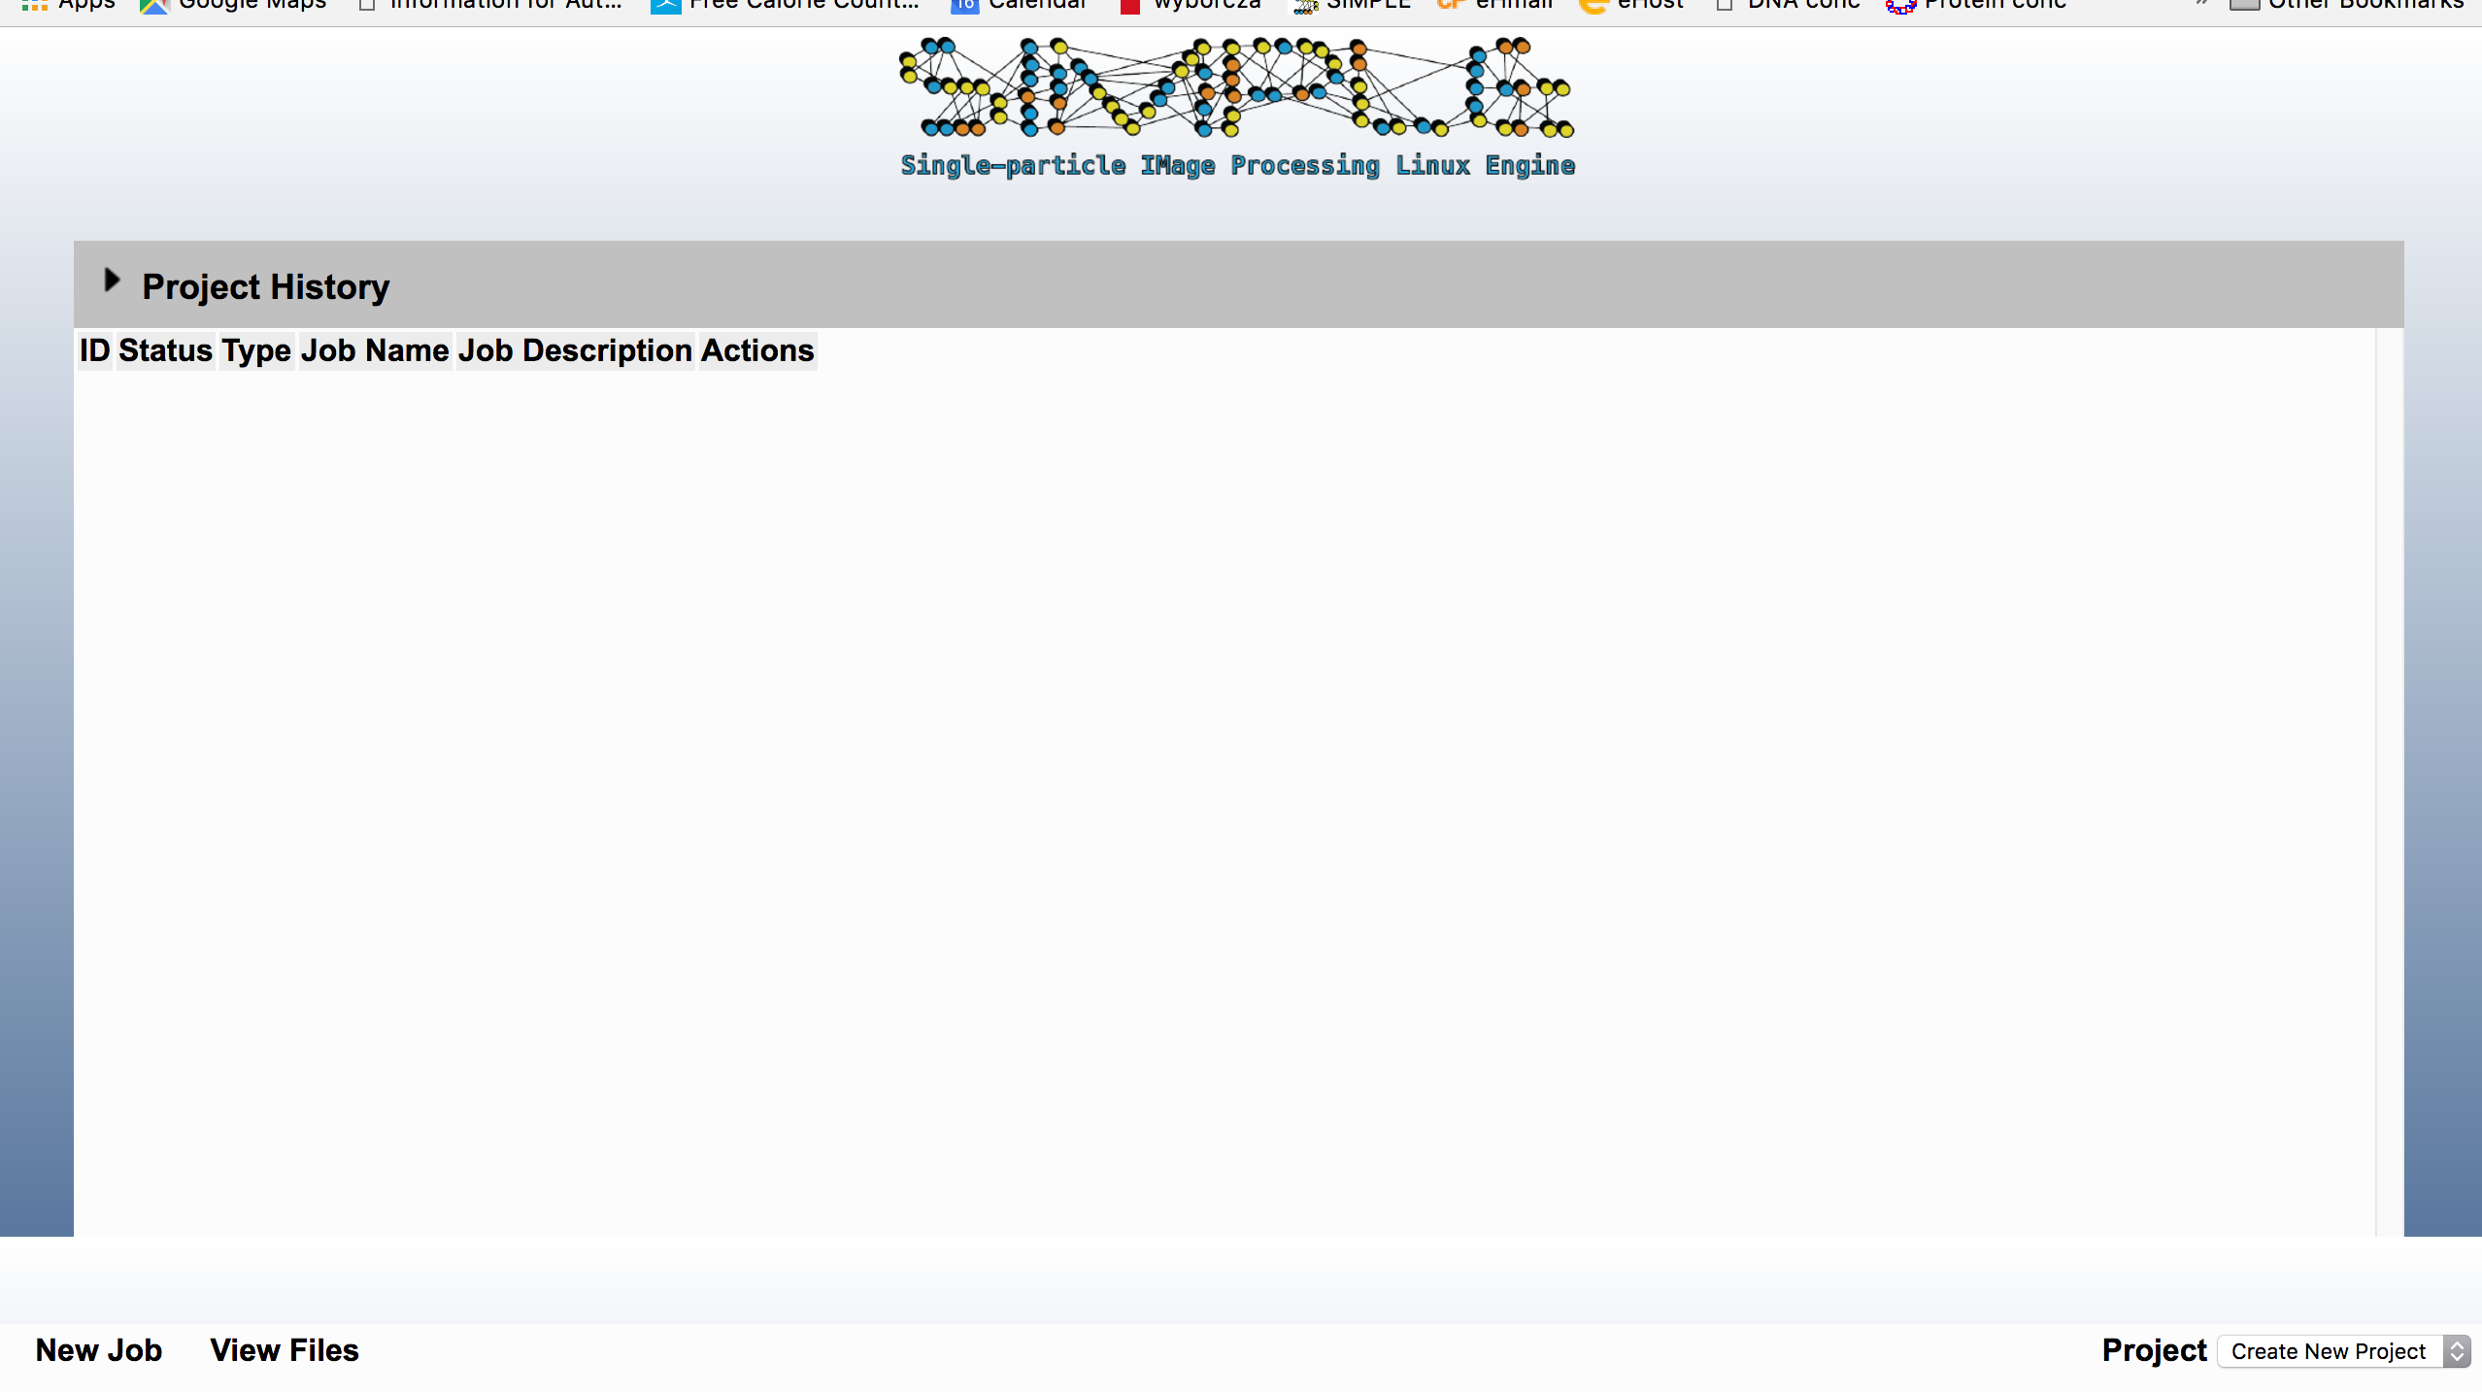

Footer: New Job, View Files etc. should be within the body so that the background on the sides can be the background of the body and margins should be the same as for the main window. Margin below the footer should be the same as margin above the logo (20px)

Overflow/scrolling should be in the main window

File browser and other similar windows:

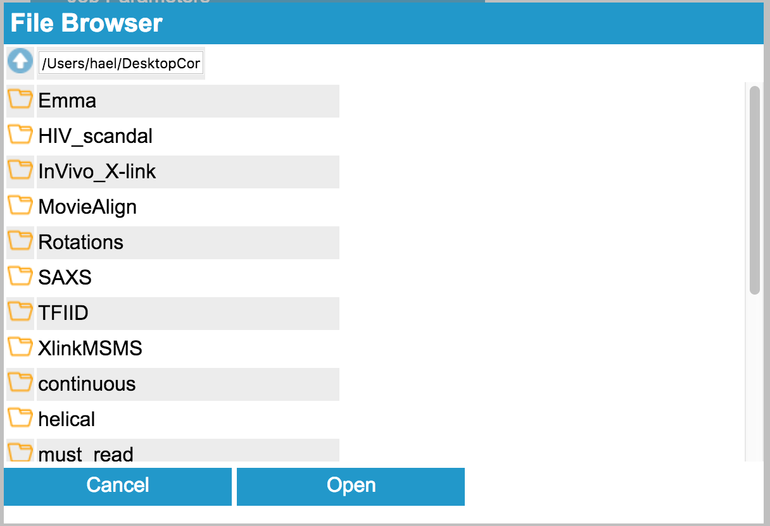

Here, extend browsing folder lines so they match Cancel/Open length and cut the remaining white space.

BUG: Clicking on Job Parameters make it disappear.

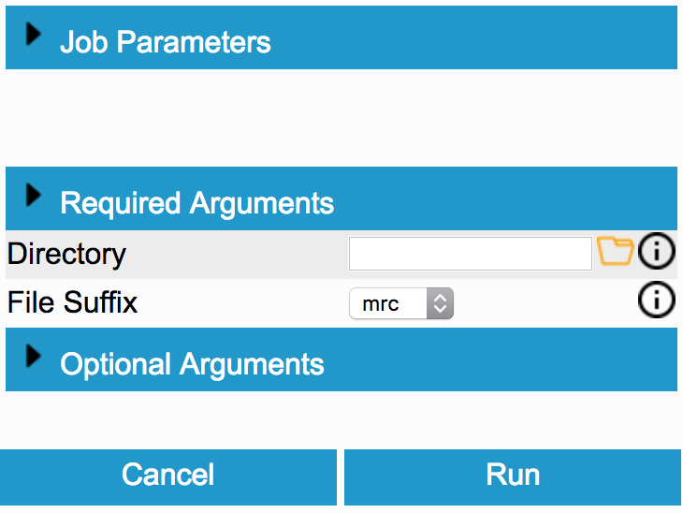

However, this looks fine—no empty spaces like in the example above.

How do you go back to the previous window, for example from import or any other programs? Cancel does not get me back to the workflow it needs to be re-pointed to the workflow.

The whole workflow must be scrollable (overflow) or it conflicts with other elements of the page.

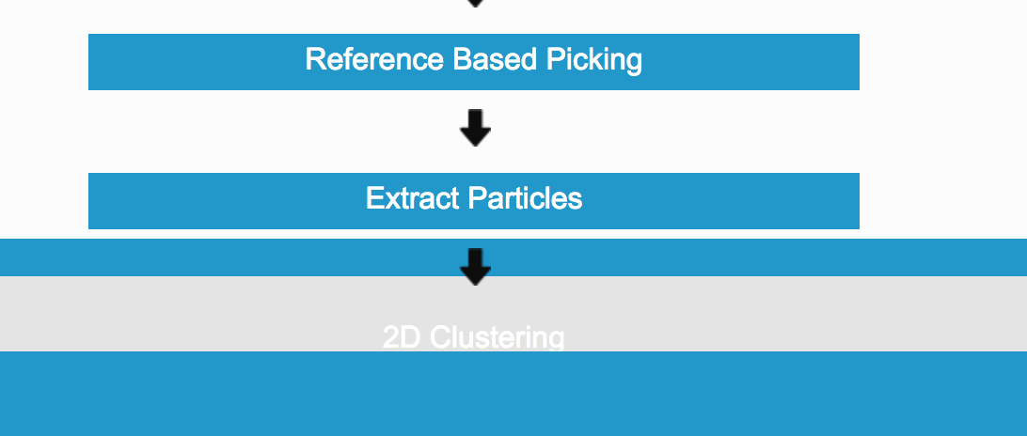

The arrows look too chunky, they should be removed. The flow of the workflow should look as below (CSS attached)

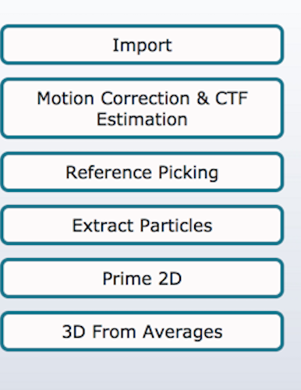

color: #0e1519;

    background-color: #bdd3dc;

    text-align: center;

    border-radius: 7px;

    border-color: rgb(39, 120, 142);

The hoovers must becentered over the text they link to and the above button must also have hoovers to indicate that they are clickable.

We need to select a better less aggressive hoover colour (perhaps slightly darker grey than the headings or something)