Solution to print out if you’re interested in live coding for your section.

clock.js

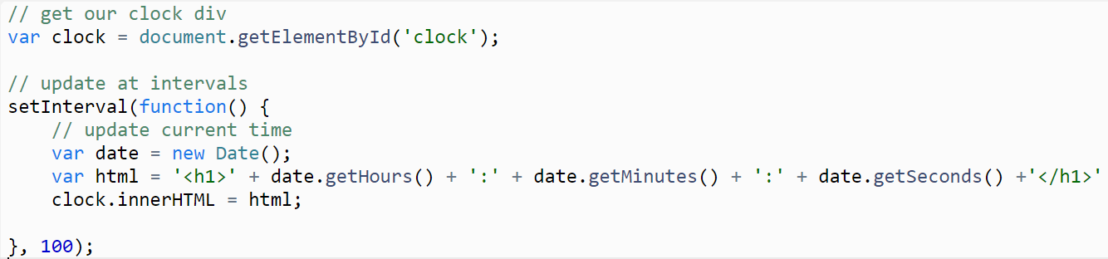

party.js

