Sprint 3 Plan

**Heading**: TutorTube,Team TutorTube, Sprint 3 completion date: March 17, 2017, revision 1, 3/2/17

**Goal**: Create a login page and a user database so users can login and control their accounts.

**Task listing, organized by user story**:

User Story 1: As a user I want to upload video or text responses so that I can help other students in my class understand the material

Task 1: create hyperlinks to posts and responses to each post (2 hours)

Task 2: make a new html and controller for comments to posts(4 hours)

Task 3: update database so comments can be children of other comments(5

hours)

Total time for user story 1: 11 hours

User Story 2: As a developer I want to be able to implement a chat room so that small group discussions can exist

Task 1: research code online that could be helpful(3 hours)

Total time for user story 3: 3 hours

User Story 3: As a developer I want to be able to style my website so that it is understandable and easy to use

Task 1: style using css and html(5 hours)

Task 2: separate posts by categories(4 hours)

Task 3: make a logo(2 hours)

Total time for user story 4: 11 hours

Total time for sprint 3: 25 hours

**Team Roles:**

Evan Hobbs: user

Haley Emerson: user, developer

Lisa Durand: developer, user

Vanessa Putnam: developer

Aishni Parab: developer

**Initial Task Assignment:**

Evan Hobbs: user story 1, create hyperlinks to posts and responses to each post; user story 1, make a new html and controller for comments to posts

Haley Emerson: user story 3, separate posts by categories

Lisa Durand: user story 3, make a logo; user story 3, style using css and html

Vanessa Putnam: user story 1, update database so comments can be children of other comments

Aishni Parab: user story 2, research code online that could be helpful

**Initial BurnUp Chart**:

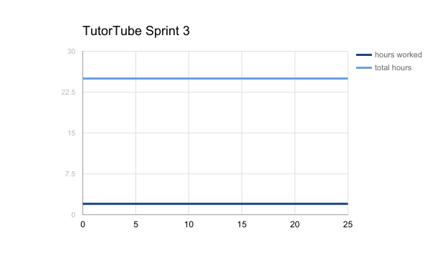

**Initial Scrum Board:**

|  |  |  |  |
| --- | --- | --- | --- |
| User Stories for TutorTube Sprint 3 | To Do | In Progress | Done |
| As a user I want to upload video or text responses so that I can help other students in my class understand the material | -create hyperlinks to posts and responses to each post  -make a new html and controller for comments to posts  -update database so comments can be children of other comments | - |  |
| As a developer I want to be able to implement a chat room so that small group discussions can exist | -research code online that could be helpful |  |  |
| As a developer I want to be able to style my website so that it is understandable and easy to use | -style using css and html  -separate posts by categories | -make a logo |  |

**Scrum Times:**

Tuesdays and Thursdays, meet from 5 to 7pm during which we hold 15 minute scrum meetings.

TA/tutor arranged time is Mondays at 12pm