Secure Internet Application Development

CPS 499-63/592-65, Summer 2017

**Lab 3 - Network Traffic with Wireshark**

1. The Basic HTTP GET/response interaction

By looking at the information in the HTTP GET and response messages, answer the following questions in your report:

With reference : academic.udayton.edu/PhuPhung

1. Is your browser running HTTP version 1.0 or 1.1?  What version of HTTP is the server running?

My browser is running in HTTP version 1.1

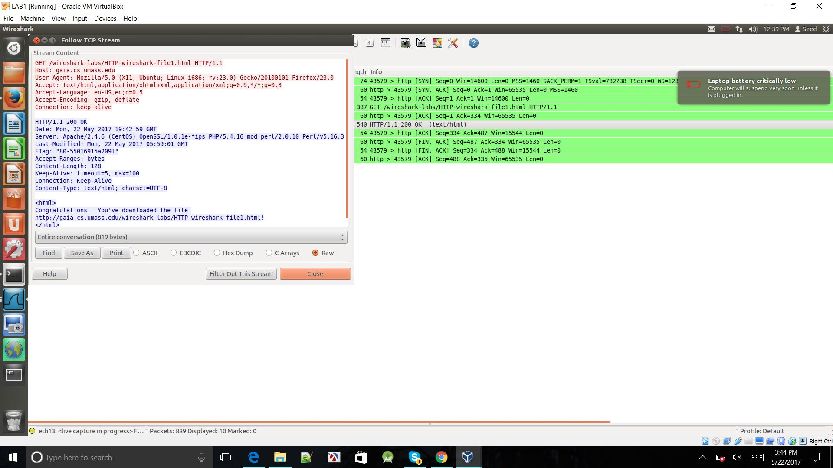

1. What languages (if any) does your browser indicate that it can accept to the server?

Language which the browser can accept to the server is

En-us,en

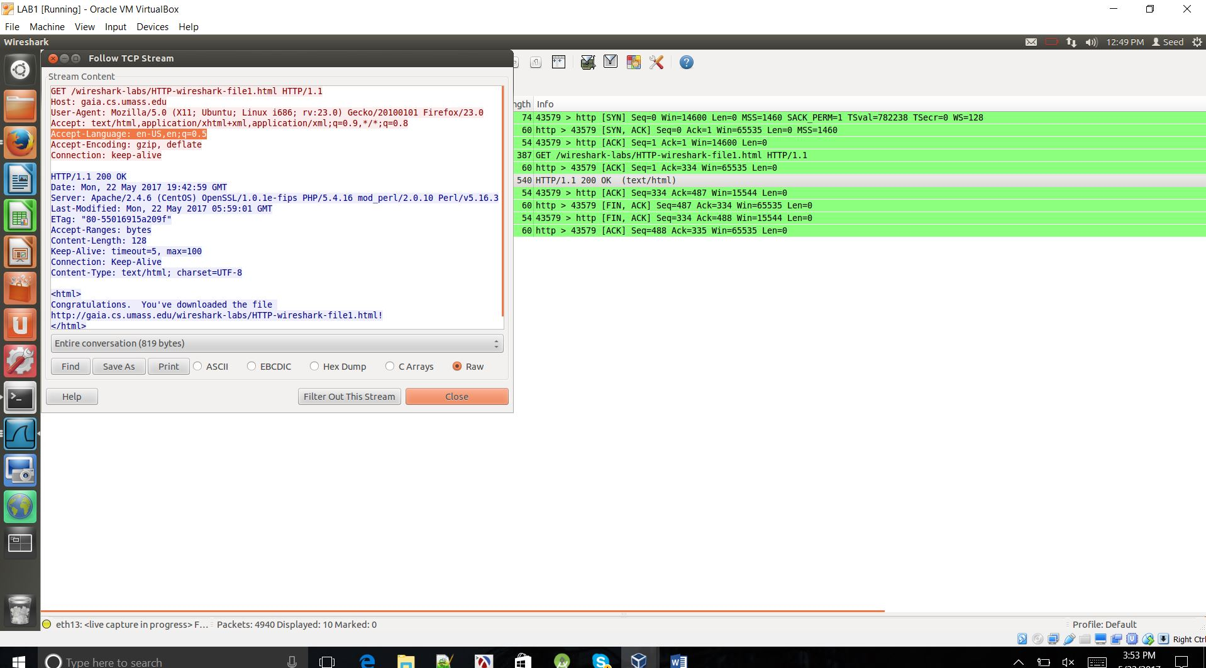

1. What is the IP address of your computer?  Of the gaia.cs.umass.edu server?

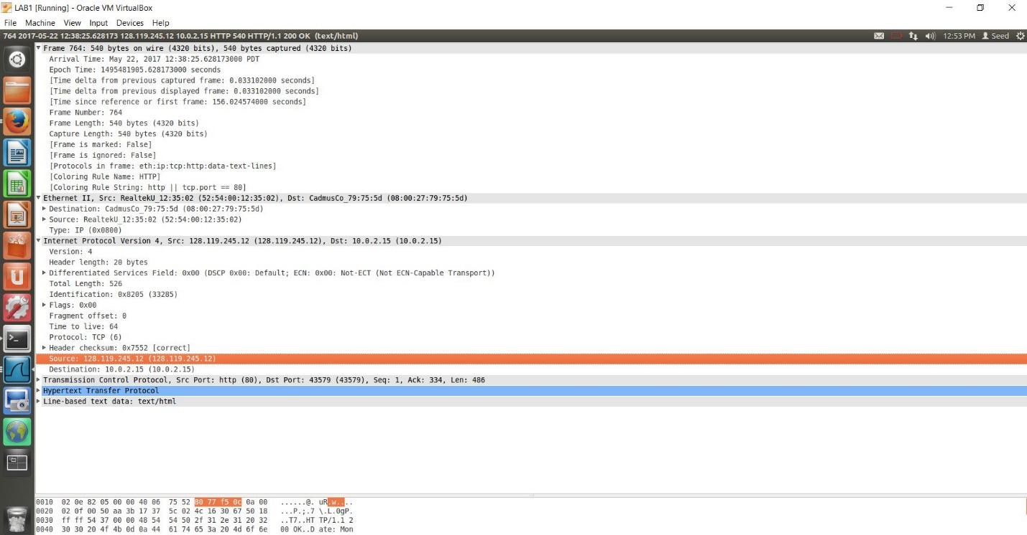

With reference to the URL: gaia.cs.umass.edu

1. What is the status code returned from the server to your browser?

Status code returned from the server to the browser is 200 (OK).



1. When was the HTML file that you are retrieving last modified at the server?

In the HTML file, Last-modified at the server is seen in the field

Last-Modified: Mon, 22 May 2017 05:59:01 GMT



1. How many bytes of content are being returned to your browser?

Number of bytes of content are being returned to your browser are 128 bytes.

Content-Length: 128



1. By inspecting the raw data in the packet content window, do you see any headers within the data that are not displayed in the packet-listing window?  If so, name one.

Few headers within the data that are not displayed in the packet-listing window are:

Headers in the packet content window are Time, Source, Destination, Protocal, Length, Info.

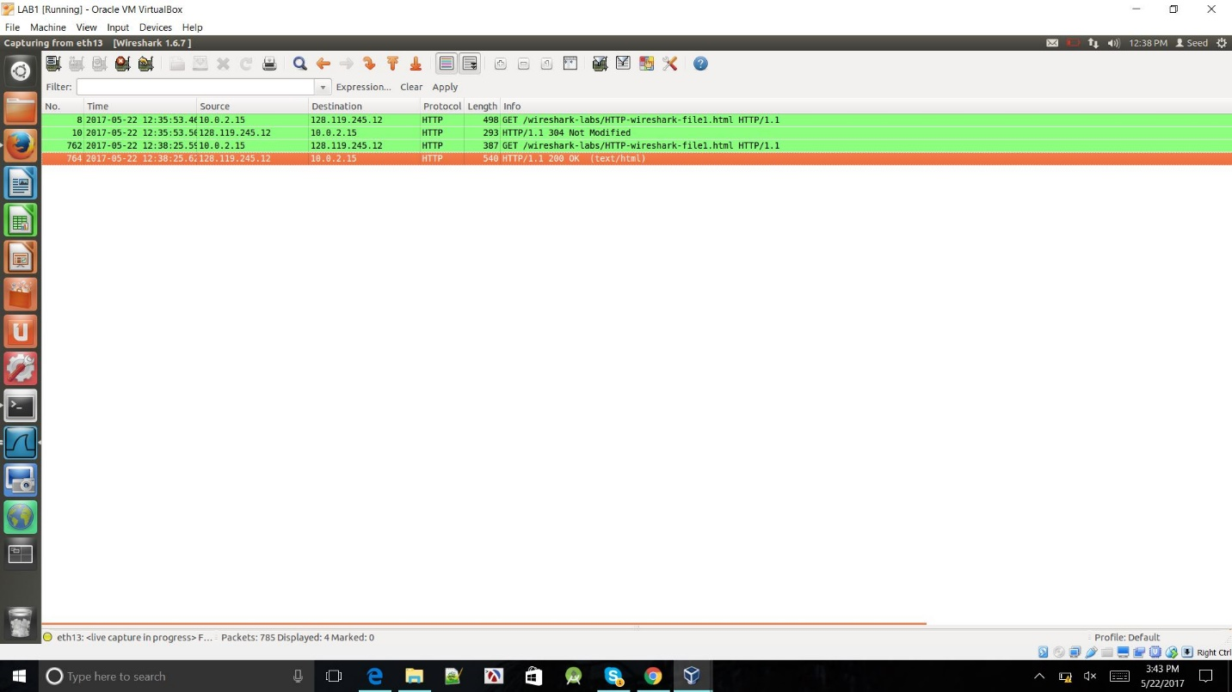

Apart from these headers, we can find:

1. Frame

Frame Number

Frame Length

1. Ethernet

Destination

Source

1. Internet Protocol

Flags

Header checksum

1. User Datagram Protocol

Source Port

Destination Port

1. Domain Name System

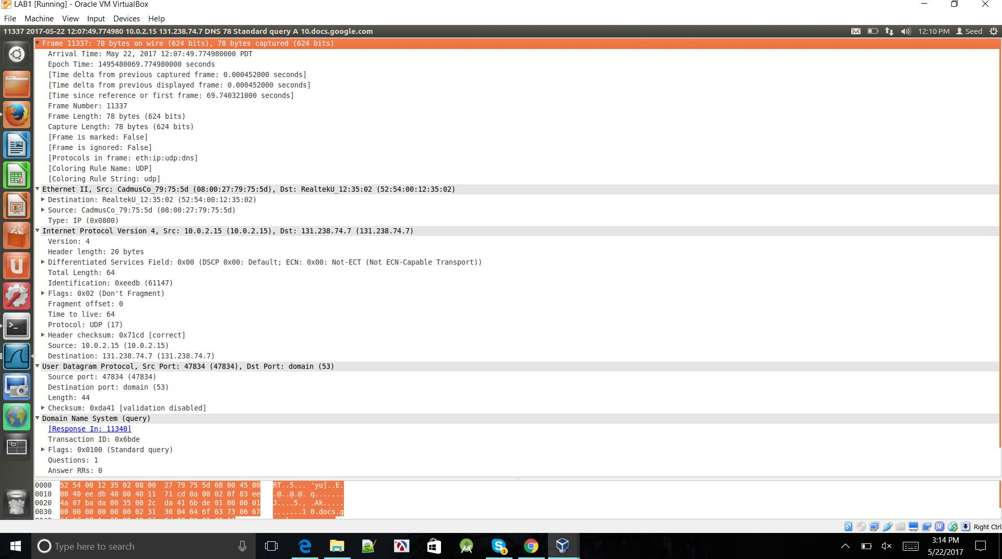

2. 301 HTTP Response

URL: <http://isslab-udayton.github.io>

1. Is your browser running HTTP version 1.0 or 1.1? What version of HTTP is the server running?

HTTP Version- 1.1

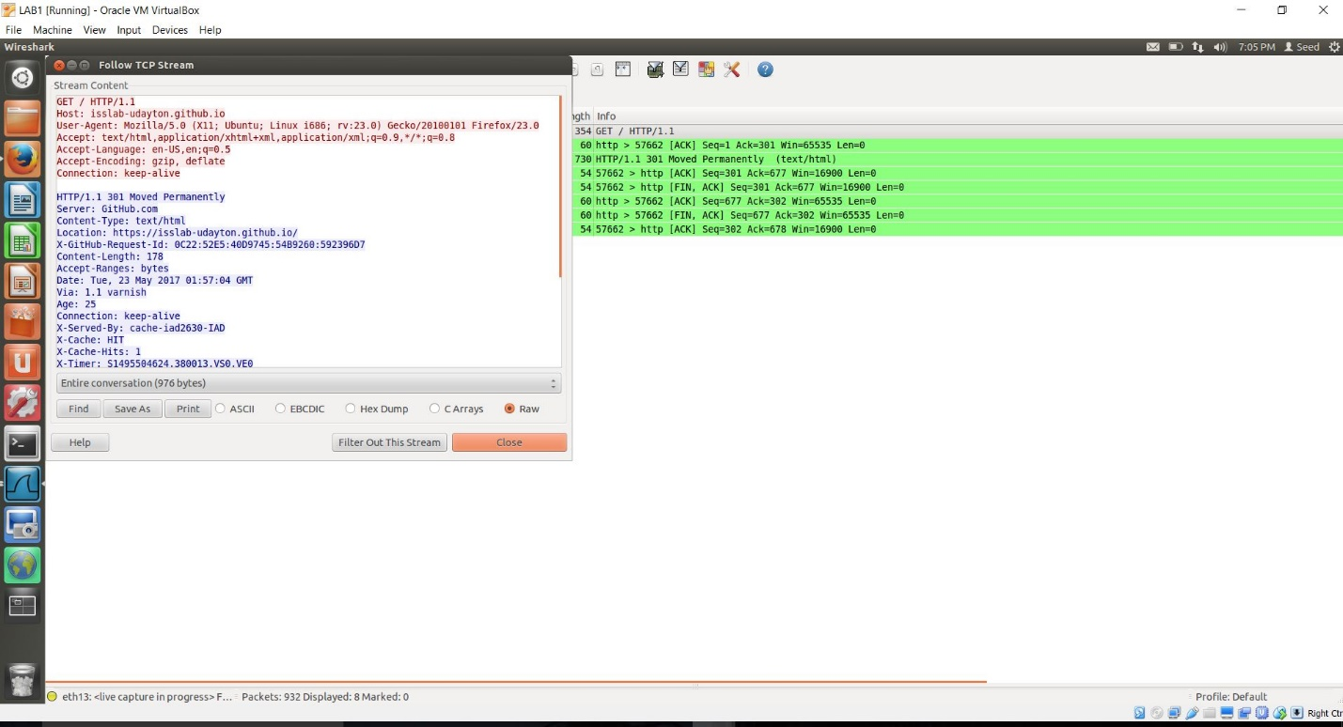

1. What languages (if any) does your browser indicate that it can accept to the server?

Accept-Language: en-US,en



1. What is the IP address of your computer? Of the gaia.cs.umass.edu server?

IP address of

Source: 151.101.32.133

Destination: 10.0.2.15

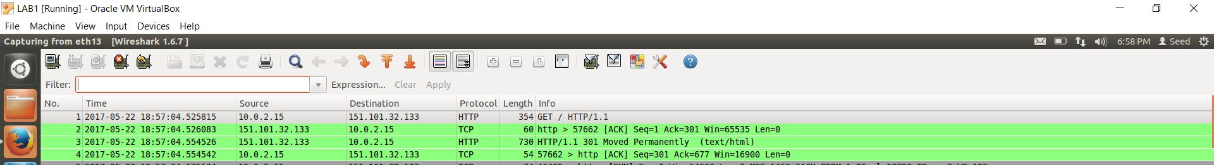

1. What is the status code returned from the server to your browser?

Status code: 301 Moved Permanently



1. **When was the HTML file that you are retrieving last modified at the server?**



1. How many bytes of content are being returned to your browser?

Number of bytes of content returned to browser is indicated by field

Content-Length: 178



1. By inspecting the raw data in the packet content window, do you see any headers within the data that are not displayed in the packet-listing window? If so, name one.

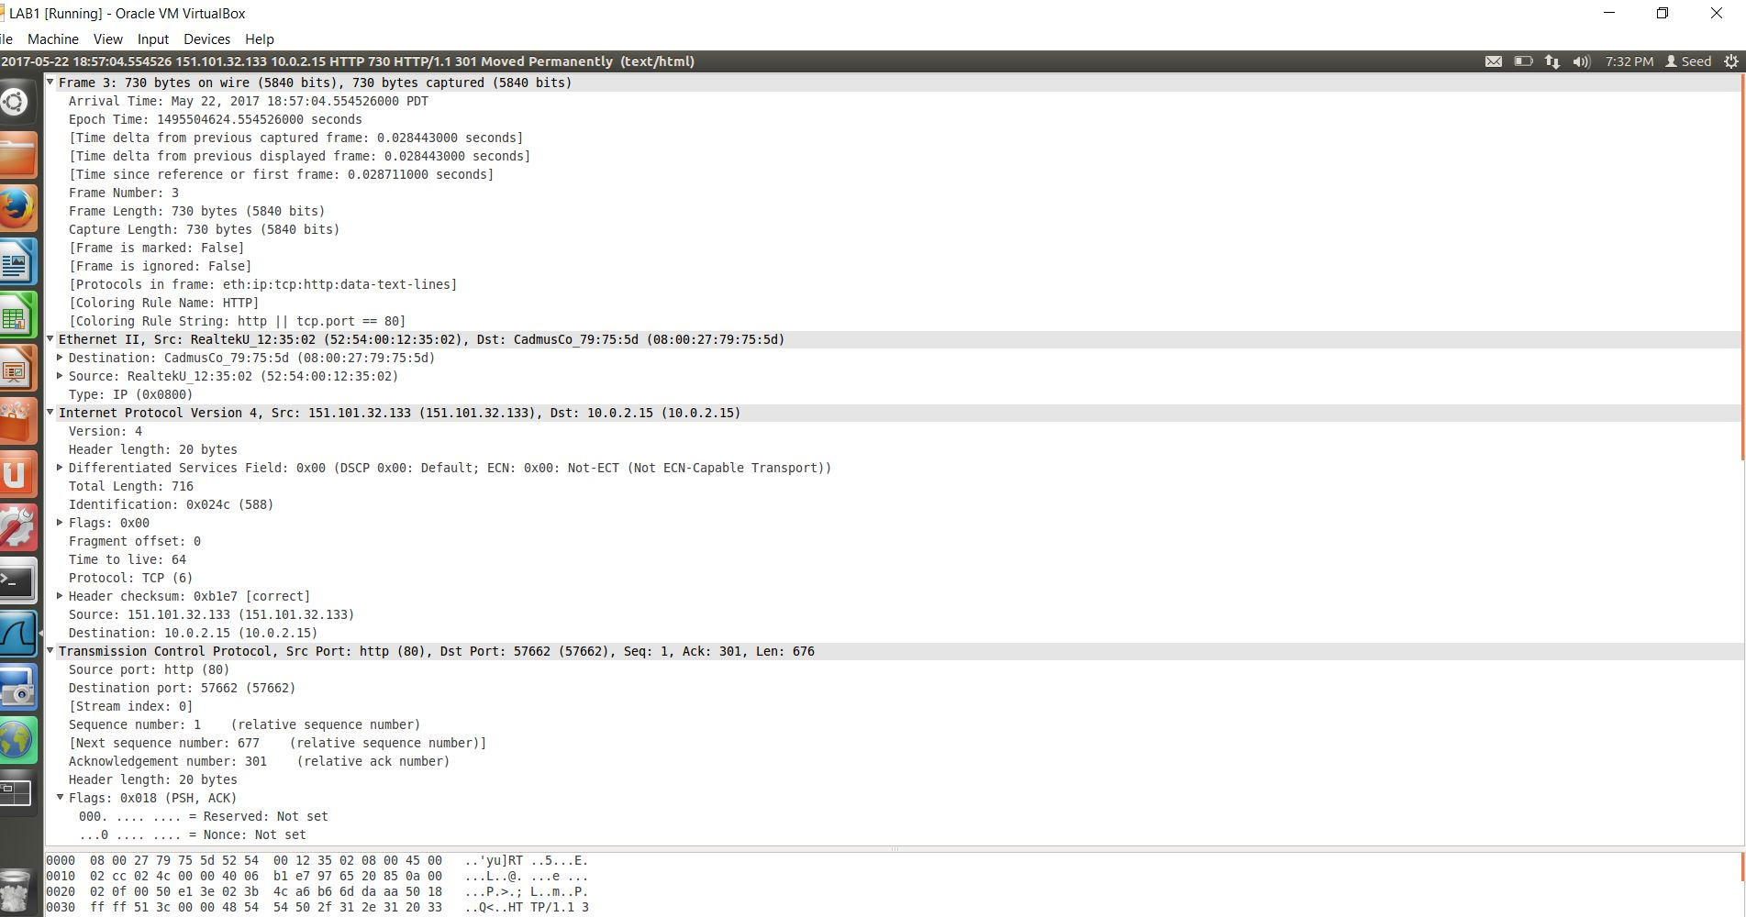

Apart from these headers, we can find:

* + - * 1. Frame

Frame Number

Frame Length

* + - * 1. Ethernet

Destination

Source

* + - * 1. Internet Protocol

Flags

Header checksum

* + - * 1. User Datagram Protocol

Source Port

Destination Port

* + - * 1. Domain Name System

3. Examine your client application

1. How many TCP messages your program have sent to the network? Capture the screenshot of this list.
2. Get the Flow Graph of your program (in Wireshark), and capture the screenshot and include in your report

