武汉纺织大学

Web应用开发课程设计

**物流单打印**

**学 院： 数学与计算机学院**

**班 级： 物联网11801**

**姓 名： 王准**

**学 号： 1804240322**

**指导老师： 聂刚**

**成 绩：**

**完成日期： 2020年12月15日**

目 录

1 需求分析 2

2 系统设计 3

2.2 ER图 3

2.3 UML类图（Class Diagram） 4

2.4 UML时序图（Sequence Diagram） 5

2.5 UML l流程图（Activity Diagram） 5

3 系统实现 6

3.1 项目结构 6

3.2 配置文件 6

3.2.1 jdbc.properties文件 6

3.2.2 log4j.properties文件 7

3.2.3 mybatis-config.xml文件 7

3.3 VO类OrderWordInfo.java 8

3.4 DAO接口类OrderWordInfo..java 8

3.5 接口映射文件OrderMapper.xml 9

3.6 工具包tools 9

3.6.1 MybatisUtils.java 9

3.7 服务层OrderDBService.java 10

3.8 function 11

4 系统测试 12

5 系统总结 12

# 需求分析

物流行业快速发展，具有一个很好的发展市场，传统的手工填写物流单已经满足不了人们的需求。设计一个生成电子物流单小程序，根据存储在数据库的订单数据打印物流单。

# **系统设计**

## ER图

数据库设计1张表，订单表。如下图所示

%3CmxGraphModel%3E%3Croot%3E%3CmxCell%20id%3D%220%22%2F%3E%3CmxCell%20id%3D%221%22%20parent%3D%220%22%2F%3E%3Cmysql.table%20entity.table.tableName%3D%22uses%22%20label%3D%22uses%22%20id%3D%222%22%3E%3CmxCell%20style%3D%22swimlane%3BfontStyle%3D0%3BchildLayout%3DstackLayout%3Bhorizontal%3D1%3Bhtml%3D1%3BstartSize%3D26%3BfillColor%3D%23b0e3e6%3BhorizontalStack%3D0%3BresizeParent%3D1%3BresizeParentMax%3D0%3BresizeLast%3D0%3Bcollapsible%3D1%3BmarginBottom%3D0%3BswimlaneFillColor%3D%23ffffff%3Balign%3Dcenter%3BfontSize%3D13%3BstrokeColor%3D%230e8088%3Brounded%3D0%3Bshadow%3D1%3Bcomic%3D0%3Bglass%3D0%3BgradientDirection%3Dsouth%3BgradientColor%3D%23ffffff%3B%22%20vertex%3D%221%22%20connectable%3D%220%22%20parent%3D%221%22%3E%3CmxGeometry%20x%3D%2260%22%20y%3D%2250%22%20width%3D%22310%22%20height%3D%22130%22%20as%3D%22geometry%22%2F%3E%3C%2FmxCell%3E%3C%2Fmysql.table%3E%3Cmysql.column%20entity.column.tableName%3D%22uses%22%20entity.column.name%3D%22userName%22%20entity.column.dataType%3D%22VARCHAR%22%20entity.column.PK%3D%22true%22%20label%3D%22%26lt%3Bimg%20title%3D%26quot%3BPrimary%20Key%26quot%3B%20src%3D%26quot%3Bimg%2Fdb%2Fkey1.png%26quot%3B%20width%3D%26quot%3B16%26quot%3B%20height%3D%26quot%3B16%26quot%3B%20align%3D%26quot%3Btop%26quot%3B%26gt%3B%26amp%3Bnbsp%3B%26lt%3Bfont%20size%3D%26quot%3B1%26quot%3B%20face%3D%26quot%3BTahoma%26quot%3B%26gt%3B%26lt%3Bspan%20style%3D%26quot%3Bfont-size%3A%2013px%26quot%3B%26gt%3B%26lt%3Bb%26gt%3Bid%20int%20primary%20key%26lt%3B%2Fb%26gt%3B%26lt%3B%2Fspan%26gt%3B%26lt%3B%2Ffont%26gt%3B%22%20entity.column.oldName%3D%22id%22%20entity.column.datalen%3D%2220%22%20entity.column.decimals%3D%22%22%20entity.column.autoIncreament%3D%22%22%20entity.column.unsigned%3D%22%22%20entity.column.bin%3D%22%22%20entity.column.ascii%3D%22%22%20entity.column.unicode%3D%22%22%20entity.column.unique%3D%22%22%20entity.column.isNotNull%3D%22NOT%20NULL%22%20entity.column.defaultValue%3D%22%22%20entity.column.comment%3D%22%22%20entity.column.enum%3D%22%22%20entity.column.set%3D%22%22%20entity.column.enumSetValue%3D%22%22%20id%3D%223%22%3E%3CmxCell%20style%3D%22text%3Bhtml%3D1%3BstrokeColor%3Dnone%3BfillColor%3Dnone%3BspacingLeft%3D4%3BspacingRight%3D4%3Boverflow%3Dhidden%3Brotatable%3D0%3BportConstraint%3Deastwest%3BfontSize%3D12%3BverticalAlign%3Dmiddle%3B%22%20vertex%3D%221%22%20parent%3D%222%22%3E%3CmxGeometry%20y%3D%2226%22%20width%3D%22310%22%20height%3D%2226%22%20as%3D%22geometry%22%2F%3E%3C%2FmxCell%3E%3C%2Fmysql.column%3E%3Cmysql.column%20entity.column.tableName%3D%22uses%22%20entity.column.name%3D%22chrName%22%20entity.column.datalen%3D%2220%22%20entity.column.dataType%3D%22VARCHAR%22%20label%3D%22%26lt%3Bimg%20title%3D%26quot%3BPrimary%20Key%26quot%3B%20src%3D%26quot%3Bimages%2Fspacer.gif%26quot%3B%20width%3D%26quot%3B16%26quot%3B%20height%3D%26quot%3B16%26quot%3B%20align%3D%26quot%3Btop%26quot%3B%26gt%3B%26amp%3Bnbsp%3B%26lt%3Bfont%20size%3D%26quot%3B1%26quot%3B%20face%3D%26quot%3BTahoma%26quot%3B%26gt%3B%26lt%3Bspan%20style%3D%26quot%3Bfont-size%3A%2013px%26quot%3B%26gt%3B%26lt%3Bb%26gt%3Bname%20varchar(10)%26lt%3B%2Fb%26gt%3B%26lt%3B%2Fspan%26gt%3B%26lt%3B%2Ffont%26gt%3B%22%20entity.column.oldName%3D%22name%22%20entity.column.decimals%3D%22%22%20entity.column.autoIncreament%3D%22%22%20entity.column.unsigned%3D%22%22%20entity.column.bin%3D%22%22%20entity.column.ascii%3D%22%22%20entity.column.unicode%3D%22%22%20entity.column.PK%3D%22false%22%20entity.column.unique%3D%22%22%20entity.column.isNotNull%3D%22%22%20entity.column.defaultValue%3D%22%22%20entity.column.comment%3D%22%22%20entity.column.enum%3D%22%22%20entity.column.set%3D%22%22%20entity.column.enumSetValue%3D%22%22%20id%3D%224%22%3E%3CmxCell%20style%3D%22text%3Bhtml%3D1%3BstrokeColor%3Dnone%3BfillColor%3Dnone%3BspacingLeft%3D4%3BspacingRight%3D4%3Boverflow%3Dhidden%3Brotatable%3D0%3BportConstraint%3Deastwest%3BfontSize%3D12%3BverticalAlign%3Dmiddle%3B%22%20vertex%3D%221%22%20parent%3D%222%22%3E%3CmxGeometry%20y%3D%2252%22%20width%3D%22310%22%20height%3D%2226%22%20as%3D%22geometry%22%2F%3E%3C%2FmxCell%3E%3C%2Fmysql.column%3E%3Cmysql.column%20entity.column.tableName%3D%22uses%22%20entity.column.name%3D%22password%22%20entity.column.datalen%3D%2250%22%20entity.column.dataType%3D%22VARCHAR%22%20label%3D%22%26lt%3Bimg%20title%3D%26quot%3BPrimary%20Key%26quot%3B%20src%3D%26quot%3Bimages%2Fspacer.gif%26quot%3B%20width%3D%26quot%3B16%26quot%3B%20height%3D%26quot%3B16%26quot%3B%20align%3D%26quot%3Btop%26quot%3B%26gt%3B%26amp%3Bnbsp%3B%26lt%3Bfont%20size%3D%26quot%3B1%26quot%3B%20face%3D%26quot%3BTahoma%26quot%3B%26gt%3B%26lt%3Bspan%20style%3D%26quot%3Bfont-size%3A%2013px%26quot%3B%26gt%3B%26lt%3Bb%26gt%3Bname%20varchar(10)%26lt%3B%2Fb%26gt%3B%26lt%3B%2Fspan%26gt%3B%26lt%3B%2Ffont%26gt%3B%22%20entity.column.oldName%3D%22chrName%22%20entity.column.decimals%3D%22%22%20entity.column.autoIncreament%3D%22%22%20entity.column.unsigned%3D%22%22%20entity.column.bin%3D%22%22%20entity.column.ascii%3D%22%22%20entity.column.unicode%3D%22%22%20entity.column.PK%3D%22false%22%20entity.column.unique%3D%22%22%20entity.column.isNotNull%3D%22%22%20entity.column.defaultValue%3D%22%22%20entity.column.comment%3D%22%E5%AF%86%E7%A0%81%22%20entity.column.enum%3D%22%22%20entity.column.set%3D%22%22%20entity.column.enumSetValue%3D%22%22%20id%3D%225%22%3E%3CmxCell%20style%3D%22text%3Bhtml%3D1%3BstrokeColor%3Dnone%3BfillColor%3Dnone%3BspacingLeft%3D4%3BspacingRight%3D4%3Boverflow%3Dhidden%3Brotatable%3D0%3BportConstraint%3Deastwest%3BfontSize%3D12%3BverticalAlign%3Dmiddle%3B%22%20vertex%3D%221%22%20parent%3D%222%22%3E%3CmxGeometry%20y%3D%2278%22%20width%3D%22310%22%20height%3D%2226%22%20as%3D%22geometry%22%2F%3E%3C%2FmxCell%3E%3C%2Fmysql.column%3E%3Cmysql.column%20entity.column.tableName%3D%22uses%22%20entity.column.name%3D%22role%22%20entity.column.datalen%3D%2220%22%20entity.column.dataType%3D%22VARCHAR%22%20label%3D%22%26lt%3Bimg%20title%3D%26quot%3BPrimary%20Key%26quot%3B%20src%3D%26quot%3Bimages%2Fspacer.gif%26quot%3B%20width%3D%26quot%3B16%26quot%3B%20height%3D%26quot%3B16%26quot%3B%20align%3D%26quot%3Btop%26quot%3B%26gt%3B%26amp%3Bnbsp%3B%26lt%3Bfont%20size%3D%26quot%3B1%26quot%3B%20face%3D%26quot%3BTahoma%26quot%3B%26gt%3B%26lt%3Bspan%20style%3D%26quot%3Bfont-size%3A%2013px%26quot%3B%26gt%3B%26lt%3Bb%26gt%3Bname%20varchar(10)%26lt%3B%2Fb%26gt%3B%26lt%3B%2Fspan%26gt%3B%26lt%3B%2Ffont%26gt%3B%22%20entity.column.oldName%3D%22chrName%22%20entity.column.decimals%3D%22%22%20entity.column.autoIncreament%3D%22%22%20entity.column.unsigned%3D%22%22%20entity.column.bin%3D%22%22%20entity.column.ascii%3D%22%22%20entity.column.unicode%3D%22%22%20entity.column.PK%3D%22false%22%20entity.column.unique%3D%22%22%20entity.column.isNotNull%3D%22%22%20entity.column.defaultValue%3D%22%22%20entity.column.comment%3D%22%E8%A7%92%E8%89%B2%22%20entity.column.enum%3D%22%22%20entity.column.set%3D%22%22%20entity.column.enumSetValue%3D%22%22%20id%3D%226%22%3E%3CmxCell%20style%3D%22text%3Bhtml%3D1%3BstrokeColor%3Dnone%3BfillColor%3Dnone%3BspacingLeft%3D4%3BspacingRight%3D4%3Boverflow%3Dhidden%3Brotatable%3D0%3BportConstraint%3Deastwest%3BfontSize%3D12%3BverticalAlign%3Dmiddle%3B%22%20vertex%3D%221%22%20parent%3D%222%22%3E%3CmxGeometry%20y%3D%22104%22%20width%3D%22310%22%20height%3D%2226%22%20as%3D%22geometry%22%2F%3E%3C%2FmxCell%3E%3C%2Fmysql.column%3E%3Cmysql.table%20entity.table.tableName%3D%22product%22%20label%3D%22product%22%20id%3D%227%22%3E%3CmxCell%20style%3D%22swimlane%3BfontStyle%3D0%3BchildLayout%3DstackLayout%3Bhorizontal%3D1%3Bhtml%3D1%3BstartSize%3D26%3BfillColor%3D%23b0e3e6%3BhorizontalStack%3D0%3BresizeParent%3D1%3BresizeParentMax%3D0%3BresizeLast%3D0%3Bcollapsible%3D1%3BmarginBottom%3D0%3BswimlaneFillColor%3D%23ffffff%3Balign%3Dcenter%3BfontSize%3D13%3BstrokeColor%3D%230e8088%3Brounded%3D0%3Bshadow%3D1%3Bcomic%3D0%3Bglass%3D0%3BgradientDirection%3Dsouth%3BgradientColor%3D%23ffffff%3B%22%20vertex%3D%221%22%20connectable%3D%220%22%20parent%3D%221%22%3E%3CmxGeometry%20x%3D%2260%22%20y%3D%22210%22%20width%3D%22310%22%20height%3D%22130%22%20as%3D%22geometry%22%2F%3E%3C%2FmxCell%3E%3C%2Fmysql.table%3E%3Cmysql.column%20entity.column.tableName%3D%22product%22%20entity.column.name%3D%22barcode%22%20entity.column.dataType%3D%22VARCHAR%22%20entity.column.PK%3D%22true%22%20label%3D%22%26lt%3Bimg%20title%3D%26quot%3BPrimary%20Key%26quot%3B%20src%3D%26quot%3Bimg%2Fdb%2Fkey1.png%26quot%3B%20width%3D%26quot%3B16%26quot%3B%20height%3D%26quot%3B16%26quot%3B%20align%3D%26quot%3Btop%26quot%3B%26gt%3B%26amp%3Bnbsp%3B%26lt%3Bfont%20size%3D%26quot%3B1%26quot%3B%20face%3D%26quot%3BTahoma%26quot%3B%26gt%3B%26lt%3Bspan%20style%3D%26quot%3Bfont-size%3A%2013px%26quot%3B%26gt%3B%26lt%3Bb%26gt%3Bid%20int%20primary%20key%26lt%3B%2Fb%26gt%3B%26lt%3B%2Fspan%26gt%3B%26lt%3B%2Ffont%26gt%3B%22%20entity.column.oldName%3D%22id%22%20entity.column.datalen%3D%2210%22%20entity.column.decimals%3D%22%22%20entity.column.autoIncreament%3D%22%22%20entity.column.unsigned%3D%22%22%20entity.column.bin%3D%22%22%20entity.column.ascii%3D%22%22%20entity.column.unicode%3D%22%22%20entity.column.unique%3D%22%22%20entity.column.isNotNull%3D%22NOT%20NULL%22%20entity.column.defaultValue%3D%22%22%20entity.column.comment%3D%22%22%20entity.column.enum%3D%22%22%20entity.column.set%3D%22%22%20entity.column.enumSetValue%3D%22%22%20id%3D%228%22%3E%3CmxCell%20style%3D%22text%3Bhtml%3D1%3BstrokeColor%3Dnone%3BfillColor%3Dnone%3BspacingLeft%3D4%3BspacingRight%3D4%3Boverflow%3Dhidden%3Brotatable%3D0%3BportConstraint%3Deastwest%3BfontSize%3D12%3BverticalAlign%3Dmiddle%3B%22%20vertex%3D%221%22%20parent%3D%227%22%3E%3CmxGeometry%20y%3D%2226%22%20width%3D%22310%22%20height%3D%2226%22%20as%3D%22geometry%22%2F%3E%3C%2FmxCell%3E%3C%2Fmysql.column%3E%3Cmysql.column%20entity.column.tableName%3D%22product%22%20entity.column.name%3D%22productName%22%20entity.column.datalen%3D%2250%22%20entity.column.dataType%3D%22VARCHAR%22%20label%3D%22%26lt%3Bimg%20title%3D%26quot%3BPrimary%20Key%26quot%3B%20src%3D%26quot%3Bimages%2Fspacer.gif%26quot%3B%20width%3D%26quot%3B16%26quot%3B%20height%3D%26quot%3B16%26quot%3B%20align%3D%26quot%3Btop%26quot%3B%26gt%3B%26amp%3Bnbsp%3B%26lt%3Bfont%20size%3D%26quot%3B1%26quot%3B%20face%3D%26quot%3BTahoma%26quot%3B%26gt%3B%26lt%3Bspan%20style%3D%26quot%3Bfont-size%3A%2013px%26quot%3B%26gt%3B%26lt%3Bb%26gt%3Bname%20varchar(10)%26lt%3B%2Fb%26gt%3B%26lt%3B%2Fspan%26gt%3B%26lt%3B%2Ffont%26gt%3B%22%20entity.column.oldName%3D%22name%22%20entity.column.decimals%3D%22%22%20entity.column.autoIncreament%3D%22%22%20entity.column.unsigned%3D%22%22%20entity.column.bin%3D%22%22%20entity.column.ascii%3D%22%22%20entity.column.unicode%3D%22%22%20entity.column.PK%3D%22false%22%20entity.column.unique%3D%22%22%20entity.column.isNotNull%3D%22%22%20entity.column.defaultValue%3D%22%22%20entity.column.comment%3D%22%22%20entity.column.enum%3D%22%22%20entity.column.set%3D%22%22%20entity.column.enumSetValue%3D%22%22%20id%3D%229%22%3E%3CmxCell%20style%3D%22text%3Bhtml%3D1%3BstrokeColor%3Dnone%3BfillColor%3Dnone%3BspacingLeft%3D4%3BspacingRight%3D4%3Boverflow%3Dhidden%3Brotatable%3D0%3BportConstraint%3Deastwest%3BfontSize%3D12%3BverticalAlign%3Dmiddle%3B%22%20vertex%3D%221%22%20parent%3D%227%22%3E%3CmxGeometry%20y%3D%2252%22%20width%3D%22310%22%20height%3D%2226%22%20as%3D%22geometry%22%2F%3E%3C%2FmxCell%3E%3C%2Fmysql.column%3E%3Cmysql.column%20entity.column.tableName%3D%22product%22%20entity.column.name%3D%22price%22%20entity.column.datalen%3D%229%22%20entity.column.dataType%3D%22DECIMAL%22%20label%3D%22%26lt%3Bimg%20title%3D%26quot%3BPrimary%20Key%26quot%3B%20src%3D%26quot%3Bimages%2Fspacer.gif%26quot%3B%20width%3D%26quot%3B16%26quot%3B%20height%3D%26quot%3B16%26quot%3B%20align%3D%26quot%3Btop%26quot%3B%26gt%3B%26amp%3Bnbsp%3B%26lt%3Bfont%20size%3D%26quot%3B1%26quot%3B%20face%3D%26quot%3BTahoma%26quot%3B%26gt%3B%26lt%3Bspan%20style%3D%26quot%3Bfont-size%3A%2013px%26quot%3B%26gt%3B%26lt%3Bb%26gt%3Bname%20varchar(10)%26lt%3B%2Fb%26gt%3B%26lt%3B%2Fspan%26gt%3B%26lt%3B%2Ffont%26gt%3B%22%20entity.column.oldName%3D%22price%22%20entity.column.decimals%3D%222%22%20entity.column.autoIncreament%3D%22%22%20entity.column.unsigned%3D%22%22%20entity.column.bin%3D%22%22%20entity.column.ascii%3D%22%22%20entity.column.unicode%3D%22%22%20entity.column.PK%3D%22false%22%20entity.column.unique%3D%22%22%20entity.column.isNotNull%3D%22%22%20entity.column.defaultValue%3D%22%22%20entity.column.comment%3D%22%22%20entity.column.enum%3D%22%22%20entity.column.set%3D%22%22%20entity.column.enumSetValue%3D%22%22%20id%3D%2210%22%3E%3CmxCell%20style%3D%22text%3Bhtml%3D1%3BstrokeColor%3Dnone%3BfillColor%3Dnone%3BspacingLeft%3D4%3BspacingRight%3D4%3Boverflow%3Dhidden%3Brotatable%3D0%3BportConstraint%3Deastwest%3BfontSize%3D12%3BverticalAlign%3Dmiddle%3B%22%20vertex%3D%221%22%20parent%3D%227%22%3E%3CmxGeometry%20y%3D%2278%22%20width%3D%22310%22%20height%3D%2226%22%20as%3D%22geometry%22%2F%3E%3C%2FmxCell%3E%3C%2Fmysql.column%3E%3Cmysql.column%20entity.column.tableName%3D%22product%22%20entity.column.name%3D%22supply%22%20entity.column.datalen%3D%2220%22%20entity.column.dataType%3D%22VARCHAR%22%20label%3D%22%26lt%3Bimg%20title%3D%26quot%3BPrimary%20Key%26quot%3B%20src%3D%26quot%3Bimages%2Fspacer.gif%26quot%3B%20width%3D%26quot%3B16%26quot%3B%20height%3D%26quot%3B16%26quot%3B%20align%3D%26quot%3Btop%26quot%3B%26gt%3B%26amp%3Bnbsp%3B%26lt%3Bfont%20size%3D%26quot%3B1%26quot%3B%20face%3D%26quot%3BTahoma%26quot%3B%26gt%3B%26lt%3Bspan%20style%3D%26quot%3Bfont-size%3A%2013px%26quot%3B%26gt%3B%26lt%3Bb%26gt%3Bname%20varchar(10)%26lt%3B%2Fb%26gt%3B%26lt%3B%2Fspan%26gt%3B%26lt%3B%2Ffont%26gt%3B%22%20entity.column.oldName%3D%22price%22%20entity.column.decimals%3D%22%22%20entity.column.autoIncreament%3D%22%22%20entity.column.unsigned%3D%22%22%20entity.column.bin%3D%22%22%20entity.column.ascii%3D%22%22%20entity.column.unicode%3D%22%22%20entity.column.PK%3D%22false%22%20entity.column.unique%3D%22%22%20entity.column.isNotNull%3D%22%22%20entity.column.defaultValue%3D%22%22%20entity.column.comment%3D%22%22%20entity.column.enum%3D%22%22%20entity.column.set%3D%22%22%20entity.column.enumSetValue%3D%22%22%20id%3D%2211%22%3E%3CmxCell%20style%3D%22text%3Bhtml%3D1%3BstrokeColor%3Dnone%3BfillColor%3Dnone%3BspacingLeft%3D4%3BspacingRight%3D4%3Boverflow%3Dhidden%3Brotatable%3D0%3BportConstraint%3Deastwest%3BfontSize%3D12%3BverticalAlign%3Dmiddle%3B%22%20vertex%3D%221%22%20parent%3D%227%22%3E%3CmxGeometry%20y%3D%22104%22%20width%3D%22310%22%20height%3D%2226%22%20as%3D%22geometry%22%2F%3E%3C%2FmxCell%3E%3C%2Fmysql.column%3E%3Cmysql.table%20entity.table.tableName%3D%22saleDetail%22%20label%3D%22saleDetail%22%20id%3D%2212%22%3E%3CmxCell%20style%3D%22swimlane%3BfontStyle%3D0%3BchildLayout%3DstackLayout%3Bhorizontal%3D1%3Bhtml%3D1%3BstartSize%3D26%3BfillColor%3D%23b0e3e6%3BhorizontalStack%3D0%3BresizeParent%3D1%3BresizeParentMax%3D0%3BresizeLast%3D0%3Bcollapsible%3D1%3BmarginBottom%3D0%3BswimlaneFillColor%3D%23ffffff%3Balign%3Dcenter%3BfontSize%3D13%3BstrokeColor%3D%230e8088%3Brounded%3D0%3Bshadow%3D1%3Bcomic%3D0%3Bglass%3D0%3BgradientDirection%3Dsouth%3BgradientColor%3D%23ffffff%3B%22%20vertex%3D%221%22%20connectable%3D%220%22%20parent%3D%221%22%3E%3CmxGeometry%20x%3D%22480%22%20y%3D%2280%22%20width%3D%22280%22%20height%3D%22208%22%20as%3D%22geometry%22%2F%3E%3C%2FmxCell%3E%3C%2Fmysql.table%3E%3Cmysql.column%20entity.column.tableName%3D%22saleDetail%22%20entity.column.name%3D%22lsh%22%20entity.column.dataType%3D%22VARCHAR%22%20entity.column.PK%3D%22true%22%20label%3D%22%26lt%3Bimg%20title%3D%26quot%3BPrimary%20Key%26quot%3B%20src%3D%26quot%3Bimg%2Fdb%2Fkey1.png%26quot%3B%20width%3D%26quot%3B16%26quot%3B%20height%3D%26quot%3B16%26quot%3B%20align%3D%26quot%3Btop%26quot%3B%26gt%3B%26amp%3Bnbsp%3B%26lt%3Bfont%20size%3D%26quot%3B1%26quot%3B%20face%3D%26quot%3BTahoma%26quot%3B%26gt%3B%26lt%3Bspan%20style%3D%26quot%3Bfont-size%3A%2013px%26quot%3B%26gt%3B%26lt%3Bb%26gt%3Bid%20int%20primary%20key%26lt%3B%2Fb%26gt%3B%26lt%3B%2Fspan%26gt%3B%26lt%3B%2Ffont%26gt%3B%22%20entity.column.oldName%3D%22id%22%20entity.column.datalen%3D%2220%22%20entity.column.decimals%3D%22%22%20entity.column.autoIncreament%3D%22%22%20entity.column.unsigned%3D%22%22%20entity.column.bin%3D%22%22%20entity.column.ascii%3D%22%22%20entity.column.unicode%3D%22%22%20entity.column.unique%3D%22%22%20entity.column.isNotNull%3D%22NOT%20NULL%22%20entity.column.defaultValue%3D%22%22%20entity.column.comment%3D%22%22%20entity.column.enum%3D%22%22%20entity.column.set%3D%22%22%20entity.column.enumSetValue%3D%22%22%20id%3D%2213%22%3E%3CmxCell%20style%3D%22text%3Bhtml%3D1%3BstrokeColor%3Dnone%3BfillColor%3Dnone%3BspacingLeft%3D4%3BspacingRight%3D4%3Boverflow%3Dhidden%3Brotatable%3D0%3BportConstraint%3Deastwest%3BfontSize%3D12%3BverticalAlign%3Dmiddle%3B%22%20vertex%3D%221%22%20parent%3D%2212%22%3E%3CmxGeometry%20y%3D%2226%22%20width%3D%22280%22%20height%3D%2226%22%20as%3D%22geometry%22%2F%3E%3C%2FmxCell%3E%3C%2Fmysql.column%3E%3Cmysql.column%20entity.column.tableName%3D%22saleDetail%22%20entity.column.name%3D%22barcode%22%20entity.column.datalen%3D%2210%22%20entity.column.dataType%3D%22VARCHAR%22%20label%3D%22%26lt%3Bimg%20title%3D%26quot%3BPrimary%20Key%26quot%3B%20src%3D%26quot%3Bimages%2Fspacer.gif%26quot%3B%20width%3D%26quot%3B16%26quot%3B%20height%3D%26quot%3B16%26quot%3B%20align%3D%26quot%3Btop%26quot%3B%26gt%3B%26amp%3Bnbsp%3B%26lt%3Bfont%20size%3D%26quot%3B1%26quot%3B%20face%3D%26quot%3BTahoma%26quot%3B%26gt%3B%26lt%3Bspan%20style%3D%26quot%3Bfont-size%3A%2013px%26quot%3B%26gt%3B%26lt%3Bb%26gt%3Bname%20varchar(10)%26lt%3B%2Fb%26gt%3B%26lt%3B%2Fspan%26gt%3B%26lt%3B%2Ffont%26gt%3B%22%20entity.column.oldName%3D%22barcode%22%20entity.column.decimals%3D%22%22%20entity.column.autoIncreament%3D%22%22%20entity.column.unsigned%3D%22%22%20entity.column.bin%3D%22%22%20entity.column.ascii%3D%22%22%20entity.column.unicode%3D%22%22%20entity.column.PK%3D%22false%22%20entity.column.unique%3D%22%22%20entity.column.isNotNull%3D%22%22%20entity.column.defaultValue%3D%22%22%20entity.column.comment%3D%22%22%20entity.column.enum%3D%22%22%20entity.column.set%3D%22%22%20entity.column.enumSetValue%3D%22%22%20id%3D%2214%22%3E%3CmxCell%20style%3D%22text%3Bhtml%3D1%3BstrokeColor%3Dnone%3BfillColor%3Dnone%3BspacingLeft%3D4%3BspacingRight%3D4%3Boverflow%3Dhidden%3Brotatable%3D0%3BportConstraint%3Deastwest%3BfontSize%3D12%3BverticalAlign%3Dmiddle%3B%22%20vertex%3D%221%22%20parent%3D%2212%22%3E%3CmxGeometry%20y%3D%2252%22%20width%3D%22280%22%20height%3D%2226%22%20as%3D%22geometry%22%2F%3E%3C%2FmxCell%3E%3C%2Fmysql.column%3E%3Cmysql.column%20entity.column.tableName%3D%22saleDetail%22%20entity.column.name%3D%22productName%22%20entity.column.datalen%3D%2250%22%20entity.column.dataType%3D%22VARCHAR%22%20label%3D%22%26lt%3Bimg%20title%3D%26quot%3BPrimary%20Key%26quot%3B%20src%3D%26quot%3Bimages%2Fspacer.gif%26quot%3B%20width%3D%26quot%3B16%26quot%3B%20height%3D%26quot%3B16%26quot%3B%20align%3D%26quot%3Btop%26quot%3B%26gt%3B%26amp%3Bnbsp%3B%26lt%3Bfont%20size%3D%26quot%3B1%26quot%3B%20face%3D%26quot%3BTahoma%26quot%3B%26gt%3B%26lt%3Bspan%20style%3D%26quot%3Bfont-size%3A%2013px%26quot%3B%26gt%3B%26lt%3Bb%26gt%3Bname%20varchar(10)%26lt%3B%2Fb%26gt%3B%26lt%3B%2Fspan%26gt%3B%26lt%3B%2Ffont%26gt%3B%22%20entity.column.oldName%3D%22productName%22%20entity.column.decimals%3D%22%22%20entity.column.autoIncreament%3D%22%22%20entity.column.unsigned%3D%22%22%20entity.column.bin%3D%22%22%20entity.column.ascii%3D%22%22%20entity.column.unicode%3D%22%22%20entity.column.PK%3D%22false%22%20entity.column.unique%3D%22%22%20entity.column.isNotNull%3D%22%22%20entity.column.defaultValue%3D%22%22%20entity.column.comment%3D%22%22%20entity.column.enum%3D%22%22%20entity.column.set%3D%22%22%20entity.column.enumSetValue%3D%22%22%20id%3D%2215%22%3E%3CmxCell%20style%3D%22text%3Bhtml%3D1%3BstrokeColor%3Dnone%3BfillColor%3Dnone%3BspacingLeft%3D4%3BspacingRight%3D4%3Boverflow%3Dhidden%3Brotatable%3D0%3BportConstraint%3Deastwest%3BfontSize%3D12%3BverticalAlign%3Dmiddle%3B%22%20vertex%3D%221%22%20parent%3D%2212%22%3E%3CmxGeometry%20y%3D%2278%22%20width%3D%22280%22%20height%3D%2226%22%20as%3D%22geometry%22%2F%3E%3C%2FmxCell%3E%3C%2Fmysql.column%3E%3Cmysql.column%20entity.column.tableName%3D%22saleDetail%22%20entity.column.name%3D%22price%22%20entity.column.datalen%3D%229%22%20entity.column.dataType%3D%22DECIMAL%22%20label%3D%22%26lt%3Bimg%20title%3D%26quot%3BPrimary%20Key%26quot%3B%20src%3D%26quot%3Bimages%2Fspacer.gif%26quot%3B%20width%3D%26quot%3B16%26quot%3B%20height%3D%26quot%3B16%26quot%3B%20align%3D%26quot%3Btop%26quot%3B%26gt%3B%26amp%3Bnbsp%3B%26lt%3Bfont%20size%3D%26quot%3B1%26quot%3B%20face%3D%26quot%3BTahoma%26quot%3B%26gt%3B%26lt%3Bspan%20style%3D%26quot%3Bfont-size%3A%2013px%26quot%3B%26gt%3B%26lt%3Bb%26gt%3Bname%20varchar(10)%26lt%3B%2Fb%26gt%3B%26lt%3B%2Fspan%26gt%3B%26lt%3B%2Ffont%26gt%3B%22%20entity.column.oldName%3D%22productName%22%20entity.column.decimals%3D%222%22%20entity.column.autoIncreament%3D%22%22%20entity.column.unsigned%3D%22%22%20entity.column.bin%3D%22%22%20entity.column.ascii%3D%22%22%20entity.column.unicode%3D%22%22%20entity.column.PK%3D%22false%22%20entity.column.unique%3D%22%22%20entity.column.isNotNull%3D%22%22%20entity.column.defaultValue%3D%22%22%20entity.column.comment%3D%22%22%20entity.column.enum%3D%22%22%20entity.column.set%3D%22%22%20entity.column.enumSetValue%3D%22%22%20id%3D%2216%22%3E%3CmxCell%20style%3D%22text%3Bhtml%3D1%3BstrokeColor%3Dnone%3BfillColor%3Dnone%3BspacingLeft%3D4%3BspacingRight%3D4%3Boverflow%3Dhidden%3Brotatable%3D0%3BportConstraint%3Deastwest%3BfontSize%3D12%3BverticalAlign%3Dmiddle%3B%22%20vertex%3D%221%22%20parent%3D%2212%22%3E%3CmxGeometry%20y%3D%22104%22%20width%3D%22280%22%20height%3D%2226%22%20as%3D%22geometry%22%2F%3E%3C%2FmxCell%3E%3C%2Fmysql.column%3E%3Cmysql.column%20entity.column.tableName%3D%22saleDetail%22%20entity.column.name%3D%22count%22%20entity.column.datalen%3D%229%22%20entity.column.dataType%3D%22INT%22%20label%3D%22%26lt%3Bimg%20title%3D%26quot%3BPrimary%20Key%26quot%3B%20src%3D%26quot%3Bimages%2Fspacer.gif%26quot%3B%20width%3D%26quot%3B16%26quot%3B%20height%3D%26quot%3B16%26quot%3B%20align%3D%26quot%3Btop%26quot%3B%26gt%3B%26amp%3Bnbsp%3B%26lt%3Bfont%20size%3D%26quot%3B1%26quot%3B%20face%3D%26quot%3BTahoma%26quot%3B%26gt%3B%26lt%3Bspan%20style%3D%26quot%3Bfont-size%3A%2013px%26quot%3B%26gt%3B%26lt%3Bb%26gt%3Bname%20varchar(10)%26lt%3B%2Fb%26gt%3B%26lt%3B%2Fspan%26gt%3B%26lt%3B%2Ffont%26gt%3B%22%20entity.column.oldName%3D%22price%22%20entity.column.decimals%3D%22%22%20entity.column.autoIncreament%3D%22%22%20entity.column.unsigned%3D%22%22%20entity.column.bin%3D%22%22%20entity.column.ascii%3D%22%22%20entity.column.unicode%3D%22%22%20entity.column.PK%3D%22false%22%20entity.column.unique%3D%22%22%20entity.column.isNotNull%3D%22%22%20entity.column.defaultValue%3D%22%22%20entity.column.comment%3D%22%22%20entity.column.enum%3D%22%22%20entity.column.set%3D%22%22%20entity.column.enumSetValue%3D%22%22%20id%3D%2217%22%3E%3CmxCell%20style%3D%22text%3Bhtml%3D1%3BstrokeColor%3Dnone%3BfillColor%3Dnone%3BspacingLeft%3D4%3BspacingRight%3D4%3Boverflow%3Dhidden%3Brotatable%3D0%3BportConstraint%3Deastwest%3BfontSize%3D12%3BverticalAlign%3Dmiddle%3B%22%20vertex%3D%221%22%20parent%3D%2212%22%3E%3CmxGeometry%20y%3D%22130%22%20width%3D%22280%22%20height%3D%2226%22%20as%3D%22geometry%22%2F%3E%3C%2FmxCell%3E%3C%2Fmysql.column%3E%3Cmysql.column%20entity.column.tableName%3D%22saleDetail%22%20entity.column.name%3D%22operator%22%20entity.column.datalen%3D%2220%22%20entity.column.dataType%3D%22VARCHAR%22%20label%3D%22%26lt%3Bimg%20title%3D%26quot%3BPrimary%20Key%26quot%3B%20src%3D%26quot%3Bimages%2Fspacer.gif%26quot%3B%20width%3D%26quot%3B16%26quot%3B%20height%3D%26quot%3B16%26quot%3B%20align%3D%26quot%3Btop%26quot%3B%26gt%3B%26amp%3Bnbsp%3B%26lt%3Bfont%20size%3D%26quot%3B1%26quot%3B%20face%3D%26quot%3BTahoma%26quot%3B%26gt%3B%26lt%3Bspan%20style%3D%26quot%3Bfont-size%3A%2013px%26quot%3B%26gt%3B%26lt%3Bb%26gt%3Bname%20varchar(10)%26lt%3B%2Fb%26gt%3B%26lt%3B%2Fspan%26gt%3B%26lt%3B%2Ffont%26gt%3B%22%20entity.column.oldName%3D%22count%22%20entity.column.decimals%3D%22%22%20entity.column.autoIncreament%3D%22%22%20entity.column.unsigned%3D%22%22%20entity.column.bin%3D%22%22%20entity.column.ascii%3D%22%22%20entity.column.unicode%3D%22%22%20entity.column.PK%3D%22false%22%20entity.column.unique%3D%22%22%20entity.column.isNotNull%3D%22%22%20entity.column.defaultValue%3D%22%22%20entity.column.comment%3D%22%22%20entity.column.enum%3D%22%22%20entity.column.set%3D%22%22%20entity.column.enumSetValue%3D%22%22%20id%3D%2218%22%3E%3CmxCell%20style%3D%22text%3Bhtml%3D1%3BstrokeColor%3Dnone%3BfillColor%3Dnone%3BspacingLeft%3D4%3BspacingRight%3D4%3Boverflow%3Dhidden%3Brotatable%3D0%3BportConstraint%3Deastwest%3BfontSize%3D12%3BverticalAlign%3Dmiddle%3B%22%20vertex%3D%221%22%20parent%3D%2212%22%3E%3CmxGeometry%20y%3D%22156%22%20width%3D%22280%22%20height%3D%2226%22%20as%3D%22geometry%22%2F%3E%3C%2FmxCell%3E%3C%2Fmysql.column%3E%3Cmysql.column%20entity.column.tableName%3D%22saleDetail%22%20entity.column.name%3D%22saleTime%22%20entity.column.datalen%3D%22%22%20entity.column.dataType%3D%22DATETIME%22%20label%3D%22%26lt%3Bimg%20title%3D%26quot%3BPrimary%20Key%26quot%3B%20src%3D%26quot%3Bimages%2Fspacer.gif%26quot%3B%20width%3D%26quot%3B16%26quot%3B%20height%3D%26quot%3B16%26quot%3B%20align%3D%26quot%3Btop%26quot%3B%26gt%3B%26amp%3Bnbsp%3B%26lt%3Bfont%20size%3D%26quot%3B1%26quot%3B%20face%3D%26quot%3BTahoma%26quot%3B%26gt%3B%26lt%3Bspan%20style%3D%26quot%3Bfont-size%3A%2013px%26quot%3B%26gt%3B%26lt%3Bb%26gt%3Bname%20varchar(10)%26lt%3B%2Fb%26gt%3B%26lt%3B%2Fspan%26gt%3B%26lt%3B%2Ffont%26gt%3B%22%20entity.column.oldName%3D%22count%22%20entity.column.decimals%3D%22%22%20entity.column.autoIncreament%3D%22%22%20entity.column.unsigned%3D%22%22%20entity.column.bin%3D%22%22%20entity.column.ascii%3D%22%22%20entity.column.unicode%3D%22%22%20entity.column.PK%3D%22false%22%20entity.column.unique%3D%22%22%20entity.column.isNotNull%3D%22%22%20entity.column.defaultValue%3D%22%22%20entity.column.comment%3D%22%22%20entity.column.enum%3D%22%22%20entity.column.set%3D%22%22%20entity.column.enumSetValue%3D%22%22%20id%3D%2219%22%3E%3CmxCell%20style%3D%22text%3Bhtml%3D1%3BstrokeColor%3Dnone%3BfillColor%3Dnone%3BspacingLeft%3D4%3BspacingRight%3D4%3Boverflow%3Dhidden%3Brotatable%3D0%3BportConstraint%3Deastwest%3BfontSize%3D12%3BverticalAlign%3Dmiddle%3B%22%20vertex%3D%221%22%20parent%3D%2212%22%3E%3CmxGeometry%20y%3D%22182%22%20width%3D%22280%22%20height%3D%2226%22%20as%3D%22geometry%22%2F%3E%3C%2FmxCell%3E%3C%2Fmysql.column%3E%3CmxCell%20id%3D%2220%22%20value%3D%221..n%22%20style%3D%22edgeStyle%3DentityRelationEdgeStyle%3BfontSize%3D12%3Bhtml%3D1%3BendArrow%3DERoneToMany%3BstrokeWidth%3D2%3BstrokeColor%3D%236c8ebf%3BexitX%3D1%3BexitY%3D0.25%3BentryX%3D0%3BentryY%3D0.5%3B%22%20edge%3D%221%22%20source%3D%224%22%20target%3D%2214%22%20parent%3D%221%22%3E%3CmxGeometry%20relative%3D%221%22%20as%3D%22geometry%22%2F%3E%3C%2FmxCell%3E%3CmxCell%20id%3D%2221%22%20value%3D%221..n%22%20style%3D%22edgeStyle%3DentityRelationEdgeStyle%3BfontSize%3D12%3Bhtml%3D1%3BendArrow%3DERoneToMany%3BstrokeWidth%3D2%3BstrokeColor%3D%236c8ebf%3BexitX%3D1%3BexitY%3D0.5%3BentryX%3D0%3BentryY%3D0.5%3B%22%20edge%3D%221%22%20source%3D%228%22%20target%3D%2216%22%20parent%3D%221%22%3E%3CmxGeometry%20relative%3D%221%22%20as%3D%22geometry%22%2F%3E%3C%2FmxCell%3E%3C%2Froot%3E%3C%2FmxGraphModel%3E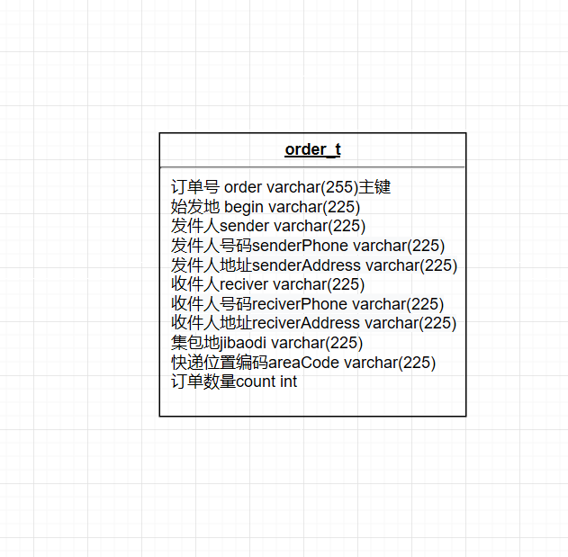

数据库ER图

## UML类图（Class Diagram）

* VO实体类OrderWordInfo：与数据库结构进行映射的类。主要由属性，setter, getter方法组成，VO类中的属性与表中的字段相对应，每一个VO类的对象都表示表中的每一条记录
* DAO接口OrderWordInfoDAO：主要定义操作的接口，定义一系列数据库的原子性操作，例如增删改查（通常称为CRUD）等。
* Tools 工具类MybatisUtils:封装会话的底层操作
* 业务逻辑实现类Service：功能实现，对数据库进行操作。
* 功能类function:实现画条形码，生成二维码等操作：

各类的结构及类之间的关系如图2-5所示：

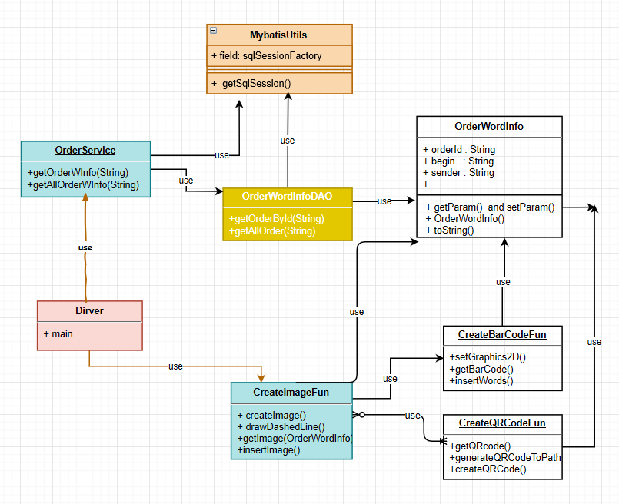

用户功能类图

## 

## UML时序图（Sequence Diagram）

程序执行过程

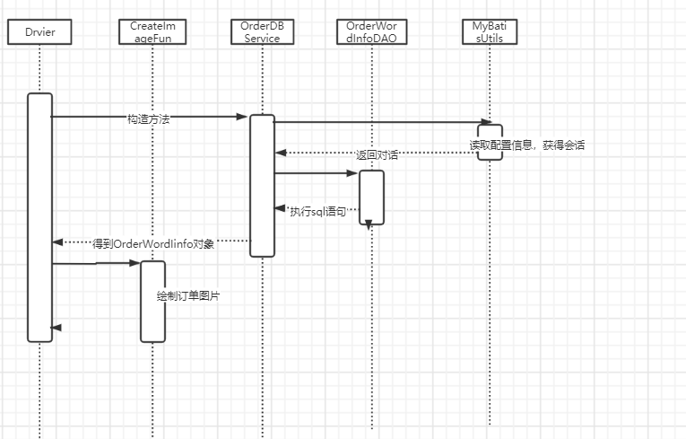

## 流程图

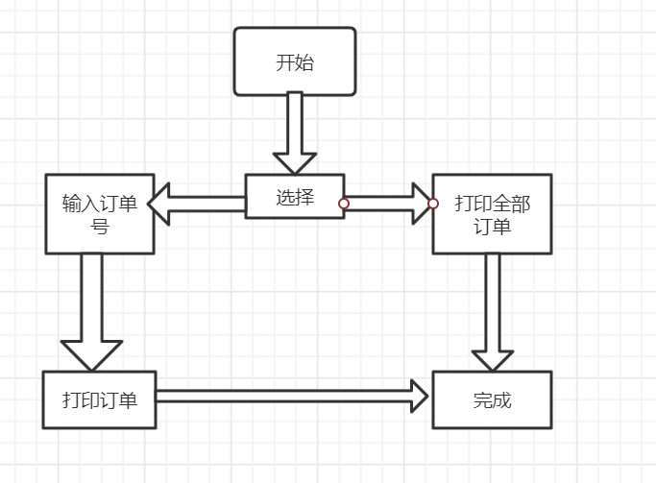

# **3 系统实现**

## 项目结构

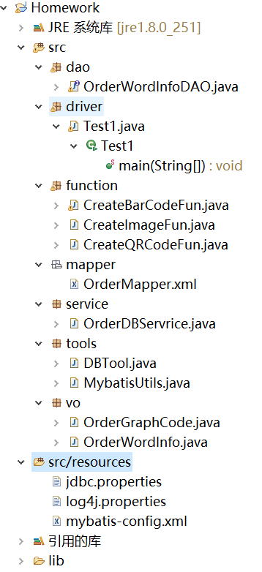

## 3.2 配置文件

在项目下新建Source Folder，名为resources

### 3.2.1 jdbc.properties文件

该配置文件主要是以文件形式保存数据库的驱动类名称，连接数据库的URL地址，访问数据库的用户名及对应的密码，程序运行时会读取该文件相关信息，避免硬编码，当相关信息发生变化时，只需修改配置文件而不用修改源代码，增加程序的可扩展型。

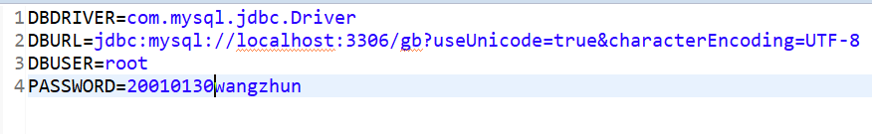

### 3.2.2 log4j.properties文件

日志配置文件，指定日志在控制台输出，控制日志输出格式

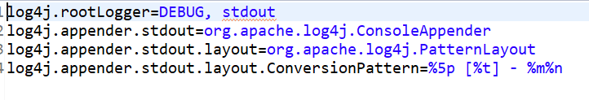

### 3.2.3 mybatis-config.xml文件

Mybatis配置文件

configuration最外层标签，表示这里面的都是配置内容。

settings标签用来设置全局参数，大多数情况下，这些参数使用它们的默认值即可。为满足应用特定的需求，在这里是控制日志输出。

environments是配置mybatis当前工作的数据库环境的地方

mappers标签用来配置SQLMapper文件路径。mappers里面每一个mapper子标签都可以从不同类型的资源中加载映射mapper

## VO类OderWordInfo.java

订单文字信息，get,set方法自动生成。

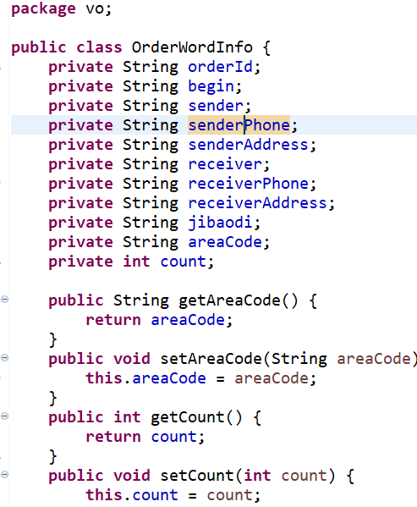

**VO类OderGraphInfo.java**

订单图片信息

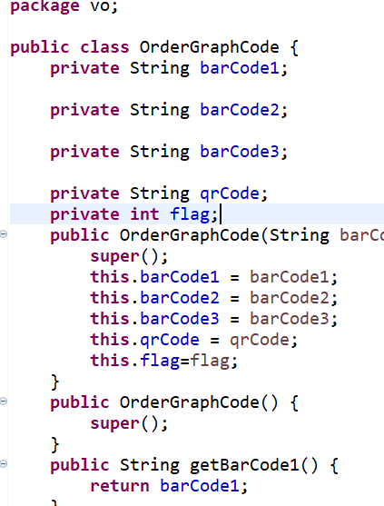

## DAO接口类OrderWordInfoDAO.java

## 

## 接口映射文件OrderMapper.xml

会话映射文件，实现数据库操作

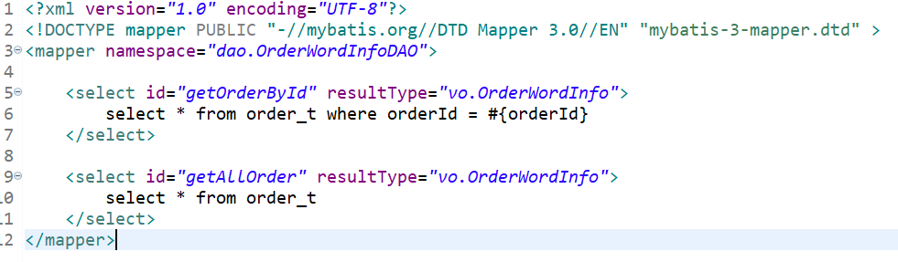

## 工具包Util，MybatisUtils.java

数据库底层操作封装

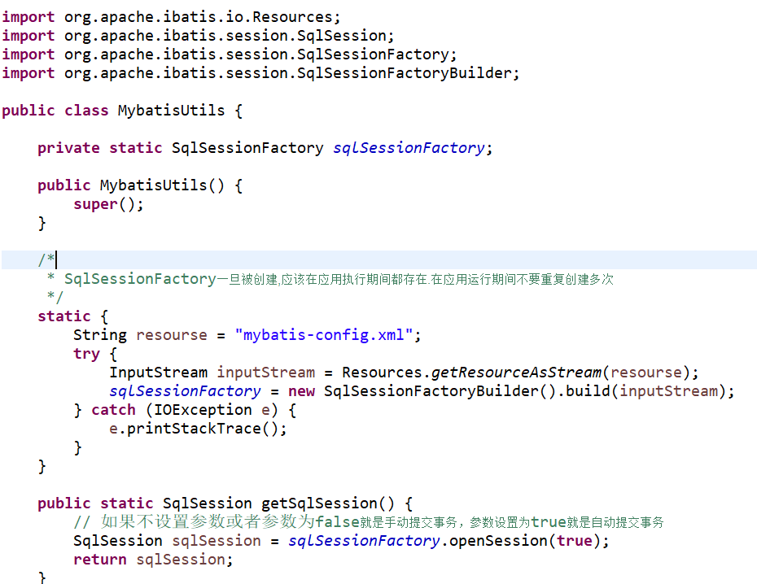

## 服务层OrderDBService.java

从数据库获取信息，对数据库原子操作进行封装

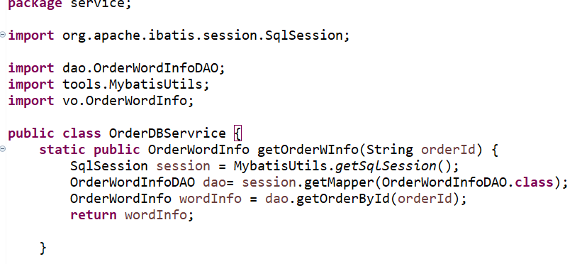

## 功能层function，CreateQRCodeFun.java

实现二维码生成

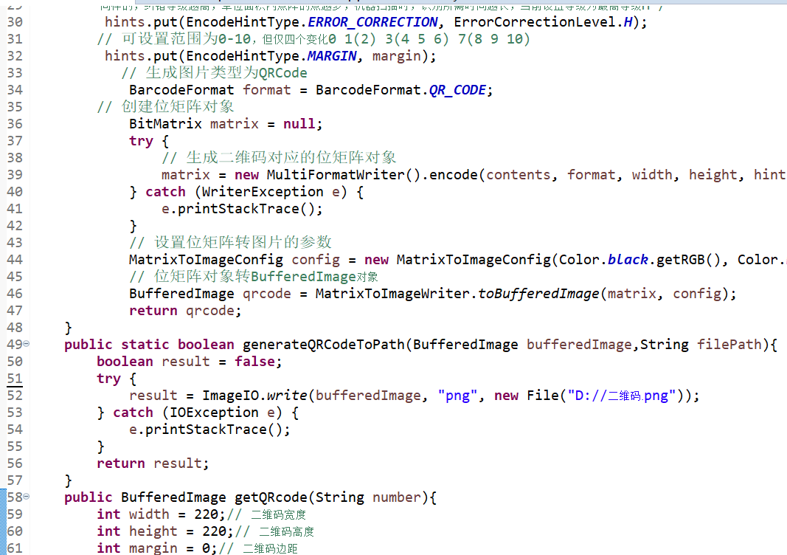

## CreateQRCodeFun.java

条形码生成。

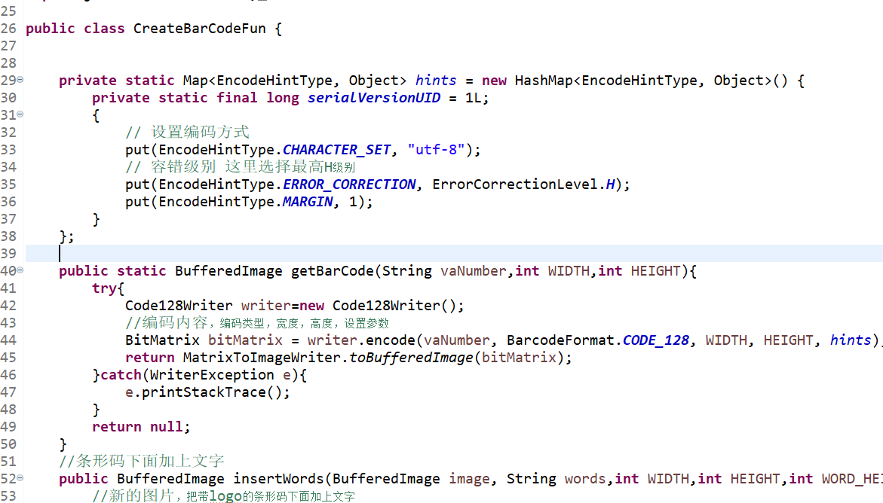

**CreateImageFun.java**

绘制订单

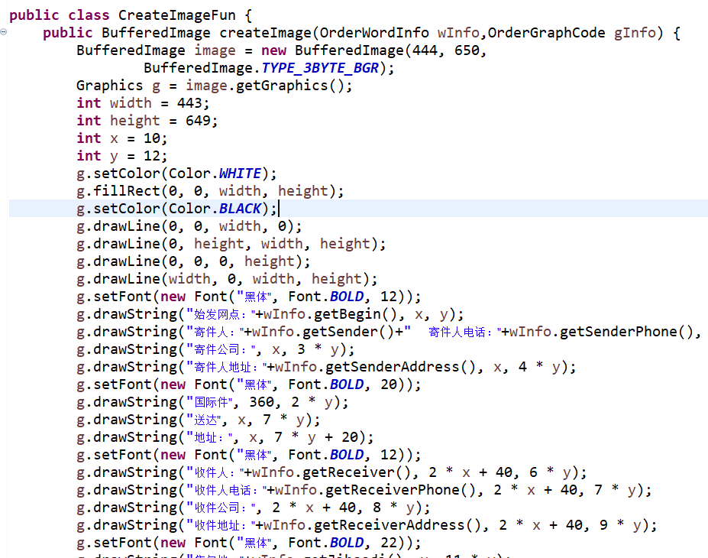

# **4 系统测试**

打印订单

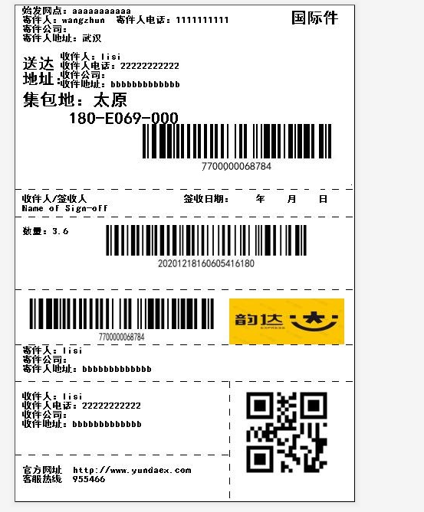

# **5 系统总结**

主要遇到的问题就是关于二维码，条形码的生成，通过在网上找到的一些教程熟悉zxing，了解函数以及参数的功能。