武汉纺织大学

Web应用开发课程设计

**物流单打印**

**学 院： 数学与计算机学院**

**班 级： 物联网11801**

**姓 名： 王准**

**学 号： 1804240322**

**指导老师： 聂刚**

**成 绩：**

**完成日期： 2020年12月15日**

目 录

1 需求分析 2

2 系统设计 3

2.2 ER图 3

2.3 UML类图（Class Diagram） 4

2.4 UML时序图（Sequence Diagram） 5

2.5 UML l流程图（Activity Diagram） 5

3 系统实现 6

3.1 项目结构 6

3.2 配置文件 6

3.2.1 jdbc.properties文件 6

3.2.2 log4j.properties文件 7

3.2.3 mybatis-config.xml文件 7

3.3 VO类Order.java 8

3.4 DAO接口类OrderDAO..java 8

3.5 接口映射文件OrderMapper.xml 9

3.6 工具包tools 9

3.6.1 MybatisUtils.java 9

3.7 服务层OrderDBService.java 10

3.8 function 12

4 系统测试 19

5 系统总结 12

# 需求分析

物流行业快速发展，具有一个很好的发展市场，传统的手工填写物流单速度慢，出错率高，已经满足不了人们的需求。设计一个生成电子物流单小程序，根据存储在数据库的订单数据打印物流单。

**技术实现**

数据库:mybatis框架

**数据显示**

数据源 + 视图 + 控制器

# **系统设计**

## ER图

数据库设计1张表，订单表。如下图所示

%3CmxGraphModel%3E%3Croot%3E%3CmxCell%20id%3D%220%22%2F%3E%3CmxCell%20id%3D%221%22%20parent%3D%220%22%2F%3E%3Cmysql.table%20entity.table.tableName%3D%22uses%22%20label%3D%22uses%22%20id%3D%222%22%3E%3CmxCell%20style%3D%22swimlane%3BfontStyle%3D0%3BchildLayout%3DstackLayout%3Bhorizontal%3D1%3Bhtml%3D1%3BstartSize%3D26%3BfillColor%3D%23b0e3e6%3BhorizontalStack%3D0%3BresizeParent%3D1%3BresizeParentMax%3D0%3BresizeLast%3D0%3Bcollapsible%3D1%3BmarginBottom%3D0%3BswimlaneFillColor%3D%23ffffff%3Balign%3Dcenter%3BfontSize%3D13%3BstrokeColor%3D%230e8088%3Brounded%3D0%3Bshadow%3D1%3Bcomic%3D0%3Bglass%3D0%3BgradientDirection%3Dsouth%3BgradientColor%3D%23ffffff%3B%22%20vertex%3D%221%22%20connectable%3D%220%22%20parent%3D%221%22%3E%3CmxGeometry%20x%3D%2260%22%20y%3D%2250%22%20width%3D%22310%22%20height%3D%22130%22%20as%3D%22geometry%22%2F%3E%3C%2FmxCell%3E%3C%2Fmysql.table%3E%3Cmysql.column%20entity.column.tableName%3D%22uses%22%20entity.column.name%3D%22userName%22%20entity.column.dataType%3D%22VARCHAR%22%20entity.column.PK%3D%22true%22%20label%3D%22%26lt%3Bimg%20title%3D%26quot%3BPrimary%20Key%26quot%3B%20src%3D%26quot%3Bimg%2Fdb%2Fkey1.png%26quot%3B%20width%3D%26quot%3B16%26quot%3B%20height%3D%26quot%3B16%26quot%3B%20align%3D%26quot%3Btop%26quot%3B%26gt%3B%26amp%3Bnbsp%3B%26lt%3Bfont%20size%3D%26quot%3B1%26quot%3B%20face%3D%26quot%3BTahoma%26quot%3B%26gt%3B%26lt%3Bspan%20style%3D%26quot%3Bfont-size%3A%2013px%26quot%3B%26gt%3B%26lt%3Bb%26gt%3Bid%20int%20primary%20key%26lt%3B%2Fb%26gt%3B%26lt%3B%2Fspan%26gt%3B%26lt%3B%2Ffont%26gt%3B%22%20entity.column.oldName%3D%22id%22%20entity.column.datalen%3D%2220%22%20entity.column.decimals%3D%22%22%20entity.column.autoIncreament%3D%22%22%20entity.column.unsigned%3D%22%22%20entity.column.bin%3D%22%22%20entity.column.ascii%3D%22%22%20entity.column.unicode%3D%22%22%20entity.column.unique%3D%22%22%20entity.column.isNotNull%3D%22NOT%20NULL%22%20entity.column.defaultValue%3D%22%22%20entity.column.comment%3D%22%22%20entity.column.enum%3D%22%22%20entity.column.set%3D%22%22%20entity.column.enumSetValue%3D%22%22%20id%3D%223%22%3E%3CmxCell%20style%3D%22text%3Bhtml%3D1%3BstrokeColor%3Dnone%3BfillColor%3Dnone%3BspacingLeft%3D4%3BspacingRight%3D4%3Boverflow%3Dhidden%3Brotatable%3D0%3BportConstraint%3Deastwest%3BfontSize%3D12%3BverticalAlign%3Dmiddle%3B%22%20vertex%3D%221%22%20parent%3D%222%22%3E%3CmxGeometry%20y%3D%2226%22%20width%3D%22310%22%20height%3D%2226%22%20as%3D%22geometry%22%2F%3E%3C%2FmxCell%3E%3C%2Fmysql.column%3E%3Cmysql.column%20entity.column.tableName%3D%22uses%22%20entity.column.name%3D%22chrName%22%20entity.column.datalen%3D%2220%22%20entity.column.dataType%3D%22VARCHAR%22%20label%3D%22%26lt%3Bimg%20title%3D%26quot%3BPrimary%20Key%26quot%3B%20src%3D%26quot%3Bimages%2Fspacer.gif%26quot%3B%20width%3D%26quot%3B16%26quot%3B%20height%3D%26quot%3B16%26quot%3B%20align%3D%26quot%3Btop%26quot%3B%26gt%3B%26amp%3Bnbsp%3B%26lt%3Bfont%20size%3D%26quot%3B1%26quot%3B%20face%3D%26quot%3BTahoma%26quot%3B%26gt%3B%26lt%3Bspan%20style%3D%26quot%3Bfont-size%3A%2013px%26quot%3B%26gt%3B%26lt%3Bb%26gt%3Bname%20varchar(10)%26lt%3B%2Fb%26gt%3B%26lt%3B%2Fspan%26gt%3B%26lt%3B%2Ffont%26gt%3B%22%20entity.column.oldName%3D%22name%22%20entity.column.decimals%3D%22%22%20entity.column.autoIncreament%3D%22%22%20entity.column.unsigned%3D%22%22%20entity.column.bin%3D%22%22%20entity.column.ascii%3D%22%22%20entity.column.unicode%3D%22%22%20entity.column.PK%3D%22false%22%20entity.column.unique%3D%22%22%20entity.column.isNotNull%3D%22%22%20entity.column.defaultValue%3D%22%22%20entity.column.comment%3D%22%22%20entity.column.enum%3D%22%22%20entity.column.set%3D%22%22%20entity.column.enumSetValue%3D%22%22%20id%3D%224%22%3E%3CmxCell%20style%3D%22text%3Bhtml%3D1%3BstrokeColor%3Dnone%3BfillColor%3Dnone%3BspacingLeft%3D4%3BspacingRight%3D4%3Boverflow%3Dhidden%3Brotatable%3D0%3BportConstraint%3Deastwest%3BfontSize%3D12%3BverticalAlign%3Dmiddle%3B%22%20vertex%3D%221%22%20parent%3D%222%22%3E%3CmxGeometry%20y%3D%2252%22%20width%3D%22310%22%20height%3D%2226%22%20as%3D%22geometry%22%2F%3E%3C%2FmxCell%3E%3C%2Fmysql.column%3E%3Cmysql.column%20entity.column.tableName%3D%22uses%22%20entity.column.name%3D%22password%22%20entity.column.datalen%3D%2250%22%20entity.column.dataType%3D%22VARCHAR%22%20label%3D%22%26lt%3Bimg%20title%3D%26quot%3BPrimary%20Key%26quot%3B%20src%3D%26quot%3Bimages%2Fspacer.gif%26quot%3B%20width%3D%26quot%3B16%26quot%3B%20height%3D%26quot%3B16%26quot%3B%20align%3D%26quot%3Btop%26quot%3B%26gt%3B%26amp%3Bnbsp%3B%26lt%3Bfont%20size%3D%26quot%3B1%26quot%3B%20face%3D%26quot%3BTahoma%26quot%3B%26gt%3B%26lt%3Bspan%20style%3D%26quot%3Bfont-size%3A%2013px%26quot%3B%26gt%3B%26lt%3Bb%26gt%3Bname%20varchar(10)%26lt%3B%2Fb%26gt%3B%26lt%3B%2Fspan%26gt%3B%26lt%3B%2Ffont%26gt%3B%22%20entity.column.oldName%3D%22chrName%22%20entity.column.decimals%3D%22%22%20entity.column.autoIncreament%3D%22%22%20entity.column.unsigned%3D%22%22%20entity.column.bin%3D%22%22%20entity.column.ascii%3D%22%22%20entity.column.unicode%3D%22%22%20entity.column.PK%3D%22false%22%20entity.column.unique%3D%22%22%20entity.column.isNotNull%3D%22%22%20entity.column.defaultValue%3D%22%22%20entity.column.comment%3D%22%E5%AF%86%E7%A0%81%22%20entity.column.enum%3D%22%22%20entity.column.set%3D%22%22%20entity.column.enumSetValue%3D%22%22%20id%3D%225%22%3E%3CmxCell%20style%3D%22text%3Bhtml%3D1%3BstrokeColor%3Dnone%3BfillColor%3Dnone%3BspacingLeft%3D4%3BspacingRight%3D4%3Boverflow%3Dhidden%3Brotatable%3D0%3BportConstraint%3Deastwest%3BfontSize%3D12%3BverticalAlign%3Dmiddle%3B%22%20vertex%3D%221%22%20parent%3D%222%22%3E%3CmxGeometry%20y%3D%2278%22%20width%3D%22310%22%20height%3D%2226%22%20as%3D%22geometry%22%2F%3E%3C%2FmxCell%3E%3C%2Fmysql.column%3E%3Cmysql.column%20entity.column.tableName%3D%22uses%22%20entity.column.name%3D%22role%22%20entity.column.datalen%3D%2220%22%20entity.column.dataType%3D%22VARCHAR%22%20label%3D%22%26lt%3Bimg%20title%3D%26quot%3BPrimary%20Key%26quot%3B%20src%3D%26quot%3Bimages%2Fspacer.gif%26quot%3B%20width%3D%26quot%3B16%26quot%3B%20height%3D%26quot%3B16%26quot%3B%20align%3D%26quot%3Btop%26quot%3B%26gt%3B%26amp%3Bnbsp%3B%26lt%3Bfont%20size%3D%26quot%3B1%26quot%3B%20face%3D%26quot%3BTahoma%26quot%3B%26gt%3B%26lt%3Bspan%20style%3D%26quot%3Bfont-size%3A%2013px%26quot%3B%26gt%3B%26lt%3Bb%26gt%3Bname%20varchar(10)%26lt%3B%2Fb%26gt%3B%26lt%3B%2Fspan%26gt%3B%26lt%3B%2Ffont%26gt%3B%22%20entity.column.oldName%3D%22chrName%22%20entity.column.decimals%3D%22%22%20entity.column.autoIncreament%3D%22%22%20entity.column.unsigned%3D%22%22%20entity.column.bin%3D%22%22%20entity.column.ascii%3D%22%22%20entity.column.unicode%3D%22%22%20entity.column.PK%3D%22false%22%20entity.column.unique%3D%22%22%20entity.column.isNotNull%3D%22%22%20entity.column.defaultValue%3D%22%22%20entity.column.comment%3D%22%E8%A7%92%E8%89%B2%22%20entity.column.enum%3D%22%22%20entity.column.set%3D%22%22%20entity.column.enumSetValue%3D%22%22%20id%3D%226%22%3E%3CmxCell%20style%3D%22text%3Bhtml%3D1%3BstrokeColor%3Dnone%3BfillColor%3Dnone%3BspacingLeft%3D4%3BspacingRight%3D4%3Boverflow%3Dhidden%3Brotatable%3D0%3BportConstraint%3Deastwest%3BfontSize%3D12%3BverticalAlign%3Dmiddle%3B%22%20vertex%3D%221%22%20parent%3D%222%22%3E%3CmxGeometry%20y%3D%22104%22%20width%3D%22310%22%20height%3D%2226%22%20as%3D%22geometry%22%2F%3E%3C%2FmxCell%3E%3C%2Fmysql.column%3E%3Cmysql.table%20entity.table.tableName%3D%22product%22%20label%3D%22product%22%20id%3D%227%22%3E%3CmxCell%20style%3D%22swimlane%3BfontStyle%3D0%3BchildLayout%3DstackLayout%3Bhorizontal%3D1%3Bhtml%3D1%3BstartSize%3D26%3BfillColor%3D%23b0e3e6%3BhorizontalStack%3D0%3BresizeParent%3D1%3BresizeParentMax%3D0%3BresizeLast%3D0%3Bcollapsible%3D1%3BmarginBottom%3D0%3BswimlaneFillColor%3D%23ffffff%3Balign%3Dcenter%3BfontSize%3D13%3BstrokeColor%3D%230e8088%3Brounded%3D0%3Bshadow%3D1%3Bcomic%3D0%3Bglass%3D0%3BgradientDirection%3Dsouth%3BgradientColor%3D%23ffffff%3B%22%20vertex%3D%221%22%20connectable%3D%220%22%20parent%3D%221%22%3E%3CmxGeometry%20x%3D%2260%22%20y%3D%22210%22%20width%3D%22310%22%20height%3D%22130%22%20as%3D%22geometry%22%2F%3E%3C%2FmxCell%3E%3C%2Fmysql.table%3E%3Cmysql.column%20entity.column.tableName%3D%22product%22%20entity.column.name%3D%22barcode%22%20entity.column.dataType%3D%22VARCHAR%22%20entity.column.PK%3D%22true%22%20label%3D%22%26lt%3Bimg%20title%3D%26quot%3BPrimary%20Key%26quot%3B%20src%3D%26quot%3Bimg%2Fdb%2Fkey1.png%26quot%3B%20width%3D%26quot%3B16%26quot%3B%20height%3D%26quot%3B16%26quot%3B%20align%3D%26quot%3Btop%26quot%3B%26gt%3B%26amp%3Bnbsp%3B%26lt%3Bfont%20size%3D%26quot%3B1%26quot%3B%20face%3D%26quot%3BTahoma%26quot%3B%26gt%3B%26lt%3Bspan%20style%3D%26quot%3Bfont-size%3A%2013px%26quot%3B%26gt%3B%26lt%3Bb%26gt%3Bid%20int%20primary%20key%26lt%3B%2Fb%26gt%3B%26lt%3B%2Fspan%26gt%3B%26lt%3B%2Ffont%26gt%3B%22%20entity.column.oldName%3D%22id%22%20entity.column.datalen%3D%2210%22%20entity.column.decimals%3D%22%22%20entity.column.autoIncreament%3D%22%22%20entity.column.unsigned%3D%22%22%20entity.column.bin%3D%22%22%20entity.column.ascii%3D%22%22%20entity.column.unicode%3D%22%22%20entity.column.unique%3D%22%22%20entity.column.isNotNull%3D%22NOT%20NULL%22%20entity.column.defaultValue%3D%22%22%20entity.column.comment%3D%22%22%20entity.column.enum%3D%22%22%20entity.column.set%3D%22%22%20entity.column.enumSetValue%3D%22%22%20id%3D%228%22%3E%3CmxCell%20style%3D%22text%3Bhtml%3D1%3BstrokeColor%3Dnone%3BfillColor%3Dnone%3BspacingLeft%3D4%3BspacingRight%3D4%3Boverflow%3Dhidden%3Brotatable%3D0%3BportConstraint%3Deastwest%3BfontSize%3D12%3BverticalAlign%3Dmiddle%3B%22%20vertex%3D%221%22%20parent%3D%227%22%3E%3CmxGeometry%20y%3D%2226%22%20width%3D%22310%22%20height%3D%2226%22%20as%3D%22geometry%22%2F%3E%3C%2FmxCell%3E%3C%2Fmysql.column%3E%3Cmysql.column%20entity.column.tableName%3D%22product%22%20entity.column.name%3D%22productName%22%20entity.column.datalen%3D%2250%22%20entity.column.dataType%3D%22VARCHAR%22%20label%3D%22%26lt%3Bimg%20title%3D%26quot%3BPrimary%20Key%26quot%3B%20src%3D%26quot%3Bimages%2Fspacer.gif%26quot%3B%20width%3D%26quot%3B16%26quot%3B%20height%3D%26quot%3B16%26quot%3B%20align%3D%26quot%3Btop%26quot%3B%26gt%3B%26amp%3Bnbsp%3B%26lt%3Bfont%20size%3D%26quot%3B1%26quot%3B%20face%3D%26quot%3BTahoma%26quot%3B%26gt%3B%26lt%3Bspan%20style%3D%26quot%3Bfont-size%3A%2013px%26quot%3B%26gt%3B%26lt%3Bb%26gt%3Bname%20varchar(10)%26lt%3B%2Fb%26gt%3B%26lt%3B%2Fspan%26gt%3B%26lt%3B%2Ffont%26gt%3B%22%20entity.column.oldName%3D%22name%22%20entity.column.decimals%3D%22%22%20entity.column.autoIncreament%3D%22%22%20entity.column.unsigned%3D%22%22%20entity.column.bin%3D%22%22%20entity.column.ascii%3D%22%22%20entity.column.unicode%3D%22%22%20entity.column.PK%3D%22false%22%20entity.column.unique%3D%22%22%20entity.column.isNotNull%3D%22%22%20entity.column.defaultValue%3D%22%22%20entity.column.comment%3D%22%22%20entity.column.enum%3D%22%22%20entity.column.set%3D%22%22%20entity.column.enumSetValue%3D%22%22%20id%3D%229%22%3E%3CmxCell%20style%3D%22text%3Bhtml%3D1%3BstrokeColor%3Dnone%3BfillColor%3Dnone%3BspacingLeft%3D4%3BspacingRight%3D4%3Boverflow%3Dhidden%3Brotatable%3D0%3BportConstraint%3Deastwest%3BfontSize%3D12%3BverticalAlign%3Dmiddle%3B%22%20vertex%3D%221%22%20parent%3D%227%22%3E%3CmxGeometry%20y%3D%2252%22%20width%3D%22310%22%20height%3D%2226%22%20as%3D%22geometry%22%2F%3E%3C%2FmxCell%3E%3C%2Fmysql.column%3E%3Cmysql.column%20entity.column.tableName%3D%22product%22%20entity.column.name%3D%22price%22%20entity.column.datalen%3D%229%22%20entity.column.dataType%3D%22DECIMAL%22%20label%3D%22%26lt%3Bimg%20title%3D%26quot%3BPrimary%20Key%26quot%3B%20src%3D%26quot%3Bimages%2Fspacer.gif%26quot%3B%20width%3D%26quot%3B16%26quot%3B%20height%3D%26quot%3B16%26quot%3B%20align%3D%26quot%3Btop%26quot%3B%26gt%3B%26amp%3Bnbsp%3B%26lt%3Bfont%20size%3D%26quot%3B1%26quot%3B%20face%3D%26quot%3BTahoma%26quot%3B%26gt%3B%26lt%3Bspan%20style%3D%26quot%3Bfont-size%3A%2013px%26quot%3B%26gt%3B%26lt%3Bb%26gt%3Bname%20varchar(10)%26lt%3B%2Fb%26gt%3B%26lt%3B%2Fspan%26gt%3B%26lt%3B%2Ffont%26gt%3B%22%20entity.column.oldName%3D%22price%22%20entity.column.decimals%3D%222%22%20entity.column.autoIncreament%3D%22%22%20entity.column.unsigned%3D%22%22%20entity.column.bin%3D%22%22%20entity.column.ascii%3D%22%22%20entity.column.unicode%3D%22%22%20entity.column.PK%3D%22false%22%20entity.column.unique%3D%22%22%20entity.column.isNotNull%3D%22%22%20entity.column.defaultValue%3D%22%22%20entity.column.comment%3D%22%22%20entity.column.enum%3D%22%22%20entity.column.set%3D%22%22%20entity.column.enumSetValue%3D%22%22%20id%3D%2210%22%3E%3CmxCell%20style%3D%22text%3Bhtml%3D1%3BstrokeColor%3Dnone%3BfillColor%3Dnone%3BspacingLeft%3D4%3BspacingRight%3D4%3Boverflow%3Dhidden%3Brotatable%3D0%3BportConstraint%3Deastwest%3BfontSize%3D12%3BverticalAlign%3Dmiddle%3B%22%20vertex%3D%221%22%20parent%3D%227%22%3E%3CmxGeometry%20y%3D%2278%22%20width%3D%22310%22%20height%3D%2226%22%20as%3D%22geometry%22%2F%3E%3C%2FmxCell%3E%3C%2Fmysql.column%3E%3Cmysql.column%20entity.column.tableName%3D%22product%22%20entity.column.name%3D%22supply%22%20entity.column.datalen%3D%2220%22%20entity.column.dataType%3D%22VARCHAR%22%20label%3D%22%26lt%3Bimg%20title%3D%26quot%3BPrimary%20Key%26quot%3B%20src%3D%26quot%3Bimages%2Fspacer.gif%26quot%3B%20width%3D%26quot%3B16%26quot%3B%20height%3D%26quot%3B16%26quot%3B%20align%3D%26quot%3Btop%26quot%3B%26gt%3B%26amp%3Bnbsp%3B%26lt%3Bfont%20size%3D%26quot%3B1%26quot%3B%20face%3D%26quot%3BTahoma%26quot%3B%26gt%3B%26lt%3Bspan%20style%3D%26quot%3Bfont-size%3A%2013px%26quot%3B%26gt%3B%26lt%3Bb%26gt%3Bname%20varchar(10)%26lt%3B%2Fb%26gt%3B%26lt%3B%2Fspan%26gt%3B%26lt%3B%2Ffont%26gt%3B%22%20entity.column.oldName%3D%22price%22%20entity.column.decimals%3D%22%22%20entity.column.autoIncreament%3D%22%22%20entity.column.unsigned%3D%22%22%20entity.column.bin%3D%22%22%20entity.column.ascii%3D%22%22%20entity.column.unicode%3D%22%22%20entity.column.PK%3D%22false%22%20entity.column.unique%3D%22%22%20entity.column.isNotNull%3D%22%22%20entity.column.defaultValue%3D%22%22%20entity.column.comment%3D%22%22%20entity.column.enum%3D%22%22%20entity.column.set%3D%22%22%20entity.column.enumSetValue%3D%22%22%20id%3D%2211%22%3E%3CmxCell%20style%3D%22text%3Bhtml%3D1%3BstrokeColor%3Dnone%3BfillColor%3Dnone%3BspacingLeft%3D4%3BspacingRight%3D4%3Boverflow%3Dhidden%3Brotatable%3D0%3BportConstraint%3Deastwest%3BfontSize%3D12%3BverticalAlign%3Dmiddle%3B%22%20vertex%3D%221%22%20parent%3D%227%22%3E%3CmxGeometry%20y%3D%22104%22%20width%3D%22310%22%20height%3D%2226%22%20as%3D%22geometry%22%2F%3E%3C%2FmxCell%3E%3C%2Fmysql.column%3E%3Cmysql.table%20entity.table.tableName%3D%22saleDetail%22%20label%3D%22saleDetail%22%20id%3D%2212%22%3E%3CmxCell%20style%3D%22swimlane%3BfontStyle%3D0%3BchildLayout%3DstackLayout%3Bhorizontal%3D1%3Bhtml%3D1%3BstartSize%3D26%3BfillColor%3D%23b0e3e6%3BhorizontalStack%3D0%3BresizeParent%3D1%3BresizeParentMax%3D0%3BresizeLast%3D0%3Bcollapsible%3D1%3BmarginBottom%3D0%3BswimlaneFillColor%3D%23ffffff%3Balign%3Dcenter%3BfontSize%3D13%3BstrokeColor%3D%230e8088%3Brounded%3D0%3Bshadow%3D1%3Bcomic%3D0%3Bglass%3D0%3BgradientDirection%3Dsouth%3BgradientColor%3D%23ffffff%3B%22%20vertex%3D%221%22%20connectable%3D%220%22%20parent%3D%221%22%3E%3CmxGeometry%20x%3D%22480%22%20y%3D%2280%22%20width%3D%22280%22%20height%3D%22208%22%20as%3D%22geometry%22%2F%3E%3C%2FmxCell%3E%3C%2Fmysql.table%3E%3Cmysql.column%20entity.column.tableName%3D%22saleDetail%22%20entity.column.name%3D%22lsh%22%20entity.column.dataType%3D%22VARCHAR%22%20entity.column.PK%3D%22true%22%20label%3D%22%26lt%3Bimg%20title%3D%26quot%3BPrimary%20Key%26quot%3B%20src%3D%26quot%3Bimg%2Fdb%2Fkey1.png%26quot%3B%20width%3D%26quot%3B16%26quot%3B%20height%3D%26quot%3B16%26quot%3B%20align%3D%26quot%3Btop%26quot%3B%26gt%3B%26amp%3Bnbsp%3B%26lt%3Bfont%20size%3D%26quot%3B1%26quot%3B%20face%3D%26quot%3BTahoma%26quot%3B%26gt%3B%26lt%3Bspan%20style%3D%26quot%3Bfont-size%3A%2013px%26quot%3B%26gt%3B%26lt%3Bb%26gt%3Bid%20int%20primary%20key%26lt%3B%2Fb%26gt%3B%26lt%3B%2Fspan%26gt%3B%26lt%3B%2Ffont%26gt%3B%22%20entity.column.oldName%3D%22id%22%20entity.column.datalen%3D%2220%22%20entity.column.decimals%3D%22%22%20entity.column.autoIncreament%3D%22%22%20entity.column.unsigned%3D%22%22%20entity.column.bin%3D%22%22%20entity.column.ascii%3D%22%22%20entity.column.unicode%3D%22%22%20entity.column.unique%3D%22%22%20entity.column.isNotNull%3D%22NOT%20NULL%22%20entity.column.defaultValue%3D%22%22%20entity.column.comment%3D%22%22%20entity.column.enum%3D%22%22%20entity.column.set%3D%22%22%20entity.column.enumSetValue%3D%22%22%20id%3D%2213%22%3E%3CmxCell%20style%3D%22text%3Bhtml%3D1%3BstrokeColor%3Dnone%3BfillColor%3Dnone%3BspacingLeft%3D4%3BspacingRight%3D4%3Boverflow%3Dhidden%3Brotatable%3D0%3BportConstraint%3Deastwest%3BfontSize%3D12%3BverticalAlign%3Dmiddle%3B%22%20vertex%3D%221%22%20parent%3D%2212%22%3E%3CmxGeometry%20y%3D%2226%22%20width%3D%22280%22%20height%3D%2226%22%20as%3D%22geometry%22%2F%3E%3C%2FmxCell%3E%3C%2Fmysql.column%3E%3Cmysql.column%20entity.column.tableName%3D%22saleDetail%22%20entity.column.name%3D%22barcode%22%20entity.column.datalen%3D%2210%22%20entity.column.dataType%3D%22VARCHAR%22%20label%3D%22%26lt%3Bimg%20title%3D%26quot%3BPrimary%20Key%26quot%3B%20src%3D%26quot%3Bimages%2Fspacer.gif%26quot%3B%20width%3D%26quot%3B16%26quot%3B%20height%3D%26quot%3B16%26quot%3B%20align%3D%26quot%3Btop%26quot%3B%26gt%3B%26amp%3Bnbsp%3B%26lt%3Bfont%20size%3D%26quot%3B1%26quot%3B%20face%3D%26quot%3BTahoma%26quot%3B%26gt%3B%26lt%3Bspan%20style%3D%26quot%3Bfont-size%3A%2013px%26quot%3B%26gt%3B%26lt%3Bb%26gt%3Bname%20varchar(10)%26lt%3B%2Fb%26gt%3B%26lt%3B%2Fspan%26gt%3B%26lt%3B%2Ffont%26gt%3B%22%20entity.column.oldName%3D%22barcode%22%20entity.column.decimals%3D%22%22%20entity.column.autoIncreament%3D%22%22%20entity.column.unsigned%3D%22%22%20entity.column.bin%3D%22%22%20entity.column.ascii%3D%22%22%20entity.column.unicode%3D%22%22%20entity.column.PK%3D%22false%22%20entity.column.unique%3D%22%22%20entity.column.isNotNull%3D%22%22%20entity.column.defaultValue%3D%22%22%20entity.column.comment%3D%22%22%20entity.column.enum%3D%22%22%20entity.column.set%3D%22%22%20entity.column.enumSetValue%3D%22%22%20id%3D%2214%22%3E%3CmxCell%20style%3D%22text%3Bhtml%3D1%3BstrokeColor%3Dnone%3BfillColor%3Dnone%3BspacingLeft%3D4%3BspacingRight%3D4%3Boverflow%3Dhidden%3Brotatable%3D0%3BportConstraint%3Deastwest%3BfontSize%3D12%3BverticalAlign%3Dmiddle%3B%22%20vertex%3D%221%22%20parent%3D%2212%22%3E%3CmxGeometry%20y%3D%2252%22%20width%3D%22280%22%20height%3D%2226%22%20as%3D%22geometry%22%2F%3E%3C%2FmxCell%3E%3C%2Fmysql.column%3E%3Cmysql.column%20entity.column.tableName%3D%22saleDetail%22%20entity.column.name%3D%22productName%22%20entity.column.datalen%3D%2250%22%20entity.column.dataType%3D%22VARCHAR%22%20label%3D%22%26lt%3Bimg%20title%3D%26quot%3BPrimary%20Key%26quot%3B%20src%3D%26quot%3Bimages%2Fspacer.gif%26quot%3B%20width%3D%26quot%3B16%26quot%3B%20height%3D%26quot%3B16%26quot%3B%20align%3D%26quot%3Btop%26quot%3B%26gt%3B%26amp%3Bnbsp%3B%26lt%3Bfont%20size%3D%26quot%3B1%26quot%3B%20face%3D%26quot%3BTahoma%26quot%3B%26gt%3B%26lt%3Bspan%20style%3D%26quot%3Bfont-size%3A%2013px%26quot%3B%26gt%3B%26lt%3Bb%26gt%3Bname%20varchar(10)%26lt%3B%2Fb%26gt%3B%26lt%3B%2Fspan%26gt%3B%26lt%3B%2Ffont%26gt%3B%22%20entity.column.oldName%3D%22productName%22%20entity.column.decimals%3D%22%22%20entity.column.autoIncreament%3D%22%22%20entity.column.unsigned%3D%22%22%20entity.column.bin%3D%22%22%20entity.column.ascii%3D%22%22%20entity.column.unicode%3D%22%22%20entity.column.PK%3D%22false%22%20entity.column.unique%3D%22%22%20entity.column.isNotNull%3D%22%22%20entity.column.defaultValue%3D%22%22%20entity.column.comment%3D%22%22%20entity.column.enum%3D%22%22%20entity.column.set%3D%22%22%20entity.column.enumSetValue%3D%22%22%20id%3D%2215%22%3E%3CmxCell%20style%3D%22text%3Bhtml%3D1%3BstrokeColor%3Dnone%3BfillColor%3Dnone%3BspacingLeft%3D4%3BspacingRight%3D4%3Boverflow%3Dhidden%3Brotatable%3D0%3BportConstraint%3Deastwest%3BfontSize%3D12%3BverticalAlign%3Dmiddle%3B%22%20vertex%3D%221%22%20parent%3D%2212%22%3E%3CmxGeometry%20y%3D%2278%22%20width%3D%22280%22%20height%3D%2226%22%20as%3D%22geometry%22%2F%3E%3C%2FmxCell%3E%3C%2Fmysql.column%3E%3Cmysql.column%20entity.column.tableName%3D%22saleDetail%22%20entity.column.name%3D%22price%22%20entity.column.datalen%3D%229%22%20entity.column.dataType%3D%22DECIMAL%22%20label%3D%22%26lt%3Bimg%20title%3D%26quot%3BPrimary%20Key%26quot%3B%20src%3D%26quot%3Bimages%2Fspacer.gif%26quot%3B%20width%3D%26quot%3B16%26quot%3B%20height%3D%26quot%3B16%26quot%3B%20align%3D%26quot%3Btop%26quot%3B%26gt%3B%26amp%3Bnbsp%3B%26lt%3Bfont%20size%3D%26quot%3B1%26quot%3B%20face%3D%26quot%3BTahoma%26quot%3B%26gt%3B%26lt%3Bspan%20style%3D%26quot%3Bfont-size%3A%2013px%26quot%3B%26gt%3B%26lt%3Bb%26gt%3Bname%20varchar(10)%26lt%3B%2Fb%26gt%3B%26lt%3B%2Fspan%26gt%3B%26lt%3B%2Ffont%26gt%3B%22%20entity.column.oldName%3D%22productName%22%20entity.column.decimals%3D%222%22%20entity.column.autoIncreament%3D%22%22%20entity.column.unsigned%3D%22%22%20entity.column.bin%3D%22%22%20entity.column.ascii%3D%22%22%20entity.column.unicode%3D%22%22%20entity.column.PK%3D%22false%22%20entity.column.unique%3D%22%22%20entity.column.isNotNull%3D%22%22%20entity.column.defaultValue%3D%22%22%20entity.column.comment%3D%22%22%20entity.column.enum%3D%22%22%20entity.column.set%3D%22%22%20entity.column.enumSetValue%3D%22%22%20id%3D%2216%22%3E%3CmxCell%20style%3D%22text%3Bhtml%3D1%3BstrokeColor%3Dnone%3BfillColor%3Dnone%3BspacingLeft%3D4%3BspacingRight%3D4%3Boverflow%3Dhidden%3Brotatable%3D0%3BportConstraint%3Deastwest%3BfontSize%3D12%3BverticalAlign%3Dmiddle%3B%22%20vertex%3D%221%22%20parent%3D%2212%22%3E%3CmxGeometry%20y%3D%22104%22%20width%3D%22280%22%20height%3D%2226%22%20as%3D%22geometry%22%2F%3E%3C%2FmxCell%3E%3C%2Fmysql.column%3E%3Cmysql.column%20entity.column.tableName%3D%22saleDetail%22%20entity.column.name%3D%22count%22%20entity.column.datalen%3D%229%22%20entity.column.dataType%3D%22INT%22%20label%3D%22%26lt%3Bimg%20title%3D%26quot%3BPrimary%20Key%26quot%3B%20src%3D%26quot%3Bimages%2Fspacer.gif%26quot%3B%20width%3D%26quot%3B16%26quot%3B%20height%3D%26quot%3B16%26quot%3B%20align%3D%26quot%3Btop%26quot%3B%26gt%3B%26amp%3Bnbsp%3B%26lt%3Bfont%20size%3D%26quot%3B1%26quot%3B%20face%3D%26quot%3BTahoma%26quot%3B%26gt%3B%26lt%3Bspan%20style%3D%26quot%3Bfont-size%3A%2013px%26quot%3B%26gt%3B%26lt%3Bb%26gt%3Bname%20varchar(10)%26lt%3B%2Fb%26gt%3B%26lt%3B%2Fspan%26gt%3B%26lt%3B%2Ffont%26gt%3B%22%20entity.column.oldName%3D%22price%22%20entity.column.decimals%3D%22%22%20entity.column.autoIncreament%3D%22%22%20entity.column.unsigned%3D%22%22%20entity.column.bin%3D%22%22%20entity.column.ascii%3D%22%22%20entity.column.unicode%3D%22%22%20entity.column.PK%3D%22false%22%20entity.column.unique%3D%22%22%20entity.column.isNotNull%3D%22%22%20entity.column.defaultValue%3D%22%22%20entity.column.comment%3D%22%22%20entity.column.enum%3D%22%22%20entity.column.set%3D%22%22%20entity.column.enumSetValue%3D%22%22%20id%3D%2217%22%3E%3CmxCell%20style%3D%22text%3Bhtml%3D1%3BstrokeColor%3Dnone%3BfillColor%3Dnone%3BspacingLeft%3D4%3BspacingRight%3D4%3Boverflow%3Dhidden%3Brotatable%3D0%3BportConstraint%3Deastwest%3BfontSize%3D12%3BverticalAlign%3Dmiddle%3B%22%20vertex%3D%221%22%20parent%3D%2212%22%3E%3CmxGeometry%20y%3D%22130%22%20width%3D%22280%22%20height%3D%2226%22%20as%3D%22geometry%22%2F%3E%3C%2FmxCell%3E%3C%2Fmysql.column%3E%3Cmysql.column%20entity.column.tableName%3D%22saleDetail%22%20entity.column.name%3D%22operator%22%20entity.column.datalen%3D%2220%22%20entity.column.dataType%3D%22VARCHAR%22%20label%3D%22%26lt%3Bimg%20title%3D%26quot%3BPrimary%20Key%26quot%3B%20src%3D%26quot%3Bimages%2Fspacer.gif%26quot%3B%20width%3D%26quot%3B16%26quot%3B%20height%3D%26quot%3B16%26quot%3B%20align%3D%26quot%3Btop%26quot%3B%26gt%3B%26amp%3Bnbsp%3B%26lt%3Bfont%20size%3D%26quot%3B1%26quot%3B%20face%3D%26quot%3BTahoma%26quot%3B%26gt%3B%26lt%3Bspan%20style%3D%26quot%3Bfont-size%3A%2013px%26quot%3B%26gt%3B%26lt%3Bb%26gt%3Bname%20varchar(10)%26lt%3B%2Fb%26gt%3B%26lt%3B%2Fspan%26gt%3B%26lt%3B%2Ffont%26gt%3B%22%20entity.column.oldName%3D%22count%22%20entity.column.decimals%3D%22%22%20entity.column.autoIncreament%3D%22%22%20entity.column.unsigned%3D%22%22%20entity.column.bin%3D%22%22%20entity.column.ascii%3D%22%22%20entity.column.unicode%3D%22%22%20entity.column.PK%3D%22false%22%20entity.column.unique%3D%22%22%20entity.column.isNotNull%3D%22%22%20entity.column.defaultValue%3D%22%22%20entity.column.comment%3D%22%22%20entity.column.enum%3D%22%22%20entity.column.set%3D%22%22%20entity.column.enumSetValue%3D%22%22%20id%3D%2218%22%3E%3CmxCell%20style%3D%22text%3Bhtml%3D1%3BstrokeColor%3Dnone%3BfillColor%3Dnone%3BspacingLeft%3D4%3BspacingRight%3D4%3Boverflow%3Dhidden%3Brotatable%3D0%3BportConstraint%3Deastwest%3BfontSize%3D12%3BverticalAlign%3Dmiddle%3B%22%20vertex%3D%221%22%20parent%3D%2212%22%3E%3CmxGeometry%20y%3D%22156%22%20width%3D%22280%22%20height%3D%2226%22%20as%3D%22geometry%22%2F%3E%3C%2FmxCell%3E%3C%2Fmysql.column%3E%3Cmysql.column%20entity.column.tableName%3D%22saleDetail%22%20entity.column.name%3D%22saleTime%22%20entity.column.datalen%3D%22%22%20entity.column.dataType%3D%22DATETIME%22%20label%3D%22%26lt%3Bimg%20title%3D%26quot%3BPrimary%20Key%26quot%3B%20src%3D%26quot%3Bimages%2Fspacer.gif%26quot%3B%20width%3D%26quot%3B16%26quot%3B%20height%3D%26quot%3B16%26quot%3B%20align%3D%26quot%3Btop%26quot%3B%26gt%3B%26amp%3Bnbsp%3B%26lt%3Bfont%20size%3D%26quot%3B1%26quot%3B%20face%3D%26quot%3BTahoma%26quot%3B%26gt%3B%26lt%3Bspan%20style%3D%26quot%3Bfont-size%3A%2013px%26quot%3B%26gt%3B%26lt%3Bb%26gt%3Bname%20varchar(10)%26lt%3B%2Fb%26gt%3B%26lt%3B%2Fspan%26gt%3B%26lt%3B%2Ffont%26gt%3B%22%20entity.column.oldName%3D%22count%22%20entity.column.decimals%3D%22%22%20entity.column.autoIncreament%3D%22%22%20entity.column.unsigned%3D%22%22%20entity.column.bin%3D%22%22%20entity.column.ascii%3D%22%22%20entity.column.unicode%3D%22%22%20entity.column.PK%3D%22false%22%20entity.column.unique%3D%22%22%20entity.column.isNotNull%3D%22%22%20entity.column.defaultValue%3D%22%22%20entity.column.comment%3D%22%22%20entity.column.enum%3D%22%22%20entity.column.set%3D%22%22%20entity.column.enumSetValue%3D%22%22%20id%3D%2219%22%3E%3CmxCell%20style%3D%22text%3Bhtml%3D1%3BstrokeColor%3Dnone%3BfillColor%3Dnone%3BspacingLeft%3D4%3BspacingRight%3D4%3Boverflow%3Dhidden%3Brotatable%3D0%3BportConstraint%3Deastwest%3BfontSize%3D12%3BverticalAlign%3Dmiddle%3B%22%20vertex%3D%221%22%20parent%3D%2212%22%3E%3CmxGeometry%20y%3D%22182%22%20width%3D%22280%22%20height%3D%2226%22%20as%3D%22geometry%22%2F%3E%3C%2FmxCell%3E%3C%2Fmysql.column%3E%3CmxCell%20id%3D%2220%22%20value%3D%221..n%22%20style%3D%22edgeStyle%3DentityRelationEdgeStyle%3BfontSize%3D12%3Bhtml%3D1%3BendArrow%3DERoneToMany%3BstrokeWidth%3D2%3BstrokeColor%3D%236c8ebf%3BexitX%3D1%3BexitY%3D0.25%3BentryX%3D0%3BentryY%3D0.5%3B%22%20edge%3D%221%22%20source%3D%224%22%20target%3D%2214%22%20parent%3D%221%22%3E%3CmxGeometry%20relative%3D%221%22%20as%3D%22geometry%22%2F%3E%3C%2FmxCell%3E%3CmxCell%20id%3D%2221%22%20value%3D%221..n%22%20style%3D%22edgeStyle%3DentityRelationEdgeStyle%3BfontSize%3D12%3Bhtml%3D1%3BendArrow%3DERoneToMany%3BstrokeWidth%3D2%3BstrokeColor%3D%236c8ebf%3BexitX%3D1%3BexitY%3D0.5%3BentryX%3D0%3BentryY%3D0.5%3B%22%20edge%3D%221%22%20source%3D%228%22%20target%3D%2216%22%20parent%3D%221%22%3E%3CmxGeometry%20relative%3D%221%22%20as%3D%22geometry%22%2F%3E%3C%2FmxCell%3E%3C%2Froot%3E%3C%2FmxGraphModel%3E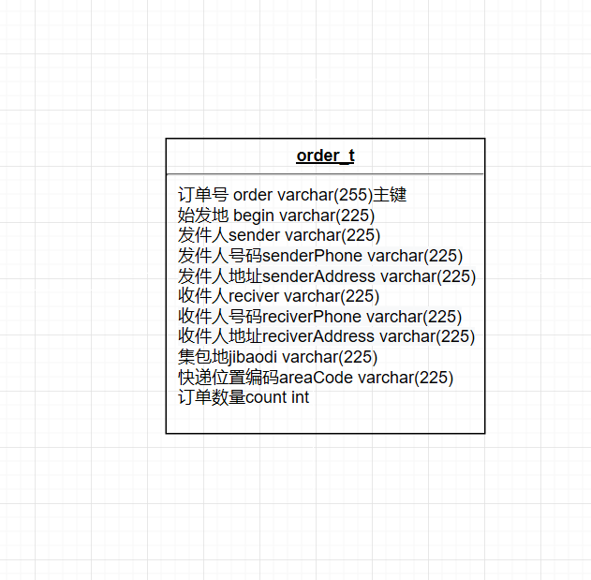

数据库ER图

## UML类图（Class Diagram）

* VO实体类Order：与数据库结构进行映射的类。主要由属性，setter, getter方法组成，VO类中的属性与表中的字段相对应，每一个VO类的对象都表示表中的每一条记录
* DAO接口OrderDAO：主要定义操作的接口，定义一系列数据库的原子性操作，例如增删改查（通常称为CRUD）等。
* Tools 工具类MybatisUtils:封装会话的底层操作
* Service业务逻辑实现类OrderDBService：功能实现，对数据库进行操作。
* function功能类MakeOrder.Java,MakeBarCodeFun.java,MakeQRCode.java:实现画条形码，填充并生成二维码等操作：
* GUI界面实现数据与表现分离，即 数据 <------ 视图 --------> 控制器 模型
* TableInfo.java:程序界面数据存放，数据从数据库获取。
* MyFrame.java:程序视图
* Controller.java:控制器

各类的结构及类之间的关系如图2-5所示：

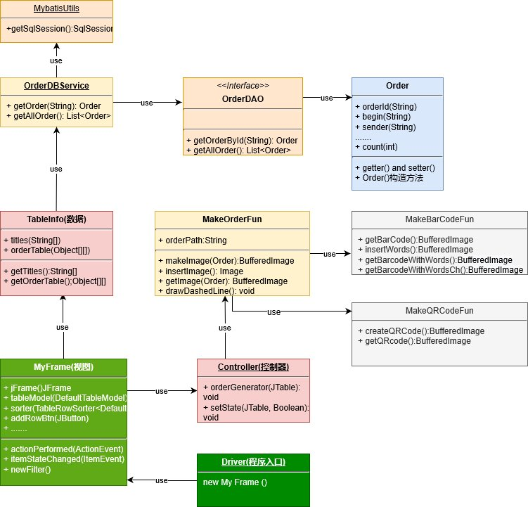

用户功能类图

## 

## UML时序图（Sequence Diagram）

程序执行过程

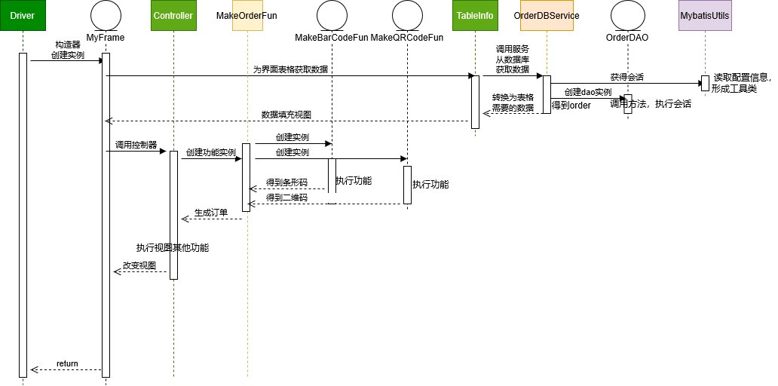

## 流程图

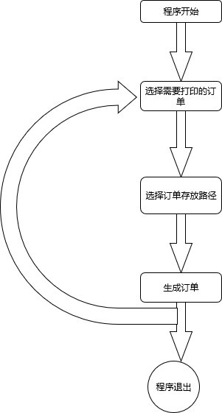

# **3 系统实现**

## 项目结构

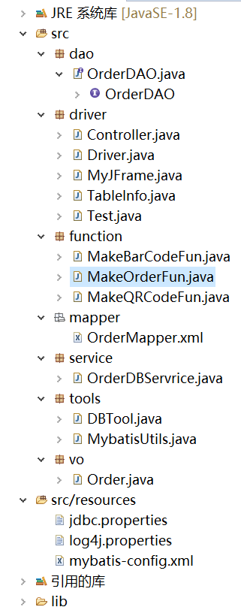

## 3.2 配置文件

在项目下新建Folder，名为resources，注意要加入到资源文件路径，不然系统会提示找不到资源文件。

### 3.2.1 jdbc.properties文件

该配置文件主要是以文件形式保存数据库的驱动类名称，连接数据库的URL地址，访问数据库的用户名及对应的密码，程序运行时会读取该文件相关信息，避免硬编码，当相关信息发生变化时，只需修改配置文件而不用修改源代码，增加程序的可扩展型。

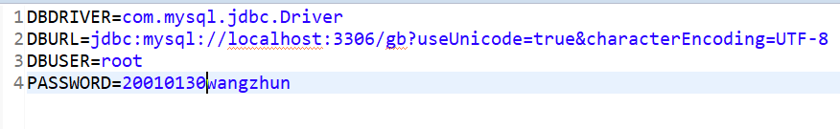

### 3.2.2 log4j.properties文件

日志配置文件，指定日志在控制台输出，控制日志输出格式

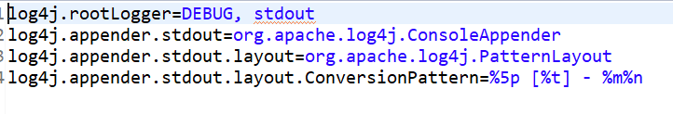

### 3.2.3 mybatis-config.xml文件

Mybatis配置文件

configuration最外层标签，表示这里面的都是配置内容。

settings标签用来设置全局参数，大多数情况下，这些参数使用它们的默认值即可。为满足应用特定的需求，在这里是控制日志输出。

从资源文件jdbc.properties,读取数据库配置信息

environments是配置mybatis当前工作的数据库环境的地方

mappers标签用来配置SQLMapper文件路径。mappers里面每一个mapper子标签都可以从不同类型的资源中加载映射mapper

## 

## 3.2.4 orderMapper.xml映射文件

Mapper.xml映射文件中定义了操作数据库的sql，每个sql是一个statement，映射文件是mybatis的核心。

|  |
| --- |
| <?xml version=*"1.0"* encoding=*"UTF-8"*?>  <!DOCTYPE mapper PUBLIC "-//mybatis.org//DTD Mapper 3.0//EN" "mybatis-3-mapper.dtd" >  <mapper namespace=*"dao.OrderDAO"*>  <select id=*"getOrderById"* resultType=*"vo.Order"*>  select * from order_t where orderId = #{orderId}  </select>    <select id=*"getAllOrder"* resultType=*"vo.Order"*>  select * from order_t  </select>  </mapper> |

## VO类Oder.java

订单文字信息，get,set方法自动生成。

|  |
| --- |
| **package** vo;  **public** **class** Order {  **private** String orderId;  **private** String begin;  **private** String sender;  **private** String senderPhone;  **private** String senderAddress;  **private** String receiver;  **private** String receiverPhone;  **private** String receiverAddress;  **private** String jibaodi;  **private** String areaCode;  **private** **int** count; |

## DAO接口类OrderDAO.java

DAO是Data Access Object数据访问接口,数据访问:顾名思义就是与数据库打交道。夹在业务逻辑与数据库资源中间。

|  |
| --- |
| package dao;  import java.util.List;  import vo.Order;  public interface OrderDAO {    public Order getOrderById(String orderId);    public List<Order> getAllOrder();  } |

## 工具包Util，MybatisUtils.java

数据库底层操作封装

|  |
| --- |
| package tools;  import java.io.IOException;  import java.io.InputStream;  import org.apache.ibatis.io.Resources;  import org.apache.ibatis.session.SqlSession;  import org.apache.ibatis.session.SqlSessionFactory;  import org.apache.ibatis.session.SqlSessionFactoryBuilder;  public class MybatisUtils {  private static SqlSessionFactory sqlSessionFactory;  public MybatisUtils() {  super();  }  /*  * SqlSessionFactory一旦被创建,应该在应用执行期间都存在.在应用运行期间不要重复创建多次  */  static {  String resourse = "mybatis-config.xml";  try {  InputStream inputStream = Resources.getResourceAsStream(resourse);  sqlSessionFactory = new SqlSessionFactoryBuilder().build(inputStream);  } catch (IOException e) {  e.printStackTrace();  }  }  public static SqlSession getSqlSession() {  // 如果不设置参数或者参数为false就是手动提交事务，参数设置为true就是自动提交事务  SqlSession sqlSession = sqlSessionFactory.openSession(true);  return sqlSession;  }  } |

## 服务层OrderDBService.java

从数据库获取信息，对数据库原子操作进行封装

|  |
| --- |
| package service;  import java.util.List;  import org.apache.ibatis.session.SqlSession;  import dao.OrderDAO;  import tools.MybatisUtils;  import vo.Order;  public class OrderDBServrice {  static public Order getOrder(String orderId) {  SqlSession session = MybatisUtils.getSqlSession();  OrderDAO dao= session.getMapper(OrderDAO.class);  Order order = dao.getOrderById(orderId);  session.close();  return order;  }    static public List<Order> getAllOrder(){  SqlSession session = MybatisUtils.getSqlSession();  OrderDAO dao= session.getMapper(OrderDAO.class);  List<Order> list = dao.getAllOrder();  session.close();  return list;  }  } |

## 功能层function，MakeQRCodeFun.java

实现二维码生成

|  |
| --- |
| package function;  public class MakeQRCodeFun {  public static BufferedImage createQRCode(String contents,int width,int height,int margin){  //二维码基本参数设置  Map<EncodeHintType, Object> hints = new HashMap<EncodeHintType, Object>();  // 设置编码字符集utf-8  hints.put(EncodeHintType.CHARACTER_SET, CharacterSetECI.UTF8);  /* 设置纠错等级L/M/Q/H,当二维码被损毁一部分时，纠错等级越高，越可能读取成功；  同样的，纠错等级越高，单位面积内点阵的点越多，机器扫描时，识别所需时间越长，当前设置等级为最高等级H*/  hints.put(EncodeHintType.ERROR_CORRECTION, ErrorCorrectionLevel.H);  // 可设置范围为0-10，但仅四个变化0 1(2) 3(4 5 6) 7(8 9 10)  hints.put(EncodeHintType.MARGIN, margin);  // 生成图片类型为QRCode  BarcodeFormat format = BarcodeFormat.QR_CODE;  // 创建位矩阵对象  BitMatrix matrix = null;  try {  // 生成二维码对应的位矩阵对象  matrix = new MultiFormatWriter().encode(contents, format, width, height, hints);  } catch (WriterException e) {  e.printStackTrace();  }  // 设置位矩阵转图片的参数  MatrixToImageConfig config = new MatrixToImageConfig(Color.black.getRGB(), Color.white.getRGB());  // 位矩阵对象转BufferedImage对象  BufferedImage qrcode = MatrixToImageWriter.toBufferedImage(matrix, config);  return qrcode;  }  public BufferedImage getQRcode(String orderId){  int width = 220;// 二维码宽度  int height = 220;// 二维码高度  int margin = 0;// 二维码边距  //生成二维码  BufferedImage qrcode =createQRCode(orderId,width,height,margin);  return qrcode;  }  } |

## MakeBarCodeFun.java

条形码生成。

|  |
| --- |
| **package** function;  **public** **class** MakeBarCodeFun {  **private** **static** Map<EncodeHintType, Object> *hints* = **new** HashMap<EncodeHintType, Object>() {  **private** **static** **final** **long** ***serialVersionUID*** = 1L;  {  // 设置编码方式  put(EncodeHintType.***CHARACTER_SET***, "utf-8");  // 容错级别 这里选择最高H级别  put(EncodeHintType.***ERROR_CORRECTION***, ErrorCorrectionLevel.***H***);  put(EncodeHintType.***MARGIN***, 1);  }  };    **public** **static** BufferedImage getBarCode(String orderId,**int** WIDTH,**int** HEIGHT){  **try**{  Code128Writer writer=**new** Code128Writer();  //编码内容，编码类型，宽度，高度，设置参数  BitMatrix bitMatrix = writer.encode(orderId, BarcodeFormat.***CODE_128***, WIDTH, HEIGHT, *hints*);  **return** MatrixToImageWriter.*toBufferedImage*(bitMatrix);  }**catch**(WriterException e){  e.printStackTrace();  }  **return** **null**;  }  //条形码下面加上文字  **public** BufferedImage insertWords(BufferedImage image, String words,**int** WIDTH,**int** HEIGHT,**int** WORD_HEIGHT){  //新的图片，把带logo的条形码下面加上文字  BufferedImage outImage = **new** BufferedImage(WIDTH, WORD_HEIGHT, BufferedImage.***TYPE_INT_RGB***);  Graphics2D g2d=outImage.createGraphics(); setGraphics2D(g2d);  setColorWhite(g2d);  g2d.drawImage(image, 0, 0, image.getWidth(), image.getHeight(), **null**);  Color color=**new** Color(0,0,0);  g2d.setColor(color);  g2d.setFont(**new** Font("黑体",Font.***PLAIN***,14));  **int** strWidth=g2d.getFontMetrics().stringWidth(words);  **int** wordStartX=(WIDTH-strWidth)/2;  **int** wordStartY=HEIGHT+15;  g2d.drawString(words, wordStartX, wordStartY);  g2d.dispose();  outImage.flush();  **return** outImage;    }  **private** **void** setGraphics2D(Graphics2D g2d) {  g2d.setRenderingHint(RenderingHints.***KEY_ANTIALIASING***, RenderingHints.***VALUE_ANTIALIAS_ON***);  g2d.setRenderingHint(RenderingHints.***KEY_TEXT_ANTIALIASING***, RenderingHints.***VALUE_TEXT_ANTIALIAS_ON***);  g2d.setRenderingHint(RenderingHints.***KEY_STROKE_CONTROL***, RenderingHints.***VALUE_STROKE_DEFAULT***);  Stroke s = **new** BasicStroke(1, BasicStroke.***CAP_ROUND***, BasicStroke.***JOIN_MITER***);  g2d.setStroke(s);  }  **private** **void** setColorWhite(Graphics2D g2d) {  g2d.setColor(Color.***WHITE***);  g2d.fillRect(0, 0, 400, 60);  g2d.setColor(Color.***BLACK***);  }    **public** BufferedImage getBarcodeWithWords(String orderId){;  BufferedImage image = insertWords(*getBarCode*(orderId,400,40),orderId,400,40,60);  **return** image;  }    **public** BufferedImage getBarcodeWithWordsCh(){  LocalDateTime now=LocalDateTime.*now*();  String s=now.format(DateTimeFormatter.*ofPattern*("yyyyMMddHHmmssSSS"));  **int** i=(**int**)(Math.*random*()*900)+100;  s += String.*valueOf*(i);  BufferedImage image = insertWords(*getBarCode*(s,400,40),s,400,40,60);  **return** image;  }  } |

**MakeOrderFun.java**

绘制订单

|  |
| --- |
| package function;  public class MakeOrderFun {  static public String orderPath = "E:\\data\\orders";    public BufferedImage makeImage(Order order) {  BufferedImage image = new BufferedImage(455, 650,  BufferedImage.TYPE_3BYTE_BGR);  Graphics g = image.getGraphics();  int width = 443;  int height = 649;  int x = 10;  int y = 12;  g.setColor(Color.WHITE);  g.fillRect(0, 0, width, height);  g.setColor(Color.BLACK);    g.drawLine(0, 0, width, 0);  g.drawLine(0, height, width, height);  g.drawLine(0, 0, 0, height);  g.drawLine(width, 0, width, height);  ........剩下代码就不加进来了 |

**dirver程序界面布置以及启动**

视图与数据分离，控制器控制视图

数据<- - - - 视图 - - - - ->控制器架构

**MyFrame.java**

视图

|  |
| --- |
| **public** **class** MyJFrame **implements** ActionListener,ItemListener{//实现事件监听  **private** JFrame jFrame;//实例化窗体对象  **private** JTable table; //声明JTable对象  **private** DefaultTableModel tableModel;//声明DefaultTableModel对象    **private** TableRowSorter<DefaultTableModel> sorter; //表格过滤  **private** JButton addRowBtn;  **private** JButton removeRowBtn;  **private** JTextField filterText;  **private** JTextField statusText;  **private** JTextField orderPath;  **private** JTextField defaultOrderPath = **new** JTextField(MakeOrderFun.*orderPath*);  **private** JButton browseBtn;  **private** JButton orderMakeBtn;  **private** JRadioButton allSelectBox = **new** JRadioButton("全选");  **private** JRadioButton allEmptyBox = **new** JRadioButton("清空");  **private** JCheckBox checkBox = **new** JCheckBox("默认路径:");      **public** MyJFrame() {  // **TODO** 自动生成的构造函数存根  jFrame = **new** JFrame("物流单");  tableModel = **new** DefaultTableModel(TableInfo.*getOrderTable*(),TableInfo.*getTiles*());  //tableModel.getColumnClass(columnIndex)  table = **new** JTable(tableModel);//根据tableModel显示内容  sorter = **new** TableRowSorter<DefaultTableModel>(tableModel);  table.setRowSorter(sorter); //为表格添加过滤  table.setSelectionMode(ListSelectionModel.***SINGLE_SELECTION***);  //When selection changes, provide user with row numbers for  //both view and model.  table.getSelectionModel().addListSelectionListener(  **new** ListSelectionListener() {  **public** **void** valueChanged(ListSelectionEvent event) {  **int** viewRow = table.getSelectedRow();  **if** (viewRow < 0) {  //Selection got filtered away.  statusText.setText("");  } **else** {  **int** modelRow =  table.convertRowIndexToModel(viewRow);  statusText.setText(  String.*format*("Selected Row in view: %d. ",  viewRow, modelRow));  }  }  }  );  .........(代码略) |

**TableInfo.java**

数据

|  |
| --- |
| package driver;  import java.util.List;  import service.OrderDBServrice;  import vo.Order;  public class TableInfo {  static private String[] titles = {"订单号","始发地","发件人","发件人电话","发件人地址","收件人","收件人电话","收件人地址","集包地","订单编码","订单数量","是否生成"};    static private Object[][] orderTable;    static {  List<Order> orderList = OrderDBServrice.getAllOrder();  orderTable = new Object[orderList.size()][12];  int i = 0;  for (Order order : orderList) {  orderTable[i][0] = order.getOrderId();  orderTable[i][1] = order.getBegin();  orderTable[i][2] = order.getSender();  orderTable[i][3] = order.getSenderPhone();  orderTable[i][4] = order.getSenderAddress();  orderTable[i][5] = order.getReceiver();  orderTable[i][6] = order.getReceiverPhone();  orderTable[i][7] = order.getReceiverAddress();  orderTable[i][8] = order.getJibaodi();  orderTable[i][9] = order.getAreaCode();  orderTable[i][10] = order.getCount();  orderTable[i][11] = false;  i++;  }  }    static public String[] getTiles() {  return titles;  }    static public Object[][] getOrderTable(){  return orderTable;  }  } |

**Controller.java**

控制器

|  |
| --- |
| package driver;  import javax.swing.JTable;  import function.MakeOrderFun;  import vo.Order;  public class Controller {  static public void orderGenerator(JTable oT) {  MakeOrderFun m = new MakeOrderFun();  int rowCount = oT.getRowCount();  for (int i = 0; i < rowCount; i++) {  if((Boolean)oT.getValueAt(i, 11)&&(Boolean)oT.getValueAt(i, 11)!=null)  m.getImage(new Order((String)oT.getValueAt(i,0),(String)oT.getValueAt(i,1),(String)oT.getValueAt(i,2),  (String)oT.getValueAt(i,3),(String)oT.getValueAt(i,4),(String)oT.getValueAt(i,5),(String)oT.getValueAt(i,6),  (String)oT.getValueAt(i,7),(String)oT.getValueAt(i,8),(String)oT.getValueAt(i,9),(int)oT.getValueAt(i,10)));  }  }    static public void setState(JTable table,Boolean state) {  for(int i = 0; i < table.getRowCount(); i++) {  table.setValueAt(state, i, 11);  }  }  } |

**Driver.java**

程序入口

|  |
| --- |
| **package** driver;  **public** **class** Driver {  **public** **static** **void** main(String[] args) {  **new** MyJFrame();  }  } |

# **4 系统测试**

运行程序，得到如下图所示的界面

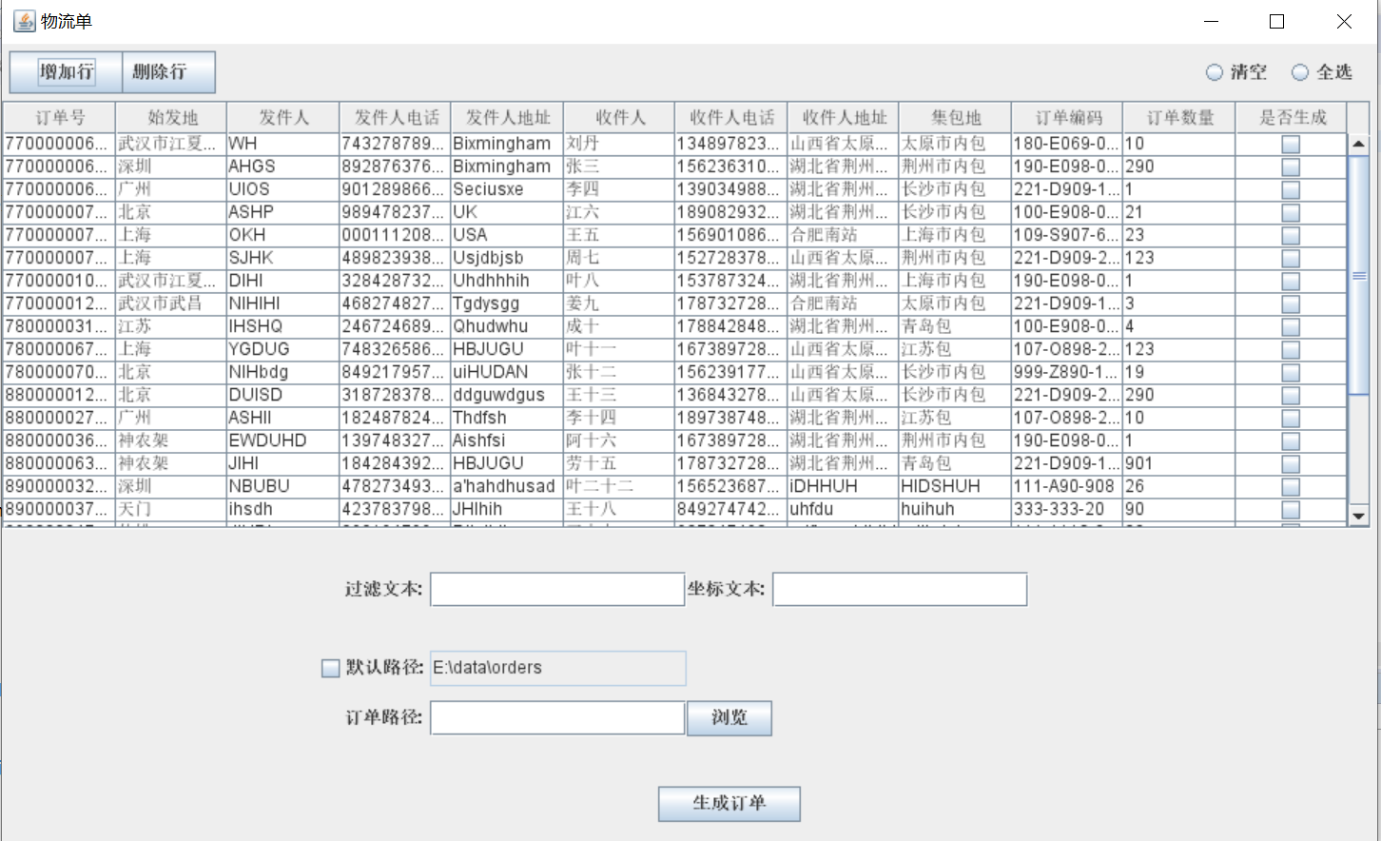

可通过过滤文本选择出要打印的订单现在打印出全部订单号以7700000开头的订单，一个个选中后面是否生成的的按钮(也可以通过全选按钮全部选中)，

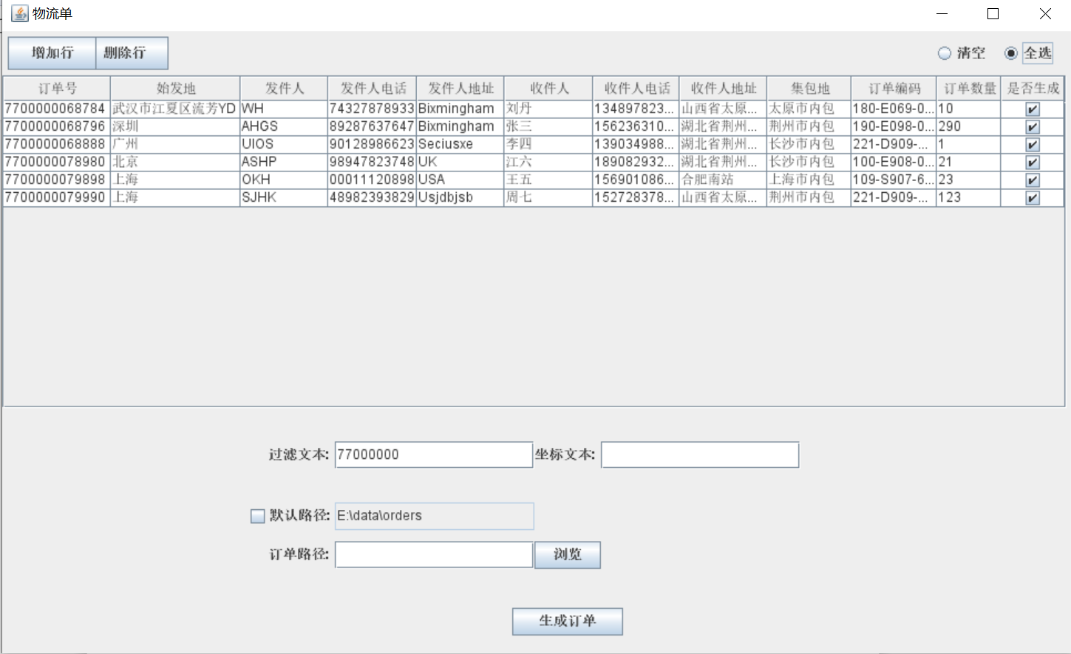

然后选择订单存放路径为桌面的orders文件夹，如下图

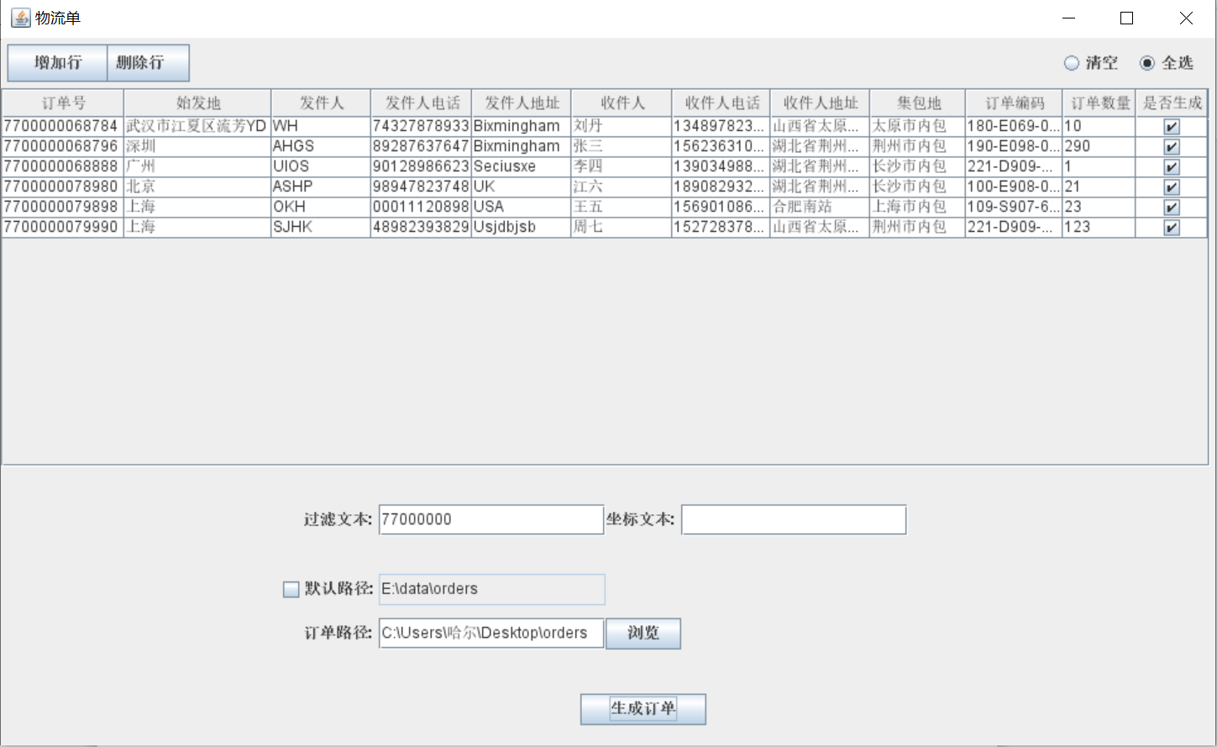

点击生成按钮，查看ordes文件夹，发现选择的订单全部生成成功

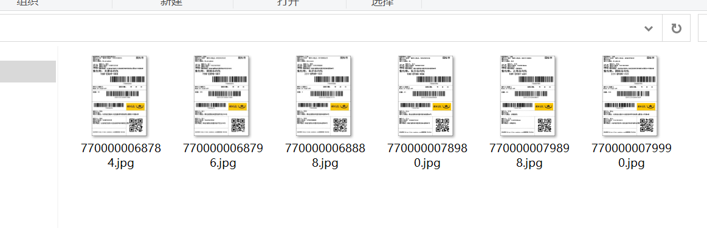

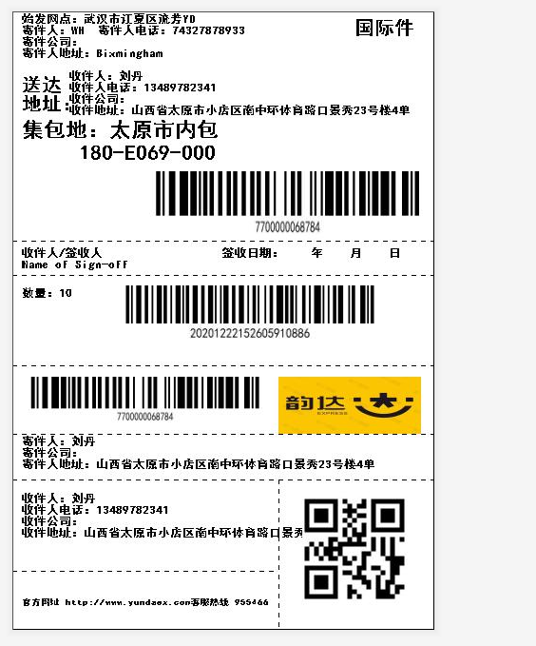

测试结束

# **5 系统总结**

主要遇到的问题就是关于二维码，条形码的生成，通过在网上找到的一些教程熟悉zxing，了解函数以及参数的功能，要尽量减少硬编码的使用，降低不必要的耦合。