**AP* Chemistry** 

**Chemical Foundations**

**Chemistry: An Overview**

• **Matter** – takes up space, has mass, exhibits inertia

- composed of atoms only 100 or so different types

- Water made up of one oxygen and two hydrogen atoms

- Pass an electric current through it to separate the two types of atoms and they rearrange to become two different types of molecules

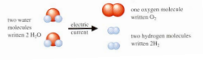

- reactions are reversible

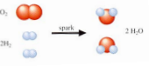

**Chemistry** – is defined as the study of matter and energy and more importantly, the changes between them • **Why study chemistry?**

- become a better problem solver in all areas of your life

- safety – had the Roman’s understood lead poisoning, their civilization would not have fallen - to better understand all areas of science

**The Scientific Method**

• A plan of attack! 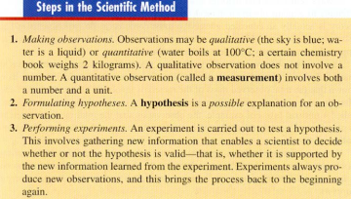

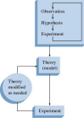

The fundamental steps of the

scientific method

*AP is a registered trademark of the College Board, which was not involved in the production of this product. © 2013 by René McCormick. All rights reserved.

• Good experimental design coupled with repetition is key!

**Theory** – hypotheses are assembled in an attempt at *explaining* “why” the “what” happened. • **Mode**l – we use many models to explain natural phenomenon – when new evidence is found, the model changes! 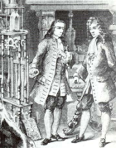

• **Robert Boyle**

o loved to experiment with air

o created the first vacuum pump

o coin and feather fell at the same rate due to gravity

o in a vacuum there is no air resistance to impede the fall of either

object!

o Boyle defined elements as anything that cannot be broken into

simpler substances.

Boyle’s Gas Law: *P1V1 = P2V2*

• **Scientific Laws** – a summary of observed (measurable) behavior [a theory is an explanation of behavior] *A law summarizes what happens; a theory (model) is an attempt to explain WHY it happens.* - **Law of Conservation of Mass** – mass reactants = mass products

- **Law of Conservation of Energy** – (a.k.a. first law of thermodynamics)

***Energy CANNOT be created NOR destroyed; can only change forms.*** - Scientists are human and subjected to 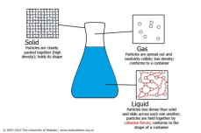

• Data misinterpretations

• Emotional attachments to theories

• Loss of objectivity

• Politics

• Ego

• Profit motives

• Fads

• Wars

• Religious beliefs

• **Galileo** – forced to recant his astronomical observations in 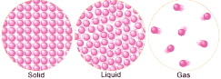

the face of strong religious resistance

• **Lavoisier** – “father of modern chemistry”; beheaded due

to political affiliations.

• The need for better explosives; (rapid change of solid 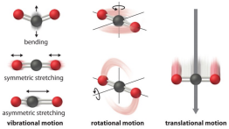

or liquid to gas where molecules become ≈2,000

diameters farther apart and exert massive forces as a

result) for wars have led to

-fertilizers that utilizes nitrogen

- Nuclear devices

Chemical Foundations 2

**Units of Measure**

A quantitative observation, or measurement, ALWAYS consists of two parts: a *number* and a *unit*.

Two major measurements systems exist: English (US and some of Africa) and Metric (the rest of the globe!) • SI system – 1960 an international agreement was reached to set up a system of units so scientists everywhere could better communicate measurements. Le Système International in French; all based upon or derived from the metric system

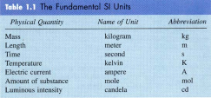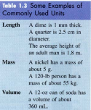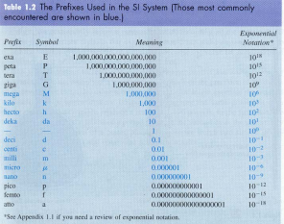KNOW THE UNITS AND PREFIXES shown in **BLUE**!!! 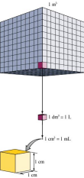

• Volume – derived from length; consider a cube 1m on each edge ∴1.0 m3

- A decimeter is 1/10 of a meter so

(1m)3 = (10 dm)3= 103 dm3= 1,000 dm3

1dm3 = 1 liter (L) and is slightly larger than a quart also

1dm3 = 1 L = (10 cm)3= 103cm3 = 1,000 cm3 = 1,000 mL

AND 1 cm3 = 1 mL = 1 gram of H2O (at 4ºC if you want to be picky)

Mass vs. Weight – chemists are quite guilty of using these terms interchangeably.

o mass (g or kg) – a measure of the resistance of an object to a change in its state of motion (i.e. exhibits inertia); the quantity of matter present

o weight (a force∴ has units of Newtons) – the response of mass to gravity; since all of our measurements will be made here on Earth, we consider the acceleration due to gravity a constant so we’ll use the terms interchangeably as well *although* it is technically incorrect! We “weigh” chemical quantities on a **balance NOT a scale!!**

Chemical Foundations 3

**Gravity** – varies with altitude here on planet Earth

• The closer you are to the center of the Earth, the stronger the gravitational field SINCE it originates from the center of the Earth.

• Every object has a gravitational field – as long as you’re on Earth, they are masked since the Earth’s field is so HUGE compared to the object’s.

• The strength of the gravitational field ∝ mass

• Ever seen astronauts in space that are “weightless” since they are very far removed from the center of Earth? Notice how they are constantly “drawn” to the sides of the ship and must push away?

• The ships’ mass is greater than the astronaut’s mass ∴ “g” is greater for the ship and the astronaut is attracted to the ship just as you are attracted to Earth! The moon has 61 the mass of the Earth ∴ you would experience 61 the gravitational field you experience on Earth and ∴ you’d WEIGH 61 of what you weigh on Earth.

**Precision and Accuracy**

**Physics connection:**

Fw = *ma*

Fw = *mg*

s *w F m*  =      

9.8 m

2

∴its units are

*N*  =      

m kgs

( ) 2

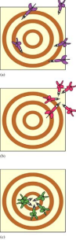The results of several dart throws show the difference between precise and accurate.

(a) Neither nor

precise (large random errors).

(b) Precise but

not accurate (small random errors, large systematic error). (c) Bull’s-eye! Both precise and accurate (small random errors, no systematic error).

- **Accuracy** – correctness; agreement of a measurement with the true value - **Precision** – reproducibility; degree of agreement among several measurements. - **Random or indeterminate error** – equal probability of a measurement being high or low

- **Systematic or determinate error** – occurs in the same direction each time

**Exercise 1 Precision and Accuracy**

To check the accuracy of a graduated cylinder, a student filled the cylinder to the 25-mL mark using water delivered from a buret and then read the volume delivered. Following are the results of five trials:

*Trial Volume Shown by Volume Shown*

*Graduated Cylinder by the Buret*

1 25 mL 26.54 mL

2 25 mL 26.51 mL

3 25 mL 26.60 mL

4 25 mL 26.49 mL

5 25 mL 26.57 mL

*Average 25* mL *26.54* mL

Is the graduated cylinder accurate?

**Note that the average value measured using the buret is significantly different from 25 mL. Thus, this graduated cylinder is not very accurate. It produces a systematic error (in this case, the indicated result is low for each measurement).**

Chemical Foundations 4

**Significant Figures and Calculations**

**Determining the Number of Significant Figures (or Digits) in a Measurement**

• Nonzero digits are significant. (Easy enough to identify!)

• A zero is significant IF and ONLY IF it meets one of the conditions below:

- The zero in question is “terminating AND right” of the decimal [must be both]

- The zero in question is “sandwiched” between two significant figures

• Exact or counting numbers have an ∞ amount of significant figures as do fundamental constants (never to be confused with derived constants)

**Exercise 2 Significant Figures (SF)**

Give the number of significant figures for each of the following experimental results.

a. A student’s extraction procedure on a sample of tea yields 0.0105 g of caffeine.

b. A chemist records a mass of 0.050080 g in an analysis.

c. In an experiment, a span of time is determined to be 8.050 × 10‒3 s .

**a. three; b. five; c. four**

**Reporting the Result of a Calculation to the Proper Number of Significant Figures**

• When × and ⎟ , the term with the **least** number of *significant figures* (∴least accurate measurement) determines the number of **maximum** number of significant figures in the answer. (It’s helpful to underline the digits in the least significant number as a reminder.)

4.56 × 1.4 = 6.38 corrected → 6.4

• When + and (−), the term with the least number of *decimal places* (∴least accurate measurement) determines the number of significant figures in the final answer.

12.11

18.0 ← limiting term (only 1 decimal place)

1.013

31.123 → *corrected* 31.1 (limits the overall answer to only one decimal place)

• pH – the *number of significant figures in least accurate measurement* determines *number decimal places* on the reported pH (usually explained in the appendix of your text)

**Rounding Guidelines for the AP Exam and This Course:**

• Round ONLY at the end of all calculations (keep the numbers in your calculator)

• Examine the significant figure one place beyond your desired number of significant figures. IF > 5 round up; < 5 drop the remaining digits.

• Don’t “double round”! Example: The number 7.348 rounded to 2 SF is reported as 7.3 In other words, DO NOT look beyond the 4 after the decimal and think that the 8 rounds the 4 up to a five which in turn makes the final answer 7.4.

[Even though you may have conned a teacher into rounding your final average this way before!] Chemical Foundations 5

**Dimensional Analysis** 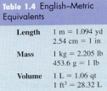

**Example:** Consider a straight pin measuring 2.85 cm in length. Calculate its

length in inches.

Start with a conversion factor such as 2.54 cm = 1 inch ∴ you can write TWO

Conversion factors: 1 in

2.54 cmor 2.54 cm

1 in . Why is this legal? Both quantities

represent the exact same “thing” so the conversion factor is actually equal to “1”.

To convert the length of the pin from cm to inches, simply multiply your given quantity by a conversion factor you engineer so that it “cancels” the undesirable unit and places the desired unit where you want it. For our example, we want inches in the numerator so our numerical answer is not reported in reciprocal inches! Thus,

2.85 cm 1 in

⋅ = 1.12 in

2.54 cm

Let’s practice!

**Exercise 3**

A pencil is 7.00 in. long. Calculate the length in centimeters?

**17.8 cm**

**Exercise 4**

You want to order a bicycle with a 25.5-in. frame, but the sizes in the catalog are given only in centimeters. What size should you order?

**64.8 in**

**Exercise 5**

A student has entered a 10.0-km run. How long is the run in miles?

We have kilometers, which we want to change to miles. We can do this by the following route: kilometers → meters → yards → miles

To proceed in this way, we need the following equivalence statements (conversion factors):

1 km = 1000 m

1 m = 1.094 yd

1760 yd = 1 mi

**6.22 mi** Chemical Foundations 6

**Exercise 6**

The speed limit on many highways in the United States is 55 mi/h. What number would be posted if expressed in kilometers per hour?

**88 km/h**

**Exercise 7**

A Japanese car is advertised as having a fuel economy of 15 km/L. Convert this rating to miles per gallon.

**35 mi /gal**

**Temperature**

I suspect you are aware there are **three** temperature scales commonly in use today. A comparison follows:

Notice a degree of temperature change on the Celsius scale represents the same quantity of change on the Kelvin scale.

Chemical Foundations 7

**Density**

mass

**Density =** volume

**Exercise 8 Determining Density**

A chemist, trying to identify the main component of a compact disc cleaning fluid, determines that 25.00 cm3  of the substance has a mass of 19.625 g at 20°C. Use the information in the table below to identify which substance may serve as the main component of the cleaning fluid. Justify your answer with a calculation.

*Compound* Density (g/cm3) at 20°C

Chloroform 1.492

Diethyl ether 0.714

Ethanol 0.789

Isopropyl alcohol 0.785

Toluene 0.867

**Density = 0.7850 g / cm3**∴ **isopropyl alcohol**

**Classification of Matter**

**States of Matter (mostly a vocabulary lesson)**

▪ **Be very, very clear that changes of state involve altering IMFs not altering actual chemical bonds!!** ▪ **solid –** rigid; definite shape and volume; *molecules close together vibrating about fixed points* ∴ *virtually incompressible*

▪ **liquid** – definite volume but takes on the shape of the container; *molecules still vibrate but also have rotational and translational motion and can slide past one another BUT are still close together* ∴ *slightly compressible*

▪ **gas** – no definite volume and takes on the shape of the container; *molecules vibrate, rotate and translate and are independent of each other* ∴ *VERY far apart* ∴ *highly compressible*

- **vapor** – the gas phase of a substance that is normally a solid or liquid at room temperature - **fluid** – that which can flow; gases and liquids

• **Mixtures** – can be **physically** separated

- **homogeneous** – have visibly indistinguishable

parts, solutions including air

- **heterogeneous** – have visibly distinguishable parts

- means of physical separation include: filtering,

fractional crystallization, distillation,

chromatography

Chemical Foundations 8

Paper Chromatography: Distillation:

Paper chromatograph of ink. (a) A line of the mixture to be separate

is placed at one end of a sheet of porous paper. (b) The paper acts as

a wick to draw up the liquid. (c) The component with the weakest

attraction for the paper travels faster than those that cling to the paper.

• **Pure substances** – compounds like water, carbon dioxide etc. and elements. Compounds can be separated into elements by **chemical** means

- electrolysis is a common chemical method for separating compounds into

elements

- elements can be broken down into atoms which can be further broken down into

- nuclei and electrons

- *p*+, *n*0 and *e*-

- quarks

Electrolysis is an example of a

chemical change. In this apparatus,

water is decomposed to hydrogen gas

(filling the red balloon) and Oxygen

gas (filling the blue balloon).

Chemical Foundations 9