# Headline

docx2md supports converting *simple* docx documents to markdown. The following formatting, images and tables are supported:

a**\*b**c*

## Subheadline

Text bla *italics* **bold** __underlined__

* Bullet point
* Level 2 pb
* Level 2 pb
* Other point

A [Link](http://www.github.com/haesleinhuepf/git-bob) and more ***and*** another [link](https://github.com/haesleinhuepf/m2d).

Image:

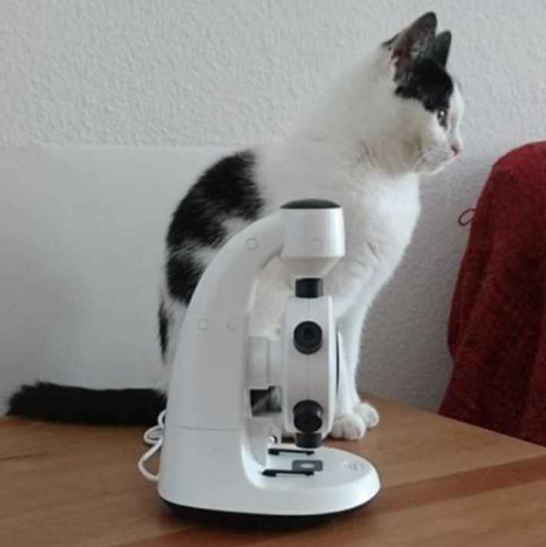

Table:

|  |  |  |  |
| --- | --- | --- | --- |
| a | b | c | D |
| 1 | 3 | 5 | 6 |
| 2 | 4 | 5 | 6 |

Hello world.