1. Linear Probing

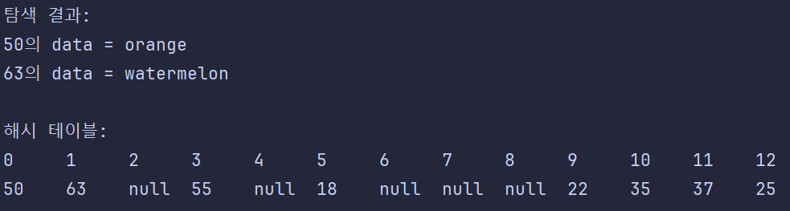

1. Chaining

