**Task 1**

**Step 1: Below screenshot represents the name of all the Scripts created in the scripts directory which includes:**

1. **cleanup.sh** – Cleans all the created directories and files in the given scripts directory as well as cleans the script directory itself.
2. **process_files.sh** – It is used to perform the following tasks:
3. Unzip the un_sorted_files.zip and make the directories for each of the file types requested and also create a miscellaneous directory.
4. Fetch the names of the file types from the command line arguments to create the respective directories.
5. Provides a list of all the files in each directory which is sorted by size.
6. Create a summary.txt file for each directory, which includes all the file names of each directory that is sorted in the reverse alphabetical order.
7. **Un_sorted_files.zip** – It is a zip file that includes all the different types of sample documents such as .doc, .docx, .txt, .jpg, .jpeg, .gif, .pptx, .pdf

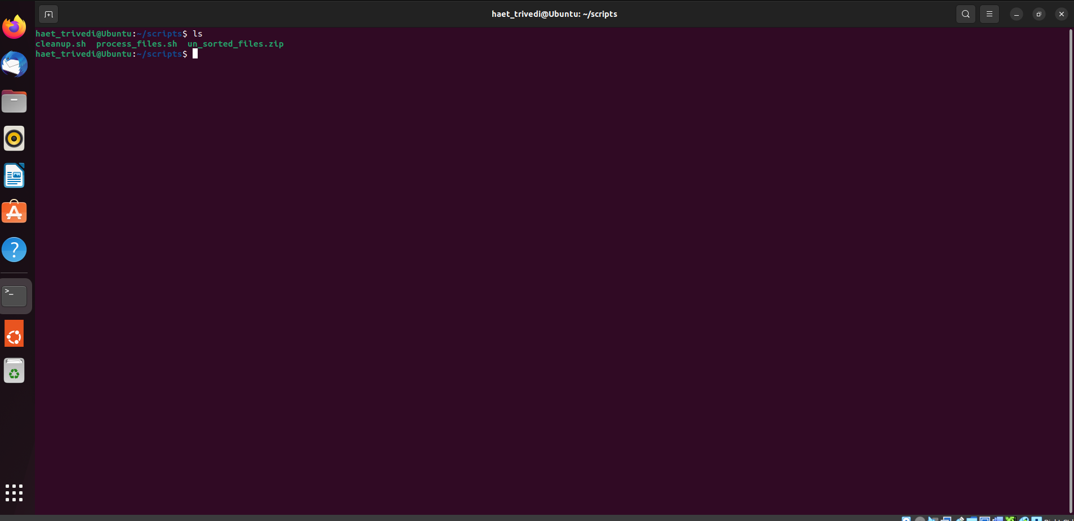

**Step 2: Provide Command Line Arguments to create the respective directories.**

In the below screenshot, user input is taken from the command line arguments to create the respective directories and separate the files from the un_sorted_files directory with respect to each directory.

According to the user input, 4 different directories (doc, jpeg, txt, misc) are created in the scripts directory by using the following command.

In addition to the above, a summary.txt file is also created.

Command: ./process_files.sh doc jpeg txt

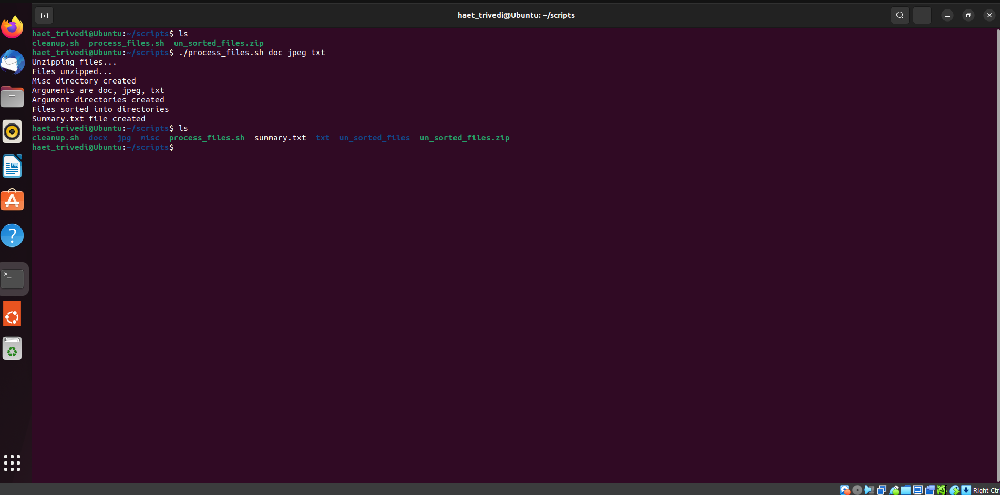

**Step 3: Represent the files separated in the respective directories**

The below screenshots show all the files which are present in the different directories after executing the process_files.sh file which moves the different files in the respective directories created.

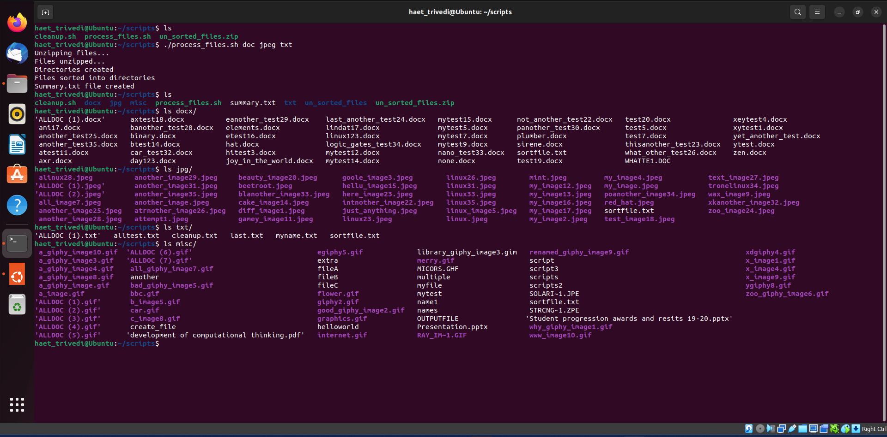

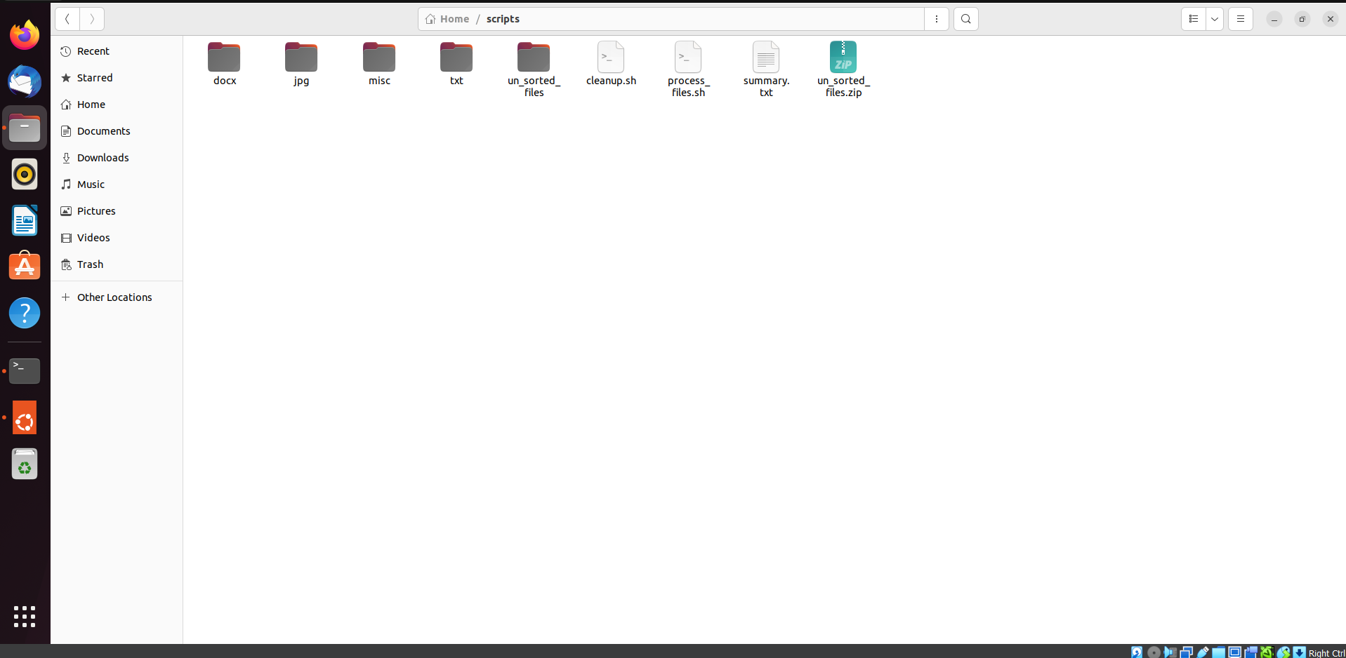

**Step 4: Create and present the summary.txt file content**

The below screenshot presents the summary.txt file created which includes the label of all the directories created along with all the file names which are sorted in the reverse order alphabetically.

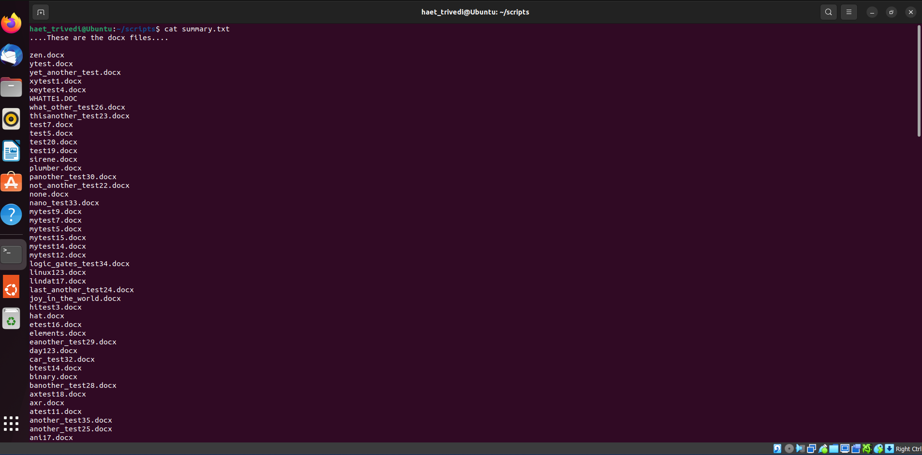

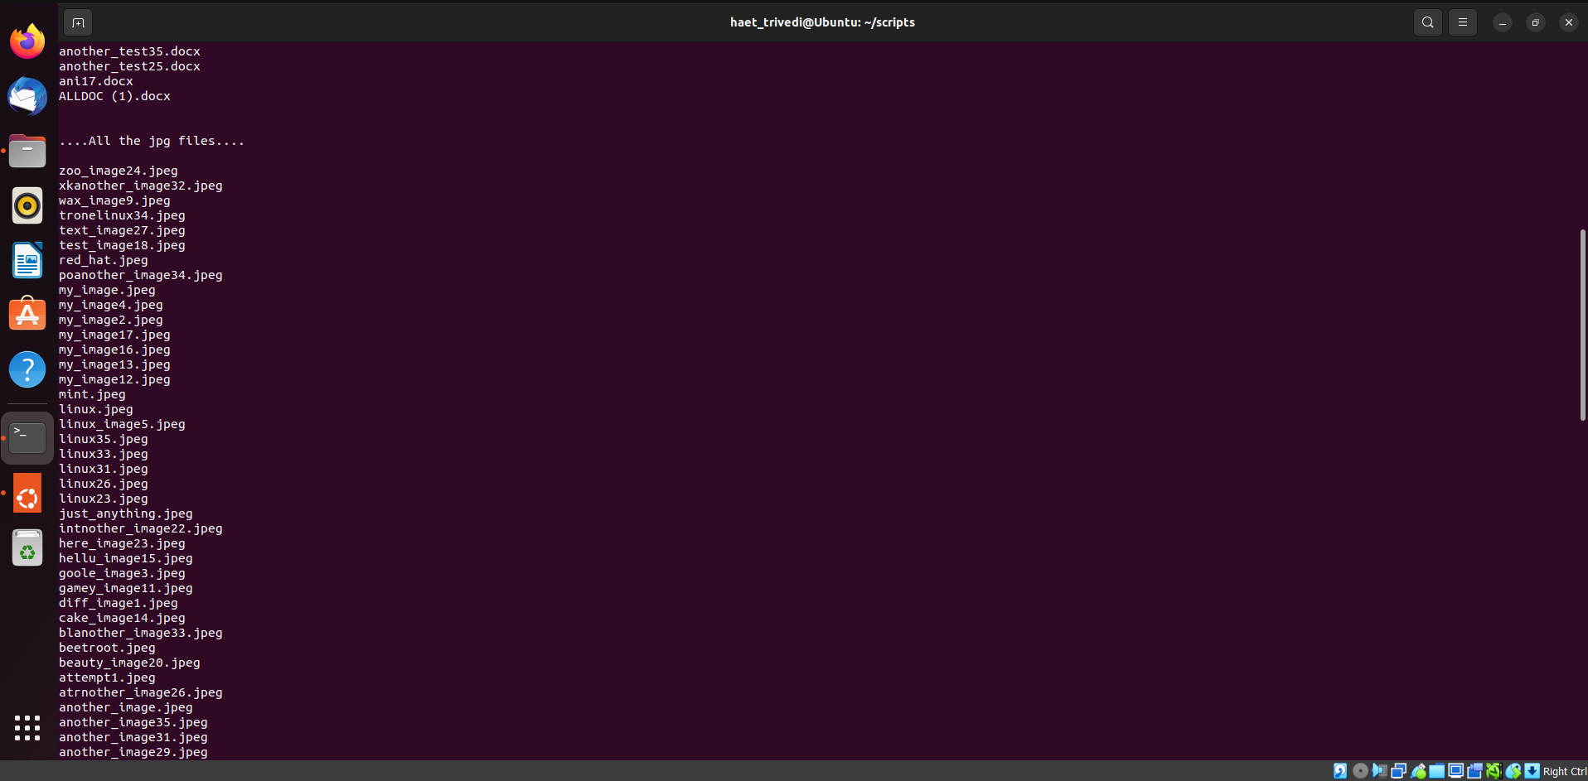

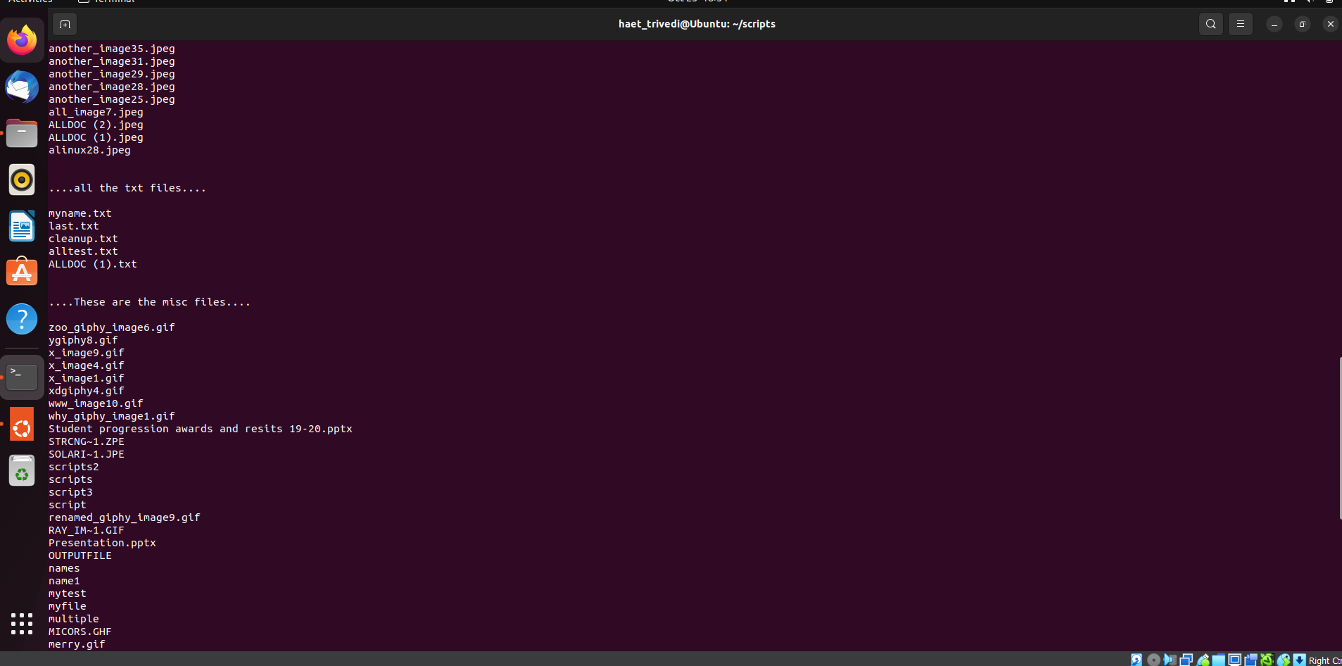

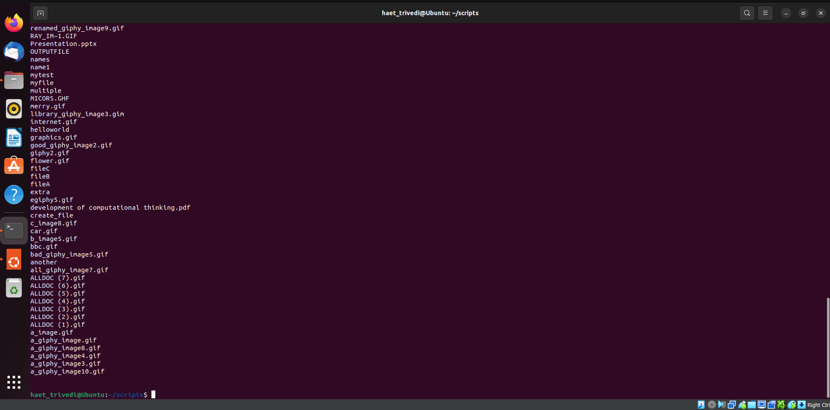

**Step 5: Sortfile created in the docx directory**

Sortfile.txt is created inside the docx folder which includes all the .doc / .docx file names that are sorted in ascending order with respect to file size.

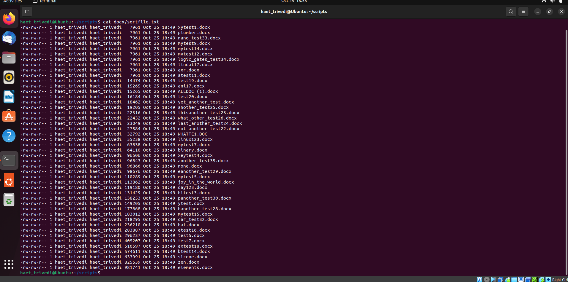

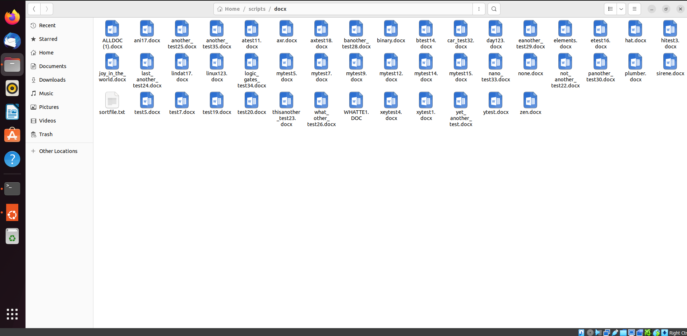

**Step 6: Sortfile created in the jpg directory**

Sortfile.txt is created inside the jpg folder which includes all the .jpg / .jpeg file names that are sorted in ascending order with respect to file size.

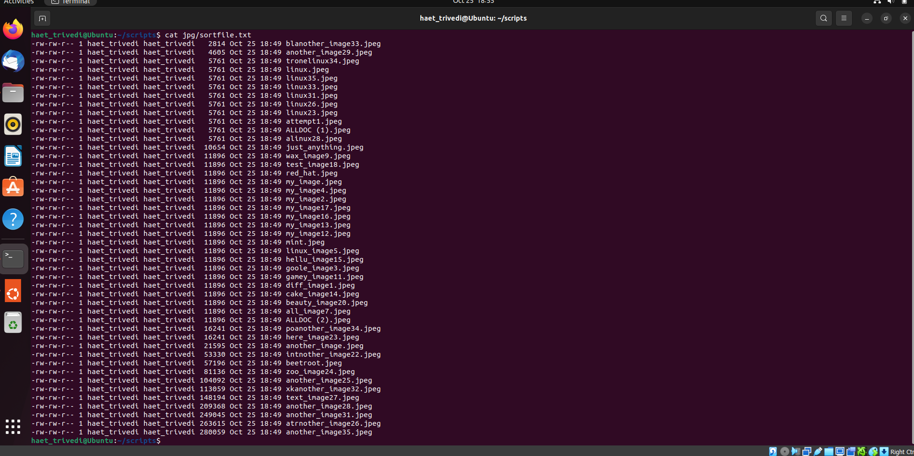

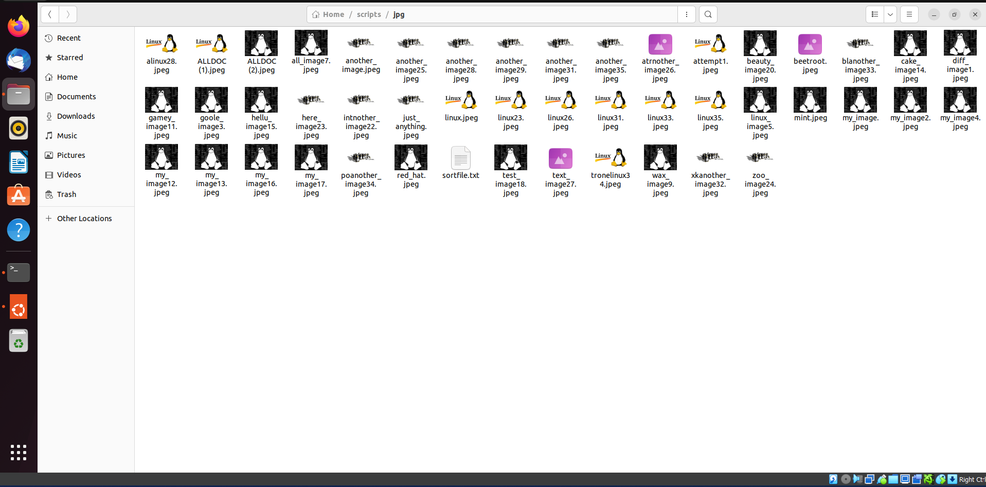

**Step 7: Sortfile created in the txt directory**

Sortfile.txt is created inside the txt folder which includes all the .txt file names that are sorted in ascending order with respect to file size.

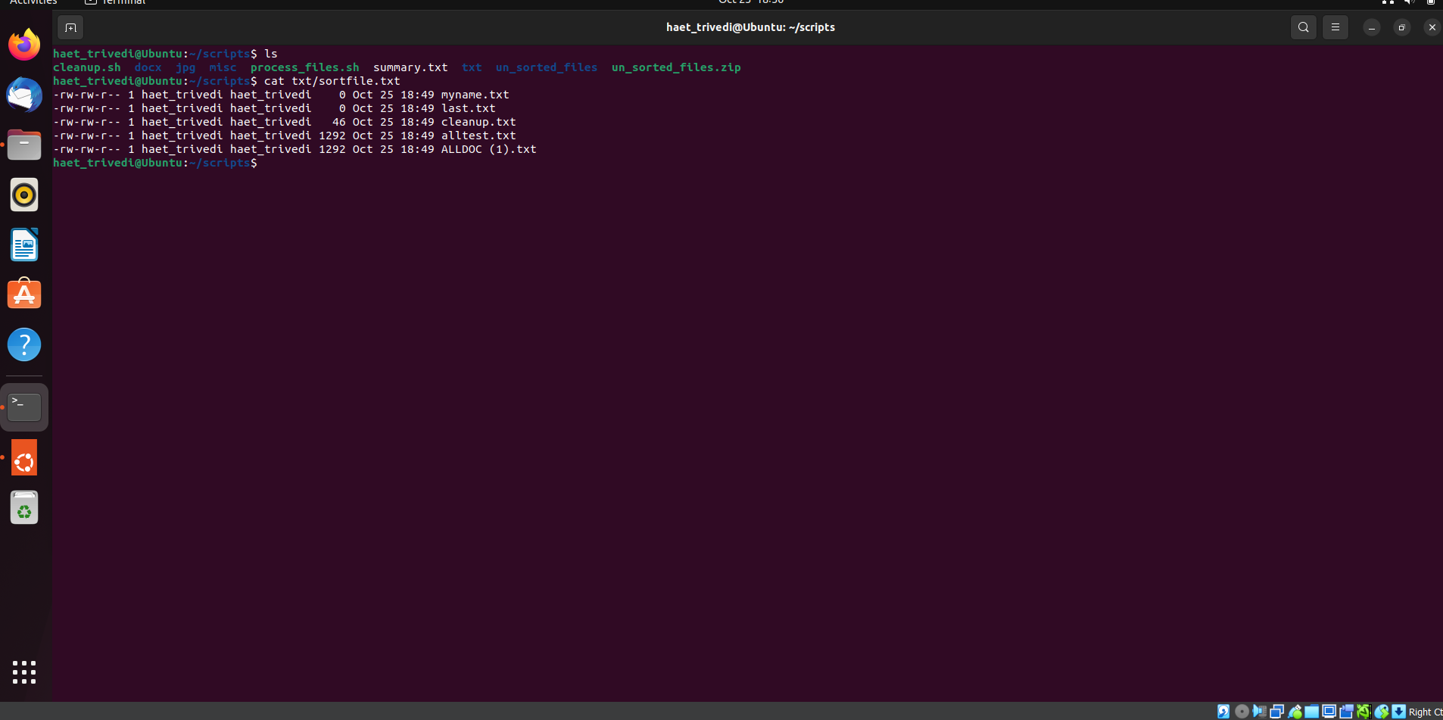

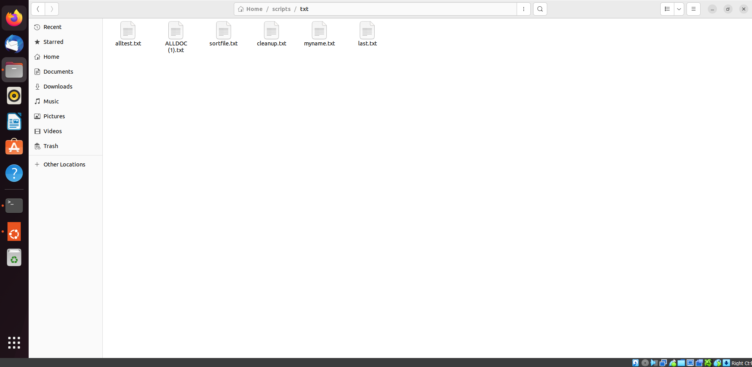

**Step 8: Sortfile created in the misc directory**

Sortfile.txt is created inside the misc folder which includes all the other types of file names that are sorted in ascending order with respect to file size.

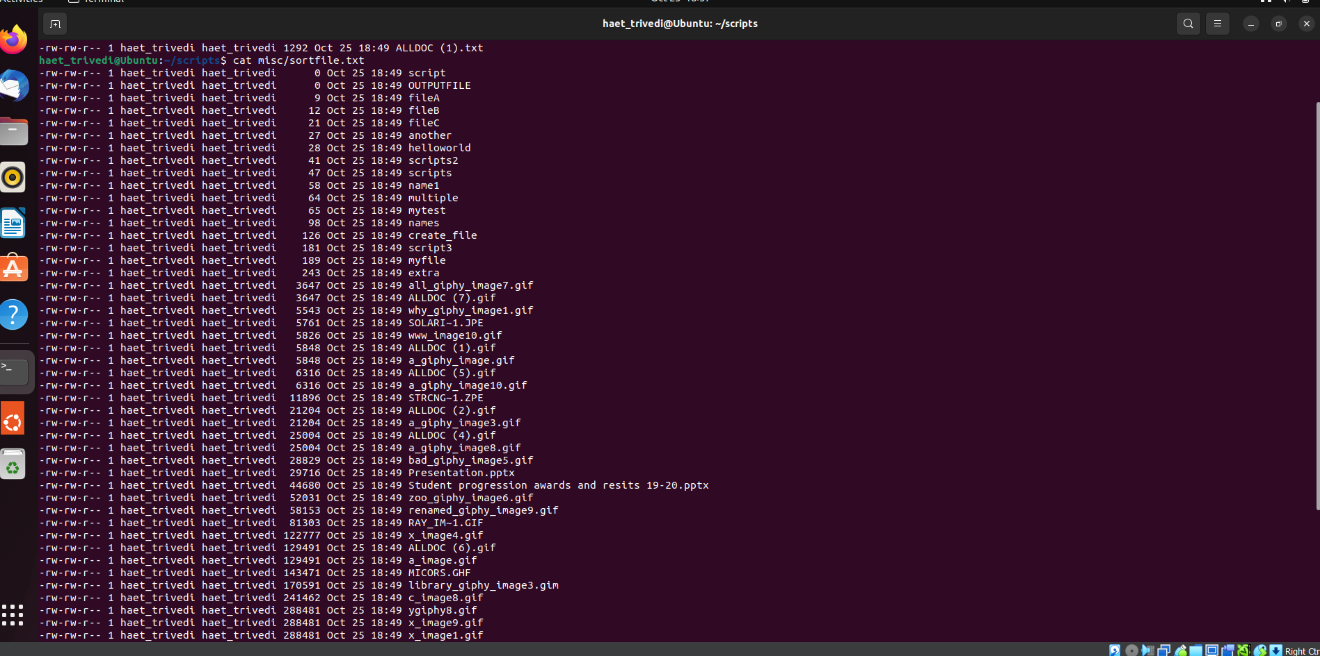

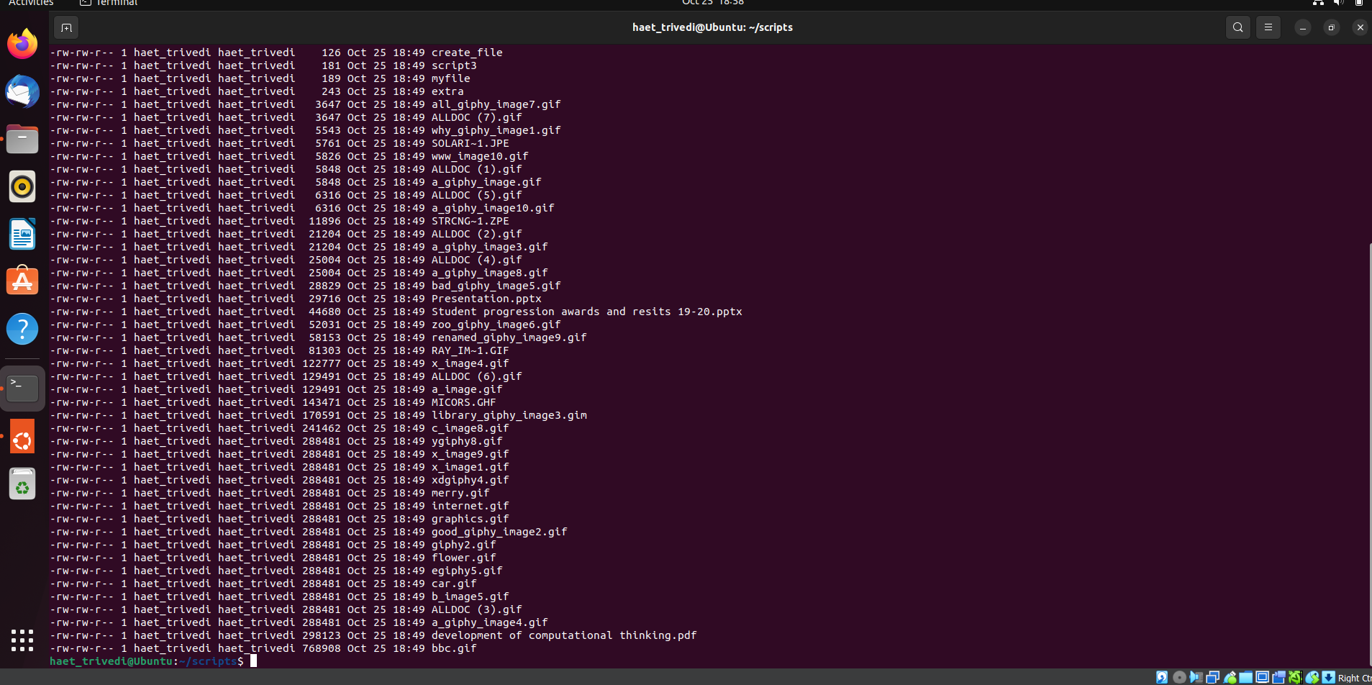

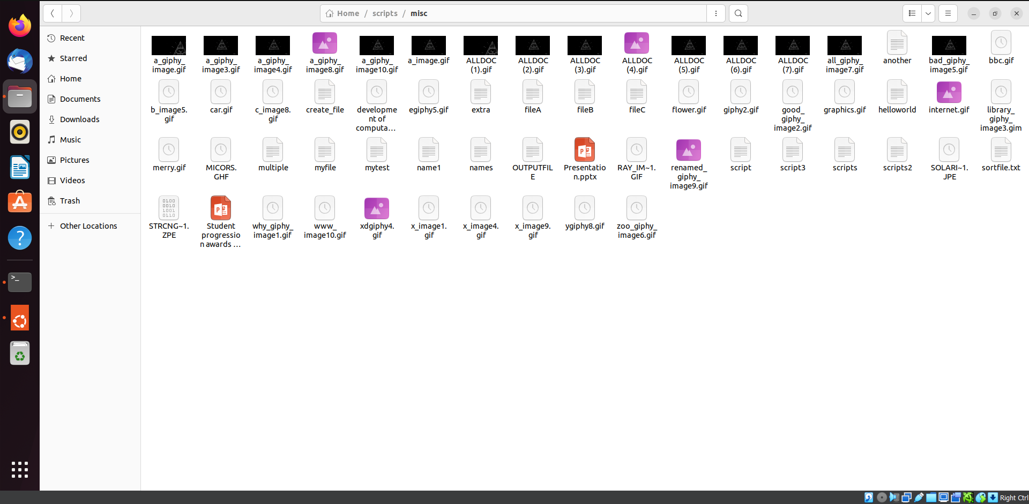

**Step 9: Clean Script**

Cleans all the created directories and files in the given scripts directory as well as cleans the script directory itself.

