# Raycast Radar

Version 0.3.2

Raycast Radar is a simple module that tries to generate a halfway realistic radar image of the environment. For this purpose raycasts are used, which in turn are processed and written into a texture.

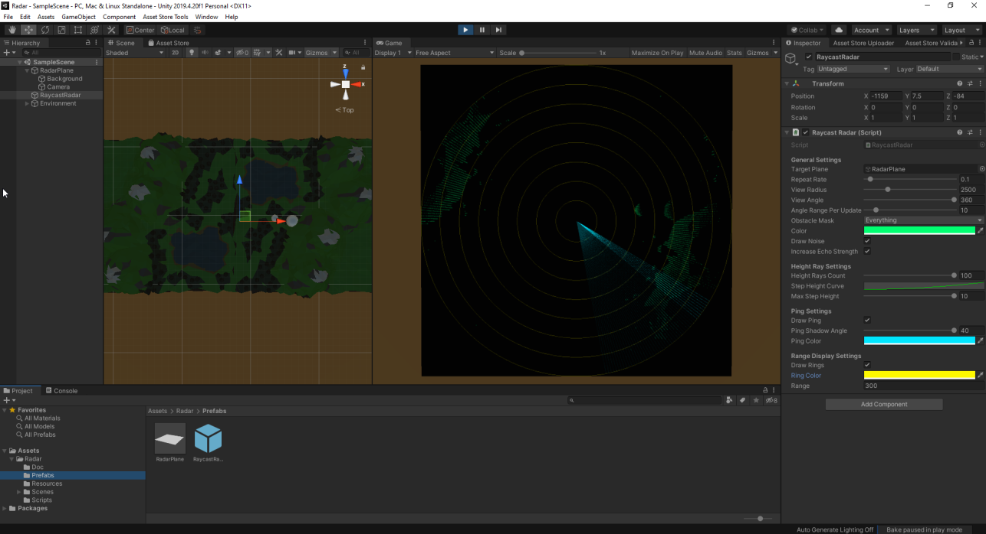

## How it works...

Drag the RaycastRadar prefab into the scene, select the plane on which the radar image is to be displayed in the Inspector under TargetPlane. There is also a RadarPlane Prefab which already has a black background and a camera aligned to it.

Since it is a raycast based radar, objects can be detected by the radar if they have a collider.

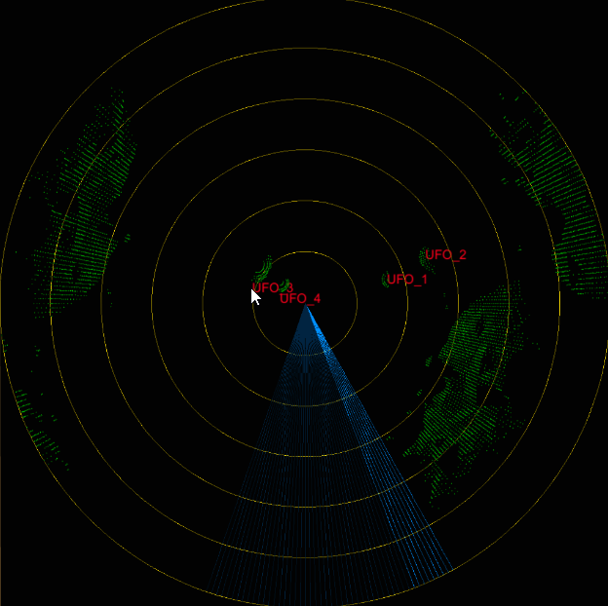

Green - Detected objects, Blue - Sweep, Yellow - Range indicating rings, Red object identifiers

## Setting options

### General Settings

**Target Plane** - target area for the radar image

**Repeat Rate** - Execution rate in seconds

**View Radius** - Indicates how far the radar can see.

**View Angle** - How big is the angle of the radar's beamwidth

**Angle Range per Update** - How big is the angle covered by the radar per execution step

**Angle Resolution** – In how many rays is one degree divided

**Obstacle Mask** - Which object layers are taken into account by the radar

**Color** - Color of the objects found by the radar

**Draw Noise** - Adds a simple noise to the detected objects

**Increase Echo Strength** - Increases the visibility of the detected objects

### Height Ray Settings

**Height Ray Count** - Indicates how many rays are sent per angle offset in height.

**Step Height Curve** - Indicates the distribution of the rays on the different height levels

**Max Step Height** - Is the maximum height that can be between two ray levels

### Sweep Settings

**Draw Sweep** - Should the sweep be drawn as well. Indicates which beams are currently being sent out.

**Sweep Shadow Angle** - Expanded sweep rays for better identification.

**Sweep Color** - Color of the sweep

### Range Display Settings

**Draw Rings** - If the rings should be drawn for better distance recognition

**Ring Color** - Color of the rings

**Range** - How big are the distances between the rings

Identifiable Objects Settings  
  
*All gameobjects with a „identifiable_by_radar“ tag will be considered.*

**Draw Identifiers** - If the object names should be drawn

**Time Before Deactivation** – When an identifiable object is not found again in the given seconds here. The identifier will be removed from from the radar plane.

**Font Color** - Color identifier font

**Font Size** – Size of the identifier font