Company Profile

1.0 Executive Summary

Funmetric is a team of expert and experience team. We are set to deliver proactive services and even exceed the expectation of the clients, when it comes to General Services ( such as Office Equipment and stationery/consumable items), security and IT project design, implementation and Service Level Agreement (SLA). We have robust technical support strategies as following:

Project implementation
The process for implementing project at your facilities requires very limited time on your part. The first phase of project implementation involves working directly with your management team to determine how propose project equipment best suits your needs. Our specialists will evaluate your current system posture, reporting systems, emergency response procedures, and other aspects of your overall facility management plan. During the final phases of project implementation, our team will prepare customized training materials for distribution to the users you identify. Those training materials will also reside on-line so new personnel in your organization can quickly become familiar with the current security system.

Level of system complexity continues to rise
As technology continues to evolve, your system provides you with even greater functionality and advanced feature capability. However, as the level of sophistication grows, system support becomes more complex. Maintaining peak system performance and availability requires a dedicated team of expert technical support who can ensure rapid response and resolution to any system issue. Funmetric technical support team help solve even the most challenging system issues.

Layered support every time you need it
Funmetric Technical Support Service provides an additional layer of support through centralized, telephone consultation for technical issues that require a high level of system network expertise and troubleshooting capabilities. Support is just a phone call away and ensures that any client issue is professionally and consistently handled in the shortest possible time frame.

Value proposition
- Available when you need it: Highly trained Funmetric team provide expert technical support whenever you need it, 24x7x365 (or 8x5 depending on contract).
- State-of-the-art resources: The Funmetric team uses test systems for in-house laboratory simulations that can duplicate your issue, as well as access to a continuously updated knowledge database of common issues and solutions to speed resolution.
- Rapid and consistent resolution: Expert resources, sophisticated tools, defined severity levels and proven case management methodology ensures rapid response and resolution.
- Service level commitment: Support provided to an agreed service level as opposed to a best effort basis.

The Funmetric difference
Funmetric understands the vital importance of ensuring maximum system availability. As a result, Funmetric has created a comprehensive portfolio of service offerings and choices that provide the exact level of support that fits your unique business, including hardware, software repair & return, field support, security systems management and so much more.

You are welcome to the world of Funmetric Technologies Limited, where RESULTS matters.

2.0 Company Profile: Funmetric Security Services
Funmetric was incorporated in 2011 by the Directors with over ten years experience across general services (such as supplier of stationery etc), security and IT industries. At Funmetric we aim to surpass our competition in meeting the standards of what a service Providers company consists of in the industry today. As a reliable service provider we provide much more than client expectation.
Funmetric is the next generation of contract service providers. We know what it takes to keep you and your business safe, but more importantly, we know how to add value to your company by providing superior customer service and attention to detail. We take ownership of every customer’s company and property. We are proud of what you and your company have accomplished and ensure that each of our team displays that pride to you and your customers through their appearance and attitude.
At Funmetric Technologies Limited, we care about our customers and their business. We focus on detail that will bring your company to the forefront in your industry. We will add value to your company by providing you more than just supply and installation; we will provide that first impression and customer service that will set your company ahead of others.

3.0 About Us
We have the pleasure to introduce our company as Funmetric Technologies Limited. Established in 2011 by qualified managements, with more than 7 years of experience, across Security and Information Technology industries; we specializing in Security, Safety systems and special projects (Supply of special security solutions and training). We also specializes in Communication and Security Equipment in the areas of selling, marketing, importing and exporting, distributing, supplying, installing and maintenance of all kinds of Electronic Security and Communication Equipments.
Our Vision is to seeing your business growing.
Our Mission is to deploy a robust technology that will add value and improve the productivity of our clients.
Our main objectives is to maximize corporate value from the medium to Long term goal
Our Goal is to deploy highly cost effective and cost efficient technology to the fulfillment and satisfaction of our customers.

4.0 Our Solutions
House of Worship Solutions
Whether your system requirements are generated by day-to-day operations, specific business needs or outside regulations and requirements, they must all be taken into account when designing a system. We know there is more to your investment than equipments — understanding the environment where the solution will be used is crucial to ensuring that it has the capability to meet end user needs.
Maintaining an open environment and welcoming atmosphere within the constraints of today's budgets is a challenge for every religious institution. From the smallest chapels to the largest multi-site worship centers, Funmetric offers integrated solutions that help you meet the challenge— providing peace of mind while also protecting your facilities against incidents that disrupt worship.
Banking Solutions
A financial institution's reputation and success are based on how well it proves to customers that it can effectively protect their hard-earned assets and investments. Funmetric’s solutions are designed to provide security — and instill customer confidence — at every level. Our trusted experience, combined with the quality and reliability of our integrated security systems, help banking customers to meet their existing and emerging security challenges.
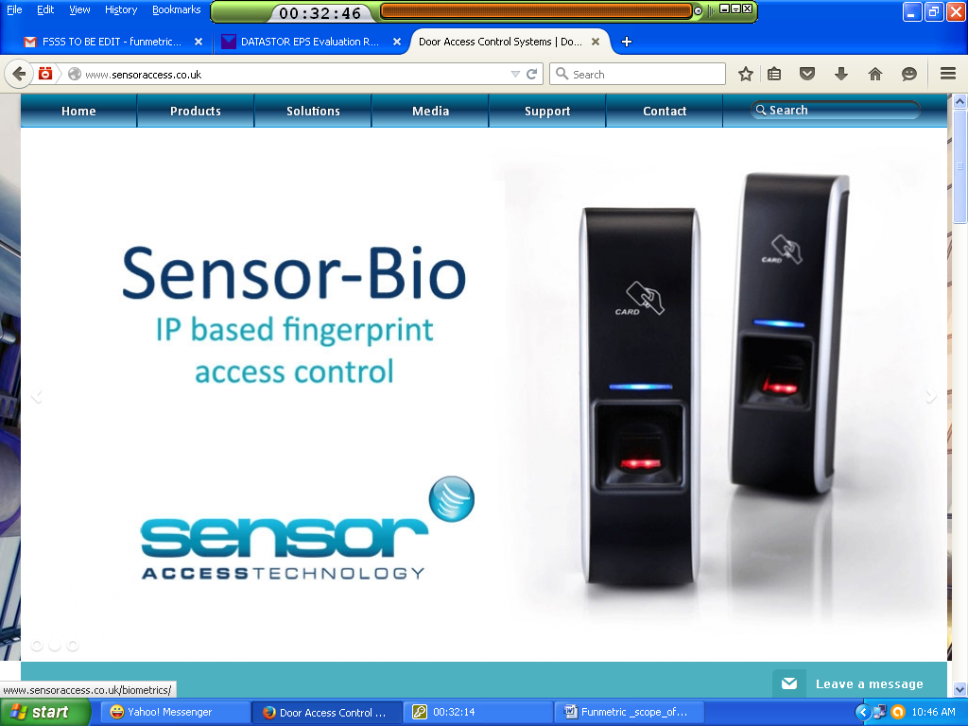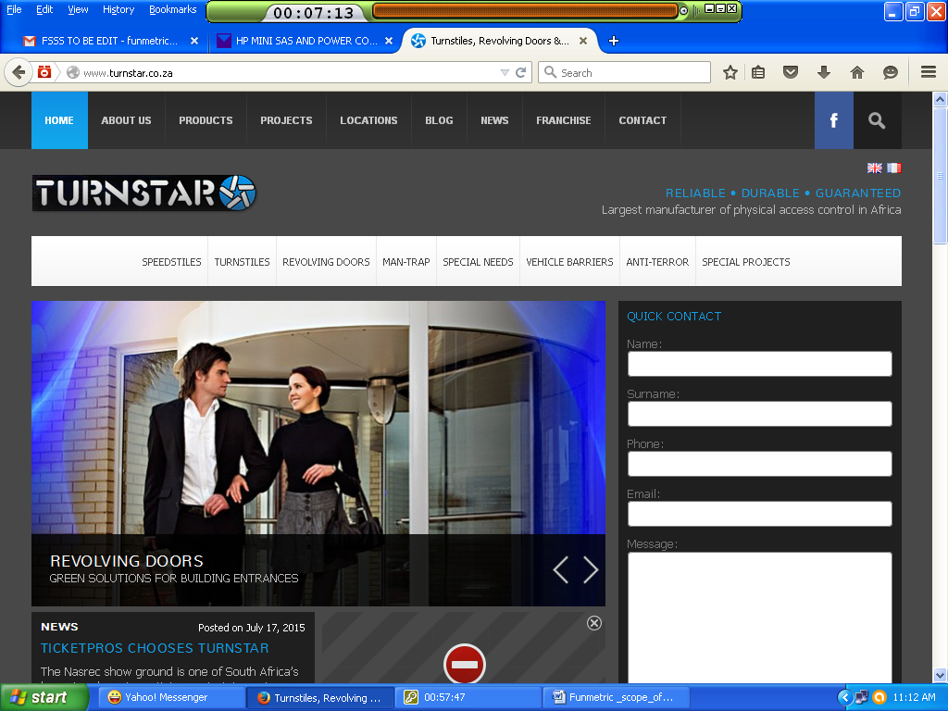
Airport & Seaport Solutions
As a cornerstone of the global economy, seaports & airport transport goods swiftly and efficiently—but it places them high on the list of potential targets. The need for heightened security should be balanced with the need for fast throughput. With threat levels ranging from common vandalism to domestic terrorism, the security of our seaport & airports is paramount. We continually making research in emerging technologies such as facial recognition to provide an integrated solution that can enhance perimeter protection as well as internal security.
Residential Solutions
To sleep soundly, you need peace of mind. You need to know that what you value most—your home, your assets, and your family—are safe and secure. From fire, theft and flood protection, to services that keep families connected, Funmetric offers effective solutions to help you protect your love ones’ and your property.
Commercial & Government Buildings
Protect commercial centers, offices and government buildings with high-quality IP cameras, identification solution system, centralized management system, and comprehensive access control solutions
Industrial Solutions
With production costs rising and employee theft costing businesses in excess of N50 billion a year, loss prevention is more important than ever. Funmetric is equipped to meet the security challenges that exist in large industrial environments. We can provide you with the best solutions to protect your property, inventory and employees, and reduce shrinkage. Funmetric offers ways to help safeguard your operations against the threat of vandalism, theft, fire and other hazards.
Health Care Solutions
The people of your community depend on you to deliver the care they need, 24/7. Funmetric helps protect your facilities around-the-clock so you can focus on your patients — patients who count on you every day of the week. We will help you deploy innovative security solutions for that will give you peace of mind — and the individuals, families and communities you serve.
Campus/University Solutions
Pressure to strengthen safety at schools and university campuses continues to increase. From theft to serious personal crimes to vandalism, we understand your need to effectively secure your campus. Funmetric’s solutions work with products you have in place now to enhance your overall security and help you get the most out of your original investment. We help you protect the safety of your students, teachers and staff, while also protecting your school against incidents that can lead to litigation.
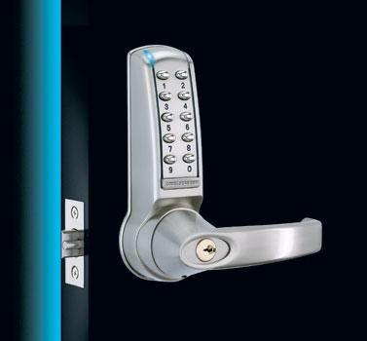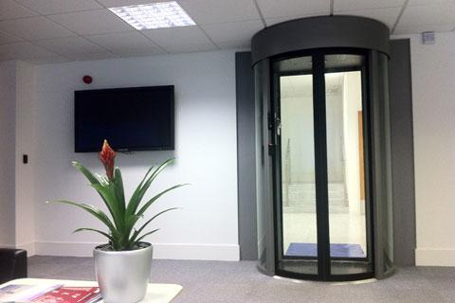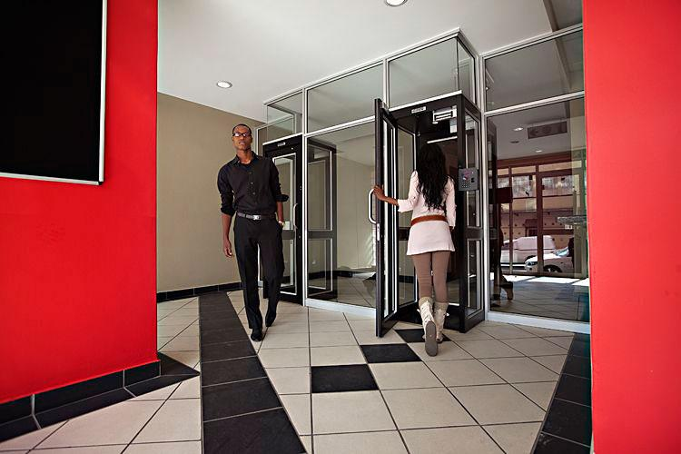

5.0 Our Scope of services
Funmetric Technologies Limited has the technological knowledge to design and develop all forms of system from the Conceptual design to the commissioning and maintenance of the required system all in accordance with the client’s requirements. Funmetric Technologies Limited takes a management approach and that is proactive rather than reactive. Our plans are never generic in nature. Rather, we seek to understand the singular nature of our client’s mission and the risks that threaten that mission; and then we customize a plan to mitigate those risks. As a result, the organization is free to focus on its essential purpose, regardless of the operating environment.
We offer the following Services:
- General services ( office tools and stationery & consumable items etc)
- Security Surveillance System (CCTV, Access Control, Fire & Burglary Alarm System etc)
- IT Services (Computer and networking system etc)

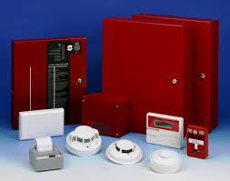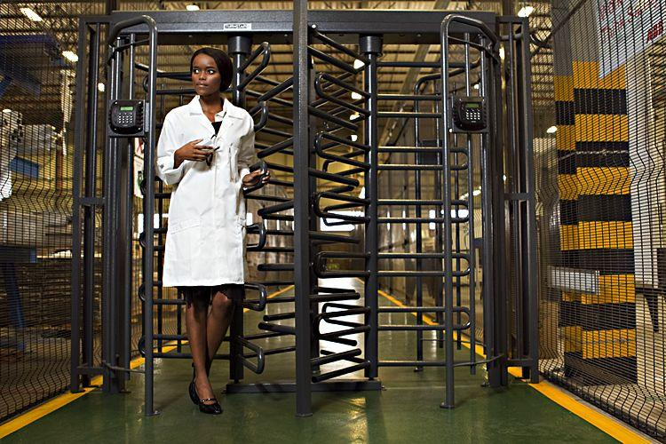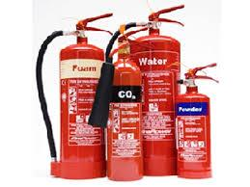

6.0 Our Products and Strategic Alliances
We are an independent supplier so have a range of manufacturers to choose from, this ensures you get the best products, but also the most cost effective solution available. Our core business lies in the supply, installation and distribution of high-quality, affordable generic gadgets. We offer approximately 500 generic products nationwide. We aim to be one of leading providers of differentiated, value-added products, including state-of-the-art technology from world known manufacturers’. Below are some of the manufacturers’ we have strategic alliance with:-
Honeywell
Honeywell is a leading global manufacturer of security and automation solutions for residential and commercial applications. From intrusion, fire and home automation systems, to the latest in IP video and access control, we are focused on technologies that create “connected homes” and “connected buildings.”
Axis 
Axis is the world-leading provider of network video solutions for professional installations. The products have considerable growth potential based on the ongoing technology shift from analog surveillance systems to network video solutions.

Sensor access Sensor access is one of the UK’S leading manufacturers of integrated access range of readers, controllers and software systems. As an independent company we are able to offer excellent pre-sales and after-sales service and have a wealth of experience within the industry.
Paxton Access
Paxton Access Ltd is a leading manufacturer of electronic access control systems. From its inception Paxton has aimed for engineering excellence. This means designing and manufacturing intelligent and innovative products that are fit for their purpose.
C-TEC
C-TEC is a leading UK independent manufacturer of quality life safety electronic equipment with a portfolio of products that includes fire alarm control panels, fire detectors, voice alarm systems, power supplies, disabled refuge systems, nursecall systems and audio-frequency induction loop systems.
Turnstar
Turnstar is Africa’s largest manufacturer of secure physical access control products, offering a host of solutions, ranging from turnstiles and revolving doors to vehicle barriers and boom gates.
7.0 Why Funmetric?
Adherence to standards: We adhere to the worldwide technical concepts such as: Open architecture because we believe that the software and data are one of the most valuable assets to our customers, thus changing the hardware should not affect the software application.
Reliability: Our proven reliability means that you can count on us to continue deliver our services no matter what the circumstances. Also, we deliver positive, rapid and the best return on investment.
Punctuality: We take into consideration the importance of meeting deadlines; our projects are delivered on or before the due date.
Highly Qualified Staff: Our staffs are given extensive training and they are trained on state-of-the-art of modern technique and support. Our staffs are committed, dynamic character, innovation and acceleration in learning.
Sustainability: Through minimising maintenance and support requirements by providing you with sustainable solutions.

8.0 Our Value added
S/N | YOUR EXPECTATION | OUR PROPOSITION
1 | Promptly deploy the required solutions and Provide robust & excellent support | Our Support Strategy ensures that we attend to our clients’ support issues within record times.
2 | Have a track record of performance anchored on integrity & deliverable. | Our team is well experience and having taking part in several projects
3 | Provide warranties and maintain of equipment and Spares | We have unparallel commitment to the functionality of our Installations which are backed with 2 years OEMs warranties. Our reservation policy ensures that WE GET YOU GOING before faulty equipment is repaired or replaced.
4 | Maintain strong Alliances and robust supply chain contacts. | We maintain Alliances with Leading world manufacturers in IT, security & safety Industry worldwide. We leverage such alliances for technical supports, supply chain & emerging Technologies. We have thus acquired extensive expertise in security and information technology.
5 | Value Added | We offer BOT (Build, Operate &Transfer) as strategic options for project financing and ownership. We offer flexible payment terms and leasing options for our installations. Our High Level Security/IT Audit is conducted using Specialized Tools at moderate charges.
6 | Total Cost of Ownership (TCO) | We offer lowest total-cost-of-ownership. We help our customers maximize production uptime and minimise operating cost of key security equipments.

Contact us today on:
Tel: +234-8102664987. E-mail: funmetrictech@yahoo.com, Website: www.funmetric.com.ng

