

22/06/2018
The Head Purchasing,
Faith Tabernacle,
Living Faith Church,
Canaan land,
Ota, Ogun State.

Dear Sir,
LETTER OF INTRODUCTION
We hereby wish to formally introduce the company WILFEL CRYSTAL VENTURES to your organization.
The company WILFEL CRYSTAL VENTURES is into the supply of assorted types of toiletries and general merchandise as may be required by our client.
Our commitment is built on integrity of service, favorable competitive prices in line with quality products to our deserving clients
We look forward to render sincere, cost effective, competitive and high value adding services to your organization, thereby increasing your productivity and impact to our present world.
Yours sincerely,
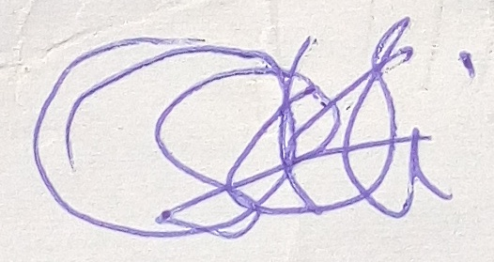
Happiness F. Williams (Mrs)
CEO - Wilfel Crystal Ventures
+234-805-9295-089, +234-817-9610-905

