OGO OLUWA FREELANCE VENTURES

***Specializes In Contract, Project Supervision and General Merchandise***

**Km 7 Idiroko Expressway, Davol Bus-Stop Iyana Iyesi Ota Ogun State.**

**Phone: +234-8023589523,+234-8173865772**

20th September, 2018.

Dear Sir,

**LETTER OF INTRODUCTION**

We are pleased to introduce our company ***OGO OLUWA FREELANCE VENTURES*** to the services of your establishment.

The general nature of our business is:

1. Sales and services of computers and allied products.
2. Supply of consumables such as toner, inks e.t.c.
3. General sales and supplying of ICT and electronics materials
4. Supplies of stationeries
5. General merchandise.

***OGO OLUWA FREELANCE VENTURES*** has a unique business orientation with a mindset for customer satisfaction with integrity to match.

We therefore seek a relationship with your organization which we believe shall be a mutual benefit.

We shall be grateful, if we are given favorable consideration.

Thanks in anticipation.

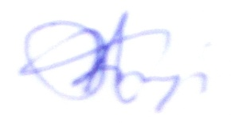

**Adebiyi Abraham**

*For:* ***Ogo Oluwa Freelance Ventures***

**DIRECTORS/ STAFF STRENGTH**

My name is **Adebiyi Abraham**; I am the CEO of ***OGO OLUWA FREELANCE VENTURES*** .Our Company is blessed with quality human capital as a major boost to our quality service delivery.

We also enjoy collaboration of consultants and experts for technical supports towards our quest for quality service delivery.

The teams that made up our work force are formidable and excellent in the discharge of our duties and responsibilities.

I am confident about the capacity and capability of our workforce to produce satisfaction and quality service delivery anywhere we find ourselves.

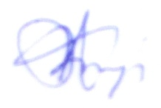

**Adebiyi Abraham**

*For:* ***Ogo Oluwa Freelance Ventures.***

08023589523

|  |
| --- |
| **OGO OLUWA FREELANCE VENTURES.**  **Corporate Address:Micolaf Club House, Plot 5A Block 7, Pipe-Line B/Stop, Aboru Road Iyana Ipaja Lagos.**  **Contact Address: Ogo Oluwa Shop KM 7 Idiroko Road Davo B/Stop Ota, Ogun State Tel: 08023589523**  The General Nature Of Our  Business Are:  Sales and services of computers and allied products  Supplier of consumables such as toner, inks, etc.  General supplying of ICT materials, Stationeries and  General merchandise |