

**12th SEPTEMBER, 2018.**

**THE PURCHASING OFFICE**

**FAITH TABERNACLE**

**CANAANLAND,**

**OTA.**

DEAR SIR,

**LETTER OF INTRODUCTION**

I wish to introduce our company **CHALCEDONY INTERNATIONAL LIMITED** to your kind organization.

**CHALCEDONY INTERNATIONAL LIMITED** is registered with **Corporate Affair Commission (CAC)** in May 1998 with **RC NO 333,783** to carry out business of **Electrical/Electronics, Telecommunication and Security Surveillance System** job.

We look forward to doing business with your kind organization soonest.

Thanks.

Yours Faithfully;

For: **CHALCEDONY INTERNATIONAL LTD**

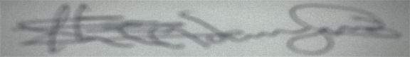

**ADEMUYIWA CLEMENT**

**MANAGING DIRECTOR**

***189, IGBOSERE RD, LAGOS ISLAND, LAGOS.***

***5/7, DOMINION STREET, BENJA, OTA. OGUN STATE.***

[***TEL:+2348023177113***](TEL:+2348023177113)***, +2348095295144. EMAIL: chalcedonyng@gmail.com***