oo PAID ON RCR NO. 297265 OF 31/3/03 CERT. NO. LAZ. 129755 OF

CORPORATE AFFAIRS COMMISSION

(Established under the Companies and Allied Matters Decree 1, 1990)

AREA 11, GARKI ABUJA

 Form 2

With the exception ofsignature please type or write information in Block Capital Letters 

2314t

THE COMPANIES AND ALLIED MATTERS DECREE 1990

FORM OFAPPUCATIONFORREGISTR4770NOFA BUSINESS

(FOR USEBYWDIWDUALS)

1. The business name (ifthe business is carried on under two or more_business names, each ofthose namesshould be state

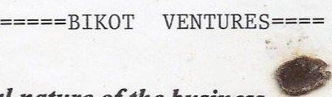

1. The general nature ofthe business.

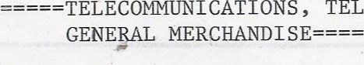TELEPHONINGS , CYBERCAFE ; BUSINESS OFFICE,

1. Thefull address ofthe principal place ofbusiness.

136A AKOWONJO ROAD, ANIMASHAUN BUS STOP, AKOWONJO ,

1. Thefull address ofeach branch.

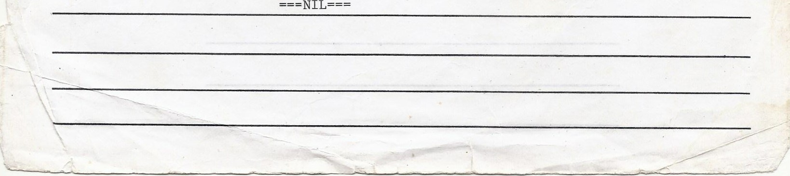

|  |  |  |  |  |
| --- | --- | --- | --- | --- |
| __The present forenames and surname  (e) | Any former forenames or surname  (f) | The nationality (g) | Any former nationality (h) | The age |
| AFOLABI ABOSEDE ADIJAT | NEE BAKARE | NIGERIAN | NIL | ADULT |

MRS

31/3/03

* + 1. The date of commencement of the business
    2. To be completed only by an individual carrying on business on behalf of another individual whether as

m.lstee or nominee.

 The following particulars in respect of each individual on whose behalf the business is carried on:-

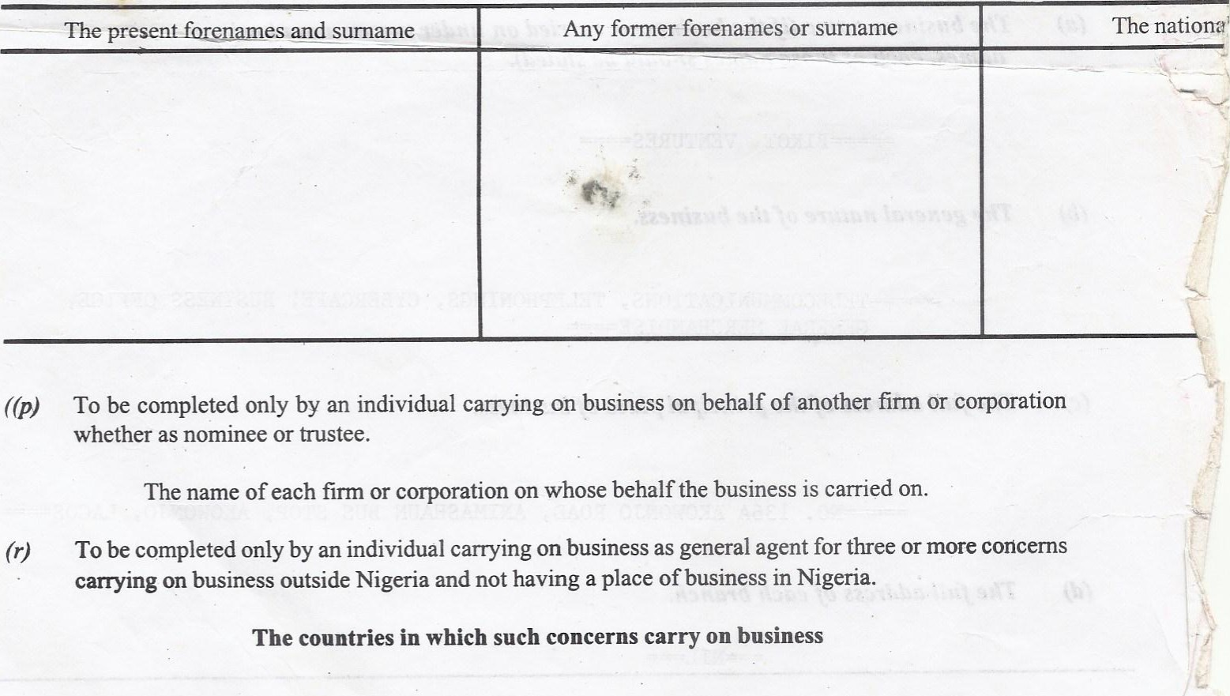((p) To be completed only by an individual carrying on business on behalf of another firm or corporation whether as nominee or trustee.

The name of each firm or corporation on whose behalf the business is carried on.

* 1. To be completed only by an individual carrying on business as general agent for three or more concerns carrying on business outside Nigeria and not having a place of business in Nigeria. The countries in which such concerns carry on business

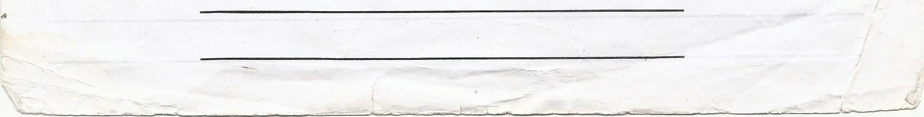

* 1. I hereby certify that the foregoing particulars are, to the best of my knowledge and belief, correct and I undertake to notify the Business Names whenever any change is made or occurs in any of them other than the age Of the individual.

(SCD) AFOLABI ABOSEDE ADIJAT

Signature ofperson registering