T A O Systems

COMPANY PROFILE

CONTENT

* THE COMPANY
* KEY PERSONNEL
* PROJECT LIST



**THE COMPANY**

**T A O Systems**is a specialised electrical engineering Contracting/Services Company primarily into Fire Training and Design, Sales, Installation and Maintenance of the under mentioned systems.

## PRODUCTS AND SERVICES

## Security Design, supply, installation and maintenance

## of various Security systems including CCTV, Burglar Alarm Systems, Access Control, X-ray Scanning Machines, Security Doors, Strong Room Doors and Safes

## Fire Prevention Supply of Equipment and Installation for water

## Sprinkler, Fire Alarm Systems, Fire Extinguishers and Gaseous Extinguishing Systems (FM 200).Also fire training.

## Telecommunication Supply and Installation of Voice & Data,

## Public Address and PABX Systems

**MAINTENANCE**

Periodic Maintenance and System Monitoring Service are also provided by **T A O Systems** on all types of equipment as we are in constant touch with manufacturers and opens to full technical supports when required.



**KEY PERSONNEL**

**Timothy Oyediran (Head, Operations)**

Mr. Oyediran is a graduate of ObafemiAwolowo University, Ile-Ife. His experience has ranged through sales, management, administration and operations. He had undergone various related professional trainings. He has served as Admin and Support Services Officer at Industrial Mercantile and Investment Limited, and also served as Admin/Operations Manager atA.C. Mainline Limited, among others.

**Akosile JacobAdepoju – (Head, Technical Services)**

Mr. Akosile is a 1997 graduate of Electrical & Electronics Engineering from the famous Yaba College of Technology and had a Post Graduate Diploma in Information Technology from Federal University of Technology, Owerri.

Amongst others, he had worked as a Project Engineer at Omecon Integrated Engineering Services, Oshodi.

.

**Usman, Hammed Oluwashola – (Consultant & Head of Training)**

Mr. Usman (GIFireE, ANISP) is a safety and health professional with many years of experience.He had undergone various related academic and professional training – local and foreign and a member of various professional organisation/body. He had worked with Federal Fire Service, Nigeria as an instructor for not less than ten years.

**AkeemRasaq – (Supervisor, Technical)**

Mr. Rasaq has undergone several local and international trainings in the course of his career with many years of experience as a technical person in this business line. He worked with Safequip Limited before joining this team.

**KunleOyewole- (Accounts and Investment)**

Mr.Oyewole is a graduate of Accountancy from OlabisiOnabanjo University, Ago Iwoye, and an associate of Chartered Institute of Accountants (ACA). He had acquired several years of professional work experiences.

**The above persons are supported by various technical and administrative staff in the dispensation of their duties.**

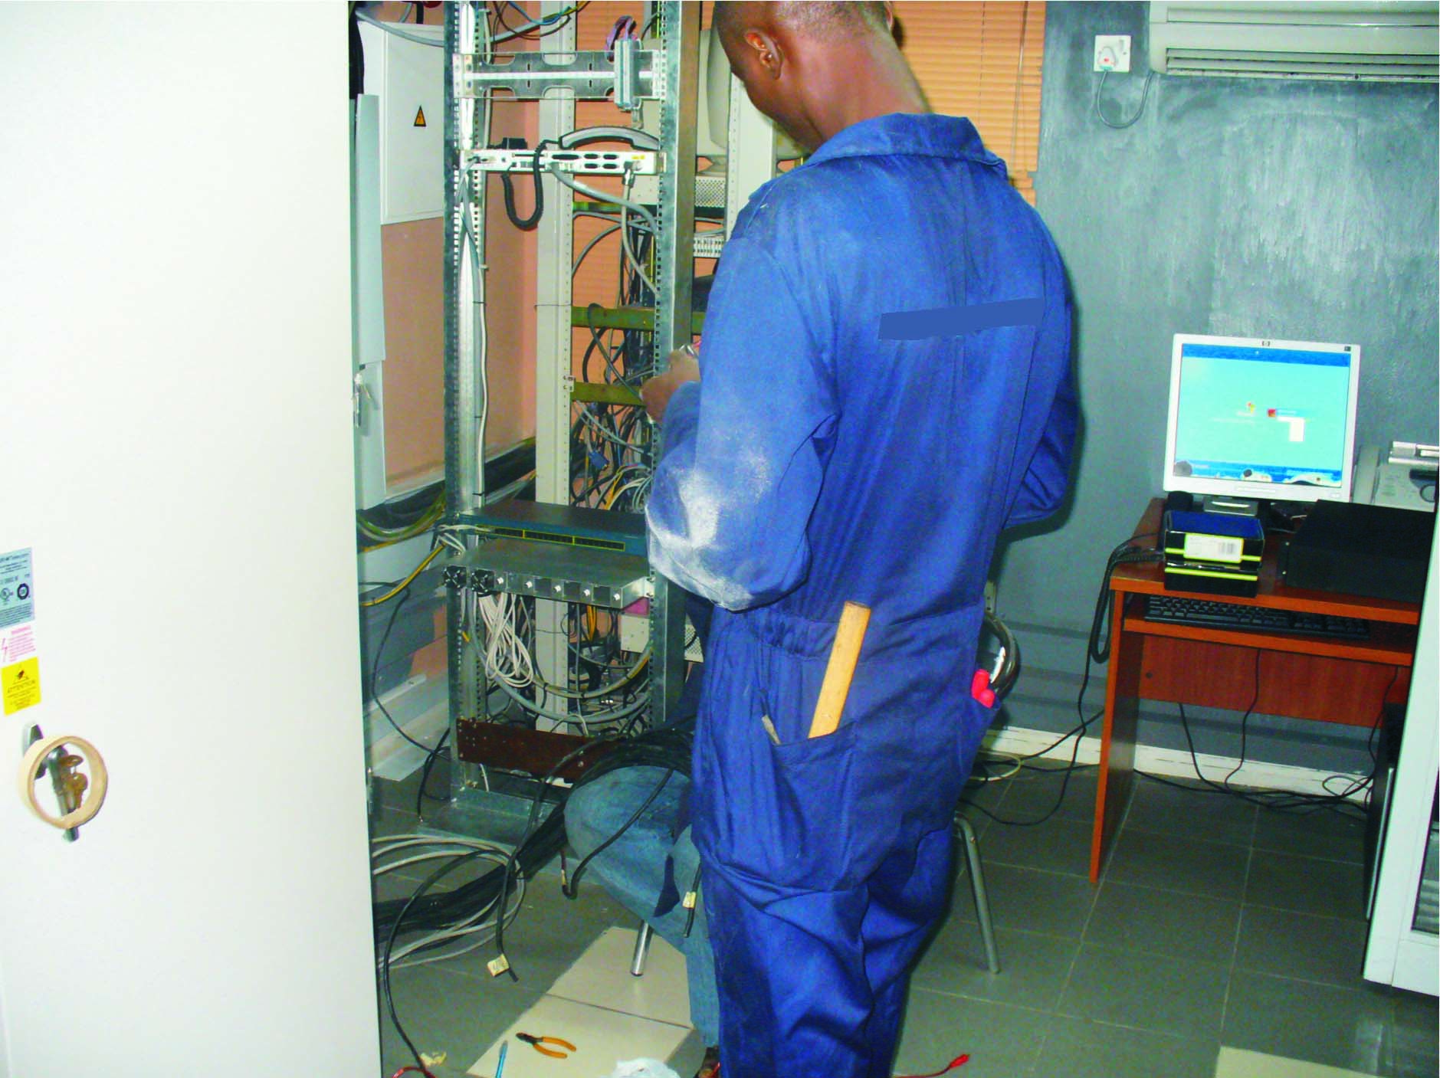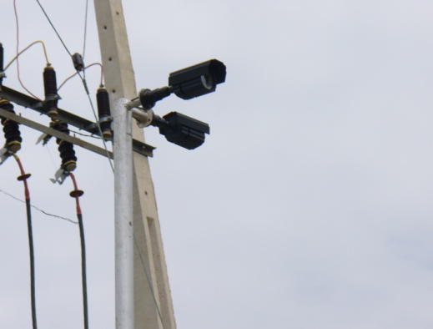

**PROJECTS**

Amongst others, please find below some executed projects list.

**CLIENT PROJECT CONTRACTOR**

|  |  |  |
| --- | --- | --- |
| FCMB Plc (Took the job with A.C Mainline Ltd, former Company name) | Installation of Vault Doors at FCMB Plaza, Marina, Lagos. | Cappa and Dalberto  Contact:EzeCgigozie 08036706634 |
| FCMB Plc | CCTV, Fire Alarm Supply ,installation &maintenenance at various branches | By Client |
| Kwara State Government | Installation of Security, Fire Prevention and Communication System at Press Pavillion , Ilorin. | Godab Nigeria Limited |
| Kwara State Government | Installation of Securityand Fire Prevention Systems at Governor’s Residence, Ilorin. | Godab Nigeria Limited |
| Shell Nig Closed Pension Fund Administrator Ltd. | Supply and Installation of Video Entry System, Ikoyi. | PROVAST Limited |
| CONSOL Limited | Supply & Installation of CCTV, Fire Alarm/Fire Extinguisher and Training | By Client |
| PIL Limited | Supply & installation of Battery Operated Smoke Detectors and Fire Extinguishers. | By Client.  Contact: Abigael 08035812188 |
| TV Continental | New Studio Project: Installation of Fire Alarm, CCTV, Access Control, Voice & Data, PA System | Mayfield Engineering, (Technoton Ltd as Electrical Contractor)  Contact: AuduDin’gan 08033298221 |
| Consult Ventures Limited | Fire Training | By Client  Contact: Mr. Lamija 08053091788 |
| TV Continental | Installation of Fire Extinguishers at the New Studio building | Technoton Limited  Contact: AuduDin’gan 08033298221 |
| Consat Television | Supply & Installation of fire sensors & fire extinguishers | By Client  Contact: TitiAdekoya 08102510659 |
| Redline Logistics Ltd | Servicing of Fire Extinguishers | By Client  Contact: AkeemAkinola 08066304835 |
| Rausty Brown Enterprises | Supply & Installation of Extinguishers/servicing | By Client  Contact: Mr. Ekpo 08067909591 |
| TECHNO OIL LTD | Installation & Maintenance of Fire Alarm System | By Client |