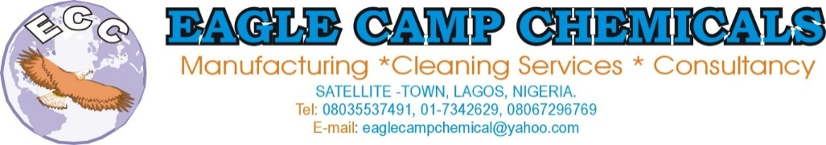

EAGLE CAMP CHEMICALS LTD.

**Manufacturing, Cleaning Services, Fumigation & Pest Control, Procurement & Support Services**

Suit D, Litigo Plaza, Alakija Satellite Town, Lagos

***Email:*** [eaglecampchemical@yahoo.com](mailto:eaglecampchemical@yahoo.com), [eaglekleaners@gmail.com](mailto:eaglekleaners@gmail.com)

***Tel:*** ***08170402274, 08027760173***

22nd November, 2018

Head of Procurement,

Living Faith Church,

Canaan Land,

Ota.

Dear Sir,

**LETTER OF INTRODUCTION / PROPOSAL FOR SUPPLY OF CLEANING / HOUSE KEEPING CHEMICALS AND MOBILE TOILET TREATMENT**

With respect to the above subject, we hereby introduce our company & services to your organization.

EAGLE CAMP CHEMICALS is an independent manufacturing company which produces cleaning/house-keeping chemicals such as mobile toilet treatment, multipurpose liquid detergent, degreaser; tiles/ceramics stain remover, glass cleaner, bleach/fabric stain remover, liquid hand wash, liquid air fresheners, germicide, disinfectants etc.

Also we are very pleased to present this proposal. The objective of this document is to propose our solution in the context of our capabilities, experience and sincerity. In a quest to support a clean and hygienic environment and enhance the quality of life.

EAGLE CAMP CHEMICALS over the years have been actively involved in the chemical sector of Nigerian economy, rendering effective services, satisfying our clients need for chemicals, guaranteeing peace of mind.

Please note that we are willing to supply good chemicals on call.

**OUR CORE ACTIVITIES**

1. Manufacturing of chemical products
2. Sourcing and importation of chemical products
3. General Cleaning Services
4. Mobile Toilet Treatment, Sanitary Services
5. Fumigation & Pest Control Services
6. Procurement and support services
7. Consultancy Services

**OUR PRODUCTS**

Our products include the following:

1. **Rose of Sharon Air Freshener** – Is an advance liquid air freshener meant to use without limitations on area of application which induces fresh, dry and cool ventilation, with a powerful - sustainable fragrance with anti-bacteria effect for offices, hotels, hospitals, living rooms, toilets, reception, churches, car etc.
2. **Rose of Sharon Liquid detergent** – A cleaning & washing solution, specially formulated blend of cold wash detergent for multipurpose washing of fabric, cars, fine & delicate – silky materials, kitchen wares etc.
3. **ECC Germicide** – Helps to prevent infection by killing disease-causing bacteria, and germs quickly
4. **ECC Bleach (fabric stain removal)** – for removing organic and inorganic stains from fabric, both white and colorless materials, living it brighter.
5. **ECC Tile Stripper (Ceramic Stain Removal)** – For cleaning sinks, toilets, tile floors, ceramics etc.
6. **ECC Disinfectant (ECCTOL)** – Helps to prevent infections by killing disease causing bacteria and germs quickly.
7. **ECC Glass Cleaner** – Effectively cleans and removes all stains on glass and makes it shine.
8. **ECC Degreases** – Ideal for cleaning oil spillage, grease deposits and oil dirt. Etc.
9. **Mobile Toilet Sanitary Services for your events.**

**PACKAGING**

**LITRES QUANTITY PRICE (N) PRODUCTS**

4 lit 4 x 4 (in a carton) 7,000 Germicide (Izal)

500mls 500mls x 24 (in a carton) 4,800 Liquid Air Freshener

300mls 300mlsx12 (in a carton) 3,200 Liquid Air Freshener

(improved)

4 lit 4 x 4 (in a carton) 8,000 Liquid Soap

See price list behind for the other products.

**OUR CLIENTS**

* Sunfit Amuwo Odofin, Lagos
* Golden Tulip Hotel, Airport Road, Lagos
* Rock view Hotels, Festac Town, Lagos
* Living Faith Church, Cannan Land
* Rita Lori Hotels, Surulere, Lagos
* Klassic Maintenance
* Benny Hotels, Festac
* Radiance School
* Sadacruz Hotels, Abuja
* Ibis Royale, Airport Road, Lagos
* Elite Events Centre and Suites, Ojo, Lagos
* D Boss Hotels, Ajao, Lagos
* Etc

**OUR EDGE**

* Friendly and Reliable
* Very Quick Response
* 24 Hour Service
* Very flexible
* Excellent Reference
* Effective Quality Control

We look forward to partnering with you in satisfying your chemical needs, keeping your environment refreshingly clean and healthy all the time.

Please call us to further explanation if need be and present our product samples, if you so wish.

Yours faithfully,

**EAGLE CAMP CHEMICALS**

………………………

**David Akutebo**

***C.E.O.***

08035537491