**LIMITED**

**SUPPLIER, CIVIL AND GENERAL MERCHANDISE**

**12, Abikoye Street, Mosafejo, Amukoko, Lagos.**

**Phone: 08050995587**

23rd November, 2018.

The Manager,

Purchasing Department,

Living Faith Church,

KLM 10, Idiroko Road,

Sango Ota,

Ogun State.

Dear Sir,

**LETTER OF INTRODUCTION**

Qualitech Global Concept Limited with due respect to you and the office, sir we wish to apply as a vendor/supply of Electrical and Building Materials needs to the church.

God bless you sir for your consideration and cooperate sir.

Yours Faithfully.

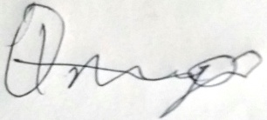

_____________________

**For: Qualitech**