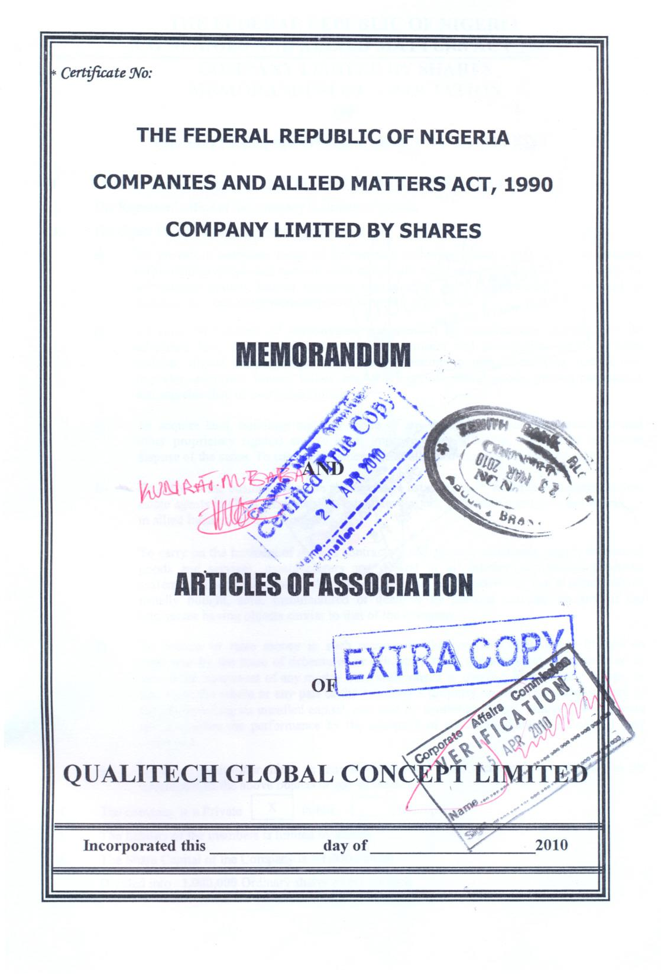*:*

2010





