PROFILES

BUSINESS NAME:

**BN 2570861**

COVENANT JOY BLESSED ENTERPRISE

**CORE BUSINESS:**

* **SUPPLY AND DISTRIBUTION OF STATIONARIES AND HOUSE KEEPING MATERIALS**

**ADDRESS NO: 1, AJARATU SANI STREET, AKITAN ROAD, AGBELEKALE, ABULE EGBA, LAGOS STATE.**

**EMAIL:** [**JOYSEYI2015@GMAIL.COM**](mailto:JOYSEYI2015@GMAIL.COM)

**TEL: 08051577744**

COMPANY PROFILE

**INTRODUCTION**

C

OVENANT JOY BLESSED ENTERPRISE: Is A Company Found And Managed highly skilled professionals to meet the demand of products, designs, supervision and management of generals supplies nationwide.

We are always mindful of the fact that the decision to invest in our project is an important first step functionality, operationally, efficiency, durability increased revenue and good returns on investment are the ultimate goals.

**OUR VISION**

Nurture a winning network of customers and suppliers, together we create mutual , enduring value

**OUR MISSION**

Covenant joy blessed enterprises offer our customer the best possible service, solution, quality and value.

**COVENANT JOY BLESSED ENTERPRISES**

COMPANY PROFILE

CORE VALUE

Leadership – the courage to shape the better future

Collaboration – leverage collective genius

Integrity - be real

Accountability – if it is to be, it`s up to me

Passion – committed in heart and mind

Diversity – as inclusive as our brand

Quality – what we do, we do well

**OUR STRENGTH**

Our strength lies in the areas of attention to detail a sense of urgency and commitment.

**COVENANT JOY BLESSED ENTERPRISE** **3**

COMPANY PROFILE

WHAT WE DO

**Supplies of office stationery**

We supply organizations with

- Printing papers - Highlighters

- Flash disks - Labels

- Files - Letter trays

- Photocopying papers - Markers

- Writing, Legal Pads - Paper Punches

- Short hand notebooks - Pens

- Envelopes - Post it notes

- Packing & masking tape - Rubber Band

- Folders - Tacks Push pins

- Glue - Paper clips



**4** **COVENANT JOY BLESSED ENTERPRISE**

COMPANY PROFILE

**WE SUPPLY HOUSE KEEPING MATERIALS**

* DUST COB WITH STICK
* ROUND MOP WITH STICK
* DUST PAN WITH BROOM
* MOP WITH STICK
* DRY MOP
* TOILET BRUSH WITH CUP
* FLOOR WIPER
* PLASTIC BOWL
* DUSTBIN BASKET
* NEPTHALYENE BALLS
* HARD BRUSH

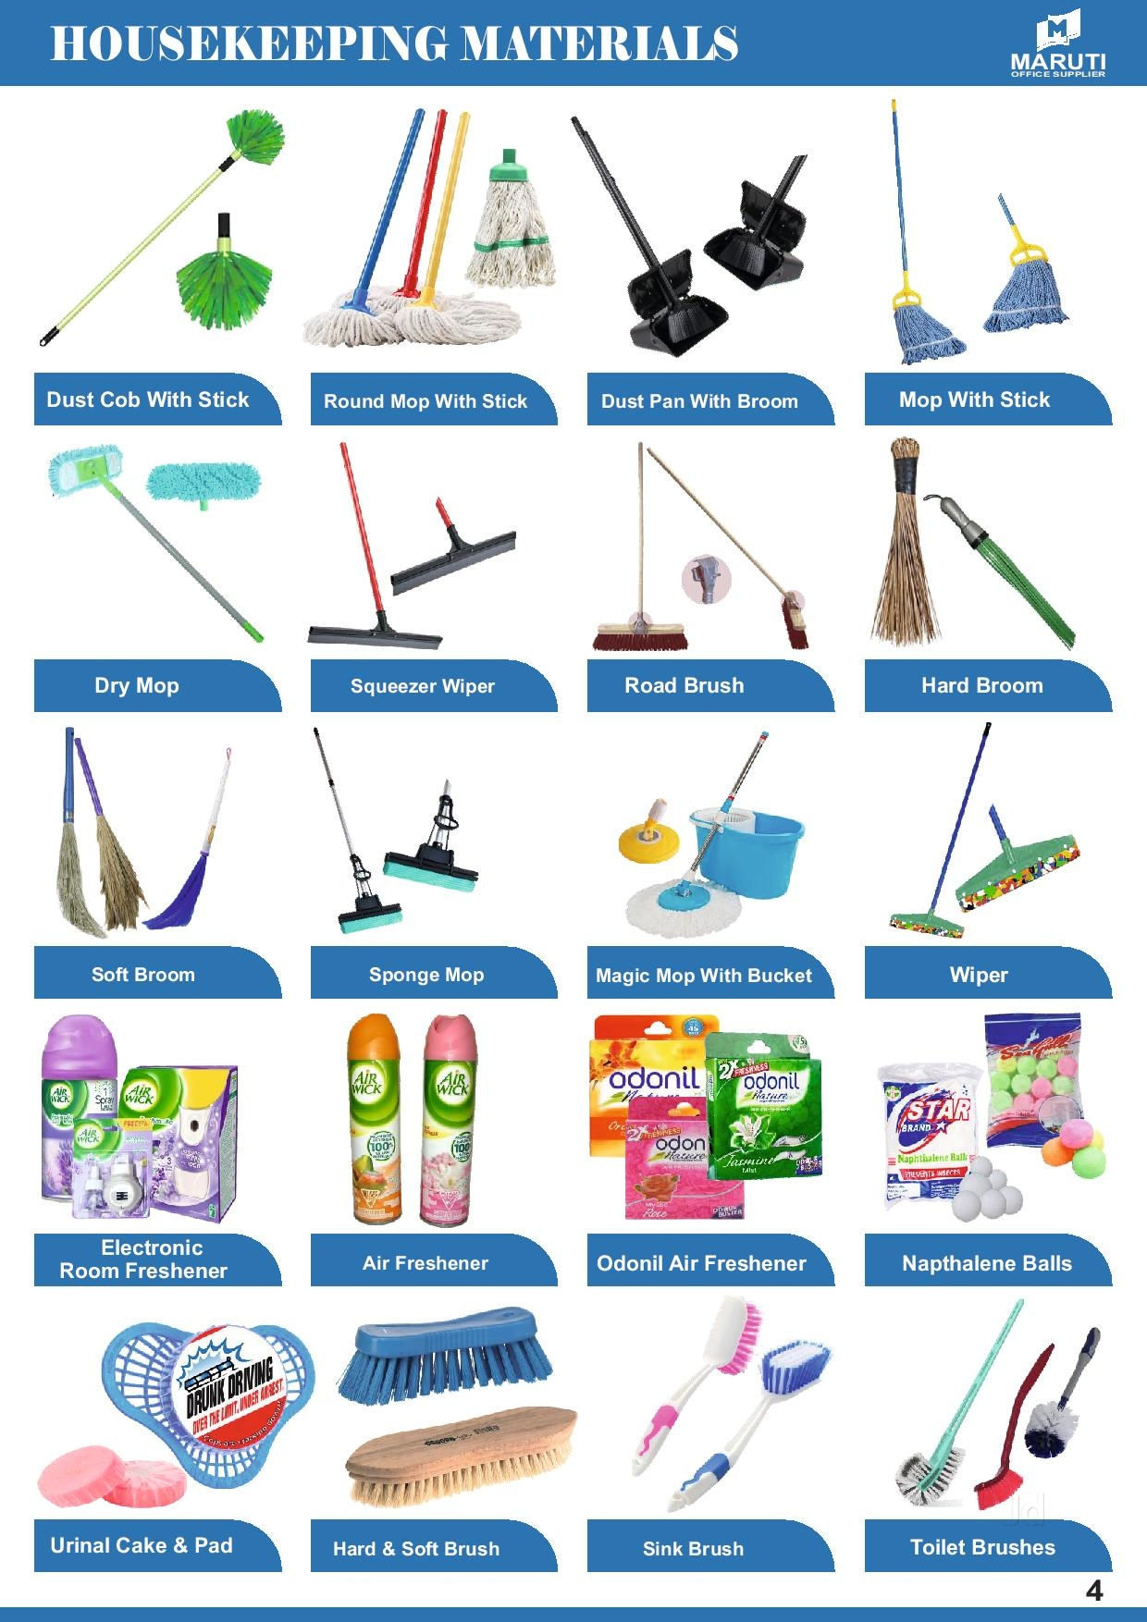

**6** **COVENANT JOY BLESSED ENTERPRISE**

COMPANY PROFILE

**COVENANT JOY BLESSED ENTERPRISE** **7**