**Assignment # 2**

**Hafeez Ullah  
SN: S368783**

**Introduction:**

In this report, I’m going to share how I went about creating the "Guess the Number" game. I'll explain what I aimed for and what I needed to make it happen. Also, I'll explain about the tool I used to ensure everything worked fine.

**Setting Goals and Figuring Out What I Needed:**

My first goal was to design a game where people could guess a special number. I wanted this game to be easy to play and understand. To achieve this, I needed to follow some steps and have the right tools.

**Meet the Automated Unit Testing Tool:**

I had this tool that acted like an assistant. It helped me double-check my game and find any mistakes. It's called an "**automated unit testing tool.**" This tool was like my game's personal inspector, making sure everything worked as it should.

**Process:**

I created the "Guess the Number" game step by step, using an approach called Test-Driven Development (TDD). Here's how I did it:

**Planning Tests:** Before writing the game, I made a plan by writing tests. Tests are like instructions that show what the game should do.

**Knowing What to Expect:** In my tests, I said what I expect the game to do. For example, one test said the random number should have four digits.

**Trying the Tests:** I used a tool called unittest to run the tests. When I ran the tests, they didn't work at first because I hadn't written the game code yet.

**Writing Game Code:** I started writing the game code so that the tests would start working. For instance, I wrote code to create a random four-digit number.

**Testing and Coding Again:** I kept repeating the process. I wrote tests, ran them, and then wrote code to match the tests. This helped me build the game step by step.

**Using the Automated Unit Testing Tool (unittest):**

I used a tool called unittest to test the game automatically:

**Creating Tests:** I made a special place for my tests called TestGuessTheNumber. Each test checked a different part of the game, like guessing and generating numbers.

Checking with Assertions: In my tests, I used special words like self.assertTrue and self.assertEqual to check if the game does what it's supposed to. For example, self.assertTrue(number.isdigit()) checked if the number was made of digits.

**Running All Tests Together:** I used unittest.main() to run all the tests together. This helped me see if the game worked well in different parts.

**Getting Feedback:** unittest told me if my tests passed or not. If a test didn't pass, I knew I had to fix something in the game code.

**Screenshots:**

**Pylint:**

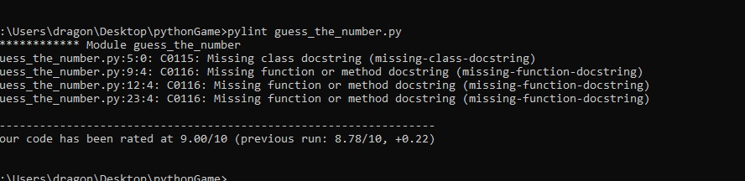

**Flake8:**

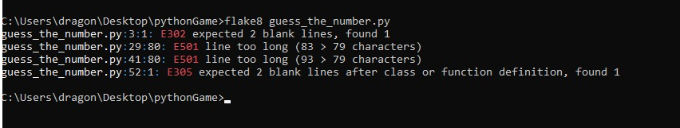

**UnitTest:**

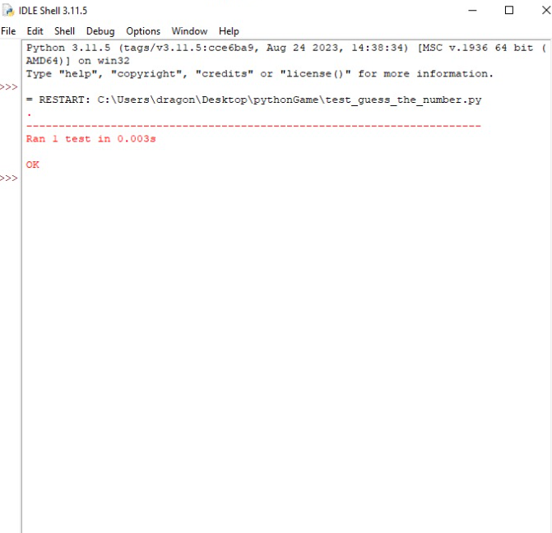

**Main Code:**

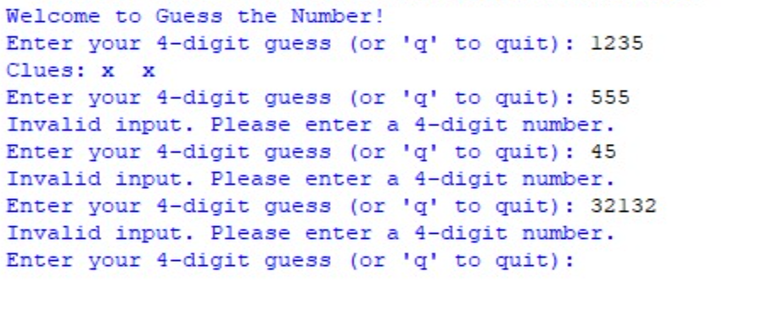

**Conclusion:**

**What Went Well:** I made the "Guess the Number" game. This helped me plan and catch mistakes early. I used a tool named unittest to check if my game worked as planned.

**Room for Improvement:** Practicing and trying out new things will help me create cooler games in the future.

**Making it Even Better:** To improve, I can ask my friends to look at my game and give me ideas. Also, learning more about coding.

You can check out my full report and the coding on GitHub by following this link: GitHub Link Here.

There you'll find everything I've talked about in this report.

<https://github.com/hafeezullah125/PYthonAssignment.git>

**=========================END==================**