Geospatial analysis of Oktibbeha County of Mississippi, USA

Hafez Ahmad1 & Your Name1,2

1 Mississippi State University

2 Mississippi State University

Author note

This is solely made for My Graduate ‘Spring2022,WFA 8993 Special Topic: R for Managing Wildlife and Fisheries Data’ class for developing Reproducible Research Article using R markdown package.

The authors made the following contributions. Hafez Ahmad: Conceptualization, Writing - Original Draft Preparation, Writing - Review & Editing; Your Name: Writing - Review & Editing.

Correspondence concerning this article should be addressed to Hafez Ahmad, College of Forest Resources,Mississippi State, MS 39762. E-mail: [ha626@msstate.edu](mailto:ha626@msstate.edu)

Abstract

The Landsat satellite imageries have been analyzed for the vegetation monitoring and estimation of land use from 2020 to 2022 along with land surface temperature and precipitation in Oktiheba county, Mississippi.

*Keywords:* Rmarkdown,GIS,Remote sensing,NDVI, Land use

*Word count:* X

Geospatial analysis of Oktibbeha County of Mississippi, USA

# 1 Introduction

Monitoring vegetation over time is an essential component of geographical resource management applications. On-site monitoring is frequently carried out by taking detailed measurements, such as canopy level measurements. In situ measurements are time-consuming, labor-intensive, and difficult to carry out over large geographic areas. Remote sensing, on the other hand, is a very viable option for monitoring numerous vegetation characteristics using various vegetation indices such as Normalized Difference Vegetation Index, Near-Infrared / Red Ratio, Soil and atmospherically resistant vegetation index (Im & Jensen, 2008). The natural and anthropogenic features found on the Earth’s surface are referred to as land cover. Examples include deciduous forests, wetlands, developed/built up areas, grasslands, and water. Land use, on the other hand, describes the activities that take place on the land and indicates the current use of the land. Examples include residential homes, shopping centers, tree nurseries, state parks, and reservoirs. Land cover and land use are frequently studied together in remote sensing studies because satellite imagery and aerial photography can identify land cover, but inferring land use often requires more knowledge of the study region, so a compromise is sometimes made between identifying the variable of interest and inferring land use (Fonji & Taff, 2014).

Local and place-specific global climate change (LULCC) is a type of global climate change, and these changes add up to global climate change. These changes, in turn, have an impact on other components of our earth-atmosphere system, frequently leading to negative outcomes such as biodiversity loss, desertification, and climate change. Several methods exist for tracking or detecting changes in land cover over time. Previously, researchers mapped LULCC over smaller areas using field data and aerial photographs. Because satellite images can cover large geographic areas and have a long temporal coverage, remote sensing is an excellent tool for studying LULCC (Jensen, 1986 ; Berlanga-Robles & Ruiz-Luna, 2002).

Oktibbeha County experiences the hottest temperatures in July with an average high of C.

In this mini paper, the **objectives** are (a) to present results of an analysis of the land surface temperature and precipitation data, (b) to quantify normalized vegetation index for three years and estimate the land use /land cover, (c) to determine the relationship between vegetation and land use.

# 2 Methods and Materials

## 2.1 Study area

Oktibbeha County is a micropolitan county in east-central Mississippi that is home to Starkville city and Mississippi State University. The county is located within Mississippi’s golden triangle region. The name of the county is derived from a Native American term that means “bloody water” or “icy creek” (Gannett, 1902). According to the 2020 United States Census, the county had 51,788 people, 17,798 households, and 9,263 families.

## 2.2 Data collection

Landsat8 imageries (land 8-9 OLI /tirs c2 l1 ) from 2020 to 2022 for February and June with less than 10% cloud were downloaded from USGS earth explorer[<https://earthexplorer.usgs.gov/>]. Moreover, eight-day composite of Precipitation data from 2000 to 2022 was part of “GPM: Monthly Global Precipitation Measurement (GPM)” . Furthermore, Land Surface Temperature was part of “MOD11A2.006 Terra Land Surface Temperature and Emissivity 8-Day Global 1km” . Then Precipitation and land surface temperature data were clipped with the study area. Then they are converted comma separated format for further analysis.

## 2.3 NDVI calculation

For the vegetation analysis, we used Normalized Difference Vegetation Index (NDVI).NDVI is a dimensionless index that depicts the difference between the reflectance of vegetation in the visible and near-infrared spectrum.It can be used to assess changes in plant health and vegetation density (Tucker et al., 2001). An NDVI is calculated as a ratio of the red (R) value and the near-infrared (NIR) value. It ranges from -1.0 to 1.0, mainly representing greens, where negative values are mainly made up of clouds, snow, and water, and values close to zero are primarily made up of rocks and bare soil. A very low NDVI value (0.1 or less) corresponds to empty areas of rocks, sand, or snow. Moderate values (between 0.2 and 0.3) represent shrubs and meadows, while large values (between 0.6 and 0.8) indicate temperate and tropical forests.

for the Landsat 8, the formula is given

Band 5– reflection in the near-infrared spectrum Band 4 – reflection in the red range of the spectrum

## 2.4 Correlation analysis

Correlation analysis is a statistical method used to examine the relationship between two or more variables. The correlation coefficients range between -1 and 1. 0 indicates no relationship between variables, -1 indicates negative, and +1 indicates positive correlation. The equation of Correlation Coefficient is given below.

## 2.5 Land surface temperature and precipitation data analysis

## 2.6 Landsate satellite imageries preprocessing

Landsat sensors capture reflected energy and store data as 8-bit digital numbers (DNs). USGS data includes metadata. The first step is to convert DN to radiance and then radiance to top of reflectance by using provided metadata.

### 2.6.1 Radiometric calibration and Atmospheric Correction.

#### 2.6.1.1 Conversion DN values to spectral radiance.

#### 2.6.1.2 Conversion of spectral radiance to reflectance.

# 3 Results

## 3.1 Mapping

## 3.2 Land surface temperature and precipitation

## 3.3 precipiation works

Throughout the year, the average land surface temperature (LST) ranges from 9 to 28 . January has the coldest LST at 9.16 , and July has the hottest LST at 28.55. According to data recorded between 2010 and 2022, January and December experienced the lowest LST, ranging from -0.5 to -0.3, whereas August and June experienced higher LST, ranging from 35.5 to 33.77 (see table 1).

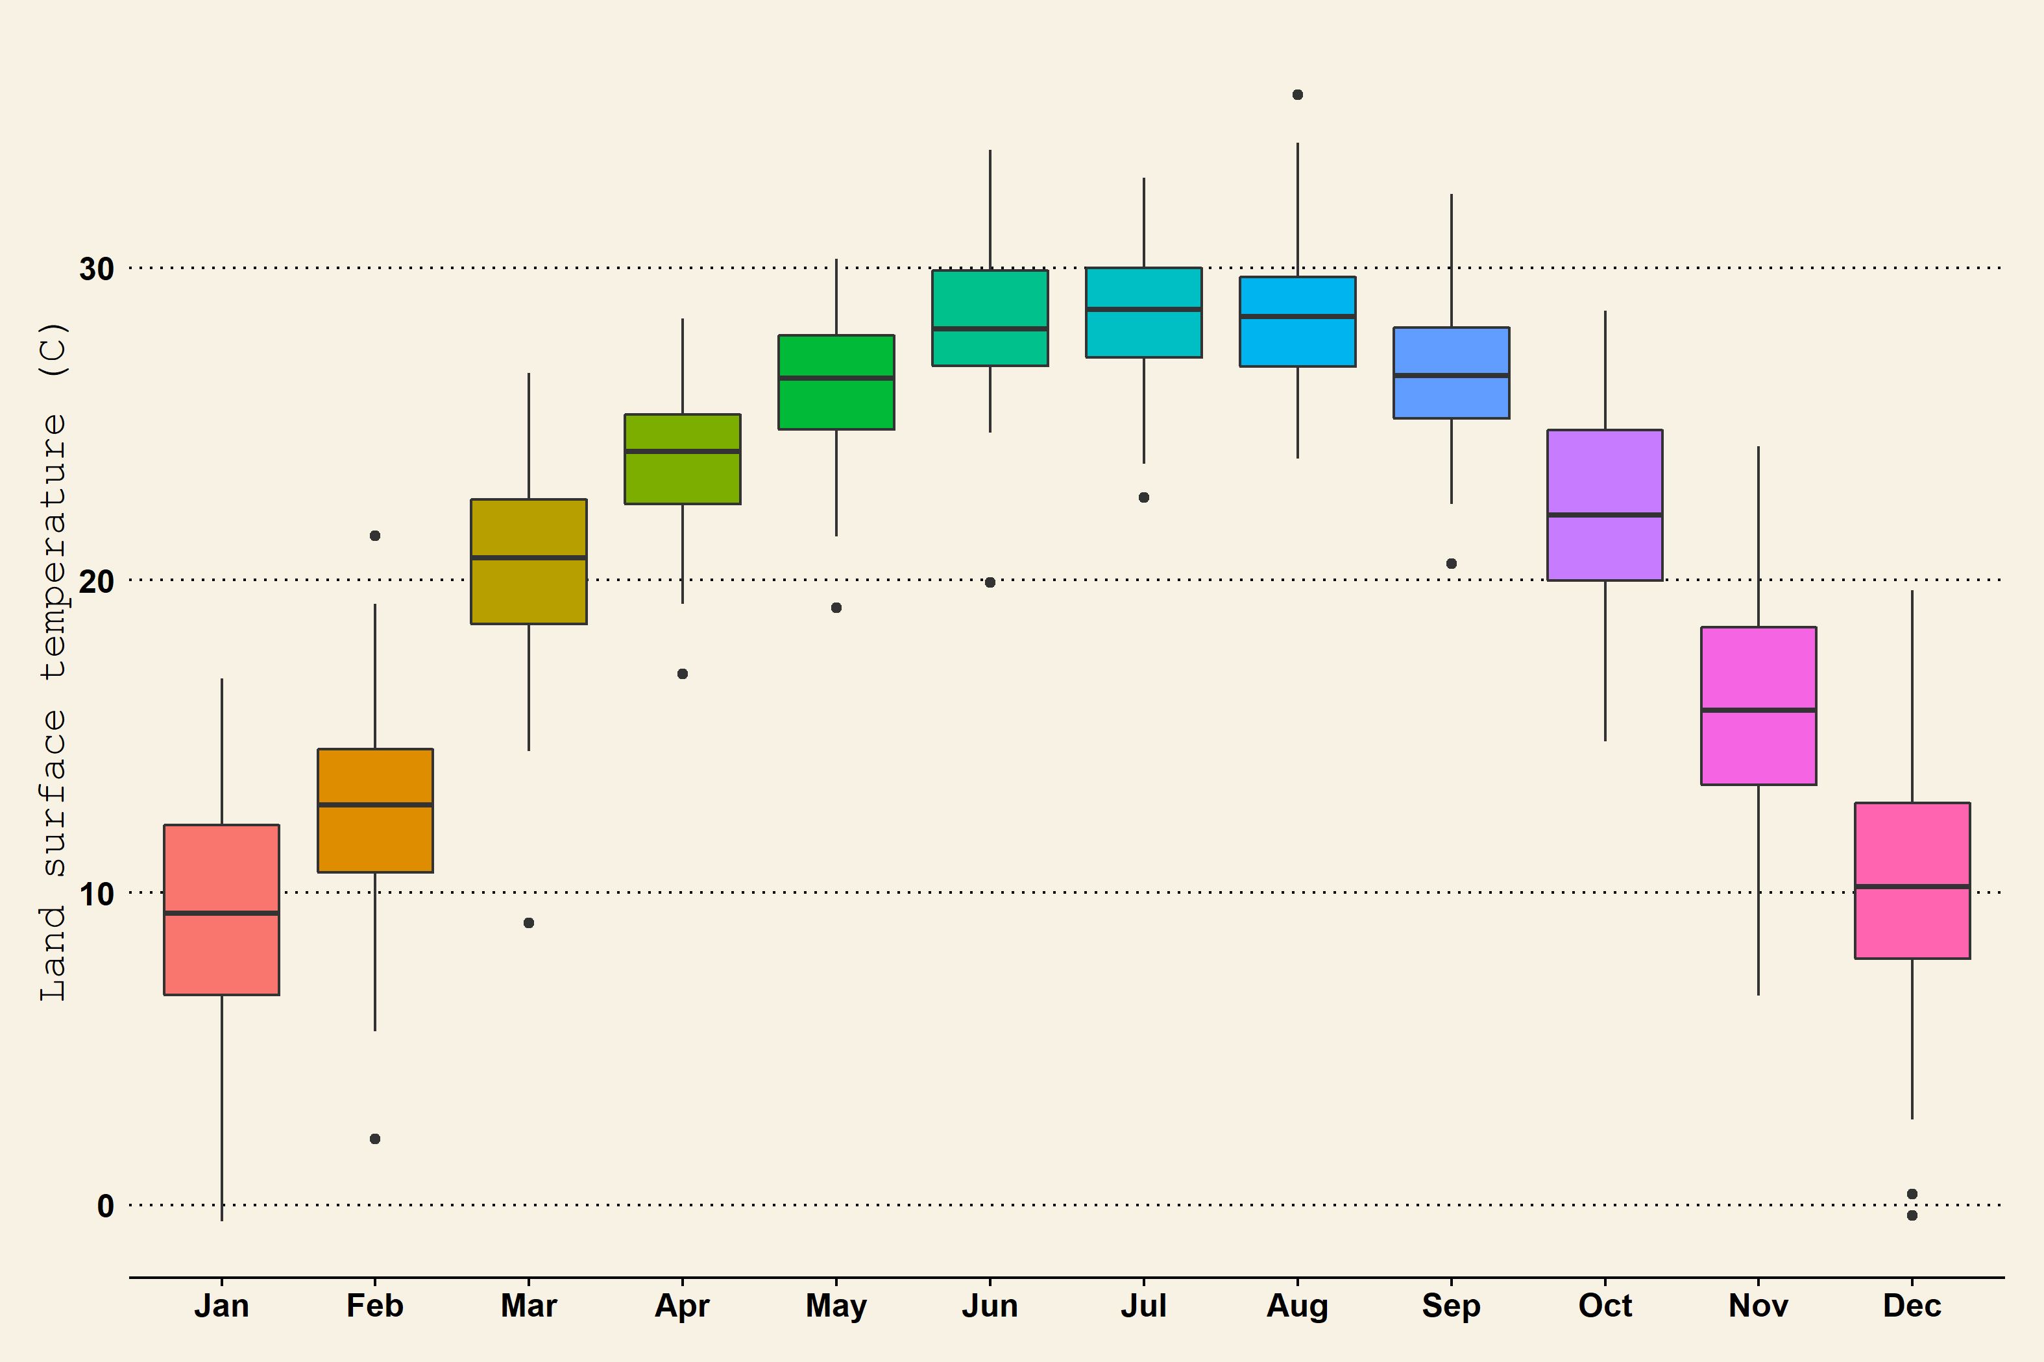

*Figure* *1.*  Boxplot of Land surface temperature

Monthly average temperature is 21.00 and standard deviation is 2.75

Table 1:

*1. Descriptive statistics of Land surface temperature*

| Month | Mean | Median | Max | Min | SD |
| --- | --- | --- | --- | --- | --- |
| Jan | 9.16 | 9.33 | 16.84 | -0.53 | 3.93 |
| Feb | 12.53 | 12.80 | 21.43 | 2.11 | 3.62 |
| Mar | 20.44 | 20.71 | 26.63 | 9.03 | 3.16 |
| Apr | 23.78 | 24.12 | 28.37 | 17.00 | 2.35 |
| May | 26.22 | 26.46 | 30.28 | 19.12 | 2.25 |
| Jun | 28.41 | 28.05 | 33.77 | 19.92 | 2.29 |
| Jul | 28.55 | 28.67 | 32.88 | 22.65 | 2.10 |
| Aug | 28.47 | 28.43 | 35.53 | 23.89 | 2.31 |
| Sep | 26.67 | 26.55 | 32.36 | 20.52 | 2.38 |
| Oct | 22.28 | 22.09 | 28.62 | 14.85 | 3.45 |
| Nov | 16.07 | 15.84 | 24.29 | 6.70 | 3.48 |
| Dec | 10.23 | 10.20 | 19.67 | -0.34 | 3.87 |

*Note.* MOD11A2.006 Terra Land Surface Temperature and Emissivity 8-Day Global 1km

Monthly precipitation data covered a period of over 20 years. During this period, the average precipitation rate ranged from 0.12 to 0.22 . These rates remained relatively constant throughout the month. December to April had a higher precipitation rate of around 0.40 , while August to November had a lower rate ranging from 0.05 to 0 .

Table 2:

*2. Descriptive statistics of Precipitation (mm/hr)*

| Month | Mean | Median | Max | Min | SD |
| --- | --- | --- | --- | --- | --- |
| Jan | 0.19 | 0.19 | 0.39 | 0.08 | 0.07 |
| Feb | 0.22 | 0.21 | 0.42 | 0.07 | 0.11 |
| Mar | 0.19 | 0.18 | 0.41 | 0.03 | 0.07 |
| Apr | 0.21 | 0.20 | 0.40 | 0.09 | 0.09 |
| May | 0.15 | 0.13 | 0.32 | 0.05 | 0.07 |
| Jun | 0.16 | 0.14 | 0.36 | 0.04 | 0.09 |
| Jul | 0.17 | 0.15 | 0.31 | 0.04 | 0.07 |
| Aug | 0.15 | 0.13 | 0.28 | 0.05 | 0.07 |
| Sep | 0.13 | 0.13 | 0.40 | 0.00 | 0.10 |
| Oct | 0.12 | 0.09 | 0.33 | 0.00 | 0.10 |
| Nov | 0.16 | 0.14 | 0.35 | 0.04 | 0.08 |
| Dec | 0.20 | 0.20 | 0.41 | 0.07 | 0.08 |

*Note.* GPM: Monthly Global Precipitation Measurement (GPM) v6

## 3.4 Discussion

# 4 Conclusion

# 5 used R libraries

We used R [Version 4.1.2; R Core Team (2021)] and the R-packages *dplyr* [Version 1.0.7; Wickham, François, Henry, and Müller (2021)], *forcats* [Version 0.5.1; Wickham (2021a)], *ggplot2* [Version 3.3.5; Wickham (2016)], *gridExtra* [Version 2.3; Auguie (2017)], *lattice* [Version 0.20.45; Sarkar (2008)], *lubridate* [Version 1.8.0; Grolemund and Wickham (2011)], *papaja* [Version 0.1.0.9997; Aust and Barth (2020)], *purrr* [Version 0.3.4; Henry and Wickham (2020)], *raster* [Version 3.5.2; Hijmans (2021); Perpiñán and Hijmans (2021)], *rasterVis* [Version 0.51.0; Perpiñán and Hijmans (2021)], *readr* [Version 2.0.2; Wickham and Hester (2021)], *rgdal* [Version 1.5.27; Bivand, Keitt, and Rowlingson (2021)], *RStoolbox* [Version 0.3.0; Leutner, Horning, and Schwalb-Willmann (2019)], *sp* [Version 1.4.5; Pebesma and Bivand (2005)], *stringr* [Version 1.4.0; Wickham (2019)], *tibble* [Version 3.1.5; Müller and Wickham (2021)], *tidyr* [Version 1.1.4; Wickham (2021b)], and *tidyverse* [Version 1.3.1; Wickham et al. (2019)] for all our analyses.

# 6 References

Auguie, B. (2017). *gridExtra: Miscellaneous functions for "grid" graphics*. Retrieved from <https://CRAN.R-project.org/package=gridExtra>

Aust, F., & Barth, M. (2020). *papaja: Create APA manuscripts with R Markdown*. Retrieved from <https://github.com/crsh/papaja>

Berlanga-Robles, C. A., & Ruiz-Luna, A. (2002). Land use mapping and change detection in the coastal zone of northwest mexico using remote sensing techniques. *Journal of Coastal Research*, 514–522.

Bivand, R., Keitt, T., & Rowlingson, B. (2021). *Rgdal: Bindings for the ’geospatial’ data abstraction library*. Retrieved from <https://CRAN.R-project.org/package=rgdal>

Fonji, S. F., & Taff, G. N. (2014). Using satellite data to monitor land-use land-cover change in north-eastern latvia. *Springerplus*, *3*(1), 1–15.

Gannett, H. (1902). The origin of certain place names in the state of mississippi. *Publications of the Mississippi Historical Society*, *6*, 339–349.

Grolemund, G., & Wickham, H. (2011). Dates and times made easy with lubridate. *Journal of Statistical Software*, *40*(3), 1–25. Retrieved from <https://www.jstatsoft.org/v40/i03/>

Henry, L., & Wickham, H. (2020). *Purrr: Functional programming tools*. Retrieved from <https://CRAN.R-project.org/package=purrr>

Hijmans, R. J. (2021). *Raster: Geographic data analysis and modeling*. Retrieved from <https://CRAN.R-project.org/package=raster>

Im, J., & Jensen, J. R. (2008). Hyperspectral remote sensing of vegetation. *Geography Compass*, *2*(6), 1943–1961.

Jensen, J. R. (1986). *Introductory digital image processing: A remote sensing perspective*. Univ. of South Carolina, Columbus.

Leutner, B., Horning, N., & Schwalb-Willmann, J. (2019). *RStoolbox: Tools for remote sensing data analysis*. Retrieved from <https://CRAN.R-project.org/package=RStoolbox>

Müller, K., & Wickham, H. (2021). *Tibble: Simple data frames*. Retrieved from <https://CRAN.R-project.org/package=tibble>

Pebesma, E. J., & Bivand, R. S. (2005). Classes and methods for spatial data in R. *R News*, *5*(2), 9–13. Retrieved from <https://CRAN.R-project.org/doc/Rnews/>

Perpiñán, O., & Hijmans, R. (2021). *rasterVis*. Retrieved from <https://oscarperpinan.github.io/rastervis/>

R Core Team. (2021). *R: A language and environment for statistical computing*. Vienna, Austria: R Foundation for Statistical Computing. Retrieved from <https://www.R-project.org/>

Sarkar, D. (2008). *Lattice: Multivariate data visualization with r*. New York: Springer. Retrieved from <http://lmdvr.r-forge.r-project.org>

Tucker, C. J., Slayback, D. A., Pinzon, J. E., Los, S. O., Myneni, R. B., & Taylor, M. G. (2001). Higher northern latitude normalized difference vegetation index and growing season trends from 1982 to 1999. *International Journal of Biometeorology*, *45*(4), 184–190.

Wickham, H. (2016). *ggplot2: Elegant graphics for data analysis*. Springer-Verlag New York. Retrieved from <https://ggplot2.tidyverse.org>

Wickham, H. (2019). *Stringr: Simple, consistent wrappers for common string operations*. Retrieved from <https://CRAN.R-project.org/package=stringr>

Wickham, H. (2021a). *Forcats: Tools for working with categorical variables (factors)*. Retrieved from <https://CRAN.R-project.org/package=forcats>

Wickham, H. (2021b). *Tidyr: Tidy messy data*. Retrieved from <https://CRAN.R-project.org/package=tidyr>

Wickham, H., Averick, M., Bryan, J., Chang, W., McGowan, L. D., François, R., … Yutani, H. (2019). Welcome to the tidyverse. *Journal of Open Source Software*, *4*(43), 1686. <https://doi.org/10.21105/joss.01686>

Wickham, H., François, R., Henry, L., & Müller, K. (2021). *Dplyr: A grammar of data manipulation*. Retrieved from <https://CRAN.R-project.org/package=dplyr>

Wickham, H., & Hester, J. (2021). *Readr: Read rectangular text data*. Retrieved from <https://CRAN.R-project.org/package=readr>