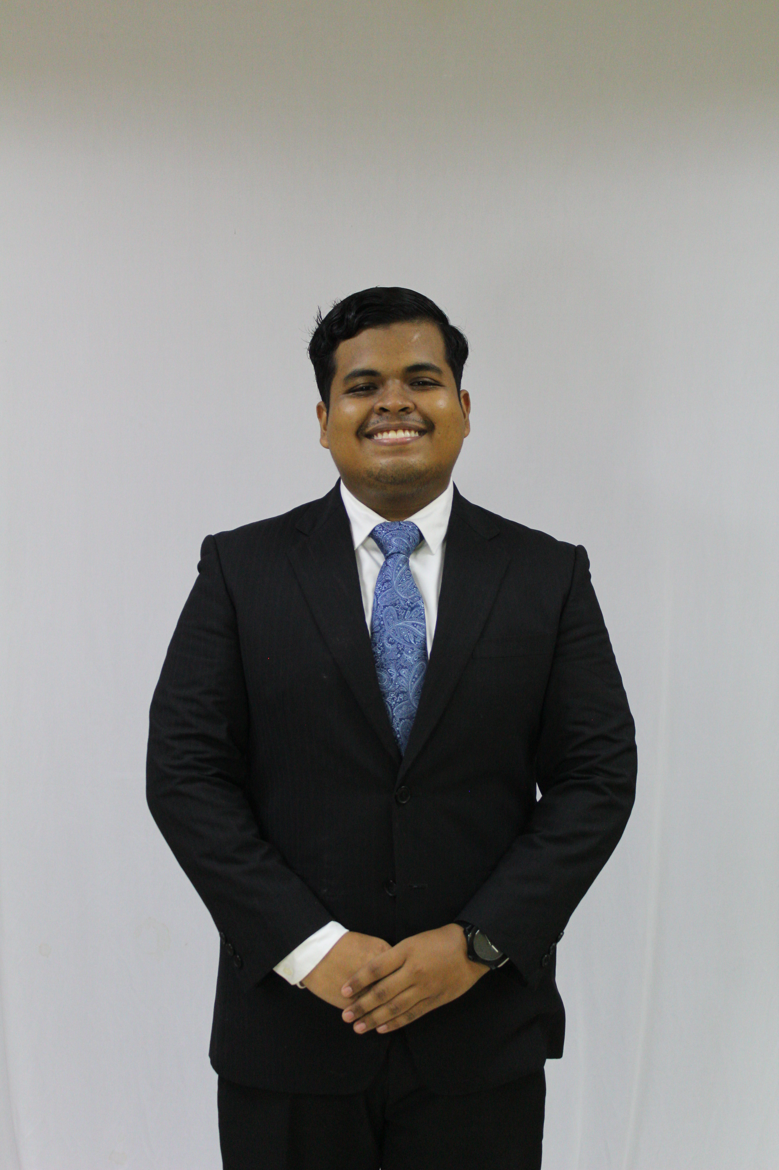
MUHAMMAD HAFFIZOL BIN SUFFIAN
  - Mechatronics | Smart Manufacturing | Industrial IoT and Applied AI
haffizol.suf@gmail.com | +60 19-558 6247 | Shah Alam, Selangor, Malaysia

SUMMARY
First Class Mechatronic Engineering Technology graduate with two years of automotive manufacturing experience, including a one-year internship. Lead and advise 38 Sugihara digital initiatives across two plants, combining industrial IoT, manufacturing software, applied AI and user-centred process improvement.

WORK EXPERIENCE
Executive, Digital Transformation Unit November 2025 - Present
Sugihara Grand Industries Sdn. Bhd. | Selangor, Malaysia
- Lead 38 digital initiatives across two plants; report to the Factory General Manager and supervise one permanent staff and five engineering interns.
- Independently developed a CMMS: 73% improvement in maintenance response time, 34% reduction in downtime and 98% work-order completion.
- Build applications with React, TypeScript, Node.js and SQL; integrate machines using Python, Raspberry Pi, MQTT and Node-RED.
- Independently developed HR, SHE and face-recognition attendance systems; support users through training and Kaizen.
- Led evidence preparation for MARii Auto-SMART Level 3; guide interns and continue development after handover.
Digital Transformation Advisor November 2025 - Present
Sanyco Grand Industries Sdn. Bhd. | Shah Alam, Selangor, Malaysia
- Advise Sanyco Grand, a sibling company within SIMS Group, on feasible IoT, software and automation initiatives based on operational requirements.
Digital Transformation Intern October 2024 - October 2025
Sugihara Grand Industries Sdn. Bhd. | Selangor, Malaysia
- Developed real-time machine monitoring and IoT weighing systems, covering requirements, sensor integration, calibration, validation, deployment and user support.
- Built pipelines using Raspberry Pi, Python, MQTT, Node-RED, InfluxDB and Grafana; contributed to a published automotive manufacturing case study.

PROJECTS
OEE Monitoring and Smart Checksheet | Sugihara | Principal developer
- Expanded the programme with an intern across two plants. Original implementation: 98% machine-state accuracy, latency below one second, packet loss below 0.5% and 54.7% less product-count error; IIDEX 2025 Gold. Led data flow and most frontend/backend development.
Computerized Maintenance Management System | Sugihara | Independent developer
- Centralised work orders, spares, preventive maintenance, KPIs and reporting; integrated functional AI weekly summaries and machine-risk insights, with workflows refined through user feedback.
UHF RFID Stock and Roll Monitoring | Sugihara | In development
- Developing UHF tag/reader integration with a Raspberry Pi edge layer to automate roll stock, finished-goods and racking tracking for Sendayan operations.
SLAM Based Autonomous Wheelchair | UiTM | Navigation team leader
- Contributed to the RoboPioneers team’s navigation development using ROS, LiDAR, SLAM mapping, odometry and path planning for an autonomous wheelchair prototype.
Piezoelectric Cantilever Energy Harvesting | UiTM | Research project
- Used ANSYS finite element analysis to study piezoelectric layer length and thickness through modal and harmonic response analysis. The best simulated configuration produced 2.33 V with a 30 mm layer length and 1 mm thickness at 9 Hz.

EDUCATION
Master of Science in Mechanical Engineering
Universiti Teknologi MARA | Full-time | Expected completion September 2027
Evening classes after work.
Bachelor of Mechatronic Engineering Technology with Honours
Universiti Teknologi MARA | 2021 - 2025 | CGPA 3.68/4.00 | First Class Honours
Best Student of the Semester (2025); Dean's List in Semesters 1, 3, 4, 6, 7 and 8.
Foundation in Engineering
Universiti Teknologi MARA | 2020 - 2021 | CGPA 3.64/4.00

EXTRACURRICULAR ACTIVITIES
Head of Navigation Department | UiTM RoboPioneers | 2023 - 2024
Team runner-up, IEEE Malaysia Section Robotics Competition 2024; participated in IEEE R10 Robotics Competition 2024.
Secretary, Student Activities Committee | IEEE Malaysia Section | 2023 - 2025

PUBLICATIONS
- Noorpini, M.S., Suffian, M.H., et al. (2025). Implementing a Cost-Effective IoT Control System for Real-time Operational Monitoring: A Case Study in a Malaysian Automotive SME Factory. IEICES, 11, 976-981. DOI: 10.5109/7395631.
- Suffian, M.H., et al. (2025/2026). Effect of Piezoelectric Layer Length and Thickness on Cantilever Performance for Energy Harvesting Application. 1st National Mechanical Engineering Students' Scientific Conference, 32-43.

TRAINING
Professional Certificate in Internet of Things | Utechtium | May 2026 | Requirements fulfilled
AI for Manufacturing: Vision & Workflow Automation | SHRDC | August 2026 | Attendance
Generative AI: Prompt Engineering Essentials for Industry 4.0 | SHRDC | March-April 2026 | Attendance

SKILLS
Manufacturing and improvement: OEE, 4M Henkaten, CMMS, preventive-maintenance workflows, Kaizen and user-centred process digitalization.
Industrial IoT and robotics: Raspberry Pi, industrial sensors, UHF RFID, MQTT, Node-RED, InfluxDB, Grafana, ROS, LiDAR, SLAM and odometry.
Software and databases: Python, JavaScript, TypeScript, React, Node.js, Express/Fastify, REST APIs, SQL, PostgreSQL and SQLite.
Applied AI and automation: Langflow, n8n, Ollama/local LLMs, document extraction, face-recognition integration, OpenCV and YOLO.
Deployment and reporting: Docker Compose, Linux, Git/GitHub, Socket.IO, PDF/Excel automation, Power BI, Looker Studio and Google Sheets.
Engineering and PCB tools: SolidWorks, MATLAB, ANSYS finite element analysis (modal/harmonic response), OpenPLC, Siemens LOGO!, WinSPS-S7, Arduino IDE and basic KiCad.

ADDITIONAL INFORMATION
Languages: Malay (native), English (professional proficiency), German (intermediate).
Malaysian citizen | Notice period: Two months

REFERENCES
Mohamad Khairi Bin Hasan | Head of Manufacturing
Sugihara Grand Industries | mohd.khairi@gcisb.com | +60 12-374 3267
Dr. Abdul Malek Abdul Wahab | Senior Lecturer
Universiti Teknologi MARA, Shah Alam | abdmalek@uitm.edu.my | +60 19-669 2301

