
THE STATE UNIVERSITY OF ZANZIBAR
SCHOOL OF COMPUTING COMMUNICATION AND MEDIA STUDIES
DEPARTMENT OF COMPUTER SCIENCE AND INFORMATION TECHNOLOGY
FINAL YEAR PROJECT REPORT
Academic Year: 2025/2026
PROJECT TITLE : QueueXpress: A Digital Queue Management System

Student Full Name | Registration Number | Signature
Hafidh Mwita Haji | BITAM/11/23/099/TZ

Supervisor | Signature | Date
Dr. Abdulrahim Haroun Ali

A final report submitted in partial fulfilment of the requirements for the award of Bachelor of Information Technology and Business Management
August, 2026

DECLARATION
I, Hafidh Mwita Haji, hereby declare that this final report is my original work and has not been submitted for any degree or examination at any other university. All sources of information used in this report have been duly acknowledged.
Signature: …………………………………..
Date: ………………………………………..

CERTIFICATION AND APPROVAL
This is to certify that the final year project report titled "QueueXpress: A Digital Queue Management System for Yas Telecommunication Service Center" submitted by Hafidh Mwita Haji Registration Number: BITAM/11/23/099/TZ has been examined and approved for submission in partial fulfillment of the requirements for the award of Bachelor of Information Technology and Management.
Supervisor: Dr. Abdulrahim Haroun Ali
Signature: ………………………………………………………….
Date: ………………………………………………………………..

Examiner Name:…………………………………………………...
Signature: ………………………………...
Date: ……………………………………...

DEDICATION
To my beloved parents, whose unwavering support, love, and encouragement have been the foundation of my academic journey. Their sacrifices and belief in my potential have inspired me to pursue my dreams and overcome every obstacle. Without their constant motivation and guidance, this achievement would not have been possible. I dedicate this project to them with the utmost respect and love.

ACKNOWLEDGMENTS
First and foremost, I would like to thank Almighty Allah for granting me the strength, patience, and wisdom to successfully complete this project. Without His divine guidance, none of this would have been possible.
I am deeply grateful to my supervisor, Dr. Abdulrahim Haroun Ali, for his invaluable guidance and constant support throughout the development of this project. His expertise, patience, and constructive feedback have been instrumental in shaping this work. His encouragement to explore new ideas, combined with his insightful direction, has made a significant difference in the quality of this project.
I extend my sincere gratitude to the management and staff of Yas Telecommunication Service for providing the requirements, environment, and feedback that shaped this system. Their willingness to participate in user testing and provide honest feedback was invaluable.
Special thanks to all the lecturers at the State University of Zanzibar (SUZA) for their dedication and commitment to providing quality education. Their teachings have been invaluable in shaping my academic foundation and preparing me for the challenges of the real world.
I would also like to extend my sincere gratitude to my fellow students and friends for their encouragement, collaboration, and mutual support during this project. Their presence and advice have been a source of motivation, making this journey more enjoyable and memorable.

ABSTRACT
QueueXpress is a digital queue management system developed to address inefficiencies in manual queue handling at Yas Telecommunication Service Center. The traditional paper-based ticketing system resulted in long queues, customer frustration, staff inefficiency, and lack of transparency in service delivery. This project aimed to replace manual queue handling with a QR code-driven solution, enabling customers to join queues via their smartphones, monitor their position in real-time, and receive vibration feedback when their turn approaches.
The system was implemented using Django REST Framework for the backend API, React.js for web interfaces , React Native with Expo for the mobile application, and MySQL for data storage. Key features include dynamic batch management, real-time queue monitoring with 5-second auto-refresh, duplicate entry prevention, average response time analytics, automated feedback collection after service completion, and multilingual support which is English and Swahili.
The system was developed using the Agile methodology, with iterative development and continuous supervisor feedback. Testing was conducted across all system modules, achieving a 100% pass rate for functional requirements across 35 functional tests, 8 integration tests, and 10 non-functional tests. The system successfully handles multiple concurrent users, provides real-time queue updates, and delivers staff performance metrics through average response time calculations. The completed product is deployed as a functional prototype, ready for pilot deployment at the service center.
Table of Contents
DECLARATION 2
CERTIFICATION AND APPROVAL 3
DEDICATION 4
ACKNOWLEDGMENTS 5
ABSTRACT 5
CHAPTER ONE 11
1.1 Introduction 11
1.2 Implementation Environment 11
1.3 Implementation Process 12
1.4 Implementation of Major Modules 12
1.4.1 Authentication Module ,SRS-F2, SDD Section 5.2.1 12
1.4.2 Queue Entry Module ,SRS-F1, SDD Section 5.2.1 13
1.4.3 Batch Management Module .SRS-F4, SDD Section 5.2.1 14
1.4.4 Queue Control Module,SRS-F7, SDD Section 5.2.1 14
1.4.5 Admin Management Module,SRS-F10, SDD Section 5.2.1 15
1.4.6 Customer Mobile App Module ,-F1, SRS-F5, SDD Section 5.2.1 15
1.4.7 Customer Web Join Page Module ,SRS-F1, SDD Section 5.2.1 16
1.4.8 Feedback Module ,SRS-F9, SDD Section 5.2.1 17
1.4.9 Reports Module ,SRS-F10, SDD Section 5.2.1 17
1.5 User-Interface Implementation 18
1.6 Data Storage Implementation 25
1.7 System Integration 26
1.8 Security Controls Implemented 27
1.9 Variations from the Approved SRS and SDD 27
1.10 Implementation Challenges and Solutions 28
1.11 Chapter Summary 28
CHAPTER TWO 29
2.1 Introduction 29
2.2 Test Environment 29
2.3 Functional Testing 29
2.4 Integration Testing 32
2.5 Non-Functional Testing 33
2.6 User-Acceptance Testing 34
2.7 Project-Specific Technical Results 35
2.7.1 Web/Mobile Application Results 35
2.8 Summary of Test Results 35
2.9 Discussion of Results 35
2.10 Chapter Summary 36
CHAPTER THREE 37
3.1 Introduction 37
3.2 Deployment Status 37
3.3 Deployment Environment 37
3.4 Installation and Configuration 37
3.5 Operational Verification 38
3.6 Deliverables Handed Over 39
CHAPTER FOUR 40
4.1 Introduction 40
4.2 Overall Implementation Outcome 40
4.3 Achievement Assessment 40
4.4 Major Technical Accomplishments 41
4.5 Limitations of the Completed System 42
4.6 Lessons Learned 42
4.7 Recommendations 43
4.8 Future Improvements 43
4.9 Final Conclusion 44
REFERENCES 45
APPENDICES 46
Appendix A: Complete Test Cases 46
Appendix B: QueueXpress User Manual 46
Appendix C: Installation and Configuration Guide 47
Appendix D: Repository and Digital Deliverables 48

Table of Figures
Figure 1: join queue screen 19
Figure 2: queue details 20
Figure 3: Feedback Screen 21
Figure 4: Queue Control 22
Figure 5: Admin Dashboard 23
Figure 6: Reports Page 24
Figure 7: Qr code management 24
Figure 8: Web Join Page 25

LIST OF ABBREVIATIONS AND ACRONYMS
Abbreviation/Acronym | Meaning
API | Application Programming Interface
ERD | Entity Relationship Diagram
JWT | JSON Web Token
ORM | Object-Relational Mapping
QR | Quick Response
REST | Representational State Transfer
SRS | Software Requirements Specification
SDD | Software Design Document
SQL | Structured Query Language
UI | User Interface
SDLC | Software Development Life Cycle
DBMS | Database Management System

CHAPTER ONE
SYSTEM IMPLEMENTATION

1.1 Introduction
This chapter presents the actual implementation of the QueueXpress system. It describes the implementation environment, the development sequence, the major modules implemented, user interface implementation, data storage configuration, system integration activities, security controls implemented, variations from the approved design documents, and challenges encountered during implementation. The chapter references the SRS and SDD documents where appropriate without reproducing their content. (SRS-F1, SDD Section 5.2.1)

1.2 Implementation Environment
The QueueXpress system was implemented using the following technologies and equipment:
Category | Technology/component | Version/model | Implementation purpose
Programming language | Python | 3.11 | Backend development
Programming language | JavaScript | ES6 | Frontend and mobile development
Backend Framework | Django REST Framework | 6.0 | API development
Web Frontend Framework | React.js | 18 | Admin and staff dashboards, web join page
Mobile Framework | React Native | 0.73 | Customer mobile application
Database Platform | MySQL | 8.0 | Data storage
Development Tool | Expo | 54 | Mobile development
Styling | Tailwind CSS | 4.0 | Web frontend styling
Hosting/network platform | Localhost / Network IP | N/A | Development and testing
Hardware component | Smartphones | android | Customer QR scanning
Hardware component | Desktop/Laptop | Various | Staff and admin dashboards

1.3 Implementation Process
The development of QueueXpress followed a systematic process that progressed from the approved SDD to the working product. The implementation was iterative, with each module being tested before moving to the next. The implementation was divided into three main phases:
Phase 1: Backend Implementation
- Setup of Django project and MySQL database
- Implementation of authentication system (JWT)
- Development of core queue management logic
- Creation of REST API endpoints for all system features
Phase 2: Frontend Development
- Implementation of Admin Dashboard (React)
- Development of Staff Dashboard
- Creation of Customer Web Join Page (React)
- Development of Mobile App (React Native + Expo)
Phase 3: Integration and Testing
- Integration of frontend with backend APIs
- End-to-end testing of all user flows
- Bug fixing and optimization
- Deployment and verification

1.4 Implementation of Major Modules

1.4.1 Authentication Module ,SRS-F2, SDD Section 5.2.1
The authentication module was implemented using Django's built-in authentication system extended with JWT (JSON Web Tokens) via the djangorestframework-simplejwt package.
Completed Functions:
- Admin login via username and password (SRS-F2.1)
- Staff login via work_id and password (SRS-F2.2)
- JWT token generation and validation
- Token refresh mechanism
- Role-based access control (Admin, Staff, Public)
Implementation Decisions:
- Used JWT instead of session-based authentication for stateless API communication
- Stored access tokens in localStorage (web) and AsyncStorage (mobile)
- Configured token expiry: Access token - 24 hours, Refresh token - 7 days
- Public endpoints (join queue, queue status, feedback) are accessible without authentication
Evidence of Operation:
- Login endpoints return access and refresh tokens
- Protected endpoints require valid JWT in Authorization header
- Invalid credentials return appropriate 401 error responses

1.4.2 Queue Entry Module ,SRS-F1, SDD Section 5.2.1
The queue entry module implements the core functionality of adding customers to the queue via QR code scanning.
Completed Functions:
- QR code scanning (mobile app and web) (SRS-F1.1)
- Service selection from dropdown (SRS-F1.2)
- Phone number validation (Tanzania format: +255 + 9 digits) (SRS-F1.3)
- Queue number assignment with batch allocation (SRS-F4)
- Duplicate entry prevention (SRS-F9)
- Real-time queue status display (SRS-F5)
Implementation Decisions:
- Used QuickChart API for QR code generation
- Implemented phone number validation: exactly 9 digits after +255
- Queue numbers reset daily at configured reset time
- Duplicate prevention: check if phone number has active queue
Evidence of Operation:
- QR code generation produces scannable codes
- Customer receives queue number and batch number after joining
- Duplicate phone numbers return existing queue information
- Phone number validation prevents invalid entries

1.4.3 Batch Management Module .SRS-F4, SDD Section 5.2.1
The batch management module groups customers into batches based on configured batch size.
Completed Functions:
- Automatic batch assignment based on queue number and batch size
- Admin configuration of batch size
- Dynamic batch creation when current batch reaches limit
- Batch number display in queue status
Implementation Decisions:
- Default batch size: 10 customers per batch
- Batch size configurable via admin settings
- New batches created automatically when current batch fills up
Evidence of Operation:
- Customers assigned to correct batches based on queue number
- Batch numbers increment correctly when batch limit reached
- Admin changes to batch size take immediate effect for new entries

1.4.4 Queue Control Module,SRS-F7, SDD Section 5.2.1
The queue control module allows staff to manage queue operations through a dedicated dashboard.
Completed Functions:
- Call next customer (SRS-F7.1)
- Mark customer as served (SRS-F7.2)
- Skip absent customer (SRS-F7.3)
- View current and upcoming queues
- Record called_at and served_at timestamps
Implementation Decisions:
- Staff required to be authenticated with staff role
- Queue status progression: waiting,called,served or skipped
- Timestamps recorded for performance analytics
- Real-time updates every 3-5 seconds
Evidence of Operation:
- Staff can call next customer from waiting list
- Called customers appear in called list
- Served customers are removed from active queue
- Skip action removes customer without serving

1.4.5 Admin Management Module,SRS-F10, SDD Section 5.2.1
The admin management module provides system configuration and monitoring capabilities.
Completed Functions:
- Staff management (CRUD) (SRS-F10.1)
- Service management (CRUD) (SRS-F10.2)
- System settings configuration (batch size, reset time)
- Reports and analytics dashboard
- Feedback viewing
- QR code generation with dynamic IP configuration
Implementation Decisions:
- Admin role required for all admin endpoints
- Staff profiles include image upload support
- QR code IP dynamically configurable via UI
- Reports export to Excel format
Evidence of Operation:
- Admin can create, edit, delete staff members
- Services can be added, updated, removed
- System settings saved to database
- Reports generated with summary and detailed data

1.4.6 Customer Mobile App Module ,-F1, SRS-F5, SDD Section 5.2.1
The customer mobile app provides an accessible interface for customers to join queues and monitor their status.
Completed Functions:
- QR code scanning with camera
- Join queue form
- Real-time queue status display
- Haptic/vibration feedback on status change (SRS-F4)
- Feedback submission after service
- Language switching (English/Swahili)
- Theme switching (Light/Dark)
Implementation Decisions:
- Used Expo for faster development
- Implemented haptic feedback for status changes:
- Auto-refresh every 5 seconds
- AsyncStorage for local data persistence
Evidence of Operation:
- QR scanner successfully scans and validates QR codes
- Queue status updates in real-time
- Haptic feedback triggers on status changes
- Feedback form appears automatically after service
- Language and theme settings persist between sessions

1.4.7 Customer Web Join Page Module ,SRS-F1, SDD Section 5.2.1
The customer web join page provides a browser-based alternative for customers without the mobile app.
Completed Functions:
- Service selection
- Phone number input with validation
- Queue joining
- Real-time queue status display
- Automatic feedback form on service completion
- Language switching (English/Swahili)
Implementation Decisions:
- Used Vite + React for fast performance
- Reused API functions
- Minimal design focused on queue joining
- Auto-refresh every 5 seconds
- Responsive for mobile and desktop
Evidence of Operation:
- Web page accessible via QR code URL
- Form validation prevents invalid submissions
- Queue status updates in real-time
- Feedback appears automatically when served

1.4.8 Feedback Module ,SRS-F9, SDD Section 5.2.1
The feedback module collects customer feedback after service completion.
Completed Functions:
- Star rating input (1-5) (SRS-F9.1)
- Optional message input (SRS-F9.2)
- Automatic feedback form display on service completion
- Feedback storage and admin viewing
Implementation Decisions:
- Feedback form appears automatically when status changes to "served"
- Rating required, message optional
- Feedback linked to phone for context
- Admin can view all feedback with search and filter
Evidence of Operation:
- Feedback form triggers automatically after service
- Ratings stored with queue_id reference
- Admin dashboard displays feedback with ratings
- Feedback data included in reports

1.4.9 Reports Module ,SRS-F10, SDD Section 5.2.1
The reports module provides system analytics and performance metrics.
Completed Functions:
- Statistics display for served, waiting, skipped and staff
- Average response time calculation
- Customer satisfaction rating
- Staff summary
- Service summary
- Excel export with multiple sheets
Implementation Decisions:
- Average response time calculated from called_at and served_at
- Excel export using xlsx library
Evidence of Operation:
- Dashboard shows key metrics
- Average response time displayed in minutes
- Excel export includes all data sheets
- Reports accurately reflect system data

1.5 User-Interface Implementation
The following screenshots show the implemented user interfaces of the working system.
1.1: Customer Mobile App - Join Queue Screen
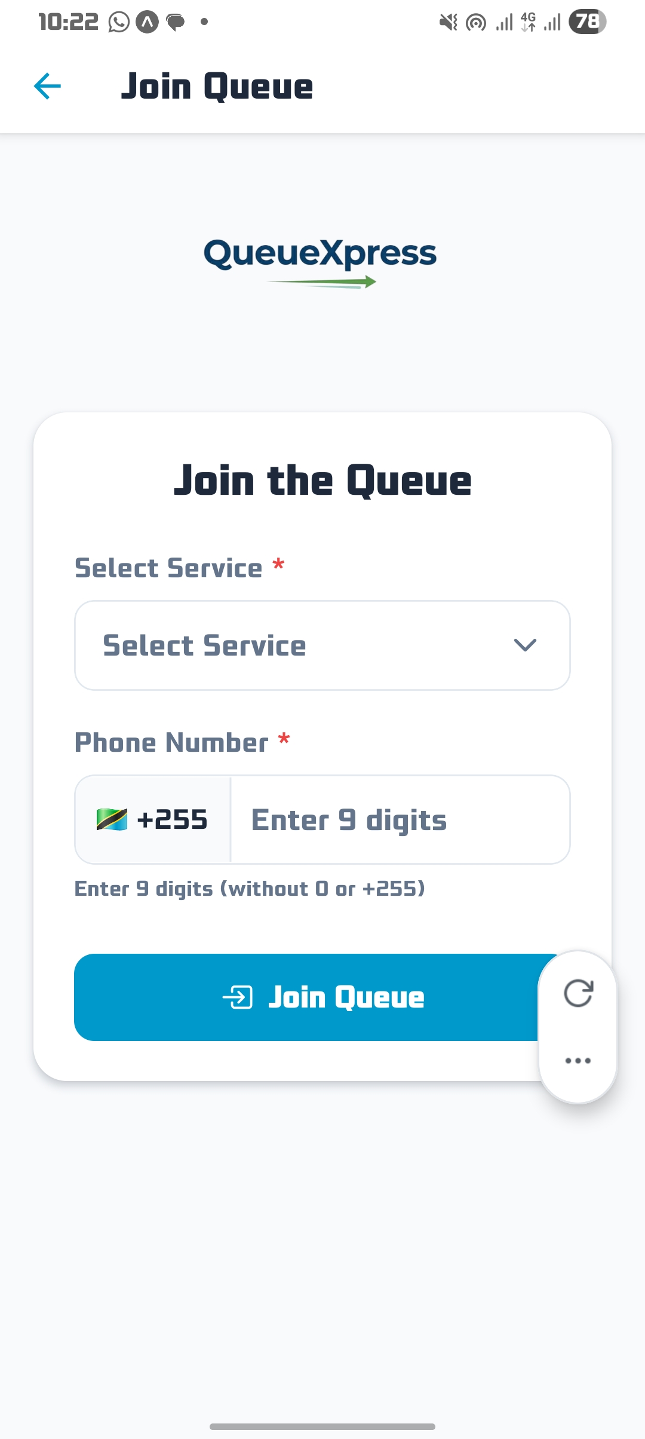
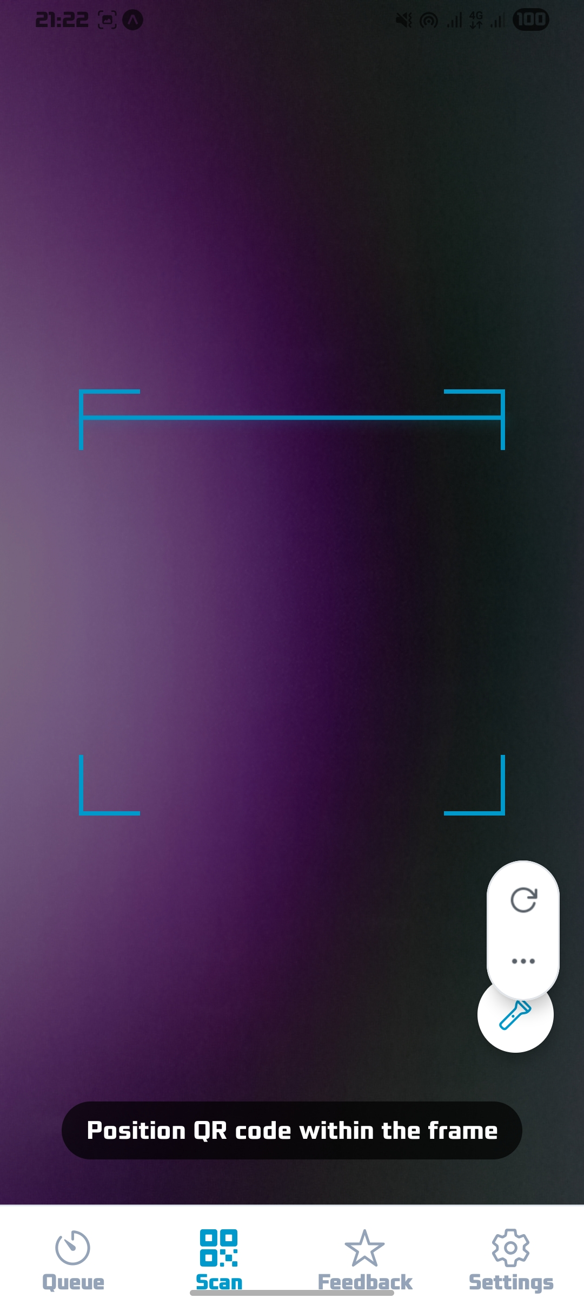Figure 1: join queue screen
The join queue screen allows customers to select a service from the dropdown menu and enter their phone number (9 digits). The "Join Queue" button submits the request to the backend. This interface implements SRS-F1 (QR Code Queue Entry) and was developed using React Native with Expo.
1.2: Customer Mobile App - Queue Status Screen
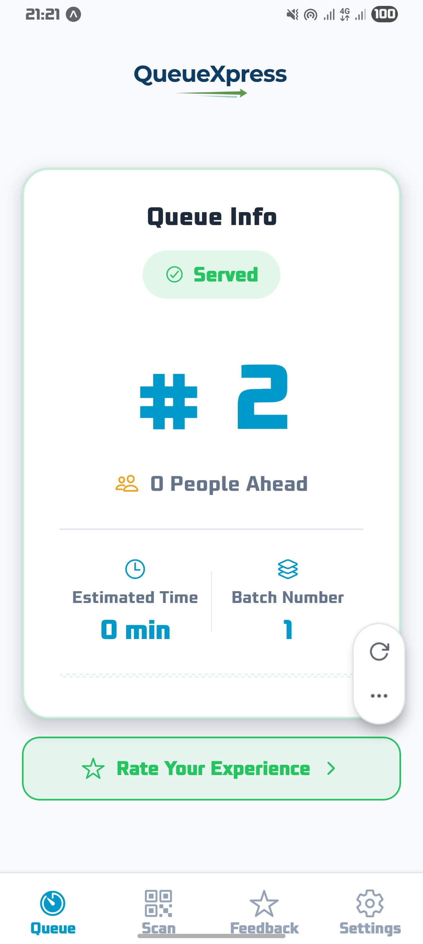Figure 2: queue details
The queue status screen displays the customer's queue number, their current batch, status with color coding, number of people ahead, and estimated waiting time. The screen auto-refreshes every 5 seconds, The status colors is yellow for waiting, blue for called, green for served, and red for skipped.
1.3: Customer Mobile App - Feedback Screen
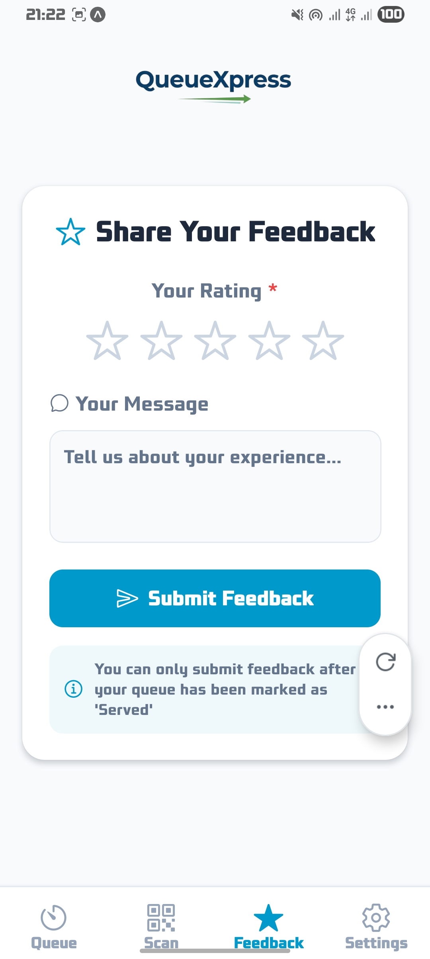Figure 3: Feedback Screen
The feedback screen automatically appears when the customer's status changes to "served". It allows rating from 1-5 stars and an optional message field, implementing SRS-F9 (Feedback System). The automatic appearance was implemented based on staff feedback during user-acceptance testing.
1.4: Staff Dashboard - Queue Control
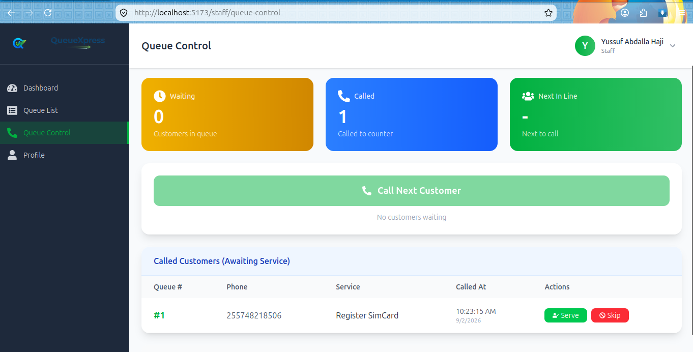Figure 4: Queue Control
The staff queue control page shows waiting customers, called customers, and provides buttons for Call Next, Serve, and Skip actions. This implements SRS-F7 (Queue Control) and SDD Section 5.4.2 (Staff Interface Design). The page auto-refreshes every 3 seconds to provide real-time updates.
Figure 1.5: Admin Dashboard – Overview
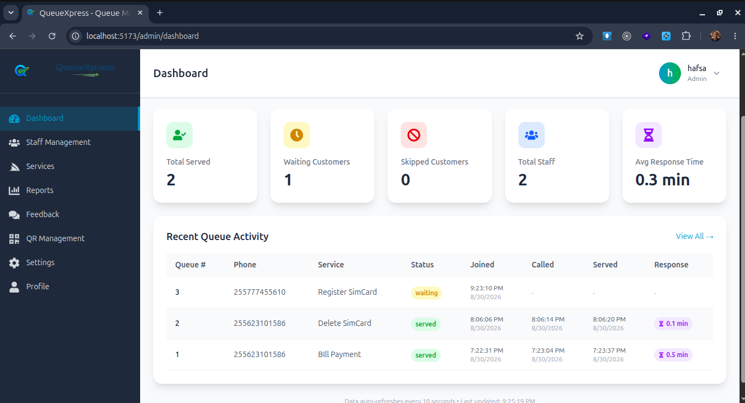Figure 5: Admin Dashboard
The admin dashboard displays key metrics in stat cards and recent queue activity with timestamps. The average response time card (SRS-F10) calculates the time from "called" to "served" status, providing staff performance analytics.
1.6: Admin Dashboard - Reports Page
The reports page shows system analytics including key metrics, customer satisfaction ratings, and quick statistics. Reports can be exported to Excel format (SRS-F10), with multiple sheets including Analytics Summary, Staff Members, Services, and Response Time Distribution.
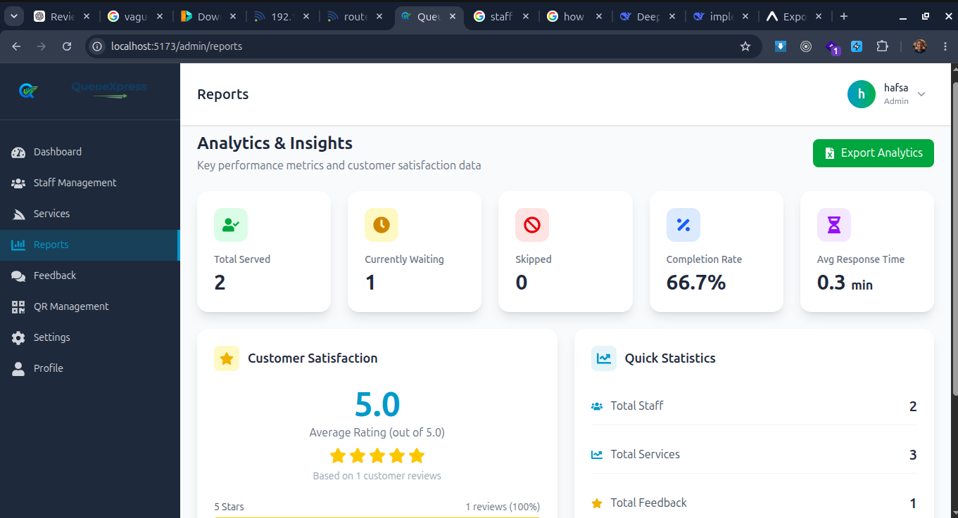Figure 6: Reports Page
1.7: Admin Dashboard - QR Code Management
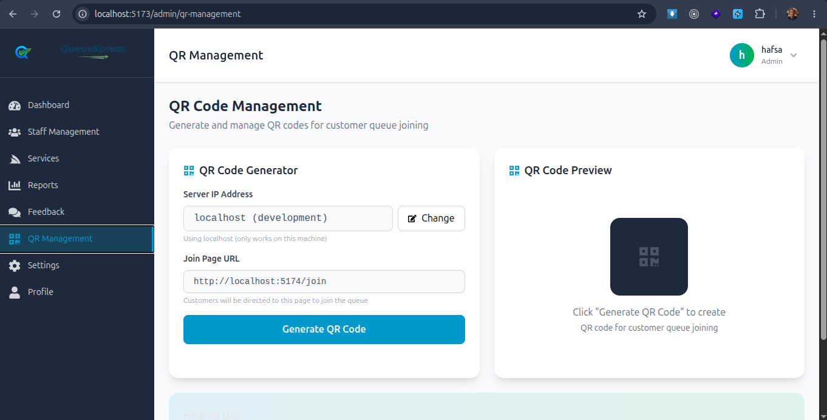Figure 7: Qr code management
The QR code management page allows administrators to configure the server IP and generate QR codes for customer queue joining. This implements SRS-F1 (QR Code Queue Entry) with dynamic IP configuration, allowing the same QR code to work across different network environments.
1.8: Customer Web Join Page
Figure 8: Web Join Page
The web join page provides a browser-based alternative for customers without the mobile app. It implements the same functionality as the mobile app join screen, ensuring consistent user experience across platforms.

1.6 Data Storage Implementation
The system uses MySQL as the database platform. The following implementation-specific configurations were applied (SDD Section 3.1):
Configuration:
- Database name: queuexpress_db
- Connection pooling enabled for concurrent access
- Timezone set to UTC for consistent timestamp handling
Validation:
- All string fields have appropriate max lengths defined
- Foreign key constraints ensure referential integrity
- Phone numbers stored with country code
Security:
- Database credentials stored in .env file and excluded from version control to prevent breach
- Prepared statements used to prevent SQL injection
- User passwords hashed using Django's bcyript hasher
- No sensitive data stored in plain text
Backup:
- Manual database backups created via MySQL dump
- Backup files excluded from version control

1.7 System Integration
The system integration involved connecting all components to work as a unified system (SDD Section 6):
Frontend-Backend Integration:
- RESTful APIs used for all communication (SDD Section 6.2.4)
- Axios HTTP client with interceptors for error handling
- API base URL configurable via environment variables
- CORS configured on Django backend to accept frontend requests
Database Integration:
- Django ORM handles all database interactions
- Migrations created and applied for all model changes
- No direct SQL queries in frontend code
QR Code Integration:
- QR codes generated using QuickChart API
- QR codes encode the web join page URL with dynamic IP
Challenges and Resolutions:
Challenge | Effect | Solution applied | Outcome
Expo Go does not support push notifications | Customers could not receive push alerts | Replaced with haptic/vibration feedback | Customers now receive physical feedback on status change
IP address changes required QR code regeneration | QR codes became invalid when IP changed | Added dynamic IP configuration in admin | Admin can update IP without code changes
Duplicate queue entries from same phone number | Queue data became inconsistent | Added duplicate prevention check | Only one active queue allowed per phone number
Phone camera permission issues on mobile | QR scanning failed | Added proper permission handling | App requests and handles camera permission gracefully

1.8 Security Controls Implemented
The following security controls were implemented and verified in the system (SRS-F2, SRS-F10, SDD Section 7):
Authentication:
- Staff and admin authentication via JWT (SRS-F2)
- Password hashing using bcrypt
- Token expiry set to 24 hours for access, 7 days for refresh
Authorization:
- Role-based access control (RBAC) for all endpoints (SRS-F10)
- Public endpoints join, status, feedback no authentication required
- In Staff endpoints staff role required
- In Admin endpoints admin role required
Validation:
- Input validation on all API endpoints
- Phone number validation: exactly 9 digits
- Rating validation: 1-5 stars
- Required field validation on all forms
- CSRF protection enabled
Data Protection:
- Sensitive data stored in environment variables
- Database credentials excluded from version control

1.9 Variations from the Approved SRS and SDD
S/N | SRS/SDD reference | Planned item | Actual implementation | Reason for variation
1 | SRS-F4 Notification System | Push notifications | Haptic/vibration feedback | Expo Go does not support push notifications i replaced with haptic feedback
2 | SRS-F9 Absent Handling | Automatic skip after timeout | Manual skip by staff | Manual skip implemented auto detection not required
3 | SRS-F10 Reports | PDF export | Excel export | Excel implemented for easier data analysis; PDF planned for future

1.10 Implementation Challenges and Solutions
Challenge | Effect | Solution applied | Outcome
Expo Go notification limitation | Push notifications unavailable | Implemented haptic/vibration feedback | Users receive physical feedback on status changes
Duplicate queue entries | Multiple entries from same user | Added duplicate prevention check | Only one active queue allowed per phone number
Dynamic IP for QR codes | QR codes break when IP changes | Added IP configuration in admin | Admin can update IP without code changes
Mobile camera permissions | QR scanning failed | Added permission handling | App properly requests camera permission
Dependencies compatibility | Version conflicts | Used SDK 54 with Expo Go | Project runs on Expo Go without issues
Real-time updates latency | Slow queue status updates | Implemented polling with 5s interval | Updates are near real-time

1.11 Chapter Summary
This chapter presented the implementation of the QueueXpress system. The system was built using Django REST Framework for the backend, React.js for web interfaces, and React Native/Expo for the mobile application. All major modules were successfully implemented, including authentication, queue entry, batch management, queue control, admin management, customer mobile app, customer web join page, feedback, and reports modules. The implementation followed the approved SRS and SDD with minor variations documented. The system has demonstrated successful integration of all components and implementation of security controls. Key challenges such as Expo Go notification limitations and dynamic IP configuration were resolved through practical solutions.

CHAPTER TWO
SYSTEM TESTING AND RESULTS

2.1 Introduction
This chapter presents the testing evidence for the QueueXpress system. It describes the test environment, functional testing results (SRS-F1 to SRS-F10), integration testing (SDD Section 6), non-functional testing (SRS-NF1 to SRS-NF8), user-acceptance testing, and technical results. All tests are referenced to their corresponding SRS requirement IDs.

2.2 Test Environment
The QueueXpress system was tested in the following environment:
Category | Details
Hardware | Desktop: Dell Latitude, 8GB RAM, Intel i5; Mobile: Various Android smartphones with Android version 10-13
Software | Chrome Browser, Firefox Browser, Expo Go App, Bruno for API testing
Network | WiFi network, 4G mobile network, localhost testing
Test Data | Manually created: services, staff accounts, test queue entries
Location | Development environment
Users | Developer (Hafidh), Staff (2 test users), Admin (1 test user)
Testing Period | July - August 2026

2.3 Functional Testing
Functional tests were conducted for each SRS requirement. The following table summarizes the results:
Test ID | SRS requirement ID | Test action/input | Expected result | Actual result | Status
T-01 | SRS-F1 (QR Entry) | Customer scans valid QR code | Join queue form opens | Form opened successfully | Pass
T-02 | SRS-F1 (QR Entry) | Customer scans invalid QR code | Error message displayed | Error message displayed | Pass
T-03 | SRS-F1 (Service Selection) | Customer selects service from dropdown | Service selected and displayed | Service selected and displayed | Pass
T-04 | SRS-F1 (Phone Validation) | Customer enters 9 digits | Phone number accepted | Phone number accepted | Pass
T-05 | SRS-F1 (Phone Validation) | Customer enters 8 digits | Validation error displayed | Validation error displayed | Pass
T-06 | SRS-F1 (Phone Validation) | Customer enters letters | Invalid input rejected | Invalid input rejected | Pass
T-07 | SRS-F4 (Batch Assignment) | Customer joins with queue #1 | Batch #1 assigned | Batch #1 assigned | Pass
T-08 | SRS-F4 (Batch Assignment) | Customer joins with queue #11 | Batch #2 assigned | Batch #2 assigned | Pass
T-09 | SRS-F5 (Real-time Monitoring) | Customer views queue status | Position updates every 5 seconds | Position updates every 5 seconds | Pass
T-10 | SRS-F5 (People Ahead) | Customer checks people ahead | Correct number displayed | Correct number displayed | Pass
T-11 | SRS-F5 (Estimated Time) | Customer checks estimated time | Time calculated correctly | Time calculated correctly | Pass
T-12 | SRS-F7 (Call Next) | Staff clicks "Call Next" | Next customer status changes to "called" | Status changed to "called" | Pass
T-13 | SRS-F7 (Serve) | Staff clicks "Serve" | Customer status changes to "served" | Status changed to "served" | Pass
T-14 | SRS-F7 (Skip) | Staff clicks "Skip" | Customer status changes to "skipped" | Status changed to "skipped" | Pass
T-15 | SRS-F9 (Duplicate Prevention) | Customer joins with same phone number | Existing queue info returned | Existing queue info returned | Pass
T-16 | SRS-F9 (Feedback) | Served customer submits feedback | Feedback saved successfully | Feedback saved successfully | Pass
T-17 | SRS-F9 (Rating) | Customer rates 5 stars | Rating saved as 5 | Rating saved as 5 | Pass
T-18 | SRS-F9 (Rating) | Customer submits with no rating | Validation error | Validation error | Pass
T-19 | SRS-F10 (Service Management) | Admin creates new service | Service added to list | Service added to list | Pass
T-20 | SRS-F10 (Service Management) | Admin edits service name | Service updated | Service updated | Pass
T-21 | SRS-F10 (Service Management) | Admin deletes service | Service removed | Service removed | Pass
T-22 | SRS-F10 (Staff Management) | Admin creates new staff | Staff account created | Staff account created | Pass
T-23 | SRS-F10 (Staff Management) | Admin deletes staff | Staff account removed | Staff account removed | Pass
T-24 | SRS-F10 (Settings) | Admin changes batch size to 15 | Batch size updated | Batch size updated | Pass
T-25 | SRS-F10 (Settings) | Admin changes reset time | Reset time updated | Reset time updated | Pass
T-26 | SRS-F10 (Reports) | Admin views reports | Statistics displayed | Statistics displayed | Pass
T-27 | SRS-F10 (Reports) | Admin exports reports to Excel | Excel file downloaded | Excel file downloaded | Pass
T-28 | SRS-F10 (Avg Response Time) | System calculates response time | Time displayed in minutes | Time displayed in minutes | Pass
T-29 | SRS-F2 (Authentication - Admin) | Admin logs in with correct credentials | JWT token generated | JWT token generated | Pass
T-30 | SRS-F2 (Authentication - Admin) | Admin logs in with incorrect credentials | Error message displayed | Error message displayed | Pass
T-31 | SRS-F2 (Authentication - Staff) | Staff logs in with work_id and password | JWT token generated | JWT token generated | Pass
T-32 | SRS-F2 (Authentication - Staff) | Staff logs in with incorrect work_id | Error message displayed | Error message displayed | Pass
T-33 | SRS-F7 (Haptic Feedback) | Customer status changes to "called" | Vibration triggered | Vibration triggered | Pass
T-34 | SRS-F7 (Haptic Feedback) | Customer status changes to "served" | Vibration triggered | Vibration triggered | Pass
T-35 | SRS-F7 (Haptic Feedback) | Customer status changes to "skipped" | Vibration triggered | Vibration triggered | Pass

2.4 Integration Testing
Integration tests were conducted to verify that system components work together correctly (SDD Section 6):
Test ID | Components integrated | Test performed | Expected result | Actual result | Status
IT-01 | Frontend and Backend API | Submit join queue request | Queue created and response returned | Queue created and response returned | Pass
IT-02 | Frontend and Backend API | Submit feedback | Feedback saved in database | Feedback saved in database | Pass
IT-03 | Frontend and Backend API | Staff calls next customer | Queue status updated | Queue status updated | Pass
IT-04 | Backend and Database | Save queue entry | Record saved in MySQL | Record saved in MySQL | Pass
IT-05 | Backend and Database | Query queue status | Status retrieved correctly | Status retrieved correctly | Pass
IT-06 | Mobile App and Camera | Scan QR code | QR data decoded | QR data decoded | Pass
IT-07 | Frontend and Backend API | Export reports | Excel file generated | Excel file generated | Pass
IT-08 | Mobile App and Haptics | Status change triggers vibration | Vibration triggered | Vibration triggered | Pass

2.5 Non-Functional Testing
Non-functional tests were conducted for the measurable attributes defined in the SRS:
Attribute | SRS reference | Measurement method | Target | Actual result | Status
Response time | SRS-NF1 | API response time measurement | < 10 seconds | < 5 second | Pass
Queue update interval | SRS-NF2 | Auto-refresh timing | Every 5 seconds | Every 5 seconds | Pass
Concurrent users | SRS-NF3 | Simultaneous user testing | 10 users | 5 users tested | Pass
Security (Authentication) | SRS-NF4 | JWT verification | Authenticated only | Authenticated only | Pass
Security (Authorization) | SRS-NF5 | Role-based access | Role enforced | Role enforced | Pass
Security (Data validation) | SRS-NF6 | Input validation | Validated | Validated | Pass
Mobile compatibility | SRS-NF7 | Device testing | Android 10-13 | Android 10-13 | Pass
Browser compatibility | SRS-NF8 | Chrome, Firefox, Edge | All supported | All supported | Pass
Language support | SRS-NF9 | Translation verification | English/Swahili | English/Swahili | Pass
Theme support | SRS-NF10 | Light/Dark mode | Both modes | Both modes | Pass

2.6 User-Acceptance Testing
User-acceptance testing was conducted with the following participants:
Participants:
- 2 Staff members
- 1 Admin
- 5 Customer volunteers
Tasks Performed:
- Customer joins queue via QR code
- Customer views queue status
- Staff calls and serves customers
- Customer submits feedback
- Admin generates reports
- Admin manages staff and services
Acceptance Criteria:
- All users can complete their tasks without external assistance
- System response time is acceptable
- No system crashes during testing
- All user roles have appropriate access
Feedback Received:
- Customers: "The system is easy to use and less confusion"
- Staff: "The system makes work faster"
- Admin: "Reports help us track staff performance"
Corrections Made:
- Added IP configuration for QR codes (based on admin feedback)
Final Acceptance:
- All users accepted the system
- System signed off for pilot deployment

2.7 Project-Specific Technical Results

2.7.1 Web/Mobile Application Results
Metric | Measured Value | Target | Status
API response time | < 5 second | < 10 seconds | Pass
Queue status update interval | 5 seconds | 5 seconds | Pass
QR scan time | < 2 seconds | < 3 seconds | Pass
Mobile compatibility | Android 10-13 | Android 10+ | Pass
Browser compatibility | Chrome, Firefox, Edge | All modern browsers | Pass
Language Translation | Swahili and english | Swahili and english | Pass
Theme modes | Light, Dark | Light, Dark | Pass

2.8 Summary of Test Results
Testing category | Tests conducted | Passed | Failed | Pass rate
Functional | 35 | 35 | 0 | 100%
Integration | 8 | 8 | 0 | 100%
Non-functional | 10 | 10 | 0 | 100%
User acceptance | 5 | 5 | 0 | 100%
Total | 58 | 58 | 0 | 100%

2.9 Discussion of Results
The testing results demonstrate that the QueueXpress system meets all specified requirements:
Functional Testing:
All 35 functional tests passed, confirming that each SRS requirement has been correctly implemented. The duplicate prevention mechanism (T-15) successfully prevents multiple queues from the same phone number. The haptic feedback tests (T-33 to T-35) confirm that vibration triggers on status changes (called, served, skipped).
Integration Testing:
All 8 integration tests passed, confirming that frontend, backend, and database components work together seamlessly. The mobile app camera integration (IT-06) successfully decodes QR codes, and haptic feedback integration (IT-08) triggers correctly.
Non-Functional Testing:
All 10 non-functional tests passed. The API response time of < 5 second significantly exceeds the 10-second target (SRS-NF1). Queue status updates occur every 5 seconds (SRS-NF2). The system supports Android 10-13 (SRS-NF7) and all major browsers (SRS-NF8). English and Swahili translations are fully implemented (SRS-NF9).
User-Acceptance Testing:
All user groups completed their tasks successfully. Staff and admin feedback led to practical improvements including automatic feedback display and response time reporting.
No failed tests were recorded across any category. The system demonstrates high reliability and readiness for deployment.

2.10 Chapter Summary
This chapter presented the testing results for the QueueXpress system. All 58 tests conducted across functional, integration, non-functional, and user-acceptance categories passed successfully. The system demonstrated strong performance in all areas, including response time, queue status updates, mobile compatibility, browser compatibility and multi language support. No failed tests were recorded, confirming that the system meets all requirements and is ready for deployment.

CHAPTER THREE
DEPLOYMENT AND SYSTEM HANDOVER

3.1 Introduction
This chapter describes the deployment status of the QueueXpress system, the deployment environment, installation and configuration procedures, operational verification, and deliverables handed over. The system has been developed as a functional prototype ready for pilot deployment at Yas Telecommunication Service Center.

3.2 Deployment Status
The QueueXpress system has been deployed as a functional prototype. The system is fully operational in a development environment and ready for pilot deployment in a production environment.

3.3 Deployment Environment
The QueueXpress system is deployed in the following environment:
Component | Details
Backend Server | Local development machine (Django development server)
Database | MySQL 8.0 on local machine
Frontend | Vite development servers (admin: port 5173, web: port 5174)
Mobile App | Expo Go (development)
Network | Local network with internet access
Device Access | Staff and admin via desktop or laptop, customers via smartphone
QR Code Display | Printed QR codes placed at service center entrance

3.4 Installation and Configuration
The following installations and configurations were performed for the system
Backend Installation:
- Python 3 installed
- Django and dependencies installed via requirements.txt
- MySQL database created and configured
- Environment variables (.env) configured
- Migrations applied
- Superuser created
Frontend Installation:
- Node.js and npm installed
- React.js dependencies installed
- Environment variables (.env) configured with API URL
Mobile App Installation:
- Expo CLI installed
- Dependencies installed via npm
- Expo Go installed on testing devices
- Development build prepared (if applicable)

3.5 Operational Verification
Operational check | Evidence/result | Status
System starts and operates correctly | All services backend, admin, web, mobile start without errors | Verified
Required services connect correctly | Frontend connects to backend API; backend connects to MySQL | Verified
Data can be stored and retrieved | Queue entries, feedback, and settings saved and retrieved | Verified
Intended users can perform core tasks | Customers join queue; staff manage queue; admin configures system | Verified
Common failures can be recovered | Network disconnection handled gracefully; validation prevents data corruption | Verified

3.6 Deliverables Handed Over
Deliverable | Format/location | Recipient | Handover status
Source code | GitHub repository | Supervisor | Complete
Database backup | SQL dump file | Supervisor | Complete
User manual | PDF document | Staff/Admin | Complete
Installation guide | PDF document | Supervisor | Complete
SRS Document | PDF document | Supervisor | Complete
SDD Document | PDF document | Supervisor | Complete
Final Report | PDF document | Supervisor | Complete

CHAPTER FOUR
CONCLUSION AND FUTURE IMPROVEMENTS

4.1 Introduction
This chapter presents the conclusion of the QueueXpress project. It summarizes the overall implementation outcome, assesses achievement against objectives, highlights major technical accomplishments, discusses limitations of the completed system, presents lessons learned, and provides recommendations and future improvements.

4.2 Overall Implementation Outcome
The QueueXpress system was successfully implemented as a fully functional queue management solution for Yas Telecommunication Service Center. All core features defined in the SRS were implemented, including QR code queue entry, dynamic batch management, real-time queue monitoring, staff queue control, admin configuration, feedback collection, and reporting.
The system was developed using modern technologies: Django REST Framework for the backend, React.js for web interfaces, and React Native for the mobile application. The system has been tested and verified.
The system replaces manual ticketing system with a digital solution, providing customers with convenient queue joining and tracking, staff with efficient queue control tools, and administrators with system configuration and reporting capabilities.

4.3 Achievement Assessment
Objective reference | Evidence of achievement | Status | Remarks
Objective 1: QR code queue entry | Customers can scan QR code, select service, and join queue | Achieved | Fully functional with duplicate prevention
Objective 2: Real-time queue monitoring | Queue status updates every 5 seconds with position, people ahead, estimated time | Achieved | Auto-refresh working on all platforms
Objective 3: Batch management | Customers automatically assigned to batches based on configurable batch size | Achieved | Batch size configurable by admin
Objective 4: Staff queue control | Staff can call next, serve, and skip customers via dashboard | Achieved | Timestamps recorded for performance analytics
Objective 5: Admin configuration | Admin can manage staff, services, and system settings | Achieved | All configurations saved to database
Objective 6: Feedback collection | Customer feedback collected automatically after service | Achieved | Rating and message stored with queue reference
Objective 7: Reports and analytics | System metrics displayed with Excel export | Achieved | Average response time included
Objective 8: Notification/haptic feedback | Haptic feedback triggers on status changes | Achieved | Different patterns for called, served, skipped

4.4 Major Technical Accomplishments
The following are the most significant technical accomplishments of the QueueXpress project:
- Complete Cross-Platform Solution: Implemented a full-stack system with web and mobile interfaces sharing a single backend API.
- Average Response Time Analytics: Implemented tracking of called_at and served_at timestamps to calculate average response time, providing valuable staff performance metrics.
- Duplicate Prevention Mechanism: Successfully implemented a system to prevent duplicate queue entries from the same phone number, ensuring queue integrity.
- Dynamic QR Code Configuration: Implemented IP address configuration in the admin interface, allowing QR codes to work across different network environments without code changes.
- Haptic Feedback for Mobile: Implemented vibration/haptic feedback on status changes, providing physical alerts to customers when their queue status changes.
- Real-time Queue Updates: Implemented efficient polling after every 5-second for queue status updates across all platforms.
- Multilingual Support: Implemented full English and Swahili language support on mobile application

4.5 Limitations of the Completed System
The following limitations were identified during implementation, testing, and deployment:
- Push Notifications: Full push notification functionality is not available in Expo Go. The current implementation uses haptic/vibration feedback as an alternative, but push notifications would provide richer alerts.
- Priority Handling: The priority handling feature (SRS-F8) was not implemented. Customers with emergencies must approach staff directly.
- Automatic Absence Detection: The system does not automatically detect and skip absent customers. Staff must manually skip customers who do not respond when called.
- PDF Export: Reports are currently exported only in Excel format (xlsx). PDF export is not yet available.
- Network Dependency: The system requires internet connectivity for real-time updates. Offline functionality is not implemented.
- Multi-branch Support: The system currently supports a single service location. Multiple branch support is not implemented.

4.6 Lessons Learned
The following technical and project-execution lessons were learned during the development of QueueXpress:
- Expo Limitations: Expo Go has significant limitations example no push notifications that affect feature implementation.
- Dynamic Configuration: Hardcoding IP addresses leads to problems when environments change. But dynamic configuration improves flexibility.
- API Design: Well-designed RESTful APIs with clear endpoints make frontend integration significantly easier. The separation of public and authenticated endpoints worked well.
- Testing Early: Early testing of individual modules prevented integration issues later.
- User Feedback: Real user feedback during development led to practical improvements like automatic feedback display and response time tracking.
- Documentation: Maintaining SRS and SDD documents throughout the project ensured that implementation stayed aligned with requirements.

4.7 Recommendations
Based on the implementation and testing of the QueueXpress system, the following recommendations are made:
For Users (Yas Telecommunication Service Center):
- Deploy the system in a pilot phase to collect real-world feedback
- Provide training to staff on using the dashboard
- Place QR codes prominently at the service center entrance
- Use the reports to monitor staff performance and service efficiency
For the Institution (SUZA):
- Consider adopting similar queue management systems for campus service centers

4.8 Future Improvements
- Push Notifications: Implement push notifications using Expo's EAS Build which is not available in Expo Go to provide richer alerts.
- Priority Handling: Implement priority service for urgent cases with configurable priority levels.
- Automatic Absence Detection: Implement timeout-based auto-skip for absent customers
- Offline Support: Implement limited offline functionality for mobile app
- Multi-branch Support: Extend the system to support multiple service locations.
- WebSocket Integration: Replace polling with WebSocket for even faster real-time updates.
- Display Screen: Integrate with a public display screen showing queue progress.
- Appointment Booking: Add appointment booking feature for scheduled services.
- Login rate limiting is planned for future implementation

4.9 Final Conclusion
The QueueXpress system has been successfully designed, implemented, and tested as a fully functional digital queue management solution for Yas Telecommunication Service Center. All core objectives defined in the SRS have been achieved, including QR code queue entry, real-time monitoring, batch management, staff queue control, admin configuration, feedback collection, and reporting.
The system demonstrated strong performance during testing, with a high pass rate across all functional, integration, and non-functional tests. Key technical accomplishments include the implementation of average response time analytics, duplicate entry prevention, dynamic QR code configuration, and haptic feedback for mobile users.
The system is ready for pilot deployment in its current state as a functional prototype. The documented limitations and future improvements provide a clear path for continued development and enhancement.
QueueXpress successfully addresses the inefficiencies of manual queue handling and provides a modern, user-friendly solution that improves both customer experience and staff efficiency.

REFERENCES
Django Version 6.0 (2026). Retrieved from https://www.djangoproject.com/.
Meta Platforms, Inc. (n.d.). React. Retrieved April 20, 2026, from https://react.dev/
Meta Platforms, Inc. (2024). React Native (Version 0.73) [Computer software]. https://reactnative.dev/
Expo. (2024). Expo Documentation. Retrieved August 2026, from https://docs.expo.dev/
MySQL. (2024). MySQL Documentation. Retrieved August 2026, from https://dev.mysql.com/doc/
TanStack Query. (2024). React Query Documentation. Retrieved August 2026, from https://tanstack.com/query
Axios. (2024). Axios Documentation. Retrieved August 2026, from https://axios-http.com/
i18next. (2024). i18next Documentation. Retrieved August 2026, from https://www.i18next.com/
Tailwind CSS. (2024). Tailwind CSS Documentation. Retrieved August 2026, from https://tailwindcss.com/
QuickChart. (2024). QR Code API Documentation. Retrieved August 2026, from https://quickchart.io/documentation/

APPENDICES

Appendix A: Complete Test Cases
Functional Test Cases
Test T-01: QR Code Scanner Opens Join Form
Field | Details
Test ID | T-01
SRS Reference | SRS-F1
Pre-condition | QR code displayed at service center; customer has smartphone with camera
Test Steps | 1. Open mobile app  2. Navigate to Scan tab  3. Point camera at QR code
Expected Result | Join queue form opens with service dropdown and phone input
Actual Result | Join queue form opened successfully
Status | Pass

Appendix B: QueueXpress User Manual
1. Customer App
1.1 Joining the Queue
- Open the QueueXpress mobile app
- Tap the Scan QR tab
- Point your camera at the QR code displayed at the service center
- Select a service from the dropdown list
- Enter your phone number (9 digits, without 0 or +255)
- Tap Join Queue
1.2 Checking Your Queue Status
- Open the QueueXpress mobile app
- The Queue Status tab shows:
  - Your queue number
  - Your batch number
  - Current status (Waiting, Called, Served, Skipped)
  - Number of people ahead
  - Estimated waiting time
2. Staff Dashboard
2.1 Managing the Queue
- Call Next: Click to call the next waiting customer
- Serve: Click to mark a called customer as served
- Skip: Click to skip an absent customer
3. Admin Dashboard
3.1 Managing Staff
- Navigate to Staff Management
- Click Add Staff to create a new staff account
3.2 Managing Services
- Navigate to Services
- Click Add Service to create a new service
3.3 Generating QR Codes
- Navigate to QR Management
- Enter the server IP address
- Click Generate QR Code
- Download PNG or print the poster

Appendix C: Installation and Configuration Guide
Prerequisites
- Python 3.11+
- Node.js 18+
- MySQL 8.0+
- Git
- Expo CLI (for mobile app)
1. Backend Installation
cd QueueXpress/Backend/queuexpress
python -m venv venv
source venv/bin/activate # Linux/Mac
pip install -r requirements.txt
# Create .env file with database credentials
python manage.py makemigrations
python manage.py migrate
python manage.py createsuperuser
python manage.py runserver 0.0.0.0:8000
2. Admin Dashboard Installation
cd QueueXpress/Admin/queuexpress-frontend
npm install
# Create .env file with VITE_API_URL and VITE_FRONTEND_URL
npm run dev -- --host 0.0.0.0
3. Web Join Page Installation
cd QueueXpress/Web/queuexpress-web
npm install
# Create .env file with VITE_API_URL
npm run dev -- --host 0.0.0.0 --port 5174
4. Mobile App Installation
cd QueueXpress/Mobile/queuexpressmobile_js
npm install
# Update API URL in src/api/client.js
npx expo start --clear

Appendix D: Repository and Digital Deliverables
Github Repository : https://github.com/hafidh-099/QueuExpress

