
THE STATE UNIVERSITY OF ZANZIBAR
SCHOOL OF COMPUTING, COMMUNICATION AND MEDIA STUDIES
DEPARTMENT OF COMPUTER SCIENCE AND INFORMATION TECHNOLOGY

Software Design Document (SDD)
QueuExpress System

Prepared by: Hafidh Mwita Haji
Student ID: BITAM/11/23/099/TZ
Supervisor: Dr. Abdulrahim Haroun Ali

Contents
INRODUCTION 4
1.1 Purpose and Scope 4
1.2 Project Executive Summary 4
1.2.1 System Overview 4
1.2.2 Design Constraints 5
1.2.3 Future Contingencies 5
1.3 Document Organization 6
1.4 Points of Contact 6
1.5 Project References 6
1.6 Glossary 7
SYSTEM ARCHITECTURE 8
2.1 System Hardware Architecture 8
2.2 System Software Architecture 9
2.3 Internal Communications Architecture 9
FILE AND DATABASE DESIGN 11
3.1 Database Management System Files 11
3.2 Non-Database Management System Files 14
HUMAN-MACHINE INTERFACE 16
4.1 Inputs 16
4.2 Outputs 18
DETAILED DESIGN 20
5.1 Hardware Detailed Design 20
5.2 Software Detailed Design 20
5.2.1 System Modules 20
5.2.2 Processing Logic 22
5.3 Internal Communications Detailed Design 23
EXTERNAL INTERFACES 25
6.1 Interface Architecture 25
6.2 Interface Detailed Design 26
SYSTEM INTEGRITY CONTROLS 29
7.1 Internal Security 29
7.2 Audit Procedures 29
7.3 Data Validation Controls 30

Figure 1 System Hardware Architecture 9
Figure 2 System Software Architecture 10
Figure 3 Internal Communication Architecture 11
Figure 4 Entity Relationship Diagram 15
Figure 5 Qr code scanner and feedback submission page 17
Figure 6 staff dashboard 18
Figure 7 admin configure page 18
Figure 8 queue details 19
Figure 9 use case diagram 22
Figure 10 Communication Diagram 24

INRODUCTION

1.1 Purpose and Scope
The purpose of this System Design Document (SDD) is to provide a detailed design description of the QueueXpress System, a digital queue management solution developed to improve service delivery efficiency in Yas telecommunication shop.
This document translates the system requirements defined in the Software Requirements Specification into a structured system design that can be used to implement the system. It covers system architecture, database design, user interfaces, and system interactions.

1.2 Project Executive Summary
QueueXpress is a mobile-based queue management system designed to replace traditional and manual queuing systems with a modern digital solution.
The system allows customers to join queues by scanning a QR code, monitor their queue position in real time, and receive notifications when their turn is approaching. Staff members manage the queue using a dashboard, while administrators configure system settings and monitor performance.
The system is built using React.js for web interface, React native for mobile application, Django for logic and MySQL for database and storage
The design focuses on simplicity, scalability, and efficiency, ensuring that it can operate effectively even in environments with limited infrastructure.

1.2.1 System Overview
QueueXpress follows a three-tier architecture where users interact with the system through web or mobile interfaces. Main Components are
Presentation Layer: This is a customer mobile interface, Staff dashboard and Admin dashboard
Application Layer: This is where the business logic a handled like Manages queue operations and Processes requests
Database Layer: This is where the Stores users, queues, batches, and logs is stored
Core Workflow
1. Customer scans QR code at service center entrance using smartphone camera
2. Mobile browser opens QueueXpress and adds customer to queue
3. Customer receives queue number and batch number instantly
4. Customer views real-time status including people ahead and estimated wait time
5. Staff calls next customer from dashboard when ready
6. System notifies customer through visual update on status page
7. Staff serves customer and marks as completed
8. Customer submits optional feedback after service

1.2.2 Design Constraints
The system design is subject to the following constraints:
- Limited infrastructure. display screens for showing queue progress to customer
- Dependence on internet connectivity
- Limited technical skills of end users
- Academic project time constraints
Assumptions Made:
- The service center has reliable internet connectivity
- Customers have smartphones with camera and internet access
- Staff have access to computers or tablets for dashboard
- Daily customer volume does not exceed 500 customers per day
- QR code will remain physically displayed

1.2.3 Future Contingencies
The following potential changes may affect system design:
- Addition of appointment booking feature
- Expansion to support multiple branches
- Upgrade to real-time communication using WebSocket
- Integration with push notification systems (SMS, push notifications)
- Response time analytics and staff performance tracking
- Upgrade to real-time communication using WebSocket

1.3 Document Organization
This document is organized into the following sections:
Section 1: Introduction
Section 2: System Architecture
Section 3: Database Design
Section 4: Human-Machine Interface
Section 5: Detailed Design
Section 6: External Interfaces
Section 7: System Integrity Controls
Each section provides detailed information necessary for system development and implementation.

1.4 Points of Contact
- Project Developer for Project Development
- Supervisor for Project guidance and evaluation
- End Users for Provide requirements and feedback

1.5 Project References
Software Requirements Specification (SRS) Document
MySQL Documentation
Django (Version 6.0) [Computer Software]. (2026). Retrieved from https://www.djangoproject.com/.
Meta Platforms, Inc. (n.d.). React. Retrieved April 20, 2026, from https://react.dev/
Meta Platforms, Inc. (2024). React Native (Version 0.73) [Computer software].
https://reactnative.dev/

1.6 Glossary
Appendix A: Glossary
Terms | Definition
API | Application Programming Interface
ERD | Entity Relationship Diagram
SRS | Software Requirements Specification
System Setting | Configurable parameters such as batch size and working hours
Dashboard | Interface used by staff/admin to monitor and manage the system
Notification | A system alert sent to customers regarding queue status
Counter | A service point where staff attend customers
Priority Service | Special handling of urgent customers by staff
QueueXpress | The proposed digital queue management system
Customer | A user who joins the queue to receive service
Staff | A service provider responsible for attending customers
Admin | A system administrator responsible for managing and configuring the system
Queue | A sequence of customers waiting for service
Batch | A group of customers allowed to be near the service area at a given time
QR Code | A machine-readable code used for quick access to the queue system
Check-in | The process of confirming arrival at the service center
No-show | A customer who fails to appear when called
WebSocket | Protocol for real-time bidirectional communication
ORM | Object-Relational Mapping (Django's method for database interaction)

SYSTEM ARCHITECTURE

2.1 System Hardware Architecture
The QueueXpress system operates using standard computing devices and does not require specialized hardware infrastructure.
Hardware Components
Client Devices: This is used by customers, staff, and administrators to access the system. This includes Smartphones for customers, Desktop/Laptop computers for staff and admin
QR Code Display: Printed QR code or digital display which is used by customers to join the queue
Network Infrastructure: Internet connection required for communication
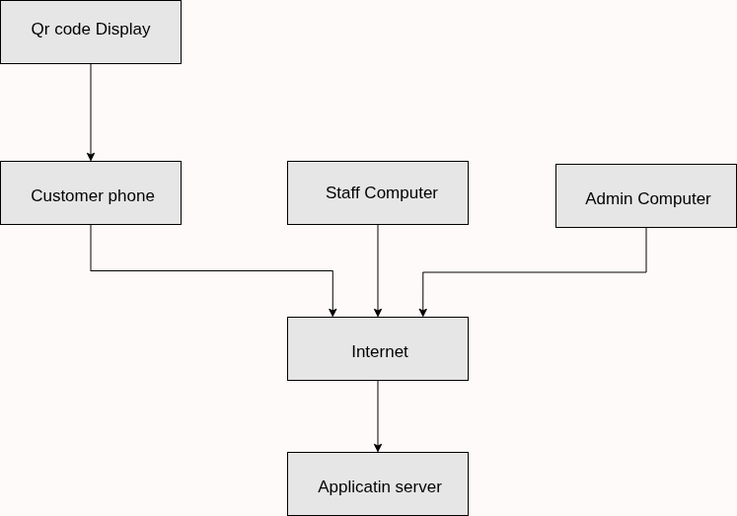
Figure 1 System Hardware Architecture

2.2 System Software Architecture
The system follows a three-tier software architecture consisting of frontend, backend, and database layers.
Presentation Layer: This is user interface which is play role for User interaction, display queue information and Send requests to backend. Technology used HTML, CSS, JavaScript React.js and React native.
Application Layer: This is layer which handle the business logic processing, Queue management, Authentication and authorization, API handling. Technology used is Django rest framework
Data Layer: This is where the system data stored, Manage data integrity and Support queries and reporting. Technology used is MySQL
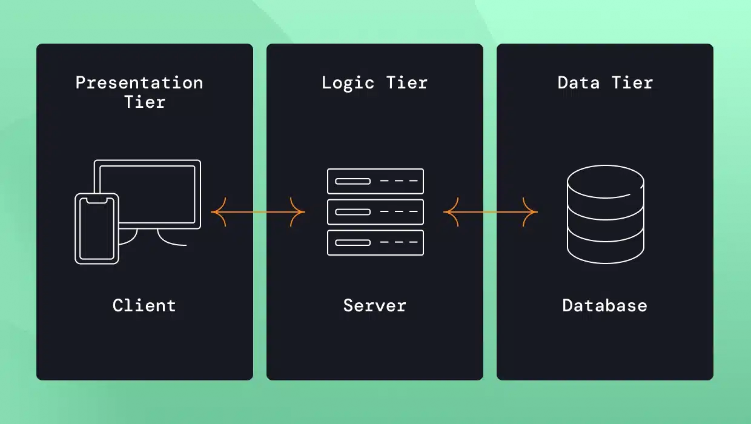
Figure 2 System Software Architecture

2.3 Internal Communications Architecture
Communication Between Frontend and Backend: The system uses RESTful APIs, Communication via HTTP/HTTPS protocols and all data is exchanged in JSON format
Communication Between Backend and Database: Backend communicates with database using Django ORM where all SQL queries are executed internally
User Interaction Flow
1. User scans QR
2. Frontend sends request to backend
3. Backend processes request
4. Backend interacts with database
5. Response is sent back to frontend
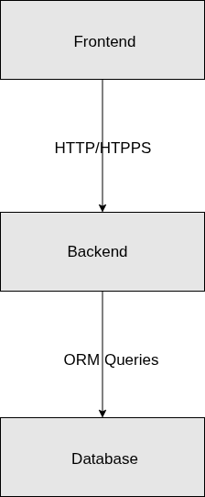
6. Frontend displays result to user
Figure 3 Internal Communication Architecture

FILE AND DATABASE DESIGN

3.1 Database Management System Files
The QueueXpress system uses MySQL Database Management System (DBMS) to store structured data.
The database is designed using relational principles and consists of the following main tables:
User Table
Stores all system users including staff and administrators.
FIELD | TYPE | DESCRIPTION | CONSTRAINT
id | INT (PK) | Unique identifier | PRIMARY KEY, AUTO_INCREMENT
name | VARCHAR | Full name | NOT NULL
phone | VARCHAR | Contact number | NOT NULL
role | ENUM (Staff or Admin) | User role for permission | NOT NULL, DEFAULT 'staff
password | VARCHAR | Encrypted password | NOT NUL
created at | DATETIME | Account creation date | DEFAULT CURRENT_TIMESTAMP

Service Table
Stores available services offered by the organization.
Field | Type | Description | CONSTRAINT
id | INT (PK) | Service ID | PRIMARY KEY, AUTO_INCREMENT
name | VARCHAR | Service name | NOT NULL
description | TEXT | Service description

Queue Table
Stores all queue entries generated when customers join the queue.

Field | Type | Description | CONSTRAINT
id | INT (PK) | Unique queue record ID | PRIMARY KEY, AUTO_INCREMENT
queue number | INT | Sequential queue number | NOT NULL
batch number | INT (FR) | Batch group number | NOT NULL
serviced | INT (FR) | Selected service | NOT NULL
phone_number | VARCHAR(15) | Customer phone number | NOT NULL
status | ENUM | waiting / active / served / skipped | NOT NULL, DEFAULT 'waiting'
created at | DATETIME | Time customer joined queue | DEFAULT CURRENT_TIMESTAMP
updated at | DATETIME | Last status update time | NULL
called_at | DATETIME | Time when customer was called by staff | NULL
served_at | DATETIME | Time when customer was served | NULL
served_by | INT (FK) | Staff who served the customer | NULL

Batch Table
Stores batch group information used for queue control.
Field | Type | Description | CONSTRAINT
id | INT (PK) | Batch ID | PRIMARY KEY, AUTO_INCREMENT
batch number | INT | Batch identifier | NOT NULL
Max size | INT | Number of users per batch | NOT NULL
status | ENUM | pending / active / completed | NOT NULL, DEFAULT 'pending '
batch_limit | INT | Max customers per batch | NOT NULL

Setting Table
Stores system settings for queue control.
Field | Type | Description | CONSTRAINT
id | INT (PK) | Batch ID | PRIMARY KEY, AUTO_INCREMENT
batch size | INT | Number of users per batch | NOT NULL
Queue reset | datetime | Time to reset queue | NOT NULL
created at | DATETIME | Time updated | DEFAULT CURRENT_TIMESTAMP
updated_at | DATETIME | Last update time | DEFAULT CURRENT_TIMESTAMP

Feedback Table
Stores customer feedback after service.
Field | Type | Description | CONSTRAINT
id | INT (PK) | Feedback ID | PRIMARY KEY, AUTO_INCREMENT
Queue id | INT (FK) | Linked queue entry | NOT NULL
message | TEXT | Feedback message
rating | INT | Rating (1–5)
created at | DATETIME | Time submitted | DEFAULT CURRENT_TIMESTAMP

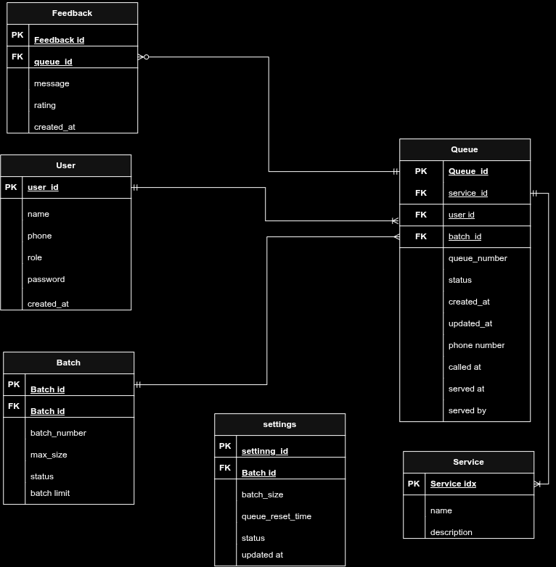
Figure 4 Entity Relationship Diagram

3.2 Non-Database Management System Files
QueueXpress uses the following non-DBMS files:
- Configuration Files (.env) which - Stores sensitive system settings such as Database credentials, Secret keys and Environment variables
- Static Files Used for user interface design such as CSS stylesheets, JavaScript files and Images and icons
- QR Code Assets Used for queue entry
- Backup Files Used for recovery in case of failure such as Database backup files

HUMAN-MACHINE INTERFACE

4.1 Inputs
Customer Inputs: Customers interact with the system without registration using simple inputs.
QR Code Scan Used to join the queue by scanning a QR code, Feedback Submission which include Text message input and Rating selection
Staff Inputs: Staff interact with the system through a dashboard interface. Call Next Customer Button to move queue forward, Serve Customer which Marks current customer as served and Skip Customer which Skips absent customer
Administrator Inputs: Administrators configure and manage the system. User Management Inputs Which Add staff/admin, Edit user details. Also, System Configuration Inputs include Set batch size Update system settings
Input Validation
- All inputs are validated to ensure correctness:
- Required fields must not be empty
- Rating must be within allowed range (1–5)
- Invalid QR codes are rejected
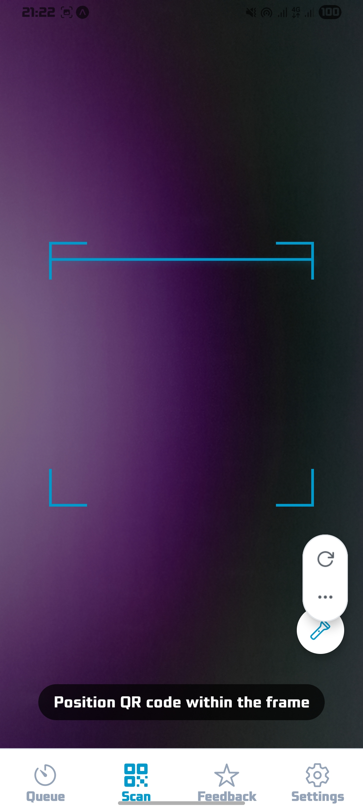
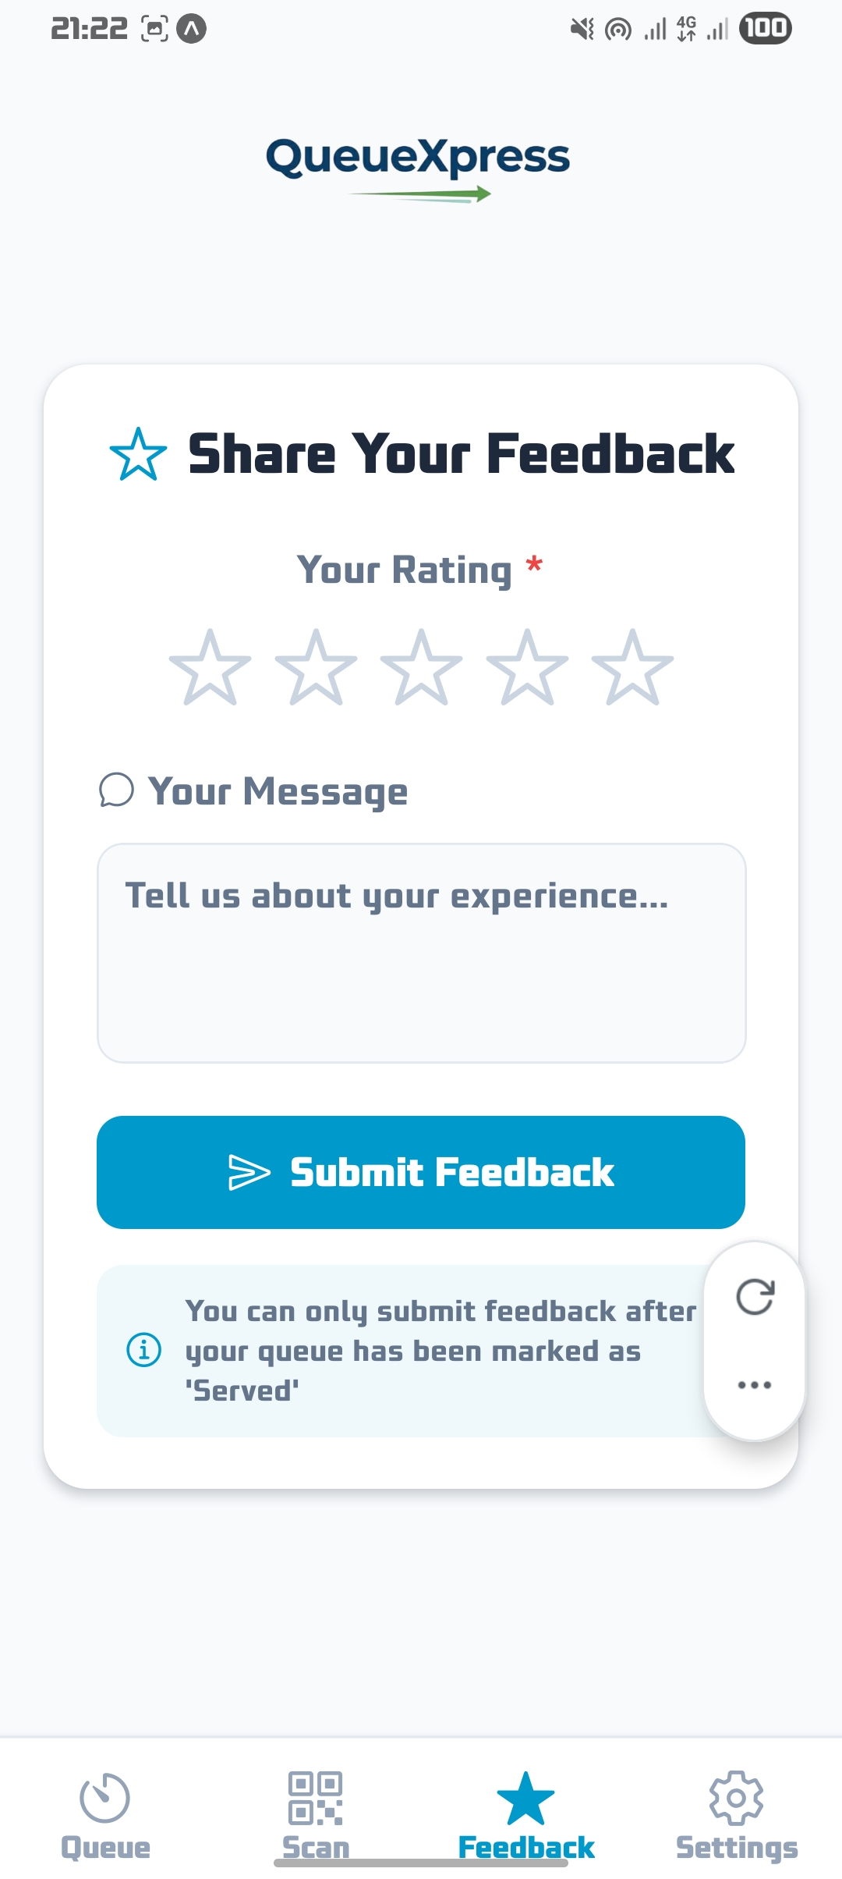
Figure 5 Qr code scanner and feedback submission page
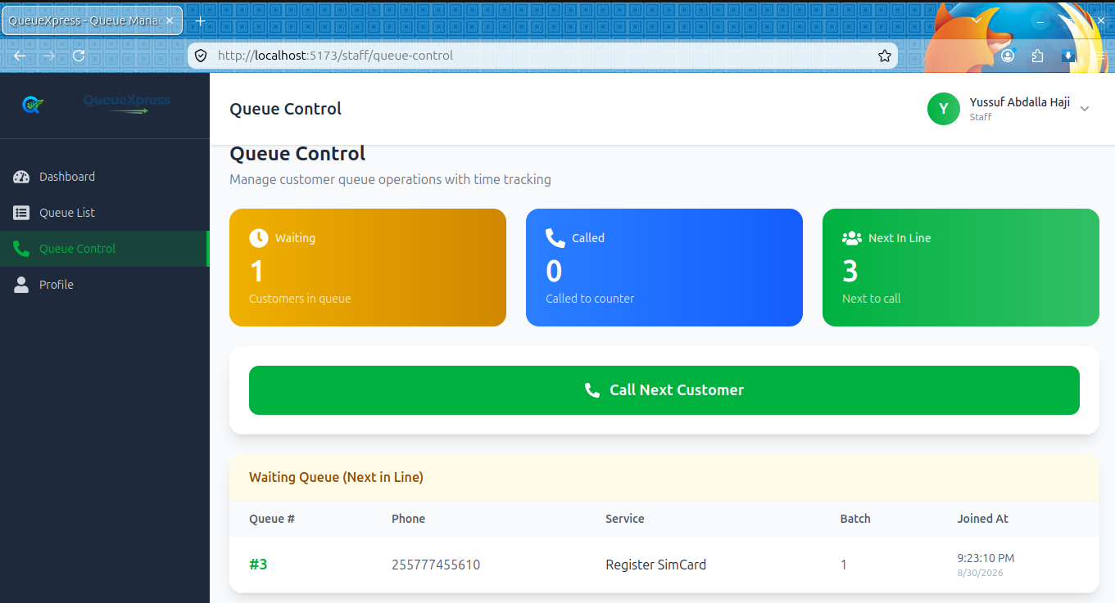
Figure 6 staff dashboard
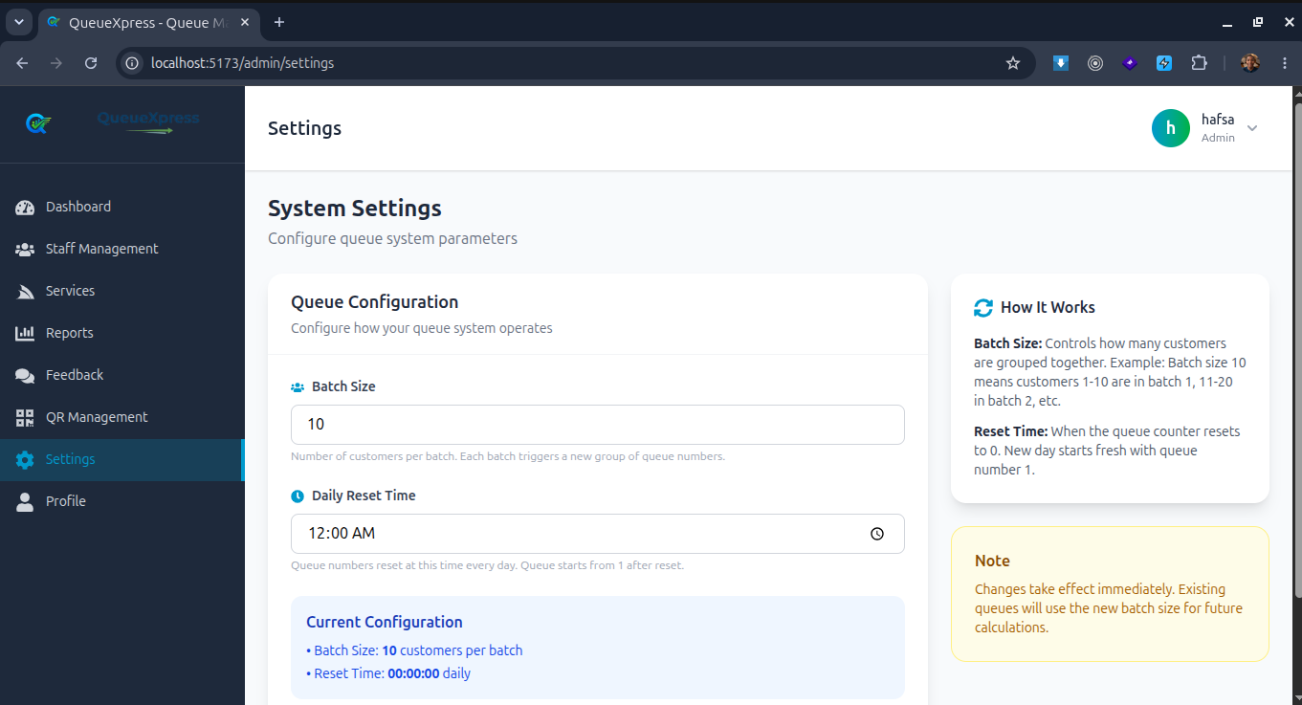
Figure 7 admin configure page

4.2 Outputs
QueueXpress generates outputs for customers, staff, and administrators
Customer Outputs: After joining the queue, customers receive Queue Number, Batch Number, estimated waiting time, Queue Status (waiting, active, served, skipped) and People Ahead
Staff Outputs: Staff dashboard displays Current queue number, List of upcoming customers, Queue progress
Administrator Outputs: Admin interface provides System usage reports, Number of customers served and Performance statistics, Average Response Time (time from called to served)
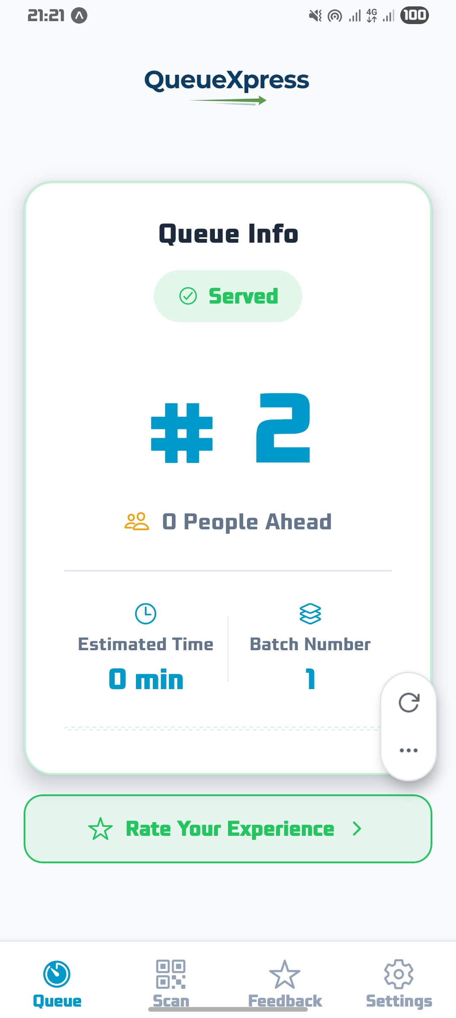
System Messages: The system provides feedback messages such as Successful queue entry and Error messages
Figure 8 queue details

DETAILED DESIGN

5.1 Hardware Detailed Design
Client Devices
These devices are used by end users to access the system.
a) Customer Devices
- Smartphones with camera capability
- Used for scanning QR codes and viewing queue status
b) Staff Devices
- Desktop or laptop computers
- Used to manage queue operations through dashboard
c) Administrator Devices
- Desktop or laptop computers
- Used for system configuration and monitoring
QR Code Infrastructure
- Printed QR code or digital display
- Positioned at service location
- Used as entry point to the system
Network Requirements
- Internet connectivity required

5.2 Software Detailed Design

5.2.1 System Modules
- Queue Entry Module
This module handles the core operation of adding a customer to the queue. When a customer scans the QR code, this module is invoked. It retrieves today's highest queue number, increments it, calculates the batch number, creates a new queue record, and returns the assigned numbers to the customer.
2. Batch Management Module
This module handles Controls grouping of customers. The batch is configured by admin with fixed number of user and when user scan Qr code automatically system assign it into current batch
- Queue Control Module
This is used by stuff. Staff member can click the "Call Next" button to call for the next customer and it updates that record's status to 'active', records the called timestamp. Also, staff can Marks a customer as served. This is typically called after the customer has completed their transaction. Updates status to 'served'. And finally, can click skip if the customer is absent in area
4. Feedback Module
Allows customers to submit feedback. Where the user must input the rate for services and feedback message. This will be store anonymous using queue id to protect customer
5. User Management Module
This module is Managed by admin to controll staff accounts include create, update, read or delete the user
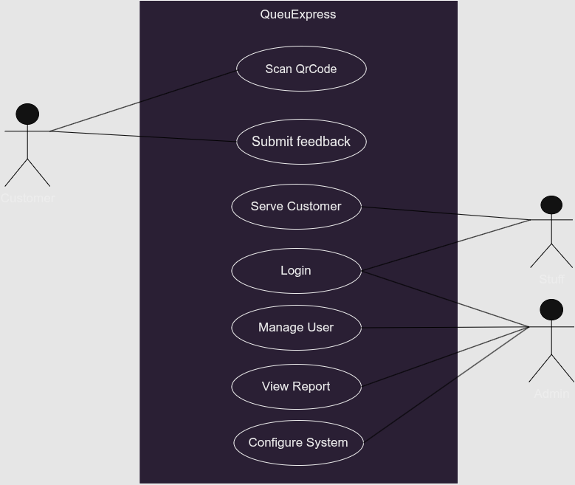
Figure 9 use case diagram

5.2.2 Processing Logic
a) Queue Assignment logic
1. Receive request from QR scan
2. Get last queue number
3. Increment queue number
4. Assign batch based on size
5. Check for duplicate active queue (same phone number with status 'waiting' or 'called')
6. Save record
7. Return queue details
b) Batch Allocation Algorithm
1. Count users in current batch
2. If count < 10 → assign same batch
3. Else → create new batch
4. Assign new batch number
c) Queue Processing Algorithm
1. Staff clicks "Call Next"
2. Select next waiting queue
3. Update status to "called"
4. Record called_at timestamp
d) Skip Logic
1. If customer absent
2. Staff clicks skip
3. Update status to "skipped"
4. Move to next queue
d) Serve Logic
    - Staff clicks "Serve"
    - Update status to "served"
    - Record served_at timestamp
    - Record served_by (staff ID)

5.3 Internal Communications Detailed Design
Frontend to Backend Communication
- Protocol: HTTP/HTTPS
- Format: JSON
- Method: REST API
Backend to Database Communication
- Uses Django ORM
- Executes SQL queries internally
Communication Flow
1. User action (scan or click)
2. Frontend sends API request
3. Backend processes logic
4. Backend queries database
5. Response sent to frontend
6. Frontend updates UI
Figure 10 Communication Diagram
Error Communication Handling
Backend returns error messages
Frontend displays user-friendly alerts
Security in Communication
HTTPS encryption
Input validation
Authentication for staff/admin

EXTERNAL INTERFACES

6.1 Interface Architecture
The system uses a client-server interface architecture, where users interact through the frontend, which communicates with the backend services.
User Interfaces
The system provides interfaces for:
Customers: Access interfaces via smartphone which enable to Scan QR code, join queue and View queue status
Staff: Stuff Access Dashboard interface which enable to Manage queue operations
Administrators: Admin has Control panel interface which enable admin to Manage users and system settings
Hardware Interfaces
The system interacts with:
- Smartphone cameras for QR scanning
- Computers for staff and admin dashboards
- QR code display wither printed or digital
Software Interfaces
The system integrates internal software components:
- Frontend (React)
- Backend (Django)
- Database (MySQL)
Communication Interfaces
Communication is handled using RESTful APIs in JSON data format through HTTP/HTTPS protocols

6.2 Interface Detailed Design
Customer Interface Design
Input:
QR code scanning
Feedback submission
Output
Queue number
Batch number
Queue status
Notifications
Staff Interface Design
Input:
Call next
Serve customer
Skip customer
Output
Current queue
Next queue list
Queue updates
Administrator Interface Design
Input
- Add/edit users
- Configure system
Output:
Reports
System status
User management data
API Interface Design
The system uses REST APIs for communication.
Endpoint | Method | Description
/api/join/ | POST | Customer joins queue
/api/queue/status/<queue_id>/ | GET | Get queue status
/api/feedback/ | POST | Submit feedback
/api/staff/call-next/ | POST | Staff calls next customer
/api/staff/serve/<queue_id>/ | POST | Staff serves customer
/api/staff/skip/<queue_id>/ | POST | Staff skips customer
/api/staff/queue-list/ | GET | Staff views waiting queues
/api/admin/dashboard-stats/ | GET | Admin dashboard stats (includes response time)
/api/admin/report/ | GET | Admin report data
/api/admin/feedback/ | GET | Admin views feedback
/api/admin/settings/ | PUT | Admin updates settings
/api/admin/services/ | GET/POST | Admin manages services
/api/admin/staff/ | GET/POST | Admin manages staff

Data Format
All data exchanged uses JSON format
Error Handling in Interfaces
Invalid requests return error messages
Network issues handled with retry mechanisms
User-friendly messages displayed
Security in Interfaces
- HTTPS communication
- Input validation
- Authentication for staff/admin

SYSTEM INTEGRITY CONTROLS

7.1 Internal Security
QueueXpress implements multi-layered security controls to protect sensitive information.
Authentication Controls:
Password Hashing: Passwords are hashed using bcrypt algorithm with
JWT Authentication: Access tokens expire after 24 hours, refresh tokens after 7 days
Token Management: Tokens stored in localStorage (web) and AsyncStorage (mobile)
Authentication: Admin uses username + password; Staff uses work_id + password
Session Fixation Prevention: Session identifier is regenerated after successful login
Login Rate Limiting: Planned for future implementation
HTTPS Enforcement
Authorization (Role-Based Access Control
Customer will have full access into customer page only and restriction to the staff and admin dashboard
staff will have full access into customer and staff dashboard page and restriction to the admin dashboard
adman will have full access the whole system

7.2 Audit Procedures
The following events are logged in the logs table:
Authentication audit Login success, login failure, logout, password change
Queue Operations auditing Call next, serve, skip
User Management audit Staff creation, staff edit, staff disable, role change
System Configuration audit Batch size change, reset time change

7.3 Data Validation Controls
Client-side (JavaScript) Type checking, format validation, required field checking and Immediate feedback to user before submission
Server-side (Django Forms and Serializers) Type checking, format validation, length checking, range checking, business logic validation for Primary defense against invalid data |
Duplicate Queue Prevention: System checks if a phone number already has an active queue (status = 'waiting' or 'called') before creating a new entry. If a duplicate is found, the existing queue info is returned instead of creating a new one.
Database Column data types, constraints, foreign key integrity

