DOCUMENT  
SOFTWARE NEED SPECIFICATIONS

I’SCHOOL

for:

Sageri

Arranged by:

|  |  |  |
| --- | --- | --- |
| Muhamad Hafidh Nofal | 1301174494 | Project Leader |
| Mohamad Ichwan Arrasid | 1301174580 | Analyst |
| Naufal Adi Nugroho | 1301174510 | Analyst |
| Ilham Muhamad Nizar | 1301174523 | Designer |
| I Putu Ananda Miarta U | 1301174616 | Designer |

Prodi Teknik Informatika – Universitas Telkom

2016

|  |  |  |  |  |
| --- | --- | --- | --- | --- |
| D:\BPP\Logo Tel-U\TU-logo-primer-memusat.jpg | **Prodi S1- Teknik Informatika**  **Universitas Telkom** | Nomor Dokumen | | Halaman |
| *SKPL-003* | | *1 / 69* |
| Revisi | *-* | *18 MARET 2018* |

List of Changes

|  |  |
| --- | --- |
| Revision | Description |
| A |  |
| B |  |
| C |  |
| D |  |
| E |  |
| F |  |
| G |  |

|  |  |  |  |  |  |  |  |  |
| --- | --- | --- | --- | --- | --- | --- | --- | --- |
| INDEX  TGL | - | A | B | C | D | E | F | G |
| Ditulis oleh |  |  |  |  |  |  |  |  |
| Diperiksa oleh |  |  |  |  |  |  |  |  |
| Disetujui oleh |  |  |  |  |  |  |  |  |

List of Page’s Changes

|  |  |  |  |
| --- | --- | --- | --- |
| Page | Revision | Page | Revision |
|  |  |  |  |

Daftar Isi

1 Preliminary 7

1.1 Purpose of Writing Documents 7

1.2 Scope of the problem 7

1.3 Definitions and Terms 8

1.4 Naming and numbering rules 8

1.5 References 8

1.6 document overview 8

2 General Software Description 9

2.1 General System Description 9

2.2 Product Function 9

2.3 characteristic of users 10

2.4 Limitation 10

2.5 Operating Environment 11

3 General Descriptions of Needs 11

3.1 External Interface Requirement 11

3.1.1 Users Interface 11

3.1.2 Hardware Interface 11

3.1.3 Software Interface 12

3.1.4 Communication Interface 12

3.2 Fungsional Description 13

3.2.1 Use Case Diagram 13

3.2.2 Function 1: Login 13

3.2.2.1 Scenario View Schedule 13

3.2.3 Function 2 : View Schedule 15

3.2.3.1 Skenario : Kelola User 15

3.2.4 Function 3 : View Grade 16

3.2.4.1 Skenario : View Grade 16

3.2.5 Function 4 : View Attend 18

3.2.5.1 Skenario : View Attend 18

3.2.6 Function 5 : View Materials 19

3.2.6.1 Skenario : View Materials 19

3.2.7 Function 6 : View Assignment 20

3.2.7.1 Skenario : View Assignment 20

3.2.8 Function 7 : Upload Assigment 22

3.2.8.1 Skenario : Upload Assignment 22

3.2.9 Function 8 : View Student Info 23

3.2.9.1 Skenario : View Student Info 23

3.2.10 Function 9 : View Teacher Info 24

3.2.10.1 Skenario : View Teacher Info 24

3.2.11 Function 10 : View Parent Info 25

3.2.11.1 Skenario : View Parent Info 25

3.2.12 Class Diagram 26

3.2.13 Class Diagram 27

List of Table

Table 1 Naming and Numbering Rules 8

Table 2 User Characteristics 10

Table 3 Login Scenario 13

Table 4 View Schedule Scenario 15

Tabel 5 View Grade Scenario 16

Table 6 View Attend Scenario 18

Table 7 View Materials Scenario 19

Table 8 View Assignment Scenario 20

Table 9 Upload Assignment 22

Table 10 View Student Info Scenario 23

Table 11 View Teacher Info Scenario 24

Table 12 View Parent Info Scenario 25

Picture List

Gambar 1 Use Case Diagram 13

Gambar 2 Class Diagram 26

Gambar 3 ERD 27

# Preliminary

## Purpose of Writing Documents

This document contains an explanation of the Software Requirements Specification (SRS) with a process-oriented approach to the software that will be created.

## Scope of the Problem

The purpose of writing this document is to describe the stages of the process of making software to be built. For the developer, this SKPL can be used as a reference in developing software in detail so that the software is built according to the needs of the user. It is expected that with this SKPL document, software development is more directed towards the purpose of developing this software. As for users, this SKPL document is used to record the specifications of software requirements to be built and expectations that the user wants.

## Definitions and Terms

Berikut adalah daftar definisi dan istilah penting yang digunakan dalam dokumen SKPL ini:

* SKPL : Software Requirements Specification Document analysis that contains software requirements specifications.
* IEEE : *Institute of Electrical and Electronics Engineering* Standar internasional

For product development and design

* ANSI : *American National Standard Institute* is a standardization institute in america
* *Use Case Diagram* :A graph of some or all actors, use case and the interaction
* TBD : *To be defined*

## Naming and numbering rules

Writing this SKPL document uses a variety of different naming and numbering rules for certain parts. The rules for naming and numbering that are used based on these things / sections are as listed in Table 1 below.

Tabel 1 Naming and Numbering Rules

| **Thing / section** | **Numbering / Naming Rules** |
| --- | --- |
| Functional Needs | SKPL-Fxx : Shows xx Functional Needs |
| Non Functional Needs | SKPL-NFxx : Shows xx non-functional requirements |
| Summary of Functional Needs | SKPL-Fxxx where xxx is a three digit integer starting from 001 |
| Summary of Non-Functional Needs | SKPL-NFxxx where xxx is a three digit integer starting from 001 |

## References

## Document overview

This SKPL document is divided into three main parts. The main section contains an explanation of the skpl document which includes the purpose of making this document, the scope of the problem solved by the software, the definitions and terms contained in this document, the rules for naming and numbering, references to making documents and recommendations for the entire contents of this document. The second part contains a general description of the software to be developed.

# General Software Description

## The global description described in SKPL includes general software descriptions, software functions, user characteristics, limitations, and assumptions and software dependence.

## General System Description

## Product Function

This software has several main functions, among others:

1. Login
2. View Schedule
3. Input Schedule
4. View Grade
5. Input Grade
6. View Attendance
7. Input Attendance
8. View Materials
9. Input Materials
10. View Assignment
11. Input Assignment
12. Download Assignment
13. Upload Assignment
14. View Parent Information
15. Input Parent Information
16. View Student Information
17. Input Student Information
18. View Teacher Information
19. Input Teacher Information

## Characteristics of Users

User characteristics are described in the following table.

Table 2 User Characteristics

| **User Category** | **Task** | **Access rights to the application** | **A must-have ability** |
| --- | --- | --- | --- |
| Admin | Input the data for Student, Teacher, and Parent. View the information of Student, Teacher and Parent | -Login  -Update User Profile  -Manage User  -Reset Password | -Admin have to understand about database and etc.  -Can operate the Computer and application. |
| Student | View the Schedule, Grade, Attendance, Material, and Assignment. Upload assignment, and download material | -Login  -Update/Change Password  -View Schedule  -View Grade  -View Attendance  -View and Download Material  -View and Upload Assignment | -can operate the computer and application |
| Teacher | Input and View the Grade, and Attendance. View and Upload Assignment. View and Upload Material. View Schedule and Profile | -Login  -Update/Change Password  -View Schedule  -Input Grade  -Input Attendance  -Input/Upload Material  -Input/Upload Assignment  -View Profile  -View Material  -View Grade | -can operate the computer and application. |
| Parent | View Schedule, Attendance and Profile | -Login  -Update/Change Password  -View Schedule  -View Attendance  -View Profile | -can operate the computer and application |

## Limitation

Limitations that are used in developing this software are:

1. Software is web application based.

2. Software is built using Java Script, PHP, HTML,CSS,My and the database using

MySQL.

## Operating environment

Asumsi-asumsi pada perangkat lunak ini adalah:

1. Users are divided into 4 roles, Admin, Students, Teachers, ParentsSemua user dapat update password.
2. Admin can manage users, reset passwords and database backups.
3. The teacher can upload assignments, input grade, upload material, and input student attendance
4. Student can View the Schedule, Grade, Attendance, Material, and Assignment. Upload assignment, and download material
5. Teacher can Input and View the Grade, and Attendance. View and Upload Assignment. View and Upload Material. View Schedule and Profile.
6. Parent can view schedule, attendance, and profile

# General Descriptions of Needs

## External Interface Requirements

### Users Interface

### The user interface will be developed using graphical mode and based on Executeable Windows Programs. Users interact with software through the program interface. I’School receives input from actors that will be described in the Use Case Diagram and the output of this software is a message or hard copy of the report.

### Hardware Interface

Hardware Requirement:

* Any resolution screens
* Processor intel Pentium 4
* RAM 1 GB
* HardDisk 500GB
* LAN
* Internet
* Mouse & Keyboard

Hardware Requirement :

* Display Resolution 640 x 480
* Processor Intel Dual Core 1Ghz
* RAM 512MB
* HDD 128 GB
* LAN
* Internet
* Mouse & Keyboard

### Software Interface

Software Requirements:

* Operating system
* MySQL DBMS
* New version of browser

Software Facts:

• Windows XP 32bit Operating System

### Communication Interface

Communication needs of several computer interfaces for each role are connected Client-Server within the scope of internet networks based on Transmission Control Protocol / Internet Protocol.

## Fungsional Description

### Use Case Diagram

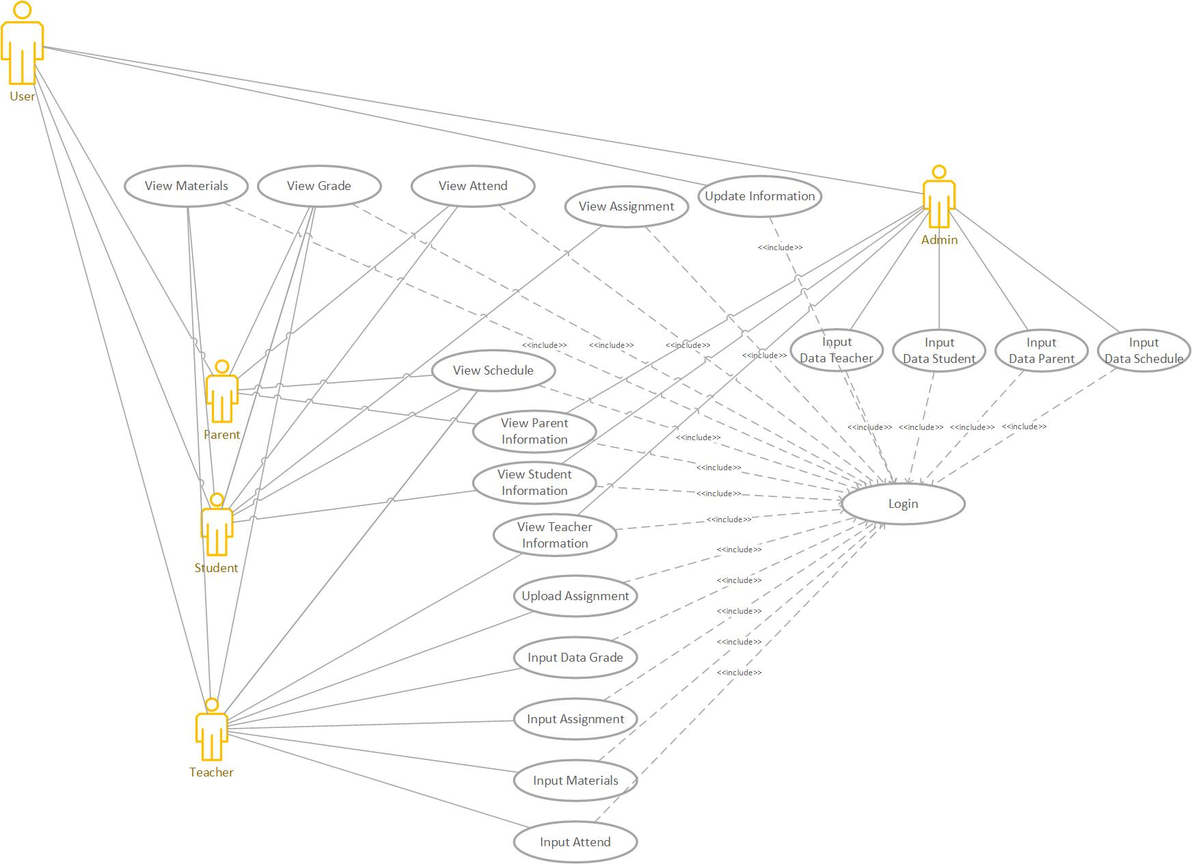

Picture 1 Use Case Diagram

### Function 1: Login

#### The Login Procedure functions as a gateway to enter the module module next to the role user.

#### Scenario: Login

Tabel 3 Skenario Login

|  |  |
| --- | --- |
| Nama Use-Case | Login |
| ID Use-Case | UC-01 |
| Priority | High |
| Source | - |
| Primary Business Actor | Student, Parent, Admin, Teacher |

|  |  |  |
| --- | --- | --- |
| Other Participating Actor | - | |
| Other Interested Stakeholders | - | |
| Deskription | User: Admin, Student, Teacher, Parent  Enter your Username and Password to enter the I’School menu. | |
| Precondition | User have to created an account. | |
| Trigger | Use-Case will show when user open the application. | |
| Scenario |  | |
| Normal | Actor Action | System Response |
|  | 1. Enter *Username and* *Password* |  |
|  |  | 1. Check whether or not the valid data username and password entered by the user. |
|  |  | 1. Checking role users who enter their Username and Password to then enter the I’School menu according to the role. |
| Alternative | 1. User enter *Username and* *Password* |  |
|  |  | 1. The system checks for valid or not data Username and Password entered by the user. |
|  |  | 1. Showing invalid messages |
|  | 1. User enter *Username and* *Password* |  |
|  |  | 1. 5. The system checks whether or not the data username and password entered by the user is valid. |
|  |  | 1. 6. The system checks for role users who enter their Username and Password to enter the I’School Information System menu according to the role. |

### Function 2: View Schedule

#### The View Schedule Procedure functions is for check the schedule for users.

#### Scenario: View Schedule

Table 4 View Schedule Scenario

|  |  |  |
| --- | --- | --- |
| Nama Use-Case | View Schedule | |
| ID Use-Case | UC-02 | |
| Priority | High | |
| Source | - | |
| Primary Business Actor | Student, Parent, Admin, Teacher | |
| Other Participating Actor | - | |
| Other Interested Stakeholders | - | |
| Deskription | User: Admin, Student, Teacher, Parent  If user want to see the schedule, they can use view schedule feature. | |
| Precondition | User already login in to the system. | |
| Trigger | System will show the schedule. | |
| Scenario |  | |
| Normal | Actor Action | System Response |
|  | 1. User already login |  |
|  | 1. User want check the schedule |  |
|  | 1. And choose view schedule |  |
|  |  | 1. System will be showing the schedule |
| Alternative | 1. User already login |  |
|  | 1. User want check the schedule |  |
|  | 1. And choose view schedule |  |
|  |  | 1. If there is no schedule inputted by admin it will show “there is no schedule inputted” |

### Function 3: View Grade

#### Teacher, Parent and Student can view the grade of the student in this feature.

#### Scenario: View Grade

Table 5 View Grade Scenario

|  |  |  |
| --- | --- | --- |
| Nama Use-Case | View Grade | |
| ID Use-Case | UC-03 | |
| Priority | High | |
| Source | - | |
| Primary Business Actor | Student, Parent, Teacher | |
| Other Participating Actor | - | |
| Other Interested Stakeholders | - | |
| Deskription | User: Student, Teacher, Parent  If user want to see the grade, they can use view grade feature. | |
| Precondition | User already login in to the system. | |
| Trigger | System will show the grade. | |
| Scenario |  | |
| Normal | Actor Action | System Response |
|  | 1. User already login |  |
|  | 1. User want check the grade |  |
|  | 1. And choose view grade |  |
|  |  | 1. System will be showing the grade |
| Alternative | 1. User already login |  |
|  | 1. User want check the grade |  |
|  | 1. And choose view grade |  |
|  |  | 1. If there is no value of the grade, the system just will show the subject name |

### Function 4: View Attend

#### Teacher, Parent and Student can view the attend of the student in this feature.

#### Scenario: View Attend

Table 6 View Attend Scenario

|  |  |  |
| --- | --- | --- |
| Nama Use-Case | View Attend | |
| ID Use-Case | UC-03 | |
| Priority | High | |
| Source | - | |
| Primary Business Actor | Student, Parent, Teacher | |
| Other Participating Actor | - | |
| Other Interested Stakeholders | - | |
| Deskription | User: Student, Teacher, Parent  If user want to see the attend, they can use view attend feature. | |
| Precondition | User already login in to the system. | |
| Trigger | System will show the student attendance. | |
| Scenario |  | |
| Normal | Actor Action | System Response |
|  | 1. User already login |  |
|  | 1. User want check the attend |  |
|  | 1. And choose view attend |  |
|  |  | 1. System will be showing the attend |
| Alternative | 1. User already login |  |
|  | 1. User want check the attend |  |
|  | 1. And choose view attend |  |
|  |  | 1. If there is no value of the attend, the system just will show the last student attendance. |

### Function 5: View materials

#### Teacher and Student can view the materials in this feature.

#### Scenario: View Materials

Table 7 View Materials Scenario

|  |  |  |
| --- | --- | --- |
| Nama Use-Case | View Material | |
| ID Use-Case | UC-03 | |
| Priority | High | |
| Source | - | |
| Primary Business Actor | Student, Teacher | |
| Other Participating Actor | - | |
| Other Interested Stakeholders | - | |
| Deskription | User: Student, Teacher  If user want to see the material and download, they can use view materials feature. | |
| Precondition | User already login in to the system. | |
| Trigger | System will show the material. | |
| Scenario |  | |
| Normal | Actor Action | System Response |
|  | 1. User already login |  |
|  | 1. User want check the Materials |  |
|  | 1. And choose view Materials |  |
|  |  | 1. System will be showing the material |
| Alternative | 1. User already login |  |
|  | 1. User want check the material |  |
|  | 1. And choose view material |  |
|  |  | 1. If there is no value of the material, the system just will show the last material and if there is no material uploaded it will show “no material uploaded” |

### Function 6: View Assignment

#### Teacher and Student can view the assignment in this feature.

#### Scenario: View Assignment

Table 8 View Assignment Scenario

|  |  |  |
| --- | --- | --- |
| Nama Use-Case | View assignment | |
| ID Use-Case | UC-03 | |
| Priority | High | |
| Source | - | |
| Primary Business Actor | Student, Teacher | |
| Other Participating Actor | - | |
| Other Interested Stakeholders | - | |
| Deskription | User: Student, Teacher  If user want to see the assigment, they can use view assigment feature. | |
| Precondition | User already login in to the system. | |
| Trigger | System will show the assigment. | |
| Scenario |  | |
| Normal | Actor Action | System Response |
|  | 1. User already login |  |
|  | 1. User want check the assignment |  |
|  | 1. And choose view assignment |  |
|  |  | 1. System will be showing the assignment |
| Alternative | 1. User already login |  |
|  | 1. User want check the assignment |  |
|  | 1. And choose view assignment |  |
|  |  | 1. If there is no value of the assigment, the system just will show the last assignment and if there is no assignment uploaded “there is no assignment” |

### Function 7: Upload Assignment

#### Teacher and Student can upload the assignment in this feature.

#### Scenario: Upload Assignment

Table 9 Upload Assignment

|  |  |  |
| --- | --- | --- |
| Nama Use-Case | Upload Assignment | |
| ID Use-Case | UC-03 | |
| Priority | High | |
| Source | - | |
| Primary Business Actor | Student, Teacher | |
| Other Participating Actor | - | |
| Other Interested Stakeholders | - | |
| Deskription | User: Student, Teacher  If teacher want to upload the assignment, teacher can choose the feature upload, and if student want to upload answer assignment, student can choose the feature upload. | |
| Precondition | User already login in to the system. | |
| Trigger | System will upload assignment | |
| Scenario |  | |
| Normal | Actor Action | System Response |
|  | 1. User already login |  |
|  | 1. User want upload the assignment |  |
|  | 1. And choose upload assignment |  |
|  |  | 1. System will be uploading the assignment |
| Alternative | 1. User already login |  |
|  | 1. User want upload the assignment |  |
|  | 1. And choose upload assignment |  |
|  |  | 1. If the student/teacher already upload the assignment it will show the uploaded file. |

### Function 8: View Student Info

#### Student and Admin can view the profile of student.

#### Scenario: View Student Info

Table 10 View Student Info Scenario

|  |  |  |
| --- | --- | --- |
| Nama Use-Case | View Student Info | |
| ID Use-Case | UC-03 | |
| Priority | High | |
| Source | - | |
| Primary Business Actor | Student, admin | |
| Other Participating Actor | - | |
| Other Interested Stakeholders | - | |
| Deskription | User: Student, admin  If user want to see student info, they can use view student info feature. | |
| Precondition | User already login in to the system. | |
| Trigger | System will show student info | |
| Scenario |  | |
| Normal | Actor Action | System Response |
|  | 1. User already login |  |
|  | 1. User want check the student info |  |
|  | 1. And choose view student info |  |
|  |  | 1. System will be showing the student info |

### Function 9: View Teacher Info

#### Teacher and Admin can view the profile of teacher.

#### Scenario: View Teacher Info

Table 11 View Teacher Info Scenario

|  |  |  |
| --- | --- | --- |
| Nama Use-Case | View Teacher info | |
| ID Use-Case | UC-03 | |
| Priority | High | |
| Source | - | |
| Primary Business Actor | Admin, Teacher | |
| Other Participating Actor | - | |
| Other Interested Stakeholders | - | |
| Deskription | User: admin, Teacher  If user want to see the teacher info, they can use view teacher info | |
| Precondition | User already login in to the system. | |
| Trigger | System will show the teacher info | |
| Scenario |  | |
| Normal | Actor Action | System Response |
|  | 1. User already login |  |
|  | 1. User want check the teacher info |  |
|  | 1. And choose view teacher info |  |
|  |  | 1. System will be showing the teacher info |

### Function 10: View Parent Info

#### Parent and Admin can view the profile of the parent.

#### Scenario: View Parent info

Table 12 View Parent Info Scenario

|  |  |  |
| --- | --- | --- |
| Nama Use-Case | View parent info | |
| ID Use-Case | UC-03 | |
| Priority | High | |
| Source | - | |
| Primary Business Actor | Parent, admin | |
| Other Participating Actor | - | |
| Other Interested Stakeholders | - | |
| Deskription | User: Admin, Parent  If user want to see the parent info, they can use view parent info feature. | |
| Precondition | User already login in to the system. | |
| Trigger | System will show the parent info. | |
| Scenario |  | |
| Normal | Actor Action | System Response |
|  | 1. User already login |  |
|  | 1. User want check the parent info |  |
|  | 1. And choose view parent info |  |
|  |  | 1. System will be showing the parent info |

### Class Diagram

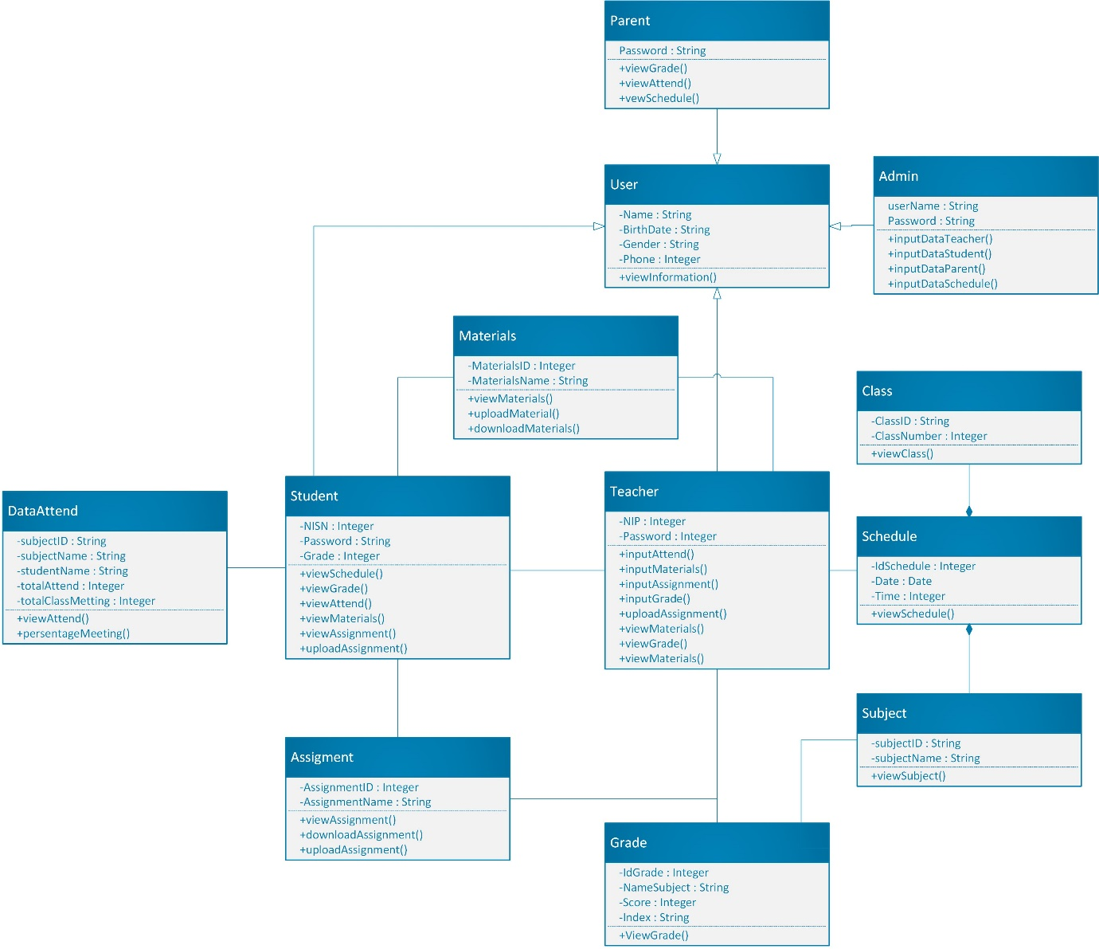

Picture 2 Use Class Diagram

### ERD

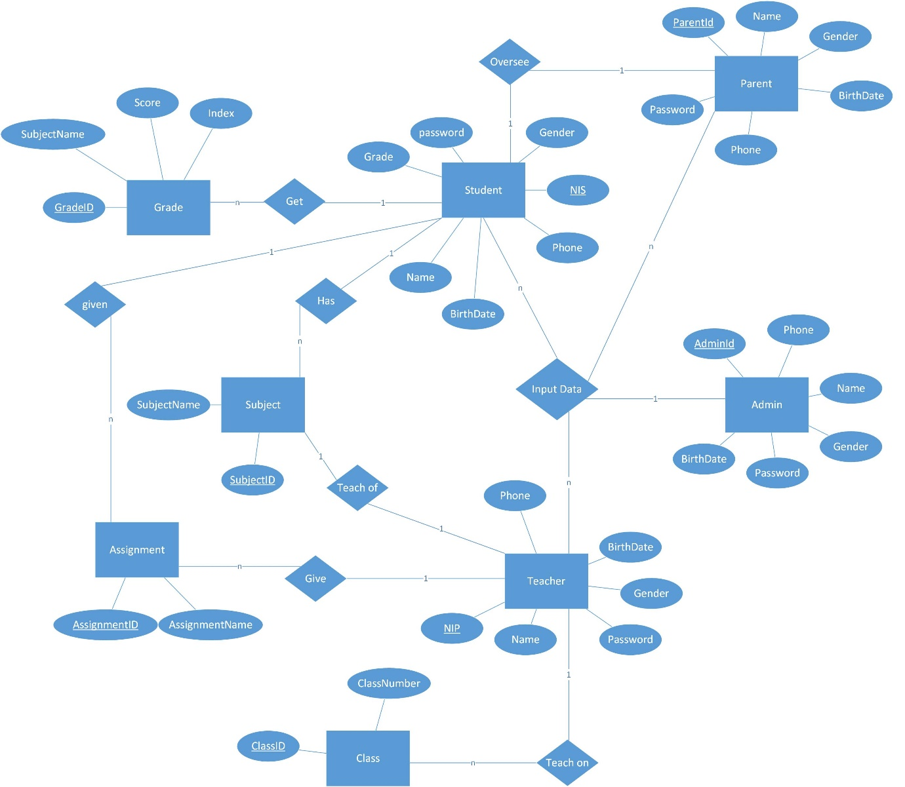

Picture 3 ERD