CMB 66

Admin Panel
CMB 66 Management
- dashboard Dashboard
- inventory_2 Products
- shopping_bag Orders
- group Customers
- settings Settings
add Add Product

Product Management
Manage inventory, pricing, and product details.

search
filter_list

Total Products
1,248
inventory_2

Low Stock Alerts
24
warning

Active Categories
12
category

Image | Product Name | Category | Price | Stock | Actions
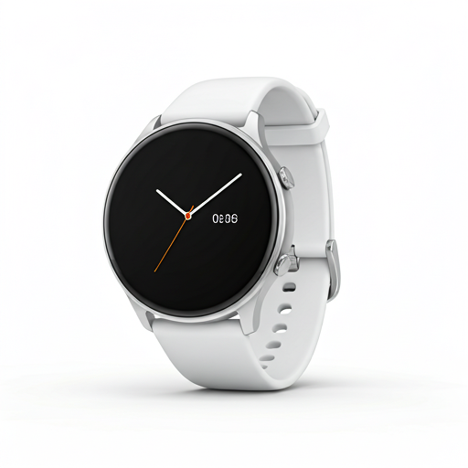 | Premium Smartwatch | Electronics | $299.99 | 145 | edit delete
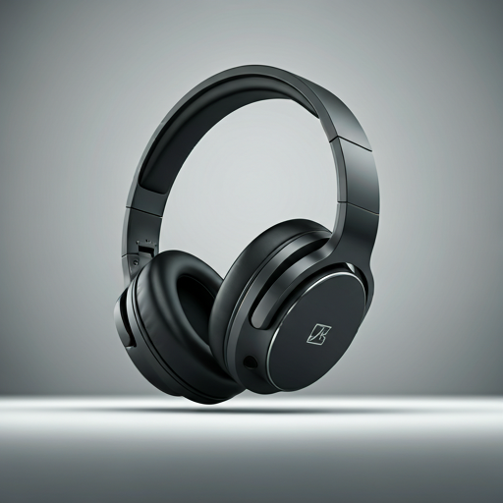 | Noise-Cancelling Headphones | Audio | $199.50 | 12 | edit delete
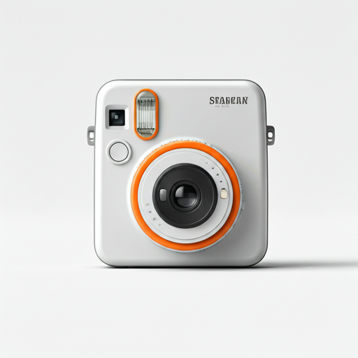 | Retro Instant Camera | Photography | $89.99 | Out of Stock | edit delete
Showing 1 to 3 of 1,248 entries
chevron_left 1 2 3 ... chevron_right

Add New Product
close

add_photo_alternate
Click to upload product image
PNG, JPG, WebP up to 5MB

Product Name
Category Select a category... Electronics Furniture Apparel
Price ($)
Initial Stock
Description
Cancel Save Product

