CMB 66
Admin Panel
CMB 66 Management
dashboard Dashboard inventory_2 Products shopping_bag Orders group Customers settings Settings
add Add Product

Admin User
Manager

menu
CMB 66
qr_code_scanner
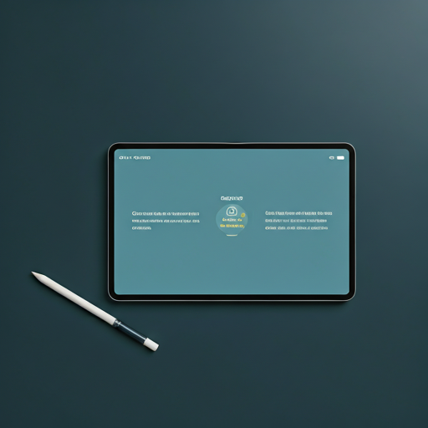

Kamera Aktif - Arahkan ke QR Code
keyboard Input Manual Nomor Pesanan
flashlight_on cameraswitch

check_circle
QR Valid
close

ID Pesanan
#ORD-8829

Detail Barang:

apparel
Classic Black Tee
Ukuran: L
Qty: 1

Budi Santoso
Customer

Serahkan Barang?
cancel Batal check Ya, Serahkan

