arrow_back Back to Cart
CMB 66
lock Secure Checkout

Checkout

local_shipping Delivery Information
Edit

Full Name
Phone Number
Email Address

storefront Fulfillment Method

School Pickup
Collect your items directly from the CMB 66 campus front office.
Free

Direct Delivery
Items shipped via standard courier to your provided address.
From Rp 15.000
Order Notes (Optional)

Order Summary

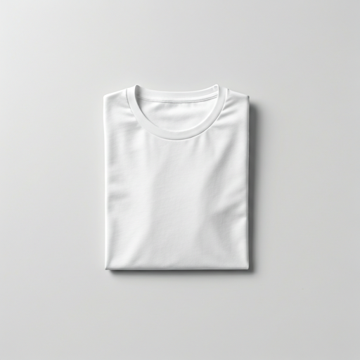

CMB 66 Official T-Shirt
Size: M, Color: White
Rp 150.000
- 1 +

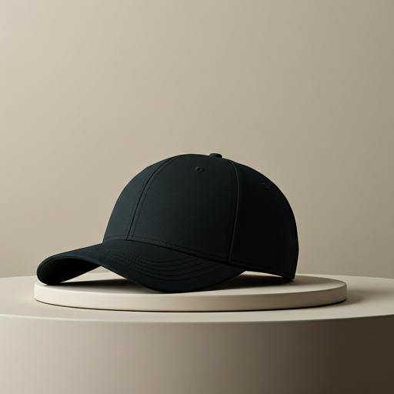

Classic Logo Cap
Size: One Size, Color: Black
Rp 85.000
- 2 +
Promo Code
Apply

Subtotal (3 items) Rp 320.000
Delivery (School Pickup) Rp 0
Discount - Rp 0
Total Rp 320.000
lock Place Order
verified_user Payments are secure and encrypted.

M
Midtrans Checkout
close

C66

CMB 66
Rp 320.000
Order #CMB-88291

Select Payment Method

account_balance Virtual Account
chevron_right
credit_card Credit / Debit Card
chevron_right
qr_code_scanner QRIS
chevron_right
account_balance_wallet GoPay / e-Wallet
chevron_right
lock Secured by Midtrans

