# Lab Task (20th Jan 2019)

* Make an android ‘Contact’ App to save and show contacts.
* App contains the following fields:

1. Contact Image
2. Contact Name
3. Contact Number (with type : Mobile, Home, Work)
4. Address (with type : Home, Work)
   1. House No.
   2. Block
   3. City
   4. Country
5. Contact Email

* Address should be an embedded object.
* 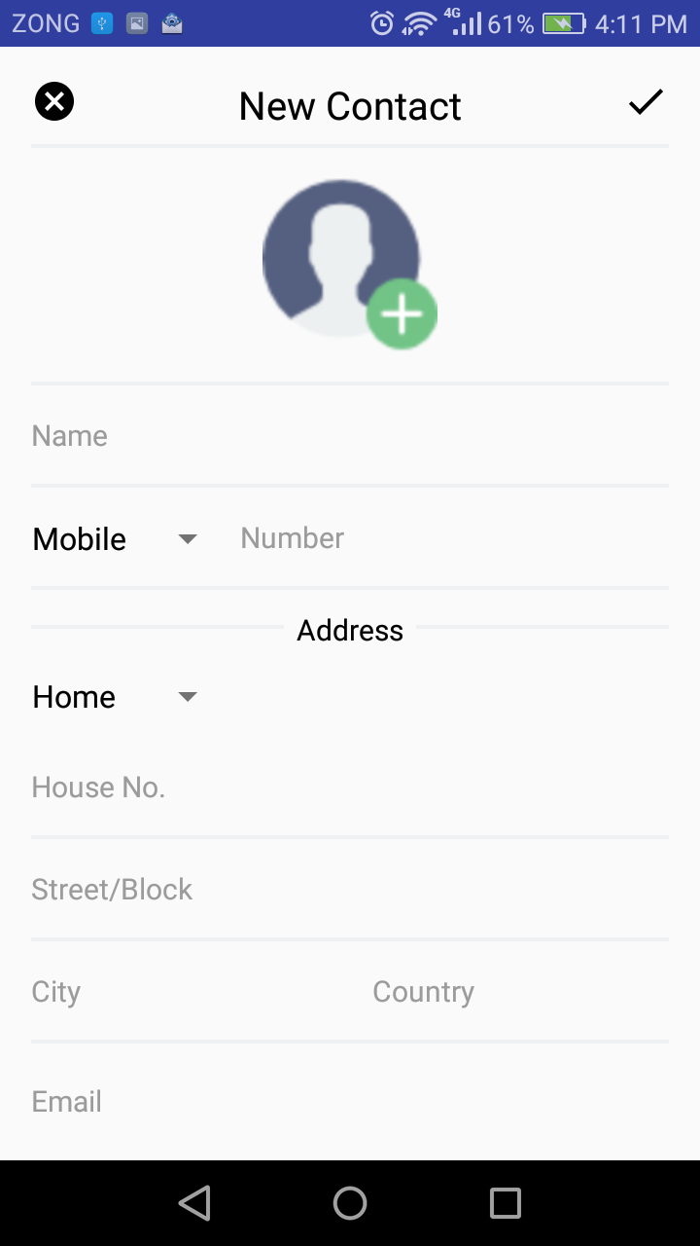UI should be as follows: