SEA TRIAL REPORT AND PROJECT DOCUMENTATION
Real-Time Grey-Box Vessel Speed Prediction and Monitoring
PINN + XGBoost | Sea trial on Jati 6, off Kemaman, 10 August 2026
Item | Detail
Author | Muhammad Hafiz Hamzah bin Fansuri (2212803)
Institution | Dept. of Mechatronics Engineering, Kulliyyah of Engineering, International Islamic University Malaysia (IIUM)
Supervisor | Assoc. Prof. Ir. Dr. Noor Hazrin Hany Bt Mohamad Hanif
Test vessel | Jati 6
Trial site and date | Off Kemaman, Terengganu; 10 August 2026, 12:18 to 14:18 (local time)

1. Background
Vessel speed is one of the central operating variables in maritime transport. It governs fuel consumption, schedule reliability and navigational safety, and for offshore supply vessels it is often tied to contractual minimum transit speeds. Speed is in turn shaped by the operating state of the vessel (throttle, loading, hull condition) and by the environment it moves through, mainly wind, waves and current. Modern vessels can log position, speed and weather continuously, which makes it practical to use machine learning to predict speed and to flag deviations in real time.
This project develops a hybrid grey-box model that combines a physics-based prior with a Physics-Informed Neural Network (PINN) and an XGBoost residual corrector to predict vessel speed from wind speed, significant wave height and recent speed history. The model runs inside an ESP32-based monitoring prototype (Airmar 200WX weather station and BNO085 IMU) with a real-time IoT dashboard and a three-state threshold alert (green / yellow / red).
Earlier project stages established the model offline on four months of Jati 6 operational data (April to July 2025; RMSE 0.246 kn, R² 0.9991) and validated the prototype through three iterative road tests on the IIUM campus circuit (3 May, 30 May and 6 June 2026). Those road tests were a proxy for the sea. This document covers the first at-sea trial of the prototype, carried out on Jati 6 off Kemaman on 10 August 2026, and documents the project as a whole around it.

2. Objectives
The overall project objectives are:
- To develop a machine learning model that can accurately predict vessel speed under different environmental conditions.
- To implement a vessel speed monitoring prototype with a real-time dashboard that displays vessel speed, predictions and threshold-based alerts.
- To validate the functionality and performance of the machine learning and monitoring system.
The objectives specific to the Jati 6 sea trial are:
- To verify that the prototype acquires and streams wind, wave, attitude and speed data end to end while installed on a working vessel at sea.
- To characterise the wind and sea-state conditions encountered during the trial.
- To quantify how closely the grey-box model predicts measured speed over ground (SOG) using RMSE, MAE, R², bias and tolerance bands.
- To examine where and why prediction error concentrates, and how it relates to wind, wave height and speed transients.

3. Scope
In scope. One sea trial on Jati 6 off Kemaman on 10 August 2026, covering two hours (12:18 to 14:18) and 121 one-minute samples. The variables analysed are wind speed, significant wave height (Hs, estimated from the IMU), speed over ground, roll, pitch, yaw, position and the model-predicted speed. The analysis covers the wind and wave time series and the agreement between predicted and measured speed.
Out of scope. The following were not assessed in this trial and are left for future work:
- Validation of the GREEN and YELLOW alert states. Peak predicted speed in the trial was 10.2 kn, so the dashboard stayed in the RED state (Vp < 18 kn) throughout and the 18 kn and 20 kn transitions were not exercised.
- Fuel consumption, engine load, draught and hull-condition effects, and sea current (none were logged).
- Wind direction and true-wind analysis. The cleaned dataset contains wind speed only.
- Retraining the model on sea data, and multi-voyage or multi-vessel generalisation.

4. Problem Statement
Accurate vessel speed prediction is essential for efficient and compliant maritime operations. Existing approaches often integrate environmental factors and vessel characteristics poorly, so their predictions do not fully reflect real operating conditions. Physics-based models are interpretable but lose accuracy in complex scenarios, while purely data-driven models are flexible but can return physically inconsistent results; few methods hybridise the two. Many studies are also validated on restricted datasets or controlled environments, which limits confidence in how they generalise to real maritime operation [1]–[3], [12].
For this project the gap is sharper still. The grey-box model and monitoring prototype had been validated only on historical vessel data and on a road circuit, which cannot reproduce hydrodynamic loading, vessel motion or the sensor and communication conditions at sea. There was therefore no evidence of how the complete system performs on a vessel in open water. The sea trial on Jati 6 was designed to close that gap.

5. Background Study

5.1 Factors affecting vessel speed
Speed loss in a seaway is conventionally explained through added resistance. Total resistance is decomposed into a calm-water term plus added resistance due to waves and due to wind:
R_{T} = R₀ + ΔR_{AW} + ΔR_{AA} (1)
where R0 is calm-water resistance, ΔRAW is wave-induced added resistance and ΔRAA is wind-induced added resistance [1], [2]. Added resistance depends on wave height, wave period and encounter angle, and on wind speed and relative direction. In practice the operator's throttle setting dominates speed. In the April 2025 Jati 6 data (Section 5.5), Pearson correlation of speed with significant wave height and wind speed was only −0.13 and −0.12, against 0.90 for fuel flow, which is a proxy for throttle.

5.2 Speed prediction approaches
Physics-based and semi-empirical methods derive speed loss from resistance theory with correction terms for waves, wind and current [1], [3], [8]. They are interpretable and need little operational data, but their calm-water and constant-displacement assumptions make them unreliable in dynamic sea states [2].
Data-driven methods such as ANN, LSTM, Random Forest and XGBoost learn the nonlinear link between speed and environmental or operational inputs without explicit hydrodynamic equations [4]–[6]. They can be very accurate and tree ensembles give feature-importance rankings, but they behave as black boxes, need large volumes of good data and generalise poorly outside the conditions they were trained on.
Grey-box and physics-informed approaches use a physics-based relationship as a baseline and a learned layer to capture what the physics misses [7], [8]. They offer a favourable balance of interpretability and accuracy [9], but most reported studies cover a single vessel or a narrow range of sea conditions [10], [11]. The literature therefore points to three recurring gaps: incomplete integration of environmental and vessel factors, limited physics/data hybridisation, and validation that rarely spans genuinely different operating domains [12]. This sea trial addresses the third gap.

5.3 Grey-box model used in this project
Because the hydrodynamic coefficients of Jati 6 were not available, the physics prior is approximated as a second-order polynomial in wind speed W and significant wave height H, with coefficients fitted by ridge regression:
V_{phys}(W, H) = β₀ + β₁W + β₂H + β₃W² + β₄H² + β₅WH (2)
A PINN residual network then corrects the prior, and an XGBoost model corrects the error that remains:
V_{PINN} = V_{phys} + f_{PINN}(x) (3)
V_{p} = V_{PINN} + f_{XGB}(x, V_{phys}, V_{PINN}) (4)
The feature vector x includes wind speed, wave height, lagged SOG terms and cyclical time encodings. The PINN is "physics-informed" through a monotonicity penalty in its loss that discourages predicting higher speed when wind or wave loading increases. The two features that matter most for interpreting the sea-trial results are the lagged SOG inputs, which make the prediction partly autoregressive, and the monotonic penalty, which should make predictions fall as wind and waves increase.

5.4 Measurement background
The Airmar 200WX outputs NMEA 0183 sentences. Its wind speed is apparent wind, the vector sum of true wind and the wind generated by the vessel's own motion, so it changes with vessel speed and heading even when true wind is constant. Significant wave height is not measured directly; it is estimated from the vertical acceleration measured by the BNO085 IMU, so it reflects the vessel's heave response and not an independent wave-buoy reading. SOG is the GPS-derived speed relative to the ground and therefore includes the effect of any current.

5.5 Historical Jati 6 operational data
The model was built from four months of Jati 6 operational records (April to July 2025) on the Kuala Terengganu Jetty to offshore rig route, about 181 km one way and roughly six hours in duration. Figure 1 shows the speed profile for each month together with the 20 kn contractual target, wave height and wind speed. For most of the period the vessel operated below the 20 kn target, with only brief excursions to or above it. The speed record is dominated by repeated transit cycles, and wave height and wind change far more slowly than speed does.
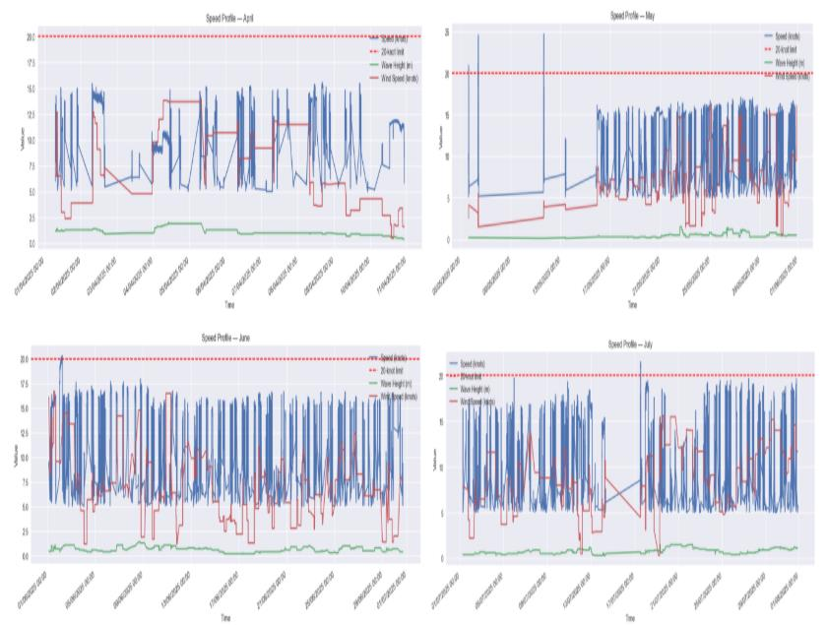
Figure 1: Vessel speed profile, April to July 2025 (speed, 20 kn limit, wave height and wind speed). Source: FYP report, Figure 4.1.
Figure 2 shows the Pearson correlation heatmap for April 2025, the month with the most notable environmental effect. Vessel speed correlates weakly and negatively with significant wave height (−0.13) and wind speed (−0.12), and almost not at all with temperature (0.12), while it correlates strongly with fuel flow (0.90). Wave height and wind speed are themselves strongly correlated (0.81). The sign of the environmental terms agrees with the added-resistance picture, but their size shows that operational control, not weather, governs most of the speed variation. This is the baseline against which the sea-trial results in Section 7 are read.
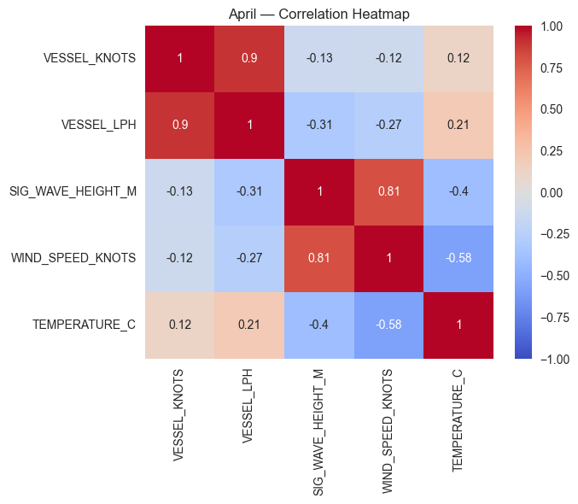
Figure 2: Correlation heatmap for April 2025 (Jati 6 operational data). Source: FYP report, Figure 4.3.

6. Experimental Setup

6.1 Test vessel, site and conditions
The trial was conducted on the offshore supply vessel Jati 6, the same vessel that supplied the four-month operational dataset used to train the model. The trial took place off Kemaman, Terengganu, on 10 August 2026 between 12:18 and 14:18. Logged positions fall between approximately 4.2°N to 4.3°N and 103.4°E to 103.5°E. Timestamps are taken to be local time (UTC+8), consistent with the earlier Jati 6 datasets.

6.2 Hardware
The sea trial used the prototype validated in the road tests. Its architecture is sensing, processing, prediction and monitoring layers (Fig. 1 in the project report). Table 1 lists the components and their role.
Table 1: Prototype hardware used in the sea trial
Component | Role | Interface and notes
ESP32 microcontroller | Data acquisition, time synchronisation, preprocessing, streaming | Firmware v6.6; WiFi with MQTT over TLS to a cloud broker; USB for local debug
Airmar 200WX weather station | Apparent wind speed, GPS position, SOG | NMEA 0183 over RS-232 through a MAX3232 level shifter, 4800 baud, ESP32 UART2 (GPIO16/17)
Adafruit BNO085 9-DOF IMU | Roll, pitch, yaw; vertical acceleration for Hs estimation | I²C, address 0x4B; on-chip quaternion fusion
Power supply | Stabilised DC for Airmar and tower light; 5 V for ESP32 | 220 V AC to 12/24 V DC industrial PSU, then adjustable DC-DC buck to 5 V
Enclosure | Houses ESP32, IMU and wiring | 203.2 × 152.4 × 76.2 mm (8 × 6 × 3 in); placed on the vessel floor, no drilling
Laptop | Runs the grey-box inference bridge and the local web dashboard | Receives the ESP32 stream; model combines physics prior, PINN and XGBoost
The Airmar 200WX is mounted externally so that wind measurement is unobstructed.
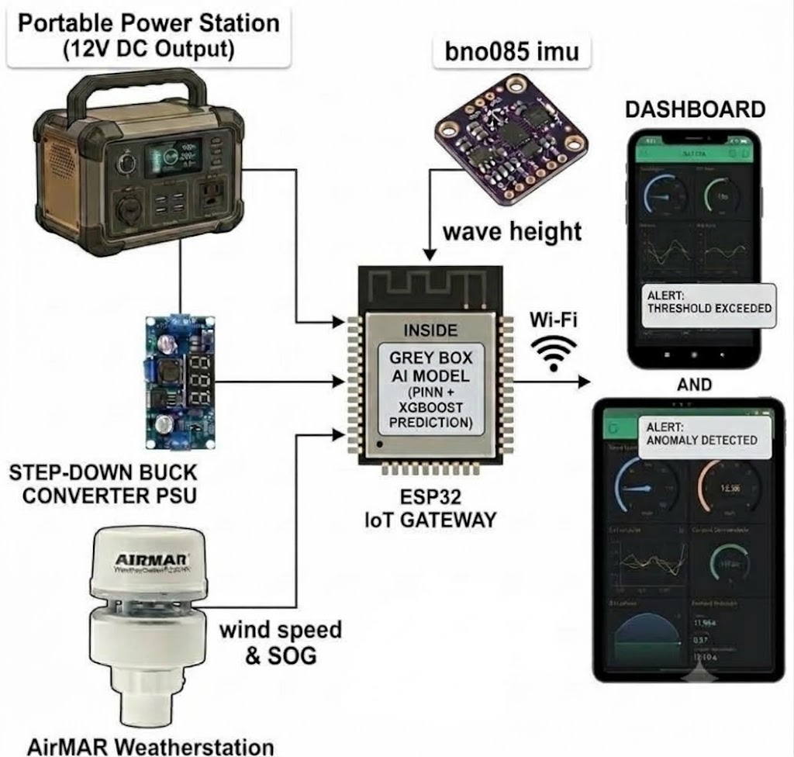

6.3 Data acquisition and processing
The ESP32 reads the Airmar NMEA stream, fuses the IMU data, timestamps every record and publishes it over MQTT to a cloud broker. A Python inference bridge subscribes to the stream, computes the grey-box speed prediction and forwards the results to the dashboard. The logged data were then cleaned of GPS errors, repeated readings and sensor faults, and down-sampled to a one-minute record for analysis. Processing and plotting for this report were done in Python (pandas, matplotlib).

6.4 Real-time monitoring dashboard
Unlike the Blynk dashboard used in the road tests, the sea trial used a browser-based dashboard titled "Grey-Box Speed Prediction System", served locally by the inference bridge at localhost:8080 and updated as each record arrives. A persistent header shows the connection status and a colour-coded alert banner together with live Vp, SOG, wind and Hs readouts, and the footer legend gives the alert thresholds: GREEN at Vp ≥ 20 kn, YELLOW at 18 kn ≤ Vp < 20 kn and RED at Vp < 18 kn, as in the project alert logic. Because the trial speeds never reached 18 kn, every screenshot shows the RED state ("Below threshold: vessel speed below minimum safe limit"). The dashboard has five tabs, four of which are shown in Figures 3 to 6:
- Overview (Figure 3): tiles for predicted speed Vp (labelled +60 s) in knots and km/h, measured SOG with its difference from Vp, corrected wind speed, and estimated wave height Hs (in cm), above a rolling chart of Vp and SOG over the last 60 ticks.
- Charts (Figure 4): a larger Vp-versus-SOG chart (solid line Vp, dashed line SOG) with separate wind speed and wave height charts below it.
- IMU (Figure 5): a 3D model of the vessel driven by the BNO085 roll, pitch and heading, for a live view of vessel attitude.
- Track (Figure 6): the GPS track drawn on a map, with the start point and the current vessel position. The track runs from the Kemaman river mouth out to sea.
- Log: the record log (not shown).
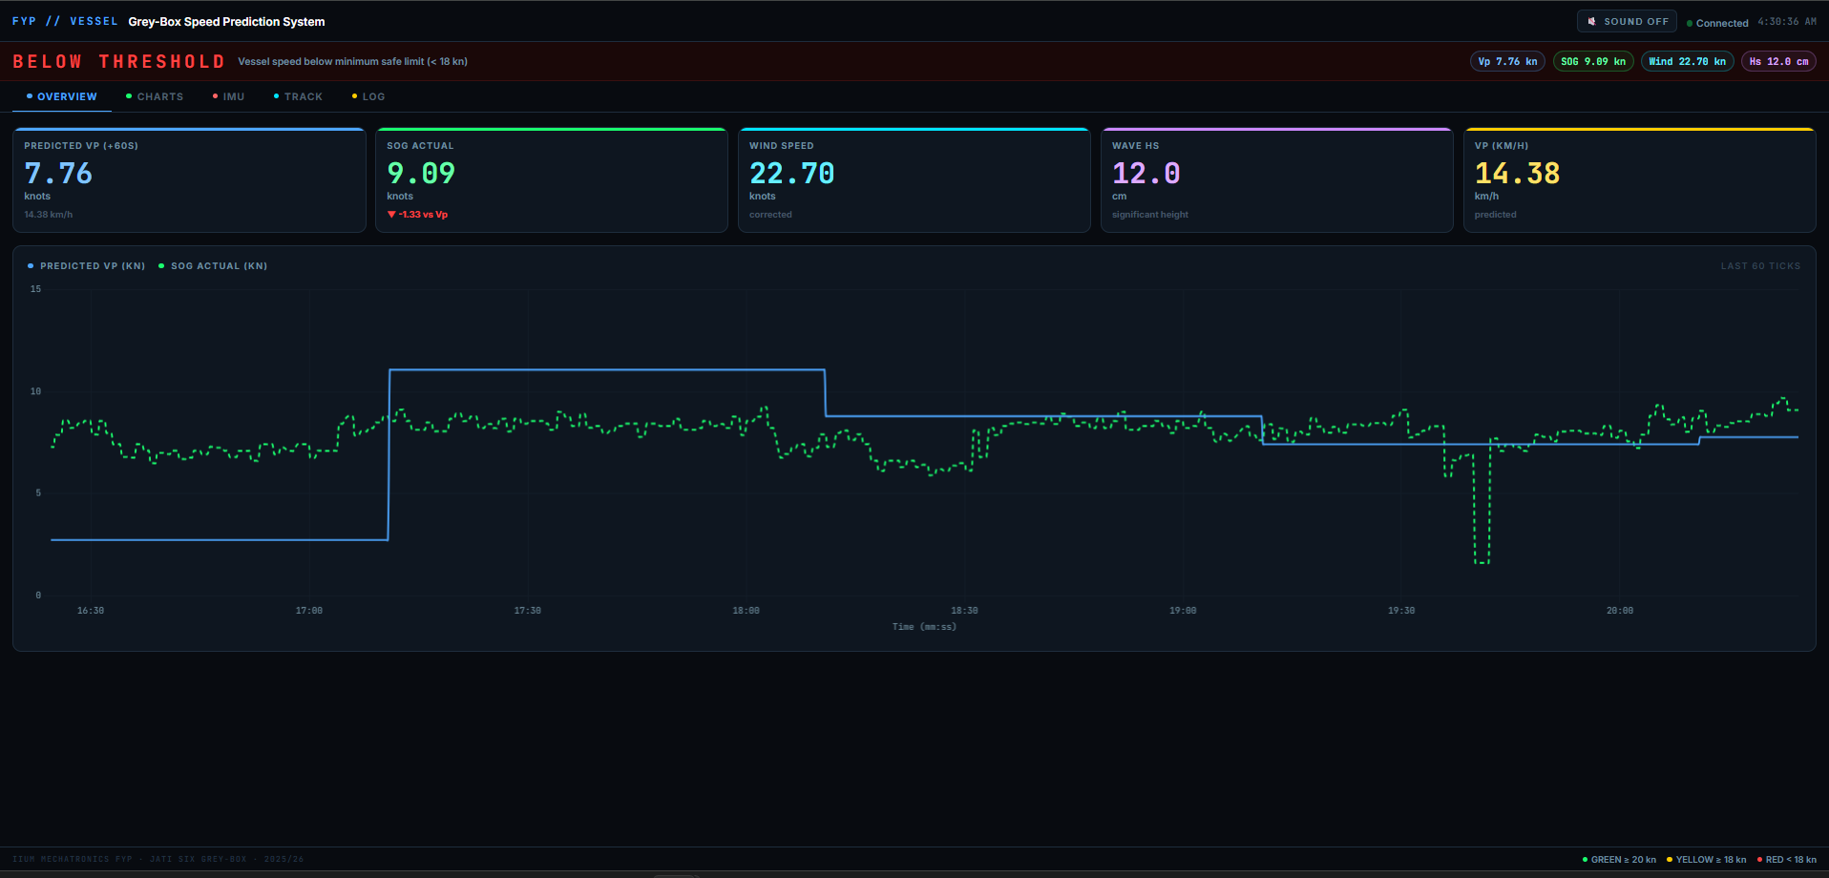
Figure 3: Dashboard, Overview tab (alert banner, live readouts and Vp / SOG chart).
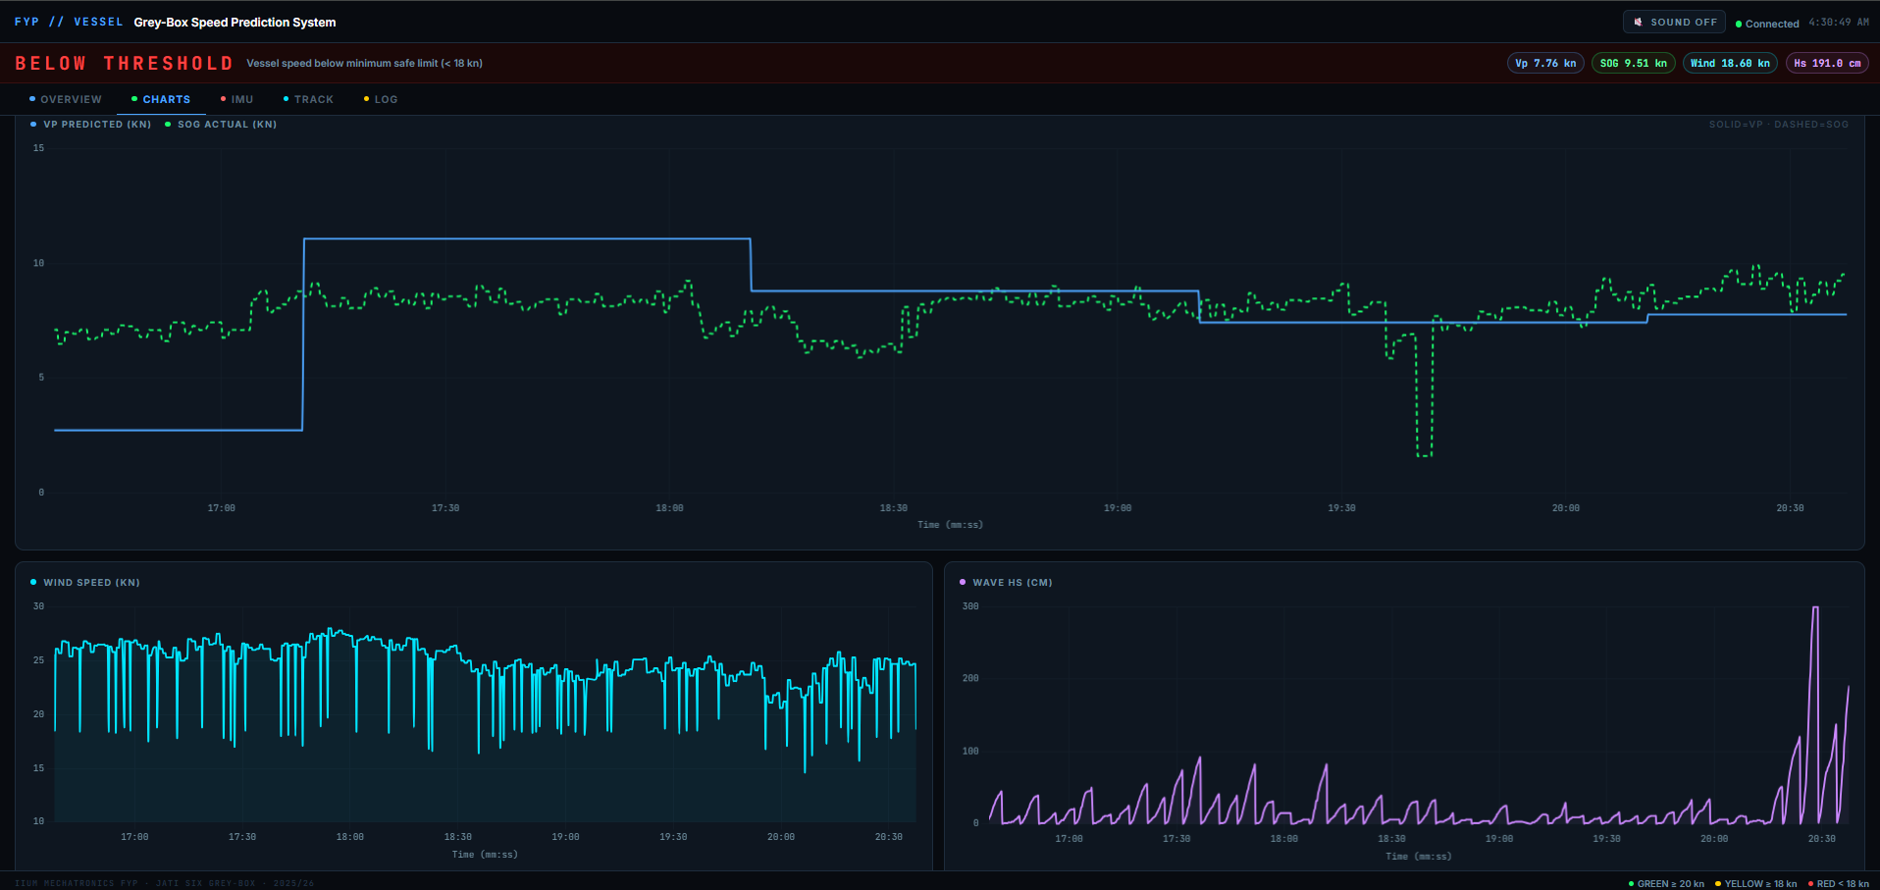
Figure 4: Dashboard, Charts tab (Vp versus SOG, wind speed and wave height).
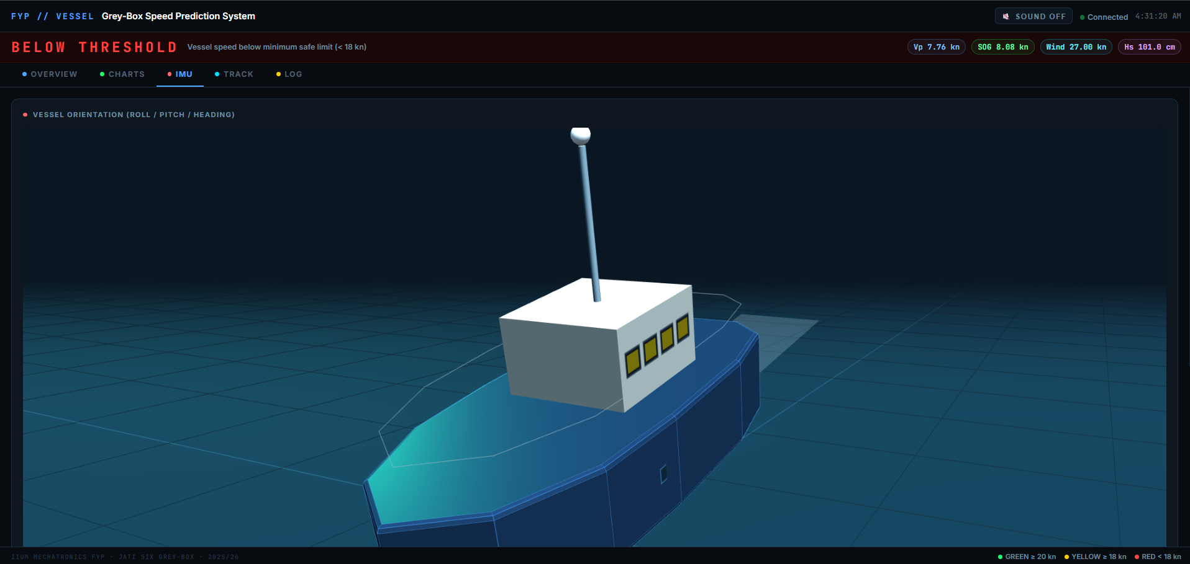
Figure 5: Dashboard, IMU tab (3D vessel orientation from roll, pitch and heading).
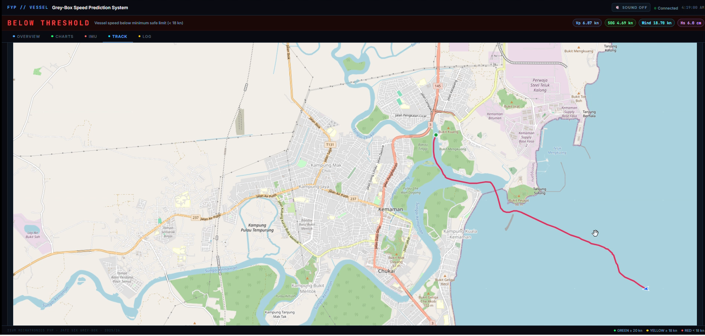
Figure 6: Dashboard, Track tab (GPS track off Kemaman).

6.5 Dataset description
Table 2: Channels in the cleaned sea-trial dataset
Channel | Description | Unit | Source
Timestamp | Sample time, 1-minute interval, 12:18 to 14:18 | hh:mm | ESP32 (GPS-synchronised)
lat, lon | Vessel position (rounded to 0.1° in the cleaned file) | deg | Airmar GPS
sog_kn | Speed over ground; measured reference | kn | Airmar GPS
wind_kn | Wind speed as measured (apparent) | kn | Airmar 200WX
wave_hs_m | Significant wave height (estimated) | m | BNO085 vertical acceleration
roll_deg, pitch_deg, yaw_deg | Vessel attitude | deg | BNO085
vp_forecast_kn | Predicted vessel speed | kn | Grey-box model
Table 3: Summary statistics of the trial (n = 121)
Channel | Min | Max | Mean | Std. dev.
SOG (kn) | 0.05 | 10.40 | 5.59 | 2.81
Predicted speed (kn) | 0.22 | 10.16 | 5.77 | 2.78
Wind speed (kn) | 2.71 | 26.16 | 14.62 | 7.55
Significant wave height (m) | 0.02 | 1.27 | 0.25 | 0.25
Roll (deg) | 1.54 | 2.67 | 2.13 | 0.26
Pitch (deg) | 1.56 | 2.37 | 2.00 | 0.14

6.6 Model configuration
The model is the grey-box configuration from the offline study: ridge regression (α = 10) for the physics prior; a PINN with hidden dimension 128, four residual blocks, learning rate 1 × 10⁻³ and monotonicity weight λ = 0.5; and XGBoost with 1000 estimators, maximum depth 5 and learning rate 0.02. The training split was 75 % / 10 % / 15 % (train / validation / test).

6.7 Evaluation method
Prediction error is defined as e = Vp − SOG, so a positive error means the model over-predicts speed. Agreement is reported with RMSE, MAE, mean bias, R², and the share of predictions within ±0.5 kn and ±1.0 kn of measured SOG. To link error to operating conditions, the trial was split into six phases from the SOG profile (Table 4) and the error statistics were computed per phase. A naive persistence baseline (predict the previous minute's SOG) is included as a reference for how much the model adds.

7. Results and Discussion

7.1 Overview of the trial
The SOG profile divides naturally into six phases. The vessel accelerated from rest at 12:21, made a 45-minute run at 4 to 9 kn, slowed to about 1.2 kn for roughly 20 minutes from 13:10, accelerated to a 9 to 10.4 kn run, settled to about 6 kn, and stopped at the end of the record. Table 4 summarises the conditions and prediction error in each phase.
Table 4: Trial phases, conditions and prediction error (error = predicted − SOG)
Phase | Time | n | SOG mean (kn) | Wind mean (range) kn | Hs mean (max) m | Bias (kn) | RMSE (kn)
A Departure | 12:18–12:23 | 6 | 2.79 | 11.9 (5.9–24.0) | 0.11 (0.18) | −0.15 | 0.76
B Outbound run, strong wind and waves | 12:24–13:08 | 45 | 6.40 | 22.9 (7.1–26.2) | 0.42 (1.27) | +0.52 | 0.90
C Speed reduction / hold | 13:09–13:30 | 22 | 2.19 | 12.3 (5.1–18.2) | 0.20 (0.74) | +0.06 | 0.36
D High-speed run | 13:31–13:54 | 24 | 8.72 | 10.9 (6.7–20.5) | 0.17 (0.75) | −0.16 | 0.53
E Steady cruise | 13:55–14:12 | 18 | 5.99 | 5.7 (3.0–8.9) | 0.06 (0.10) | −0.14 | 0.57
F Deceleration / stop | 14:13–14:18 | 6 | 1.12 | 5.8 (2.7–9.5) | 0.12 (0.20) | +0.63 | 0.91

7.2 Wind speed versus time
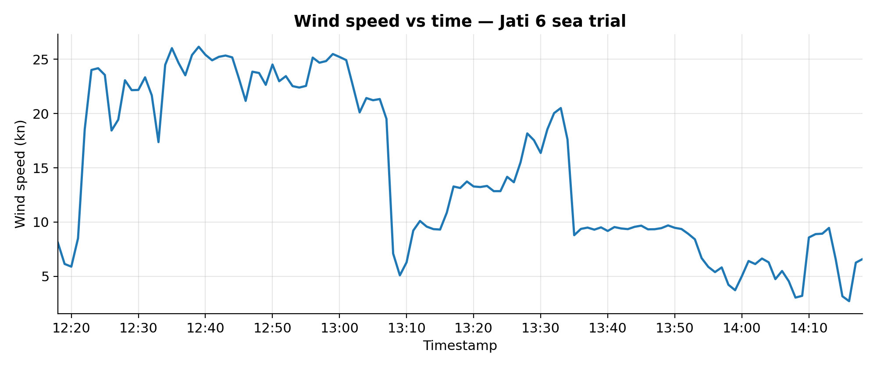
Figure 7: Wind speed versus time during the Jati 6 sea trial.
Figure 7 shows a strongly stepped wind record. While the vessel was stationary (12:18 to 12:21) wind read 6 to 8.5 kn. As the vessel accelerated it rose to 18.6 kn at 12:22 and 24.0 kn at 12:23, and then stayed between roughly 21 and 26 kn until 13:07, with a peak of 26.2 kn at 12:39. That band corresponds to the upper end of Beaufort 6 (22 to 27 kn). The rise may reflect the vessel leaving a sheltered departure area for open water, together with the wind component generated by the vessel's own speed.
At 13:08 the reading fell from 19.5 kn to 7.1 kn within one minute. True wind does not change that quickly. The IMU yaw over the same minutes swings from about 199° to 107° and then 52°, which points to a course alteration that changed the relative wind angle. A second abrupt fall, from 17.6 kn to 8.8 kn, occurs at 13:35 as SOG rises from 6.9 to 9.3 kn. Wind then stays near 9 kn to 13:54 and settles at 3 to 9 kn (mean 5.7 kn) for the rest of the trial. The key point for the model is that the measured wind is apparent wind. It is a function of heading and speed as well as of the weather, so it is a noisier proxy for environmental load than true wind would be.

7.3 Wave height versus time
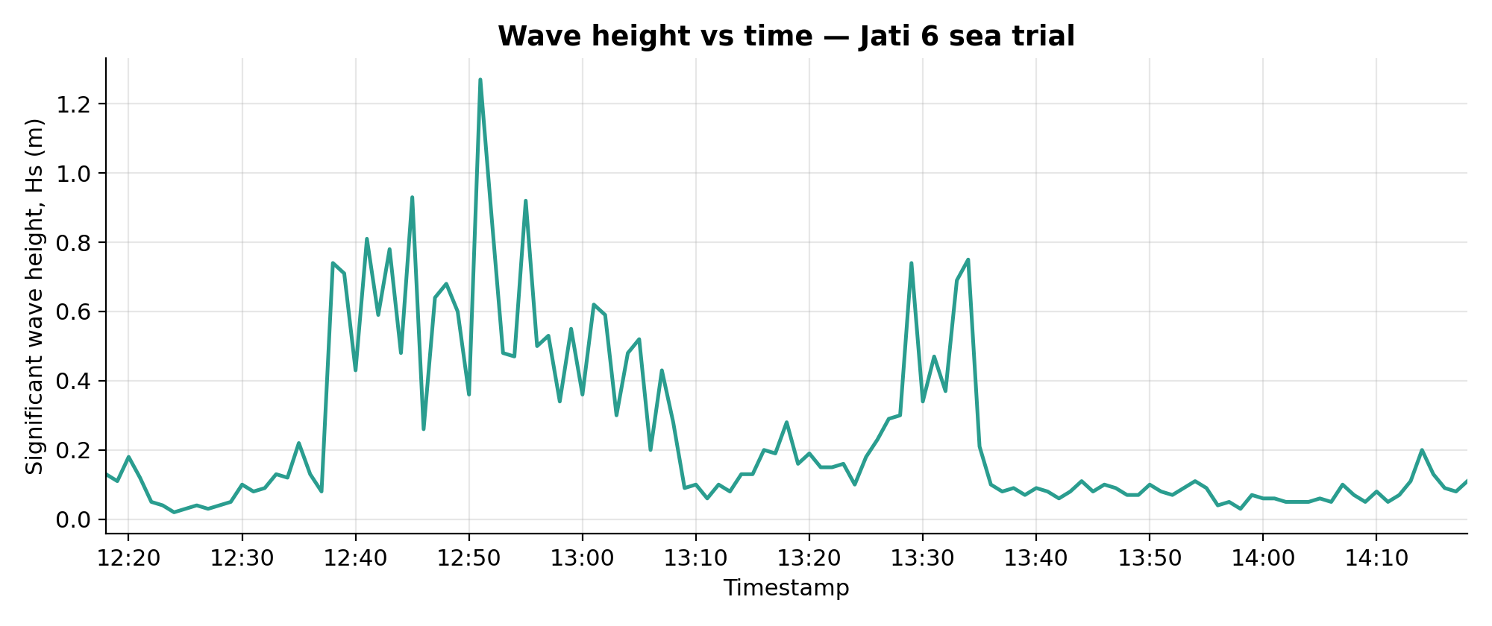
Figure 8: Estimated significant wave height versus time during the Jati 6 sea trial.
Figure 8 shows that Hs stayed below 0.2 m until about 12:36 even though wind was already 22 to 25 kn, and then jumped to 0.74 m at 12:38. The sea state therefore lagged the wind by roughly 15 minutes, which is typical of a wind sea that needs time and fetch to build, although the vessel moving into a different area also plays a part. From 12:38 to 13:07 Hs stayed between about 0.2 and 0.9 m with a peak of 1.27 m at 12:51. Twenty samples exceed 0.5 m, all between 12:38 and 13:34. Hs then fell to 0.1 to 0.3 m, rose briefly to 0.75 m at 13:33 to 13:35, and stayed below 0.2 m (mean 0.06 m) from 13:36 onwards.
On the Douglas sea scale, conditions were smooth to slight, touching moderate only at the 12:51 peak. Wind speed and Hs are moderately correlated over the trial (r = 0.63), so the wave field was broadly wind-driven. Roll and pitch stayed within about 1.5° to 2.7° with very small variance (Table 3), consistent with a modest sea state for a vessel of this type, although a constant offset of about 2° suggests a mounting or calibration offset in the IMU that should be zeroed in future trials.

7.4 Actual versus predicted speed versus time
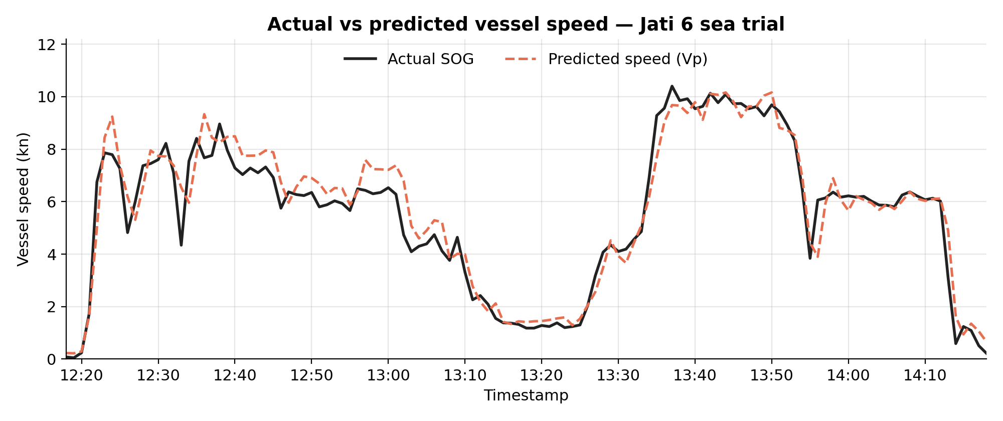
Figure 9: Measured SOG and grey-box predicted speed (Vp) versus time during the Jati 6 sea trial.
The predicted speed follows the measured SOG closely across the whole trial (Figure 9). The model reproduces the departure, the slowdown to about 1.3 kn, the high-speed run above 9 kn, the cruise at about 6 kn and the final stop, including the peak speeds (10.16 kn predicted against 10.40 kn measured). Table 5 gives the quantitative agreement.
Table 5: Prediction accuracy over the full sea trial
Metric | Grey-box model | Persistence baseline
RMSE (kn) | 0.708 | 1.000
MAE (kn) | 0.520 | 0.596
Mean bias, predicted − SOG (kn) | +0.177 | —
R² | 0.936 | —
RMSE as share of speed range (10.35 kn) / of mean SOG | 6.8 % / 12.7 % | —
Within ±0.5 kn | 52.9 % | 65.0 %
Within ±1.0 kn | 87.6 % | —
Largest errors | +2.20 kn (12:33), −2.16 kn (13:56) | —
The model beats the persistence baseline on RMSE (0.71 against 1.00 kn) and MAE, which shows it adds real information beyond the previous speed. It does not win on every measure: persistence puts more samples within ±0.5 kn (65.0 % against 52.9 %), because the model carries a systematic bias in one phase, discussed next. The bias is positive overall (+0.18 kn), and 64 % of samples are over-predicted.

7.5 Where the error comes from
Strong wind and waves (phase B). Error is worst and most one-sided during the 12:24 to 13:08 run, with a bias of +0.52 kn and RMSE of 0.90 kn. In Figure 9 the prediction sits about 0.5 to 1 kn above the measured speed from roughly 12:38 to 13:05, when wind was 22 to 25 kn and Hs reached 1.27 m. Across the whole trial, samples with Hs ≥ 0.2 m have a mean bias of +0.36 kn against +0.07 kn for calmer samples, and error correlates positively with wind (r = 0.29) and with Hs (r = 0.25). The model is therefore over-predicting speed when the environment is heaviest, meaning its learned speed penalty for wind and waves is too small for Jati 6 under these conditions. The monotonic penalty only guarantees the direction of the effect, not its magnitude. An alternative explanation is that the operator reduced throttle in these conditions, which the dataset cannot rule out because throttle and engine load were not logged.
Speed transients. The strongest single driver of error is how fast speed changes: the correlation between absolute error and absolute one-minute speed change is 0.64. The two largest errors show the pattern. At 12:33 SOG dipped for a single minute to 4.34 kn (between 7.10 and 7.54 kn either side) while the prediction stayed at 6.54 kn. At 13:56 SOG jumped from 3.85 to 6.06 kn while the prediction stayed near 3.9 kn. At the final deceleration (14:13) the prediction is 4.9 kn against 3.1 kn measured. In each case the prediction trails the measurement by about one sample, which is what would be expected from a model that leans on lagged SOG inputs. It cannot anticipate an abrupt change, and it also does not filter out a one-minute dropout.
Steady conditions. Where speed is steady, the model is accurate. During the slow hold (phase C, 13:10 to 13:30) RMSE is 0.36 kn, and during the cruise at about 6 kn (13:57 to 14:12) the predicted and measured curves are almost indistinguishable. The high-speed run (phase D) gives RMSE 0.53 kn with a small negative bias (−0.16 kn), so the model slightly under-predicts in calm conditions and over-predicts in rough ones, which is what a model with too weak an environmental response would do.
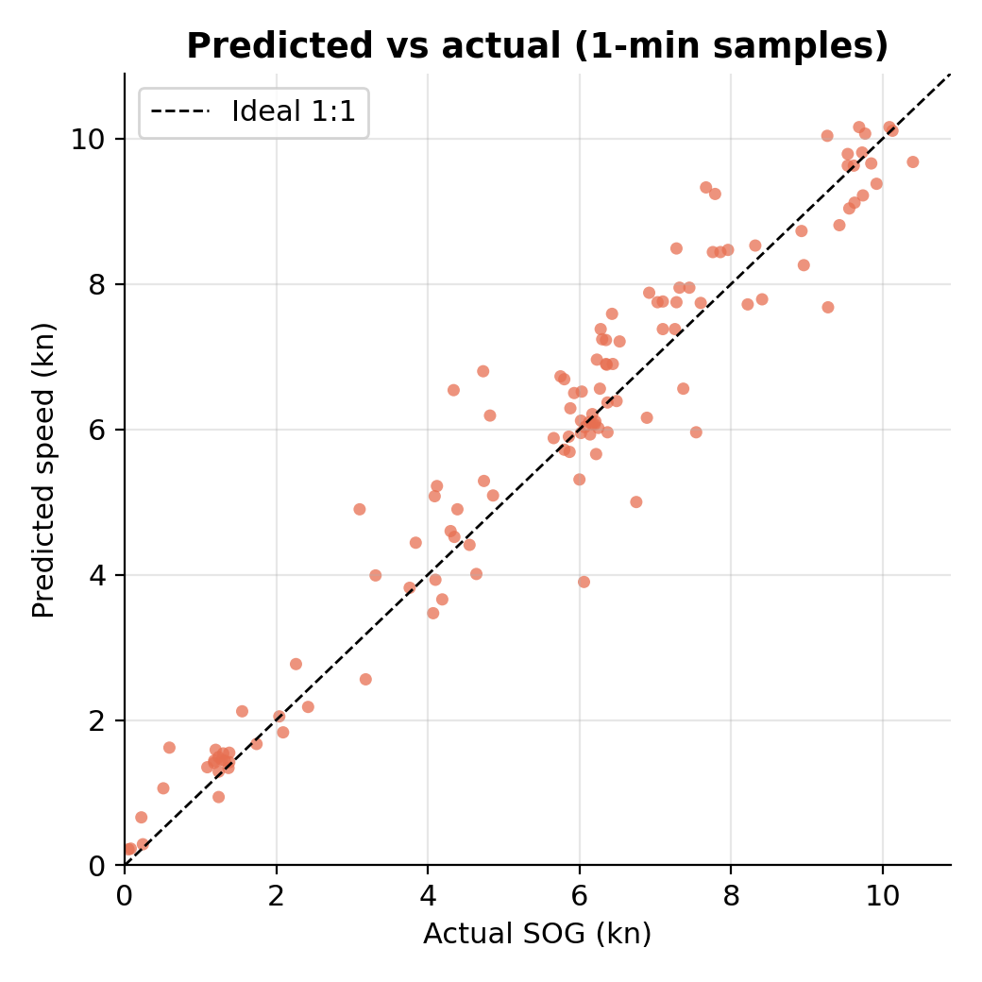
Figure 10: Predicted versus measured speed for all 121 samples; the dashed line is the ideal 1:1 relationship.
Figure 10 confirms the picture. Points lie tightly along the 1:1 line at low speed and above 9 kn, and scatter above the line between about 5 and 8 kn, which is the speed range of the strong-wind, high-wave phase.

7.6 Wind, waves and speed
The sea trial cannot isolate the environmental effect on speed, and the data show why. Over the whole trial, SOG correlates weakly and positively with wind (r = +0.21) and not at all with Hs (r = +0.02). The positive sign is not physical: speed changes in the trial were dominated by operational decisions (departure, the 20-minute slowdown, the acceleration at 13:31, the stop), and apparent wind rises with vessel speed. The slowdown in phase C, for example, took place when wind (12.3 kn) and waves (0.20 m) were already moderate to low, so it was operational and not environmental.
There is some consistent evidence of the expected direction. The fastest run (phase D, mean 8.72 kn, peak 10.4 kn) occurred in the calmest spell of the trial (mean wind 10.9 kn, Hs 0.17 m), and the 45-minute run in 22.9 kn wind and 0.42 m waves averaged 6.40 kn. A 2.3 kn difference is of the right sign for added resistance, but throttle is unknown, so it cannot be attributed to the environment. This agrees with the April 2025 heatmap (Figure 2), where wind and wave height explain only a small share of speed variation compared with operational control. The wind-to-wave correlation in the sea trial (r = 0.63) is also of the same sign as, though weaker than, the 0.81 seen in April.

7.7 Comparison with earlier validation stages
Table 6: Grey-box model performance across all evaluation stages
Stage | Data | RMSE (kn) | R² | Within ±0.5 kn
Offline test | Jati 6 operational data, Apr–Jul 2025 | 0.246 | 0.9991 | 97.9 %
Road test 1 | Vessel-trained model, IIUM circuit | 15.05 | −2.99 | 4.2 %
Road test 2 | Retrained on Test 1 data | 6.594 | −0.05 | 0.9 %
Road test 3 | Retrained on Tests 1 and 2 data | 0.187 | 0.9989 | 99.8 %
Sea trial | Jati 6, Kemaman, 10 Aug 2026 | 0.708 | 0.936 | 52.9 %
Sea-trial RMSE is about three times the offline figure and close to four times the best road-test figure, and only about half the samples fall within ±0.5 kn. This is a weaker result than the earlier stages and should be presented that way. Some of the gap is expected: the sea trial has a different environment, real vessel dynamics, and abrupt speed changes that the smoother offline and road records do not contain. Even so, R² of 0.936 and 87.6 % of samples within ±1 kn show that the architecture carries over to an at-sea operating domain with usable accuracy. The road-test pattern suggests the residual error is largely a calibration problem and is likely to fall if the model is retrained on sea data.

7.8 Limitations
- Short record. The data are one two-hour session, 121 one-minute samples, in one sea state range (Hs up to 1.27 m) on one day. The results should not be extrapolated to severe weather.
- Autoregressive inputs. The model uses lagged SOG. High R² therefore partly reflects the persistence of speed and is not an independent forecast of the environmental effect. The persistence comparison in Table 5 is a guard against over-reading this.
- Missing explanatory variables. Throttle or engine load, wind direction, true wind, sea current, draught and wave direction were not logged, so error causes are inferred and cannot be proven.
- Apparent wind and estimated Hs. Wind is apparent, and Hs is IMU-derived and was not checked against a reference wave sensor. IMU yaw also shows large swings, including zero-degree samples, and should be verified before being used as a heading.
- Reference SOG provenance. During the trial the Airmar RMC and VTG sentences were lost in the v6.6 firmware (256-byte UART receive buffer and a blocking MQTT call placed ahead of the serial read), while wind and GGA sentences survivedReduced position resolution. Latitude and longitude in the cleaned file are rounded to 0.1°, so the vessel track and distance run cannot be reconstructed from it.
- Alert logic only partly tested. The dashboard showed the RED state correctly for the whole trial, but GREEN and YELLOW were never triggered because speeds stayed below 18 kn.
- Prediction horizon. The dashboard labels Vp as a 60-second-ahead prediction, but in the logged data Vp at time t matches SOG at t (RMSE 0.71 kn) and at t−1 (0.69 kn) about equally well, and matches SOG at t+1 much worse (1.27 kn). The evaluation here is therefore effectively a same-time comparison, not a check of a 60-second lead. 8. Conclusion
This document recorded the first at-sea trial of the grey-box vessel speed monitoring prototype, on Jati 6 off Kemaman on 10 August 2026. The prototype acquired wind, wave, attitude and speed data over a two-hour session, with conditions ranging from near-calm to 26 kn apparent wind and 1.27 m significant wave height.
The grey-box model tracked measured speed with an RMSE of 0.708 kn, MAE of 0.520 kn and R² of 0.936, with 87.6 % of predictions within ±1 kn and a clear advantage over a persistence baseline in RMSE. Accuracy was high in steady conditions and degraded in two ways. First, the model over-predicted speed by about 0.5 kn during the strong-wind, high-wave run, which shows its environmental penalty is too weak for Jati 6 at sea. Second, it lagged by about one sample at abrupt speed changes, where errors of around 2 kn occurred. The result is weaker than the offline (0.246 kn) and road-test (0.187 kn) figures, but it demonstrates that the architecture transfers to a real maritime domain.
Recommended next steps:
- Retrain the model on sea-trial data, following the iterative retraining that worked in the road tests, and re-evaluate on a separate voyage.
- Log throttle or engine load, wind direction and vessel heading, compute true wind, and use relative wind angle as a feature so that the environmental effect can be separated from operator action.
- Validate the IMU-derived Hs against a reference, and zero the roll and pitch offsets.
- Fix the SOG acquisition path (larger UART buffer, serial read before blocking network calls, and a GPGGA-derived SOG fallback on the bridge) so live SOG and lag features are valid at sea.
- Repeat the trial over a full transit at operating speed to test the full GREEN (≥ 20 kn) / YELLOW (18 to 20 kn) / RED alert logic.

References
[1] E. Filtz, E. S. De La Cerda, M. Weber, and D. Zirkovits, "Factors affecting ocean-going cargo ship speed and arrival time," Lecture Notes in Business Information Processing, vol. 215, pp. 305–316, 2015.
[2] J. Zhao, Y. Chen, Z. Zhou, J. Zhao, S. Wang, and X. Chen, "Extracting vessel speed based on machine learning and drone images during ship traffic flow prediction," Journal of Advanced Transportation, vol. 2022, 2022.
[3] N. H. Babbedge, "Statistical analysis of the voyage data of three fast cargo ships," International Shipbuilding Progress, vol. 19, no. 4, pp. 187–198, 1977.
[4] M. Bassam, A. B. Phillips, S. R. Turnock, and P. A. Wilson, "Artificial neural network-based prediction of ship speed under operating conditions for operational optimization," Ocean Engineering, vol. 278, 2023.
[5] D. Wang, Y. Wang, H. Shi, S. Gan, and S. Liang, "Predicting ship speed in the inland waterways with LSTM network," in Proc. 2022 IEEE 7th Int. Conf. Intelligent Transportation Engineering (ICITE), 2022, pp. 35–39.
[6] M. Abebe, Y. Shin, Y. Noh, S. Lee, and I. Lee, "Machine learning approaches for ship speed prediction towards energy efficient shipping," Applied Sciences, vol. 10, no. 7, 2020.
[7] L. Moreira, R. Vettor, and C. G. Soares, "Neural network approach for predicting ship speed and fuel consumption," Journal of Marine Science and Engineering, vol. 9, no. 2, pp. 1–14, 2021.
[8] X. Lang and W. Mao, "A semi-empirical model for ship speed loss prediction at head sea and its validation by full-scale measurements," Ocean Engineering, vol. 209, 2020.
[9] X. Lang, D. Wu, and W. Mao, "Physics-informed machine learning models for ship speed prediction," Expert Systems with Applications, vol. 238, 2024.
[10] O. Tarovik, D. Eremenko, and A. Topaj, "A benchmark study on ship speed prediction models in Arctic conditions: machine learning, process-based and hybrid approaches," Ocean Engineering, vol. 311, 2024.
[11] M. L. Schirmann, M. D. Collette, and J. W. Gose, "Data-driven models for vessel motion prediction and the benefits of physics-based information," Applied Ocean Research, vol. 120, 2022.
[12] X. Lang, D. Wu, and W. Mao, "Comparison of supervised machine learning methods to predict ship propulsion power at sea," Ocean Engineering, vol. 245, 2022.

