Prediction and Monitoring of Vessel Speed Under Environmental Influences Using a Hybrid Grey-Box Machine Learning Model

Muhammad Hafiz Hamzah bin Fansuri
Dept. of Mechatronics Engineering, Kulliyyah of Engineering
International Islamic University Malaysia (IIUM)
Gombak, Malaysia
hafizfansuri10@gmail.com
Noor Hazrin Hany Mohamd Hanif
Dept. of Mechatronics Engineering, Kulliyyah of Engineering
International Islamic University Malaysia (IIUM)
Gombak, Malaysia
noorhazrin@iium.edu.my
Zulkifli Zainal Abidin
Dept. of Integrated Engineering,Faculty of Engineering
Universiti Teknologi PETRONAS (UTP)
Seri Iskandar, Malaysia
line 5: email address
Mohd Fazurin Abidin
Group Offshore Marine Services
Dinastia Jati Group
Petaling Jaya, Malaysia
fazurin@dinastiajati.com

Abstract— Vessel speed is a critical parameter in maritime operations, directly influencing fuel consumption, schedule adherence, and navigational safety, yet accurate prediction remains difficult under varying environmental conditions. This paper presents a hybrid grey-box framework that combines a Physics-Informed Neural Network (PINN) with XGBoost to predict and monitor vessel speed in real-time. Four months of operational data from an offshore supply vessel were analyzed to characterize the relationship between vessel speed and environmental variables. The proposed grey-box model, trained and validated offline on this dataset, achieved a root-mean-square error (RMSE) of 0.246 knots and a coefficient of determination (R²) of 0.9991. The model and its supporting hardware that included an ESP32 microcontroller, an Airmar 200WX weather station, and a BNO085 inertial measurement unit were validated through three iterative road tests, as a proxy for sea trials. Iterative retraining across the three tests reduced the RMSE from 15.05 knots to 0.187 knots and raised the proportion of predictions within ±0.5 knots from 4.2% to 99.8%, demonstrating that the framework adapts rapidly to a new operating domain given representative data. A three-state (green/yellow/red) threshold alert system, delivered through an IoT dashboard, achieved 100% classification accuracy across all sessions. This framework offers a practical, low-cost digital twin solution that can be readily deployed to optimize fleet management and enhance maritime safety.
Keywords— vessel speed prediction, grey-box model, physics-informed neural network, XGBoost
Identify applicable funding agency here. If none, delete this text box.

Introduction
The shipping industry is a backbone of global trade, moving goods across oceans every day, and vessel speed is one of the central operational variables affecting fuel consumption, cost, and schedule reliability. Ship speed is strongly influenced by environmental conditions, and understanding this relationship allows operators to plan voyages more efficiently, reduce fuel use, and improve safety. Modern sensors, GPS, and Automatic Identification Systems (AIS) now make it possible to collect large volumes of vessel and environmental data, and machine learning offers a practical way to extract useful patterns from this data for real-time prediction and monitoring.
Accurate vessel speed prediction is essential for efficient and compliant maritime operations. However, many existing approaches insufficiently integrate environmental factors with vessel design characteristics, and existing methods tend to rely either on physics-based models, which are interpretable but limited in complex scenarios, or on purely data-driven models, which are flexible but can produce physically inconsistent results [1], [2]. This gap between interpretability and predictive accuracy limits both physical realism and forecasting performance. In addition, many prior studies are validated only on restricted datasets or controlled environments, which constrains their applicability and generalisation to real-world maritime deployment [3].
This paper addresses these gaps by presenting a hybrid grey-box framework that combines a Physics-Informed Neural Network (PINN) with XGBoost regression to predict vessel speed under varying wind and wave conditions, and by validating the framework through a complete embedded hardware prototype and an iterative field-testing protocol. The contributions of this paper are threefold: (1) a correlation analysis of four months of operational vessel data that quantifies the influence of wind speed and significant wave height on vessel speed; (2) a hybrid PINN–XGBoost grey-box model that achieves high offline prediction accuracy while retaining physical interpretability; and (3) an ESP32-based real-time monitoring prototype with a threshold alert system, validated through three iterative road-test sessions that progressively adapt the model from a maritime training domain to a new physical operating environment.
The remainder of this paper is organized as follows. Section II reviews related work on ship speed prediction techniques. Section III describes the system architecture, data acquisition process, grey-box model, and monitoring hardware. Section IV presents correlation analysis, offline model performance, and prototype road test results. Section V concludes the paper and outlines directions for future work.

Related work
Ship speed prediction techniques can be broadly grouped into physics-based, data-driven, and hybrid approaches. Semi-empirical and physics-based formulas derive vessel speed loss from calm-water resistance theory together with correction terms for wave, wind, and current effects [1], [3]. These methods are interpretable and require little operational data, but their simplifying assumptions of calm water and constant displacement make them unreliable under highly dynamic sea states [2].
Data-driven techniques, including Artificial Neural Networks (ANN), Long Short-Term Memory (LSTM) networks, and ensemble regression methods such as Random Forest and XGBoost, have been used to model the nonlinear relationship between vessel speed and environmental or operational inputs without requiring explicit hydrodynamic equations [4]– [6]. These models can achieve strong predictive accuracy and, in the case of tree-based ensembles, provide feature-importance rankings that highlight the relative influence of wind, wave height, and other variables. However, they behave like black boxes, require large volumes of high-quality training data, and generalize poorly outside the range of conditions on which they were trained.
Grey-box and physics-informed machine learning approaches attempt to combine the two paradigms by using a physics-based model to establish a baseline speed–resistance relationship and a machine learning residual layer to correct for effects the physics model does not capture, such as short-term environmental disturbances [7], [8]. This class of model has been shown to offer a favourable balance between interpretability and accuracy [9]. However, its performance still depends on how well the embedded physical assumptions match the true operating domain. Most reported grey-box studies are validated on a single vessel or a narrow range of sea conditions [10], [11]. Overall, the literature indicates three recurring gaps: incomplete integration of environmental and vessel factors in predictive models, limited hybridization between physics-based and data-driven methods, and validation that rarely extends across genuinely different operating domains [12]. The work presented in this paper is designed to directly address the third gap, using an iterative road-test protocol to study how a grey-box model adapts when it is deployed outside its original training domain.

METHODOLOGY

System Architecture Overview
Figure 1 shows a flowchart of the proposed system follows a layered architecture consisting of a sensing layer, a processing layer, a prediction layer, and a monitoring and alert layer. At the sensing layer, an Airmar 200WX weather station measures wind speed and Speed Over Ground (SOG), while a BNO085 nine-degree-of-freedom Inertial Measurement Unit (IMU) is used to estimate significant wave height from vertical acceleration. The processing layer, implemented on an ESP32 microcontroller, performs data acquisition, time synchronization, and preprocessing before the prediction layer applies the grey-box model to estimate vessel speed. The monitoring and alert layer compares the predicted speed against operational thresholds and displays vessel speed, environmental readings, and alert status on a real-time IoT dashboard.
- Flowchart of the Overall Vessel Speed Monitoring System

Governing Physical Relationships and Grey-Box Formulation
Ship speed loss under environmental loading is conventionally expressed as an increase in total resistance relative to the calm-water condition, decomposed into a calm-water term and added-resistance terms attributable to waves and wind:
R_{T} = R₀ + ΔR_{AW} + ΔR_{AA} (1)
where RT is the total resistance relative to calm water condition, R0 is the calm-water resistance, ΔRAW is the added resistance caused by waves, and ΔRAA is the added resistance caused by wind, consistent with the wave- and wind-induced speed losses reported in the literature [1], [2]. Because the coefficients linking added resistance to speed loss require full hydrodynamic characterization that was not available for this study, the relationship was instead approximated in the physics-informed component of the grey-box model as a second-order polynomial in wind speed and significant wave height:
V_{phys}(W, H) = β₀ + β₁W + β₂H + β₃W² + β₄H² + β₅WH (2)
where V_{phys} is the physics-informed model of the vessel speed, W is wind speed, H is significant wave height, and the coefficients β0–β5 were obtained by least-squares regression on the historical vessel dataset, with the output clipped to the physically valid range [0, Vmax]. The final grey-box prediction adds an XGBoost-based residual correction to this physics-based estimate:
V_{pinn} = V_{phys}(W, H) + f_{pinn}(x) (3)
V_{p} = V_{pinn} + f_{XGB}(x, V_{phys}, V_{pinn}) (4)
where x is the 8-dimensional feature vector (apparent wind speed, wave height, first-order SOG lag, 3-sample rolling-mean SOG lag, and cyclical hour/month encodings), f_{pinn} is the PINN residual correction described below, and f_{XGB} is trained to predict the error remaining after the PINN correction, not the raw speed itself.

Physics-Informed Neural Network (PINN) Residual Learning

The PINN component f_{pinn} is a feed-forward residual network trained to predict the portion of vessel speed unexplained by the physics prior V_{phys}. Its architecture consists of an input projection layer, four stacked residual blocks (each comprising layer normalization, a linear transformation, a ReLU activation, and a second linear transformation with a skip connection), and a final linear output layer producing a single scalar residual.
What distinguishes this network as physics-informed is a monotonicity penalty incorporated into its training loss, which discourages the network from predicting that higher wind or wave loading increases vessel speed:
L=MSE(f_{pinn}(x),r) +λ[ReLU(Δf_{pinn},wind)+ReLU(Δf_{pinn},wave)] (5)
Where r is the (normalized) target residual, λ is the penalty weight, and Δf_{pinn},wind / Δf_{pinn},wave denote the network's change in output under a small wind or wavescaled perturbation of the input. This soft constraint encodes the physical expectation that added environmental loading should not be predicted to increase vessel speed, without requiring the full governing differential equation to be solved explicitly (see Equation 1), which was not feasible given the absence of complete hydrodynamic characterization for the vessel.

Data Acquisition and Preprocessing
Two data sets were used in this study. The first was an offline operational dataset provided by an offshore supply vessel over four months (April to July 2025) along its route between Kuala Terengganu Jetty and an offshore oil rig, an approximately 181 km transit. The raw log also includes navigational data (position, speed, heading), operational data (operating mode, fuel consumption), and additional logged fields such as temperature. However, only significant wave height and wind speed were used as environmental factors in this study, since they are the two parameters directly measured by the onboard hardware and used as inputs to the grey-box model. The complete offline dataset comprises 160,480 timestamped records across the four collection months (April–July 2025), sampled at a median 60-second interval. After removing near-stationary readings 117,202 records remained for model development.
The second dataset was collected using the physical prototype during road testing on IIUM campus circuit, a 2.7 km loop containing twelve road humps used to simulate vessel motion disturbances such as heave, pitch and wave heights. Raw sensor readings in both datasets were cleaned to remove GPS errors, negative or extreme speed values, and repeated readings caused by sensor faults. Outliers were filtered using an interquartile-range method, and continuous variables were normalized before being passed to the model.

Grey-Box Model Training and Evaluation
Training proceeded in three stages. The physics prior's coefficients (Equation 2) were first calibrated by ridge regression on the training split. The PINN was then trained to predict the residual between measured speed and the physics prior's output, using the loss in Equation 5. Finally, XGBoost was trained on the combined feature set. The eight raw inputs together with the physics and PINN-stage predictions to predict the error remaining after the PINN correction. Table II summarizes the key configuration for the model
- GREY-BOX MODEL CONFIGURATION
Parameter | Value
Regularization (Ridge α) | 10.0
Hidden dim / residual blocks | 128 / 4
Learning rate | 1 × 10⁻³
Max epochs / patience | 500 / 80
Monotonicity weight (λ) | 0.5
Estimators / max depth | 1000 / 5
Learning rate | 0.02
L1 / L2 regularization | 0.1 / 2.0
Early-stopping rounds | 50
Train / val / test | 75% / 10% / 15%

The model performance was evaluated on a held-out test split using the root-mean-square error (RMSE), mean absolute error (MAE), and coefficient of determination (R²):
RMSE = √(1/n) Σ(V_{i} − V̂_{i})² (6)
MAE = (1/n) Σ|V_{i} − V̂_{i}| (7)
R² = 1 − Σ(V_{i} − V̂_{i})² / Σ(V_{i} − V̄)² (8)
where Vi is the measured speed, V̂i is the predicted speed, V̄ is the mean measured speed, and n is the number of samples. The proportion of predictions falling within ±0.5 knots of the measured value were also tracked as an operationally meaningful accuracy measure.

Real-Time Monitoring and Alert System
As the vessel operator is contractually required to maintain a minimum transit speed of 20 knots, the alert system was designed around this operational threshold. Predicted speed is classified into three states: Green when V_{p} ≥ 20 knots, indicating the vessel is meeting the contractual speed requirement; Yellow when 18 ≤ V_{p} < 20 knots, serving as an early warning that speed is approaching the threshold; and Red when V_{p} < 18 knots, with an additional audible alarm triggered if the RED state persists beyond a set duration. Sensor readings, predicted speed, and the current alert state are streamed to a Blynk IoT dashboard for continuous operator awareness.

Prototype Road-Test Protocol
At this stage of project, three iterative road-test sessions were conducted in IIUM campus as a controlled proxy for maritime conditions. The purpose of this road circuit was to validate the system’s functionality, verification of sensor communication and synchronization, evaluation of IMU response to motion disturbances as well assessing the stability of real-time data acquisition and transmission of the system.
In Test 1, the grey-box model trained exclusively on the maritime vessel dataset was deployed as-is to establish a baseline and confirm system functionality in an entirely different physical domain. In Test 2, the model was retrained using the road data collected in Test 1, to determine whether domain-matched training data could resolve the maritime-to-road mismatch. In Test 3, the model was retrained on the combined Test 1 and Test 2 road data to assess whether broader training coverage improves robustness while preserving accuracy. Fig. 1 shows the assembled speed monitoring system and road-testing setup while Fig. 2 shows the road test route used for prototype validation.
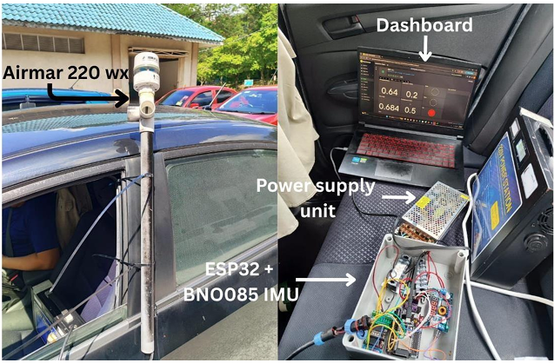
- Assembled speed monitoring system and road-testing set-up

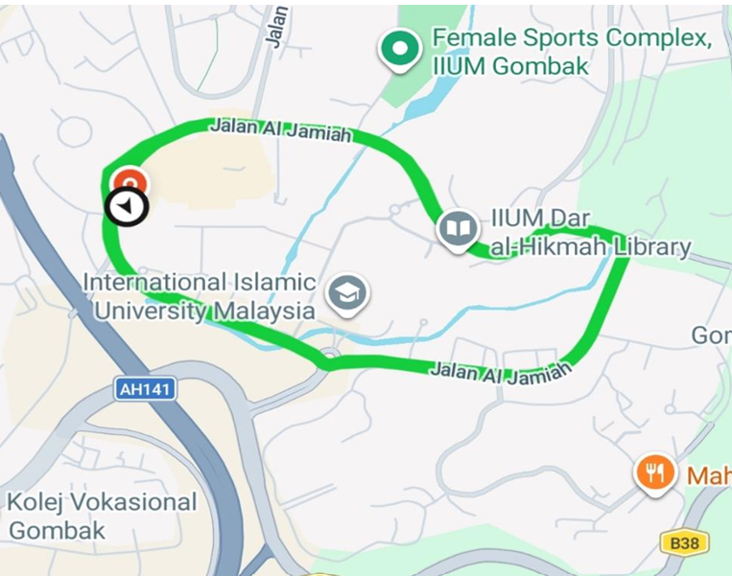
- Road test route used for prototype validation

Results and Discussion

Vessel Speed and Environmental Correlation Analysis
This study considers wind speed and significant wave height as the two environmental factors influencing vessel speed, consistent with the two parameters directly measured by the onboard hardware and used as inputs to the grey-box model. To characterize their relationship with vessel speed, one representative month (April 2025) was selected for detailed analysis. During this month, the vessel recorded an average speed of 11.64 knots and a maximum speed of 15.54 knots and did not reach the 20-knot operational target at any point during the month. A Pearson correlation analysis between vessel speed and these two environmental factors for April (Fig. 3) showed that while there is a direct correlation of operation throttling (Vessel_LPH signifies the fuel consumption of fuel in liter per hour), there are some extent of correlations of environmental conditions to vessel speed: 13% for significant wave height and 12% for wind speed.
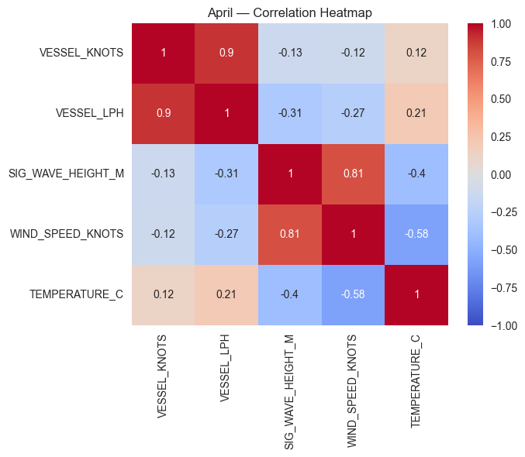
- Pearson correlation heatmap for April 2025

Offline Grey-Box Model Performance
The hybrid PINN–XGBoost grey-box model was trained and validated on the four-month vessel dataset using an 75/10/15 train/validation/test split. As shown in Table II, the model achieved an RMSE of 0.246 knots, and an R² of 0.9991, with 97.9% of predictions falling within ±0.5 knots.
This result should not be read as an artifact of an unusually favorable split. The physics prior (Equation 2) omits any lag term, so it cannot inflate R² by learning a trivial identity mapping on the autocorrelated SOG signal. This accuracy is instead carried explicitly by the PINN and XGBoost stages. Lag features are computed per source file prior to pooling, so no validation or test row depends on training-partition data.
Because of the chronological split places the held-out 15% almost entirely within July, the most recent and largest month in the dataset, the result reflects genuine out-of-time generalization rather than same-period interpolation. The model's accuracy should nonetheless be understood as demonstrated within the range of wind and wave conditions observed during data collection, rather than assumed to extend to more severe sea states.

Prototype Road-Test Validation
The road-test validation was conducted in three trials. In Test 1, the maritime-trained model was deployed directly on the road circuit without any retraining. The predicted speed never exceeded 13.1 knots (24 km/h) even as the vehicle reached 35.3 knots (65 km/h), giving an RMSE of 15.05 knots (27.8 km/h). This large offset was expected as the test speed range fell outside the maritime training distribution, and the model had no prior exposure to road-surface dynamics such as speed-hump events.

- Grey-Box Model Performance Across All Evaluation Phases
Evaluation Phase | RMSE (kn) | R² | MAPE (%) | Within ±0.5 kn (%)
Offline (Vessel dataset) | 0.246 | 0.9991 | — | 97.9
Test 1 — Trained on vessel data | 15.05 | −2.99 | 65.4 | 4.2
Test 2: Retrained on Test 1 data | 6.594 | −0.05 | 38.4 | 0.9
Test 3 — retrained on Test 1+2 data | 0.187 | 0.9989 | 2.09 | 99.8

The samples collected from Test 1 were used to retrain the model for Test 2, reducing RMSE by 56% to 6.594 knots (12.2 km/h). The R² remained strongly negative at −0.05. This indicating that the model had learned the correct relative dynamics of the speed profile but not yet its correct absolute scale. The accuracy breakdown supports this reading by only 0.9% of Test 2 predictions fell within ±0.5 knots and MAPE remained high at 38.4%, showing that the improvement over Test 1 was directional rather than operationally usable.
In Test 3, the model was retrained on the combined Test 1 and Test 2 road data. The RMSE fell to 0.187 knots (0.35 km/h), R² rose to 0.9989, and 99.8% of predictions fell within ±0.5 knots at a MAPE of 2.09%. Because this evaluation used data from a session excluded from both retraining stages, the result reflects genuine generalization rather than re-fitting to already-seen data. The RMSE trajectory across the three trials supports a causal reading of progressively broader domain-matched training data resolving first the trend. The calibration offset shows rather than a single retraining step coincidentally producing a near-perfect fit. The main limitation is scope rather than mechanism: all three sessions were collected on the same 2.7 km campus circuit with the same twelve speed humps and the same vehicle, so the architecture's ability to adapt across sessions is well demonstrated.
Fig. 5 shows the measured SOG vs the predicted vessel speed for Test 1 - Test 3.
(a) Test 1: System trained on Vessel Data
(b) Test 2: Retrained on Test 1 Road Data
(c) Test 3: Retrained on Test 1 & 2 Road Data

Alert System Validation
The alert classification (Green/Yellow/Red) was verified against the logged predicted speed and was 100% correct across all three road-test sessions, with no cloud interruptions observed on the Blynk dashboard. The distribution of alert states shifted accordingly as model accuracy improved: Test 1 remained 100% ‘Red’ throughout, since the uncalibrated model never predicted a speed near the operating threshold; Test 2 produced ‘Green’ or ‘Yellow’ states for 19.3% of the session; and Test 3, using the fully combined training dataset, produced ‘Green’ or ‘Yellow’ states for 49.2% of the session, consistent with the vehicle's actual speed profile. This confirms that the alert logic itself was correct throughout, and that the change in alert distribution reflects the improving accuracy of the underlying prediction model rather than any change to the threshold logic. Fig. 5 shows the dashboard in all three stages (Red / Yellow / Green).

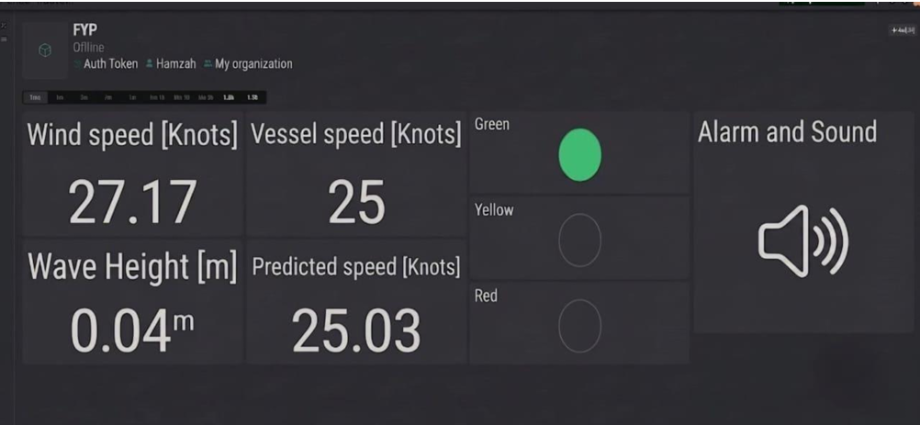
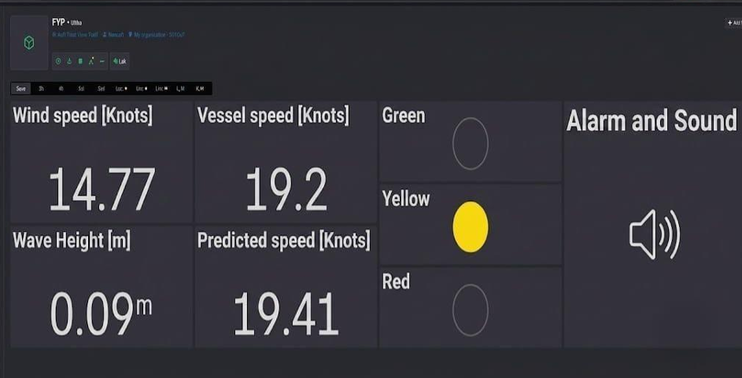
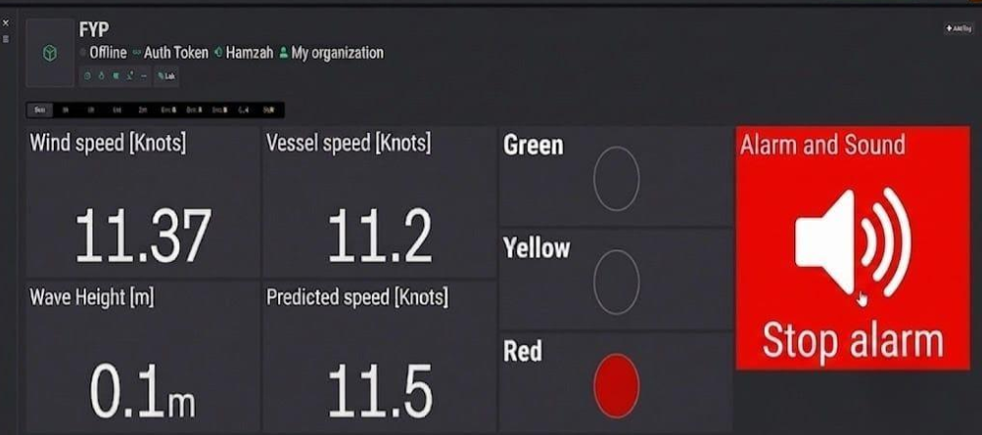
- Dashboard for Red (< 18 knots), Yellow (18 ≤ V_{p}< 20 knots) and Green (≥ 20 knots).

Conclusion and Future Work
This paper presented a hybrid grey-box framework combining a Physics-Informed Neural Network with XGBoost for vessel speed prediction and real-time monitoring, together with an ESP32-based prototype and a threshold alert system. Correlation analysis of four months of operational data showed that wind speed and significant wave height have only a marginal effect on vessel speed compared with operational control. The grey-box model achieved an RMSE of 0.246 knots and an R² of 0.9991 offline, and, after three iterative retraining cycles on prototype road-test data, reduced its road-domain RMSE by 98.8%, reaching 99.8% of predictions within ±0.5 knots. The alert system achieved 100% classification accuracy across all sessions with no cloud interruptions, indicating that the complete hardware, model, and monitoring pipeline is stable enough for continued field development.
Future work will prioritize deployment and validation on an actual vessel at sea, since road testing, while useful for establishing the adaptability of the grey-box architecture, cannot fully reproduce maritime hydrodynamic conditions. The alert logic could also be extended from a purely reactive system into a forecast-driven one that uses predicted wind and wave conditions to warn operators before an unsafe condition materializes. Finally, model compression techniques such as quantization, pruning, or knowledge distillation will be explored to enable the XGBoost component to run fully on embedded hardware, removing the current dependency on an external laptop or PC for inference.

REFERENCE
- E. Filtz, E. S. De La Cerda, M. Weber, and D. Zirkovits, "Factors affecting ocean-going cargo ship speed and arrival time," Lecture Notes in Business Information Processing, vol. 215, pp. 305–316, 2015.
- J. Zhao, Y. Chen, Z. Zhou, J. Zhao, S. Wang, and X. Chen, "Extracting vessel speed based on machine learning and drone images during ship traffic flow prediction," Journal of Advanced Transportation, vol. 2022, 2022.
- N. H. Babbedge, "Statistical analysis of the voyage data of three fast cargo ships," International Shipbuilding Progress, vol. 19, no. 4, pp. 187–198, 1977.
- M. Bassam, A. B. Phillips, S. R. Turnock, and P. A. Wilson, "Artificial neural network-based prediction of ship speed under operating conditions for operational optimization," Ocean Engineering, vol. 278, 2023.
- D. Wang, Y. Wang, H. Shi, S. Gan, and S. Liang, "Predicting ship speed in the inland waterways with LSTM network," in Proc. 2022 IEEE 7th Int. Conf. Intelligent Transportation Engineering (ICITE), 2022, pp. 35–39.
- M. Abebe, Y. Shin, Y. Noh, S. Lee, and I. Lee, "Machine learning approaches for ship speed prediction towards energy efficient shipping," Applied Sciences, vol. 10, no. 7, 2020.
- L. Moreira, R. Vettor, and C. G. Soares, "Neural network approach for predicting ship speed and fuel consumption," Journal of Marine Science and Engineering, vol. 9, no. 2, pp. 1–14, 2021.
- X. Lang and W. Mao, "A semi-empirical model for ship speed loss prediction at head sea and its validation by full-scale measurements," Ocean Engineering, vol. 209, 2020.
- X. Lang, D. Wu, and W. Mao, "Physics-informed machine learning models for ship speed prediction," Expert Systems with Applications, vol. 238, 2024.
- O. Tarovik, D. Eremenko, and A. Topaj, "A benchmark study on ship speed prediction models in Arctic conditions: machine learning, process-based and hybrid approaches," Ocean Engineering, vol. 311, 2024.
- M. L. Schirmann, M. D. Collette, and J. W. Gose, "Data-driven models for vessel motion prediction and the benefits of physics-based information," Applied Ocean Research, vol. 120, 2022.
- X. Lang, D. Wu, and W. Mao, "Comparison of supervised machine learning methods to predict ship propulsion power at sea," Ocean Engineering, vol. 245, 2022.

