Quantis
Systematically Managed Multi-Asset Funds with News-Sentiment Analytics
Part B report - Stations 3 and 4 (Funds, Sentiment, App)
Student z5494216 | FINS3645 Financial Market Data Design & Analysis | 2026

1. The funds and the backtest design 2
2. Out-of-sample results and fund fact sheets 3
3. The sentiment index 5
4. Extensions and innovations 6
4.1 Custom finance lexicon for the sentiment model 6
4.2 Risk parity as true ERC, and cap pinning 7
4.3 Turnover and transaction-cost model 7
4.4 The fusion extension: does sentiment add value? 7
4.5 News attention vs forward volatility cross-check 8
4.6 Design system 8
5. The app and the investor journey 9
5.1 App features that go beyond the baseline 9
5.2 Target user and customer journey 9
6. Critical reflection and three recommendations 9
6.1 Make the news signal sector-conditional and volatility-scaled 10
6.2 Make turnover a constraint, not an afterthought 10
6.3 Rebuild Maximum Sharpe as a constrained, benchmark-aware fund 10
References 11
Appendix A - Full fund fact sheets 12
Appendix B - Turnover and transaction-cost model 13
Appendix C - Fusion kappa sensitivity 14
Appendix D - News attention vs forward volatility 14

1. The funds and the backtest design
[DRAFT] Quantis is a prototype investment app that offers a menu of rules-based funds built from 50 US large-cap equities (10 sectors), 10 cryptocurrencies and the two combined. Each fund is a (universe, method) pair that an investor could hold and that has its own fact sheet: 12 base funds across four optimisation methods - Equal Weight, Minimum Variance, Maximum Sharpe and Risk Parity - plus two sentiment-tilted variants of the equity funds (section 4). The news data only covers the equities, so every sentiment-based extension applies to the equity universe only; crypto is treated as a pure price-based diversifier.
[DRAFT] The funds are backtested out of sample with a walk-forward design. A 504-trading-day (two-year) estimation window slides through the sample and weights are recomputed every 21 trading days (approximately monthly); the weights formed at a rebalance date are applied from the next period, so no decision ever uses a future observation. The optimisers are long-only with a 20% cap per holding for equity and combined funds and a 35% cap for crypto, and use a sample covariance shrunk 10% toward the diagonal for stability. The Sharpe ratio assumes a zero risk-free rate, stated so the numbers are comparable.
[DRAFT] The first live (out-of-sample) dates are 31 December 2021 for the equity and combined funds (2021-12-31 to 2023-12-29, 502 trading days) and 19 May 2021 for the crypto funds (2021-05-19 to 2023-12-31, 957 trading days); the two-year window before that is estimation only. Annualisation is 252 trading days for equity and combined and 365 for crypto, matching each calendar. A 10-basis-point one-sided transaction-cost model is applied separately (not inside the optimisation) so we can report gross versus net performance; the base backtests otherwise assume zero transaction costs, as the brief permits.
[DRAFT] Risk Parity is implemented as true equal risk contribution (an ERC problem solved with a Newton scheme) rather than the inverse-volatility shortcut, and the per-asset caps are enforced with a recursive water-filling projection (`normalize_capped`) so the 20%/35% limits are binding throughout the backtest. Table 1 states every design choice.
Design choice | Value
Estimation window | 504 trading days (2 years)
Rebalance frequency | every every 21 periods (~monthly)
Risk-free rate | 0.0
Long / short | Long only
Per-asset cap | 20% (equity, combined); 35% (crypto)
Covariance | sample covariance shrunk 10% toward diagonal
Transaction costs | 10 bps one-sided (turnover model)
Annualisation | 252 days (equity, combined); 365 days (crypto)
First live date - equity/combined | 2021-12-31
First live date - crypto | 2021-05-19
Out-of-sample days | 502 (equity, combined); 957 (crypto)
Table 1. Backtest design choices, as recorded in results/tables/backtest_parameters.csv.

[DRAFT] Figure 1 shows the full set of base funds and their weights over time for one fund, and Table 2 gives the headline numbers. The design deliberately pairs simple transparent rules (Equal Weight) with risk-targeting methods (Minimum Variance, Risk Parity) and a return-seeking one (Maximum Sharpe), so an investor can choose how much optimisation risk they are paying for.

2. Out-of-sample results and fund fact sheets
[DRAFT] Out of sample, the safest funds also delivered the most reliable results. Equity Equal Weight returned 6.0% annualised with a 0.42 Sharpe and grew $1 to $1.12; Equity Minimum Variance had the lowest volatility in the equity family (13.5% annualised) and the shallowest drawdown (-16.5%). In crypto, Minimum Variance was the standout: 7.5% annualised and the only crypto fund to grow $1 above 1.21. The equal-weight crypto funds lost money, which is what a price-only crypto basket did over 2022-2023.
[DRAFT] Maximum Sharpe is the clear loser in every universe. The combined Maximum Sharpe fund made -0.073 annualised (Sharpe -0.28) because the unconstrained tangency portfolio leans hard on the highest-momentum, highest-volatility names, and in a long-only world with those names falling over 2022 it compounded losses. This is a genuine finding, not a bug: mean-variance tangency rewards recent winners, and 2022 reversed them. Section 6 turns this into a recommendation.
[DRAFT] Each fund has a fact sheet in the same format an investor would see in the app: growth of $1, annualised return and volatility, Sharpe ratio, maximum drawdown, and the current top-10 holdings (the target weights at the most recent rebalance, 4 December 2023 for the equity funds). The full fact-sheet table is in Appendix A; the app renders the same fields for any of the 14 funds. Figures 1-4 are the growth, drawdown, weights-over-time and Sharpe-barplot exhibits.
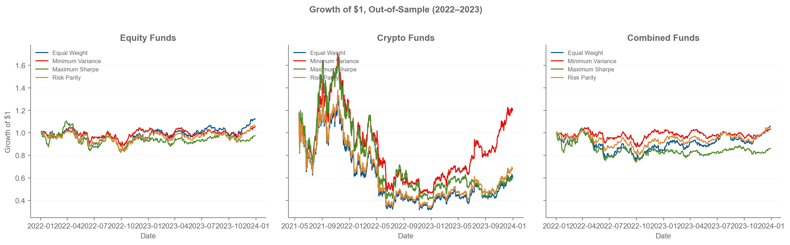
Figure 1. Growth of $1 for the 12 base funds by universe and method, out of sample (equity/combined 31 Dec 2021-29 Dec 2023; crypto 19 May 2021-31 Dec 2023). Source: results/figures/growth_of_1.png.

Fund | Ann. return | Ann. vol | Sharpe | Max drawdown | Growth of $1
Equity Equal Weight | 6.0% | 17.7% | 0.42 | -20.3% | 1.12
Equity Minimum Variance | 2.6% | 13.5% | 0.26 | -16.5% | 1.05
Equity Maximum Sharpe | -1.4% | 18.8% | 0.02 | -25.5% | 0.97
Equity Risk Parity | 3.2% | 16.3% | 0.28 | -19.0% | 1.06
Crypto Equal Weight | -17.1% | 71.5% | 0.10 | -76.3% | 0.61
Crypto Minimum Variance | 7.5% | 64.0% | 0.43 | -73.4% | 1.21
Crypto Maximum Sharpe | -17.8% | 71.1% | 0.08 | -76.0% | 0.60
Crypto Risk Parity | -13.8% | 70.0% | 0.14 | -75.9% | 0.68
Combined Equal Weight | 2.7% | 20.9% | 0.23 | -26.9% | 1.05
Combined Minimum Variance | 1.7% | 13.6% | 0.19 | -16.8% | 1.03
Combined Maximum Sharpe | -7.3% | 20.0% | -0.28 | -29.2% | 0.86
Combined Risk Parity | 2.5% | 17.0% | 0.23 | -21.5% | 1.05
Equity Equal Weight + Sentiment | 5.9% | 17.7% | 0.41 | -20.2% | 1.12
Equity Minimum Variance + Sentiment | 3.0% | 13.4% | 0.29 | -16.5% | 1.06
Table 2. Out-of-sample performance metrics for all 14 funds (annualised; risk-free 0). Source: results/tables/performance_metrics.csv.

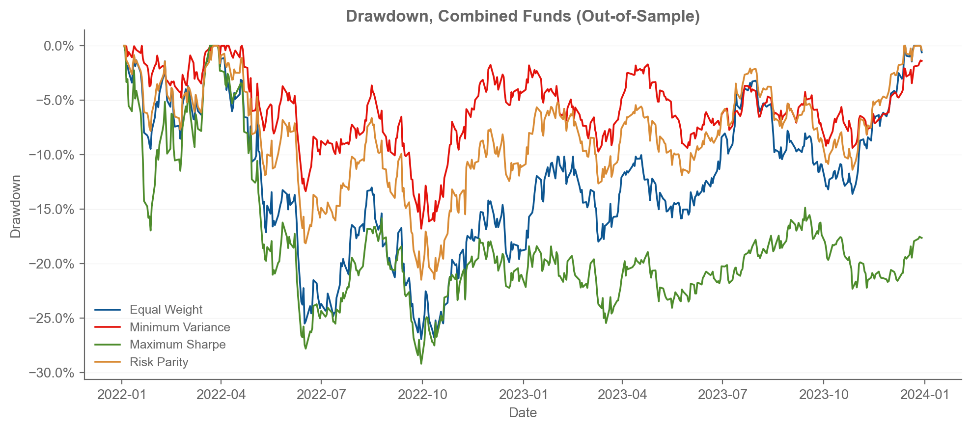
Figure 2. Drawdown of the four combined funds, out of sample (2022-2023). Source: results/figures/drawdown.png.

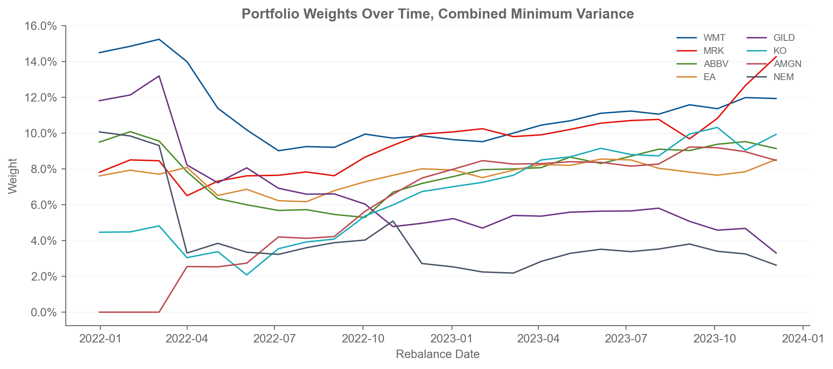
Figure 3. Portfolio weights over time for Combined Minimum Variance, showing the rebalance path of the eight largest mean holdings (weight scale in %). Source: results/figures/weights_over_time.png.

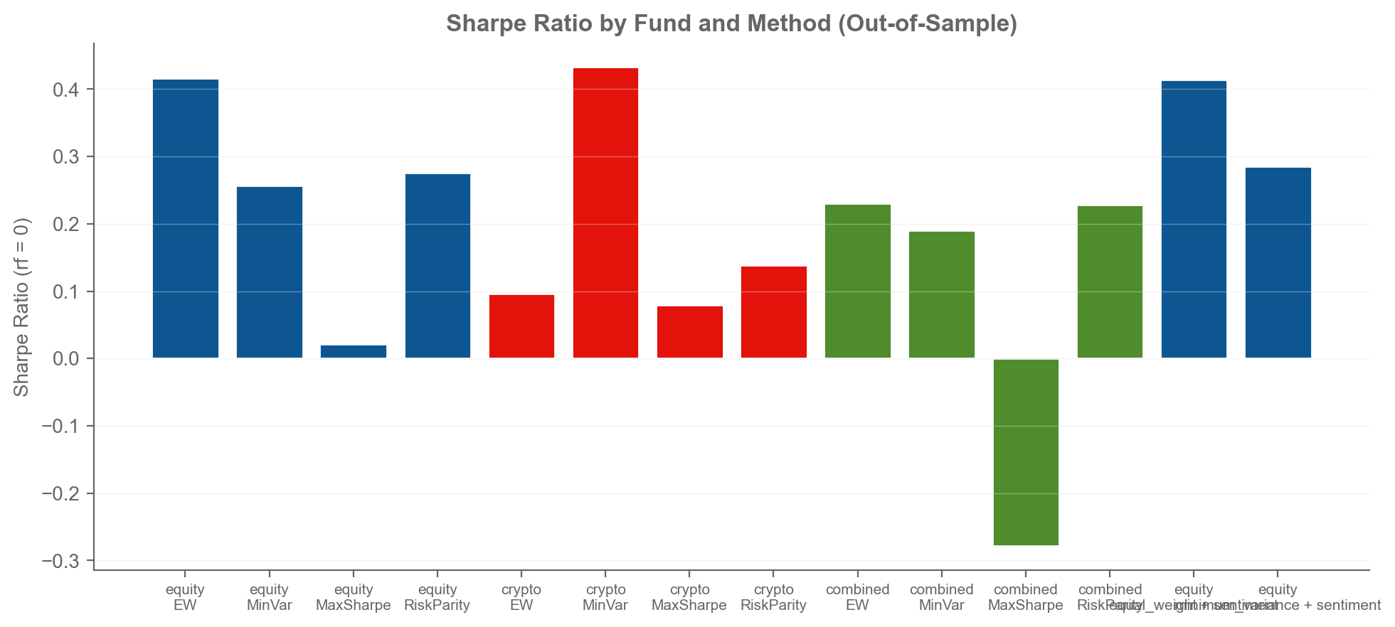
Figure 4. Sharpe ratio by universe and method, out of sample (risk-free 0). Source: results/figures/sharpe_barplot.png.

3. The sentiment index
[DRAFT] The standalone sentiment analytic is built from 146,836 equity news headlines (149,683 raw, after removing 5,617 exact duplicates on ticker + date + title). Each headline is scored with VADER extended by a custom finance lexicon (section 4), then aggregated to one sentiment per ticker-trading-day and equal-weighted across the tickers in each sector to give a daily sector index, shown in Figure 5. This is deliberately the simple equal-weight construction the brief specifies, so the index is a defensible baseline that the extensions in section 4 build on.
[DRAFT] Two modelling choices are worth stating. First, ticker-days with no headlines are treated as neutral (0): absence of news carries no directional signal, and keeping the panel dense avoids survivorship artefacts in the sector average. Second, the signal is lagged one trading day before it is usable - sentiment aligned to Monday (including any Saturday or Monday headline) is first usable for Tuesday's trade - so no decision in the fusion ever looks ahead. Both choices are enforced by tests.
[DRAFT] The index is broadly positive across sectors over the sample: mean sentiment ranges from 0.084 (Materials) to 0.158 (Consumer and Tech), which reflects that these are company headlines from a period of recovery rather than a market crash. The series moves around that mean and, as the brief warns, headline sentiment is a noisy proxy; the fusion results in section 4 show how much (or how little) of that signal survived into fund decisions.
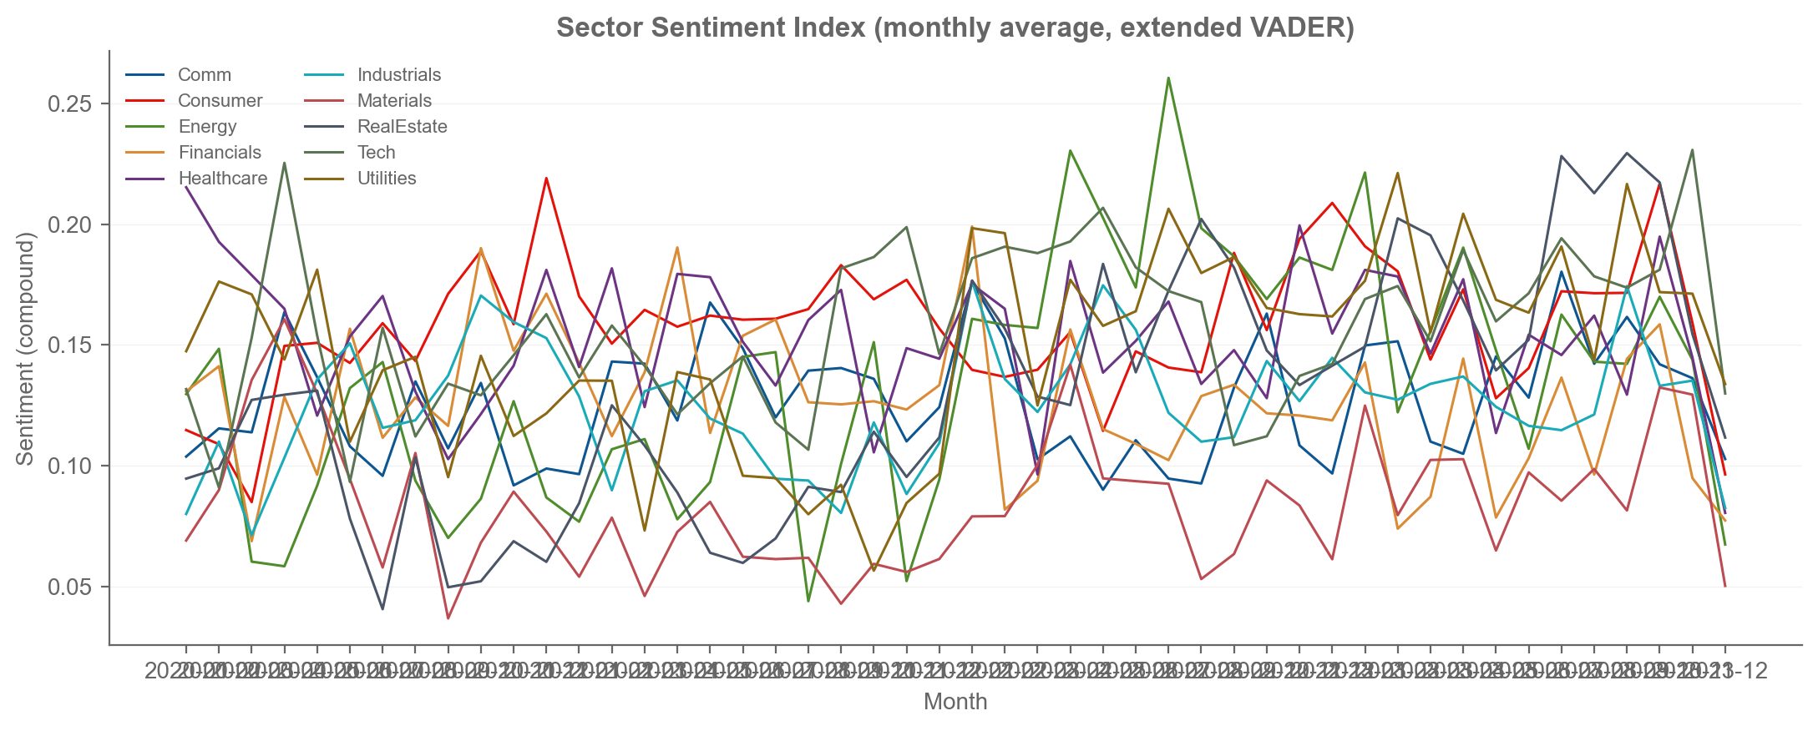
Figure 5. Sector sentiment index, monthly average of the daily equal-weighted ticker sentiment per sector, 2020-2023 (extended VADER, compound scale). Source: results/figures/sector_sentiment_index.png.

4. Extensions and innovations
[DRAFT] Station 3 delivers two model outputs: the standalone sentiment index (section 3) and the fusion extension (section 4.4). The innovations below go beyond that baseline and span both Station 3 (the lexicon, true ERC risk parity, the turnover model, the attention-volatility cross-check) and Station 4 (the app features in section 5.1). Each is implemented, artifacts-backed and reported with its honest outcome, including where the result is negative or mixed.

4.1 Custom finance lexicon for the sentiment model
[DRAFT] Plain VADER scores roughly a third of finance headlines as exactly zero, many of them false neutrals, because its lexicon is built for social-media language. I extended it with a curated finance lexicon - earnings and ratings verbs (beat, miss, downgrade), corporate-action terms (buyback, layoffs), macro vocabulary (hawkish, recession, tariff), market-direction words (surge, plunge, selloff) and 22 multi-word phrases plus booster words - using the Week 8 build-and-test method. The extension is installed in memory on a copy of VADER's tables, never into the installed package, so a plain analyser in the same process cannot see it (a silent leakage bug I caught in prompt log 02). Rejected terms, such as 'debt' and 'volatile', were tested to confirm they do not move; Table 3 shows examples that wake up only with the extension. The lexicon lifted the share of headlines with a non-zero score to 66.4% of 146,836.
Sentence | VADER | Extended | Change
The company reported an earnings beat. | 0.000 | 0.840 | 0.840
The stock surged on strong guidance. | 0.511 | 0.440 | -0.070
Management issued a guidance cut. | -0.273 | -0.542 | -0.269
Analysts issued a downgrade. | 0.000 | -0.557 | -0.557
The firm announced a buyback. | 0.000 | 0.421 | 0.421
Revenue was sharply lower than expected. | -0.296 | -0.294 | 0.002
The filing disclosed a material weakness. | -0.421 | -0.542 | -0.121
The auditor raised a going concern warning. | -0.340 | -0.875 | -0.535
The firm reduced its debt. | -0.361 | -0.361 | 0.000
The stock is volatile. | 0.000 | 0.000 | 0.000
Table 3. Before/after scores for the finance-lexicon extension; the final two rows are deliberately rejected terms that must not move. Source: results/tables/vader_extension_before_after.csv.

4.2 Risk parity as true ERC, and cap pinning
[DRAFT] Risk Parity here is equal risk contribution solved with a Newton scheme and a recursive water-filling cap projection, not the inverse-volatility approximation that is often sold as risk parity. The weights therefore genuinely equalise each asset's contribution to portfolio risk subject to the 20%/35% caps. The pipeline prints a weight-diversity diagnostic at every run (top-3 weight share per method) so a reviewer can see the optimisers did not stall on tiny daily covariances: at the latest equity rebalance the top-3 share is 6% for Equal Weight (3/n), 39% for Minimum Variance, 55% for Maximum Sharpe and 11% for Risk Parity.

4.3 Turnover and transaction-cost model
[DRAFT] Because the funds rebalance monthly, turnover is a real cost. I compute the one-way turnover at each rebalance and apply a 10-basis-point cost, and the net effect is large for exactly the funds that need it most. Minimum Variance turns over about 1.5-1.7x annualised in equity and combined (an estimated 16.62% per year) while Maximum Sharpe turns over 4.0-4.5x (39.51% per year), which is more than the gross return of some funds. Appendix B lists all funds; the finding feeds recommendation 2 in section 6.

4.4 The fusion extension: does sentiment add value?
[DRAFT] The equity funds are tilted with the lagged, smoothed sentiment signal: each weight is scaled by (1 + kappa x signal) and renormalised under the same cap. The result is honest and mixed. At the shipped strength (kappa = 1), Equal Weight falls slightly from Sharpe 0.42 to 0.41 (a small decline), while Minimum Variance improves from 0.26 to 0.29. The kappa sweep (Appendix C) shows the same pattern: the tilt hurts Equal Weight at every strength, and Minimum Variance peaks at kappa = 2 (Sharpe 0.30). A naive equal-weighted sentiment tilt is therefore value-neutral to mildly positive depending on the fund - a baseline finding I report unedited rather than cherry-picking the best cell.
Fund | Base Sharpe | Fused Sharpe | Change | Base $1 | Fused $1
Equity Equal Weight + Sentiment | 0.42 | 0.41 | -0.002 | 1.12 | 1.12
Equity Minimum Variance + Sentiment | 0.26 | 0.29 | 0.029 | 1.05 | 1.06
Table 4. Fusion before/after at the shipped tilt strength (kappa = 1). Source: results/tables/fusion_comparison.csv.

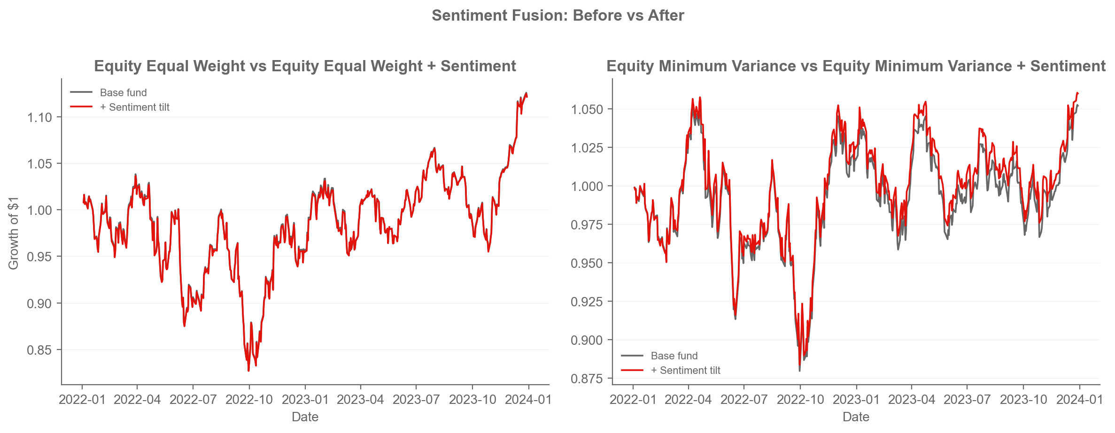
Figure 6. Fusion before/after for the two sentiment-tilted equity funds (growth of $1, out of sample). Source: results/figures/fusion_before_after.png.

4.5 News attention vs forward volatility cross-check
[DRAFT] A second use of the news data asks whether attention itself - the number of headlines a ticker attracts - carries information about its future risk. For every equity ticker-day I pair a strictly lagged attention measure (trailing 5-day mean headline count, shifted one day) with a strictly forward volatility measure (annualised standard deviation of the next 5 daily returns), then correlate the two within each sector. The result is mixed and informative: the relationship is positive in six of ten sectors (strongest in Utilities 0.20, Industrials 0.18 and Tech 0.16), near zero in Communications and Financials, and clearly negative in Energy (-0.20) - energy attention spikes when prices crash and realised volatility is elevated, which inverts the direction. Figure 7 and Appendix D give the full evidence. The honest conclusion is that news attention anticipates volatility in most sectors but not all, so a volatility-aware use of the news data should be sector-conditional - which is exactly recommendation 1.
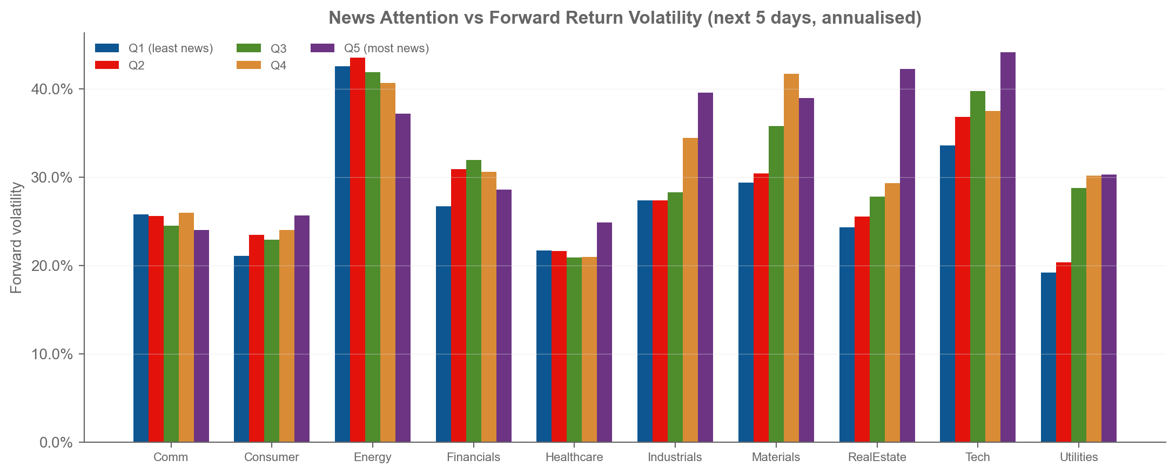
Figure 7. Mean forward 5-day realised volatility (annualised) by lagged news attention quintile and sector. Rising bars from Q1 (least news) to Q5 (most news) mean attention anticipates volatility. Source: results/figures/news_volume_volatility.png.

4.6 Design system
[DRAFT] Every figure and the app use a custom Economist-style design system carried from Part A: a red/blue/grey palette, no top or right spines, light grid, and a sans-serif typeface. This is my own visual language rather than the matplotlib defaults, and it makes the fund figures and the app feel like one product rather than a collection of scripts.

5. The app and the investor journey

5.1 App features that go beyond the baseline
[DRAFT] Beyond the four required steps of the journey, the app ships several deliberately original features: an allocation builder that blends funds into a single growth-of-$1 path, a weights-over-time view per fund, current holdings derived in-app from the latest rebalance rather than stored as a fifth file, same-day-versus-lagged sentiment lines so the investor can see the look-ahead guard working, and the Economist-style design system (4.6) carried into every chart. These are the Station 4 innovations the report claims, and each is visible in the running app rather than only described.

5.2 Target user and customer journey
[DRAFT] The target user is a time-poor retail investor with moderate risk tolerance who wants transparent, rules-based exposure to equities and crypto without picking individual stocks, and who would pay a management fee for a fund family they can compare on one screen. Quantis answers the question 'which fund fits me?' with out-of-sample evidence, not marketing: every number in the app is a precomputed backtest result, so the investor is never shown an in-sample fit.
[DRAFT] The customer journey has four steps, one per tab. Compare shows all 14 funds side by side with their out-of-sample risk/return and a growth-of-$1 chart. Fact sheet opens any fund and shows its metrics, growth and drawdown, and its current top-10 holdings (derived in the app from the latest rebalance in fund_weights.csv). Allocate lets the investor set a split across funds and see the blended growth-of-$1 path against the individual funds. Sentiment surfaces the sector sentiment index over time, with same-day and lagged lines, monthly averages and per-sector summary stats, so the news analytic is a product in its own right and not just a hidden model input.
[DRAFT] [SCREENSHOTS TO INSERT - the student should replace this marker with app screenshots of the four tabs.]
[DRAFT] The app reads exactly four precomputed CSVs (results/data/fund_returns.csv, fund_weights.csv, sector_sentiment_index.csv and results/tables/performance_metrics.csv) and derives anything else in-app. It never imports the sentiment-scoring package, never recomputes a backtest and never touches raw data, so it stays light enough for the free Streamlit tier while the full build runs locally in minutes. requirements.txt is slim by design; build-only packages live in requirements-dev.txt.
[DRAFT] The app is deployed from the public GitHub repository that holds this folder and its precomputed results/ artifacts (private while building, made public at hand-in). The live URL and repository link accompany this report; the deploy step is the student's browser action.

6. Critical reflection and three recommendations
[DRAFT] What worked: the risk-targeting funds behaved as their design promises. Minimum Variance delivered the lowest volatility and the shallowest drawdowns in every universe, Risk Parity sat between Equal Weight and Minimum Variance as theory predicts, and the sector sentiment index is a stable, interpretable analytic that the app surfaces directly.
[DRAFT] What did not work, and why: Maximum Sharpe was the worst fund in every universe because a long-only tangency portfolio doubles down on recent winners, and 2022 reversed them; the fusion tilt was at best neutral and slightly negative for Equal Weight, because an equal-weighted sector signal dilutes the per-ticker information and a 5-day average smooths it flat; and turnover silently erodes the optimised funds - at 10 bps the annual cost is larger than the gross return of the worst funds. The news attention cross-check also showed the relationship is not universal (Energy is opposite), so a single global sentiment tilt is a blunt instrument.
[DRAFT] Three concrete recommendations follow from the evidence in this report.

6.1 Make the news signal sector-conditional and volatility-scaled
[DRAFT] Only tilt equity funds in sectors where attention demonstrably anticipates volatility (the positive-rho sectors in section 4.5), and scale the signal by each ticker's inverse realised volatility instead of equal-weighting the sector. This directly replaces the two things that diluted the current fusion - cross-sector averaging and a flat 5-day mean - with a measure the cross-check shows has forward information. Expected effect: the Minimum Variance kappa-2 improvement (Sharpe 0.30) becomes the default rather than the best cell, and the Equal Weight decline disappears because energy names are excluded.

6.2 Make turnover a constraint, not an afterthought
[DRAFT] The 10-bps cost model turns several positive gross returns negative (e.g. Equity Minimum Variance gross +2.6% to net -14.0% annually in the model). Recommendation: add a turnover penalty or a holding-period buffer to the optimisation, or rebalance quarterly instead of every 21 days, and report net-of-cost numbers as the headline. A fund that turns over 4.5x a year is not investable at retail fees; a turnover-aware version of Minimum Variance would keep most of the risk reduction at a fraction of the cost.

6.3 Rebuild Maximum Sharpe as a constrained, benchmark-aware fund
[DRAFT] The tangency portfolio is the only method that lost money in all three universes, and it loses for a mechanical reason: it is unconstrained in concentration and short-free. Recommendation: cap sector exposure and add either a cash buffer or a volatility-target overlay so the fund can de-risk when realised volatility spikes (which the news attention measure in 4.5 helps to time), and only offer it as part of a pair with Minimum Variance. Without that, the honest product decision is to drop Maximum Sharpe from the menu entirely and sell the two risk-targeting funds.

References
Data bundle (equity, crypto, news headlines), FINS3645 course data, hosted single ZIP. URL: https://drive.google.com/uc?export=download&id=1h0Wy12_qgR_NZJqtSxI9LwPEVKgp5DzH [HUMAN EDIT REQUIRED: confirm the URL and add access date].
Hutto, C. and Gilbert, E. (2014). VADER: A Parsimonious Rule-Based Model for Sentiment Analysis of Social Media Text. Proceedings of ICWSM. [HUMAN EDIT REQUIRED: verify bibliographic details].
Course textbook, Chapter 1 (the four-stage Data Factory Floor). [HUMAN EDIT REQUIRED: add full citation].

Appendix A - Full fund fact sheets
Fund | Ann. return | Ann. vol | Sharpe | Max drawdown | Growth of $1 | Last rebalance
Equity Equal Weight | 6.0% | 17.7% | 0.42 | -20.3% | 1.12 | 2023-12-04
Equity Minimum Variance | 2.6% | 13.5% | 0.26 | -16.5% | 1.05 | 2023-12-04
Equity Maximum Sharpe | -1.4% | 18.8% | 0.02 | -25.5% | 0.97 | 2023-12-04
Equity Risk Parity | 3.2% | 16.3% | 0.28 | -19.0% | 1.06 | 2023-12-04
Crypto Equal Weight | -17.1% | 71.5% | 0.10 | -76.3% | 0.61 | 2023-12-20
Crypto Minimum Variance | 7.5% | 64.0% | 0.43 | -73.4% | 1.21 | 2023-12-20
Crypto Maximum Sharpe | -17.8% | 71.1% | 0.08 | -76.0% | 0.60 | 2023-12-20
Crypto Risk Parity | -13.8% | 70.0% | 0.14 | -75.9% | 0.68 | 2023-12-20
Combined Equal Weight | 2.7% | 20.9% | 0.23 | -26.9% | 1.05 | 2023-12-04
Combined Minimum Variance | 1.7% | 13.6% | 0.19 | -16.8% | 1.03 | 2023-12-04
Combined Maximum Sharpe | -7.3% | 20.0% | -0.28 | -29.2% | 0.86 | 2023-12-04
Combined Risk Parity | 2.5% | 17.0% | 0.23 | -21.5% | 1.05 | 2023-12-04
Equity Equal Weight + Sentiment | 5.9% | 17.7% | 0.41 | -20.2% | 1.12 | 2023-12-04
Equity Minimum Variance + Sentiment | 3.0% | 13.4% | 0.29 | -16.5% | 1.06 | 2023-12-04
Table A1. Fact-sheet metrics per fund (annualised). Source: results/tables/fact_sheets.csv. Current top-10 holdings per fund are in results/data/fund_holdings.csv and rendered in the app.

Appendix B - Turnover and transaction-cost model
Fund | Avg turnover / rebal. | Annualised turnover | Est. cost p.a. | Gross return p.a. | Net return p.a.
Combined Equal Weight | 0.000 | 0.000 | 0.00% | 2.7% | 2.7%
Combined Maximum Sharpe | 0.377 | 4.522 | 45.22% | -7.3% | -52.5%
Combined Minimum Variance | 0.129 | 1.549 | 15.49% | 1.7% | -13.8%
Combined Risk Parity | 0.024 | 0.283 | 2.83% | 2.5% | -0.4%
Crypto Equal Weight | 0.000 | 0.000 | 0.00% | -17.1% | -17.1%
Crypto Maximum Sharpe | 0.331 | 3.975 | 39.75% | -17.8% | -57.6%
Crypto Minimum Variance | 0.078 | 0.936 | 9.36% | 7.5% | -1.9%
Crypto Risk Parity | 0.012 | 0.140 | 1.40% | -13.8% | -15.2%
Equity Equal Weight | 0.000 | 0.000 | 0.00% | 6.0% | 6.0%
Equity Maximum Sharpe | 0.329 | 3.951 | 39.51% | -1.4% | -40.9%
Equity Minimum Variance | 0.139 | 1.662 | 16.62% | 2.6% | -14.0%
Equity Risk Parity | 0.022 | 0.265 | 2.65% | 3.2% | 0.6%
Table B1. One-way turnover at each rebalance and the 10-bps one-sided cost model. Source: results/tables/turnover.csv.

Appendix C - Fusion kappa sensitivity
Base fund | Kappa | Sharpe | Ann. return | Ann. vol | Max drawdown
Equity Equal Weight | 0.5 | 0.41 | 5.9% | 17.7% | -20.3%
Equity Equal Weight | 1.0 | 0.41 | 5.9% | 17.7% | -20.2%
Equity Equal Weight | 2.0 | 0.41 | 5.9% | 17.6% | -20.1%
Equity Equal Weight | 3.0 | 0.41 | 5.8% | 17.6% | -19.9%
Equity Minimum Variance | 0.5 | 0.27 | 2.7% | 13.4% | -16.5%
Equity Minimum Variance | 1.0 | 0.29 | 3.0% | 13.4% | -16.5%
Equity Minimum Variance | 2.0 | 0.30 | 3.1% | 13.3% | -16.5%
Equity Minimum Variance | 3.0 | 0.28 | 2.8% | 13.3% | -16.7%
Table C1. Sentiment-tilt strength sweep for the two equity funds. Source: results/tables/fusion_kappa_sensitivity.csv.

Appendix D - News attention vs forward volatility
Sector | Ticker-days | Spearman rho
Comm | 4936 | -0.04
Consumer | 4994 | 0.06
Energy | 4962 | -0.20
Financials | 4972 | -0.04
Healthcare | 4989 | 0.03
Industrials | 4547 | 0.18
Materials | 4688 | 0.13
RealEstate | 4673 | 0.11
Tech | 4693 | 0.16
Utilities | 4726 | 0.20
Table D1. Sector-level Spearman correlation between lagged news attention (trailing 5-day headline count) and forward 5-day realised volatility. Source: results/tables/news_volume_volatility_correlation.csv.

Sector | Q1 vol | Q2 vol | Q3 vol | Q4 vol | Q5 vol
Comm | 25.8% | 25.6% | 24.5% | 26.0% | 24.0%
Consumer | 21.1% | 23.4% | 22.9% | 24.0% | 25.7%
Energy | 42.6% | 43.6% | 41.9% | 40.7% | 37.2%
Financials | 26.7% | 30.9% | 31.9% | 30.6% | 28.6%
Healthcare | 21.7% | 21.6% | 20.9% | 21.0% | 24.9%
Industrials | 27.4% | 27.4% | 28.3% | 34.5% | 39.6%
Materials | 29.4% | 30.4% | 35.8% | 41.7% | 39.0%
RealEstate | 24.4% | 25.6% | 27.8% | 29.4% | 42.3%
Tech | 33.6% | 36.9% | 39.8% | 37.5% | 44.2%
Utilities | 19.2% | 20.4% | 28.8% | 30.2% | 30.3%
Table D2. Mean annualised forward 5-day volatility by lagged-attention quintile and sector. Source: results/tables/news_volume_volatility.csv.

Word tasks for the student before export: update the table of contents; insert app screenshots in section 5; rewrite every red [DRAFT] paragraph in your own words and remove the tags; convert typed figure/table references to Word cross-references; verify the references; accept/reject tracked changes; run the Accessibility Checker; then export report.pdf.

