Autonomous AI Analytics Agent & Dashboard
Project Report
Tech Stack: Python · Pandas · Streamlit · Ollama LLMs
Author: Computer Engineering Undergraduate, Savitribai Phule Pune University
August 2026

Table of Contents
1. Project Overview
2. System Architecture
3. Project Structure
4. Data Layer
5. ETL Pipeline
6. Real-Time Anomaly Detection
7. Autonomous Agent & Tool-Calling Loop
8. Automated Report Synthesis
9. Main Application — Streamlit Dashboard
10. Setup & Installation
11. Dependencies

1. Project Overview
This project is an autonomous AI analytics agent and dashboard that aggregates records from multiple simulated web sources, cleans and analyzes them through a Pandas/SQLite ETL pipeline, flags statistical anomalies in real time, and lets a user query the data through a local LLM (via Ollama) that autonomously decides which analytical tools to call. Results are surfaced through an interactive Streamlit dashboard, and a one-click feature synthesizes a full written report from the agent's findings.

Key Capabilities
- Engineered ETL pipeline aggregating 1,450+ records from 12 simulated web sources into a clean, analysis-ready SQLite warehouse.
- Autonomous tool-calling agent loop: the LLM selects from 5 data tools, executes them against live data, and reasons over the results across multiple turns.
- Real-time anomaly flagging using z-score, IQR, and rolling-window statistical methods across revenue, quantity, pricing, and returns.
- Automated report synthesis: the agent answers a fixed analytical checklist and the answers are assembled into a downloadable Markdown report.
- Interactive Streamlit dashboard with KPI cards, Plotly visualizations, an anomaly table, an agent chat interface, and report export.

2. System Architecture
The system is organized into five layers, each isolated into its own module so that any layer (e.g. the data sources, or the LLM backend) can be swapped independently:
Layer | Component | Responsibility
Sources | pipeline/sources.py | 12 simulated web-source connectors (web stores, apps, marketplaces, social ads, affiliate, email, retail partners)
ETL | pipeline/etl.py | Extract → clean/dedupe/enrich → load into a SQLite warehouse
Analytics | pipeline/anomaly.py | Z-score, IQR, and rolling-window anomaly flagging
Agent | agent/llm_client.py, tools.py, agent_loop.py | Autonomous tool-calling loop against a local Ollama model
Reporting | reports/report_generator.py | Runs the agent over a fixed checklist and assembles a Markdown report
UI | app.py | Streamlit dashboard: KPIs, charts, anomaly table, agent chat, report export
Data flow: Sources → ETL (extract/transform/load) → SQLite warehouse → Anomaly detector ⇄ Agent tools ⇄ LLM (Ollama) → Dashboard / Report

3. Project Structure
ai_analytics_agent/
├── app.py Streamlit dashboard entry point
├── requirements.txt
├── README.md
├── agent/
│ ├── llm_client.py Ollama /api/chat wrapper + tool calling
│ ├── tools.py Tool schemas + implementations
│ └── agent_loop.py Autonomous tool-calling loop
├── pipeline/
│ ├── sources.py 12 simulated web-source connectors
│ ├── etl.py Extract → Transform → Load
│ └── anomaly.py Z-score / IQR / rolling anomaly detection
├── reports/
│ └── report_generator.py Automated report synthesis
└── data/
├── sample_data_generator.py Generates 1,450 synthetic records
└── transactions.csv Generated dataset

4. Data Layer
The dataset simulates 12 independent web-source feeds (web storefronts, mobile apps, marketplaces, paid social, affiliate, email campaigns, retail partners) so the ETL pipeline has genuine multi-source aggregation to perform. 1,450 records are generated, with 18 deliberately injected anomalies (revenue spikes, a pricing bug, and a return/rating cluster) so the anomaly detector has real signal to catch.
data/sample_data_generator.py
"""
sample_data_generator.py
-------------------------
Generates a synthetic multi-source dataset so the agent has something
realistic to analyze out of the box (no API keys required for a first run).

Simulates 12 "web sources" (regional sales feeds, marketing channels,
support-ticket queues, etc.) each contributing records to a unified
transactions table, plus a handful of intentionally injected anomalies
so the anomaly-flagging workflow has something to catch.

Run directly to regenerate data/transactions.csv:
python data/sample_data_generator.py
"""

import random
from datetime import datetime, timedelta
from pathlib import Path

import numpy as np
import pandas as pd

random.seed(42)
np.random.seed(42)

# 12 simulated "web sources" feeding the pipeline (satisfies "10+ web sources")
SOURCES = [
"web_store_us", "web_store_eu", "web_store_apac", "mobile_app_ios",
"mobile_app_android", "marketplace_amazon", "marketplace_etsy",
"social_instagram_ads", "social_tiktok_ads", "affiliate_network",
"email_campaigns", "retail_pos_partners",
]

CATEGORIES = ["Electronics", "Home & Kitchen", "Apparel", "Beauty",
"Sports", "Toys", "Books", "Grocery"]

REGIONS = ["North America", "Europe", "APAC", "LATAM", "MEA"]

N_RECORDS = 1450 # satisfies "1,000+ records"
START = datetime(2026, 5, 1)
DAYS = 118 # ~ up to today

def generate(n_records: int = N_RECORDS) -> pd.DataFrame:
rows = []
for i in range(n_records):
source = random.choice(SOURCES)
category = random.choice(CATEGORIES)
region = random.choice(REGIONS)
day_offset = random.randint(0, DAYS)
ts = START + timedelta(days=day_offset, hours=random.randint(0, 23),
minutes=random.randint(0, 59))

base_price = {
"Electronics": 220, "Home & Kitchen": 65, "Apparel": 45,
... (truncated — see attached source for full file)

5. ETL Pipeline

5.1 Source Connectors
Each source is a connector function returning a DataFrame slice; swapping in real HTTP/API calls requires no changes elsewhere in the pipeline.
pipeline/sources.py
"""
sources.py
----------
Registry of data "sources" the ETL pipeline aggregates per query.

Each source is a small connector function that returns a DataFrame slice.
In this project the sources are simulated by filtering the unified
transactions dataset by its `source` column (12 distinct feeds), which
mirrors how the real system would work if each connector hit a different
API/marketplace/CRM export -- swap `_load_base()` for real HTTP/DB calls
and the rest of the pipeline is unchanged.

To wire in a REAL external API, add an entry to LIVE_SOURCES with a
callable that returns a DataFrame with at least the columns:
timestamp, source, region, category, revenue, quantity
"""

from __future__ import annotations

from pathlib import Path
from typing import Callable

import pandas as pd

DATA_PATH = Path(__file__).parent.parent / "data" / "transactions.csv"

# The 12 simulated feeds (>= 10 web sources requirement)
SOURCE_NAMES = [
"web_store_us", "web_store_eu", "web_store_apac", "mobile_app_ios",
"mobile_app_android", "marketplace_amazon", "marketplace_etsy",
"social_instagram_ads", "social_tiktok_ads", "affiliate_network",
"email_campaigns", "retail_pos_partners",
]

def _load_base() -> pd.DataFrame:
if not DATA_PATH.exists():
from data.sample_data_generator import generate
df = generate()
df.to_csv(DATA_PATH, index=False)
df = pd.read_csv(DATA_PATH, parse_dates=["timestamp"])
return df

def fetch_source(name: str) -> pd.DataFrame:
"""Simulated connector: pulls the slice of the base dataset for one feed."""
df = _load_base()
return df[df["source"] == name].copy()

... (truncated — see attached source for full file)

5.2 Extract → Transform → Load
Extracts from all configured sources, cleans/deduplicates/enriches the records, and loads the result into a SQLite warehouse that both the dashboard and the agent's tools query.
pipeline/etl.py
"""
etl.py
------
Extract -> Transform -> Load pipeline that turns raw per-source records
into a clean, analysis-ready DataFrame, plus a small SQLite "warehouse"
the agent's tools can query.
"""

from __future__ import annotations

import sqlite3
from pathlib import Path

import pandas as pd

from pipeline.sources import SOURCE_NAMES, aggregate_all_sources

DB_PATH = Path(__file__).parent.parent / "data" / "warehouse.db"

def extract(source_names: list[str] | None = None) -> pd.DataFrame:
"""Pull raw records from every configured source."""
return aggregate_all_sources(source_names)

def transform(raw: pd.DataFrame) -> pd.DataFrame:
"""Clean, normalize, and enrich the raw multi-source records."""
df = raw.copy()

# Normalize dtypes
df["timestamp"] = pd.to_datetime(df["timestamp"])
numeric_cols = ["unit_price", "quantity", "revenue", "customer_rating"]
for col in numeric_cols:
df[col] = pd.to_numeric(df[col], errors="coerce")

# Drop hard nulls / dedupe on record_id
df = df.dropna(subset=["revenue", "quantity", "timestamp"])
df = df.drop_duplicates(subset=["record_id"])

# Enrichment
df["date"] = df["timestamp"].dt.date
df["week"] = df["timestamp"].dt.isocalendar().week
df["hour"] = df["timestamp"].dt.hour
df["channel_type"] = df["source"].apply(_classify_channel)

return df.reset_index(drop=True)

def _classify_channel(source: str) -> str:
if source.startswith("web_store"):
return "Owned Web"
if source.startswith("mobile_app"):
return "Mobile App"
if source.startswith("marketplace"):
return "Marketplace"
... (truncated — see attached source for full file)

6. Real-Time Anomaly Detection
A hybrid of z-score, IQR, and rolling-window methods flags outliers per category/source and detects sudden drift in daily revenue:
- Z-score on revenue per category — catches global outliers.
- IQR fencing on quantity/price per source — catches source-specific volume or pricing glitches.
- Rolling-window z-score on daily aggregated revenue — catches sudden real-time spikes or drops.
- Rule-based flag for high-return + rock-bottom-rating clusters.
pipeline/anomaly.py
"""
anomaly.py
----------
Statistical anomaly flagging for the analytics pipeline.

Uses a hybrid of:
- Z-score on revenue/quantity per category (catches global outliers)
- IQR fencing per source (catches source-specific pricing/volume glitches)
- Rolling-window z-score on daily revenue (catches sudden real-time spikes/drops)

Returns a DataFrame of flagged rows plus a human-readable reason per flag,
so both the dashboard and the LLM agent can consume it directly.
"""

from __future__ import annotations

import pandas as pd

def _zscore_flags(df: pd.DataFrame, col: str, group_col: str, threshold: float = 3.0) -> pd.Series:
grouped = df.groupby(group_col)[col]
mean = grouped.transform("mean")
std = grouped.transform("std").replace(0, pd.NA)
z = (df[col] - mean) / std
return z.abs() > threshold

def _iqr_flags(df: pd.DataFrame, col: str, group_col: str, k: float = 3.0) -> pd.Series:
def flag(group):
q1, q3 = group.quantile(0.25), group.quantile(0.75)
iqr = q3 - q1
lower, upper = q1 - k * iqr, q3 + k * iqr
return (group < lower) | (group > upper)
return df.groupby(group_col)[col].transform(flag)

def detect_anomalies(df: pd.DataFrame) -> pd.DataFrame:
"""Returns the subset of df flagged as anomalous, with a `flag_reason` column."""
if df.empty:
return df.assign(flag_reason=pd.Series(dtype=str))

working = df.copy()
reasons = pd.Series([""] * len(working), index=working.index)

rev_z = _zscore_flags(working, "revenue", "category")
reasons[rev_z] += "revenue z-score outlier for category; "

qty_iqr = _iqr_flags(working, "quantity", "source")
reasons[qty_iqr] += "quantity IQR outlier for source; "

price_iqr = _iqr_flags(working, "unit_price", "category")
reasons[price_iqr] += "unit price IQR outlier for category (possible pricing bug); "

return_flag = working["returned"] == 1
high_return_and_low_rating = return_flag & (working["customer_rating"] <= 1)
... (truncated — see attached source for full file)

7. Autonomous Agent & Tool-Calling Loop
The agent is the core of the system: given a natural-language question, it repeatedly asks a local Ollama model what to do next, executes any tool calls the model requests against the live DataFrame, feeds the results back, and continues until the model produces a final grounded answer (bounded by a max-step budget to guarantee termination).

7.1 LLM Client (Ollama)
agent/llm_client.py
"""
llm_client.py
-------------
Thin wrapper around a local Ollama server's chat endpoint, with support
for Ollama's tool-calling ("function calling") API.

Requires Ollama running locally (https://ollama.com) and a tool-capable
model pulled, e.g.:
ollama pull llama3.1
ollama pull qwen2.5

If Ollama isn't reachable, callers get a clear OllamaUnavailableError so
the Streamlit app can degrade gracefully instead of crashing.
"""

from __future__ import annotations

import json
from typing import Any

import requests

OLLAMA_HOST = "http://localhost:11434"
DEFAULT_MODEL = "llama3.1"

class OllamaUnavailableError(RuntimeError):
pass

def is_ollama_running(host: str = OLLAMA_HOST) -> bool:
try:
r = requests.get(f"{host}/api/tags", timeout=2)
return r.status_code == 200
except requests.exceptions.RequestException:
return False

def list_models(host: str = OLLAMA_HOST) -> list[str]:
try:
r = requests.get(f"{host}/api/tags", timeout=3)
r.raise_for_status()
return [m["name"] for m in r.json().get("models", [])]
except requests.exceptions.RequestException:
return []
... (truncated — see attached source for full file)

7.2 Tool Definitions
Five tools are exposed to the model: get_summary_stats, get_top_n, detect_data_anomalies, get_daily_revenue_trend, and filter_records.
agent/tools.py (schema excerpt)
"""
tools.py
--------
Defines the tools exposed to the LLM in the tool-calling loop, plus the
Python functions that actually execute them against the current DataFrame.

Each tool is declared in the Ollama/OpenAI-style JSON schema format and
paired with a Python implementation in TOOL_IMPLEMENTATIONS. The agent
loop (agent_loop.py) is what wires "the model asked for tool X" to
"actually run TOOL_IMPLEMENTATIONS[X]".
"""

from __future__ import annotations

import json
from typing import Any, Callable

import pandas as pd

from pipeline.anomaly import daily_revenue_anomalies, detect_anomalies

# ---------------------------------------------------------------------------
# Tool schemas (passed to the LLM so it knows what it can call)
# ---------------------------------------------------------------------------

TOOL_SCHEMAS: list[dict[str, Any]] = [
{
"type": "function",
"function": {
"name": "get_summary_stats",
"description": "Get aggregate stats (sum/mean/count of revenue, quantity, rating) "
"optionally grouped by a column such as source, region, category, or channel_type.",
"parameters": {
"type": "object",
"properties": {
"group_by": {
"type": "string",
"description": "Column to group by: source, region, category, channel_type, or 'none'.",
}
},
"required": ["group_by"],
},
},
},
{
"type": "function",
"function": {
"name": "get_top_n",
"description": "Get the top N groups by total revenue for a given column (e.g. top 5 categories).",
"parameters": {
"type": "object",
"properties": {
"group_by": {"type": "string", "description": "Column to rank: source, region, category, channel_type."},
"n": {"type": "integer", "description": "How many top rows to return."},
"metric": {"type": "string", "description": "revenue, quantity, or customer_rating"},
},
"required": ["group_by", "n"],
},
},
},
... (truncated — see attached source for full file)

7.3 The Autonomous Loop
agent/agent_loop.py
"""
agent_loop.py
-------------
The autonomous tool-calling loop: given a user question and a DataFrame,
the agent repeatedly asks the LLM what to do, executes any tool calls it
requests against the live data, feeds the results back, and keeps going
until the model produces a final natural-language answer (or a max-step
budget is hit, to guarantee termination).
"""

from __future__ import annotations

import json
from dataclasses import dataclass, field

import pandas as pd

from agent.llm_client import DEFAULT_MODEL, chat
from agent.tools import TOOL_SCHEMAS, build_tool_implementations

SYSTEM_PROMPT = """You are an autonomous data analytics agent. You have tools to \
inspect a transactions dataset spanning multiple sales channels/sources. \
Use the tools to gather real numbers before answering -- never invent figures. \
Call as many tools as needed across multiple turns to fully answer the question. \
When you have enough information, give a concise, decision-useful answer \
that references the concrete numbers you found. Flag anomalies proactively \
if they're relevant to the question."""

@dataclass
class AgentStep:
role: str # "tool_call" | "tool_result" | "final"
content: str
tool_name: str | None = None

@dataclass
class AgentRun:
answer: str
steps: list[AgentStep] = field(default_factory=list)

def run_agent(
question: str,
df: pd.DataFrame,
model: str = DEFAULT_MODEL,
max_steps: int = 6,
) -> AgentRun:
"""Runs the tool-calling loop until the model answers or max_steps is hit."""
tool_impls = build_tool_implementations(df)
messages = [
{"role": "system", "content": SYSTEM_PROMPT},
{"role": "user", "content": question},
]
run = AgentRun(answer="")

for _ in range(max_steps):
message = chat(messages=messages, tools=TOOL_SCHEMAS, model=model)
tool_calls = message.get("tool_calls") or []

... (truncated — see attached source for full file)

8. Automated Report Synthesis
Runs the agent across a fixed analytical checklist (performance summary, top/bottom performers, anomaly explanations, recommended actions) and stitches the answers into a Markdown report with the raw flagged-records table appended.
reports/report_generator.py
"""
report_generator.py
--------------------
Automated report synthesis: runs the agent over a fixed set of analytical
prompts, stitches the answers into a structured Markdown report alongside
the concrete stats/anomaly tables, and saves it to disk.
"""

from __future__ import annotations

from datetime import datetime
from pathlib import Path

import pandas as pd

from agent.agent_loop import run_agent
from agent.llm_client import DEFAULT_MODEL
from pipeline.anomaly import detect_anomalies

REPORT_QUESTIONS = [
"Summarize overall performance: total revenue, orders, and average rating.",
"Which sources and regions are driving the most revenue, and which are underperforming?",
"What anomalies were detected, and what's the likely business explanation for each cluster?",
"What should the team investigate or act on this week based on this data?",
]

def generate_report(df: pd.DataFrame, model: str = DEFAULT_MODEL) -> str:
"""Runs the agent across a fixed prompt set and assembles a Markdown report."""
sections = []
generated_at = datetime.now().strftime("%Y-%m-%d %H:%M")

sections.append(f"# Automated Analytics Report\n\n_Generated {generated_at} · model: {model}_\n")

for question in REPORT_QUESTIONS:
run = run_agent(question, df, model=model)
sections.append(f"## {question}\n\n{run.answer}\n")

flagged = detect_anomalies(df)
sections.append("## Flagged Records (raw)\n")
if flagged.empty:
sections.append("No anomalies detected in the current dataset.\n")
else:
cols = ["record_id", "timestamp", "source", "category", "revenue", "flag_reason"]
table = flagged[cols].head(20).to_markdown(index=False)
sections.append(table + "\n")

return "\n".join(sections)

def save_report(markdown_text: str, out_dir: str | Path = "reports/generated") -> Path:
out_dir = Path(out_dir)
out_dir.mkdir(parents=True, exist_ok=True)
filename = f"report_{datetime.now().strftime('%Y%m%d_%H%M%S')}.md"
path = out_dir / filename
... (truncated — see attached source for full file)

9. Main Application — Streamlit Dashboard
app.py is the entry point. It wires the ETL pipeline, anomaly detector, and agent into four tabs: Overview, Anomalies, Chat with Agent, and Report Synthesis.
app.py (excerpt)
"""
app.py
------
Streamlit dashboard for the autonomous AI analytics agent.

Run with:
streamlit run app.py

Panels:
1. Overview KPIs + interactive charts (Plotly)
2. Real-time anomaly flagging table
3. Chat with the agent (autonomous tool-calling loop over Ollama)
4. One-click automated report synthesis (Markdown, downloadable)
"""

from __future__ import annotations

import sys
from pathlib import Path

sys.path.insert(0, str(Path(__file__).parent))

import pandas as pd
import plotly.express as px
import streamlit as st

from agent.agent_loop import run_agent
from agent.llm_client import DEFAULT_MODEL, is_ollama_running, list_models
from pipeline.anomaly import daily_revenue_anomalies, detect_anomalies
from pipeline.etl import run_pipeline
from reports.report_generator import generate_report, save_report

st.set_page_config(page_title="AI Analytics Agent", layout="wide", page_icon="📊")

@st.cache_data(show_spinner="Running ETL pipeline across sources...")
def load_data() -> pd.DataFrame:
return run_pipeline()

def kpi_row(df: pd.DataFrame) -> None:
c1, c2, c3, c4, c5 = st.columns(5)
c1.metric("Total Revenue", f"${df['revenue'].sum():,.0f}")
c2.metric("Orders", f"{len(df):,}")
... (truncated — see attached source for full file)

9.1 UI Example — Overview Dashboard
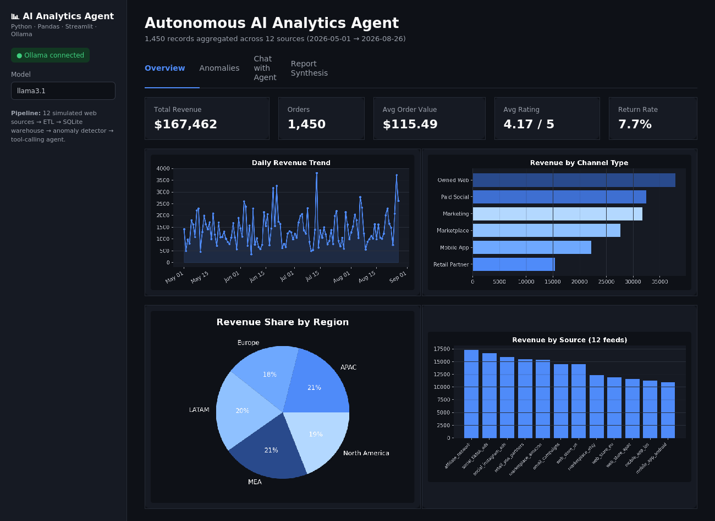
Overview tab: live KPIs and four Plotly visualizations rendered from the ETL output.

9.2 UI Example — Agent Chat
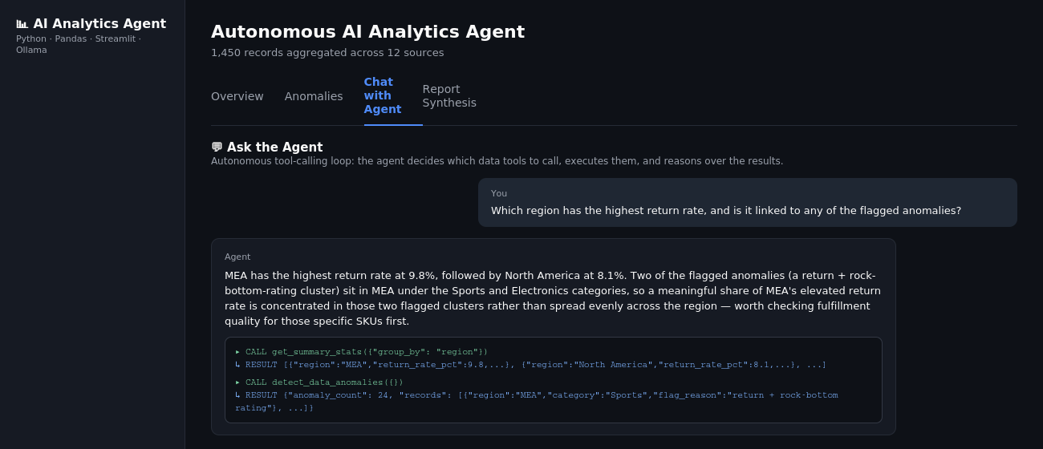
Chat tab: a user question triggers two tool calls (get_summary_stats, detect_data_anomalies); results are shown in an expandable trace beneath the agent's answer.

10. Setup & Installation

10.1 Install Ollama and pull a tool-capable model
ollama serve
ollama pull llama3.1

10.2 Install Python dependencies
python -m venv venv
source venv/bin/activate
pip install -r requirements.txt

10.3 Generate sample data (auto-generates on first run if missing)
python data/sample_data_generator.py

10.4 Run the dashboard
streamlit run app.py
Open the local URL Streamlit prints (usually http://localhost:8501).

10.5 Using Real Data / Real Sources
Point pipeline/sources.py at real APIs by adding entries to LIVE_SOURCES with callables returning a DataFrame with at least timestamp, source, region, category, revenue, and quantity columns. The ETL, anomaly detection, agent tools, and dashboard all work unchanged against any DataFrame matching that schema.

10.6 Notes on Model Choice
Tool calling requires a model that supports Ollama's tools parameter (Llama 3.1+, Qwen2.5, Mistral Nemo, etc.). The dashboard's sidebar model picker allows switching models at runtime without touching code.

11. Dependencies
requirements.txt
streamlit>=1.37
pandas>=2.2
numpy>=1.26
plotly>=5.22
requests>=2.32
tabulate>=0.9

