Homepage Interface Elements

Theme Component: Promotional Announcements

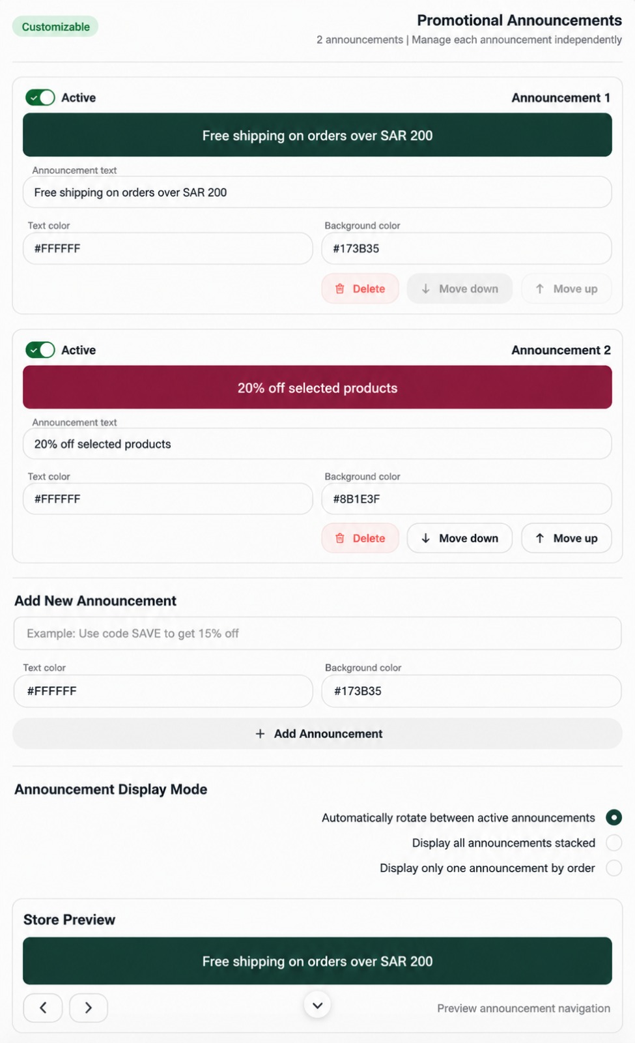
PROMOTIONAL ANNOUNCEMENTS
Theme Component Documentation & Developer Requirements

Overview
The Promotional Announcements component is a customizable element within the e-commerce theme editor. It allows store owners to create, manage, and display promotional announcement bars on their storefront. The component must be responsive, fully customizable, and compatible with desktop and mobile devices.

1. Component Header and General Information

Promotional Announcements
The component name displayed in the theme editor. It provides access to the settings used to manage promotional announcement bars.

Customizable
Indicates that the component supports customization through the theme editor, including announcement text, colors, activation status, display order, and display mode.

Announcement Count and Independent Management
The interface displays the number of announcements currently configured (for example, “2 announcements | Manage each announcement independently”). Each announcement must have its own settings so editing one does not unintentionally affect another.

2. Individual Announcement Card

2.1 Active — Enable or Disable an Announcement
Controls whether an individual announcement is eligible to appear on the storefront.
- When enabled, the announcement becomes eligible for display.
- When disabled, it remains saved in theme settings but is excluded from the storefront.
- If all announcements are disabled, hide the announcement bar.

2.2 Announcement 1 / Announcement 2 — Announcement Identifier
Displays the announcement position or identifier in the management interface. Each announcement must have a stable, unique internal ID so editing, deleting, activating, or reordering one does not affect another.

2.3 Announcement Preview Bar
- Displays the announcement text using the currently selected text and background colors.
- Updates immediately when the text or colors change.
- Reflects the current configuration before changes are saved.

2.4 Announcement Text
A text field used to define the promotional message displayed to storefront visitors.
Example: “Free shipping on orders over SAR 200.”
- Allow the store owner to enter or edit the text.
- Support Arabic and English, including long messages.
- Allow text to wrap onto multiple lines when necessary.
- Prevent empty announcements from appearing on the storefront.
Important: Announcement text is informational only. A message about free shipping or a discount does not implement the promotion unless a separate promotion or discount mechanism is connected.

2.5 Text Color
Defines the announcement text color. Example: #FFFFFF for white.
- Accept valid HEX color codes.
- Apply the selected color to the corresponding announcement only.
- Update the preview immediately and preserve the color after saving.

2.6 Background Color
Defines the announcement bar background color. Examples: #173B35 (dark green) and #8B1E3F (burgundy).
- Allow independent background colors for each announcement.
- Validate the color value before applying it.
- Update the preview immediately and preserve the color after saving.
- Maintain sufficient contrast between text and background.

2.7 Delete
- Ask for confirmation before permanent deletion.
- Delete only the selected announcement.
- Preserve all other announcements and their settings.
- Update the announcement count, list, order, and preview.
- If the deleted announcement is currently displayed, move to the next eligible announcement when applicable.
- Hide the bar if no eligible announcements remain.

2.8 Move Up / Move Down
- Move Up moves the announcement one position higher.
- Move Down moves the announcement one position lower.
- Disable Move Up for the first announcement and Move Down for the last.
- Preserve the new order after saving and apply it to relevant storefront display modes.
- Reordering must not change the announcement text, colors, activation status, or unique ID.

3. Add New Announcement

3.1 Announcement Text Input
Provides a field for entering the new announcement text. Example placeholder: “Example: Use code SAVE to get 15% off.” The placeholder is instructional text only and must not be published as an actual announcement.

3.2 Default Text and Background Colors
The reference design uses #FFFFFF for text and #173B35 for the background. These should be configurable defaults, not mandatory colors for every announcement.

3.3 Add Announcement Button
- Validate the entered text and color values.
- Create a new announcement with a unique internal ID.
- Add it to the existing list without replacing existing announcements.
- Apply the selected or default colors.
- Assign the new announcement a position in the list.
- Update the announcement count and preview.
- Prepare the updated configuration for saving.
The new announcement must not appear on the live storefront until the applicable save and publish process has completed. If it is active by default, it becomes eligible for display once the configuration is applied.

4. Announcement Display Mode
This section controls how announcements appear on the storefront. Exactly one display mode should be selected at a time.

4.1 Automatically Rotate Between Active Announcements
Displays one active announcement at a time and automatically transitions to the next eligible announcement.
- Include only active announcements with valid text.
- Follow the configured announcement order.
- Provide a configurable rotation interval if supported by the theme.
- Loop back to the first eligible announcement after the last one.
- If only one eligible announcement exists, display it without unnecessary transitions.
- If no eligible announcements exist, hide the bar.
- Avoid reloading the page during transitions.

4.2 Display All Announcements Stacked
Displays all active announcements simultaneously, with each announcement in a separate bar.
- Display all eligible announcements in the configured order.
- Render each announcement as a separate bar.
- Maintain consistent spacing between bars.
- Adapt the layout to desktop and mobile screen widths.
- Exclude disabled or invalid announcements.

4.3 Display Only One Announcement by Order
Displays one announcement at a time according to the configured order. The intended navigation behavior must be explicitly defined during implementation.
- Display the first eligible announcement by default.
- Provide previous and next controls if manual navigation is intended.
- Navigate only between eligible announcements.
- Follow the saved order.
- Update the displayed announcement when the current announcement is disabled or deleted.
- Hide the bar when no eligible announcements remain.

Shared Rules for All Display Modes
- Disabled announcements must never appear on the storefront.
- Changes to announcement order must be reflected in relevant display modes.
- Deleted announcements must be removed from the displayed sequence.
- Invalid or empty announcements must be excluded.
- The selected display mode must persist after saving and reloading the theme editor.

5. Store Preview

5.1 Announcement Preview
- Display the selected announcement using its configured text and colors.
- Update the preview immediately when text or colors change.
- Reflect the selected display mode.
- Allow the store owner to inspect individual announcements without a full page reload.

5.2 Previous and Next Arrows
- Navigate between announcements in the preview.
- Respect the current list and display order.
- Skip announcements that are not eligible for display.
- Do not modify the actual announcement order when navigating the preview.

5.3 Center Arrow Control
The reference design includes a center arrow beneath the preview. Its exact intended behavior must be confirmed during implementation. If it controls expansion, collapse, or navigation of the preview area, that behavior must be clearly defined and implemented consistently.

5.4 Preview Announcement Navigation Label
The “Preview announcement navigation” text identifies the preview navigation area. It is descriptive text rather than a separate functional control.

5.5 Recommended Enhancement: Desktop and Mobile Preview
Add an optional preview switcher that allows the store owner to inspect the announcement bar in desktop and mobile layouts. This is a proposed enhancement and is not a visible control in the current reference design. The preview must reflect the actual responsive behavior of the storefront component.

6. What Happens After Editing and Saving?
The implementation must distinguish between editing settings, saving the configuration, and publishing changes to the live storefront.

Step 1: Edit the Settings
The store owner changes announcement text, colors, activation status, order, or display mode.

Step 2: Update the Preview
The editor reflects current changes immediately so the store owner can inspect the result before saving.

Step 3: Validate the Configuration
Validate announcement text, HEX color values, unique IDs, announcement order, display mode selection, and any required fields. Handle invalid values without corrupting existing settings.

Step 4: Save the Configuration
Save the announcement list and its settings: unique IDs, text, text colors, background colors, activation status, display order, selected display mode, and any supported rotation settings.

Step 5: Apply or Publish the Changes
After successful saving and any required publishing step, the storefront must use the updated configuration. If saving and publishing are separate, changes are not live until publishing is complete.

Step 6: Verify Persistence and Storefront Output
Reload the theme editor and confirm settings remain unchanged. Open or refresh the storefront and verify text, colors, order, display mode, and desktop/mobile behavior.

Saving Behavior
The reference image does not show a dedicated Save Changes or Publish button. Use the theme platform’s existing save and publish workflow. If the platform uses autosave, display a saving status and communicate errors when saving fails.

7. Desktop and Mobile Responsiveness
Use one responsive implementation rather than separate desktop and mobile versions.
Component | Desktop | Mobile
Announcement cards | Maintain the current card layout | Fit within available screen width
Color fields | Display side by side | Stack vertically
Management buttons | Display in a row when space permits | Wrap or use a compact action menu
Announcement text | Follow existing alignment | Wrap when necessary without clipping
Display mode options | Use available horizontal layout | Stack vertically
Store preview | Use appropriate desktop width | Fit the mobile preview width
Storefront announcement bar | Adapt to storefront layout | Use flexible height and responsive spacing

Additional Responsive Requirements
- Prevent unintended horizontal scrolling.
- Avoid fixed heights that clip long text.
- Keep controls accessible and usable on touchscreens.
- Preserve the theme’s typography, spacing, and visual identity.
- Support both Arabic and English text.
- Test at 320px, 375px, 390px, 430px, 1366px, 1440px, and 1920px viewport widths.

8. Acceptance Criteria
- Announcements can be added, edited, and deleted.
- Each announcement can be enabled or disabled independently.
- Text and background colors can be customized independently.
- Announcement order can be changed and saved.
- All three display modes work according to their specified behavior.
- The preview updates when announcement settings change.
- Preview navigation does not modify the saved announcement order.
- Settings persist after reloading the theme editor.
- Changes appear on the storefront after the required save and publish steps.
- The component is responsive on desktop and mobile.
- Long text does not cause clipping, overlap, or unintended horizontal scrolling.
- Empty and disabled announcements are excluded from storefront display.
- The component uses the existing theme settings and publishing workflow.

Final Implementation Goal
The Promotional Announcements component must provide a complete, customizable announcement management experience within the e-commerce theme. It must maintain a clear separation between announcement configuration, preview behavior, and live storefront output while remaining responsive, reliable, and consistent with the theme’s visual design.
Scope restriction: These requirements apply exclusively to the Promotional Announcements component. Do not add unrelated global store settings or features outside this component’s scope. Maintain a modular implementation so other theme components can be developed consistently in the future.

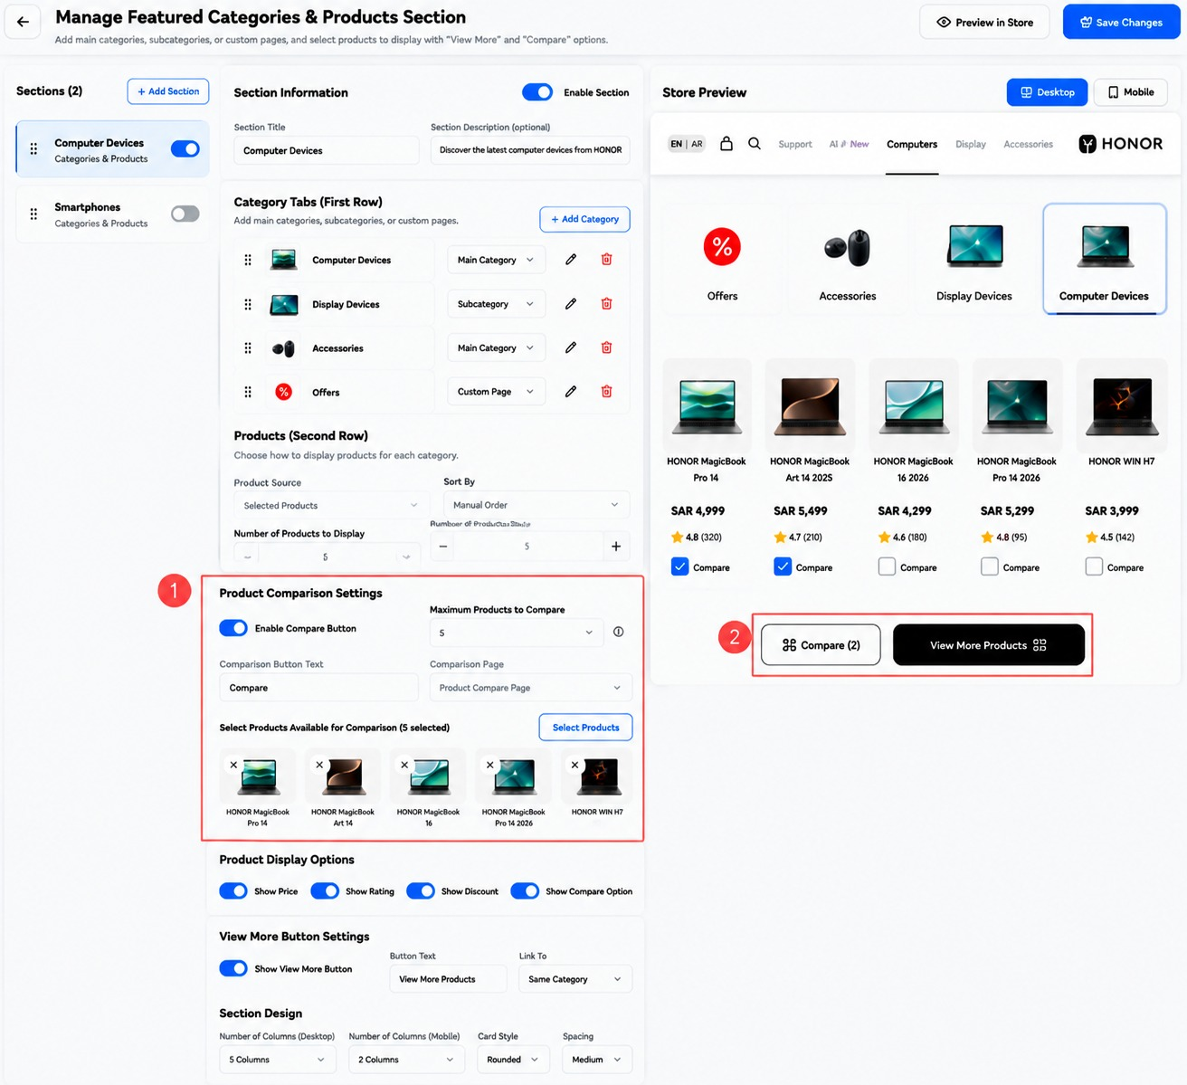

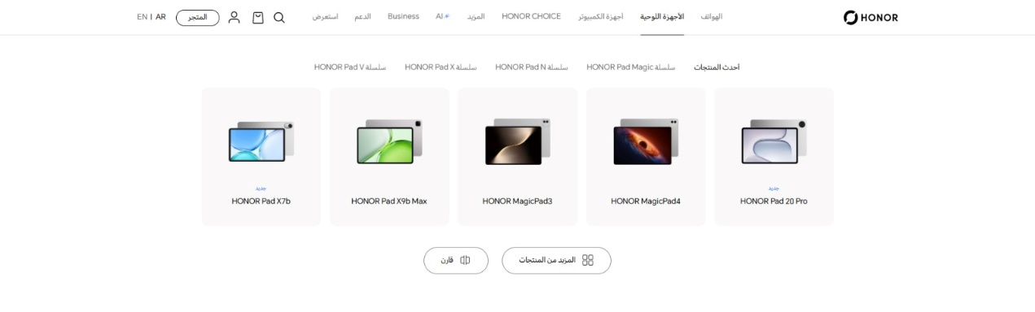

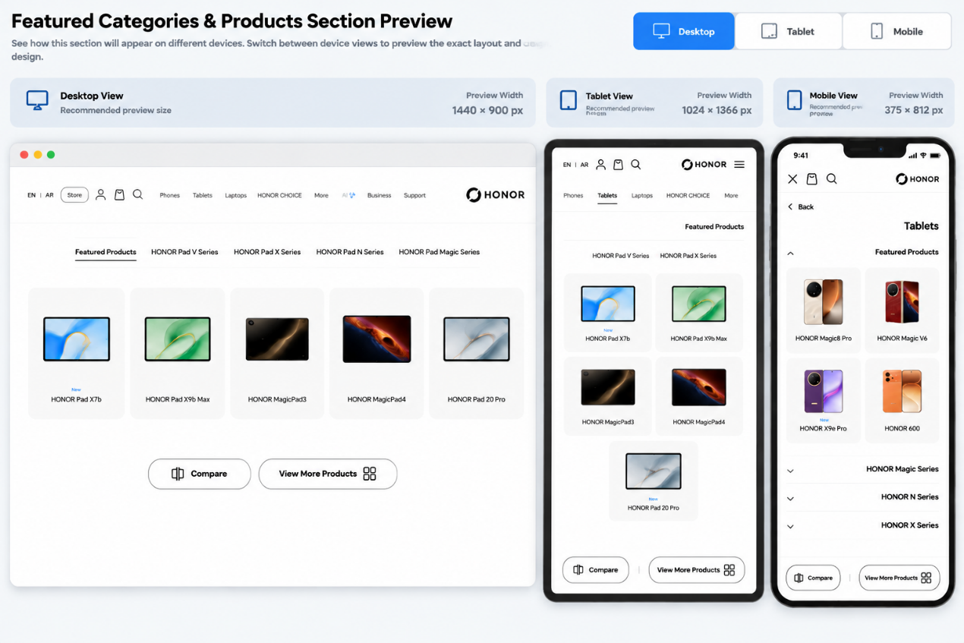

FEATURED CATEGORIES & PRODUCTS SECTION
Developer Specification: Controls, Behavior, Saving, and Responsive Preview

1. Purpose and Scope
Build the “Featured Categories & Products Section” as a configurable component inside the e-commerce theme editor. It allows a merchant to create multiple sections, configure category tabs or custom pages, choose products, control comparison and “View More” actions, and customize the product layout. The component must work on desktop, tablet, and mobile.
Scope is limited to this component. Reuse the theme platform’s existing product catalog, settings persistence, preview, and publish workflows. Do not add unrelated global store settings.

2. Top-Level Actions

2.1 Back Button
Returns to the previous theme-editor screen. It should not silently discard unsaved changes; if there are unsaved edits, warn the user or rely on the editor’s established draft/autosave behavior.

2.2 Preview in Store
Opens or focuses the storefront preview using the current draft settings. The preview should clearly indicate whether it is showing unpublished changes, if the platform supports draft previews.

2.3 Save Changes
Validates and saves the component configuration using the existing theme settings system. Show a clear success or error state. Do not report success until saving has completed. If the platform separates saving from publishing, explain that saving alone may not publish changes to the live storefront.

3. Sections Panel

3.1 Sections Count
Shows the number of sections configured, such as “Sections (2)”. Update the count after adding or deleting a section.

3.2 Add Section
Creates a new independent Featured Categories & Products section with a unique ID and sensible defaults. It must not overwrite existing sections. Add the new section to the list and open its settings.

3.3 Section List and Drag Handle
Each section appears as a card showing its title and component type. The drag handle allows reordering sections if reordering is supported. The saved order determines the order in which sections appear on the storefront.

3.4 Section Enable Toggle
Enables or disables an individual section. A disabled section remains configured in the editor but is omitted from the storefront. Toggling one section must not affect other sections.

4. Section Information

4.1 Enable Section
Controls visibility of the currently selected section. This should stay consistent with the toggle in the Sections panel.

4.2 Section Title
Defines the section heading displayed on the storefront, for example “Computer Devices”. Updating this field changes the heading in the preview and, after save/publish, on the storefront.

4.3 Section Description (Optional)
Provides optional supporting text below or near the section title. If empty, omit the description and avoid leaving unnecessary blank space.

5. Category Tabs (First Row)
This area manages the category tabs, subcategories, and custom-page entries shown in the section’s first row.

5.1 Add Category
Opens a form or picker to add an entry. The merchant should be able to choose an existing main category, a subcategory, or a custom page, then configure its label and image/icon if the design supports them.

5.2 Drag Handle / Ordering
Allows the merchant to change the order of category tabs. The storefront should display tabs in the saved order.

5.3 Entry Type Selector
Identifies the destination type for each entry: Main Category, Subcategory, or Custom Page. The selected type determines which source picker and destination fields are available.

5.4 Edit Button
Opens the selected entry’s settings so its label, source, image/icon, and destination can be changed.

5.5 Delete Button
Removes only the selected entry after confirmation where appropriate. It must not delete the underlying store category or custom page; it only removes the entry from this component.

5.6 Category Tab Behavior
- Display the configured category tabs in the first row of the storefront section.
- When a tab is selected, show the products associated with that category or configured product set.
- For a custom-page entry, navigate to its configured page or show the configured content behavior.
- Do not render broken images or links; use a fallback or validation message when required data is missing.

6. Products (Second Row)

6.1 Product Source
Determines how products are selected for display. The screenshot shows “Selected Products”. If other source types are offered (such as a category or collection), each source type must reveal the appropriate selector.

6.2 Sort By
Determines the order of products, such as Manual Order or another supported sort mode. Manual Order should respect the merchant’s selected product order. Any alternative sort mode must be clearly named and consistently applied.

6.3 Number of Products to Display
Sets how many product cards are shown in this section. The preview must update to reflect the selected count. On narrow screens, the number of columns may change, but the configured product count should remain the same unless the design explicitly uses a separate device-specific limit.

6.4 Number of Products Shown
If the control is implemented as a numeric stepper, minus decreases and plus increases the value within configured minimum and maximum limits. Prevent invalid values and keep the displayed value synchronized with the saved setting.

6.5 Product Card Data
Each displayed product should use the theme’s real product data, including product image, title, price, rating, discount, and comparison option where available and enabled. Do not hard-code the example product names or prices shown in the reference image.

7. Product Comparison Settings

7.1 Enable Compare Button
Enables or disables the product-comparison feature for this section. When disabled, hide per-product comparison checkboxes and the comparison action button.

7.2 Maximum Products to Compare
Sets the maximum number of products a shopper may select for comparison. Enforce this limit in the storefront UI. When the limit is reached, prevent additional selections and show a clear, accessible explanation.

7.3 Comparison Button Text
Defines the label shown on the comparison action button, such as “Compare”. Support localization where the theme supports multiple languages.

7.4 Comparison Page
Selects the destination page used to compare selected products. The destination must be a valid configured page or route. If no valid page is selected, show a configuration warning and prevent a broken navigation.

7.5 Select Products Available for Comparison
Opens a product picker so the merchant can define which products are eligible for comparison. Show selected products as removable thumbnails/cards.
- The Select Products button opens the picker.
- Each selected product can be removed using its remove control.
- The selected-product count is updated immediately.
- Only eligible products should expose a working comparison selection on the storefront.
- If the allowed comparison list is empty, handle it clearly rather than showing a nonfunctional Compare action.

7.6 Storefront Comparison Flow
- The shopper selects the Compare option on eligible product cards.
- The interface tracks selected products and displays the selected count.
- The shopper activates the comparison button.
- The system checks the maximum selection limit and navigates to the configured comparison page with the selected product identifiers.
- The comparison page displays the selected products using the theme’s comparison implementation.

8. Product Display Options
Each toggle controls whether a specific piece of information or action appears on product cards.

8.1 Show Price
When enabled, show the product price. When disabled, hide the price from cards in this section.

8.2 Show Rating
When enabled, show product rating and review count when the catalog provides those values. If no rating data exists, omit the rating rather than inventing a value.

8.3 Show Discount
When enabled, show the discount or sale-price presentation only when valid discount data exists. Do not calculate or display a false discount.

8.4 Show Compare Option
Controls whether comparison selection controls appear on product cards. This option must also respect the main Enable Compare Button setting. If comparison is disabled globally for this section, comparison controls must remain hidden.

9. View More Button Settings

9.1 Show View More Button
Enables or hides the “View More Products” action beneath the product list. When disabled, hide the button and avoid reserving empty space for it.

9.2 Button Text
Defines the text displayed on the button. Example: “View More Products”. Support translated text and responsive wrapping where necessary.

9.3 Link To
Determines where the button leads. The screenshot shows “Same Category”. The destination should resolve to the currently selected category or another configured destination, according to the selected option. Validate the destination before publishing.

9.4 Storefront Behavior
When clicked, the button navigates to the configured destination. It must not be shown if disabled, and it must not link to a missing or invalid destination.

10. Section Design

10.1 Number of Columns (Desktop)
Controls the number of product cards per row on desktop. The screenshot shows five columns. The preview should reflect this setting at desktop width.

10.2 Number of Columns (Mobile)
Controls the number of product cards per row on mobile. The screenshot shows two columns. Keep cards readable and ensure text, prices, ratings, and controls fit without horizontal overflow.

10.3 Tablet Layout
Provide a tablet-specific column setting if the theme design requires explicit control. Otherwise, use responsive breakpoints to select a suitable intermediate layout, typically two or three columns depending on the available width. Tablet behavior must be visible in preview.

10.4 Card Style
Controls the visual style of product cards, such as Rounded or Square. Apply the selected style consistently to all cards in this section.

10.5 Spacing
Controls the spacing between product cards and related elements, such as Small, Medium, or Large. Ensure the spacing remains appropriate on each device.

11. Store Preview and Device Switcher

11.1 Desktop / Tablet / Mobile Controls
Provide device preview controls so the merchant can inspect the same section at desktop, tablet, and mobile sizes. The selected device changes only the preview viewport, not the saved design settings.

11.2 Recommended Preview Viewports
- Desktop: 1440 × 900 CSS pixels.
- Tablet: 1024 × 1366 CSS pixels (portrait reference); optionally support landscape preview as well.
- Mobile: 375 × 812 CSS pixels.
These are recommended reference viewports, not restrictions on actual devices. The storefront must remain responsive at intermediate widths.

11.3 Preview Synchronization
- Changes to settings should update the preview immediately where possible.
- Preview should reflect category order, product count, display options, comparison controls, View More behavior, card style, spacing, and column settings.
- Preview navigation and device switching must not modify product data or saved ordering.
- Clearly distinguish draft preview from live storefront if the platform supports unpublished drafts.

12. What Happens After the Merchant Saves Changes?
- The merchant edits section settings, categories, product selection, display options, comparison settings, or design options.
- The editor validates required fields, numeric limits, selected destinations, and product/category references.
- The preview updates to show the expected storefront result.
- When Save Changes is clicked, persist the complete configuration using the theme’s existing settings mechanism.
- Show success only after the save operation succeeds; if it fails, preserve edits where possible and display a clear error.
- If saving and publishing are separate operations, apply changes to the live storefront only after the required publish step.
- After save/publish, the storefront renders the section using the saved settings and real catalog data.
- On reload, restore the saved settings and verify desktop, tablet, and mobile layouts.

13. Validation, Empty States, and Error Handling
- A section with no valid category or product content should not render a broken or empty layout; show a useful editor message or hide the empty storefront section according to the theme’s conventions.
- Validate that product count and maximum comparison count are within supported limits.
- Prevent comparison selection from exceeding the configured maximum.
- Handle deleted or unavailable products/categories gracefully.
- Use accessible labels and keyboard-operable controls; do not rely on icons alone.
- Ensure image failures have a fallback and long titles do not break card layouts.
- Preserve existing configuration if validation or saving fails.

14. Acceptance Checklist
- Multiple sections can be added and independently enabled/disabled.
- Section title and optional description are editable.
- Category tabs can be added, edited, removed, and reordered.
- Category, subcategory, and custom-page entry types work as specified.
- Product source, sorting, and displayed count work correctly.
- Comparison can be enabled/disabled and respects its maximum selection limit.
- Comparison page and eligible products can be configured.
- Price, rating, discount, and comparison visibility toggles work independently where applicable.
- View More visibility, text, and destination work correctly.
- Desktop and mobile column settings, card style, and spacing are applied.
- Desktop, tablet, and mobile previews accurately reflect current settings.
- Saving and publishing follow the theme platform’s existing workflow.
- Settings persist after reload and no unrelated sections are changed.
- No clipping, unintended horizontal scrolling, broken links, or inaccessible controls appear on supported screen sizes.

15. Implementation Notes
- Use existing theme product, category, and page data; do not hard-code demonstration data.
- Keep this component modular and separate from unrelated theme components.
- Use the existing theme editor state and save/publish system wherever possible.
- Treat preview device selection as a temporary viewport setting, not as a change to storefront content.
- Document any behavior that cannot be inferred from the reference screenshot before implementing it.

Final Goal
Deliver a configurable Featured Categories & Products Section that allows merchants to manage sections, category tabs, product selection, comparison, View More navigation, and responsive layout from one editor. The preview must accurately represent desktop, tablet, and mobile storefront behavior, and saved settings must persist and appear on the live storefront after the platform’s required save/publish workflow.



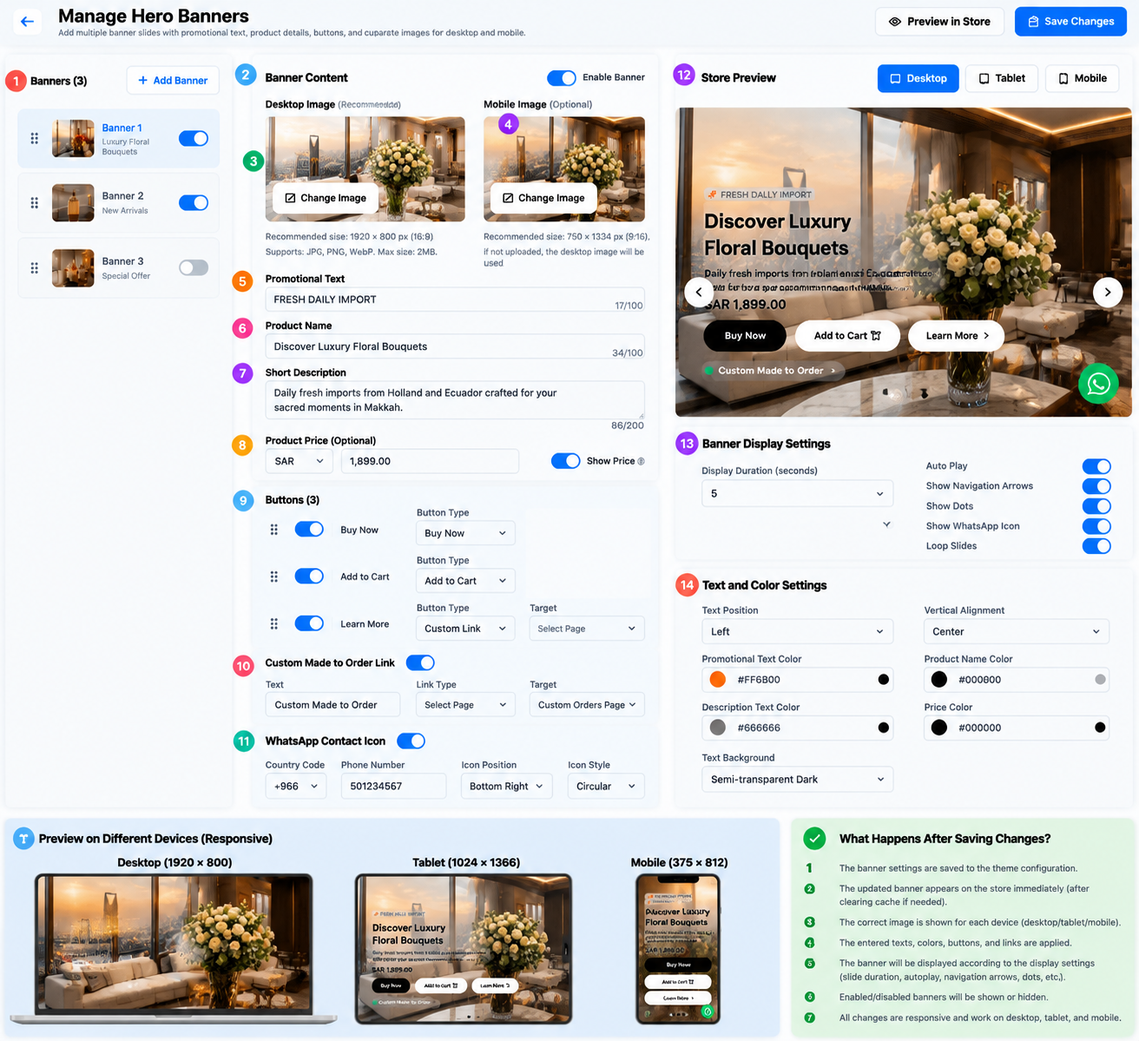

HERO BANNERS
HERO BANNERS
Developer Specification — Controls, Behavior, Saving, and Responsive Preview

1. Purpose and Scope
The Hero Banners component allows store owners to create and manage multiple large promotional slides on the storefront homepage. Each slide can include a background image, promotional text, product name, short description, optional price, action buttons, and an optional custom-order link. The component also controls slideshow behavior, text styling, navigation controls, and a WhatsApp contact icon.
This specification covers only the Hero Banners component shown in the supplied references. Reuse the theme editor’s existing save, preview, product/catalog, page-link, and publishing mechanisms. Do not add unrelated theme features.

2. Top-Level Actions

2.1 Back Button
Returns to the previous theme-editor screen. If there are unsaved edits, use the platform’s established draft/autosave behavior or warn the user before discarding changes.

2.2 Preview in Store
Opens or refreshes the storefront preview using the current draft configuration. If the platform supports draft previews, make clear that the preview may contain unpublished changes.

2.3 Save Changes
Validates and saves all banner settings. Show success only after the save completes. If saving fails, preserve the user’s edits where possible and display a clear error message. If publishing is a separate step, do not imply that saving alone updates the live storefront.

3. Banner List (Left Panel)

3.1 Banners Count
Displays the number of configured slides, for example “Banners (3)”. Update the count immediately after adding or deleting a banner.

3.2 Add Banner
Creates a new banner with a unique ID and default values. Add it to the list without replacing existing banners, select it for editing, and initialize its settings safely. A new banner should not appear on the live storefront until the applicable save/publish workflow completes.

3.3 Banner List Item
Each item displays a drag handle, thumbnail, banner name/number, short identifying text, and an enable/disable toggle.

3.4 Drag Handle / Ordering
Allows the merchant to reorder slides if supported. The saved order determines slideshow sequence and manual navigation order.

3.5 Enable Banner Toggle
- When enabled, the banner is eligible to appear in the slideshow.
- When disabled, it remains saved in the editor but is excluded from the storefront slideshow.
- If all banners are disabled, hide the hero-banner component rather than showing an empty slide.
- If the currently displayed banner is disabled, move to the next enabled banner.

4. Banner Content

4.1 Enable Banner
Controls whether the currently selected banner is active. It should stay synchronized with the toggle in the banner list.

4.2 Banner Image
Defines the primary visual image for the selected slide. The image is used as the banner background or hero visual, with text and buttons layered over it according to the design.

4.3 Change Image
Opens the media picker or upload interface so the merchant can select a replacement image.
- Recommended image size shown in the reference: 1920 × 800 pixels (16:9 is stated in the UI, although 1920 × 800 is closer to 2.4:1; confirm the intended aspect ratio with the designer).
- Supported formats: JPG, PNG, and WebP.
- Maximum file size shown: 2 MB.
- Validate file type, size, and successful upload before applying the image.
- Use responsive image sizing and an appropriate crop/focal point so the subject remains visible on desktop and mobile.
- Provide a fallback if the image is missing or fails to load.

4.4 Promotional Text
A short eyebrow or badge displayed above the main product title, for example “FRESH DAILY IMPORT”. The reference shows a 100-character limit.
Update the preview as the text changes. Enforce the documented character limit and support localized text.

4.5 Product Name
The main heading for the banner, such as “Discover Luxury Floral Bouquets”. The reference shows a 100-character limit. Display it prominently and allow wrapping without clipping.

4.6 Short Description
Supporting text that describes the product, collection, or offer. The reference shows a 200-character limit. It may be left empty; if empty, do not leave unnecessary blank space.

4.7 Product Price (Optional)
Allows the merchant to enter an optional price associated with the banner.
- Currency selector: choose the currency label, such as SAR.
- Price field: enter a valid non-negative numeric amount.
- Show Price toggle: determines whether the price appears on the storefront.
- If disabled, hide the price but preserve the saved value.
- If the price is empty or invalid, do not display a malformed price.
- If the price is manually entered, do not imply that it is synchronized with a real product price unless a product integration is implemented.

5. Buttons (Per Banner)
The reference shows three configurable action buttons. Each button has an activation toggle, a reorder handle, a label, and a button-type selector.

5.1 Enable/Disable Button
Controls whether an individual action button appears on the selected banner. Disabled buttons must not occupy unnecessary layout space.

5.2 Button Ordering
Allows the merchant to change the order of buttons. The storefront should render them in the saved order and adapt them to smaller screens without overlap.

5.3 Button Type
Determines the action performed when the visitor clicks the button. The available types shown include Buy Now, Add to Cart, and Custom Link.

5.4 Buy Now
Takes the visitor to the relevant product or purchase flow. The implementation must define how the target product is selected. If no valid product or purchase target is configured, show a validation warning and do not render a broken action.

5.5 Add to Cart
Adds the configured product to the cart using the store’s existing cart mechanism. Provide feedback on success or failure. If variants are required, use the configured default variant or prompt the visitor to choose a variant before adding.

5.6 Custom Link and Target
Allows the merchant to choose a destination, such as an internal page or supported custom URL. The Target selector should list valid destinations. Validate the destination and avoid broken or unsafe links.

5.7 Button Labels
Use the label associated with the selected button type or allow the merchant to configure it if supported by the product design. Support localization and responsive wrapping.

6. Custom Made to Order Link

6.1 Enable Toggle
Shows or hides an additional link or call-to-action, such as “Custom Made to Order”. When disabled, hide it on the storefront.

6.2 Text
Defines the visible label for the custom-order link.

6.3 Link Type
Selects the kind of destination. The reference shows a page-selection type.

6.4 Target
Specifies the destination page, such as a custom orders page. Validate that the page exists and is available.

6.5 Storefront Behavior
When enabled and correctly configured, show the custom-order link in the banner and navigate to the selected destination when clicked. Do not display a broken link when the target is missing.

7. WhatsApp Contact Icon

7.1 Enable Toggle
Controls whether the WhatsApp contact icon is displayed with the banner experience. If enabled, it must be a functional contact link rather than a decorative icon.

7.2 Country Code
Selects the country calling code, for example +966.

7.3 Phone Number
Stores the contact number. Validate the number format and remove spaces or punctuation as required to create a valid WhatsApp link.

7.4 Icon Position
Determines where the icon appears, such as Bottom Right. Ensure it does not cover important content, buttons, navigation, or accessibility controls.

7.5 Icon Style
Controls the visual shape, such as Circular. Apply the selected style consistently across supported devices.

7.6 WhatsApp Link Behavior
Open a WhatsApp conversation using the configured country code and number. Use the appropriate official wa.me link format, and ensure the icon has an accessible label. If the number is invalid or missing, show a configuration warning and do not generate a broken link.

8. Store Preview

8.1 Desktop / Mobile Preview Switcher
Allows the merchant to inspect the selected banner at desktop, tablet, and mobile viewport sizes. Switching preview mode changes only the preview viewport; it must not change saved banner content, settings, or storefront configuration.

8.2 Preview Synchronization
- Reflect image, text, price, buttons, colors, text alignment, and slideshow settings.
- Update when the merchant changes settings, ideally without a full page reload.
- Provide previous/next slide controls when navigation arrows are enabled.
- Use actual draft data rather than hard-coded sample content.

8.3 Recommended Preview Viewports
- Desktop reference: 1440 × 900 CSS pixels.
Tablet reference: 768 × 1024 CSS pixels (portrait) and optionally 1024 × 768 (landscape).
Mobile reference: 390 × 844 CSS pixels.
Also test intermediate and narrow widths; these are reference sizes, not device restrictions.
- Mobile reference: 390 × 844 CSS pixels.
- Also test intermediate and narrow widths; these are reference sizes, not device restrictions.

9. Banner Display Settings

9.1 Display Duration (Seconds)
Sets the interval between automatic slide transitions. The reference shows 5 seconds. Validate the selected duration and apply it consistently.

9.2 Auto Play
When enabled, automatically advances through enabled banners after the configured duration. When disabled, the slideshow remains on the current banner until the visitor navigates manually or another documented behavior applies.

9.3 Show Navigation Arrows
Controls visibility of previous and next arrows. When enabled, arrows move between enabled slides. Hide them when disabled and avoid showing nonfunctional controls.

9.4 Show Dots
Controls the slide indicator dots. When enabled, show the correct number of indicators and allow selection of a slide if that interaction is supported.

9.5 Show WhatsApp Icon
Controls whether the WhatsApp icon appears in the banner experience. This must be consistent with the WhatsApp Contact Icon enable setting. If either setting disables the icon, do not display it.

9.6 Loop Slides
When enabled, the slideshow returns to the first enabled banner after the last one. When disabled, stop at the final slide and disable or hide the next control as appropriate.

9.7 Accessibility and Motion
- Use accessible labels for arrows and slide indicators.
- Respect reduced-motion preferences where feasible.
- Avoid transitions that make text or buttons difficult to use.
- Do not auto-advance while the visitor is actively interacting with a slide if doing so would disrupt the interaction.

10. Text and Color Settings

10.1 Text Position
Controls horizontal placement of the text block, such as Left. Other supported options may include Center or Right. Apply the setting consistently to promotional text, title, description, price, and actions unless the design defines exceptions.

10.2 Vertical Alignment
Controls vertical placement of the text block, such as Center. Other supported values may include Top or Bottom. Ensure the content remains within the visible banner area.

10.3 Promotional Text Color
Sets the color of the promotional eyebrow/badge text. The reference value is #FF6B00.

10.4 Product Name Color
Sets the main heading color. The reference value is #000000.

10.5 Description Text Color
Sets the short-description color. The reference value is #666666.

10.6 Price Color
Sets the price text color. The reference value is #000000.

10.7 Color Input Behavior
- Allow valid HEX color values and, where supported, a color-picker control.
- Update the preview immediately.
- Preserve the selected values after saving.
- Maintain sufficient contrast against the banner image.

10.8 Text Background
Controls the background treatment behind the text block, such as “Semi-transparent Dark”. Its purpose is to improve readability over the image. Apply the selected treatment without obscuring the key image subject. If multiple styles are supported, document each option clearly.

11. Responsive Behavior: Desktop, Tablet, and Mobile
Use one responsive component rather than separate unrelated implementations. The banner layout must adapt to the available viewport width.
- Desktop: use a wide hero image, with text and buttons positioned according to the selected alignment.
- Tablet: adjust text width, spacing, and button layout to prevent overlap.
- Mobile: use a mobile-appropriate crop or image where supported; otherwise use responsive object positioning. Keep text, price, and actions readable.
- Allow title and description to wrap naturally. Never clip essential content.
- Buttons may wrap or stack vertically on narrow screens.
- Keep navigation arrows and dots within the banner boundaries.
- Position the WhatsApp icon so it does not obscure buttons or critical content.
- Avoid unintended horizontal scrolling and fixed heights that cut off content.
- Support Arabic right-to-left and English left-to-right layouts.
Suggested test widths: 320px, 375px, 390px, 430px, 768px, 1024px, 1440px, and 1920px.

11A. Device-Specific Responsive Requirements

Desktop
Use the full-width hero layout where appropriate. Keep the text block, price, action buttons, arrows, dots, and WhatsApp icon aligned without covering important image content.

Tablet
Reduce text-block width and spacing as needed. Keep the title readable, allow buttons to wrap or stack if required, and ensure the hero image crop preserves the main subject.

Mobile
Use a mobile-appropriate image crop or focal point. Stack action buttons when horizontal space is insufficient, allow text to wrap, and keep navigation controls and the WhatsApp icon away from text and buttons.

All devices
Use responsive image sizing, flexible heights, accessible touch targets, and no unintended horizontal scrolling. Support both left-to-right English and right-to-left Arabic layouts.

12. What Happens After the Merchant Fills In and Saves the Settings?
- The merchant selects a banner and edits its image, text, price, buttons, links, WhatsApp settings, slideshow behavior, or colors.
- The editor updates the preview to reflect the current draft configuration.
- The system validates required values, image format and size, character limits, numeric price and duration, URLs/pages, and phone number where applicable.
- When Save Changes is clicked, persist the full banner list, order, enabled states, content, button settings, display settings, and text/color settings using the theme’s existing settings system.
- Show a success message only after the save completes. If saving fails, retain the edits where possible and display an error.
- If publishing is separate from saving, the live storefront changes only after the required publish action.
- The storefront loads the saved enabled banners in the configured order and applies the configured slideshow behavior.
- The buttons navigate or perform their configured actions, and the WhatsApp icon opens the configured contact destination.
- After reload, confirm that the settings persist and that desktop, tablet, and mobile layouts display correctly.

13. Validation and Error Handling
- A banner without a valid image should not be published unless the design explicitly supports a text-only banner.
- Enforce the promotional text and product name character limits shown in the interface (100 characters each) and the description limit (200 characters).
- Validate image type and maximum file size before saving.
- Do not render enabled buttons with missing or invalid targets.
- Do not display malformed prices or invalid WhatsApp links.
- If no banners are enabled, hide the component cleanly.
- If one slide fails to load, avoid breaking the entire slideshow.
- Preserve the user’s existing settings if validation or saving fails.

14. Acceptance Criteria
- Banners can be added, edited, reordered, enabled, and disabled independently.
- Desktop and mobile image uploads validate supported formats and size limits; the mobile-specific image can be saved and previewed independently.
- Promotional text, product name, description, and optional price are saved correctly.
- Show Price controls storefront price visibility.
- Each action button can be enabled, configured, and ordered.
- Buy Now, Add to Cart, and Custom Link actions use valid configured destinations and existing store mechanisms.
- The custom made-to-order link works when enabled and configured.
- WhatsApp contact settings generate a valid contact link and respect visibility toggles.
- Autoplay, duration, arrows, dots, WhatsApp visibility, and looping behave as configured.
- Text alignment, vertical alignment, colors, and text background treatment update the preview.
- Desktop, tablet, and mobile previews reflect the draft configuration, including the separate mobile image when one is configured.
- The banner is responsive on desktop, tablet, and mobile without clipping, overlap, or unintended horizontal scrolling.
- Saving and publishing follow the existing theme workflow, and settings persist after reload.
- No example/demo content is hard-coded into the live storefront.

15. Items to Confirm During Implementation
- The reference text says 1920 × 800 px (16:9), but these dimensions are not a 16:9 aspect ratio. Confirm the intended aspect ratio with the designer.
- Confirm whether Buy Now and Add to Cart target a selected product, a product attached to the banner, or another configured destination.
- Confirm whether button labels are editable or automatically derived from the selected button type.
- Confirm whether the WhatsApp Contact Icon and Show WhatsApp Icon settings are intentionally separate controls; they must not conflict.
- Confirm the supported options for Text Background and the exact behavior of slide dots.

Final Implementation Goal
Deliver a flexible Hero Banners component that lets the merchant manage multiple promotional slides, their images and content, calls to action, slideshow behavior, WhatsApp contact, and text styling from the theme editor. The preview must reflect the draft configuration and responsive storefront behavior, while save/publish behavior must remain consistent with the theme platform.

FEATURED SECTION BANNERS
Developer Specification — Content, Controls, Saving, and Responsive Behavior
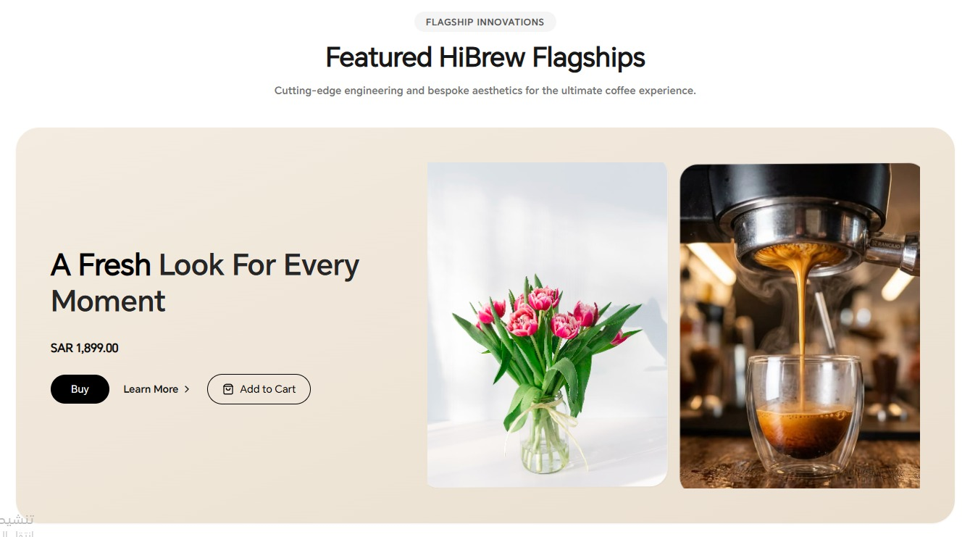
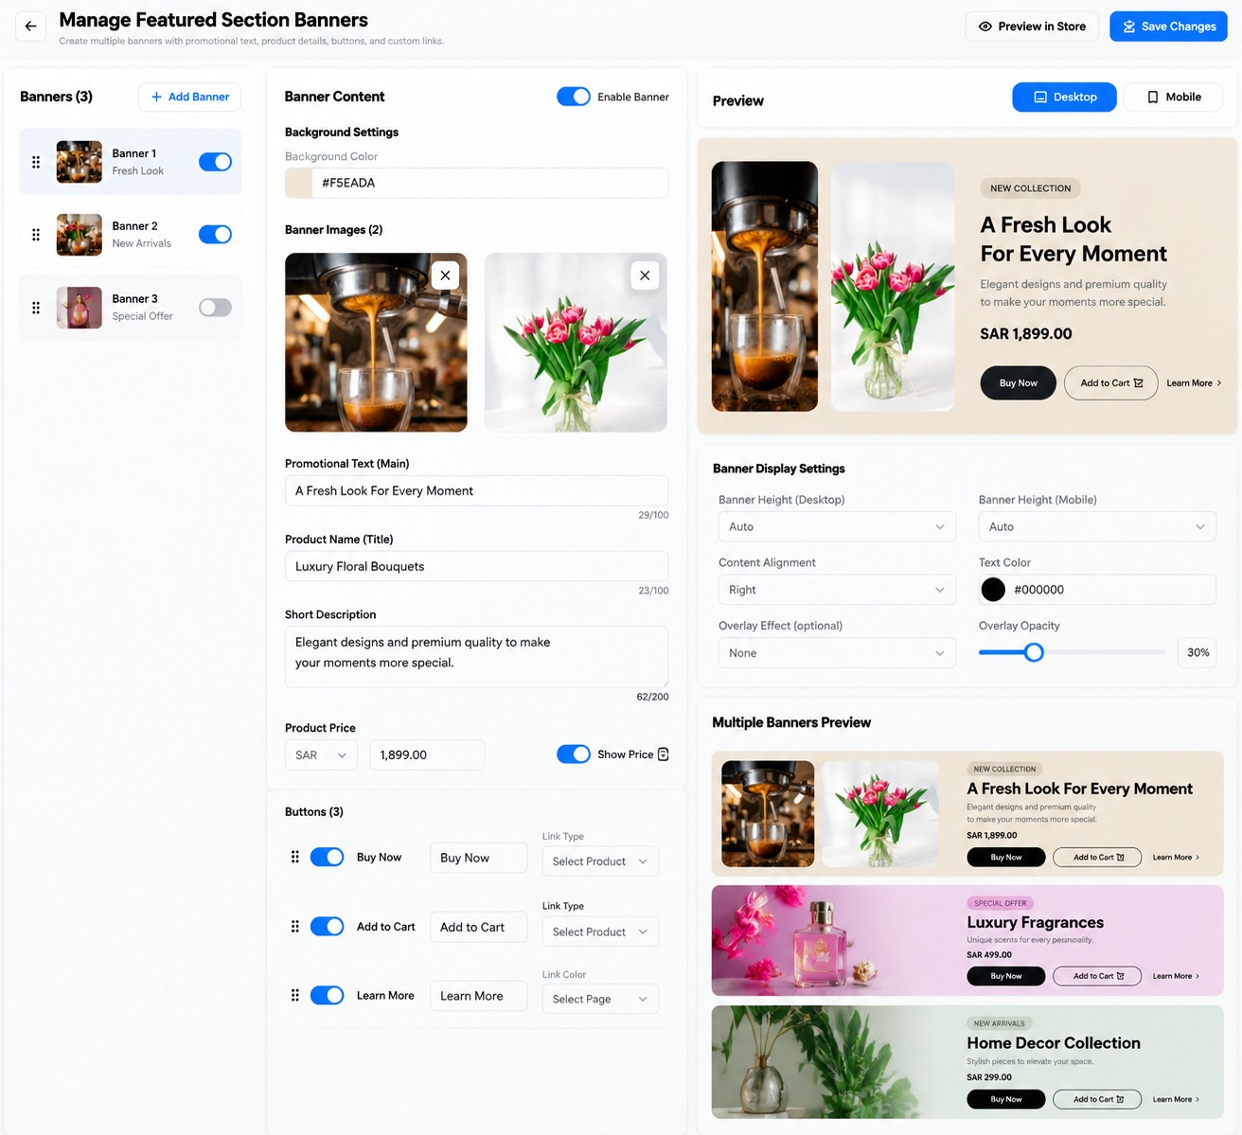

1. Purpose and Scope
The Featured Section Banners component allows a store owner to create multiple promotional content banners that combine a background color, one or more images, promotional text, product title, description, optional price, and configurable action buttons. It is intended for visually prominent homepage or landing-page sections, such as the “Featured HiBrew Flagships” example in the reference image.
This document covers only the Featured Section Banners component. Use the existing theme editor, media library, product catalog, page routing, cart, save, preview, and publish mechanisms. Do not mix this component with the separate Hero Banners component.

2. Top-Level Actions

2.1 Back Button
Returns to the previous theme-editor screen. If edits are unsaved, follow the platform’s existing draft/autosave behavior or warn before discarding changes.

2.2 Preview in Store
Opens or refreshes a storefront preview using the current draft settings. If draft preview is supported, indicate that the preview may include unpublished changes.

2.3 Save Changes
Validates and saves the complete configuration. Show success only after saving completes. If saving fails, retain the user’s edits where possible and show a clear error. If publishing is separate from saving, do not claim the live storefront has changed until publishing completes.

3. Banner List

3.1 Banner Count
Shows the number of configured banners, such as “Banners (3)”. Update it after adding or deleting a banner.

3.2 Add Banner
Creates a new banner with a unique ID and sensible defaults, adds it to the list, and selects it for editing. It must not overwrite existing banners.

3.3 Banner List Card
Each item shows a thumbnail, banner label/name, short identifying text, drag handle, and enable/disable toggle.

3.4 Reordering
The drag handle changes the order of banners. The storefront should follow the saved order wherever banners are displayed.

3.5 Enable Banner
- When enabled, the banner is eligible to appear in the storefront component.
- When disabled, it remains saved in the editor but is excluded from the storefront.
- If all banners are disabled, hide the component or use the theme’s defined empty-state behavior.
- Changing one banner’s state must not affect other banners.

4. Banner Content and Background

4.1 Enable Banner
Controls whether the currently selected banner is active. Keep it synchronized with the toggle in the banner list.

4.2 Background Color
Defines the background color of the banner container. The reference example uses a warm beige tone, #F5EADA. Accept valid HEX values, update the preview immediately, and save the color per banner.

4.3 Banner Images
Allows the merchant to add multiple images to the banner. The reference shows two images arranged beside the text content. Each image should have its own media reference and removable thumbnail.
- Allow the merchant to upload or select images from the media library.
- Display thumbnails for all selected images.
- Provide a remove control for each image.
- Preserve image order; allow drag-and-drop reordering if supported.
- Use responsive sizing and cropping so images remain clear without distortion.
- If no image is configured, handle the empty state gracefully and do not show broken image placeholders.

4.4 Image Count and Layout
The layout should support the configured number of images and use a consistent grid or flex layout. On desktop, images may sit side by side as in the reference. On tablet and mobile, the layout must adapt without clipping or overflow.

4.5 Image Accessibility
Where the platform supports it, allow alternative text for each image. Use meaningful alt text for informative images and empty alt text for purely decorative images.

5. Promotional Text and Product Details

5.1 Promotional Text (Main)
The primary headline displayed within the banner, such as “A Fresh Look For Every Moment”. The reference indicates a 100-character limit. Update the preview as the text changes and prevent text from being clipped.

5.2 Product Name (Title)
An optional or secondary product/collection title, such as “Luxury Floral Bouquets”. The reference indicates a 100-character limit. If empty, omit the title without leaving unnecessary blank space.

5.3 Short Description
Supporting copy describing the product or collection. The reference indicates a 200-character limit. Allow line wrapping and ensure it remains readable on small screens.

5.4 Character Counters
Show the current character count and maximum, as in 29/100 or 62/200. Update the count while typing and validate the limit consistently.

5.5 Product Price
Allows the merchant to enter a price associated with the banner.
- Currency selector, such as SAR.
- Numeric price field.
- Show Price toggle to control storefront visibility.
- When Show Price is disabled, hide the price but retain the saved value.
- Validate non-negative numeric values and format the price consistently.
- Do not imply synchronization with a real catalog product unless an explicit product connection is implemented.

6. Action Buttons
The reference shows three configurable actions: Buy Now, Add to Cart, and Learn More. Each action has an enable toggle, label field, and destination/type selector.

6.1 Enable/Disable Each Button
Controls whether the individual button is visible. Disabled buttons must not leave unnecessary empty gaps.

6.2 Button Ordering
The drag handle allows changing button order. The storefront must use the saved order.

6.3 Button Label
Defines the visible button text, for example “Buy Now”, “Add to Cart”, or “Learn More”. Support localization and responsive wrapping.

6.4 Link Type / Destination
Determines the action or destination for each button. The reference shows product selection for Buy Now and Add to Cart, and page selection for Learn More.

6.5 Buy Now
Navigates to the configured product or purchase flow using the store’s existing implementation. If a valid product is not selected, show a configuration warning and do not render a broken action.

6.6 Add to Cart
Adds the configured product to the cart using the existing cart mechanism. If a variant is required, use the configured default variant or prompt the shopper to select a variant. Show success or error feedback.

6.7 Learn More
Navigates to the selected page or configured destination. Validate the target before publishing.

6.8 Button Styling
Keep button appearance consistent with the theme. Support distinct primary, secondary, and text-link styles where required by the design, and ensure sufficient contrast and usable touch targets.

7. Banner Display Settings

7.1 Banner Height (Desktop)
Controls the banner height on desktop. The “Auto” option should let content and responsive layout determine a suitable height. If fixed height options are available, ensure the content still fits.

7.2 Banner Height (Mobile)
Controls the banner height on mobile independently from desktop. “Auto” should allow content to expand as needed. Avoid fixed heights that cut off text or buttons.

7.3 Content Alignment
Controls the horizontal placement of the text block, for example Left, Center, or Right. Apply alignment consistently to the headline, product title, description, price, and buttons unless the design specifies otherwise.

7.4 Text Color
Sets the main text color. Accept valid HEX values and update the preview immediately.

7.5 Overlay Effect (Optional)
Adds an optional visual overlay to improve readability when content appears over or near imagery. “None” means no overlay. Any other option must be clearly named and applied consistently.

7.6 Overlay Opacity
Controls the strength of the overlay, represented as a percentage. The reference shows 30%. The control should update the preview live and only affect the overlay, not the actual image file.
Note: If the selected overlay effect is “None”, opacity may be disabled or have no visual effect.

8. Preview

8.1 Desktop / Mobile Preview Switcher
Allows the merchant to preview the selected banner on desktop and mobile. Switching preview mode changes only the preview viewport, not the saved settings.

8.2 Preview Accuracy
- Reflect the selected background color, image count/order, headline, product title, description, price visibility, button order, labels, and destinations.
- Update while editing where possible, without requiring a full page reload.
- Use the actual draft configuration rather than hard-coded demonstration content.
- Keep preview controls separate from the storefront buttons so test clicks do not trigger unintended purchases.

8.3 Multiple Banners Preview
Displays a compact overview of configured banners, as shown in the reference. It helps the merchant compare the content and appearance of multiple banners. Each preview item should reflect its own saved/draft settings and activation status.

8.4 Recommended Preview Viewports
- Desktop: 1440 × 900 CSS pixels.
- Tablet: 768 × 1024 CSS pixels (portrait), with optional 1024 × 768 landscape preview.
- Mobile: 390 × 844 CSS pixels.
- These are reference viewport sizes; the component must remain responsive at intermediate widths.

9. Responsive Requirements: Desktop, Tablet, and Mobile

9.1 Desktop
- Use a wide banner container with text and images arranged side by side where appropriate.
- Keep image dimensions and gaps consistent with the selected layout.
- Ensure the title, description, price, and buttons fit without overlap.
- Use the configured background color and content alignment.

9.2 Tablet
- Reduce gaps and image widths as needed.
- Allow the content and image group to rearrange when the viewport is too narrow for the desktop layout.
- Keep text readable and buttons usable.
- Prevent the banner from becoming excessively tall or horizontally scrollable.

9.3 Mobile
- Use a mobile-appropriate layout, typically stacking text and images or using a compact image/text arrangement suited to the design.
- Allow text and buttons to wrap naturally; stack buttons if necessary.
- Use flexible height or the mobile-specific height setting.
- Preserve image proportions and avoid cropping the main subject unintentionally.
- Prevent horizontal overflow, clipping, and overlap.

9.4 Right-to-Left and Left-to-Right
Support Arabic RTL and English LTR layouts. Alignment, image order, button order, and reading order should remain logical in both languages.

10. What Happens After the Merchant Fills In and Saves?
- The merchant selects a banner and updates its active state, background color, images, headline, product title, description, price, buttons, destinations, or display settings.
- The editor updates the preview to reflect the current draft settings.
- The system validates character limits, color values, price values, selected images, destinations, and required fields.
- When Save Changes is clicked, persist the complete banner list, order, active states, background color, image references/order, text, price, button configuration, and responsive display settings.
- Show success only after saving completes. If saving fails, preserve edits where possible and display an actionable error.
- If the platform separates saving from publishing, the live storefront changes only after the required publish step.
- The storefront renders enabled banners using the saved configuration and real product/page data.
- On desktop, tablet, and mobile, the same saved content adapts to each viewport without requiring separate banners for each device.
- After reloading the editor, confirm that all saved settings and image associations remain intact.

11. Validation and Error Handling
- Validate image file types and dimensions according to the platform’s upload rules.
- Enforce the displayed character limits: 100 for the main promotional text, 100 for product title, and 200 for short description.
- Reject invalid color codes and invalid negative or non-numeric prices.
- Do not show enabled buttons with missing or invalid destinations.
- If an image fails to load, show a fallback instead of a broken-image icon.
- If a banner is disabled, exclude it from the storefront while retaining its settings.
- Preserve existing configuration if validation or saving fails.

12. Acceptance Criteria
- Multiple banners can be added, edited, reordered, enabled, and disabled independently.
- Each banner supports background color and multiple images.
- Image thumbnails can be removed and image order is preserved.
- Promotional text, product title, description, price, and character counters work correctly.
- Show Price toggles storefront price visibility.
- Buy Now, Add to Cart, and Learn More buttons can be configured independently.
- Product/page destinations are validated and use the theme’s existing mechanisms.
- Desktop and mobile banner heights can be configured independently.
- Content alignment, text color, overlay effect, and opacity update the preview.
- The preview switcher supports desktop, tablet, and mobile viewports.
- Multiple Banners Preview reflects the configured banners.
- The component is responsive without clipping, overlap, or unintended horizontal scrolling.
- Save/publish behavior follows the existing theme workflow and settings persist after reload.

13. Implementation Notes
- This component is “Featured Section Banners” and must remain separate from the previously specified “Hero Banners” component.
- Do not hard-code the example copy, prices, images, or product names from the reference screenshots.
- Use the existing media library, product catalog, page routing, cart, and theme save/publish systems.
- Clarify any unsupported link types or image-layout options with the designer before implementation.

Final Implementation Goal
Deliver a configurable Featured Section Banners component that lets store owners create multiple image-led promotional banners, control their content and actions, preview the result accurately, and publish responsive layouts for desktop, tablet, and mobile. The component must preserve settings reliably and remain modular within the overall theme.

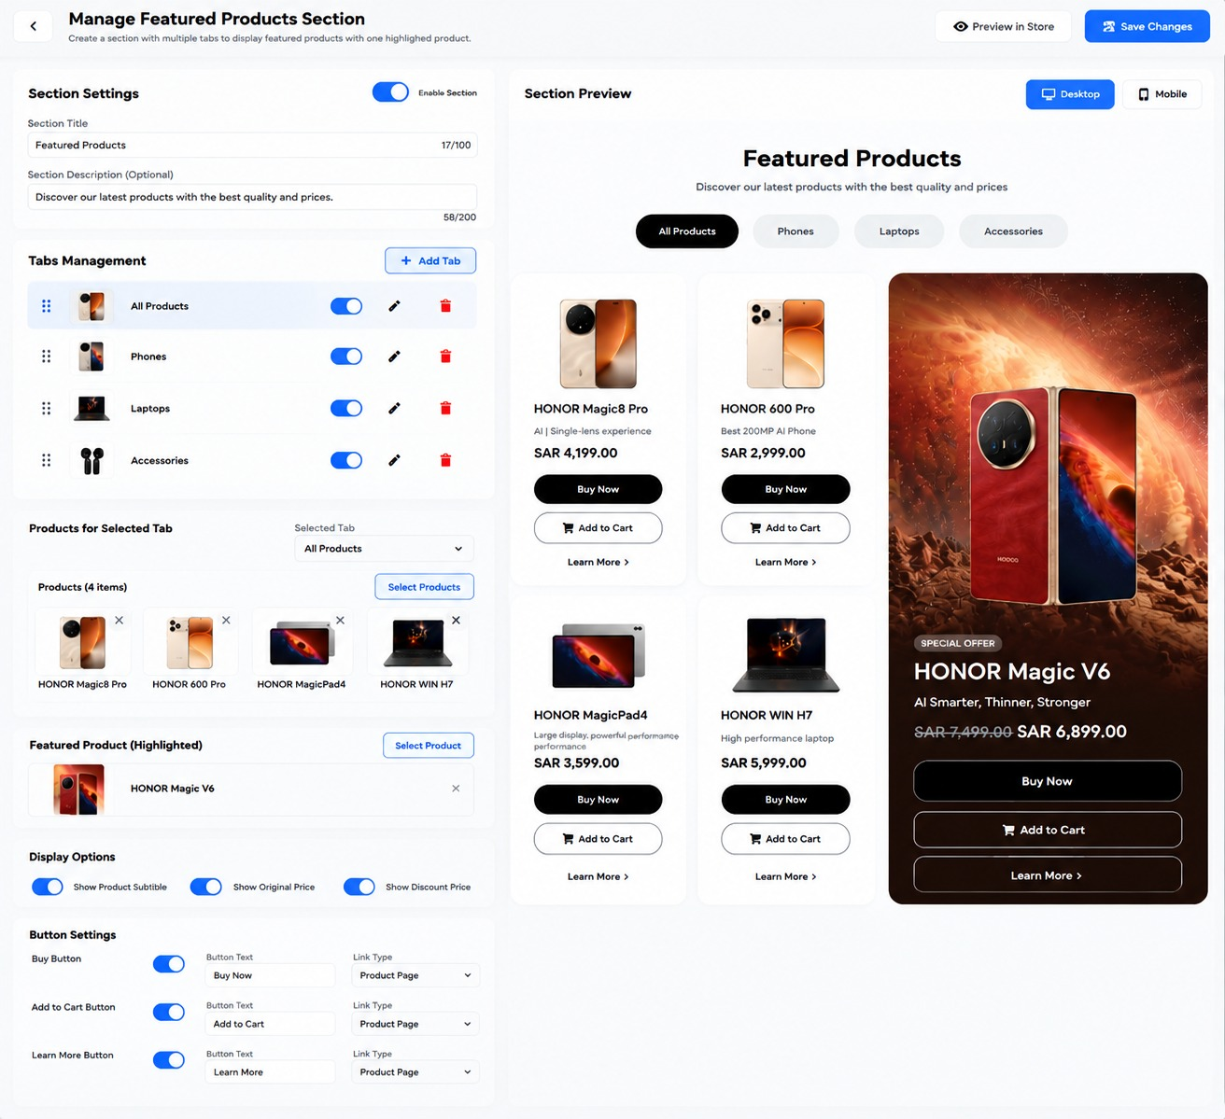

FEATURED PRODUCTS SECTION
Developer Specification — Tabs, Product Cards, Highlighted Product, and Responsive Layout

1. Purpose and Scope
The Featured Products Section allows the merchant to create a storefront section with a title, optional description, category tabs, product cards, and one highlighted product displayed prominently beside the regular product grid. Visitors can switch tabs to browse different product groups and use configured product actions.
This specification applies only to the Featured Products Section shown in the supplied references. Reuse the theme editor’s existing product catalog, cart, page routing, preview, save, and publishing systems. Do not combine this component with other previously defined theme sections.

2. Top-Level Actions

2.1 Back Button
Returns to the previous theme-editor screen. If there are unsaved edits, follow the theme editor’s established draft/autosave behavior or warn the merchant before discarding changes.

2.2 Preview in Store
Opens or refreshes a storefront preview using the current draft configuration. Preview interactions should not accidentally trigger purchases or modify the live storefront.

2.3 Save Changes
Validates and saves the complete section configuration. Show success only after saving completes. If saving fails, preserve edits where possible and show a clear error. If publishing is a separate operation, the live storefront must not change until publishing is completed.

3. Section Settings

3.1 Enable Section Toggle
Turns the entire Featured Products Section on or off. When disabled, the section is hidden on the storefront while its settings remain saved in the editor.

3.2 Section Title
Defines the main heading, for example “Featured Products”. The reference shows a 100-character limit. Display the character counter and update it while typing.

3.3 Section Description (Optional)
Defines supporting text below the heading. The reference shows a 200-character limit. If left blank, omit the description and avoid leaving an empty gap.

4. Tabs Management

4.1 Add Tab
Creates a new tab with a unique identifier, default name, enabled state, and empty product assignment. Select the new tab for editing after creation.

4.2 Tab List Item
Each tab row includes a drag handle, thumbnail or representative image, tab name, enable/disable toggle, edit control, and delete control.

4.3 Reordering Tabs
The drag handle changes tab order. The storefront displays tabs in the saved order.

4.4 Enable/Disable Tab
- Enabled tabs appear in the storefront tab navigation.
- Disabled tabs remain configured but are hidden from visitors.
- If the currently selected tab is disabled, switch to the first remaining enabled tab.
- If no tabs are enabled, hide the tab navigation and follow the section’s defined empty-state behavior.

4.5 Edit Tab
Opens the selected tab’s settings. The merchant should be able to change its display name and associated thumbnail/image where supported.

4.6 Delete Tab
Deletes only the selected tab and its tab-specific product assignment. Ask for confirmation if deletion is destructive. Do not delete products from the store catalog.

4.7 Tab Names and Storefront Behavior
Each tab label appears as a clickable pill or tab. Selecting a tab updates the regular product cards to show the products assigned to that tab. Maintain a clear selected state and support keyboard and touch interaction.

5. Products for Selected Tab

5.1 Selected Tab Selector
Chooses which tab’s product assignments are currently being edited. Switching this selector must load the correct products for that tab and must not overwrite another tab’s selection.

5.2 Product Count
Displays the number of assigned products for the selected tab, for example “Products (4 items)”. Update after adding or removing products.

5.3 Select Products
Opens the product picker connected to the store catalog. The merchant can select products for the currently selected tab. Prevent duplicate assignment within the same tab unless duplicates are explicitly supported.

5.4 Selected Product Tiles
Show each selected product’s thumbnail and name, with a remove control. Removing a tile removes it from this tab’s featured list only; it must not delete the product from the store catalog.

5.5 Product Order
Preserve the selected order or provide drag-and-drop ordering if supported. The storefront product grid should use this order unless a separate sorting setting is added.

5.6 Empty and Invalid Product States
If a tab has no products, show a helpful empty state in the editor and avoid rendering broken or empty product cards on the storefront. If a selected product becomes unavailable, omit it or show the platform’s defined unavailable state.

6. Featured Product (Highlighted)

6.1 Select Product
Opens the product picker to choose one product for a prominent highlighted card. The highlighted product is separate from the regular products assigned to tabs.

6.2 Selected Highlighted Product
Displays the selected product’s thumbnail and name, plus a remove control. Removing it clears the highlighted slot without deleting the catalog product.

6.3 Highlighted Product Storefront Card
The highlighted card displays the selected product’s main image, product name, short description or subtitle where available, original price if configured, current price, and configured action buttons. The reference shows a large image-led card beside the regular product grid.

6.4 Product Data Source
Where possible, read product title, images, prices, discount, and availability from the actual store catalog. Do not hard-code the sample products or prices shown in the screenshot.

6.5 Missing Highlighted Product
If no highlighted product is selected, hide the highlighted card and allow the regular product grid to use the available space according to the responsive layout.

7. Display Options

7.1 Show Product Subtitle
Controls whether the product subtitle/short descriptive line appears on product cards. When disabled, hide the subtitle without leaving an empty gap.

7.2 Show Original Price
Controls visibility of the original/list price, typically shown with strikethrough when a discount is present. When disabled, hide the original price.

7.3 Show Discount Price
Controls visibility of the current discounted price. When disabled, follow the theme’s pricing rules; do not show an invalid or misleading price. Keep the actual product price available to purchase flows.
The reference has separate toggles for original and discount price. Clarify with the designer whether “Show Discount Price” means the current sale price or a discount-specific price label. Use consistent pricing semantics across regular and highlighted cards.

8. Button Settings
The reference provides three global button settings that apply to product cards, including the highlighted product card unless the design explicitly specifies otherwise.

8.1 Buy Button Toggle
Controls whether the Buy button appears. When enabled, show the configured button label and use the selected link type.

8.2 Buy Button Text
Defines the visible label, such as “Buy Now”. Support localization and prevent clipping.

8.3 Buy Button Link Type
Selects the destination/action type, shown as “Product Page” in the reference. The product card’s own product should be the default destination unless the selected link type defines another valid behavior.

8.4 Add to Cart Button Toggle
Controls visibility of the Add to Cart action. When enabled, add the relevant product to the cart through the existing cart mechanism.

8.5 Add to Cart Button Text
Defines the visible label, such as “Add to Cart”.

8.6 Add to Cart Link Type
Determines how the add-to-cart action is executed. For a product card, it should target that card’s product and use the store’s existing variant/cart logic.

8.7 Learn More Button Toggle
Controls visibility of the Learn More action.

8.8 Learn More Button Text
Defines the visible label, such as “Learn More”.

8.9 Learn More Link Type
Selects the destination type, shown as “Product Page” in the reference. Use the current card’s product page by default, or another selected destination if the implementation supports it.

8.10 Button Behavior and Errors
- Hide disabled buttons without leaving unused layout space.
- Validate button labels and link types before saving.
- If Add to Cart requires a variant, use the store’s default variant or request a selection.
- Show appropriate success/error feedback for cart actions.
- Do not render links with missing or invalid destinations.

9. Section Preview

9.1 Desktop / Mobile Preview Switcher
Allows the merchant to preview the section at desktop and mobile viewport sizes. The preview switch changes only the preview viewport, not the stored configuration.

9.2 Preview Content
- Show the section title and optional description.
- Show enabled tabs in saved order with a clear selected state.
- Show products assigned to the selected tab.
- Show the highlighted product in its prominent layout.
- Apply the display option and button settings to regular and highlighted product cards.
- Update the preview when the merchant changes draft settings.

9.3 Recommended Preview Viewports
- Desktop: 1440 × 900 CSS pixels.
- Tablet: 768 × 1024 CSS pixels (portrait), optionally 1024 × 768 landscape.
- Mobile: 390 × 844 CSS pixels.
- Test narrower and intermediate widths as well; these are reference viewports, not device restrictions.

10. Responsive Behavior: Desktop, Tablet, and Mobile

10.1 Desktop
- Display tabs across the section, centered or aligned according to the theme design.
- Display regular product cards in a grid and the highlighted product in a larger adjacent card, matching the reference.
- Keep product images, names, descriptions, prices, and buttons aligned and readable.

10.2 Tablet
- Reduce the number of visible grid columns as space requires.
- Keep the highlighted product visually distinct without forcing the regular cards too narrow.
- Allow tabs to wrap or scroll horizontally if necessary, while keeping all tabs reachable.
- Use flexible image sizes and card heights.

10.3 Mobile
- Stack the highlighted product and regular product grid vertically, or use a deliberate mobile-specific order that matches the theme design.
- The reference mobile view places the highlighted product prominently above the regular product cards; preserve this behavior unless the merchant has a documented layout option.
- Regular products may use one or two columns depending on available width; avoid cards becoming too narrow.
- Allow tab navigation to scroll horizontally when tabs exceed the viewport.
- Stack or wrap action buttons without clipping, and keep touch targets comfortably usable.
- Prevent horizontal overflow, overlapping cards, and cropped text.

10.4 RTL and LTR
Support Arabic right-to-left and English left-to-right. Tab order, text alignment, card flow, prices, and button order must remain logical in both directions.

11. What Happens After the Merchant Fills In and Saves?
- The merchant enables the section and enters the title and optional description.
- The merchant adds, edits, reorders, enables, disables, or deletes tabs.
- For each tab, the merchant selects the products that should appear when that tab is active.
- The merchant selects one highlighted product for the prominent featured card.
- The merchant configures subtitle/original-price/discount-price visibility and the global Buy, Add to Cart, and Learn More button settings.
- The editor validates character limits, product references, tab configuration, button labels, and destinations.
- The preview updates to reflect the current draft configuration.
- When Save Changes is clicked, persist the section enabled state, title, description, tab list/order/states, per-tab product assignments, highlighted product reference, display options, and button settings.
- Show a success message only after the save completes. If saving fails, retain edits where possible and display an error.
- If the platform separates saving from publishing, apply changes to the live storefront only after publishing.
- On the storefront, visitors can select tabs to browse the assigned products and use the configured product actions.
- After reload, verify that the configuration remains saved and the component works on desktop, tablet, and mobile.

12. Validation and Error Handling
- Enforce the visible title limit of 100 characters and description limit of 200 characters.
- Prevent duplicate tab IDs and preserve stable identifiers when tabs are reordered.
- Do not delete catalog products when removing them from a tab or highlighted slot.
- Validate that assigned products still exist and can be displayed.
- If a tab is deleted, remove only its tab-specific configuration.
- If the highlighted product is unavailable, show a clear editor warning and avoid a broken storefront card.
- Do not show invalid prices or links.
- Preserve existing settings if validation or saving fails.

13. Acceptance Criteria
- The section can be enabled and disabled independently.
- Title and optional description can be edited and saved.
- Tabs can be added, edited, reordered, enabled/disabled, and deleted.
- Each tab maintains its own product assignment.
- Product selection and removal do not delete products from the store catalog.
- A separate highlighted product can be selected and removed.
- Display toggles control subtitle, original price, and discount price visibility.
- Buy, Add to Cart, and Learn More settings apply consistently to product cards.
- Desktop and mobile previews reflect the current draft configuration.
- The layout adapts to desktop, tablet, and mobile without clipping, overlap, or unintended horizontal scrolling.
- Arabic RTL and English LTR layouts are supported.
- Save/publish behavior follows the theme editor’s existing workflow and settings persist after reload.

14. Implementation Notes
- This is the Featured Products Section, distinct from Featured Section Banners and Hero Banners.
- Do not hard-code sample product names, images, ratings, or prices from the screenshot.
- Use actual catalog data and the existing cart/product-page integrations.
- Clarify the exact meaning of “Show Discount Price” if the platform’s pricing model distinguishes sale price, discount amount, and discount label.
- Confirm whether tab thumbnails are optional and whether each tab supports a custom image.

Final Implementation Goal
Deliver a configurable Featured Products Section with editable tabs, independent product assignments, one highlighted product, display options, and configurable product actions. The section must preview accurately, save reliably, and adapt cleanly to desktop, tablet, and mobile storefronts.

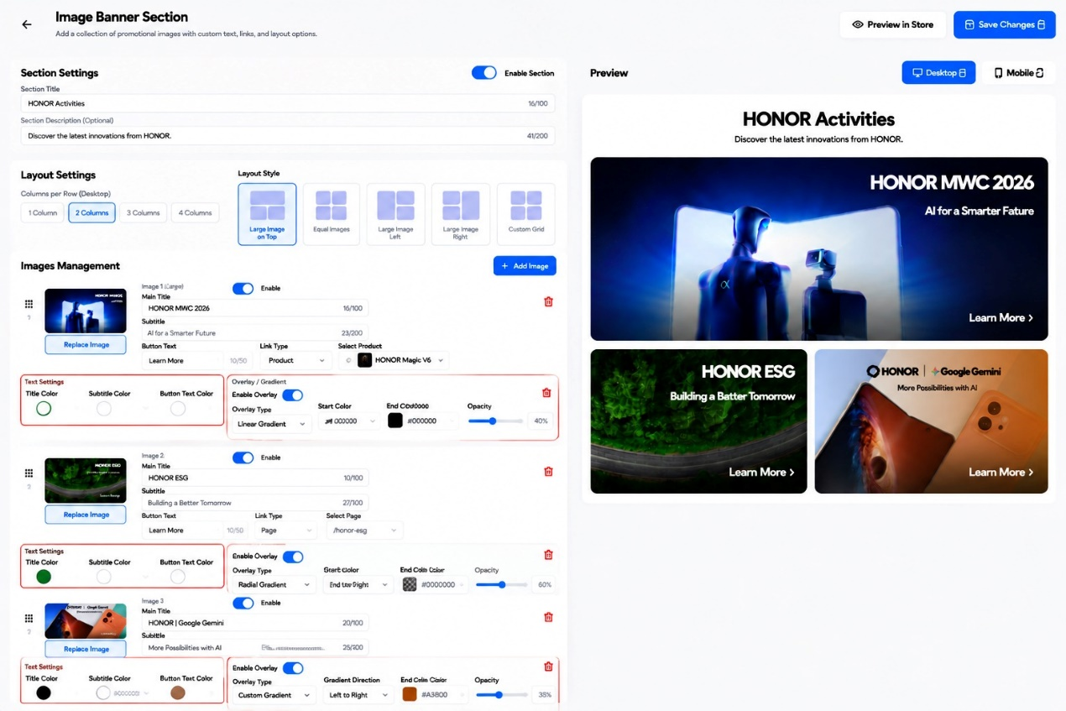

IMAGE BANNER SECTION
Developer Specification — Image Management, Layouts, Overlays, Preview, and Responsive Behavior

1. Purpose and Scope
The Image Banner Section lets a store owner create a collection of promotional image tiles with custom titles, subtitles, call-to-action buttons, links, per-image text colors, and optional overlays or gradients. The section supports several desktop layout styles and must adapt to desktop, tablet, and mobile storefronts.
This specification covers only the Image Banner Section shown in the supplied reference. Reuse the theme editor’s existing media library, page/product selectors, preview, save, and publish workflow. Do not merge this component with Hero Banners or Featured Products.

2. Top-Level Actions

2.1 Back Button
Returns to the previous theme-editor screen. If there are unsaved changes, use the editor’s established draft/autosave behavior or warn before discarding them.

2.2 Preview in Store
Opens or refreshes a storefront preview using the current draft settings. The preview must reflect unsaved draft edits where supported and must not publish changes by itself.

2.3 Save Changes
Validates and saves the full section configuration. Show success only after the save completes. If saving fails, preserve edits where possible and show a clear error. If publishing is separate, do not claim that the live storefront has changed until publishing completes.

3. Section Settings

3.1 Enable Section
Turns the entire Image Banner Section on or off. When disabled, hide the section from the storefront while retaining its configuration in the editor.

3.2 Section Title
Defines the heading above the image collection, for example “HONOR Activities”. The reference shows a 100-character limit. Display a live character counter and validate the limit.

3.3 Section Description (Optional)
Defines supporting text under the section title. The reference shows a 200-character limit. If empty, omit it and collapse the extra spacing.

4. Layout Settings

4.1 Columns per Row (Desktop)
Sets the intended number of columns for the desktop layout: 1, 2, 3, or 4. This controls the grid’s overall structure, subject to the selected layout style.

4.2 Layout Style
Chooses the arrangement of the image tiles. The reference shows five styles:
- Large Image on Top: one large image above smaller images.
- Equal Images: images use equal-sized grid cells.
- Large Image Left: a large image on the left with smaller tiles beside it.
- Large Image Right: a large image on the right with smaller tiles beside it.
- Custom Grid: a configurable grid arrangement, if supported by the implementation.
The selected style must be clearly highlighted in the editor. Layout controls should update the preview immediately.

4.3 Layout Validation
If the selected layout requires a minimum number of images, show a clear editor hint when there are too few images. Do not create blank tiles in the storefront. Gracefully adapt the layout to the actual number of enabled images.

5. Images Management

5.1 Add Image
Adds a new image item to the collection. Create a unique ID, initialize its settings, select it for editing if appropriate, and update the preview.

5.2 Drag Handle / Image Order
Allows the merchant to reorder image items. The saved order determines their position in the selected layout.

5.3 Image Thumbnail and Replace Image
Displays the selected image and opens the media picker when Replace Image is clicked. Validate the upload using the theme’s supported formats and file-size rules. Keep image aspect ratio and provide sensible cropping.

5.4 Enable Image
Controls whether the individual image item appears in the storefront. Disabled items remain saved but are excluded from the visible layout.

5.5 Delete Image
Removes the selected image item from this section after confirmation if required. It must not delete the original file from the media library unless the user explicitly requests that separate operation.

5.6 Image-Specific Content
Each image item has its own title, subtitle, button label, link type, and destination. These settings must be stored independently for each image.

5.7 Main Title
Defines the main heading displayed over the image, such as “HONOR MWC 2026”. The reference shows a 100-character limit. Show a live character count.

5.8 Subtitle
Defines supporting text displayed with the title. The reference shows a 200-character limit. Show a live counter and allow natural line wrapping.

5.9 Button Text
Defines the call-to-action label, such as “Learn More”. The reference shows a 50-character limit.

5.10 Link Type
Determines the kind of destination for the image’s call-to-action, such as a product or a page.

5.11 Select Product
When Product is selected as the link type, lets the merchant choose the target product. Clicking the storefront button opens that product’s page or the defined product destination.

5.12 Select Page
When Page is selected as the link type, lets the merchant choose a valid store page. Clicking the storefront button navigates to that page.

5.13 Conditional Fields
Show only the destination selector relevant to the chosen link type. If the type changes, preserve prior values only where appropriate and validate the newly required destination before saving.

6. Per-Image Text Settings

6.1 Title Color
Sets the main title color for the selected image item. Provide a color picker and/or valid HEX input. Update the preview immediately.

6.2 Subtitle Color
Sets the subtitle color independently from the title.

6.3 Button Text Color
Sets the call-to-action text color independently from the title and subtitle.
Text colors are per image item. Changing one image’s text colors must not alter the other image items.

7. Overlay / Gradient Settings

7.1 Enable Overlay
Turns the selected image’s overlay effect on or off. The overlay is rendered above the image and below the text and button.

7.2 Overlay Type
Selects the overlay treatment. The reference includes Linear Gradient, Radial Gradient, and Custom Gradient. If additional options exist, label them clearly.

7.3 Start Color and End Color
Define the overlay gradient colors. Accept valid color values and update the preview live. Use the selected gradient type to interpret the colors.

7.4 Gradient Direction
For linear or custom gradients, controls the direction of the color transition, for example left-to-right or top-to-bottom. Hide or disable this control if it is not relevant to the chosen overlay type.

7.5 Opacity
Controls overlay transparency as a percentage. The reference shows values such as 38%, 40%, and 60%. Higher opacity makes the overlay more prominent; lower opacity shows more of the original image.

7.6 Overlay Behavior
- When the overlay is disabled, ignore its visual settings but retain saved values unless the design specifies otherwise.
- The overlay must not replace or modify the original uploaded image file.
- Keep text and buttons above the overlay in the stacking order.
- Ensure text contrast remains sufficient at the selected opacity.
- Changing one image’s overlay must not affect other images.

8. Preview

8.1 Desktop / Mobile Preview Switcher
Allows the merchant to inspect the section at desktop and mobile viewport sizes. Switching modes changes the preview viewport only and must not alter content or saved settings.

8.2 Preview Accuracy
- Show the section title and optional description.
- Use the selected layout style and desktop column setting.
- Display enabled images in their saved order.
- Apply each image’s title, subtitle, button label, destination behavior, text colors, and overlay settings.
- Update while editing where possible without a full reload.
- Use draft settings rather than hard-coded sample content.

8.3 Recommended Preview Viewports
- Desktop: 1440 × 900 CSS pixels.
- Tablet: 768 × 1024 CSS pixels (portrait), optionally 1024 × 768 landscape.
- Mobile: 390 × 844 CSS pixels.
- Also test narrow and intermediate widths; these are reference sizes, not device restrictions.

9. Responsive Requirements: Desktop, Tablet, and Mobile

9.1 Desktop
- Apply the selected desktop column count and layout style.
- Keep image tiles aligned with consistent gaps and corner treatment.
- Position each title, subtitle, and button so they remain legible over the image.
- Avoid stretching images; use an appropriate object-fit/crop strategy.

9.2 Tablet
- Reduce the number of columns when needed to preserve image readability.
- Adapt large-image layouts so the primary image remains prominent without making smaller tiles too narrow.
- Keep titles and buttons readable and avoid overlaps.
- Use flexible gaps and heights.

9.3 Mobile
- Use a mobile-appropriate grid, usually one column or two columns when the image tiles remain usable.
- Reflow large-image layouts into a clear vertical sequence; do not simply shrink the desktop grid until content becomes unreadable.
- Allow titles and subtitles to wrap naturally.
- Keep buttons reachable and large enough for touch.
- Maintain image proportions and avoid clipping important visual subjects.
- Prevent horizontal overflow and overlapping content.

9.4 RTL and LTR
Support Arabic right-to-left and English left-to-right. Layout ordering, text alignment, and gradient direction must behave predictably in both languages. Gradient direction should remain an explicit visual setting rather than being changed unexpectedly by text direction.

10. What Happens After the Merchant Fills In and Saves?
- The merchant enables the section, enters the section title and optional description, selects a layout style and desktop column count, then adds or edits image items.
- For each image, the merchant selects/replaces the image, enables or disables it, enters a title and subtitle, sets button text and chooses a link type and destination.
- The merchant sets title, subtitle, and button text colors, then optionally enables and configures the overlay/gradient and opacity.
- The editor updates the preview to reflect the current draft configuration.
- The system validates character limits, image references, link destinations, color values, opacity range, and layout requirements.
- When Save Changes is clicked, persist the section state, title, description, layout settings, image list/order/states, each image’s content, link configuration, text colors, and overlay settings.
- Show success only after saving completes. If saving fails, preserve the user’s edits where possible and display a clear error.
- If the platform separates saving from publishing, the live storefront changes only after the required publish action.
- The storefront renders the enabled images in the saved layout. Each call-to-action opens its configured product or page destination.
- After reload, confirm all settings persist and the section displays correctly on desktop, tablet, and mobile.

11. Validation and Error Handling
- Enforce the displayed limits: section title 100 characters, section description 200, image title 100, subtitle 200, and button text 50.
- Validate image upload and media references according to the platform’s rules.
- Require a valid destination when a button is enabled and its link type requires one.
- Reject invalid color values and opacity values outside the supported range.
- Do not render disabled images or broken links.
- If there are too few images for the selected layout, adapt gracefully and show an editor hint.
- Preserve existing settings if validation or saving fails.

12. Acceptance Criteria
- The section can be enabled or disabled.
- Section title and optional description can be edited and saved.
- Desktop column count and all five layout styles work as configured.
- Images can be added, replaced, reordered, enabled, disabled, and removed independently.
- Each image stores its own title, subtitle, button text, link type, and target.
- Product and page link targets navigate correctly.
- Title, subtitle, and button text colors are independently configurable per image.
- Overlay enablement, type, start/end colors, direction, and opacity update the preview correctly.
- Desktop and mobile preview reflect draft settings.
- The section adapts to desktop, tablet, and mobile without clipping, overlap, or unintended horizontal scrolling.
- Arabic RTL and English LTR are supported.
- Save/publish behavior follows the existing theme workflow and settings persist after reload.

13. Implementation Notes
- This component is Image Banner Section and must remain separate from Hero Banners, Featured Section Banners, and Featured Products.
- Do not hard-code example images, copy, colors, or destinations from the reference screenshot.
- Use the existing media library and product/page routing integrations.
- If Custom Grid requires extra controls not visible in the reference, confirm the intended configuration with the designer before implementing additional fields.

Final Implementation Goal
Deliver a flexible Image Banner Section that supports multiple promotional image tiles, per-image content and links, independent text colors, optional gradient overlays, configurable layouts, accurate preview, reliable save/publish behavior, and responsive storefront presentation on desktop, tablet, and mobile.

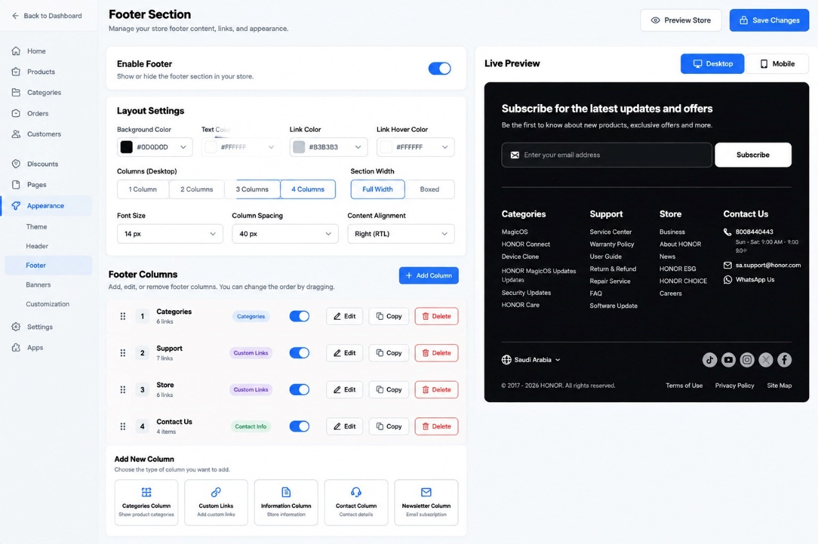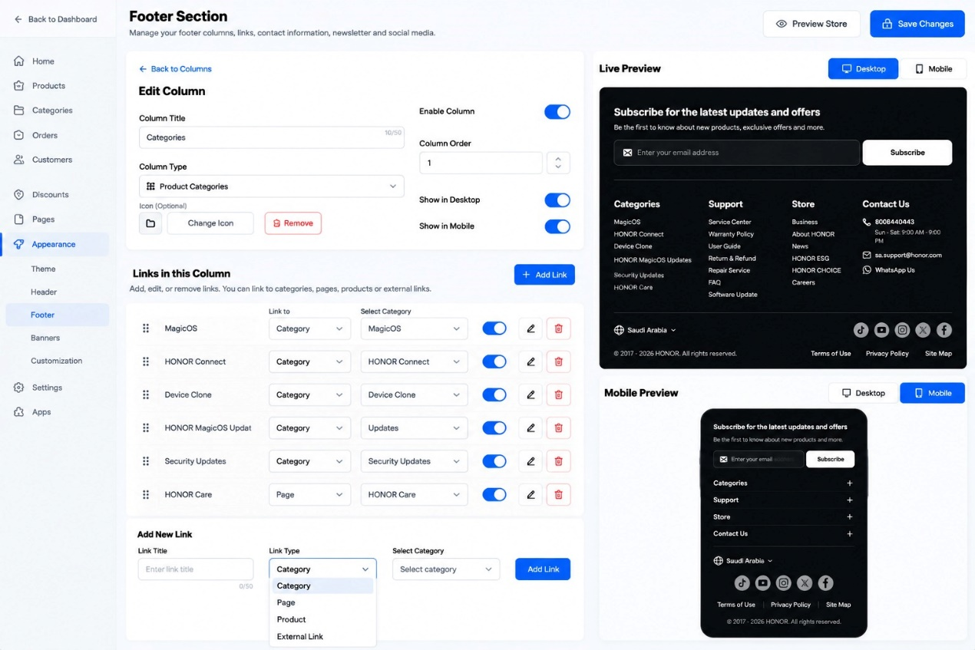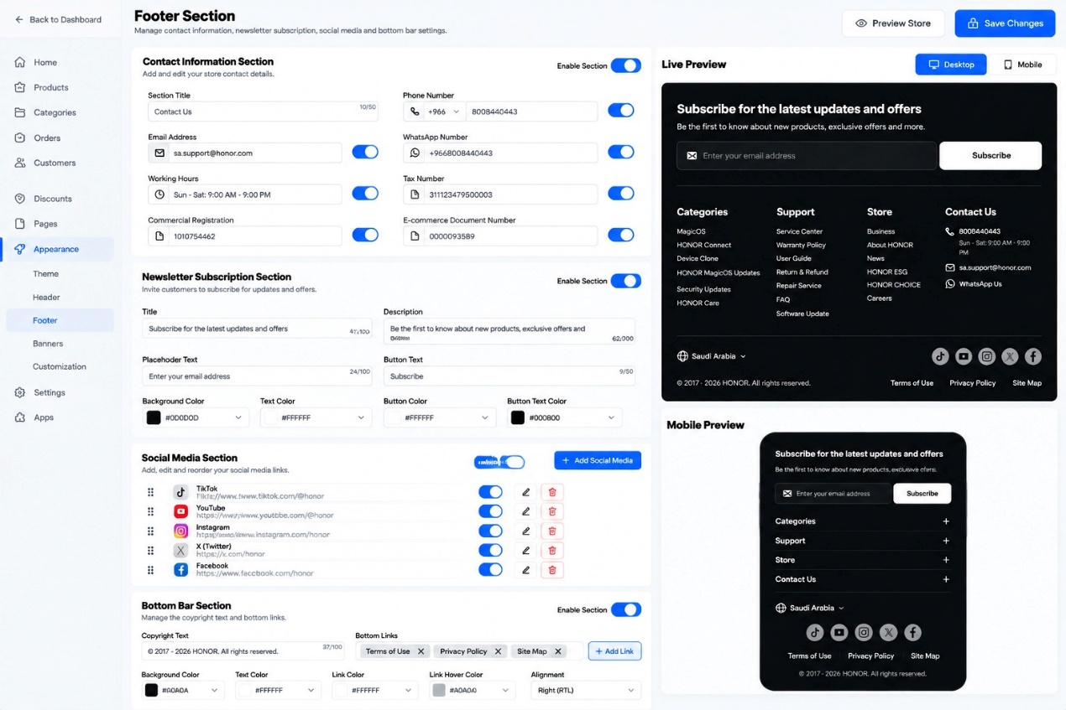

FOOTER SECTION
Developer Specification
Complete settings, column and link management, contact information, newsletter, social media, bottom bar, save workflow, and responsive requirements

1. Purpose and Scope
The Footer Section is a configurable store-wide component displayed at the bottom of storefront pages. It organizes navigation links, category links, store/contact information, newsletter signup, social media links, country/region selection, copyright text, and legal or utility links. The component must be manageable from the theme editor and responsive across desktop, tablet, and mobile.
This specification combines the three supplied reference screens: (1) footer appearance and column management, (2) editing a footer column and its links, and (3) contact information, newsletter, social media, and bottom bar settings. Keep this as one Footer Section with logically grouped subsections.

2. Global Page Actions

2.1 Back to Dashboard / Back to Columns
Back to Dashboard returns to the main admin dashboard. Back to Columns returns from the Edit Column view to the main footer-column list. If edits are unsaved, follow the platform’s established draft behavior or warn before discarding them.

2.2 Preview Store
Opens the storefront preview using the current draft configuration where supported. Previewing must not publish changes.

2.3 Save Changes
Validates and saves the full footer configuration. Show success only after the save operation completes. If saving fails, preserve the current edits where possible and display a useful error. If the platform has a separate publish step, do not claim that the live storefront has changed until publishing is complete.

3. Enable Footer
The Enable Footer switch controls whether the entire footer is rendered on the storefront. When off, hide the footer but retain all its settings in the editor. Turning it on restores the saved configuration.

4. Layout Settings

4.1 Color Controls
- Background Color: sets the overall footer background.
- Text Color: sets the default footer text color.
- Link Color: sets the default color of footer links.
- Link Hover Color: sets the color used when a visitor hovers over a link on pointer-based devices; use a suitable focus/active treatment for keyboard and touch accessibility.
Provide a color picker and valid HEX input where shown. Update the preview immediately and validate color values. Ensure the selected colors provide sufficient contrast.

4.2 Columns (Desktop)
Selects 1, 2, 3, or 4 columns for the desktop footer layout. The layout must distribute enabled columns consistently and wrap or adapt gracefully if there are more columns than fit.

4.3 Section Width
- Full Width: footer content spans the available viewport width, while internal padding keeps content away from screen edges.
- Boxed: footer content is constrained to a centered maximum-width container.

4.4 Font Size
Sets the default footer font size, for example 14 px. Use a responsive scale where needed and preserve readable sizes on small screens.

4.5 Column Spacing
Sets the gap between footer columns, for example 40 px. Reduce spacing responsively when the available width becomes limited.

4.6 Content Alignment
Controls alignment, including Right (RTL) for Arabic layouts. Support left-to-right and right-to-left direction without reversing the meaning or destination of links.

5. Footer Columns

5.1 Column List
Lists the configured columns with a drag handle, order number, title, item count/type label, enabled switch, and actions.
- Drag handle: changes the order of the column. The saved order controls storefront order.
- Column number: indicates the current order in the list.
- Column title and item count: identify the column and summarize its contents.
- Enable/Disable switch: hides or shows that column without deleting its configuration.
- Edit: opens the column editor.
- Copy: duplicates the column and its settings/links with a new unique ID; avoid duplicate IDs or unintended duplicate external actions.
- Delete: removes the selected column after confirmation if appropriate. Do not delete its underlying categories, pages, products, or media records.

5.2 Add Column
Adds a new footer column. The merchant chooses one of the available column types:
- Categories Column: shows links to product categories/collections.
- Custom Links: lets the merchant create a list of manually configured destinations.
- Information Column: displays configured store information or informational links, depending on the theme’s implementation.
- Contact Column: displays selected contact details.
- Newsletter Column: displays the email subscription form.
After selection, create a new column with a unique ID, a suitable default title, enabled state, and type-specific empty/default settings. Do not publish placeholder content automatically.

6. Edit Column

6.1 Column Title
Sets the heading shown above the column in the storefront. The reference shows a 50-character limit and a live character counter.

6.2 Column Type
Defines the column’s content type, such as Product Categories. Changing type may change which settings are available. Preserve compatible data where possible and warn before discarding incompatible settings.

6.3 Icon (Optional)
Allows the merchant to choose an icon for the column heading, change it, or remove it. If no icon is selected, display the title without an icon. Use consistent sizing and accessible labels.

6.4 Enable Column
Controls whether the column is eligible to appear in the footer. Disabled columns remain editable and retain their settings.

6.5 Column Order
Sets the column position numerically. Changes must synchronize with drag-and-drop ordering and be validated so positions remain consistent.

6.6 Show in Desktop / Show in Mobile
Controls visibility by viewport. On tablets, use a defined responsive rule—normally follow desktop visibility at wider tablet widths and mobile visibility at narrow widths, or provide a documented tablet-specific breakpoint. Hiding a column on a device must not delete its content.

7. Links in This Column

7.1 Existing Link List
Each link row contains a drag handle, link title, destination type, destination selector when applicable, enabled switch, Edit action, and Delete action.
- Drag handle: changes the link order within the column.
- Link title: visible clickable text.
- Link type: defines whether the destination is a Category, Page, Product, or External Link.
- Destination selector: selects the specific category/page/product or stores the external URL.
- Enabled switch: hides or shows the link without deleting it.
- Edit: opens the link’s settings for modification.
- Delete: removes the link from this column after confirmation if required.

7.2 Add Link
The Add Link area includes Link Title, Link Type, a conditional destination selector, and Add Link.
- Enter the visible link title.
- Choose Category, Page, Product, or External Link.
- Show the matching destination control: category picker, page picker, product picker, or URL field.
- Validate required values and the URL format for external links.
- When Add Link is clicked, append the new link to the current column, assign a unique ID, and update the preview.
- Do not add a blank link or allow a link with a missing required destination.
External links should be handled safely. If opening a new tab is supported, use safe target/rel behavior. The storefront link must navigate to the configured destination.

8. Contact Information Section
This subsection manages contact details that can be displayed in the Contact Column. The section has its own Enable Section switch. Each field has a value and an individual visibility switch.
- Section Title: heading such as “Contact Us”.
- Phone Number: country code and phone number; clicking it on compatible devices should use a tel: link.
- Email Address: clicking it should open the visitor’s email application using a mailto: link.
- WhatsApp Number: country code/full number; link to the correct WhatsApp conversation URL.
- Working Hours: text describing opening hours.
- Tax Number: store tax identifier, shown only when enabled.
- Commercial Registration: commercial registration identifier, shown only when enabled.
- E-commerce Document Number: store e-commerce registration/document identifier, shown only when enabled.
Validate field formats where appropriate without assuming a single country format. Disabled fields are hidden from the storefront but their values remain saved. Do not expose sensitive administrative data unless the merchant has enabled its display.

9. Newsletter Subscription Section
The newsletter section invites visitors to submit an email address to receive store updates and offers. It has its own Enable Section switch.
- Title: main subscription heading.
- Description: supporting text under the heading.
- Placeholder Text: hint displayed inside the email input.
- Button Text: label on the subscribe button.
- Background Color: background of the newsletter area.
- Text Color: title/description/default text color.
- Button Color: subscribe button background color.
- Button Text Color: label color on the button.

9.1 Newsletter Submission Behavior
- The visitor enters an email address and submits the form.
- Validate that the field is not empty and contains a valid email format.
- Send the email to the configured newsletter/marketing integration or backend endpoint; do not treat a front-end-only success message as a completed subscription.
- Show a clear success or error message and prevent duplicate submissions while processing.
- Handle consent/privacy requirements and any required confirmation workflow configured by the store.
- Ensure keyboard navigation and screen-reader labels are available.

10. Social Media Section
The Social Media Section has an Enable Section switch and an Add Social Media action. Each social item includes an icon/platform, URL, enabled switch, edit action, delete action, and drag handle.
- Add Social Media: creates a new social link after the platform and URL are configured.
- Platform/Icon: shows the relevant network icon, such as TikTok, YouTube, Instagram, X, or Facebook.
- URL: the destination profile/page.
- Enabled switch: controls whether the icon appears.
- Edit: changes the platform or URL.
- Delete: removes the social item from the footer.
- Drag handle: changes icon order.
Validate URLs and use accessible labels (for example, “Visit our Instagram profile”). Icons must remain legible in both desktop and mobile layouts.

11. Bottom Bar Section
The Bottom Bar has its own Enable Section switch. It controls the lowest footer row containing copyright information and utility/legal links.
- Copyright Text: editable copyright statement, with a character limit/counter where configured.
- Bottom Links: list of links such as Terms of Use, Privacy Policy, and Site Map.
- Add Link: adds a new bottom-bar link with a title and destination.
- Background Color: background color of the bottom bar.
- Text Color: copyright and default text color.
- Link Color: default link color.
- Link Hover Color: hover/focus state color.
- Alignment: controls alignment, including RTL alignment for Arabic.
Each bottom link must have a valid destination. On mobile, links may wrap onto multiple lines or move into a compact row without overlapping.

12. Country / Region Selector and External Footer Elements
The preview includes a country/region selector (for example, Saudi Arabia) and social icons. If the theme/platform supports localization, the selector should use the store’s configured markets/locales and update the storefront context appropriately. Do not hard-code the country name or create a selector that changes only its label without changing the actual locale/currency/market context. If this selector is outside the Footer Section’s editable scope, document that it is controlled by the platform’s global localization settings.

13. Live Preview

13.1 Desktop and Mobile Preview Controls
The preview switcher lets the merchant inspect the footer at desktop and mobile viewport sizes. Switching preview mode must not alter the configuration. Preview should use current draft values and update promptly after edits.

13.2 Desktop Preview
- Display footer columns side by side using the selected column count and spacing.
- Show the newsletter area according to its settings.
- Show enabled contact details and social media icons.
- Display the country/region selector and bottom bar when enabled/configured.
- Apply colors, typography, width, alignment, and link states.

13.3 Mobile Preview
- Reflow columns into a narrow layout; an accordion pattern with plus/minus controls is acceptable and matches the reference.
- Allow visitors to expand and collapse each column’s links using accessible controls.
- Keep newsletter fields and the Subscribe button usable at narrow widths.
- Wrap contact details and legal links without clipping.
- Center or wrap social icons with adequate touch spacing.
- Avoid horizontal overflow and overlapping content.

14. Responsive Requirements: Desktop, Tablet, and Mobile

14.1 Desktop
- Use the selected 1–4 column layout.
- Keep column headings, links, newsletter, and contact details aligned and readable.
- Respect Full Width or Boxed container settings.
- Apply configured font size, spacing, colors, and alignment.

14.2 Tablet
- Reduce columns or wrap them when the available width is insufficient.
- Use moderate column gaps and readable line lengths.
- Keep newsletter controls on one row only when they fit; otherwise stack them.
- Maintain logical reading and keyboard order.

14.3 Mobile
- Use a compact stacked or accordion layout for footer columns.
- Make interactive controls touch-friendly and avoid tiny links.
- Stack or responsively arrange the email field and subscribe button.
- Ensure phone, email, and WhatsApp links are easy to tap.
- Wrap bottom-bar links and copyright text naturally.
- Keep social icons within the viewport and prevent horizontal scrolling.

14.4 Recommended Preview Viewports
- Desktop: 1440 × 900 CSS pixels.
- Tablet: 768 × 1024 CSS pixels (portrait) and optionally 1024 × 768 landscape.
- Mobile: 390 × 844 CSS pixels.
- Also test narrow screens around 320–360 CSS pixels and intermediate widths.

15. What Happens After Filling In and Saving Changes?
- The merchant enables/disables the footer and configures global colors, width, desktop column count, font size, spacing, and alignment.
- The merchant adds columns, chooses their types, sets titles/icons/order/device visibility, and configures their links.
- The merchant enters contact details and toggles the visibility of each field.
- The merchant configures the newsletter content and colors, social media profiles, and bottom-bar copyright/links.
- The preview reflects the draft settings so the merchant can review desktop and mobile layouts before saving.
- The system validates field limits, color values, link types/destinations, URLs, email/phone formats where applicable, and required fields.
- When Save Changes is clicked, persist all footer settings, column order, column visibility, link data/order, contact fields and visibility, newsletter configuration, social media list/order, and bottom-bar configuration.
- Display a success message only after the save operation completes. If it fails, show the error and preserve edits where possible.
- If publishing is separate, the live store is updated only after the required publish action.
- The storefront renders the saved footer on applicable pages and breakpoints. Links navigate to their destinations; phone/email/WhatsApp controls launch their respective actions; newsletter submissions are sent to the configured integration.
- Reload the editor and storefront to confirm settings persist and the footer remains correct on desktop, tablet, and mobile.

16. Validation, Accessibility, and Error Handling
- Enforce configured character limits and show counters where displayed.
- Validate external URLs and required category/page/product destinations.
- Do not render empty or invalid links.
- Use accessible labels for icon-only buttons and accordion controls.
- Support keyboard navigation, visible focus states, and sufficient color contrast.
- Use appropriate semantic footer/navigation landmarks and form labels.
- Do not expose disabled columns or fields on the storefront, but retain their configuration.
- If a section is disabled, preserve its data rather than deleting it.
- Show clear save/subscription errors and prevent accidental duplicate actions.

17. Acceptance Criteria
- Footer can be enabled or disabled without losing configuration.
- Global layout colors, width, desktop columns, font size, spacing, and alignment work.
- Columns can be added, edited, copied, reordered, enabled/disabled, and deleted.
- All five column types can be configured according to their intended function.
- Column titles, icons, order, and desktop/mobile visibility work independently.
- Links can be added, edited, enabled/disabled, reordered, and deleted, with all four destination types supported.
- Contact fields and their visibility toggles work correctly.
- Newsletter form validates and submits through a real configured integration.
- Social media links can be added, edited, reordered, enabled/disabled, and deleted.
- Bottom-bar copyright, links, colors, and alignment are configurable.
- Desktop/mobile preview reflects draft settings; tablet responsiveness is verified in testing.
- Arabic RTL and English LTR render correctly.
- Save/publish workflow persists settings and updates the storefront only at the correct stage.
- No clipping, overlap, inaccessible controls, or unintended horizontal scrolling occurs on supported screen sizes.

18. Implementation Notes
- Treat the footer as one component with separate, independently configurable subsections.
- Use the theme’s existing media, page, product, category, localization, and newsletter integrations.
- Do not hard-code the example brand, contact details, copyright dates, colors, or social URLs from the screenshots.
- Avoid deleting referenced store records when a footer link or column is removed.
- If tablet-specific visibility is not a separate setting, document and consistently apply the responsive breakpoint rules.

Final Implementation Goal
Deliver a fully configurable Footer Section with robust column and link management, contact information, newsletter signup, social media, localization support where available, and a bottom bar. The same saved configuration must render cleanly and accessibly across desktop, tablet, and mobile.

FEATURE ICONS SECTION
Developer Specification | Responsive Theme Component
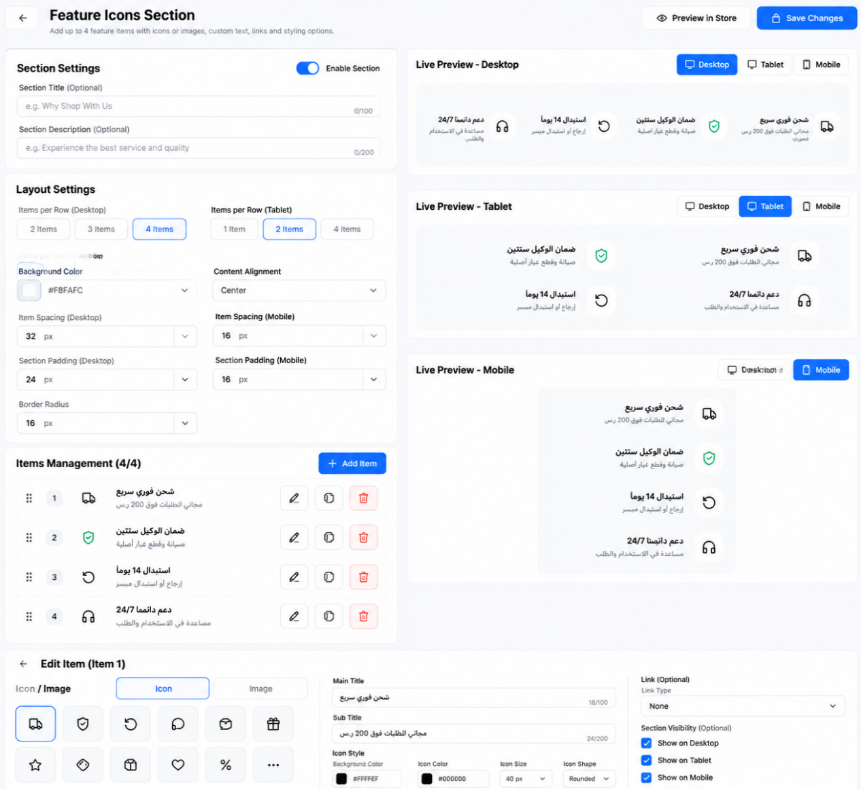
Purpose: Build an editable store-benefits strip containing up to four independent feature items. Each item supports a main title, subtitle, selectable icon or uploaded image, styling, optional link, visibility controls, and responsive previews for desktop, tablet, and mobile.

1. Component Overview
The storefront component displays four benefit messages, such as fast shipping, warranty protection, a 14-day replacement policy, and 24/7 support. All text and icons are examples and must remain editable. The merchant may customize each of the four items independently.

2. Header Actions

Back
Returns to the previous theme-editor screen. If there are unsaved changes, warn the merchant before leaving.

Preview in Store
Opens a preview of the current draft settings without publishing them.

Save Changes
Validates and saves the configuration. Show a success or error state. Do not imply that saving publishes the storefront if the platform has a separate publish step.

3. Section Settings

Enable Section
Global on/off switch for the whole feature strip. When disabled, hide the section on the storefront while retaining its saved settings.

Section Title (Optional)
Optional heading above the four items. Hide the heading when empty.

Section Description (Optional)
Optional supporting text below the heading. Hide it when empty.

4. Layout Settings

Items per Row — Desktop
Allow 2, 3, or 4 items per row. Recommended default: 4.

Items per Row — Tablet
Allow 1, 2, or 4 items per row. Recommended default: 2.

Items per Row — Mobile
Provide a mobile-specific option. Recommended default: 1 item per row for readable text; optionally allow 2 columns if the design remains legible.

Background Color
Color picker plus editable HEX value for the section background.

Content Alignment
Choose left, center, or right alignment while respecting RTL/LTR language direction.

Item Spacing
Separate spacing values for desktop, tablet, and mobile.

Section Padding
Separate internal spacing values for desktop, tablet, and mobile.

Border Radius
Controls rounded corners of the section or item containers.

5. Items Management

Add Item
Adds a new item with a unique ID and default settings. If the component limit is four items, disable the button at four and show a clear limit message. Never display blank items on the storefront.

Drag Handle / Reorder
Lets the merchant change the order. The storefront order must match the saved order.

Item Number
Administrative index only; update it after reordering.

Edit Item
Opens the editor for the selected item.

Duplicate Item
Creates an independent copy with a new unique ID.

Delete Item
Removes the selected item after confirmation. Other items remain unchanged.

Enable Item
Shows or hides one item without deleting its settings.

6. Edit Item — Content and Icon/Image

Icon / Image Selector
Choose either a built-in icon or an uploaded image for the current item.

Icon Library
Provide recognizable icons such as delivery truck, shield, return/refresh, headset, chat, gift, box, heart, tag, and percentage. If the library is large, include search or categories.

Upload Image
Allow upload or media-library selection. Validate file type and size, show a preview, and provide Replace and Remove actions. Support optional alt text.

Main Title
Editable primary benefit text, such as “Fast Shipping”. Support Arabic and English, character counters, and a sensible length limit.

Sub Title
Editable supporting explanation. Allow multiple lines and natural wrapping without clipping.

Icon Background Color
Controls the container behind an icon. If an uploaded image is selected, define whether the background remains visible around it.

Icon Color
Controls icon stroke/fill when supported. It must not recolor an uploaded image.

Icon Size
Controls icon dimensions with sensible minimum and maximum values.

Icon Shape
Choose square, rounded square, circle, or no container.

Optional Border and Padding
Controls the icon container’s border and inner spacing if supported by the theme design.

Link (Optional)
Allow no link, internal page, product, collection/category, or external URL. Make click behavior clear and keyboard accessible.

Section Visibility
Provide independent Show on Desktop, Show on Tablet, and Show on Mobile controls. Hidden items must not leave empty gaps.

7. Live Preview

Desktop Preview
Displays the desktop item count, spacing, alignment, typography, icon/image, and dimensions.

Tablet Preview
Displays tablet-specific layout settings and confirms that text and icons remain legible.

Mobile Preview
Displays the narrow-screen layout. Titles and subtitles wrap naturally, and touch targets remain usable.

Live Draft Updates
Preview updates immediately when content, order, enable state, image, icon style, colors, links, or visibility changes.

Device Preview Controls
Switching preview devices changes only the preview viewport; it must not unexpectedly overwrite the saved responsive settings.

8. Recommended Responsive Behavior
Device | Recommended layout | Behavior
Desktop (≥ 1024 px) | 4 items in one row | Use available width and balanced spacing; allow 2- or 3-item options.
Tablet (768–1023 px) | 2 items per row | Use a two-column grid by default and keep copy readable.
Mobile (< 768 px) | 1 item per row | Stack items vertically; optionally offer two columns if each item remains readable.
These breakpoints are recommendations. Use the project’s existing responsive breakpoints if defined. One component and one data model must serve all device sizes; do not create separate copies of the content for desktop, tablet, and mobile.

9. What Happens After Save
- The merchant edits titles, subtitles, icons/images, colors, shapes, links, order, visibility, and layout values.
- The live preview reflects the unsaved draft immediately.
- On Save Changes, validate required fields, HEX colors, uploaded media, URLs, item count, and responsive settings.
- If validation fails, show a field-level error and preserve the entered values.
- If validation succeeds, save the section configuration and media references to the theme settings/data store.
- Show success feedback only after saving succeeds. If saving fails, retain the draft and show an actionable error.
- If the platform separates saving from publishing, apply changes to the live storefront only after the required publish action.
- After reloading the editor, restore the saved configuration and verify that preview and storefront output match.

10. Suggested Data Model
Store section settings separately from each item. Each item should have a stable unique ID, enabled state, order, title, subtitle, display mode (icon/image), icon identifier or media reference, icon styling, optional link configuration, and per-device visibility. Store layout values by breakpoint. Do not use the item’s list index as its permanent ID.

11. Accessibility, Localization, and Performance
- Support Arabic RTL and English LTR. Alignment and icon/text order should follow the selected language direction.
- Label all controls; support keyboard navigation, visible focus indicators, and accessible names for icon-only buttons.
- Uploaded images should support optional alt text; decorative images may use empty alt text.
- Maintain sufficient text/background contrast and do not communicate meaning through color alone.
- Optimize uploaded images and reserve their dimensions to reduce layout shifts.
- Do not make an entire item clickable if it contains nested interactive controls unless the interaction is clearly defined.

12. Acceptance Criteria
- The merchant can edit the main title and subtitle independently for all four items.
- The merchant can choose a built-in icon or upload an image for each item.
- Icon color, background, size, and shape update in the preview where applicable.
- Items can be enabled, disabled, reordered, duplicated, and deleted without affecting unrelated items.
- Desktop, tablet, and mobile previews accurately reflect their layout and visibility settings.
- Long Arabic and English text wraps without clipping, overlap, or unintended horizontal overflow.
- Saving and reloading preserves content, media references, styling, order, links, and responsive settings.
- The storefront reflects saved changes according to the platform’s save/publish workflow.

13. Editable Example Content
Main title | Subtitle | Suggested icon
Fast Shipping | Free shipping on orders over SAR 200 | Delivery truck
Two-Year Warranty | Repair and replacement for original defects | Shield
14-Day Replacement | Easy returns or replacement | Return / refresh
24/7 Support | Get help with setup and troubleshooting | Headset

Store Page

HERO BANNERS
HERO BANNERS
Developer Specification — Controls, Behavior, Saving, and Responsive Preview

1. Purpose and Scope
The Hero Banners component allows store owners to create and manage multiple large promotional slides on the storefront homepage. Each slide can include a background image, promotional text, product name, short description, optional price, action buttons, and an optional custom-order link. The component also controls slideshow behavior, text styling, navigation controls, and a WhatsApp contact icon.
This specification covers only the Hero Banners component shown in the supplied references. Reuse the theme editor’s existing save, preview, product/catalog, page-link, and publishing mechanisms. Do not add unrelated theme features.

2. Top-Level Actions

2.1 Back Button
Returns to the previous theme-editor screen. If there are unsaved edits, use the platform’s established draft/autosave behavior or warn the user before discarding changes.

2.2 Preview in Store
Opens or refreshes the storefront preview using the current draft configuration. If the platform supports draft previews, make clear that the preview may contain unpublished changes.

2.3 Save Changes
Validates and saves all banner settings. Show success only after the save completes. If saving fails, preserve the user’s edits where possible and display a clear error message. If publishing is a separate step, do not imply that saving alone updates the live storefront.

3. Banner List (Left Panel)

3.1 Banners Count
Displays the number of configured slides, for example “Banners (3)”. Update the count immediately after adding or deleting a banner.

3.2 Add Banner
Creates a new banner with a unique ID and default values. Add it to the list without replacing existing banners, select it for editing, and initialize its settings safely. A new banner should not appear on the live storefront until the applicable save/publish workflow completes.

3.3 Banner List Item
Each item displays a drag handle, thumbnail, banner name/number, short identifying text, and an enable/disable toggle.

3.4 Drag Handle / Ordering
Allows the merchant to reorder slides if supported. The saved order determines slideshow sequence and manual navigation order.

3.5 Enable Banner Toggle
- When enabled, the banner is eligible to appear in the slideshow.
- When disabled, it remains saved in the editor but is excluded from the storefront slideshow.
- If all banners are disabled, hide the hero-banner component rather than showing an empty slide.
- If the currently displayed banner is disabled, move to the next enabled banner.

4. Banner Content

4.1 Enable Banner
Controls whether the currently selected banner is active. It should stay synchronized with the toggle in the banner list.

4.2 Banner Image
Defines the primary visual image for the selected slide. The image is used as the banner background or hero visual, with text and buttons layered over it according to the design.

4.3 Change Image
Opens the media picker or upload interface so the merchant can select a replacement image.
- Recommended image size shown in the reference: 1920 × 800 pixels (16:9 is stated in the UI, although 1920 × 800 is closer to 2.4:1; confirm the intended aspect ratio with the designer).
- Supported formats: JPG, PNG, and WebP.
- Maximum file size shown: 2 MB.
- Validate file type, size, and successful upload before applying the image.
- Use responsive image sizing and an appropriate crop/focal point so the subject remains visible on desktop and mobile.
- Provide a fallback if the image is missing or fails to load.

4.4 Promotional Text
A short eyebrow or badge displayed above the main product title, for example “FRESH DAILY IMPORT”. The reference shows a 100-character limit.
Update the preview as the text changes. Enforce the documented character limit and support localized text.

4.5 Product Name
The main heading for the banner, such as “Discover Luxury Floral Bouquets”. The reference shows a 100-character limit. Display it prominently and allow wrapping without clipping.

4.6 Short Description
Supporting text that describes the product, collection, or offer. The reference shows a 200-character limit. It may be left empty; if empty, do not leave unnecessary blank space.

4.7 Product Price (Optional)
Allows the merchant to enter an optional price associated with the banner.
- Currency selector: choose the currency label, such as SAR.
- Price field: enter a valid non-negative numeric amount.
- Show Price toggle: determines whether the price appears on the storefront.
- If disabled, hide the price but preserve the saved value.
- If the price is empty or invalid, do not display a malformed price.
- If the price is manually entered, do not imply that it is synchronized with a real product price unless a product integration is implemented.

5. Buttons (Per Banner)
The reference shows three configurable action buttons. Each button has an activation toggle, a reorder handle, a label, and a button-type selector.

5.1 Enable/Disable Button
Controls whether an individual action button appears on the selected banner. Disabled buttons must not occupy unnecessary layout space.

5.2 Button Ordering
Allows the merchant to change the order of buttons. The storefront should render them in the saved order and adapt them to smaller screens without overlap.

5.3 Button Type
Determines the action performed when the visitor clicks the button. The available types shown include Buy Now, Add to Cart, and Custom Link.

5.4 Buy Now
Takes the visitor to the relevant product or purchase flow. The implementation must define how the target product is selected. If no valid product or purchase target is configured, show a validation warning and do not render a broken action.

5.5 Add to Cart
Adds the configured product to the cart using the store’s existing cart mechanism. Provide feedback on success or failure. If variants are required, use the configured default variant or prompt the visitor to choose a variant before adding.

5.6 Custom Link and Target
Allows the merchant to choose a destination, such as an internal page or supported custom URL. The Target selector should list valid destinations. Validate the destination and avoid broken or unsafe links.

5.7 Button Labels
Use the label associated with the selected button type or allow the merchant to configure it if supported by the product design. Support localization and responsive wrapping.

6. Custom Made to Order Link

6.1 Enable Toggle
Shows or hides an additional link or call-to-action, such as “Custom Made to Order”. When disabled, hide it on the storefront.

6.2 Text
Defines the visible label for the custom-order link.

6.3 Link Type
Selects the kind of destination. The reference shows a page-selection type.

6.4 Target
Specifies the destination page, such as a custom orders page. Validate that the page exists and is available.

6.5 Storefront Behavior
When enabled and correctly configured, show the custom-order link in the banner and navigate to the selected destination when clicked. Do not display a broken link when the target is missing.

7. WhatsApp Contact Icon

7.1 Enable Toggle
Controls whether the WhatsApp contact icon is displayed with the banner experience. If enabled, it must be a functional contact link rather than a decorative icon.

7.2 Country Code
Selects the country calling code, for example +966.

7.3 Phone Number
Stores the contact number. Validate the number format and remove spaces or punctuation as required to create a valid WhatsApp link.

7.4 Icon Position
Determines where the icon appears, such as Bottom Right. Ensure it does not cover important content, buttons, navigation, or accessibility controls.

7.5 Icon Style
Controls the visual shape, such as Circular. Apply the selected style consistently across supported devices.

7.6 WhatsApp Link Behavior
Open a WhatsApp conversation using the configured country code and number. Use the appropriate official wa.me link format, and ensure the icon has an accessible label. If the number is invalid or missing, show a configuration warning and do not generate a broken link.

8. Store Preview

8.1 Desktop / Mobile Preview Switcher
Allows the merchant to inspect the selected banner at desktop, tablet, and mobile viewport sizes. Switching preview mode changes only the preview viewport; it must not change saved banner content, settings, or storefront configuration.

8.2 Preview Synchronization
- Reflect image, text, price, buttons, colors, text alignment, and slideshow settings.
- Update when the merchant changes settings, ideally without a full page reload.
- Provide previous/next slide controls when navigation arrows are enabled.
- Use actual draft data rather than hard-coded sample content.

8.3 Recommended Preview Viewports
- Desktop reference: 1440 × 900 CSS pixels.
Tablet reference: 768 × 1024 CSS pixels (portrait) and optionally 1024 × 768 (landscape).
Mobile reference: 390 × 844 CSS pixels.
Also test intermediate and narrow widths; these are reference sizes, not device restrictions.
- Mobile reference: 390 × 844 CSS pixels.
- Also test intermediate and narrow widths; these are reference sizes, not device restrictions.

9. Banner Display Settings

9.1 Display Duration (Seconds)
Sets the interval between automatic slide transitions. The reference shows 5 seconds. Validate the selected duration and apply it consistently.

9.2 Auto Play
When enabled, automatically advances through enabled banners after the configured duration. When disabled, the slideshow remains on the current banner until the visitor navigates manually or another documented behavior applies.

9.3 Show Navigation Arrows
Controls visibility of previous and next arrows. When enabled, arrows move between enabled slides. Hide them when disabled and avoid showing nonfunctional controls.

9.4 Show Dots
Controls the slide indicator dots. When enabled, show the correct number of indicators and allow selection of a slide if that interaction is supported.

9.5 Show WhatsApp Icon
Controls whether the WhatsApp icon appears in the banner experience. This must be consistent with the WhatsApp Contact Icon enable setting. If either setting disables the icon, do not display it.

9.6 Loop Slides
When enabled, the slideshow returns to the first enabled banner after the last one. When disabled, stop at the final slide and disable or hide the next control as appropriate.

9.7 Accessibility and Motion
- Use accessible labels for arrows and slide indicators.
- Respect reduced-motion preferences where feasible.
- Avoid transitions that make text or buttons difficult to use.
- Do not auto-advance while the visitor is actively interacting with a slide if doing so would disrupt the interaction.

10. Text and Color Settings

10.1 Text Position
Controls horizontal placement of the text block, such as Left. Other supported options may include Center or Right. Apply the setting consistently to promotional text, title, description, price, and actions unless the design defines exceptions.

10.2 Vertical Alignment
Controls vertical placement of the text block, such as Center. Other supported values may include Top or Bottom. Ensure the content remains within the visible banner area.

10.3 Promotional Text Color
Sets the color of the promotional eyebrow/badge text. The reference value is #FF6B00.

10.4 Product Name Color
Sets the main heading color. The reference value is #000000.

10.5 Description Text Color
Sets the short-description color. The reference value is #666666.

10.6 Price Color
Sets the price text color. The reference value is #000000.

10.7 Color Input Behavior
- Allow valid HEX color values and, where supported, a color-picker control.
- Update the preview immediately.
- Preserve the selected values after saving.
- Maintain sufficient contrast against the banner image.

10.8 Text Background
Controls the background treatment behind the text block, such as “Semi-transparent Dark”. Its purpose is to improve readability over the image. Apply the selected treatment without obscuring the key image subject. If multiple styles are supported, document each option clearly.

11. Responsive Behavior: Desktop, Tablet, and Mobile
Use one responsive component rather than separate unrelated implementations. The banner layout must adapt to the available viewport width.
- Desktop: use a wide hero image, with text and buttons positioned according to the selected alignment.
- Tablet: adjust text width, spacing, and button layout to prevent overlap.
- Mobile: use a mobile-appropriate crop or image where supported; otherwise use responsive object positioning. Keep text, price, and actions readable.
- Allow title and description to wrap naturally. Never clip essential content.
- Buttons may wrap or stack vertically on narrow screens.
- Keep navigation arrows and dots within the banner boundaries.
- Position the WhatsApp icon so it does not obscure buttons or critical content.
- Avoid unintended horizontal scrolling and fixed heights that cut off content.
- Support Arabic right-to-left and English left-to-right layouts.
Suggested test widths: 320px, 375px, 390px, 430px, 768px, 1024px, 1440px, and 1920px.

11A. Device-Specific Responsive Requirements

Desktop
Use the full-width hero layout where appropriate. Keep the text block, price, action buttons, arrows, dots, and WhatsApp icon aligned without covering important image content.

Tablet
Reduce text-block width and spacing as needed. Keep the title readable, allow buttons to wrap or stack if required, and ensure the hero image crop preserves the main subject.

Mobile
Use a mobile-appropriate image crop or focal point. Stack action buttons when horizontal space is insufficient, allow text to wrap, and keep navigation controls and the WhatsApp icon away from text and buttons.

All devices
Use responsive image sizing, flexible heights, accessible touch targets, and no unintended horizontal scrolling. Support both left-to-right English and right-to-left Arabic layouts.

12. What Happens After the Merchant Fills In and Saves the Settings?
- The merchant selects a banner and edits its image, text, price, buttons, links, WhatsApp settings, slideshow behavior, or colors.
- The editor updates the preview to reflect the current draft configuration.
- The system validates required values, image format and size, character limits, numeric price and duration, URLs/pages, and phone number where applicable.
- When Save Changes is clicked, persist the full banner list, order, enabled states, content, button settings, display settings, and text/color settings using the theme’s existing settings system.
- Show a success message only after the save completes. If saving fails, retain the edits where possible and display an error.
- If publishing is separate from saving, the live storefront changes only after the required publish action.
- The storefront loads the saved enabled banners in the configured order and applies the configured slideshow behavior.
- The buttons navigate or perform their configured actions, and the WhatsApp icon opens the configured contact destination.
- After reload, confirm that the settings persist and that desktop, tablet, and mobile layouts display correctly.

13. Validation and Error Handling
- A banner without a valid image should not be published unless the design explicitly supports a text-only banner.
- Enforce the promotional text and product name character limits shown in the interface (100 characters each) and the description limit (200 characters).
- Validate image type and maximum file size before saving.
- Do not render enabled buttons with missing or invalid targets.
- Do not display malformed prices or invalid WhatsApp links.
- If no banners are enabled, hide the component cleanly.
- If one slide fails to load, avoid breaking the entire slideshow.
- Preserve the user’s existing settings if validation or saving fails.

14. Acceptance Criteria
- Banners can be added, edited, reordered, enabled, and disabled independently.
- Desktop and mobile image uploads validate supported formats and size limits; the mobile-specific image can be saved and previewed independently.
- Promotional text, product name, description, and optional price are saved correctly.
- Show Price controls storefront price visibility.
- Each action button can be enabled, configured, and ordered.
- Buy Now, Add to Cart, and Custom Link actions use valid configured destinations and existing store mechanisms.
- The custom made-to-order link works when enabled and configured.
- WhatsApp contact settings generate a valid contact link and respect visibility toggles.
- Autoplay, duration, arrows, dots, WhatsApp visibility, and looping behave as configured.
- Text alignment, vertical alignment, colors, and text background treatment update the preview.
- Desktop, tablet, and mobile previews reflect the draft configuration, including the separate mobile image when one is configured.
- The banner is responsive on desktop, tablet, and mobile without clipping, overlap, or unintended horizontal scrolling.
- Saving and publishing follow the existing theme workflow, and settings persist after reload.
- No example/demo content is hard-coded into the live storefront.

15. Items to Confirm During Implementation
- The reference text says 1920 × 800 px (16:9), but these dimensions are not a 16:9 aspect ratio. Confirm the intended aspect ratio with the designer.
- Confirm whether Buy Now and Add to Cart target a selected product, a product attached to the banner, or another configured destination.
- Confirm whether button labels are editable or automatically derived from the selected button type.
- Confirm whether the WhatsApp Contact Icon and Show WhatsApp Icon settings are intentionally separate controls; they must not conflict.
- Confirm the supported options for Text Background and the exact behavior of slide dots.

Final Implementation Goal
Deliver a flexible Hero Banners component that lets the merchant manage multiple promotional slides, their images and content, calls to action, slideshow behavior, WhatsApp contact, and text styling from the theme editor. The preview must reflect the draft configuration and responsive storefront behavior, while save/publish behavior must remain consistent with the theme platform.

EXCLUSIVE BENEFITS SECTION
Developer Specification | Responsive Theme Component
Purpose: Implement a configurable “Exclusive Benefits” section for an e-commerce theme. The section displays benefit cards with a title, short description, and either a built-in icon or an uploaded PNG/GIF image. Merchants can edit the section heading, card content, gradient colors, layout, ordering, links, and device visibility. The editor must provide accurate live previews for desktop, tablet, and mobile.

1. Page Header and Actions

Back Button
Returns to the theme editor’s previous screen. If there are unsaved changes, display a confirmation prompt before leaving.

Preview in Store
Opens the storefront preview using the current draft configuration. Previewing must not publish the changes.

Save Changes
Validates and saves the configuration. Display success feedback only after saving succeeds. If the platform has a separate publish workflow, do not imply that saving alone updates the live store.

2. Section Settings

Enable Section
Global toggle for the whole Exclusive Benefits section. When disabled, hide the section on the storefront while retaining its saved settings.

Section Title
Editable heading displayed above the benefit cards, such as “Exclusive Benefits for You”. Support Arabic and English and follow RTL/LTR direction.

Section Description (Optional)
Optional supporting text below the heading. Hide the description area when the field is empty. Respect the configured character limit.

3. Design Settings

Background Gradient — From Color
Sets the gradient’s starting color. Provide a color picker and an editable HEX field.

Background Gradient — To Color
Sets the gradient’s ending color. Provide a color picker and an editable HEX field.

Gradient Direction
Controls the gradient direction, such as left-to-right, top-to-bottom, or diagonal. The preview must update immediately.

Card Border Radius
Controls the roundness of benefit card corners. Use a numeric field or select control with a px unit.

Item Spacing
Controls the gap between cards. Provide responsive values where needed so cards do not become cramped.

Background Preview Swatch
Shows the current gradient as a visual sample so the merchant can understand the selected colors.

4. Slider and Navigation Settings

Desktop Navigation Toggle
Controls whether carousel arrows are enabled on desktop. Recommended behavior: show navigation when more than four enabled items exist, and also when the actual viewport has overflow.

Mobile Navigation Toggle
Controls whether carousel navigation is enabled on mobile. Recommended behavior: show navigation when more than two enabled items exist, and also when the actual viewport has overflow.

Tablet Navigation
Tablet navigation should be responsive to the number of cards that fit within the actual tablet viewport. Show controls when additional cards are available beyond the visible area.

Previous / Next Controls
Move the carousel to the previous or next set of cards. Disable or visually mute controls at the ends when looping is disabled. Controls must be keyboard accessible and clearly labelled.

Touch Swipe
On touch screens, allow horizontal swipe when the section uses a carousel. Keep carousel overflow contained so it does not create horizontal page scrolling.

Important Threshold Rule
The thresholds above describe when controls should be displayed, not how many items may be configured. Merchants may add more benefits than fit in one row.

5. Items Management

Add Item
Creates a new benefit card with a unique ID and default settings. If the editor imposes a maximum item count, disable the add button at that limit and explain why.

Item Count
Displays the number of configured items and, if applicable, the maximum allowed count.

Drag Handle / Reorder
Allows the merchant to drag items into a new order. The storefront must use the saved order.

Item Number
Administrative index that updates after reordering. Do not use the index as the item’s permanent identifier.

Item Icon / Thumbnail
Small preview of the selected icon or uploaded image.

Item Title and Summary
Show a short administrative summary to help the merchant identify each item.

Enable / Disable Item
Hides an individual benefit without deleting its content or settings.

Edit Item
Opens the detailed editor for the selected benefit.

Duplicate Item
Creates a separate copy with a new unique ID. Editing the copy must not alter the original.

Delete Item
Removes the selected benefit after confirmation. Other items must remain unchanged.

6. Edit Item — Icon and Image

Display Mode: Icon or Image
Let the merchant choose a built-in icon or an uploaded image. Only the selected mode should render unless an explicit combined mode is implemented.

Built-in Icon Library
Provide a selectable icon grid for common benefit types such as shipping, returns, warranty, rewards, payments, and customer support.

Upload Image (PNG/GIF)
Allow upload or media-library selection for PNG and GIF files. Show the selected image and provide Replace and Remove actions. Validate file type and size, preserve PNG transparency, and support GIF animation where supported.

Alt Text
Provide optional alternative text for meaningful uploaded images. Decorative images may use empty alt text.

Icon Color
Sets the icon’s stroke or fill color where supported. This setting must not recolor uploaded images.

Icon Background
Sets the background behind the icon. Define whether the background is retained when an image is used.

Icon Size
Controls icon dimensions with sensible minimum and maximum values.

Icon Shape
Allows selection of a supported container shape, such as square, rounded square, circle, or no container.

Item Title
Editable main benefit title. Support character limits and natural wrapping.

Item Description
Editable short description. Support Arabic and English text, multiple lines, and natural wrapping without clipping.

Optional Link
Allow no link or a supported destination such as a page, product, collection/category, or external URL. Validate external URLs and define clear click behavior.

7. Item Visibility

Show on Desktop
Controls whether the individual benefit is rendered on desktop.

Show on Tablet
Controls whether the individual benefit is rendered on tablet.

Show on Mobile
Controls whether the individual benefit is rendered on mobile.
If an item is hidden on a device, remove it from that device’s rendered layout and carousel count; do not leave an empty card or gap.

8. Live Preview

Desktop Preview
Shows the heading, cards, gradient, spacing, order, and desktop navigation behavior at a desktop viewport width.

Tablet Preview
Shows the tablet layout and verifies card readability and overflow behavior.

Mobile Preview
Shows the mobile layout, including the navigation threshold and touch-friendly controls.

Device Switcher
Switches the preview viewport only. It must not overwrite the saved responsive settings.

Live Draft Updates
Changes to content, icon/image, colors, gradient direction, order, visibility, and layout should be reflected immediately in the preview without reloading the editor.

9. Recommended Responsive Behavior
Device | Suggested layout | Navigation behavior
Desktop (typically ≥ 1024 px) | Horizontal row; show up to four cards in the initial view when space allows. | Show arrows when more than four enabled items exist or when the viewport overflows.
Tablet (typically 768–1023 px) | Responsive row or carousel; commonly two to four cards depending on width. | Show arrows when additional cards exist beyond the visible area.
Mobile (typically < 768 px) | Compact carousel or stacked cards; ensure descriptions remain readable. | Show arrows when more than two enabled items exist or when the viewport overflows.
Use the project’s existing breakpoints if they are already defined. The values above are recommendations, not hard-coded device rules. Base behavior on the actual viewport and enabled/visible items.

10. What Happens After Editing and Saving
- The merchant changes the section heading, description, gradient, layout, navigation options, or individual benefit settings.
- The live preview updates immediately to show the current draft.
- When Save Changes is selected, validate text limits, color values, uploaded files, URLs, item IDs, and responsive settings.
- If validation fails, show a clear error near the relevant field and preserve all entered values.
- If validation succeeds, persist the section settings, item data, ordering, icon identifiers, media references, styling, links, and device visibility.
- Show a success message only after the save operation completes successfully. If saving fails, keep the draft and provide an error message.
- If the theme platform separates saving from publishing, the live storefront should change only after the required publish action.
- After reopening the editor or refreshing the page, restore the saved values and verify that previews and storefront output match.

11. Suggested Data Model
Keep section-level settings separate from each benefit item. Section settings should include enabled state, title, description, gradient start/end colors, gradient direction, border radius, spacing, and navigation preferences. Each item should include a stable unique ID, enabled state, order, title, description, display mode, icon identifier or media reference, alt text, icon styling, optional link configuration, and desktop/tablet/mobile visibility. Store uploaded files as media references rather than embedding raw image data in the theme configuration.

12. Accessibility, Localization, and Performance
- Support Arabic RTL and English LTR layouts, including appropriate alignment and reading order.
- Provide accessible labels for icon-only buttons and support keyboard navigation.
- Maintain sufficient text/background contrast across gradient colors.
- Ensure card text wraps naturally and does not overlap icons or controls.
- Optimize uploaded media and reserve image dimensions to reduce layout shifts.
- Respect reduced-motion preferences for carousel transitions and animated GIFs where practical.
- Prevent unintended horizontal scrolling on the whole page.

13. Acceptance Criteria
- The section can be enabled or disabled without deleting its settings.
- The merchant can edit the heading and optional section description.
- Gradient colors and direction can be changed and are reflected in the preview.
- Benefits can be added, edited, reordered, duplicated, enabled/disabled, and deleted.
- Each benefit supports an icon or uploaded PNG/GIF image, title, description, styling, optional link, and per-device visibility.
- Desktop navigation appears when more than four enabled benefits exist, subject to actual overflow.
- Mobile navigation appears when more than two enabled benefits exist, subject to actual overflow.
- Tablet behavior adapts to the real viewport and never clips cards.
- Desktop, tablet, and mobile previews reflect the selected device layout accurately.
- Saving and reopening preserves all settings and media references, and published storefront output follows the platform’s save/publish workflow.

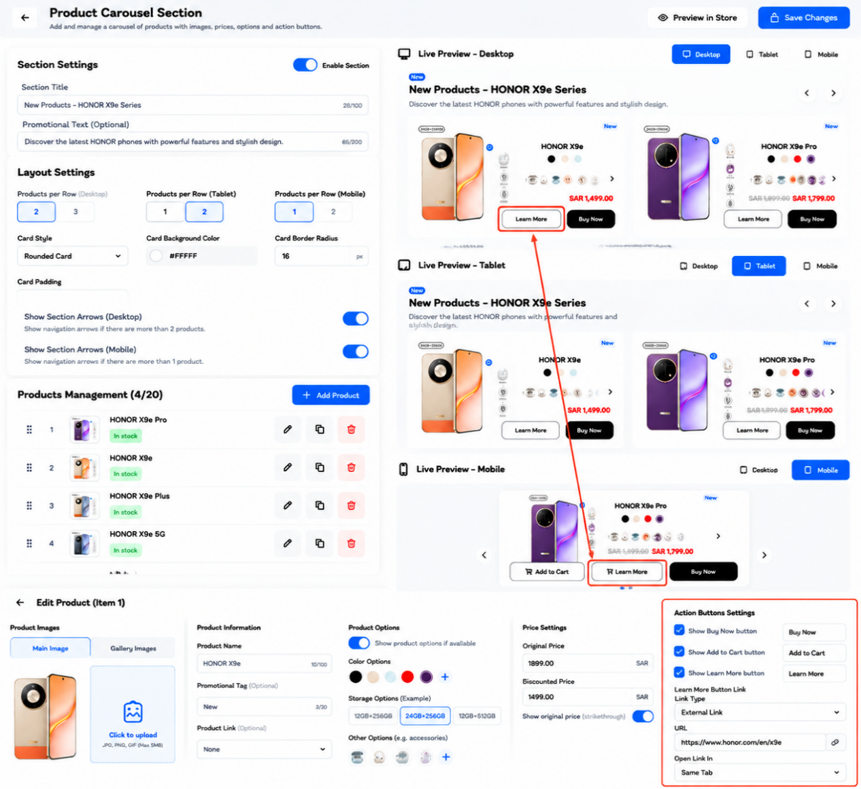
Product Carousel Section
Functional requirements, editor controls, save/publish behavior, and responsive design
Purpose: Build a configurable product carousel section for an e-commerce theme. The merchant must be able to manage section content, product cards, product options, prices, action buttons, and the destination of the “Learn More” button. The editor and storefront output must work on desktop, tablet, and mobile.

1. Section-Level Settings
Control | Purpose / Behavior | Expected Result
Enable Section (toggle) | Turns the entire product carousel on or off. | When disabled, the section is hidden from the storefront. Its saved configuration remains in the editor.
Section Title | Editable heading above the product cards. Example: “New Products – HONOR X9e Series”. | The heading updates in the live preview and storefront. Support a configurable character limit and preserve text direction for RTL languages.
Promotional Text (optional) | Optional supporting line beneath the title, used for a short promotion or description. | If empty, do not render an empty text block or extra spacing.
Preview in Store | Opens or refreshes a storefront preview using the current configuration where supported. | Preview must reflect draft edits without publishing them.
Save Changes | Validates and saves the section settings and product data. | Show saving, success, or error feedback. Do not report success until the save operation succeeds.

2. Layout Settings
Setting | Purpose / Behavior | Responsive / Acceptance Notes
Products per Row — Desktop | Controls how many product cards are visible in one row on desktop. Options shown: 2 or 3. | Apply to desktop breakpoint only; keep cards readable and avoid overflow.
Products per Row — Tablet | Controls the tablet card count. Options shown: 1 or 2. | Use tablet-specific value rather than inheriting the desktop count when explicitly configured.
Products per Row — Mobile | Controls the mobile card count. Options shown: 1 or 2. | At narrow widths, default to one card when two cards would make content cramped.
Card Style | Selects the product-card appearance, e.g. rounded card. | Apply consistently to every card in the section.
Card Background Color | Sets the background color of product cards. | Use a color picker and persist a valid color value, such as HEX.
Card Border Radius | Sets the roundness of card corners in pixels. | Apply the same radius to card backgrounds and clipped media where appropriate.
Card Padding | Controls internal spacing between card edges and content. | Ensure titles, prices, option selectors, and buttons remain comfortably spaced.
Show Section Arrows (Desktop) | Enables/disables carousel navigation arrows on desktop. | If enabled, show arrows when navigation is useful; do not show non-functional arrows.
Show Section Arrows (Mobile) | Enables/disables carousel navigation arrows on mobile. | Arrows must be touch-friendly and must not cover key product information.

3. Product Management
- Products Management counter (e.g. 4/20): shows the number of products currently added and the maximum allowed in the section. Enforce the configured limit.
- Add Product: opens a product picker or editor and adds a selected product without replacing existing products.
- Drag handle / reorder: lets the merchant change product order. The saved order controls the carousel sequence.
- Edit product: opens the selected product’s editable fields.
- Duplicate product: creates a separate carousel entry based on the selected item. Avoid sharing mutable fields unintentionally.
- Delete product: removes the item from this section after confirmation. Other products and their settings remain unchanged.
- Stock indicator: show availability status when inventory data is available. Treat this as informational unless the theme has a defined stock-state behavior.
- If a product is deleted from the store or becomes unavailable, handle it gracefully and avoid broken images or dead buttons.

4. Product Editor — Images and Information
Field / Control | Purpose | Behavior after saving
Main Image | Selects the primary product image used in the card. | Display a correctly sized image with a consistent aspect ratio. Use a suitable fallback if the image fails to load.
Gallery Images | Allows additional product images when supported by the design. | If the design supports image switching, allow the customer to view gallery images without changing the product itself.
Click to upload | Uploads/selects an image from the store’s supported media library. | Validate supported file types and size; show upload progress and errors.
Product Name | Editable display name for the card. | Render the name without clipping; allow line wrapping within the card.
Promotional Tag (optional) | Short badge such as “New”, “Sale”, or “Special Offer”. | Hide the badge when empty. Use accessible contrast and prevent overlap with the image.
Product Link (optional) | Optional product destination override if the theme supports linking the card or image. | When configured, the relevant card element opens the selected product or URL. Keep this separate from the Learn More button URL.

5. Product Options
- Show product options if available: when enabled and the product has variants/options, display the relevant choices on the card; when disabled, hide the option controls.
- Color options: display available color swatches. Selecting a swatch should update the selected variant and, where product data supports it, update the image and price.
- Storage / specification options: display available values such as storage or capacity. Only show options that exist for the selected product.
- Other options (e.g. accessories): show supported variant or add-on options only when configured in product data.
- Option controls must be keyboard-accessible, have clear selected states, and remain usable on touch devices.
- Do not invent product variants. Read actual available options from the product data source.

6. Price Settings
Field | Purpose | Expected behavior
Original Price | The regular/list price before discount. | Display only if enabled and valid. If a discounted price is also present, optionally strike through the original price.
Discounted Price | The current selling price when the product is discounted. | Use this as the active displayed price when valid. Ensure currency formatting is consistent.
Show original price (strikethrough) | Controls whether the original price is displayed with a strikethrough. | If disabled, hide the original price but keep the discounted price visible.
Currency | The currency label or store currency, e.g. SAR. | Use the store’s configured currency and locale formatting; do not hard-code SAR if the store supports other currencies.

7. Action Button Settings
Each action button must be configurable independently. The enabled state, button label, and destination behavior must be stored per section or product according to the implementation.
Button | Settings | Behavior
Buy Now | Show/hide toggle and editable label. | When enabled, route the customer to the configured purchase flow for the selected product/variant. If the platform has a standard checkout flow, use it rather than a hard-coded URL.
Add to Cart | Show/hide toggle and editable label. | When enabled, add the selected product/variant to the cart using the store’s cart mechanism and provide clear success/error feedback.
Learn More | Show/hide toggle and editable label. | When enabled, display the button and use the configurable link settings below to determine its destination.

8. Learn More Button — Link Configuration
This is a required configuration area. The Learn More button must support a destination separate from Buy Now and Add to Cart.
Control | Requirement
Show Learn More button | Enables or hides the Learn More button.
Button Text | Editable label shown to customers, e.g. “Learn More” or “View Details”.
Link Type | Provide supported destination types such as Product, Collection/Category, Store Page, and External URL. “None” may be available to disable navigation.
Target selector | When the selected link type is internal, show the relevant product, collection/category, or page picker.
URL field | When External URL is selected, show a URL input and validate that the URL is well-formed. Support https:// links.
Open Link In | Allow “Same Tab” or “New Tab”. If “New Tab” is chosen, use safe link attributes (e.g. rel=noopener) where applicable.
Link preview / validation | Optionally provide a test/open link action and display a clear validation error for invalid or missing destinations.
Live preview | Clicking Learn More in the editor preview should use the configured destination when preview interactions are supported. Do not navigate away unexpectedly while editing.

9. Responsive Preview and Storefront Behavior
- Provide preview modes for Desktop, Tablet, and Mobile. Switching preview mode changes the preview viewport only; it must not change or reset the saved settings.
- Desktop: use the configured desktop product count and section-arrow setting. Maintain balanced card proportions and comfortable button spacing.
- Tablet: use the configured tablet product count. Reflow controls and cards to prevent horizontal overflow.
- Mobile: use the configured mobile product count, stack content when necessary, and ensure product options and buttons remain readable and tappable.
- The preview should update as fields are edited, before the merchant saves.
- Use responsive CSS breakpoints and a single component implementation rather than separate duplicated components for each device.
- Prevent page-level horizontal scrolling. If the carousel itself scrolls horizontally, confine scrolling to the carousel and provide clear navigation cues.
- Support both left-to-right and right-to-left languages where the theme supports localization. Ensure arrow direction, text alignment, and currency display are correct for the active locale.
- Use accessible labels, keyboard focus states, meaningful image alt text, and sufficient color contrast.

10. Validation, Saving, and Publishing Workflow
- Merchant edits the section title, promotional text, layout, product list, product details, prices, options, or button settings.
- The editor updates the live preview immediately where possible. Draft preview changes do not automatically mean the live storefront has changed.
- On Save Changes, validate required values, product references, prices, option data, button labels, and Learn More destination settings.
- If validation fails, keep the editor values intact, identify the affected field, and show an actionable error message.
- If validation succeeds, persist the section configuration and product ordering to the theme’s designated settings/data store.
- Show a loading state during saving and a success confirmation only after the save operation completes successfully.
- If the platform separates saving from publishing, apply the saved configuration to the live storefront only after the required publish action.
- After saving, reloading the editor must restore the saved values, product order, enabled states, layout settings, prices, options, and button destinations.
- If saving fails, preserve unsaved changes and offer a retry; do not silently discard user input.

11. Acceptance Criteria
- The section can be enabled or disabled without deleting its configuration.
- Title and promotional text are editable and reflected in preview and storefront.
- Desktop, tablet, and mobile product counts are independent and work at the correct breakpoints.
- Products can be added, edited, duplicated, reordered, and deleted, respecting the configured maximum.
- Images, names, tags, product options, original prices, and discounted prices render correctly.
- Buy Now, Add to Cart, and Learn More can each be independently shown/hidden and labeled.
- Learn More supports internal destinations and external URLs, plus same-tab/new-tab behavior.
- The carousel arrows work only when enabled and when movement is possible.
- No broken images, clipped text, overlapping controls, or unintended horizontal page scrolling occur on supported screen sizes.
- Saving and reloading preserves all settings; errors are visible and do not erase unsaved changes.
- The section is usable with keyboard navigation and accessible control labels.

12. Implementation Notes
- Use the platform’s native product, variant, cart, page, and collection references wherever possible; do not hard-code product URLs or prices.
- Treat all preview content as draft until the save/publish flow confirms otherwise.
- Define sensible defaults for empty optional fields. Hide optional UI instead of rendering empty headings, badges, or buttons.
- Persist settings in a structured schema so future theme updates can add fields without breaking existing configurations.
- Confirm whether product-level button configuration overrides section-level button configuration. Document and implement one consistent precedence rule.

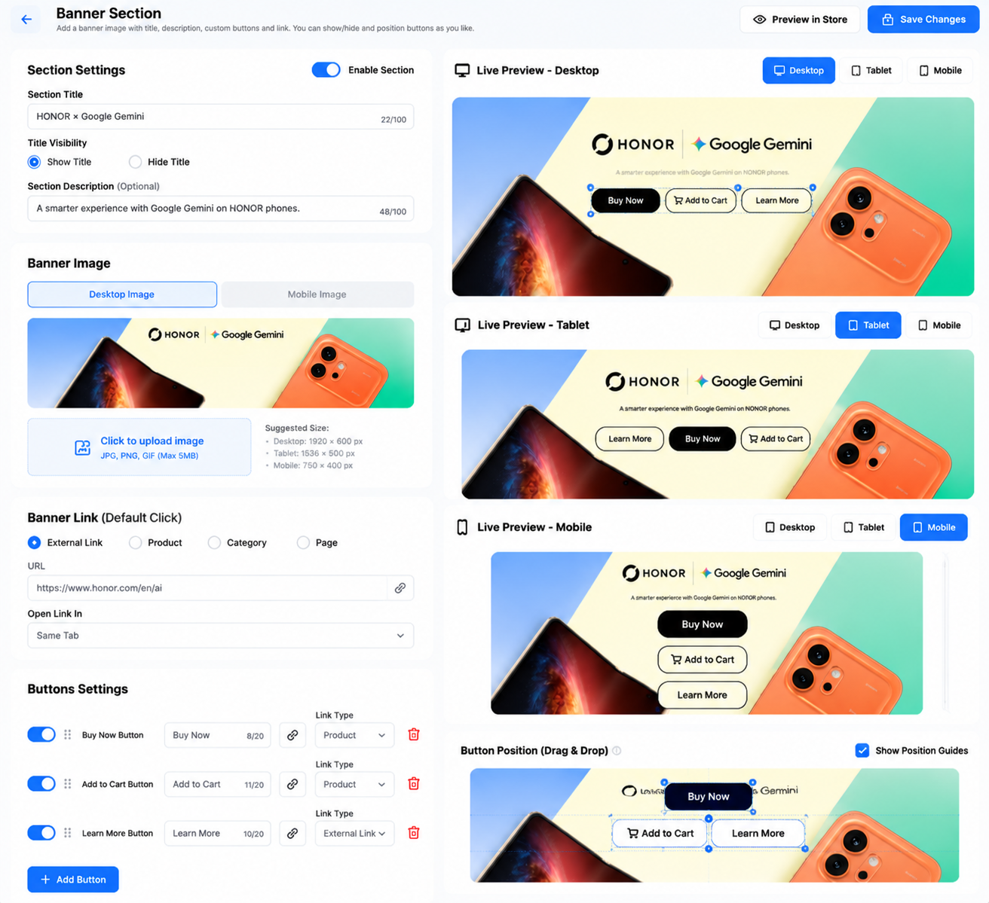

Banner Section
Functional Requirements & Responsive Behaviour
Implementation guide for a configurable storefront banner with optional section title, banner image, destination link, customizable action buttons, drag-and-drop button placement, and live previews for desktop, tablet, and mobile.
CORE REQUIREMENT
Administrators can configure the banner once, provide separate desktop and mobile artwork, choose what the banner background opens, and independently add, configure, position, or hide Buy Now, Add to Cart, and Learn More buttons. The layout must adapt to desktop, tablet, and mobile.

1. Purpose and Scope
Build an admin dashboard component named “Banner Section.” It displays a promotional banner on the storefront. The banner may contain a title, optional description, background image, and one or more action buttons. Administrators must be able to preview responsive layouts before publishing changes.
The supplied visual is a UI reference. Implement the described behaviour and use the project’s existing design system, product catalogue, category records, page records, media uploader, and save/publish flow.

2. Main Dashboard Controls
Control / Field | Purpose | Expected Behaviour
Back button | Returns to the previous admin page. | If there are unsaved edits, show a confirmation dialog before leaving.
Preview in Store | Opens a storefront preview of the current draft. | Preview should reflect unsaved form values where supported; it must not publish them.
Save Changes | Validates and persists the configuration. | Show saving state, prevent duplicate submissions, then show success or actionable errors.
Enable Section toggle | Controls whether the entire banner section is visible. | Off: hide the section on the storefront without deleting its configuration. On: render it when saved and published.
Section Title | Optional heading associated with the banner section. | Editable text with a 100-character limit. Trim surrounding whitespace.
Title Visibility | Choose Show Title or Hide Title. | When hidden, preserve the title value in admin data but do not render it publicly.
Section Description | Optional supporting text below/near the title. | Editable text with a 200-character limit. Hide the description area when empty.

3. Banner Image Management
Control / Field | Purpose | Expected Behaviour
Desktop Image tab | Uploads or selects the artwork used on larger screens. | Store the image asset ID/URL and show a thumbnail preview. Provide Replace Image and remove/change controls.
Mobile Image tab | Allows a separate crop/composition for narrow screens. | If a mobile image is set, use it on mobile. If not set, fall back to the desktop image with responsive cropping.
Image upload | Selects banner artwork from device or media library. | Support JPG/JPEG, PNG, and GIF as shown in the UI reference; enforce configured file-size limits and validate file type.
Recommended image dimensions | Helps the administrator prepare artwork. | Suggested starting points: desktop 1920 × 600 px; tablet 1536 × 500 px; mobile 750 × 400 px. These are recommendations, not mandatory fixed dimensions.
Image preview | Shows the selected image before saving. | Use object-fit/cropping rules appropriate to the preview viewport. Warn if the image is unusually small or has an unsupported format.

Responsive image rule: use a responsive image source (for example, picture/srcset or equivalent) so the correct asset is delivered for each breakpoint. Do not stretch an image out of its aspect ratio. Keep the banner’s focal subject visible and allow a configurable object-position if needed.

4. Default Banner Link
The default banner link defines the destination when a visitor clicks a non-button area of the banner. This link is optional and must not override clicks on the configured action buttons.
Control / Field | Purpose | Expected Behaviour
External Link | Opens a website URL. | Display a URL input. Validate the URL and allow only approved protocols such as HTTPS (and HTTP if the store policy permits).
Product | Links to a product detail page. | Show a product selector backed by the product catalogue; save the selected product ID.
Category | Links to a product category listing. | Show a category selector; save the selected category ID.
Page | Links to an internal content page. | Show a page selector; save the selected page ID.
Open Link In | Controls how supported links open. | Options: Same Tab and New Tab. For external links opened in a new tab, use safe rel attributes such as noopener/noreferrer.

If no destination is selected, the banner background should not behave like a link. Buttons must retain their own individual destinations and actions.

5. Action Buttons Settings
Administrators can add any combination of the following buttons. Each button is independent: it can be enabled/disabled, renamed, assigned a destination/action, reordered, and positioned over the banner.
Control / Field | Purpose | Expected Behaviour
Buy Now Button toggle | Shows or hides the Buy Now button. | When enabled, render the configured label and action. The default action should open the selected product or start the store’s existing buy-now/checkout flow.
Add to Cart Button toggle | Shows or hides the Add to Cart button. | Use the store’s existing cart API/action. Confirm success using the site’s standard cart feedback. Handle unavailable products and errors.
Learn More Button toggle | Shows or hides the Learn More button. | Navigate to its configured destination, which may be a product, category, page, or external URL.
Button label | Customizes the visible text. | Allow a short label; enforce a reasonable limit (recommended: 30 characters). If empty, use the button’s default label.
Link Type / Destination | Selects where a button leads or what action it performs. | Show the relevant selector/input for the chosen type. Do not show irrelevant destination fields.
Add Button | Adds another configurable button. | Create a new button with a default label and no destination until configured. Enforce a configurable maximum number of buttons.
Drag handle / reorder | Changes the order of buttons in the settings list. | Persist the new order after Save Changes and reflect it in the storefront where the selected layout uses ordered buttons.
Delete button | Removes a button from the banner configuration. | Ask for confirmation if appropriate. Deletion takes effect publicly only after changes are saved.

Button click handling: a button must trigger only its own action. Clicking a button must not also activate the banner background link. For Add to Cart and Buy Now, use the store’s existing product/variant selection and stock-validation logic.

6. Button Positioning (Drag & Drop)
Provide a visual positioning editor so the administrator can place buttons at the desired location on the banner image. The editor should display draggable button outlines and optional alignment guides over the image.
Control / Field | Purpose | Expected Behaviour
Position guide toggle | Shows or hides alignment guides in the editor. | Guides are admin-only and must never appear on the public storefront.
Drag-and-drop button | Moves a selected button to a desired location. | Save position using normalized coordinates (for example, x/y percentages) rather than raw screen pixels so it scales across screen sizes.
Per-device position | Allows separate positions for desktop, tablet, and mobile when needed. | If no device-specific position exists, use the general position and apply responsive layout rules. Avoid overlapping buttons on small screens.
Responsive button layout | Controls how buttons flow at different widths. | Desktop may display buttons in a row; tablet may wrap them; mobile may stack them vertically or wrap them based on available width.

Implementation recommendation: store each button’s desktop/tablet/mobile position independently when custom positioning is enabled. Provide a Reset Position action and clamp coordinates so buttons cannot be dragged completely outside the banner.

7. Live Preview: Desktop, Tablet, and Mobile
Control / Field | Purpose | Expected Behaviour
Desktop preview | Shows the banner at desktop dimensions. | Reflect desktop artwork, title visibility, description, button placement, and desktop styling.
Tablet preview | Shows the tablet layout. | Use tablet breakpoint rules and tablet-specific image/position values when provided.
Mobile preview | Shows the narrow-screen layout. | Use the mobile artwork if uploaded; otherwise use the desktop artwork with safe cropping. Stack or wrap buttons to prevent clipping.
Preview switching | Switches the preview viewport without changing saved settings. | Switching devices must not reset form values. The administrator should be able to edit a device-specific position while viewing that device.

Responsive requirements: prevent horizontal overflow; keep text readable; maintain adequate tap targets; ensure contrast over the image; and make the preview reflect the actual storefront CSS and breakpoints as closely as possible.

8. Save and Publish Workflow
- 1. Edit: The administrator changes text, images, destination links, button labels/actions, visibility, or positions.
- 2. Preview: The live preview updates as the administrator edits fields. Previewing must not publish the draft.
- 3. Validate: On Save Changes, validate required values, URLs, selected entities, image files, button configuration, and position data.
- 4. Persist: Save the complete section configuration atomically so partially saved settings are not exposed.
- 5. Confirm: Show a success message and update the saved-state indicator. If saving fails, keep the draft in the form and explain the error.
- 6. Storefront update: The published storefront uses the saved configuration after the application’s normal cache/revalidation process. Do not claim success until the server confirms the save.

9. Suggested Data Model
Use stable IDs for products, categories, and pages. Example structure (adapt names to the project’s existing conventions):
{
"enabled": true,
"title": "HONOR × Google Gemini",
"showTitle": true,
"description": "A smarter experience with Google Gemini on HONOR phones.",
"images": {
"desktop": "asset_id_or_url",
"tablet": null,
"mobile": "asset_id_or_url"
},
"backgroundLink": {
"type": "external",
"targetId": null,
"url": "https://example.com",
"openIn": "same_tab"
},
"buttons": [
{
"id": "stable-button-id",
"enabled": true,
"label": "Buy Now",
"actionType": "buy_now",
"destinationType": "product",
"targetId": "product-id",
"positions": {
"desktop": {"x": 50, "y": 42},
"tablet": {"x": 50, "y": 55},
"mobile": {"x": 50, "y": 70}
}
}
]
}

10. Validation, Accessibility, and Error Handling
- Validate character limits and required fields before saving; display errors beside the relevant field.
- Do not accept malformed URLs or unsupported link types. Ensure internal product/category/page references still exist.
- Require descriptive alternative text for meaningful banner images where the content model supports it; treat purely decorative imagery appropriately.
- Provide keyboard-accessible controls and visible focus states. Drag-and-drop positioning should have an alternative numeric/keyboard positioning method.
- Use accessible labels for icon-only controls such as remove, upload, move, and delete.
- Maintain readable text contrast. If an overlay is configured by the wider design system, allow it to protect text legibility.
- Show upload progress and clear errors for invalid file type, oversized files, or failed uploads.
- If a save request fails, do not discard the administrator’s unsaved edits.

11. Acceptance Criteria
- The entire section can be enabled or disabled without deleting its configuration.
- The title can be shown or hidden, and the optional description can be edited.
- Separate desktop and mobile banner images can be uploaded; tablet may use a dedicated image or a defined fallback.
- The banner background can link to an external URL, product, category, or page, with same-tab/new-tab behaviour where applicable.
- Buy Now, Add to Cart, and Learn More can each be independently enabled, renamed, configured, reordered, and positioned.
- A button click never triggers the banner background link as a second action.
- Desktop, tablet, and mobile previews update without losing unsaved form values.
- The public storefront layout adapts without horizontal overflow, clipped controls, or unreadable text.
- Save Changes validates and persists the complete configuration, displays success only after confirmation, and preserves edits when saving fails.
- Saved changes are reflected on the storefront according to the application’s normal publish/cache update process.

12. Recommended Responsive Defaults
Control / Field | Purpose | Expected Behaviour
Desktop | Wide banner with buttons in a row when space permits. | Use desktop image; button positions may use percentage coordinates.
Tablet | Reduce spacing and allow buttons to wrap. | Use tablet image if configured; otherwise use the desktop image with responsive cropping.
Mobile | Prioritize readable content and tap targets; stack or wrap buttons. | Use mobile image if configured; otherwise fall back to desktop image. Keep buttons within safe content bounds.

Suggested image sizes from the UI concept: Desktop 1920 × 600 px, Tablet 1536 × 500 px, Mobile 750 × 400 px. Final dimensions and file-size limits should be configurable to match the store’s performance and media standards.

13. Definition of Done
The feature is complete when the admin can configure the banner end-to-end, preview it at all three breakpoints, save without data loss, and see the expected result on the storefront. All controls must have implemented behaviour; no decorative or non-functional buttons should remain.

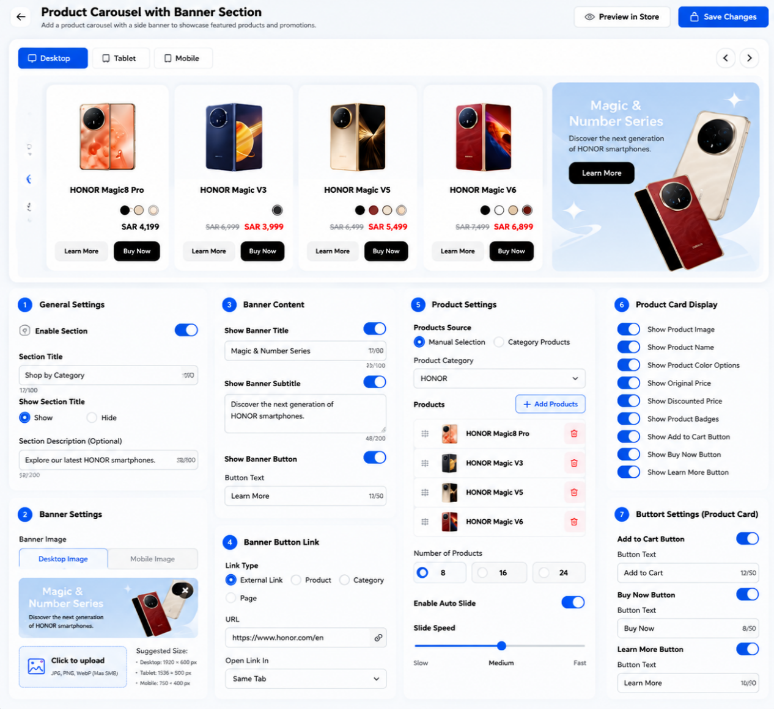

Product Carousel with Banner Section
Developer Specification — Configuration, Behaviour, Save Flow & Responsive Design
This document defines the admin controls and storefront behaviour for a section that combines a horizontally scrolling product carousel with a promotional side banner. The implementation must support desktop, tablet, and mobile layouts, with live previews for each viewport.

1. Feature Overview
The section contains two coordinated parts: (1) a product carousel showing selected products or products from a chosen category, and (2) a promotional banner with a background image, optional heading/subheading, and an optional button. The banner and product carousel must remain independently configurable.

2. Page-Level Actions and Preview
Control / Field | Purpose | Expected Behaviour
Back | Returns to the previous admin screen. | If there are unsaved changes, show a confirmation dialog before navigating away.
Preview in Store | Opens a preview of the current draft. | Preview current form values where possible; previewing must not publish or persist the draft.
Save Changes | Validates and saves the full section configuration. | Show a saving indicator; prevent duplicate submissions; report success only after server confirmation. Keep edits if saving fails.
Desktop / Tablet / Mobile preview tabs | Switch the live preview viewport. | Reflect breakpoint-specific layout, image, number of visible products, spacing, and button behaviour without clearing unsaved form values.

3. General Settings
Control / Field | Purpose | Expected Behaviour
Enable Section | Controls whether the complete section is shown on the storefront. | Off hides the section without deleting its settings. On allows it to render after saving/publishing.
Section Title | Main heading above the carousel/banner. | Editable text; suggested limit 100 characters. If title display is disabled, retain the value in admin but hide it on the storefront.
Show Section Title | Explicitly shows or hides the section heading. | When set to Hide, remove the heading space rather than leaving an empty gap.
Section Description (Optional) | Supporting sentence under the title. | Suggested limit 200 characters. Hide the description area when disabled or empty.

4. Banner Settings
Control / Field | Purpose | Expected Behaviour
Desktop Image | Banner artwork for wide screens. | Upload or select an asset; show thumbnail; allow replace/remove. Use responsive cropping without distorting the image.
Mobile Image | Alternative artwork composed for narrow screens. | Use it on mobile when provided. Otherwise fall back to the desktop image with safe cropping.
Image upload area | Selects banner media. | Support the store's approved image formats (for example JPG/JPEG, PNG, WebP, and optionally GIF). Validate file type and configured file-size limit.
Suggested image dimensions | Guidance for preparing artwork. | Recommended starting points: desktop 1920 × 600 px, tablet 1536 × 500 px, mobile 750 × 400 px. Treat these as guidance, not rigid requirements.
Show Banner Title | Controls visibility of the banner heading. | When disabled, hide the title in the storefront and preview.
Banner Title | Main promotional heading displayed on the banner. | Editable text; suggested limit 100 characters.
Show Banner Subtitle | Controls visibility of supporting banner text. | When disabled, hide subtitle and its spacing.
Banner Subtitle | Supporting banner copy. | Editable text; suggested limit 200 characters.
Show Banner Button | Controls visibility of the banner CTA. | When disabled, hide the button without deleting its label or destination.
Button Text | Custom label for the banner button. | Editable text; suggested limit 50 characters. Use a default label only if the field is empty.

5. Banner Button Link
Control / Field | Purpose | Expected Behaviour
External Link | Opens a URL outside or within the store. | Show URL field; validate URL and allow approved protocols, preferably HTTPS.
Product | Links to a product details page. | Show product selector and save the selected product ID.
Category | Links to a category listing. | Show category selector and save the selected category ID.
Page | Links to an internal content page. | Show page selector and save the selected page ID.
URL / target selector | Specifies the destination for the selected link type. | Display only the fields relevant to the selected type. Validate that the selected target still exists.
Open Link In | Selects same-tab or new-tab navigation where supported. | For new-tab external links, apply safe rel attributes such as noopener/noreferrer.

6. Product Settings
Control / Field | Purpose | Expected Behaviour
Products Source: Manual Selection | Lets the administrator curate an exact product list. | Display a product picker and selected-product list; preserve the chosen order.
Products Source: Category Products | Automatically retrieves products from a category. | Show a category selector. Apply the store's defined ordering or sorting rule to category results.
Product Category | Selects the category used when category mode is active. | Required only for category-based sourcing; hide or disable when manual selection is active.
Add Products | Opens the product picker. | Allow selecting multiple products. Prevent duplicate product IDs in the same list.
Selected product list | Shows products currently included in the carousel. | Display thumbnail, product name, and stock/status if available. Support reorder and remove.
Drag handle / ordering | Changes carousel sequence in manual mode. | Persist ordering on save. In category mode, ordering follows the configured category sorting rule.
Remove product | Removes a product from the manually selected list. | Remove only from this section; do not delete the product from the catalogue.
Number of Products: 8 / 16 / 24 | Sets the maximum number of products to render or retrieve. | Show up to the chosen number of eligible products. If fewer products exist, display only those available.
Enable Auto Slide | Automatically advances the carousel. | When enabled, advance by the configured step/interval. Pause while the user interacts or hovers where appropriate; respect reduced-motion preferences.
Slide Speed | Controls the carousel autoplay interval or animation speed. | Map Slow/Medium/Fast to documented timing values. Clearly distinguish slide interval from transition duration in implementation.
Carousel navigation arrows | Lets visitors move to previous/next products. | Show only when navigation is useful for the current viewport and content count. Buttons must be keyboard accessible.

7. Product Card Display
Control / Field | Purpose | Expected Behaviour
Show Product Image | Displays the product thumbnail. | When off, hide the image area and reflow the card.
Show Product Name | Displays the product title. | When off, hide the name without leaving an empty block.
Show Product Color Options | Displays available colour/variant swatches. | Only show if the product has selectable colour variants. Selecting a swatch updates the selected variant/image/price if the catalogue supports it.
Show Original Price | Displays the regular price, usually struck through when discounted. | Show only when a valid original price exists and the option is enabled.
Show Discounted Price | Displays the active sale price. | Use the actual current price from the catalogue; do not calculate a fake discount.
Show Product Badges | Displays labels such as New or Sale. | Render only valid configured/catalogue badges.
Show Add to Cart Button | Shows the cart action on each product card. | Use the existing cart workflow and display success/error feedback.
Show Buy Now Button | Shows the immediate purchase action. | Use the store's existing buy-now/checkout flow and validate product availability.
Show Learn More Button | Shows a product-details CTA. | Navigate to the product detail page or its configured destination.

8. Product Card Button Settings
Control / Field | Purpose | Expected Behaviour
Add to Cart toggle | Enables/disables the card-level Add to Cart button. | When enabled, show its label field and use the configured cart action.
Add to Cart Button Text | Customizes the label. | Suggested limit 50 characters; use a sensible default if blank.
Buy Now toggle | Enables/disables the card-level Buy Now button. | When enabled, show its label field and use the existing checkout workflow.
Buy Now Button Text | Customizes the label. | Suggested limit 50 characters.
Learn More toggle | Enables/disables the card-level Learn More button. | When enabled, show its label and destination controls if configurable.
Learn More Button Text | Customizes the label. | Suggested limit 50 characters.

9. Responsive Behaviour
Control / Field | Purpose | Expected Behaviour
Desktop | Show several product cards beside the banner. | Use a wide horizontal layout. Keep banner proportions and readable product cards; show navigation arrows when content overflows.
Tablet | Reduce card widths and adjust the banner/product ratio. | Use tablet-specific layout rules; wrap or reduce visible cards rather than causing horizontal page overflow.
Mobile | Prioritize one or a small number of product cards at a time. | Use mobile artwork if provided. The carousel can swipe horizontally; keep tap targets large and avoid clipped prices/buttons.
Breakpoint preview | Shows the actual responsive design at each viewport. | Preview must use the same layout logic as the storefront and retain unsaved values when switching devices.
Accessibility and motion | Makes the carousel usable for all visitors. | Support keyboard navigation, visible focus, accessible labels, and reduced-motion settings. Autoplay should not prevent manual navigation.

10. What Happens After Save Changes
- Validate: Check text limits, required category/product selections, image uploads, link destinations, and button configuration.
- Save atomically: Persist the section settings, banner assets, link targets, product source, product order, display toggles, and autoplay settings together.
- Confirm to the administrator: Show success only after the backend confirms persistence. Keep the draft visible and show actionable errors if saving fails.
- Update storefront: The published storefront renders the new configuration using the saved responsive settings after the normal cache/revalidation process.
- Preserve catalogue integrity: Removing a product from this carousel must not delete or modify the product record itself.

11. Suggested Configuration Model
{
"enabled": true,
"sectionTitle": "Shop by Category",
"showSectionTitle": true,
"sectionDescription": "Explore our latest HONOR smartphones.",
"banner": {
"desktopImage": "asset_id_or_url",
"mobileImage": "asset_id_or_url",
"showTitle": true,
"title": "Magic & Number Series",
"showSubtitle": true,
"subtitle": "Discover the next generation of HONOR smartphones.",
"showButton": true,
"buttonText": "Learn More",
"link": {
"type": "external",
"url": "https://example.com",
"targetId": null,
"openIn": "same_tab"
}
},
"products": {
"source": "manual",
"categoryId": null,
"productIds": ["product-1", "product-2"],
"limit": 8,
"autoSlide": true,
"slideSpeed": "medium"
},
"cardDisplay": {
"image": true,
"name": true,
"colorOptions": true,
"originalPrice": true,
"discountedPrice": true,
"badges": true,
"addToCart": true,
"buyNow": true,
"learnMore": true
}
}

12. Validation and Error Handling
- Reject invalid URLs and missing required targets for Product, Category, and Page link types.
- Handle deleted, unpublished, or unavailable products gracefully; skip invalid products and show a useful admin warning.
- Validate image type and size and display upload progress and failure reasons.
- Prevent duplicate product entries and enforce the selected product limit.
- If saving fails, preserve all current form inputs and show a retry option.
- Avoid layout shifts and horizontal overflow at supported viewport sizes.
- Do not show original price without a valid original price, or variant swatches when variants do not exist.
- Use accessible names for icon-only controls such as reorder, edit, remove, previous, and next.

13. Acceptance Criteria
- The administrator can enable/disable the section and edit/hide its title and description.
- The administrator can upload desktop and mobile banner images and preview the result.
- The banner can be linked to an external URL, product, category, or page.
- The administrator can select products manually or pull them from a category.
- The administrator can set the product count to 8, 16, or 24 and enable/disable autoplay.
- Product image, name, colour options, prices, badges, and action buttons can be independently shown or hidden.
- Product card buttons use the store's existing cart, checkout, and product-page logic.
- Desktop, tablet, and mobile previews accurately reflect the public storefront layout.
- Save Changes validates, persists, and reports the result without losing unsaved work on error.

14. Definition of Done
The feature is complete when all controls are functional, the product carousel and promotional banner render correctly on desktop/tablet/mobile, the admin preview matches the storefront, and saved settings persist reliably. No visible control should be decorative or non-functional.

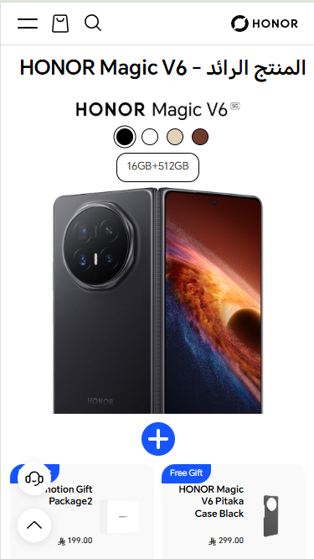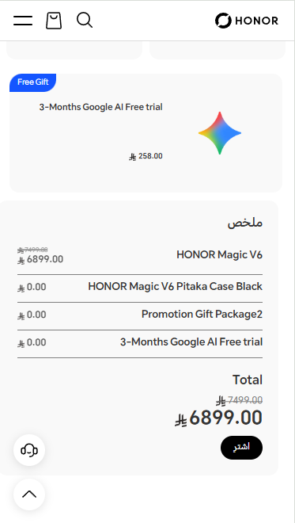
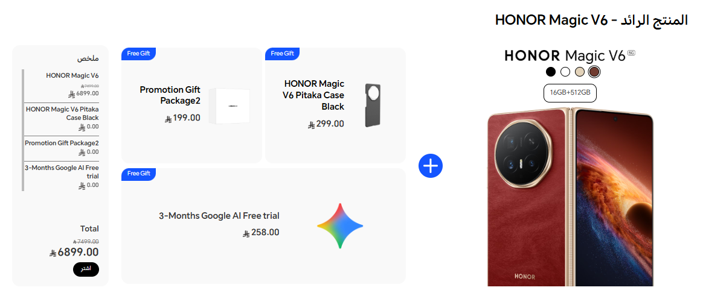
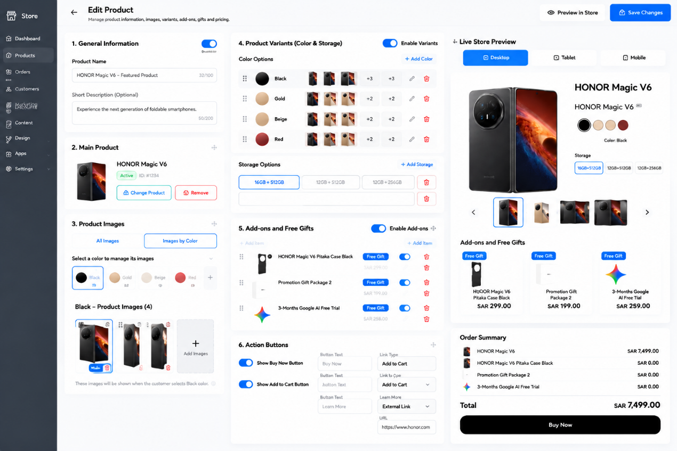

EDIT PRODUCT
Developer Functional Specification
Color-linked product images, variants, storage options, add-ons, action buttons, and live preview

Document field | Specification
Target user | Store administrator / content manager
Primary entity | Product (example shown: HONOR Magic V6)
Supported layouts | Desktop, tablet, and mobile
Primary workflow | Edit product → preview → validate → save → publish updated storefront data
Important behavior | Selecting a color on the storefront must display only the image gallery associated with that color.

1. Purpose and Scope
Build an editable product-management screen that allows an administrator to maintain product details, the main product, color-specific image galleries, storage variants, add-ons/free gifts, pricing, purchase actions, and a live preview. The screen must support desktop, tablet, and mobile without losing any functionality.
- The reference layout is a functional admin dashboard, not a static image.
- All buttons, toggles, dropdowns, upload controls, drag handles, and preview selectors must be interactive.
- Use persistent database records and media URLs; do not save the dashboard configuration only in browser state.
- The example product and prices in the reference are sample content. Do not hard-code them as permanent values.

2. Global Header and Navigation
Element | Purpose / behavior | After save
Back arrow | Returns to the previous admin page. If there are unsaved edits, show a confirmation dialog. | No data is saved by navigating back unless autosave is explicitly implemented.
Page title: Edit Product | Identifies the current editor. | Static label.
Subtitle | Briefly explains that product information, images, variants, add-ons, and pricing can be managed. | Static helper text.
Preview in Store | Opens the product page or storefront preview in a new tab or preview mode. | Preview must reflect saved data; optionally provide a draft preview for unsaved changes.
Save Changes | Validates the form and persists all changed fields, relationships, image order, and settings. | Show loading state, success confirmation, and updated preview. On error, keep entered data and show actionable messages.
Admin sidebar | Links to Dashboard, Products, Orders, Customers, Marketing, Content, Design, Apps, and Settings. | Navigation only; current section should be highlighted.

3. General Information
Field / control | Function | Rules and expected result
Enable Product toggle | Controls whether the product is active and available on the storefront. | Off: product is hidden or unavailable according to store rules. On: product can be displayed, subject to publication and inventory rules.
Product Name | Editable product title shown in the product page, cards, cart, and order summary. | Required. Enforce configured character limit (reference suggests 100). Trim whitespace and escape output.
Short Description (optional) | Short product summary used where supported by the product page and cards. | Optional; enforce configured character limit (reference suggests 200). Preserve intended line breaks where supported.

4. Main Product Selector
Element | Function | Expected behavior
Main product thumbnail and name | Shows the currently linked primary product. | Display the selected product's image and title from the product catalogue.
Change Product | Opens a product selector/search dialog. | Selecting a different product updates the primary product reference and its linked data. Confirm before replacing if dependent settings may be lost.
Remove | Clears the selected primary product. | Require confirmation. If the main product is mandatory, disable Save until a valid product is selected.
Drag/reorder handle (if enabled) | Allows the admin to change order when the design supports multiple primary items. | Persist the order after Save.

5. Product Images and Color-linked Galleries
This is a critical feature. Each color variant must have its own image gallery. The storefront image gallery must follow the selected color variant rather than showing unrelated images from other colors.
Control | Function | Required behavior
All Images tab | Shows all images attached to the product, regardless of color. | Useful for reviewing the complete media library. It must not override color-specific gallery relationships.
Images by Color tab | Switches to color-based image management. | Selecting a color filters the gallery to that color's images.
Color selector | Lets the administrator choose which color gallery to edit. | Show each configured color with its swatch and label. Provide an Add Color action.
Color-specific image list | Displays images assigned to the selected color. | Each image record stores its product ID, color/variant ID, image URL, sort order, and whether it is the primary image.
Add Images / Upload | Uploads one or more images for the selected color. | Validate file type and size; accept configured formats such as JPG, PNG, and WebP. Show upload progress and errors.
Set as main image | Sets the primary image for the selected color. | Only one primary image per color should be active. If none is selected, use the first valid image as a fallback.
Reorder images | Changes the sequence of gallery thumbnails. | Persist the sort order; storefront gallery follows this order.
Remove image | Removes the image from the selected color gallery. | Ask for confirmation. If removing the primary image, automatically select another image or show a validation warning.
Color image mapping hint | Explains that images will appear when the customer selects the matching color. | Show this hint in the admin interface to prevent incorrect assignments.

5.1 Storefront Color-selection Logic
- When the product page opens, load the default color and its associated image gallery.
- When a customer selects a different color, update the selected color state.
- Replace the main image and thumbnail gallery with images mapped to that color ID.
- Keep the selected storage option only if it is available for the newly selected color; otherwise select a valid available option or require the customer to choose one.
- Update availability, price, SKU, and add-to-cart payload if those values differ by variant.
- If the selected color has no images, use a configured fallback image and flag the missing gallery in the admin dashboard.

6. Product Variants: Color and Storage
Element | Function | Validation / behavior
Enable Variants toggle | Enables or disables color and storage options on the product page. | When disabled, hide variant selectors on the storefront and use the default product variant. Do not delete variant data merely by turning this off.
Add Color | Creates a new color variant. | Fields should include color name, swatch value, optional image, SKU/variant identifier, availability, and optional variant-specific price.
Color swatch | Represents the color visually in admin and storefront. | Allow a color picker and/or hex value. Provide a label for accessibility; do not rely on color alone.
Color image thumbnails | Shows images currently linked to a color. | Selecting a thumbnail or color opens the corresponding gallery for editing.
Edit color | Updates the color name, swatch, or associated variant details. | Changing the display name must not break image relationships; use stable variant IDs.
Delete color | Removes a color variant. | Confirm deletion and check whether orders or inventory reference it. Avoid deleting historical order data.
Add Storage | Creates a storage/capacity option such as 16GB + 512GB or 12GB + 256GB. | Storage options may be global or scoped to a specific color/variant, depending on the store's catalogue model.
Storage option field | Defines the visible storage label. | Prevent duplicate options for the same variant and validate that a selectable variant exists.
Delete storage option | Removes a storage choice from sale. | Confirm before deletion. Preserve historical order references.

7. Add-ons and Free Gifts
Element | Function | Expected behavior
Enable Add-ons toggle | Controls whether related add-ons and gifts are displayed with the product. | Off hides the add-ons area but should preserve configured records.
Add Item | Opens a selector to add an existing product or a custom add-on/gift item. | Support product selection, custom item where permitted, and gift designation.
Item thumbnail and name | Identifies the add-on or gift. | Use the selected catalogue item's image and title where applicable.
Free Gift label | Marks an item as a free gift. | A free gift must have a clearly defined price rule, such as zero price when qualifying conditions are met. Do not infer that a normal paid add-on is free.
Item enable toggle | Controls whether that add-on is available to customers. | Disabled items are not shown or selectable on the storefront.
Item price | Shows or edits the add-on price when the data model allows it. | Use the configured currency and pricing rules. Recalculate totals on the server.
Reorder handle | Changes the display order of add-ons/gifts. | Persist ordering after Save.
Delete item | Removes the item from this product's add-on list. | Require confirmation; do not delete the underlying catalogue product.

8. Action Buttons
Control | Function | Expected behavior
Show Buy Now Button | Shows or hides the direct purchase action. | When enabled, Buy Now validates the selected variant and proceeds to checkout using the selected product configuration.
Buy Now button text | Customizes the visible label. | Use the saved text in the storefront. Fall back to a default translation if blank.
Show Add to Cart Button | Shows or hides the cart action. | When enabled, add the selected variant and any chosen add-ons/gifts to the cart. Show success/error feedback.
Add to Cart button text | Customizes the cart action label. | Use saved text and support localization.
Show Learn More Button | Shows or hides the additional-information action. | When enabled, render the button using the selected link destination.
Learn More link type | Chooses the destination type, such as Product Page, Page, Category, or External Link. | Show the appropriate destination selector based on link type.
Destination / URL | Specifies the selected product/page/category or an external URL. | Validate that internal references exist and external URLs use an allowed protocol, normally HTTPS.
Open link in | Controls whether a destination opens in the same tab or a new tab. | For new tabs, use safe link attributes. For internal checkout/cart actions, follow the store's normal navigation behavior.

9. Pricing and Order Summary
The reference preview includes an order summary with the main product, add-ons/gifts, and total. If price editing is not available in the visible controls, the summary should still read the current catalogue prices rather than hard-coding sample values.
- Display the correct currency and localized number format.
- If original and discounted prices are configured, show the original price with a strikethrough and the discounted price as the current price.
- Calculate totals from the selected variant and selected add-ons using authoritative server-side pricing.
- Do not count a free gift as a paid item unless a promotion rule explicitly says otherwise.
- Do not trust client-side totals when creating a cart or checkout session; recalculate on the server.

10. Live Store Preview
Preview control | Function | Expected behavior
Desktop / Tablet / Mobile tabs | Switches the preview viewport. | Update the preview to the corresponding responsive layout without changing saved content.
Product title and image | Displays the current product information. | Reflect current edits when draft/live preview mode is active.
Color swatches | Simulates customer color selection. | Selecting a swatch updates the main image, gallery, available storage, and relevant variant data.
Storage selector | Simulates choosing a storage option. | Unavailable options must be disabled or clearly marked.
Gallery thumbnails and arrows | Navigate product images. | Show only images belonging to the currently selected color.
Add-ons and gifts | Shows configured related items. | Reflect enabled status, price/gift labels, and order.
Action buttons | Preview the configured purchase actions. | In preview mode, avoid placing real orders. Use safe test behavior or clearly mark preview-only interactions.
Order Summary | Shows product and selected add-on lines plus total. | Recalculate when the preview selection changes; label it as preview data if no live cart is created.

11. Responsive Requirements: Desktop, Tablet, and Mobile
Device | Recommended layout | Behavior and interaction
Desktop (≥ 1200 px) | Three main zones where space permits: admin navigation, editing panels, and live preview. Product editing panels can use two columns. | Keep section headings visible, allow drag-and-drop, use side-by-side fields, and maintain a readable preview.
Tablet (768–1199 px) | Collapse the sidebar or make it compact. Use a two-column editor when practical; place preview below or in a collapsible panel if width is limited. | Controls remain touch-friendly. Avoid horizontal overflow; preview tabs remain available.
Mobile (< 768 px) | Single-column stacked sections. Use a compact top bar and collapsible groups. Preview can be opened as a dedicated tab or drawer. | Use large touch targets, full-width fields, accessible upload controls, and clear save feedback. Reorder items with touch-friendly drag handles or move-up/down controls.
All devices | Responsive CSS grid/flex layout with consistent spacing and accessible labels. | Persist the same underlying data across viewports. Switching preview size must never reset or save form values by itself.

Suggested responsive breakpoints: mobile below 768 px, tablet from 768 px to 1199 px, and desktop at 1200 px and above. Treat these as starting values and adjust based on the existing design system.

12. Save Changes: End-to-end Workflow
- The administrator edits one or more fields, uploads images, assigns images to colors, changes variant options, or updates add-ons and buttons.
- The live preview updates immediately from the current draft state where feasible.
- When Save Changes is clicked, disable repeated submissions and show a loading state.
- Validate required fields, image mappings, duplicate variants, link destinations, prices, and any required default color/storage selections.
- Upload pending media and obtain persistent media URLs before saving references.
- Save the product fields and related records (colors, storage variants, image mappings, add-ons, button settings, and sort order) in a consistent transaction or equivalent safe workflow.
- Return success only after persistence completes. Show a confirmation message and update the saved-state indicator.
- Refresh the preview from the saved data and ensure the storefront reads the same configuration.
- If saving fails, preserve the user's unsaved input, explain the failure, and allow retry. Do not display a false success message.

13. Suggested Data Model
Entity | Important fields (illustrative) | Relationship / purpose
Product | id, name, short_description, is_enabled, default_variant_id | Core product record.
ProductVariant | id, product_id, color_id, storage_id, sku, price, sale_price, stock_status, is_enabled | Represents a purchasable combination when variants affect price, inventory, or SKU.
ProductColor | id, product_id, name, hex_value, swatch_image_url, sort_order, is_enabled | Stable color identity and storefront swatch.
ProductImage | id, product_id, color_id, media_url, alt_text, sort_order, is_primary | Maps each image to a product and optionally to a specific color.
StorageOption | id, product_id, label, sort_order, is_enabled | Defines selectable storage/capacity options.
ProductAddon | id, product_id, linked_product_id, title_override, price_rule, is_free_gift, is_enabled, sort_order | Related paid items and gifts.
ProductActionSettings | product_id, buy_now_enabled, buy_now_text, add_to_cart_enabled, add_to_cart_text, learn_more_enabled, link_type, destination | Controls product-page action buttons.
ProductMediaSettings | product_id, gallery_mode, fallback_image_id | Optional settings for gallery behavior and missing-image fallback.

Implementation note: the schema above is illustrative. Align it with the existing catalogue and inventory model. Use stable IDs and foreign keys; do not use a color name as the only relationship key.

14. Validation, Accessibility, and Error Handling
- Provide accessible labels for every input, color swatch, icon-only button, and image upload control.
- Provide alt text for product images; use meaningful fallback text where appropriate.
- Use keyboard-accessible alternatives for drag-and-drop ordering.
- Confirm destructive actions such as deleting a color, image, storage option, or add-on.
- Prevent invalid or unsafe external URLs and sanitize all user-provided text.
- Show field-level validation messages and a concise summary when Save fails.
- Use consistent loading, success, warning, and error states.
- Do not lose edits when switching between desktop, tablet, and mobile preview.
- Ensure the page works with RTL storefront content where required, while keeping this admin interface's layout readable in English.

15. Acceptance Criteria / QA Checklist
- ☐ Admin can edit product name and short description, then save and reload without losing changes.
- ☐ Admin can add, rename, reorder, and remove color variants subject to validation.
- ☐ Admin can upload multiple images and assign each image to a specific color.
- ☐ Selecting a color on the storefront displays only that color's gallery and primary image.
- ☐ Changing color updates variant availability and storage choices correctly.
- ☐ Admin can add, reorder, enable/disable, and remove storage options.
- ☐ Admin can configure paid add-ons and free gifts without confusing their pricing rules.
- ☐ Buy Now, Add to Cart, and Learn More can each be independently enabled or disabled.
- ☐ Learn More supports internal product/page/category destinations and validated external URLs.
- ☐ Live preview supports desktop, tablet, and mobile and reflects draft edits.
- ☐ The editor has no horizontal overflow on mobile and all controls are usable by touch.
- ☐ Save persists all related settings and displays success only after the server confirms the save.
- ☐ A failed save preserves unsaved edits and displays a useful error message.
- ☐ Storefront and cart totals are calculated using authoritative pricing and variant data.

16. Recommended Implementation Priority
Priority | Workstream | Reason
P0 — Required | Product data, color variants, image-to-color mapping, save/load, responsive layouts | Core functionality and the key requirement.
P1 — Required | Storage variants, product preview, button settings, validation and error handling | Completes the product-editing workflow.
P1 — Required | Add-ons/free gifts and correct pricing behavior | Prevents incorrect cart and order totals.
P2 — Recommended | Drag-and-drop polish, advanced preview interactions, helpful empty states | Improves admin usability.
P2 — Recommended | Audit trail/version history for high-impact edits | Helps recover from accidental configuration changes.

Final Developer Note
The most important functional requirement is the relationship between a selected color variant and its image gallery. Storefront color selection must update images and any dependent variant data immediately. The admin must be able to manage that relationship clearly, preview it on desktop, tablet, and mobile, and save all related changes reliably.

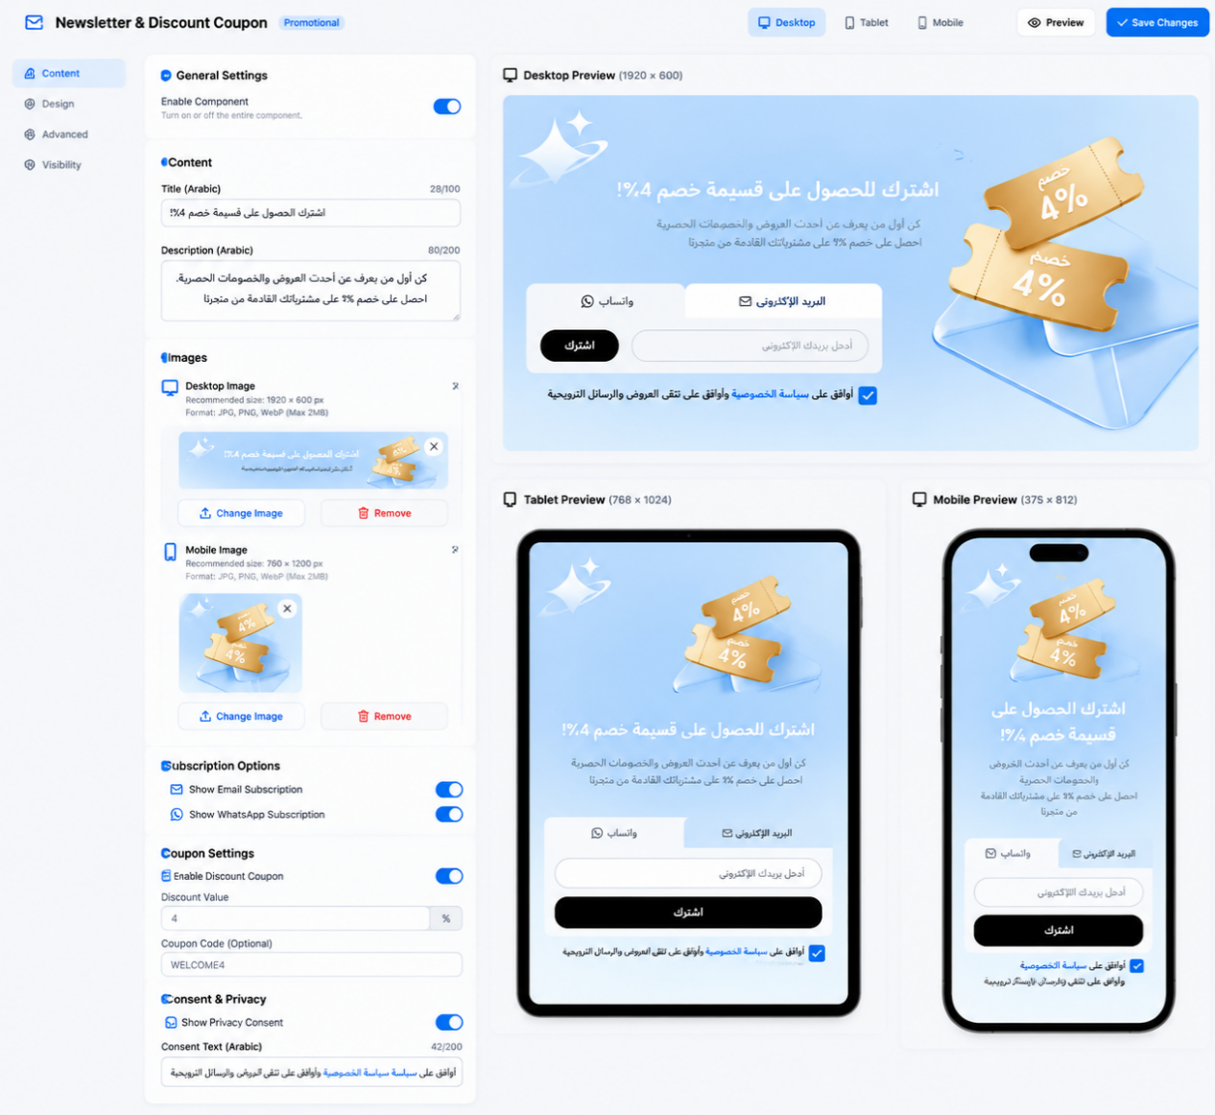

NEWSLETTER & DISCOUNT COUPON SIGN-UP
Developer Specification — Controls, Behavior, Validation, Saving, and Responsive Layout
Reference basis: the supplied screenshot showing a promotional sign-up panel offering a 4% discount coupon, with Email and WhatsApp subscription tabs, consent text, a previous-campaign link, and a subscription action.

1. Purpose and Scope
Build a configurable promotional sign-up component for the storefront. The component invites visitors to subscribe through email or WhatsApp in exchange for a 4% discount coupon. It includes a promotional headline, consent checkbox and disclosure, a previous-campaign link, channel tabs, an input field, and a Subscribe button.
Scope is limited to this sign-up component. Reuse the platform’s existing subscriber management, consent records, coupon generation, theme settings, save/publish, and storefront mechanisms wherever available. Do not add unrelated marketing automation or global store settings.

2. Component Structure and General Behavior

2.1 Promotional Panel
- Render the component as a single rounded promotional panel with a light blue background and a two-column desktop composition.
- Place the headline, consent information, campaign link, channel tabs, and form on the left; place the promotional coupon/envelope artwork on the right.
- Use the supplied artwork as a visual asset only. Do not make the image itself a clickable control unless a separate destination is configured.
- Keep text and form controls legible against the panel background. Preserve the theme’s typography, spacing, and visual identity.

2.2 Promotional Headline
Displays the primary message inviting visitors to subscribe and receive a 4% discount coupon.
- Allow the merchant to edit the headline text if the theme editor exposes content settings.
- Support Arabic and English. Apply the correct text direction for each language.
- Allow natural wrapping on narrow screens without clipping or overlapping the artwork.
- The displayed discount must match the configured coupon offer. Do not hard-code 4% if the offer is configurable.

2.3 Promotional Artwork
- Allow the merchant to select or replace the image through the existing media picker, if image settings are available.
- Preserve aspect ratio and use an appropriate contain/crop behavior so important coupon artwork is not cut off.
- Provide a fallback if the image is missing or fails to load.
- If the artwork is decorative, use empty alternative text; if it communicates offer information not present in text, provide meaningful alt text.

3. Consent and Privacy Disclosure

3.1 Consent Checkbox
The checkbox records the visitor’s affirmative consent to receive promotional communications, subject to the actual consent wording and applicable platform requirements.
- The checkbox must be independently selectable and keyboard accessible.
- Do not pre-check the box by default unless the applicable consent policy explicitly permits it.
- If consent is required for subscription, prevent submission until the visitor checks the box and show a clear validation message.
- Store the consent state and relevant consent text/version with the subscription record when supported by the existing subscriber system.
- Changing tabs between Email and WhatsApp must not silently clear or fabricate consent.

3.2 Consent Text and Privacy Link
- Display the explanatory consent text beside or below the checkbox, following the reference layout.
- Allow the disclosure to wrap across multiple lines and remain readable on mobile.
- The privacy-policy link must navigate to a valid configured privacy page or URL.
- If the privacy destination is missing, do not render a broken link; show a configuration warning in the editor.
- Do not claim that consent is legally sufficient solely because the checkbox is present. The store owner must configure wording appropriate to their policies and jurisdictions.

4. Subscription Channel Tabs

4.1 Email Tab
- Selecting Email activates the email subscription form and visually marks the Email tab as selected.
- Show an email input with an appropriate email placeholder or accessible label, plus the Subscribe action.
- Validate the address format before submission and trim leading/trailing whitespace.
- If the visitor switches away from Email and later returns, preserve the entered value during the current form session where practical.

4.2 WhatsApp Tab
- Selecting WhatsApp activates the WhatsApp subscription flow and visually marks the WhatsApp tab as selected.
- Collect the phone number using the store’s supported country-code and phone-number conventions.
- Validate the number before submission and normalize it into the format required by the existing subscriber/WhatsApp integration.
- Do not treat a phone number as subscribed unless the configured backend or integration confirms the operation.
- If WhatsApp subscription is not configured, disable the tab or show a clear setup warning in the theme editor rather than presenting a nonfunctional form.

4.3 Tab State and Accessibility
- Only one channel may be active at a time.
- Expose the selected state accessibly and support keyboard navigation.
- Switching tabs changes the input and its validation rules without changing the promotional offer.
- The active tab styling must remain distinguishable without relying on color alone.

5. Subscription Input and Subscribe Button

5.1 Input Field
- Display the input appropriate to the selected channel: email address for Email, phone number for WhatsApp.
- Use an accessible label even if the visual design relies on a placeholder.
- Support right-to-left page layout while keeping email addresses and phone numbers readable in their natural input direction where necessary.
- Do not discard the visitor’s input after a validation error.

5.2 Subscribe Button
- Submit the active channel’s form only.
- Validate required fields and consent before sending the request.
- Prevent duplicate submissions while a request is in progress; show a loading state and disable repeated activation.
- On success, show a clear confirmation message and deliver or make available the coupon according to the configured coupon workflow.
- On failure, preserve the input and show a useful error message without exposing internal technical details.
- Do not display a success state or claim a coupon was issued until the backend confirms the relevant operation.

5.3 Coupon Issuance
- The 4% offer shown in the component is promotional information; it does not itself create or apply a discount.
- Connect the subscription success event to the existing coupon or discount mechanism.
- Define whether the coupon is unique per subscriber or shared, its expiry, usage limit, eligibility, and delivery channel in the existing promotion configuration.
- If no coupon mechanism is connected, show only the configured sign-up confirmation and do not imply that a valid coupon has been generated.
- Avoid issuing duplicate coupons for repeated submissions unless the promotion rules explicitly allow it.

6. Previous Campaigns Link
The reference includes a text link inviting visitors to view previous campaigns.
- Make the label editable where content settings are available.
- Navigate to a configured campaign archive or previous-campaign destination.
- Validate the destination before publishing.
- If no destination is configured, hide the link or show an editor warning; do not render a dead link.
- The link must remain visually secondary to the subscription action.

7. Theme Editor Settings
If this component is managed through the theme editor, expose only settings supported by the design and the existing platform.
- Enable/Disable Component: controls whether the component appears on the storefront. A disabled component remains configured in the editor but is not rendered live.
- Headline Text: edits the promotional headline.
- Offer Value and Label: configures the displayed discount value and wording; it must remain consistent with the actual promotion.
- Promotional Artwork: selects or replaces the image.
- Consent Text: edits the disclosure copy.
- Privacy Policy Destination: selects a valid page or URL.
- Channel Availability: enables Email and/or WhatsApp only when the corresponding subscription workflow is configured.
- Campaign Archive Label and Destination: controls the previous-campaign link.
- Button Label: edits the Subscribe action text where localization is supported.
- Colors and Styling: if exposed, accept valid color values, update preview immediately, and maintain sufficient contrast.

8. Preview, Saving, and Publishing
- The merchant edits the available component settings in the theme editor.
- The editor updates the preview to reflect current draft text, artwork, colors, channel availability, and layout.
- Validate required text, configured destinations, image references, offer values, and enabled subscription integrations.
- Save the complete component configuration using the theme platform’s existing settings mechanism.
- Show success only after saving completes. If saving fails, retain edits where possible and display a clear error.
- If saving and publishing are separate operations, apply the changes to the live storefront only after the required publish step.
- Reload the editor and verify that settings persist. Open the storefront and confirm the published component matches the saved configuration.
The screenshot does not show a dedicated theme-editor Save Changes control. Reuse the platform’s existing save/publish workflow; do not invent a separate publishing mechanism solely for this component.

9. Responsive Behavior: Desktop, Tablet, and Mobile
- Desktop: preserve the two-column layout, with form content on the left and artwork on the right.
- Tablet: reduce column spacing and artwork size as needed; keep the headline, consent text, tabs, input, and button readable.
- Mobile: stack the content and artwork or use a compact layout that preserves the form’s priority. Do not force the desktop two-column layout into a narrow viewport.
- Allow long consent text and headlines to wrap naturally. Avoid fixed heights that clip content.
- Keep input fields and buttons large enough for touch interaction.
- Prevent horizontal overflow, overlapping elements, and inaccessible controls.
- Support Arabic RTL and English LTR layouts, including appropriate tab order and alignment.
- Test at 320px, 375px, 390px, 430px, 768px, 1024px, 1440px, and 1920px viewport widths.

10. Validation, Empty States, and Error Handling
- Do not submit an empty email address or phone number.
- Reject malformed email addresses and invalid phone numbers with channel-specific messages.
- If consent is mandatory, block submission until consent is provided.
- If a required integration is unavailable, prevent a false success state and show an actionable configuration warning in the editor.
- Handle network or server errors without clearing the form.
- Prevent repeated requests while a submission is pending.
- Do not display broken privacy-policy or campaign-archive links.
- If the component is disabled, it must not appear on the storefront.
- If the coupon configuration is invalid or unavailable, do not claim that a discount has been issued.
- Use accessible validation messages and associate them with the relevant input.

11. Acceptance Criteria
- The component displays the promotional headline, consent disclosure, channel tabs, input, Subscribe button, campaign link, and artwork according to the configured settings.
- Email and WhatsApp tabs activate the correct form and validation rules.
- Only one channel is active at a time and tab selection is accessible.
- Consent is captured correctly and required consent prevents submission when unchecked.
- Invalid input is rejected with a clear message, and entered values are preserved after errors.
- The Subscribe action prevents duplicate submissions and reports success only after confirmation from the relevant system.
- Coupon issuance is connected to a valid promotion workflow, or the interface avoids claiming that a coupon has been issued.
- Privacy and campaign links resolve to valid configured destinations.
- Preview reflects current draft settings and saved settings persist after reload.
- Changes appear on the live storefront only after the platform’s required save/publish workflow.
- The layout works on desktop, tablet, and mobile without clipping, overlap, or unintended horizontal scrolling.
- Arabic and English content render with appropriate RTL/LTR behavior.
- The component does not modify unrelated theme sections or global store settings.

12. Implementation Notes and Items to Confirm
- Confirm the source of the 4% discount and whether the offer is fixed or configurable.
- Confirm whether Email and WhatsApp subscriptions use existing integrations and what constitutes a successful subscription for each channel.
- Confirm whether the coupon is generated automatically, delivered by email/WhatsApp, shown on-screen, or made available through another existing flow.
- Confirm the exact consent wording, privacy-policy destination, and required consent-record fields.
- Confirm the destination and behavior of the previous-campaigns link.
- Confirm whether the artwork and visual styles are editable in the theme editor or fixed by the design.

13. Final Implementation Goal
Deliver a reliable, responsive subscription component that allows storefront visitors to subscribe through Email or WhatsApp and receive the configured 4% promotional offer when the underlying coupon workflow supports it. The component must provide clear consent handling, accurate validation, accessible controls, synchronized preview behavior, and consistent save/publish integration while remaining limited to the supplied design and its required functionality.

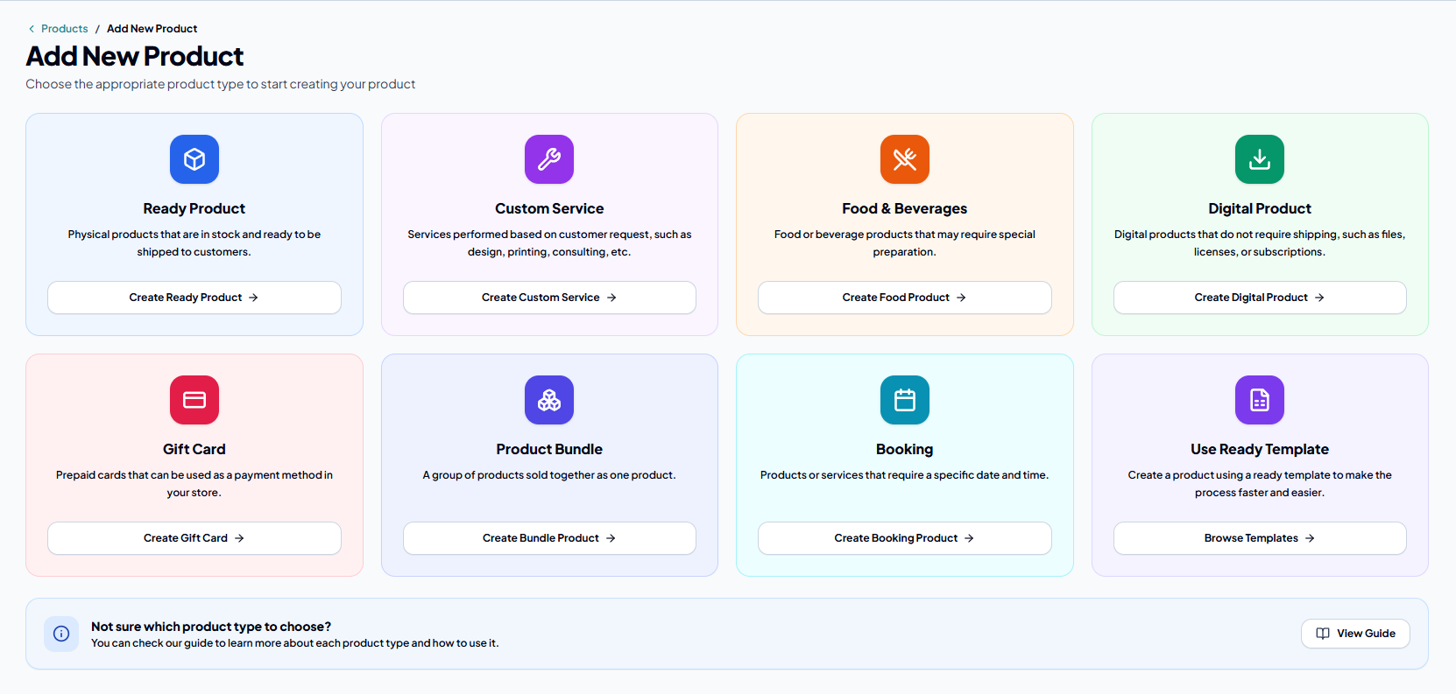
Create two additional product types:
- Fully Customizable Product — A product that supports all available features and customization options.
- Made-to-Order Product — A product that is customized and created according to the customer's specific requirements.

I will send the details soon.
As for the Fully Customizable Product, the requirements are as follows:

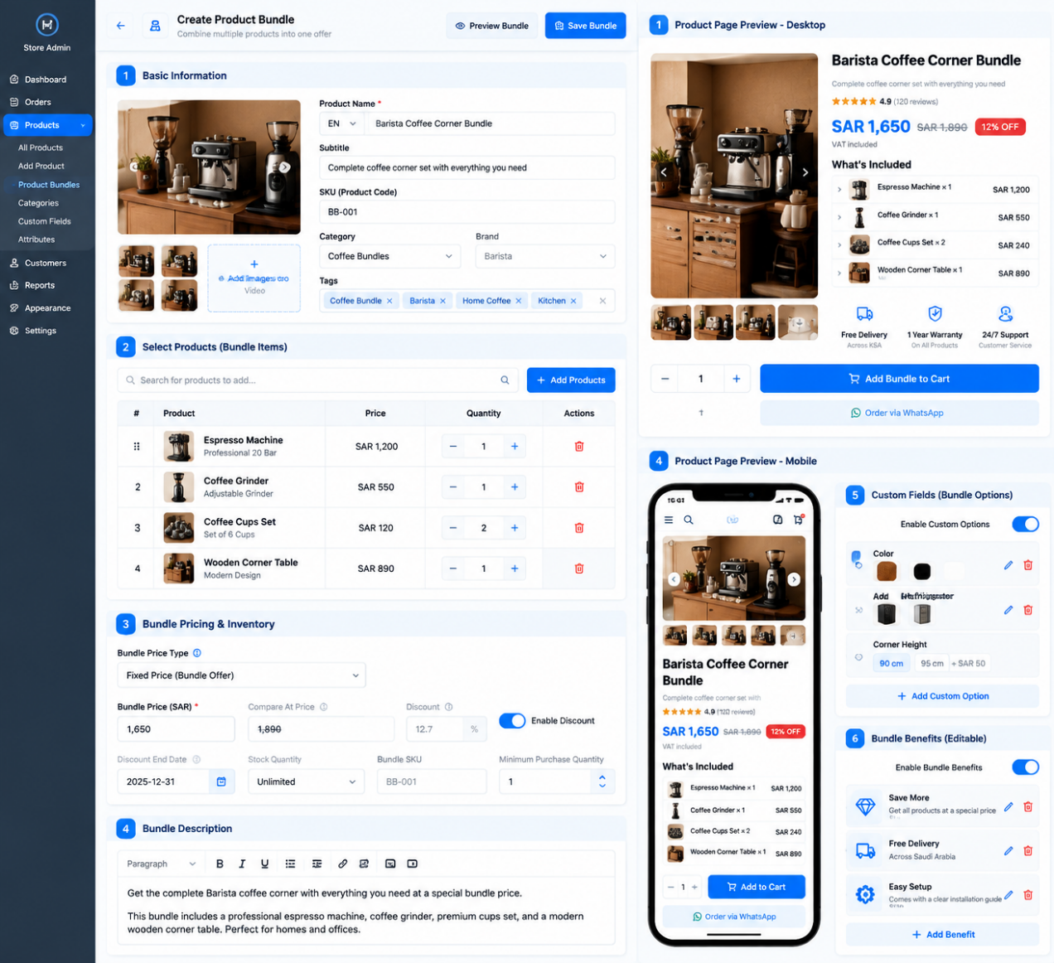

Custom Product Builder
Complete Development Specification
Product creation • Custom fields • Benefits & icons • Bundles • Responsive previews
Purpose: Define the functionality, administration controls, validation rules, and storefront behavior for a reusable Custom Product Builder, based on the supplied reference UI. This document is intended for implementation by the development team.

1. Project Overview

1.1 Objective
Develop a configurable Custom Product Builder inside the store administration dashboard. Administrators must be able to create and edit products with configurable options, additional prices, images, benefits, specifications, inventory, and product information without requiring code changes for each new product.

1.2 Core Requirements
- Dynamic product creation and editing.
- Product image and video management.
- Configurable product information, pricing, inventory, and shipping.
- Dynamic custom fields and product options.
- Editable product benefits with selectable icons.
- Editable specifications and product unit breakdowns.
- Search engine optimization (SEO) settings.
- Live desktop and mobile previews.
- Save, validate, publish, and update workflows.
- Arabic RTL and English LTR support.

2. Administration Dashboard Layout

2.1 Header Actions
- Back: Return to the product list or previous screen.
- Preview Product: Open a preview of the current draft.
- Save Product: Validate and save the current configuration.
- Publish Product: Publish the product when publishing is a separate workflow supported by the platform.
- Display loading, success, and error states. Do not report success before the operation completes.

2.2 Main Layout
- Use a responsive administration layout with a left navigation sidebar, central editor, desktop preview panel, and dedicated mobile preview.
- Allow the editor and preview to be accessed on smaller screens without horizontal overflow.
- Use numbered, clearly separated sections and collapsible panels where appropriate.

3. Product Images and Video
- Support uploading a primary image, multiple gallery images, and product videos where supported.
- Support drag-and-drop uploads, selecting the main image, reordering gallery items, and removing or replacing media.
- Preview media before saving and update the product preview after successful selection.
- Validate supported file types and maximum file sizes; display upload progress and actionable errors.
- Provide a fallback when no image is available; store stable media references rather than temporary upload URLs.

4. Basic Product Information
Provide the following fields:
Field | Requirements
Product Name | Required, localized text
Subtitle | Optional localized text
SKU / Product Code | Identifier with uniqueness validation where required
Category | Select an existing category
Brand | Select an existing brand
Tags | Add, remove, and manage multiple tags
Language | Support configured store languages
Product Status | Draft, active, or other platform-supported statuses
- Support both creating new products and editing existing products.
- Store Arabic and English content independently.
- Reuse the existing category, brand, and tagging systems.
- Preserve entered values when validation fails.

5. Pricing and Inventory

5.1 Pricing Fields
- Base Price and Currency.
- Enable/Disable Discount Price.
- Discount Price and optional Discount End Date.
- Cost Price.
- Compare-at Price, if supported by the existing platform.

5.2 Inventory Fields
- Stock Quantity and Unlimited Quantity toggle.
- SKU and Minimum Stock Alert.
- Minimum Purchase Quantity and optional Maximum Purchase Quantity.

5.3 Pricing and Inventory Behavior
- When discount pricing is enabled, display discount fields and validate that the discount price is lower than the base price.
- Display the correct current price and compare-at price in the storefront preview.
- Apply the platform's existing discount-expiration behavior when a discount ends.
- When Unlimited Quantity is enabled, disable finite stock quantity input; otherwise require a valid quantity.
- Prevent purchases exceeding available stock and revalidate inventory at checkout to prevent overselling.

6. Weight and Shipping
- Product Weight and Weight Unit.
- Shipping Length, Width, Height, and Dimension Unit.
- Shipping Method or Shipping Profile, if supported.
- Shipping Availability.
- Reject negative or invalid numeric values.
- Use the existing shipping integration for eligibility and rates; do not invent shipping costs or delivery promises.

7. Product Description
- Provide a rich-text editor supporting paragraphs, headings, bold/italic, lists, alignment, links, and images where supported.
- Sanitize formatted content to prevent script injection.
- Preserve content when switching editor sections.
- Support localized descriptions and update the preview when content changes.

8. Product Features (Benefits) — Editable Icons

8.1 Benefit Fields
- Icon, Benefit Title, Short Description, optional Secondary Description, Display Order, and Visibility Status.

8.2 Icon Management
- Choose an icon from a predefined library.
- Search icons by name or category and preview before selecting.
- Replace or remove an icon, with a supported fallback when needed.
- Keep icon size and alignment consistent.
- If custom uploads are supported, accept only supported icon formats.

8.3 Benefit Actions and Frontend Behavior
- Each benefit row must support Edit, Delete, Drag/Reorder, and Visibility Toggle.
- Provide Add Feature and Choose Icon actions.
- Display enabled benefits on the storefront with their selected icon, title, and description.
- Preserve administrator-defined order and hide disabled benefits without deleting their saved configuration.
- Update desktop and mobile previews when benefits change.
- Do not hard-code a three-benefit limit; allow multiple benefits within reasonable platform limits.

9. Product Specifications — Collapsible Section
- Each specification supports text, optional label, display order, and visibility status.
- Provide Enable/Disable, Add, Edit, Delete, Reorder, and Show/Hide controls.
- Render specifications as a bullet list inside a collapsible section.
- The heading and indicator must expand or collapse the list.
- Allow the section title and content to be configured without changing the page template.

10. Product Unit Breakdown — Collapsible Section
- Each unit supports Unit Name, optional Description, optional Image, optional Icon, Display Order, and Visibility Status.
- Provide Enable/Disable, Add Unit, Edit, Delete, Reorder, Choose Icon, and Upload/Replace Image controls.
- Render units as a list or card layout according to the selected theme.
- Support expand/collapse and synchronize changes with the preview.

11. Custom Fields and Product Options

11.1 Supported Field Types
- Short Text
- Long Text
- Number
- Single Choice
- Multiple Choice
- Image Upload
- Date
- Time
- Date and Time
- Location
- File Upload
- Color Selector
- Divider

Phase 2: Product Bundles — Multiple Products in One Product Page
The second phase focuses on developing a Product Bundle / Grouped Product feature that allows multiple existing products to be combined into a single product page.

Objective
Solve the problem of managing product information, pricing, images, and product variations when several related products need to be displayed and sold together as one offering.

Key Requirements
- Combine multiple existing products into one product bundle.
- Allow each included product to retain its own information, images, and pricing.
- Enable administrators to manage the bundle's displayed information and pricing without modifying each product individually.
- Support product-specific options and variations where applicable.
- Automatically update the bundle's displayed content and total price according to the selected products and configuration.
- Provide a unified product page with a clear presentation of all included products.
- Ensure that changes to an individual product are reflected in the bundle where appropriate, without unintentionally overriding bundle-specific settings.

Expected Outcome
A flexible product-bundling system that simplifies the management of multiple products within a single product page, reduces duplicated data entry, and ensures that product information, images, prices, and selected variations remain consistent with the underlying products.
Clarify Bundle Pricing Rules

11.2 Field Configuration
- Field Name, Description, Field Type, Required/Optional, Default Value, Placeholder, Available Options, Display Order, Visibility Status, and Conditional Display Rules.

11.3 Conditional Display
- Allow a field to appear or remain hidden depending on another field's selected value.
- Validate rules and prevent circular dependencies.
- Support dependent fields only while their parent selection remains valid.

11.4 Option Values
- Add, remove, edit, and reorder option values.
- Configure option labels, optional images, optional additional prices, and default selections.
- Apply only the settings relevant to each field type.

12. Product Customization Options

12.1 Option Group Configuration
- Option Group Name, Option Type, Required/Optional, Option Values, optional Images, optional Additional Prices, Default Selection, Display Order, and Visibility Status.
- Support Single Choice and Multiple Choice selection types.
- Display image-based options as selectable cards.

12.2 Example: Barista Coffee Corner
Option Group | Option Value | Price Adjustment
Refrigerator | Add Refrigerator | +SAR 950
Refrigerator | Without Refrigerator | +SAR 0
Corner Height | 90 cm | +SAR 0
Corner Height | 95 cm | +SAR 50
Back Panel Color | Black | +SAR 0
Back Panel Color | Same as Wood Color | +SAR 200

12.3 Frontend Behavior
- Highlight selected options and update the total price immediately.
- Enforce required selections and show additional prices beside option values.
- Support image-based cards and configured invalid-combination rules.
- Preserve selections when other non-conflicting fields change.
- Revalidate all option IDs, values, and prices on the server before adding to cart.

12.4 Price Calculation
For an additive pricing model:
Final Unit Price = Base Price + Sum of Selected Option Price Adjustments
If discounts apply to customized products, explicitly define whether the discount is calculated before or after option adjustments. Use the same pricing rule in the preview, cart, and checkout.

13. Bundle or Grouped Product Support

13.1 Bundle Management
- Search existing products and add multiple products to a bundle.
- Set the quantity of each included product.
- Remove products and reorder bundle items.
- Display each item's image, name, price, and quantity.

13.2 Bundle Pricing
- Fixed Bundle Price, Compare-at Price, Discount Amount or Percentage, Discount Expiry Date, Bundle SKU, and Bundle Stock or Availability Rules.

13.3 Inventory Rule
Define whether bundle stock is managed independently or derived from the stock of included products. At checkout, validate availability for every included product and reserve or decrement stock consistently to prevent overselling.

14. SEO and Product Links
- SEO Page Title, SEO URL/Slug, Meta Description, optional Canonical URL, and Product URL Preview.
- Validate slug format and uniqueness.
- Generate a default slug from the product name when appropriate, while allowing manual editing.
- Display character-length guidance.
- Preserve existing published URLs unless intentionally changed.
- Use the platform's redirect mechanism when a published URL changes, if available.

15. Desktop and Mobile Product Preview

15.1 Desktop Preview
- Product image gallery, product name and subtitle, price and discount.
- Benefits with icons, dimensions, specifications, unit breakdown, and customization options.
- Quantity selector, Add to Cart, and WhatsApp order button if configured.

15.2 Mobile Preview
- Stack sections vertically and use touch-friendly option cards.
- Keep price and purchase actions readable.
- Prevent horizontal scrolling and avoid distorted images.
- Respect Arabic RTL and English LTR.

15.3 Live Preview Behavior
- Update preview content when text, media, prices, benefits, icons, specifications, units, options, or visibility settings change.
- Preview the current draft; keep the live storefront on the published version until the required publish step completes.

16. Save, Validation, and Publishing Workflow
- Administrator opens Create Product or Edit Product.
- Load existing product configuration when editing.
- Administrator edits fields, media, benefits, specifications, units, and options.
- Update the draft preview as changes are made.
- Validate required fields and option configurations.
- Save the complete configuration.
- Show success or failure feedback only after the operation completes.
- Publish the saved draft if publishing is a separate workflow.
- Display the published configuration on the storefront.

16.1 Error Handling
- Preserve unsaved input when validation fails.
- Identify fields requiring correction.
- Prevent duplicate submissions and show loading states.
- Report upload, save, and publishing errors.
- Warn before discarding unsaved changes.
- Do not show success until the operation is confirmed.

17. Data Model and Technical Architecture
- Recommended entities: Product, Product Media, Product Benefit, Benefit Icon, Product Specification, Product Unit, Custom Field, Custom Field Value, Option Group, Option Value, Product Variant (if supported), Product Inventory, Product SEO Metadata, Bundle, and Bundle Item.
- Each entity must have a stable identifier and a defined relationship to its parent product.
- Reuse existing authentication, authorization, database, storage, and shipping infrastructure.
- Validate inputs on both client and server.
- Store stable media references and sanitize rich-text content.
- Enforce pricing and inventory rules on the server.
- Keep draft and published states separate when supported.
- Build reusable components for fields, option cards, icon selection, and previews.

18. Responsive Design and Accessibility
- Support desktop, tablet, and mobile layouts.
- Use accessible labels for inputs and accessible names for icon-only buttons.
- Support keyboard navigation and visible focus states.
- Associate validation messages with their fields.
- Do not rely on color alone to communicate selection or errors.
- Support Arabic RTL and English LTR with independently stored localized text.
- Keep prices, numeric values, SKUs, and dates readable in both directions.

19. Acceptance Criteria
- Administrators can create and edit products without changing application code.
- Media can be uploaded, previewed, reordered, and removed.
- Product information, pricing, inventory, and shipping validate correctly.
- Benefits can be added, edited, deleted, reordered, and assigned icons.
- Specifications are editable and collapsible.
- Units can be managed with text, images, icons, and display order.
- Custom fields support configured field types and required settings.
- Customization options support images, prices, defaults, and selection rules.
- Price updates correctly when option selections change.
- Invalid selections and unavailable inventory cannot bypass server-side validation.
- Desktop and mobile previews reflect draft changes.
- Saved configuration persists after reloading the editor.
- Published product pages display the published configuration.
- Arabic RTL and English LTR layouts work without clipping or overlap.
- Grouped products, when enabled, manage included products and inventory consistently.
- Existing store features and unrelated product pages remain unaffected.

20. Final Development Goal
Deliver a reusable, configurable product-creation system that supports ordinary products, customizable products, and grouped products through clearly separated workflows. The system must provide complete administration controls, editable product benefits with icons, dynamic custom fields, image-based options, additional pricing, inventory validation, collapsible product sections, SEO settings, and synchronized desktop/mobile previews. Use the supplied reference image as the visual and functional guide. Reuse existing store infrastructure where available, document integration limitations before implementation, and do not treat a static visual mockup as a completed functional feature.

Phase 2: Product Bundles — Multiple Products in One Product Page
The second phase focuses on developing a Product Bundle / Grouped Product feature that allows multiple existing products to be combined into a single product page.
Objective
Solve the problem of managing product information, pricing, images, and product variations when several related products need to be displayed and sold together as one offering.
Key Requirements
- Combine multiple existing products into one product bundle.
- Allow each included product to retain its own information, images, and pricing.
- Enable administrators to manage the bundle's displayed information and pricing without modifying each product individually.
- Support product-specific options and variations where applicable.
- Automatically update the bundle's displayed content and total price according to the selected products and configuration.
- Provide a unified product page with a clear presentation of all included products.
- Ensure that changes to an individual product are reflected in the bundle where appropriate, without unintentionally overriding bundle-specific settings.
Expected Outcome
A flexible product-bundling system that simplifies the management of multiple products within a single product page, reduces duplicated data entry, and ensures that product information, images, prices, and selected variations remain consistent with the underlying products.
Clarify Bundle Pricing Rules

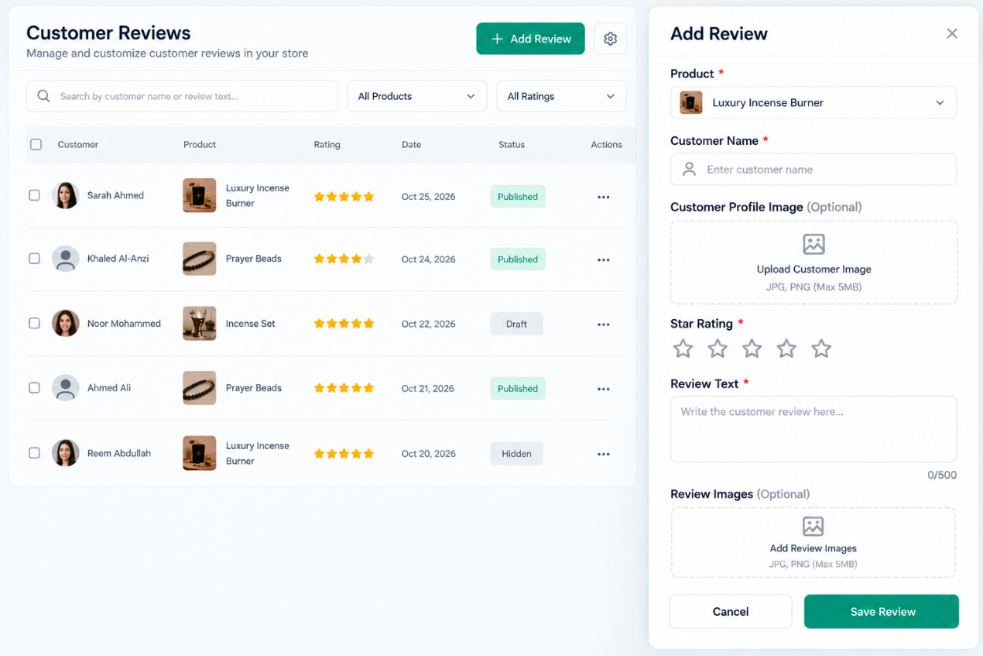

DEVELOPER IMPLEMENTATION SPECIFICATION
Customer Reviews — Manual Review Management Component
Functional requirements • UI behavior • Validation • Acceptance criteria

1. Project Scope
Implement a manual review management component within the existing Customer Reviews section of the store administration panel. The administrator must be able to add, edit, save, preview, publish, hide, and delete product reviews.
Scope restrictions:
- Modify only the Customer Reviews component and its required data integration.
- Preserve the existing store layout, theme, navigation, and unrelated functionality.
- Do not add review-type options such as “Genuine Review” or “Test Review.”
- Do not introduce unrelated features or redesign other sections.
- Keep the existing visual style: white background, subtle gray borders, rounded fields, and teal/green primary buttons.

2. Add Review Button and Form

2.1 Add Review Button
Add a clearly visible “Add Review” button to the existing Customer Reviews administration page.
- On desktop, open the form in a side panel.
- On mobile, display the form in a full-screen panel or suitable modal.
- Opening the form must not discard saved reviews.
- Closing without saving must not create a review.

2.2 Product Field
Label: Product | Type: Searchable dropdown
- Load products from the existing product database.
- Allow the administrator to search for and select a product.
- Display the selected product name and thumbnail when available.
- Store the selected product ID with the review.
- Prevent saving if no product is selected.
- Handle deleted or unavailable products without breaking the reviews page.

2.3 Customer Name Field
Label: Customer Name | Type: Text input
- Accept the customer name as text and trim unnecessary spaces before saving.
- Mark the field as required and show a validation message when empty.
- Preserve entered values if another field fails validation.

2.4 Customer Profile Image
Label: Customer Profile Image (Optional) | Type: Image upload
- Allow an optional profile image upload and show a preview after upload.
- Allow replacing or removing the image before saving.
- Validate image format and file size according to existing store limits.
- Use the existing default avatar when no image is provided.
- Do not block saving when this optional field is empty.

2.5 Star Rating Field
Label: Star Rating | Type: Interactive five-star selector
- Allow selection from 1 to 5 stars.
- Visually distinguish selected and unselected stars.
- Update the selected value immediately when a star is clicked.
- Store the rating as an integer from 1 to 5.
- Require a rating and reject values outside the permitted range.

2.6 Review Text Field
Label: Review Text | Type: Multiline text area
- Allow the administrator to enter the review text.
- Display a live character counter, such as 0/500.
- Enforce a maximum length of 500 characters.
- Trim leading and trailing whitespace before saving.
- Require non-empty text and preserve line breaks where supported.
- Render review content safely to prevent HTML or script injection.

2.7 Review Images
Label: Review Images (Optional) | Type: Multiple-image upload
- Allow one or more review-related images to be uploaded.
- Display thumbnails before saving and allow individual images to be removed.
- Validate file type, size, and maximum image count according to configured limits.
- Allow saving without review images.
- Store image references with the review.
- Show images publicly only when the review is published and the storefront supports them.

2.8 Form Buttons

Save Review
- Validate all required fields and save the review to the database.
- Show success feedback only after the save is confirmed.
- Refresh the administration list and relevant statistics.
- Prevent duplicate submissions while the request is processing.

Cancel
- Close the form without saving. If unsaved changes exist, ask for confirmation before discarding them.

Close (X)
Behave like Cancel. Do not save automatically.

3. Review Management Table

3.1 Required Columns
- Customer
- Product
- Rating
- Date
- Status
- Actions

3.2 Status Values
- Draft: Saved but not visible to storefront visitors.
- Published: Approved for display on the storefront.
- Hidden: Saved but excluded from the public review list and public review statistics.

3.3 Row Actions

Edit
- Open the selected review in the same form and load all existing values.
- Save changes to the existing record instead of creating a duplicate.

Hide / Publish
- Allow the administrator to change review visibility.
- Recalculate public statistics when visibility changes.
- Update the storefront according to the new status.

Delete
- Request confirmation before deletion.
- Remove the review from the active list after successful deletion.
- Recalculate affected statistics.
- Handle uploaded images according to existing media-management rules.

3.4 Search and Filters
- Search field: Search by customer name or review text.
- Product filter: Show reviews associated with the selected product.
- Rating filter: Filter reviews by star rating.
Search and filters must work together and must not modify underlying review records.

4. Data Storage and Automatic Statistics
Reuse the existing database and product architecture wherever possible. Do not create a separate, conflicting source of review data.
Each review must have a unique identifier and store:
- Review ID
- Product ID
- Customer name
- Customer profile image reference (optional)
- Star rating
- Review text
- Review image references (optional)
- Publication status
- Creation date
- Last updated date

4.1 Public Review Statistics
Calculate public statistics from reviews whose status is Published.
- Total published reviews
- Average star rating
- Number of one-star reviews
- Number of two-star reviews
- Number of three-star reviews
- Number of four-star reviews
- Number of five-star reviews
- Percentage distribution for each rating
- Number of published reviews containing images
Average Rating = Sum of Published Star Ratings / Total Published Reviews
If there are no published reviews, show the existing empty state and avoid division-by-zero errors.

4.2 Automatic Recalculation
Recalculate statistics when a review is created and published, edited, published, hidden, or deleted.
Draft and Hidden reviews must not contribute to public statistics. Administrative totals may include these records if clearly distinguished from public statistics.
Derive statistics from saved database records rather than manually maintained counters.

5. Save, Preview, and Publish Behavior

5.1 Saving
Saving a review must persist the record in the database. A successful save must:
- Validate input.
- Persist the review.
- Confirm success.
- Refresh the administration list.
- Recalculate affected statistics.
- Display a success message.
If saving fails, display an understandable error and preserve entered data so the administrator can retry.

5.2 Preview
If the existing component supports a preview, update it when the product, customer name, rating, review text, or images change. The preview must reflect unsaved form values. Previewing must not publish or persist the review.

5.3 Publishing
Only reviews with Published status may appear in the public storefront review list.
Changes must appear after a successful server response and any required cache refresh. Do not show success before the operation succeeds.
Draft and Hidden reviews must remain unavailable to public visitors.

6. Responsive Design

Desktop
- Keep the table and Add Review side panel aligned with the existing design.
- Ensure fields and columns remain readable and avoid horizontal overflow.

Tablet
- Reduce spacing where necessary.
- Keep controls usable and allow the form to expand when needed.

Mobile
- Display the form in a full-screen panel or suitable modal.
- Stack fields vertically and make buttons and star controls touch-friendly.
- Keep upload controls and validation messages visible.
- Prevent content from extending beyond the viewport.

Localization
- Support Arabic and English labels and validation messages.
- Use RTL for Arabic and LTR for English.
- Keep alignment, dropdowns, icons, and star selection correct in both directions.
- Avoid hardcoded labels that prevent localization.

7. Validation and Error Handling
Handle at least the following cases:
- Missing product selection
- Empty customer name
- Missing star rating
- Empty review text
- Review text exceeding 500 characters
- Unsupported image format
- Image exceeding upload limit
- Failed image upload
- Failed database save
- Failed edit or publication request
- Duplicate form submission
- Unauthorized administration request
- Deleted or unavailable product
- Network interruption during saving
Expected behavior:
- Display clear, field-specific validation messages.
- Keep valid form values when an error occurs.
- Disable repeated submission while a request is processing.
- Show success messages only after confirmed success.
- Avoid exposing internal server errors or sensitive information.
- Enforce validation on both client and server.

8. Security and Permissions
- Only authorized administrators may add, edit, publish, hide, or delete reviews.
- Validate submitted values on the server.
- Sanitize review text before rendering.
- Validate uploaded files by actual file type, not filename extension alone.
- Use existing authentication, authorization, and media-storage mechanisms.
- Do not expose private administration endpoints to public visitors.

9. Acceptance Criteria
- ☐ The Add Review button opens the form correctly.
- ☐ The product dropdown loads products from the existing catalog.
- ☐ Customer name, rating, and review text are required.
- ☐ Customer profile images and review images are optional.
- ☐ The star selector supports ratings from 1 to 5.
- ☐ The review text counter updates immediately and enforces the 500-character limit.
- ☐ A saved review appears in the administration list.
- ☐ Editing a review updates the existing record without creating a duplicate.
- ☐ Draft and Hidden reviews do not appear publicly.
- ☐ Publishing a review makes it eligible for storefront display.
- ☐ Public statistics update correctly after publication, editing, hiding, and deletion.
- ☐ Product-level statistics are calculated for the correct product.
- ☐ Search and filters return the correct results.
- ☐ Validation and upload errors are displayed clearly.
- ☐ Failed saves do not erase entered data.
- ☐ The interface works on desktop, tablet, and mobile.
- ☐ Arabic RTL and English LTR layouts are supported.
- ☐ Existing store functionality outside the review component remains unchanged.
- ☐ All changes are persisted and verified against the database.
- ☐ No success message appears unless the operation has succeeded.

10. Out of Scope
- Google review or Merchant Center integration
- Automated review-request emails or messages
- New review-type selectors
- Additional analytics dashboards
- Changes to unrelated store settings
- A complete redesign of the existing storefront review section
- New authentication systems
- Features unrelated to manual review management

Final Implementation Requirement
Integrate the component into the existing store architecture, preserve the current design, and verify all save, edit, visibility, deletion, and statistics workflows before marking the task complete.

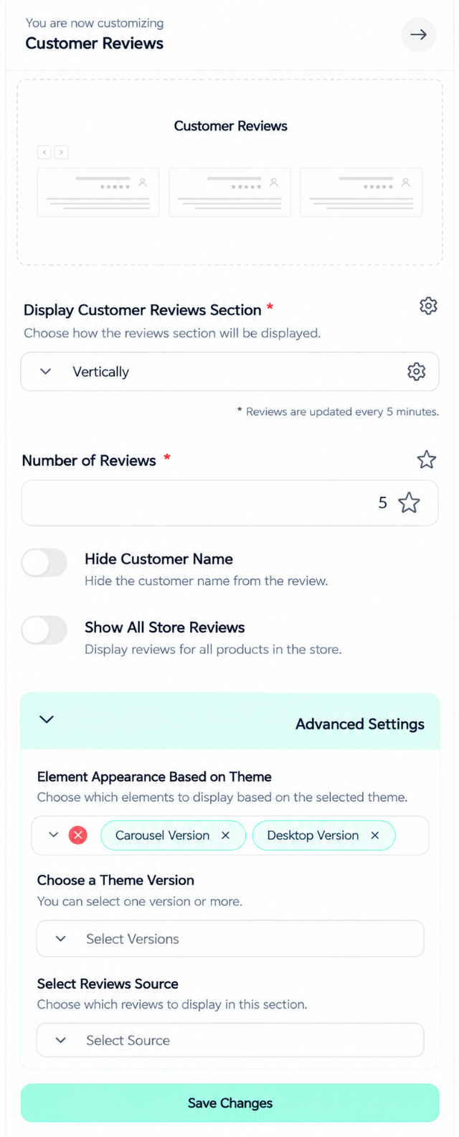
DEVELOPER IMPLEMENTATION SPECIFICATION
Customer Reviews — Manual Review Management Component
Functional requirements • UI behavior • Validation • Acceptance criteria

1. Project Scope
Implement a manual review management component within the existing Customer Reviews section of the store administration panel. The administrator must be able to add, edit, save, preview, publish, hide, and delete product reviews.
Scope restrictions:
- Modify only the Customer Reviews component and its required data integration.
- Preserve the existing store layout, theme, navigation, and unrelated functionality.
- Do not add review-type options such as “Genuine Review” or “Test Review.”
- Do not introduce unrelated features or redesign other sections.
- Keep the existing visual style: white background, subtle gray borders, rounded fields, and teal/green primary buttons.

2. Add Review Button and Form

2.1 Add Review Button
Add a clearly visible “Add Review” button to the existing Customer Reviews administration page.
- On desktop, open the form in a side panel.
- On mobile, display the form in a full-screen panel or suitable modal.
- Opening the form must not discard saved reviews.
- Closing without saving must not create a review.

2.2 Product Field
Label: Product | Type: Searchable dropdown
- Load products from the existing product database.
- Allow the administrator to search for and select a product.
- Display the selected product name and thumbnail when available.
- Store the selected product ID with the review.
- Prevent saving if no product is selected.
- Handle deleted or unavailable products without breaking the reviews page.

2.3 Customer Name Field
Label: Customer Name | Type: Text input
- Accept the customer name as text and trim unnecessary spaces before saving.
- Mark the field as required and show a validation message when empty.
- Preserve entered values if another field fails validation.

2.4 Customer Profile Image
Label: Customer Profile Image (Optional) | Type: Image upload
- Allow an optional profile image upload and show a preview after upload.
- Allow replacing or removing the image before saving.
- Validate image format and file size according to existing store limits.
- Use the existing default avatar when no image is provided.
- Do not block saving when this optional field is empty.

2.5 Star Rating Field
Label: Star Rating | Type: Interactive five-star selector
- Allow selection from 1 to 5 stars.
- Visually distinguish selected and unselected stars.
- Update the selected value immediately when a star is clicked.
- Store the rating as an integer from 1 to 5.
- Require a rating and reject values outside the permitted range.

2.6 Review Text Field
Label: Review Text | Type: Multiline text area
- Allow the administrator to enter the review text.
- Display a live character counter, such as 0/500.
- Enforce a maximum length of 500 characters.
- Trim leading and trailing whitespace before saving.
- Require non-empty text and preserve line breaks where supported.
- Render review content safely to prevent HTML or script injection.

2.7 Review Images
Label: Review Images (Optional) | Type: Multiple-image upload
- Allow one or more review-related images to be uploaded.
- Display thumbnails before saving and allow individual images to be removed.
- Validate file type, size, and maximum image count according to configured limits.
- Allow saving without review images.
- Store image references with the review.
- Show images publicly only when the review is published and the storefront supports them.

2.8 Form Buttons

Save Review
- Validate all required fields and save the review to the database.
- Show success feedback only after the save is confirmed.
- Refresh the administration list and relevant statistics.
- Prevent duplicate submissions while the request is processing.

Cancel
- Close the form without saving. If unsaved changes exist, ask for confirmation before discarding them.

Close (X)
Behave like Cancel. Do not save automatically.

3. Review Management Table

3.1 Required Columns
- Customer
- Product
- Rating
- Date
- Status
- Actions

3.2 Status Values
- Draft: Saved but not visible to storefront visitors.
- Published: Approved for display on the storefront.
- Hidden: Saved but excluded from the public review list and public review statistics.

3.3 Row Actions

Edit
- Open the selected review in the same form and load all existing values.
- Save changes to the existing record instead of creating a duplicate.

Hide / Publish
- Allow the administrator to change review visibility.
- Recalculate public statistics when visibility changes.
- Update the storefront according to the new status.

Delete
- Request confirmation before deletion.
- Remove the review from the active list after successful deletion.
- Recalculate affected statistics.
- Handle uploaded images according to existing media-management rules.

3.4 Search and Filters
- Search field: Search by customer name or review text.
- Product filter: Show reviews associated with the selected product.
- Rating filter: Filter reviews by star rating.
Search and filters must work together and must not modify underlying review records.

4. Data Storage and Automatic Statistics
Reuse the existing database and product architecture wherever possible. Do not create a separate, conflicting source of review data.
Each review must have a unique identifier and store:
- Review ID
- Product ID
- Customer name
- Customer profile image reference (optional)
- Star rating
- Review text
- Review image references (optional)
- Publication status
- Creation date
- Last updated date

4.1 Public Review Statistics
Calculate public statistics from reviews whose status is Published.
- Total published reviews
- Average star rating
- Number of one-star reviews
- Number of two-star reviews
- Number of three-star reviews
- Number of four-star reviews
- Number of five-star reviews
- Percentage distribution for each rating
- Number of published reviews containing images
Average Rating = Sum of Published Star Ratings / Total Published Reviews
If there are no published reviews, show the existing empty state and avoid division-by-zero errors.

4.2 Automatic Recalculation
Recalculate statistics when a review is created and published, edited, published, hidden, or deleted.
Draft and Hidden reviews must not contribute to public statistics. Administrative totals may include these records if clearly distinguished from public statistics.
Derive statistics from saved database records rather than manually maintained counters.

5. Save, Preview, and Publish Behavior

5.1 Saving
Saving a review must persist the record in the database. A successful save must:
- Validate input.
- Persist the review.
- Confirm success.
- Refresh the administration list.
- Recalculate affected statistics.
- Display a success message.
If saving fails, display an understandable error and preserve entered data so the administrator can retry.

5.2 Preview
If the existing component supports a preview, update it when the product, customer name, rating, review text, or images change. The preview must reflect unsaved form values. Previewing must not publish or persist the review.

5.3 Publishing
Only reviews with Published status may appear in the public storefront review list.
Changes must appear after a successful server response and any required cache refresh. Do not show success before the operation succeeds.
Draft and Hidden reviews must remain unavailable to public visitors.

6. Responsive Design

Desktop
- Keep the table and Add Review side panel aligned with the existing design.
- Ensure fields and columns remain readable and avoid horizontal overflow.

Tablet
- Reduce spacing where necessary.
- Keep controls usable and allow the form to expand when needed.

Mobile
- Display the form in a full-screen panel or suitable modal.
- Stack fields vertically and make buttons and star controls touch-friendly.
- Keep upload controls and validation messages visible.
- Prevent content from extending beyond the viewport.

Localization
- Support Arabic and English labels and validation messages.
- Use RTL for Arabic and LTR for English.
- Keep alignment, dropdowns, icons, and star selection correct in both directions.
- Avoid hardcoded labels that prevent localization.

7. Validation and Error Handling
Handle at least the following cases:
- Missing product selection
- Empty customer name
- Missing star rating
- Empty review text
- Review text exceeding 500 characters
- Unsupported image format
- Image exceeding upload limit
- Failed image upload
- Failed database save
- Failed edit or publication request
- Duplicate form submission
- Unauthorized administration request
- Deleted or unavailable product
- Network interruption during saving
Expected behavior:
- Display clear, field-specific validation messages.
- Keep valid form values when an error occurs.
- Disable repeated submission while a request is processing.
- Show success messages only after confirmed success.
- Avoid exposing internal server errors or sensitive information.
- Enforce validation on both client and server.

8. Security and Permissions
- Only authorized administrators may add, edit, publish, hide, or delete reviews.
- Validate submitted values on the server.
- Sanitize review text before rendering.
- Validate uploaded files by actual file type, not filename extension alone.
- Use existing authentication, authorization, and media-storage mechanisms.
- Do not expose private administration endpoints to public visitors.

9. Acceptance Criteria
- ☐ The Add Review button opens the form correctly.
- ☐ The product dropdown loads products from the existing catalog.
- ☐ Customer name, rating, and review text are required.
- ☐ Customer profile images and review images are optional.
- ☐ The star selector supports ratings from 1 to 5.
- ☐ The review text counter updates immediately and enforces the 500-character limit.
- ☐ A saved review appears in the administration list.
- ☐ Editing a review updates the existing record without creating a duplicate.
- ☐ Draft and Hidden reviews do not appear publicly.
- ☐ Publishing a review makes it eligible for storefront display.
- ☐ Public statistics update correctly after publication, editing, hiding, and deletion.
- ☐ Product-level statistics are calculated for the correct product.
- ☐ Search and filters return the correct results.
- ☐ Validation and upload errors are displayed clearly.
- ☐ Failed saves do not erase entered data.
- ☐ The interface works on desktop, tablet, and mobile.
- ☐ Arabic RTL and English LTR layouts are supported.
- ☐ Existing store functionality outside the review component remains unchanged.
- ☐ All changes are persisted and verified against the database.
- ☐ No success message appears unless the operation has succeeded.

10. Out of Scope
- Google review or Merchant Center integration
- Automated review-request emails or messages
- New review-type selectors
- Additional analytics dashboards
- Changes to unrelated store settings
- A complete redesign of the existing storefront review section
- New authentication systems
- Features unrelated to manual review management

Final Implementation Requirement
Integrate the component into the existing store architecture, preserve the current design, and verify all save, edit, visibility, deletion, and statistics workflows before marking the task complete.

