**Identity and Access Management System**

**Group Members:**  
 *Hafiz Farhad & Sohaib Ali*

### Abstract

We are designing Identity and Access Management (IAM) system to provide secure and efficient user authentication, role management, and password reset functionalities. The system will leverage modern security techniques such as JWT (JSON Web Tokens) for secure API access and Role-Based Access Control (RBAC) for fine-grained permission management.

### Context Model Diagram Using Draw.io

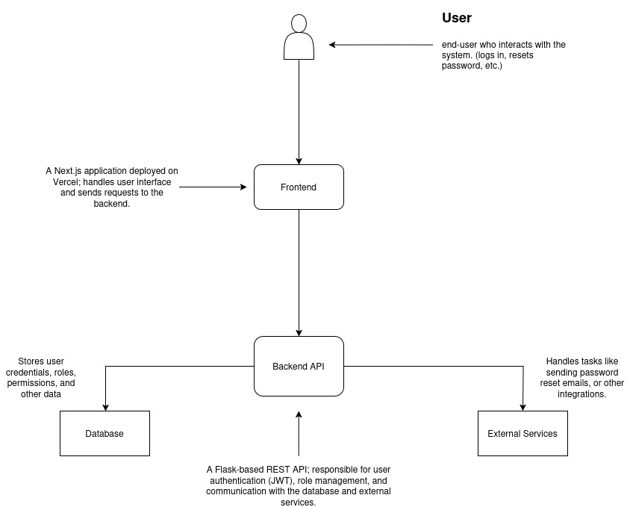Fig: A context model diagram for the IAM system