Nama : Hafizh Umar Syafiqh

NIM : 18090138

Kelas : 5D

PRAKTIKUM 1

1. Source Code

Perkenalan.php -> application/controller

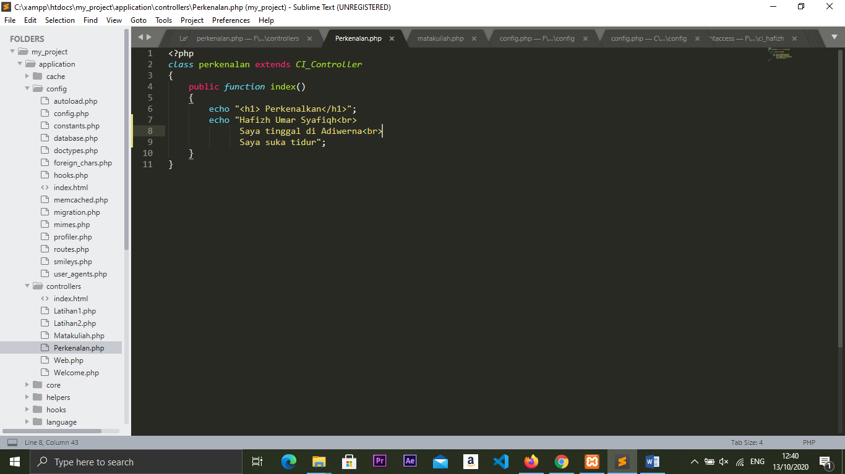

1. URL

http://localhost/my_project/index.php/Perkenalan

1. Capture Hasil

