Nama : Hafizh Umar Syafiqh

NIM : 18090138

Kelas : 5D

PRAKTIKUM 2

1. Source Code

latihan1-> application/controller

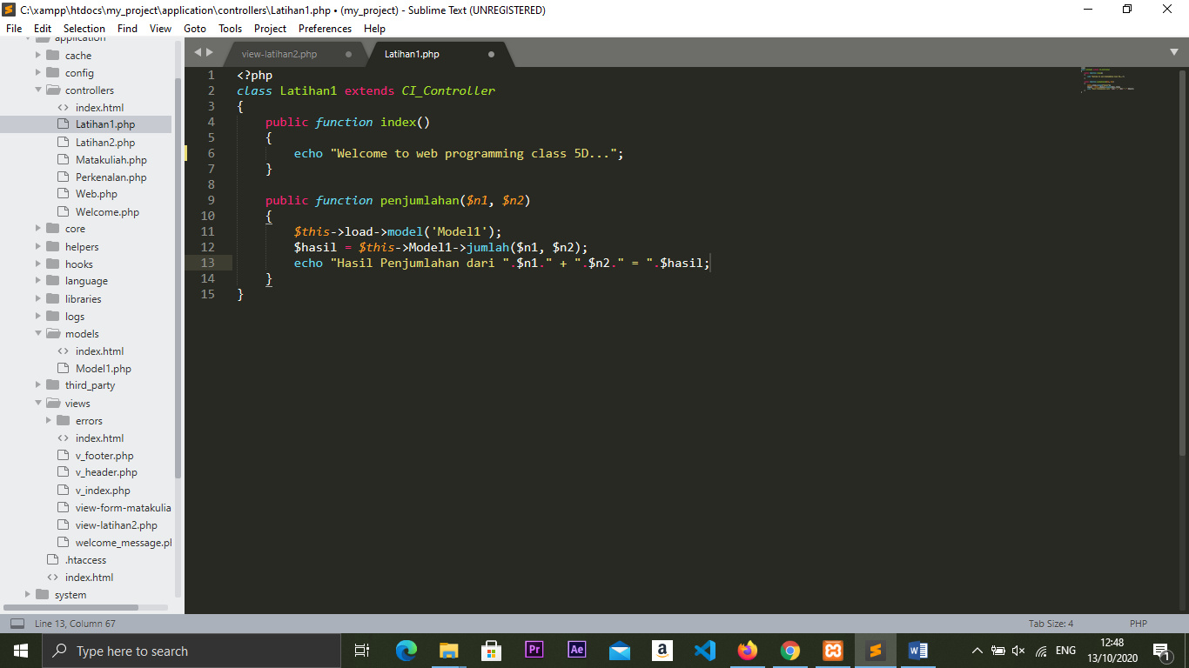

latihan2 -> application/controller

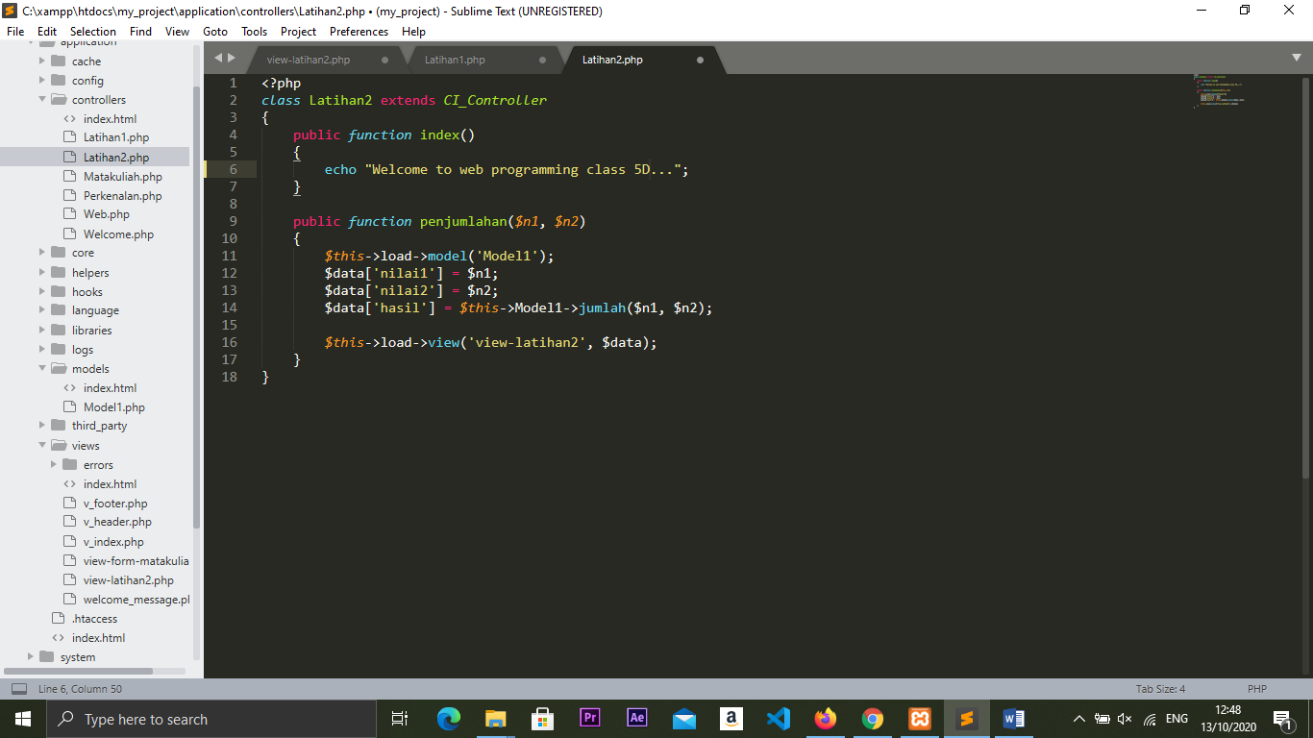

model1 -> application/model

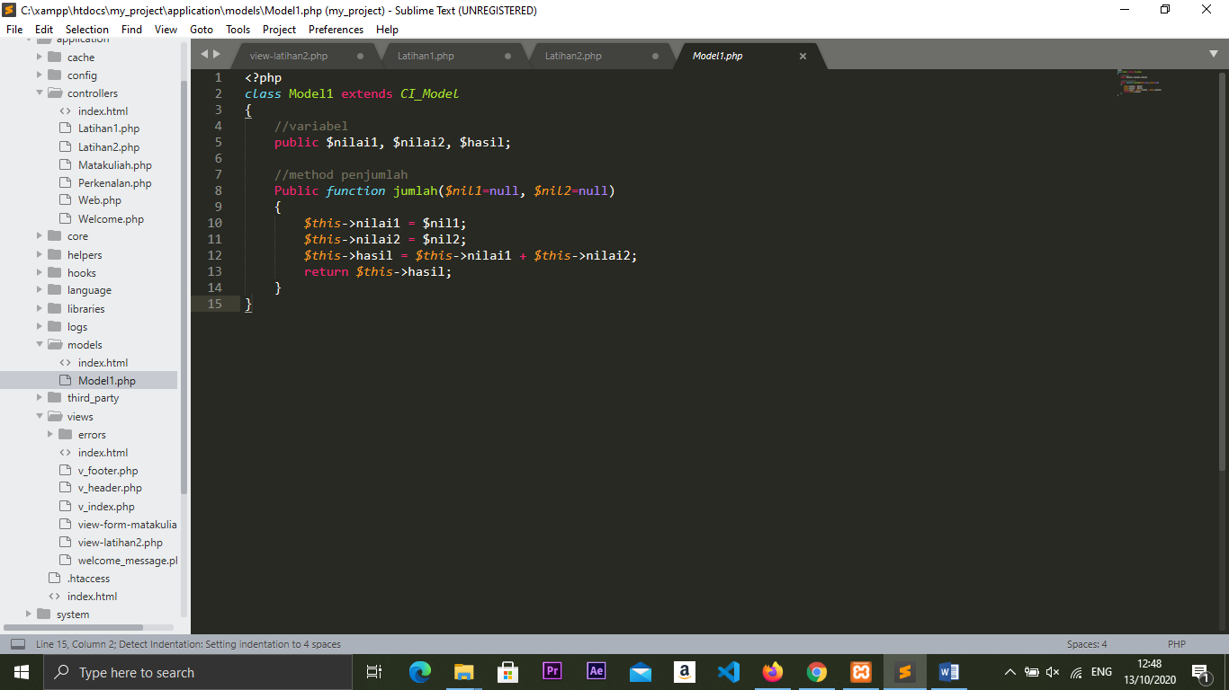

viewlatihan1.php->application/view

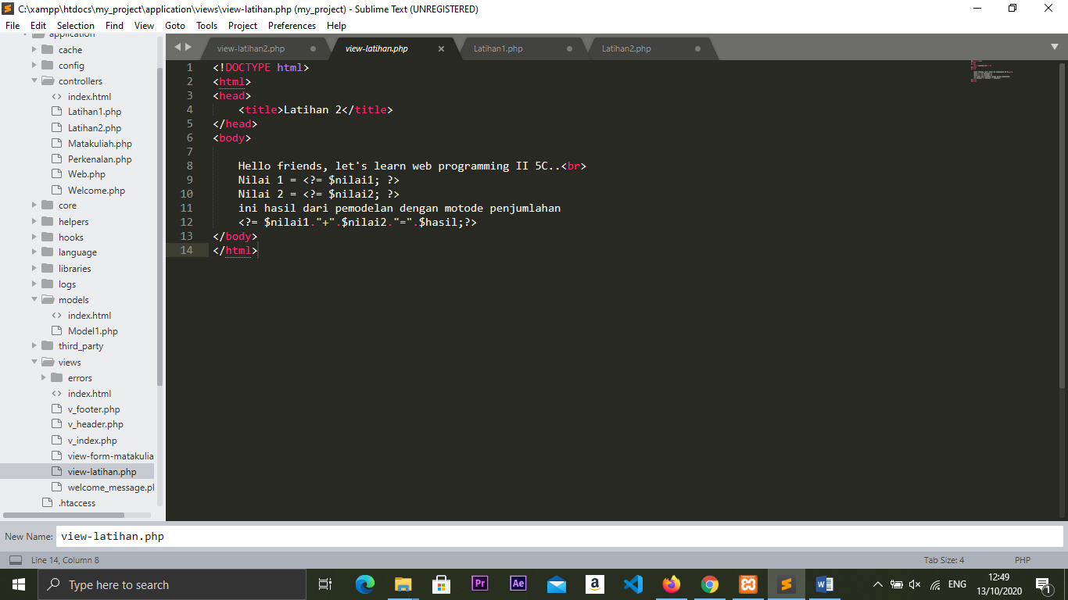

1. URL

http://localhost/my_project/index.php/Latihan2

http://localhost/my_project/index.php/Latihan2/penjumlahan/4/5

http://localhost/my_project/index.php/Latihan1/penjumlahan/8/3

1. Capture Hasil

Hasil run latihan 2

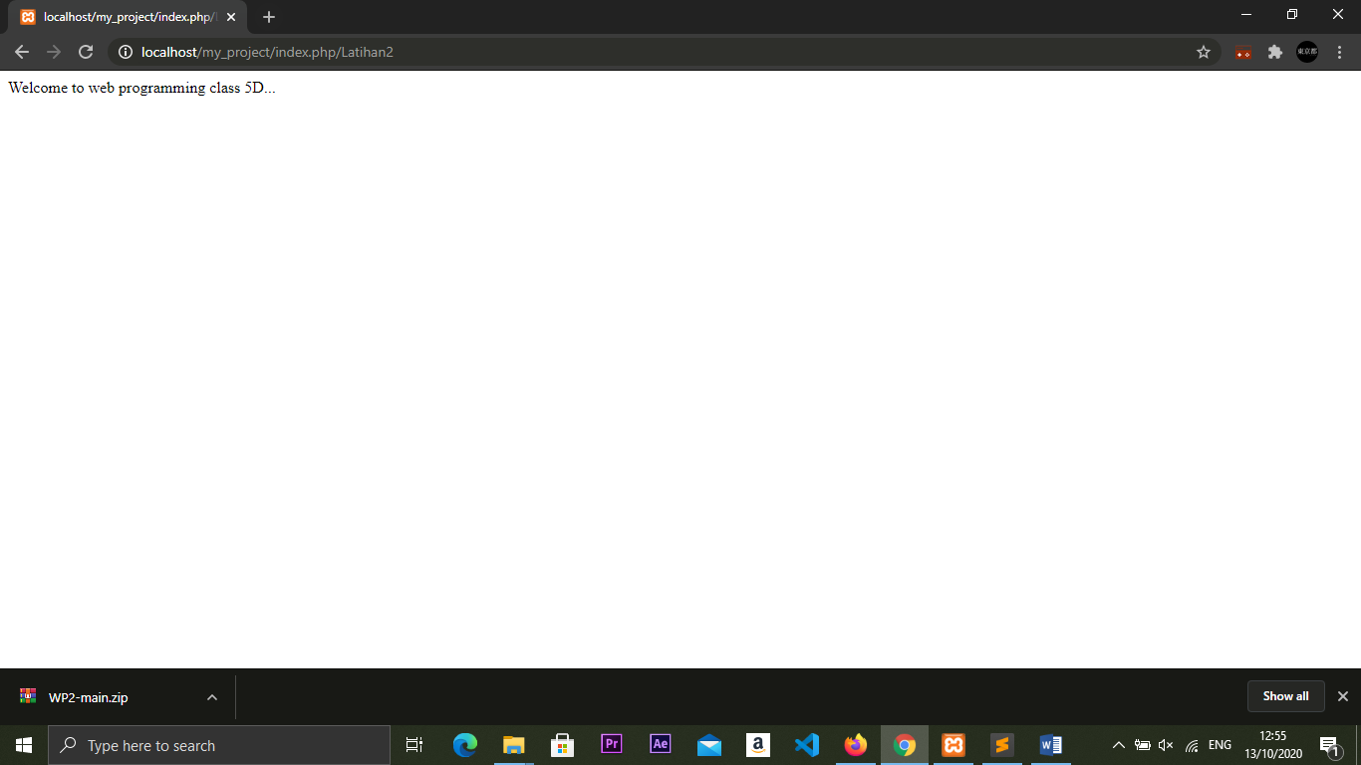

Hasil run penjumlahan

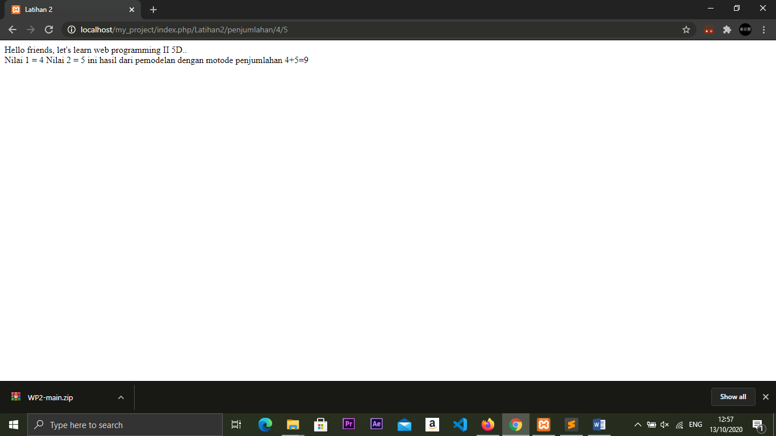

Hasil run latihan1

