Nama : Hafizh Umar Syafiqh

NIM :18090138

Kelas : 5D

PRAKTIKUM 3

1. Source Code

Matakuliah.php-> application/controller

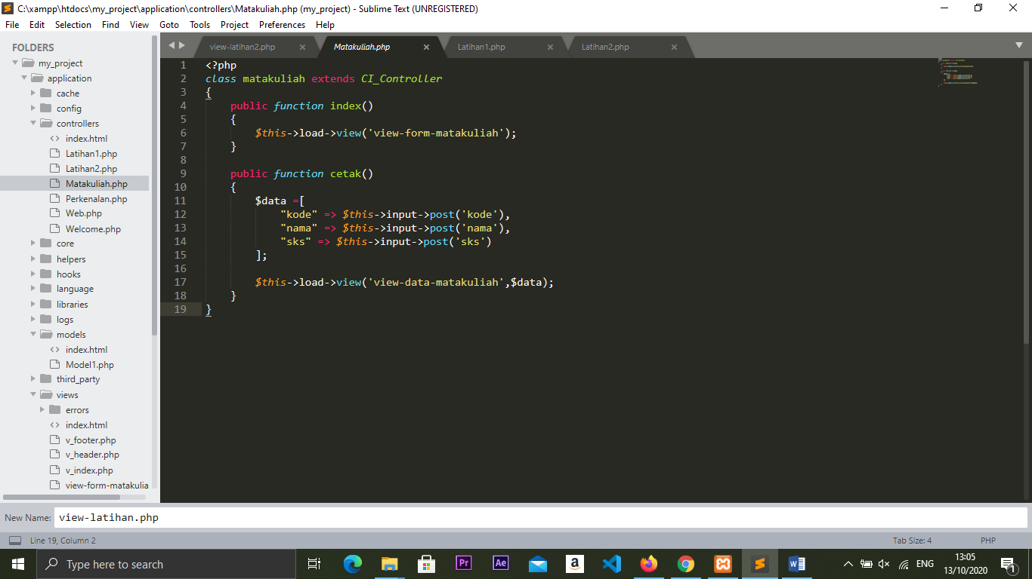

View-form-matakuliah.php->application/view

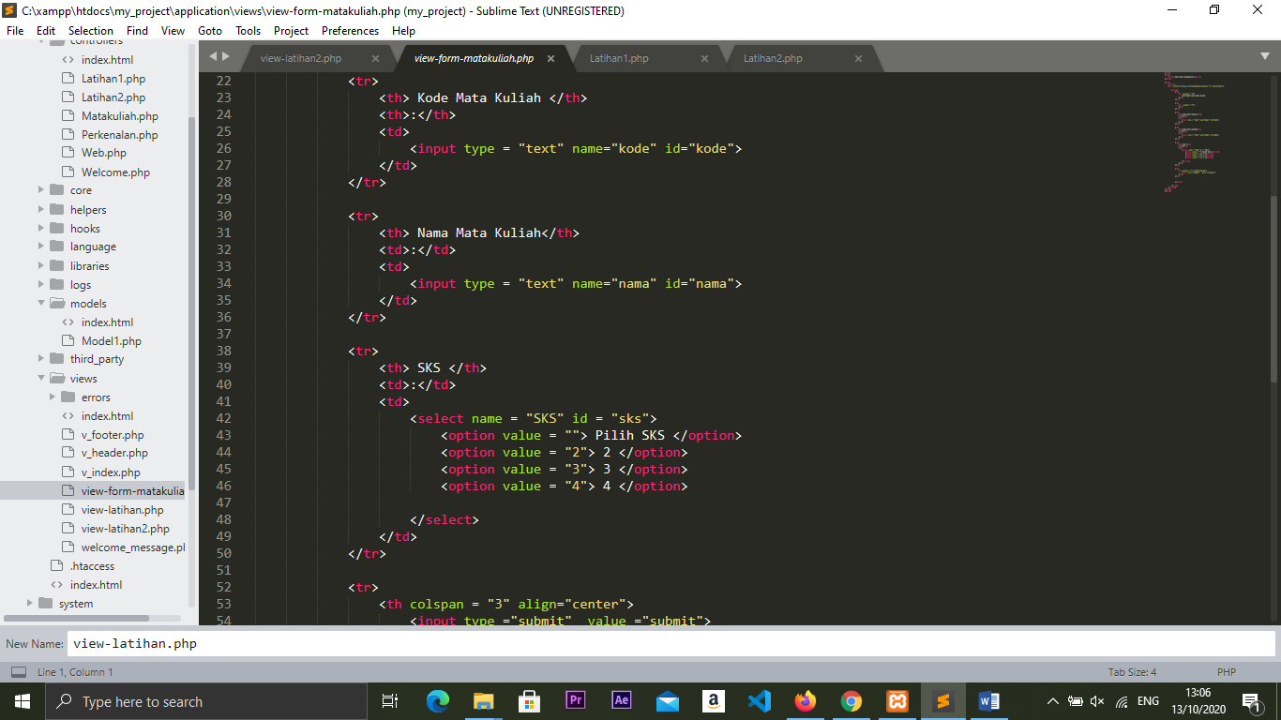

1. URL

http://localhost/my_project/index.php/Matakuliah

1. Capture Hasil

