Replication and Extension of Brain Tumor MRI Classification Using Transfer Learning with ResNet50, EfficientNetB0, and MobileNetV2
Muhammad Abdurrahman Hafizhuddin
Department of Informatics, Faculty of Science, UIN Sultan Maulana Hasanuddin Banten, Banten, Indonesia
*Corresponding email: Hafizhthericky123@gmail.com
Received: Month xx, 2026; Revised: Month xx, 2026; Accepted: Month xx, 2026.

Abstract: Brain tumor classification from Magnetic Resonance Imaging (MRI) is an important application of artificial intelligence in medical image analysis. This study replicates the article "MRI-Based Brain Tumor Classification using ResNet-50 and Optimized Softmax Regression" published in JURNAL INFOTEL in 2024 and extends the experiment by adding EfficientNetB0 and MobileNetV2 as comparative transfer learning models. The dataset used in this replication contains 7,023 MRI images separated into four classes: Glioma, Meningioma, No-tumor, and Pituitary. The experimental pipeline includes dataset preparation, image resizing to 224 x 224 pixels, normalization using ImageNet statistics, data augmentation, model training, evaluation, and interpretability visualization using Grad-CAM. Three pretrained models were trained for 8 epochs using Adam optimizer with a learning rate of 0.0001 and batch size of 32. The results show that EfficientNetB0 obtained the best performance with accuracy of 82.38%, weighted precision of 82.35%, weighted recall of 82.38%, and weighted F1-score of 81.99%. The replication result is lower than the main article benchmark, but it successfully demonstrates reproducible implementation, comparative model evaluation, and visual interpretation. This work is intended for academic replication and is not a clinical diagnostic tool.
Keywords: brain tumor classification, MRI, transfer learning, ResNet50, EfficientNetB0, Grad-CAM

1 Introduction
Artificial intelligence has become an important approach in computer vision and medical image analysis because deep learning models can learn visual patterns directly from image data. Brain tumor classification is one of the relevant healthcare AI tasks because MRI images provide detailed visual information about brain structures and abnormalities. Previous studies have shown that convolutional neural networks and transfer learning can support automated classification of glioma, meningioma, pituitary tumor, and no-tumor MRI images [1]-[7].
The main article selected for replication is the 2024 JURNAL INFOTEL article by Musa [1]. The article proposed a hybrid method that uses a pretrained ResNet-50 as a feature extractor and optimized Softmax Regression as the classifier. The article is relevant to this assignment because it was published in 2024, contains an experimental deep learning method, reports quantitative metrics, and uses a dataset type that can be replicated with publicly available MRI datasets. The article reports a best accuracy of 98.4%, which is used as the benchmark for comparison in this replication study [1].
This replication uses a similar four-class MRI classification task but implements the models using PyTorch transfer learning. ResNet50 is used as the main replication model, while EfficientNetB0 and MobileNetV2 are added as comparative models. The addition of comparative models addresses the assignment bonus component and provides a broader view of how different pretrained CNN architectures perform under the same dataset split and hyperparameter configuration.
The contributions of this study are as follows: first, it implements a reproducible replication pipeline for brain tumor MRI classification using a public dataset; second, it compares ResNet50, EfficientNetB0, and MobileNetV2 under the same experimental scenario; third, it evaluates the models using accuracy, precision, recall, F1-score, and confusion matrix; and fourth, it adds Grad-CAM visualization to support interpretability analysis of the trained model. The study is designed for academic purposes and does not claim clinical diagnostic validity.
2 Research Method
2.1. Main Article Identity and Selection Rationale
The selected article is suitable for replication because it is recent, comes from a relevant AI and informatics journal, contains an experimental method, and addresses a dataset type that can be replicated with a similar public MRI dataset. The identity of the main article is shown in Table 1.
Table 1: Identity of the main article selected for replication
Item | Description
Title | MRI-Based Brain Tumor Classification using ResNet-50 and Optimized Softmax Regression
Author | M. N. Musa
Journal | JURNAL INFOTEL, Vol. 16, No. 3, pp. 598-614
Publication year | 2024
DOI | 10.20895/infotel.v16i3.1175
Replicated component | Brain tumor MRI classification using ResNet-50 based transfer learning
Reported best accuracy | 98.4%
2.2. Dataset
The experiment used a public four-class brain tumor MRI dataset consisting of 7,023 images. The dataset was already divided into 5,712 training images and 1,311 testing images. The classes are Glioma, Meningioma, No-tumor, and Pituitary. The training set contains 1,321 Glioma, 1,339 Meningioma, 1,595 No-tumor, and 1,457 Pituitary images. The testing set contains 300 Glioma, 306 Meningioma, 405 No-tumor, and 300 Pituitary images. This structure supports reproducible multi-class evaluation and is consistent with public four-class MRI datasets described in previous studies [2], [3], [5].
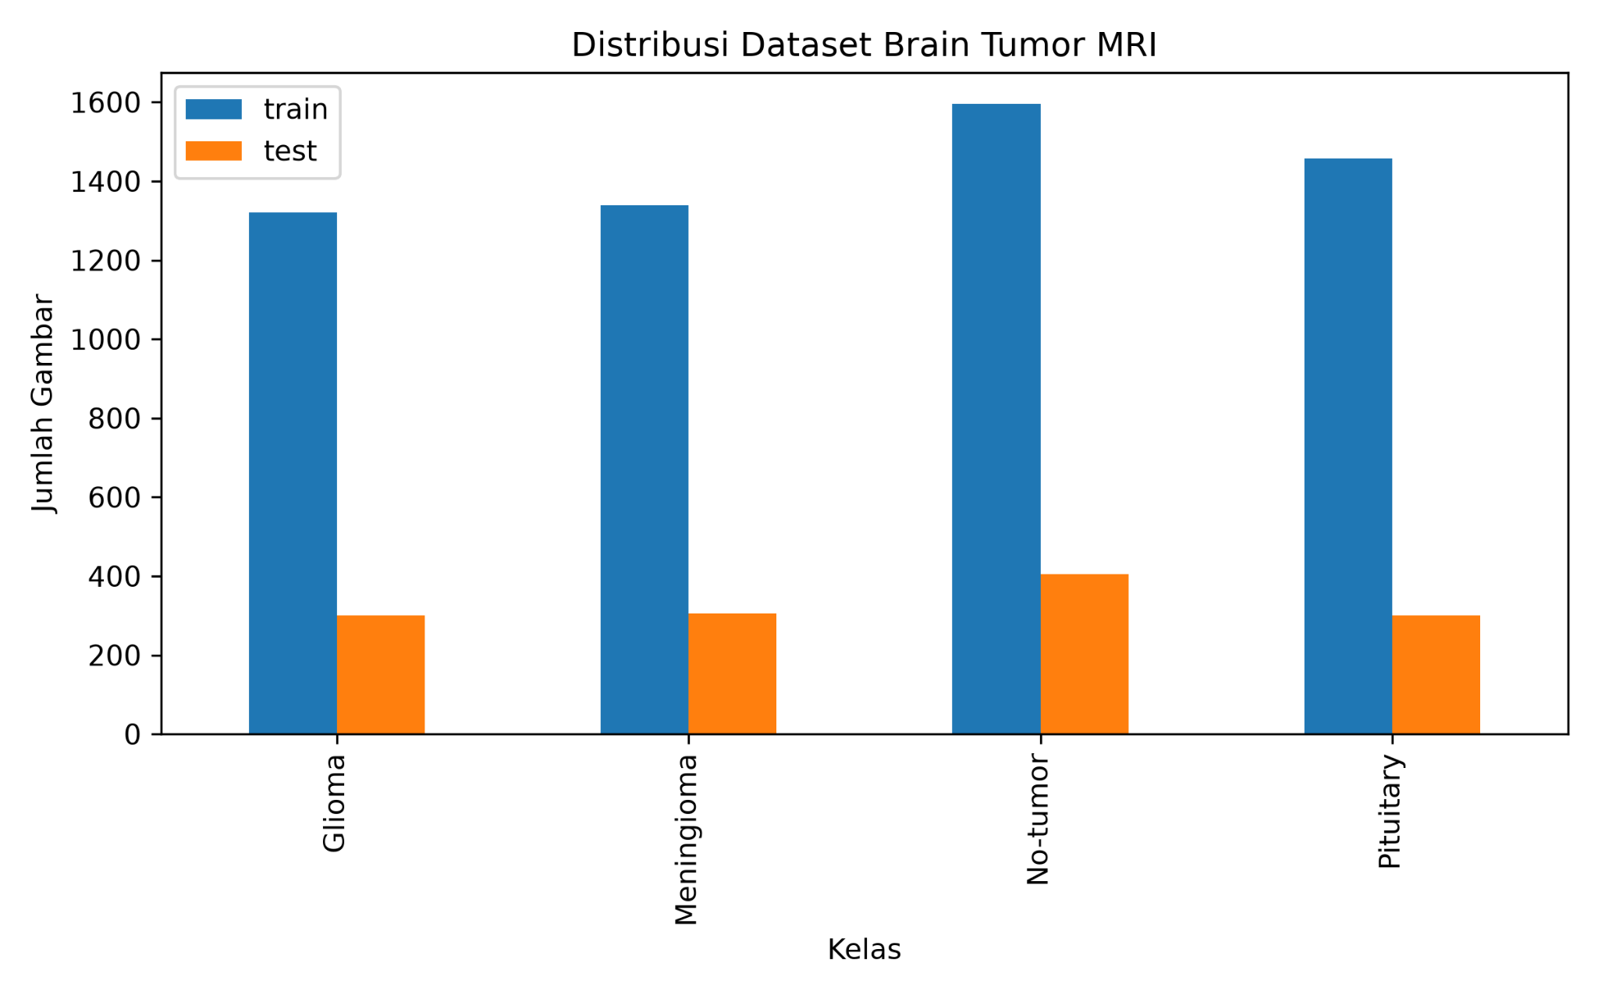
Figure 1: Distribution of training and testing MRI images across four classes.
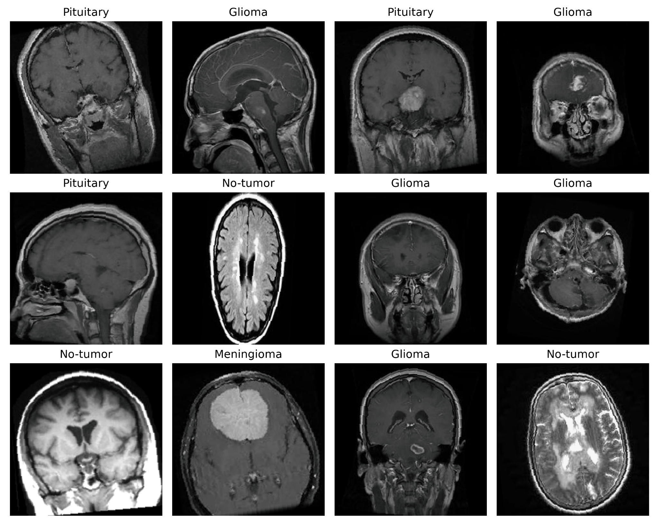
Figure 2: Sample MRI images from the training dataset.
2.3. Preprocessing and Augmentation
All MRI images were resized to 224 x 224 pixels to match the input size of pretrained CNN backbones. The images were converted into tensors and normalized using the ImageNet mean and standard deviation. Training images were augmented using random horizontal flipping, random rotation, and slight brightness and contrast adjustment. The purpose of augmentation is to improve model generalization and reduce overfitting, while the testing set was only resized and normalized to preserve evaluation consistency.
2.4. Model Architecture and Experimental Scenario
Three pretrained transfer learning models were implemented: ResNet50, EfficientNetB0, and MobileNetV2. The final classifier layer of each model was replaced with a new classifier for four output classes. The experiment used the same dataset split and hyperparameter scenario for all models so that the comparison would be fair. The overall workflow is shown in Figure 3, and the experimental configuration is summarized in Table 2.
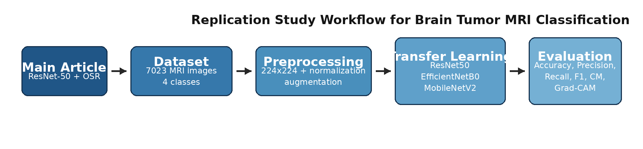
Figure 3: Workflow of the replication and extension experiment.
Table 2: Experimental scenario
Parameter | Value
Image size | 224 x 224 pixels
Training images | 5,712 images
Testing images | 1,311 images
Batch size | 32
Epochs | 8
Optimizer | Adam
Learning rate | 0.0001
Loss function | Cross Entropy Loss
Models | ResNet50, EfficientNetB0, MobileNetV2
2.5. Evaluation Metrics
The primary evaluation metrics are accuracy, weighted precision, weighted recall, weighted F1-score, and confusion matrix. Accuracy measures the overall correct prediction ratio. Precision describes the reliability of positive predictions, recall measures the model ability to retrieve correct samples for each class, and F1-score balances precision and recall. AUC was not used as the primary comparison metric because the saved replication outputs focused on hard multi-class predictions and classification reports; one-vs-rest ROC-AUC can be added in a future run by storing probability outputs for each class.
3 Results
The three transfer learning models were trained and evaluated using the same dataset split and hyperparameter configuration. The overall comparison is shown in Table 3. EfficientNetB0 achieved the best overall result with accuracy of 82.38%, weighted precision of 82.35%, weighted recall of 82.38%, and weighted F1-score of 81.99%. ResNet50 and MobileNetV2 both achieved accuracy of 80.55%, but ResNet50 obtained a slightly higher weighted F1-score than MobileNetV2.
Table 3: Comparison of model performance on the testing set
Model | Accuracy | Precision | Recall | F1-score
ResNet50 | 80.55% | 80.23% | 80.55% | 80.25%
EfficientNetB0 | 82.38% | 82.35% | 82.38% | 81.99%
MobileNetV2 | 80.55% | 80.13% | 80.55% | 80.11%
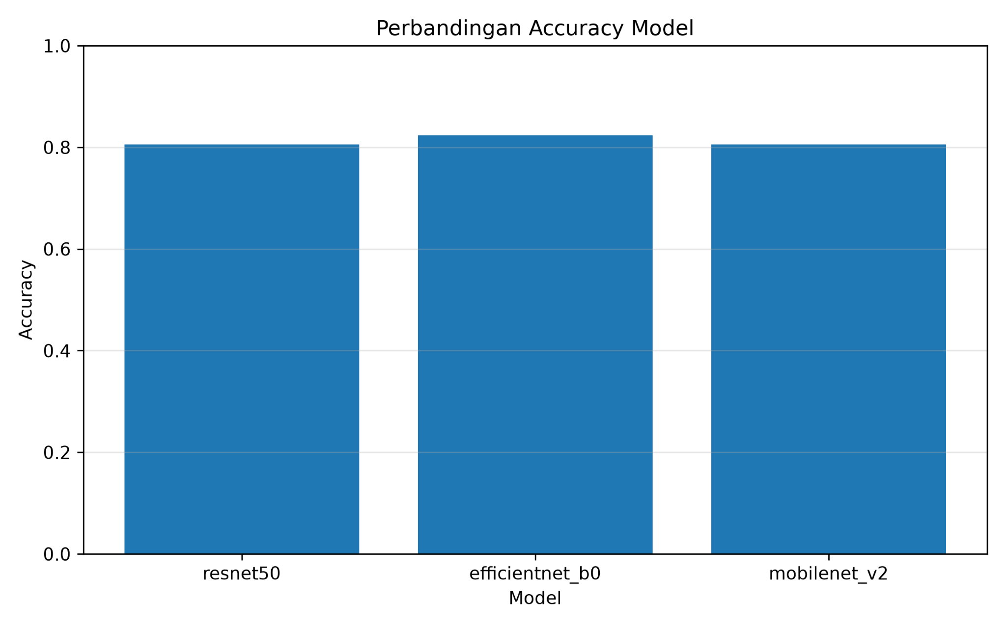
Figure 4: Accuracy comparison among ResNet50, EfficientNetB0, and MobileNetV2.
The training curves indicate that all models learned progressively from epoch 1 to epoch 8. The training and validation loss decreased across epochs, while validation accuracy increased. EfficientNetB0 showed the strongest validation performance among the three models, which suggests that its feature representation was more suitable for the dataset under the limited-epoch scenario.
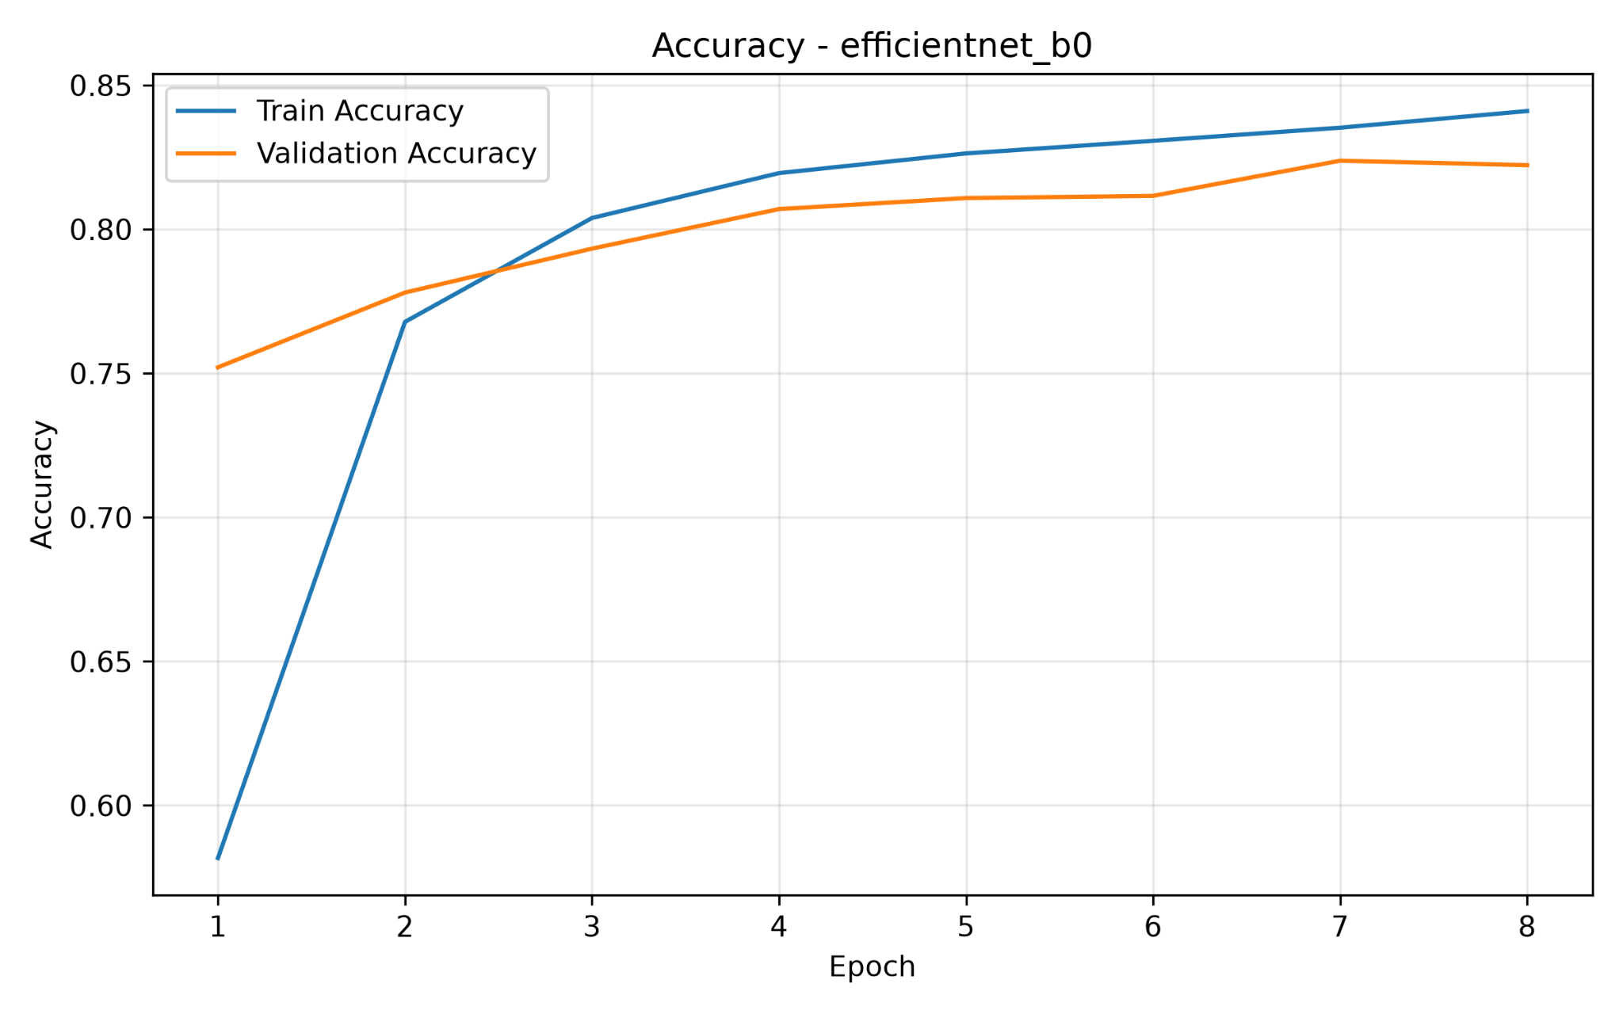
Figure 5: Training and validation accuracy of EfficientNetB0.
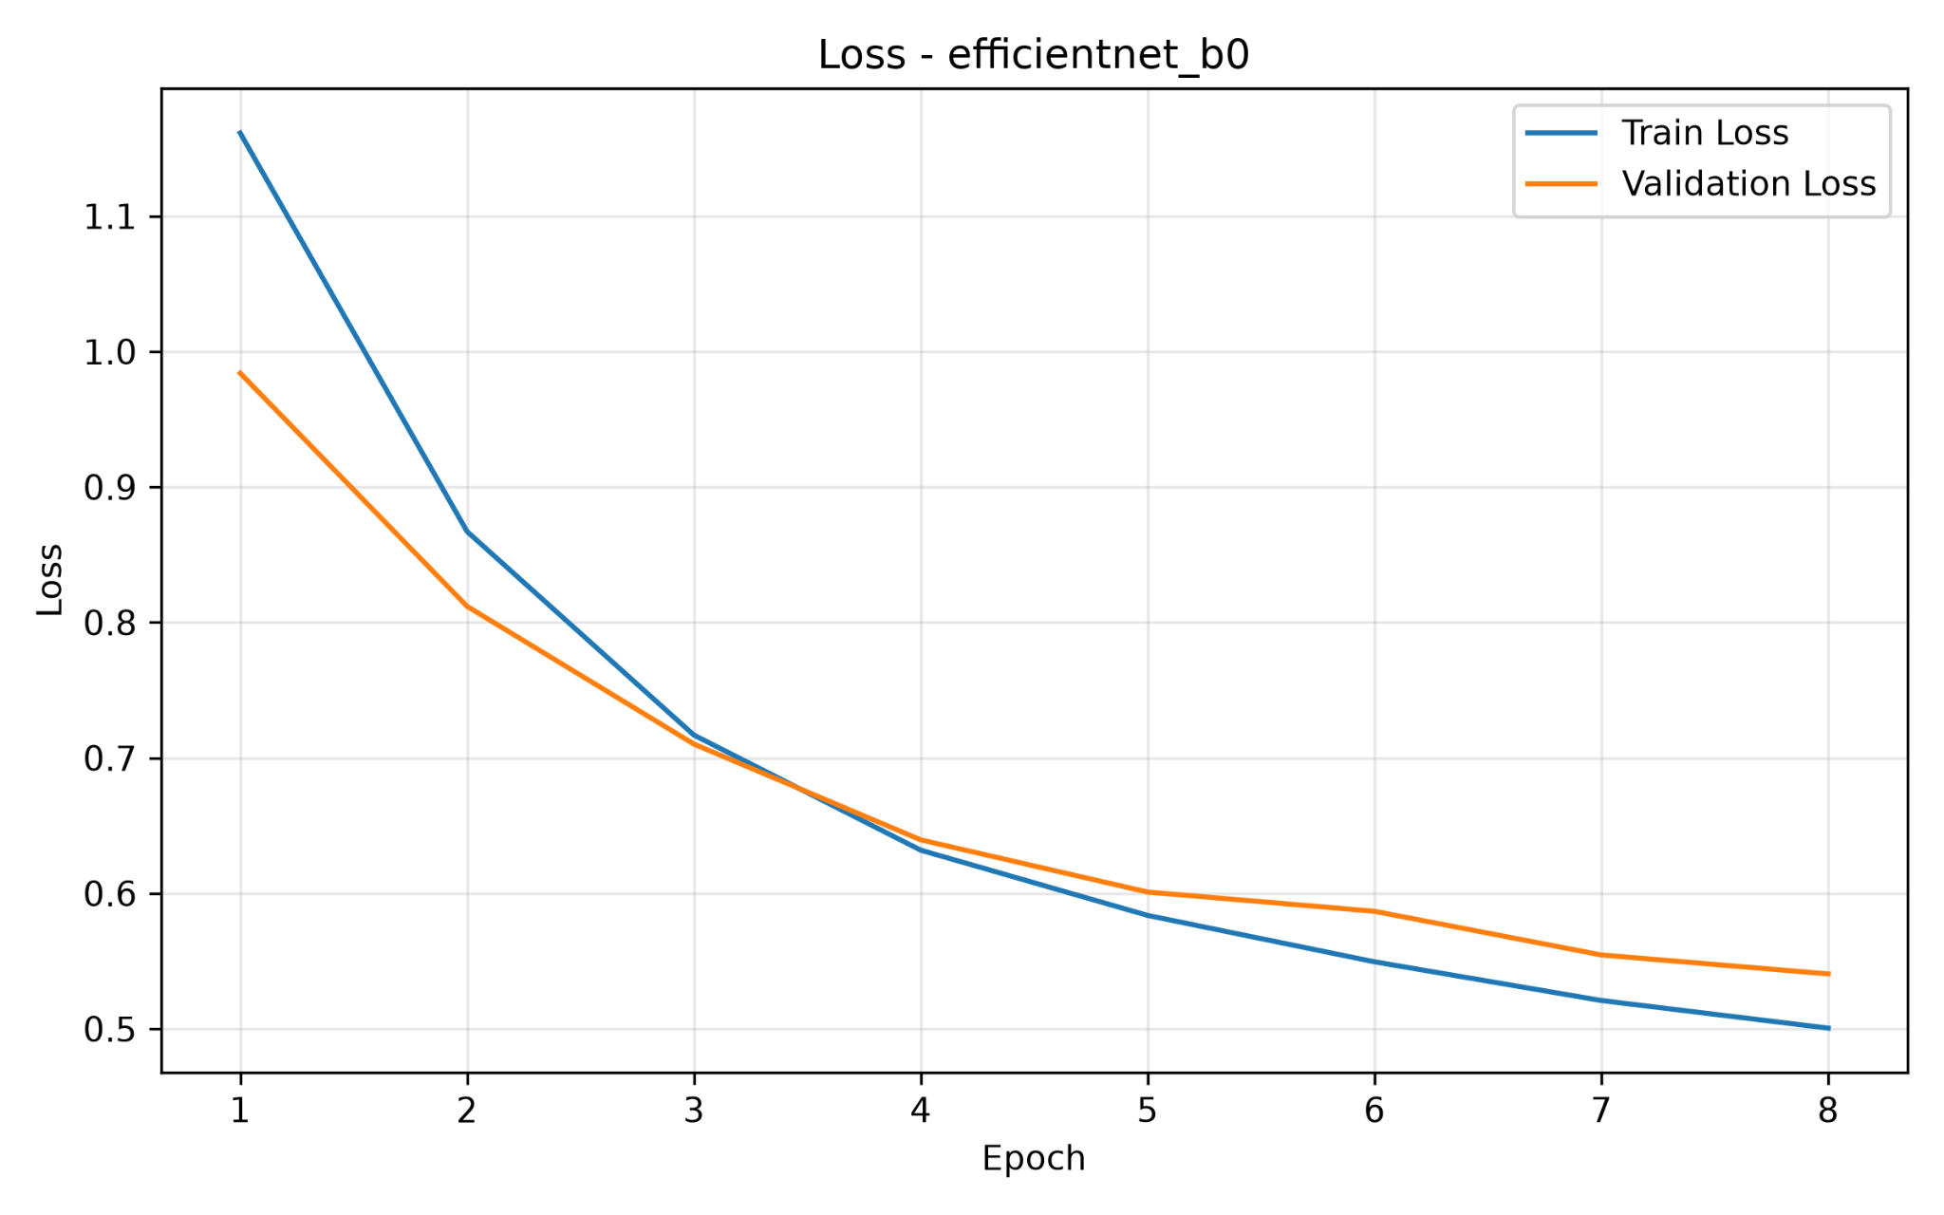
Figure 6: Training and validation loss of EfficientNetB0.
4 Discussion
The confusion matrix of EfficientNetB0 shows that the model correctly classified 390 out of 405 No-tumor images and 276 out of 300 Pituitary images. These classes achieved strong recall because their visual patterns were more separable in the dataset. The most difficult class was Meningioma: 191 out of 306 Meningioma images were correctly classified, while 75 were predicted as No-tumor and 26 as Pituitary. This indicates that Meningioma cases may have visual overlap with other classes in the current dataset and preprocessing setting.
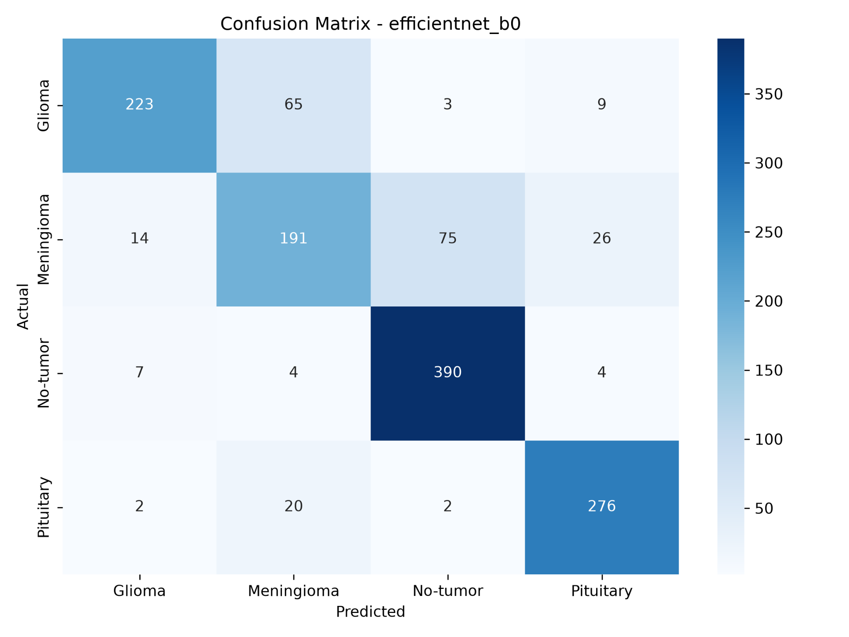
Figure 7: Confusion matrix of EfficientNetB0 on the testing set.
Table 4: Class-wise classification report of EfficientNetB0
Class | Precision | Recall | F1-score | Support
Glioma | 0.91 | 0.74 | 0.82 | 300
Meningioma | 0.68 | 0.62 | 0.65 | 306
No-tumor | 0.83 | 0.96 | 0.89 | 405
Pituitary | 0.88 | 0.92 | 0.90 | 300
Grad-CAM was applied to the trained ResNet50 model to provide a visual interpretation of the prediction. Figure 8 shows an example where the actual class is Glioma and the predicted class is also Glioma. The heatmap highlights the region that contributed most to the classification decision. This visualization supports model interpretability and helps demonstrate that the model relies on localized visual evidence; however, it should not be interpreted as a clinical diagnosis or expert radiological explanation.
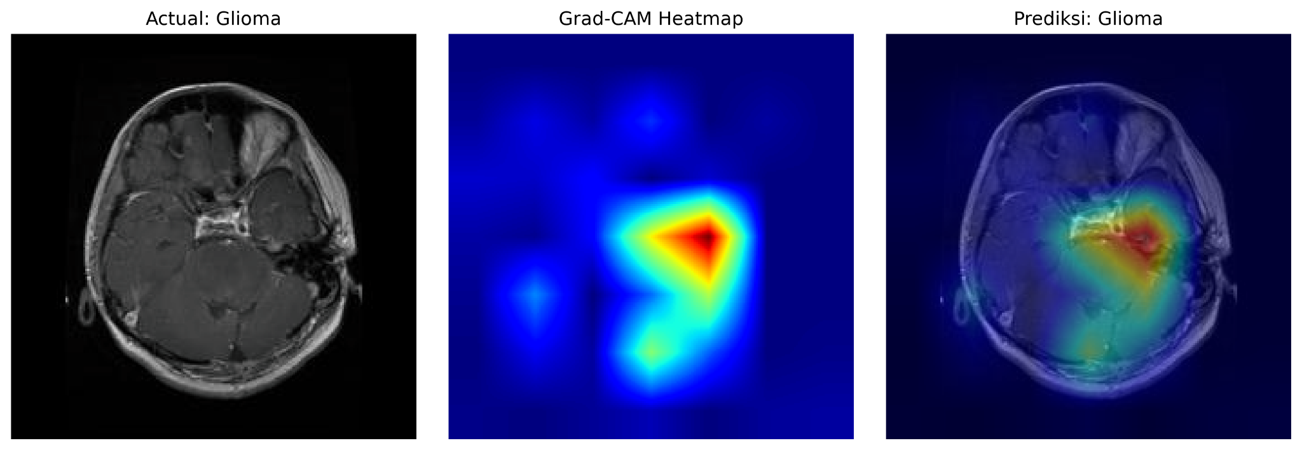
Figure 8: Grad-CAM visualization for a correctly predicted Glioma MRI image.
The main article reported accuracy of 98.4% using a hybrid approach that combines ResNet-50 feature extraction and optimized Softmax Regression [1]. In this replication, the ResNet50 model achieved accuracy of 80.55%. The difference is expected because this study used a simpler transfer learning classifier, only 8 epochs, a frozen pretrained backbone, and a public dataset split without the optimized Softmax Regression procedure used in the main article. The result still satisfies the objective of replication because the implementation reproduces the general research pipeline: dataset preparation, preprocessing, ResNet-based transfer learning, training, evaluation, confusion matrix analysis, and comparison with additional methods.
EfficientNetB0 outperformed ResNet50 and MobileNetV2 in this experiment. This finding is consistent with the idea that EfficientNet-style scaling can provide an efficient balance between feature quality and model complexity [10]. MobileNetV2 produced a competitive result despite being designed as a lightweight architecture, supporting its relevance for future deployment on devices with limited computational resources [11].
5 Conclusion
This study successfully replicated and extended a brain tumor MRI classification study using transfer learning. ResNet50 was implemented as the main replication model based on the selected article from JURNAL INFOTEL, while EfficientNetB0 and MobileNetV2 were added as comparative models. The dataset consisted of 7,023 MRI images across four classes, and all models were trained using the same preprocessing, augmentation, and hyperparameter configuration.
The best model in this experiment was EfficientNetB0, which obtained accuracy of 82.38%, weighted precision of 82.35%, weighted recall of 82.38%, and weighted F1-score of 81.99%. The model performed well on No-tumor and Pituitary classes but still had difficulty distinguishing Meningioma from other classes. Compared with the main article accuracy of 98.4%, the replication result was lower due to differences in classifier design, training duration, and experimental configuration. Nevertheless, the study achieved the assignment objectives by implementing a reproducible AI experiment, comparing multiple models, evaluating classification metrics, and adding visualization with Grad-CAM. Future work can improve performance by increasing the number of epochs, unfreezing selected backbone layers for fine-tuning, applying hyperparameter tuning, saving probability outputs for ROC-AUC analysis, and validating the model on external clinical datasets.
Data, Code, and Artifact Availability
The replication artifacts consist of the selected main paper, dataset folder, source code, Jupyter notebook, experimental result files, generated figures, the draft journal manuscript in DOCX and PDF formats, a video demonstration, and a README file. These artifacts are prepared to be uploaded to Google Drive with the access setting "Anyone with the link can view" so that the instructor can download and reproduce the experiment.
Table 5: Assignment artifact checklist
Artifact | Folder | Status
Main article | Paper_Utama/ | Prepared
Dataset | Dataset/ | Prepared
Source code | SourceCode/ | Prepared
Notebook experiment | Notebook/ | Prepared
Experimental results | Hasil_Eksperimen/ | Prepared
Figures and graphs | Gambar_Grafik/ | Prepared
Draft article | Draft_Jurnal/ | Prepared
Video demo | Video_Demo/ | To be recorded
README | README.md | Prepared
Acknowledgments
The author thanks the Artificial Intelligence course instructor for the assignment guidance and the open dataset providers for making the MRI image dataset available for academic replication.
References
[1] M. N. Musa, "MRI-Based Brain Tumor Classification using ResNet-50 and Optimized Softmax Regression," JURNAL INFOTEL, vol. 16, no. 3, pp. 598-614, Sep. 2024, doi: 10.20895/infotel.v16i3.1175.
[2] M. Abou Ali, "MRI Brain Tumor Dataset: 4-Class (7023 Images)," Kaggle Dataset, 2025. [Online]. Available: https://www.kaggle.com/datasets/mohamadabouali1/mri-brain-tumor-dataset-4-class-7023-images.
[3] M. Nickparvar, "Brain Tumor MRI Dataset," Kaggle Dataset, 2021. [Online]. Available: https://www.kaggle.com/datasets/masoudnickparvar/brain-tumor-mri-dataset.
[4] R. Disci et al., "Advanced Brain Tumor Classification in MR Images Using Transfer Learning and Pre-Trained Deep CNN Models," Cancers, vol. 17, no. 1, p. 121, 2025, doi: 10.3390/cancers17010121.
[5] M. A. Khan et al., "Transfer learning for accurate brain tumor classification in MRI: a step forward in medical diagnostics," Discover Oncology, 2025, doi: 10.1007/s12672-025-02671-4.
[6] M. A. Ilani et al., "T1-weighted MRI-based brain tumor classification using hybrid deep learning models," Scientific Reports, 2025, doi: 10.1038/s41598-025-92020-w.
[7] F. F. Jiven and Rumini, "MRI Classification of Brain Tumors Using EfficientNetB0 Feature Extraction and Machine Learning Methods," Journal of Applied Informatics and Computing, 2025, doi: 10.30871/jaic.v9i6.10363.
[8] W. Hastomo et al., "Classification of Brain Image Tumor using EfficientNet B1-B2," Semesta Teknika, 2024.
[9] K. He, X. Zhang, S. Ren, and J. Sun, "Deep Residual Learning for Image Recognition," in Proc. IEEE Conference on Computer Vision and Pattern Recognition, 2016, pp. 770-778, doi: 10.1109/CVPR.2016.90.
[10] M. Tan and Q. V. Le, "EfficientNet: Rethinking Model Scaling for Convolutional Neural Networks," in Proc. International Conference on Machine Learning, 2019, pp. 6105-6114.
[11] M. Sandler, A. Howard, M. Zhu, A. Zhmoginov, and L. Chen, "MobileNetV2: Inverted Residuals and Linear Bottlenecks," in Proc. IEEE Conference on Computer Vision and Pattern Recognition, 2018, pp. 4510-4520, doi: 10.1109/CVPR.2018.00474.
[12] R. R. Selvaraju et al., "Grad-CAM: Visual Explanations from Deep Networks via Gradient-Based Localization," in Proc. IEEE International Conference on Computer Vision, 2017, pp. 618-626, doi: 10.1109/ICCV.2017.74.
[13] E. D. Cubuk, B. Zoph, D. Mane, V. Vasudevan, and Q. V. Le, "AutoAugment: Learning Augmentation Strategies from Data," in Proc. IEEE/CVF Conference on Computer Vision and Pattern Recognition, 2019, pp. 113-123, doi: 10.1109/CVPR.2019.00020.
[14] A. Paszke et al., "PyTorch: An Imperative Style, High-Performance Deep Learning Library," in Advances in Neural Information Processing Systems, vol. 32, 2019.
[15] J. Deng et al., "ImageNet: A Large-Scale Hierarchical Image Database," in Proc. IEEE Conference on Computer Vision and Pattern Recognition, 2009, pp. 248-255, doi: 10.1109/CVPR.2009.5206848.
[16] S. J. Pan and Q. Yang, "A Survey on Transfer Learning," IEEE Transactions on Knowledge and Data Engineering, vol. 22, no. 10, pp. 1345-1359, 2010, doi: 10.1109/TKDE.2009.191.
[17] D. P. Kingma and J. Ba, "Adam: A Method for Stochastic Optimization," in Proc. International Conference on Learning Representations, 2015.
[18] F. Pedregosa et al., "Scikit-learn: Machine Learning in Python," Journal of Machine Learning Research, vol. 12, pp. 2825-2830, 2011.
[19] A. Rehman, S. Naz, M. I. Razzak, F. Akram, and M. Imran, "A deep learning-based framework for automatic brain tumors classification using transfer learning," Circuits, Systems, and Signal Processing, vol. 39, pp. 757-775, 2020, doi: 10.1007/s00034-019-01246-3.
[20] E. Irmak, "Multi-classification of brain tumor MRI images using deep convolutional neural network with fully optimized framework," Iranian Journal of Science and Technology, Transactions of Electrical Engineering, vol. 45, pp. 1015-1036, 2021, doi: 10.1007/s40998-021-00426-9.

