Event Details

Program Name : QISKIT FALL FEST 2026
Date : 24 Oktober 2026
Venue : ICC Pusat Inovasi & Komersialisasi, Universiti Teknologi Malaysia, Johor Bahru (tbc)
Tentatives Program
08:00 - 08:30: Sarapan
08:30 - 09:00: Pendaftaran
09:00 - 09:07: Pembukaan Ucapan dari Dean Fakulti Sains
09:07 - 09:14: Pembukaan Ucapan dari Dean Fakulti Kekomputeran
09:14 - 09:21: Pembukaan Majlis bersamaan dengan Dean & Penasihat
09:21 - 09:30: Rehat sebelum sesi
09:30 - 09:50: Sesi suai kenal kumpulan
10:00 - 10:07: Ceramah dari Dr Yap Yung Szen
10:07 - 10:14: Ceramah dari Ts Dr. Nur Haliza Abdul Wahab
11:15 - 11:30: Pengenalan tentatif acara
11:30 - 12:45: Sesi Interaktif bersama Pelajar
12:45 - 14:00:: Makan tengah hari & Pameran
14:00 - 14:45: Perkongsian pelajar
14:45 - 15:00: Pelancaran Komuniti Kuantum & Inisiatif Masa Hadapan
15:00 - 16:15: Sesi Interaktif bersama Pelajar
16:15 - 16:30: Penutupan Majlis
16:30 - 17:00: Prayer
17:00 - 17:30: Lawatan ke Makmal Kuantum & AQSolotl Pte Ltd
17:30 - 18:00: Lawatan ke Makmal Kuantum & AQSolotl Pte Ltd
18:00: Tamat

Committee Member

- Lua Yu Hui
Master in Physics, Faculty of Science, UTM JB
Director for QFF Malaysia 2026
Linkedin : https://www.linkedin.com/in/yu-hui-lua-7878bb228/
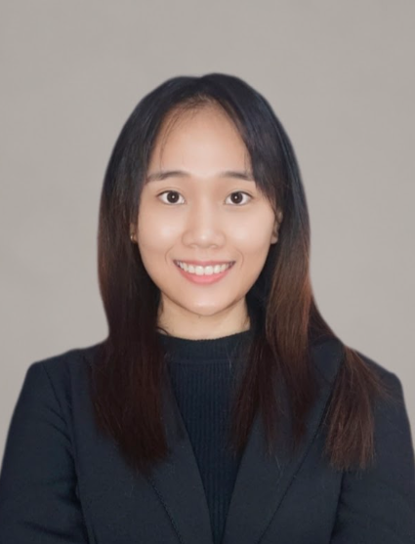
- Muhammad Hafiz bin Kamaruddin
Phd in Physics, Faculty of Science, UTM JB
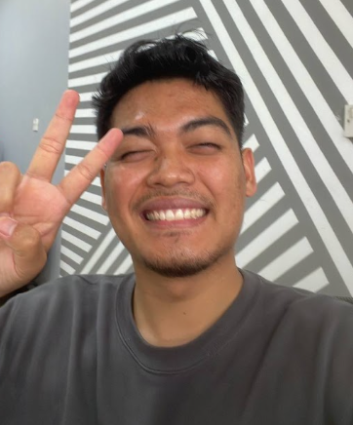

- Soh Zen Ren
Phd in Computer Science, Faculty of Computing, UTM JB
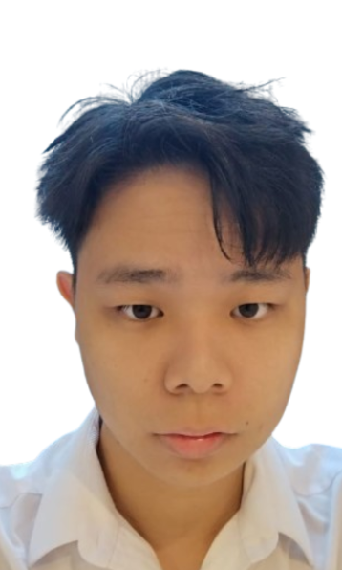

- Umar Ahmad Shahadrian
Undergraduate in Physics, Faculty of Science, UTM JB
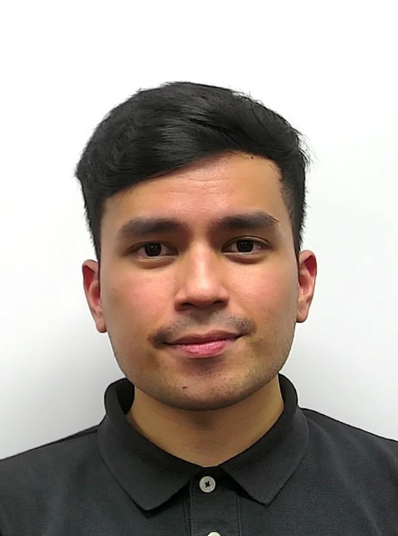

- TENG TING LI
Phd in Physics , Faculty of Science, UTM JB
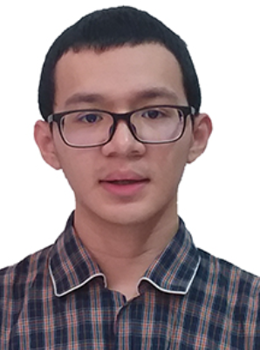

- Gregory Hong Shyang Zhao
Undergraduate in Physics, Faculty of Science, UTM JB
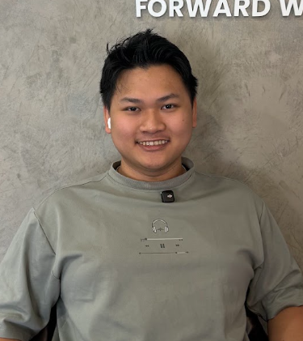

- Juniardi Nur Fadila
Phd in Computer Science, Faculty of Computing, UTM JB
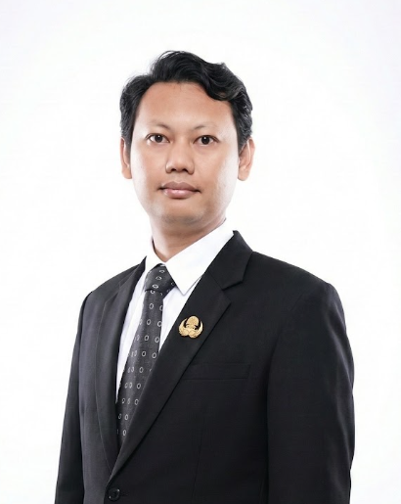

- LIM SHI KAI
Phd in Computer Science, Faculty of Computing, UTM JB
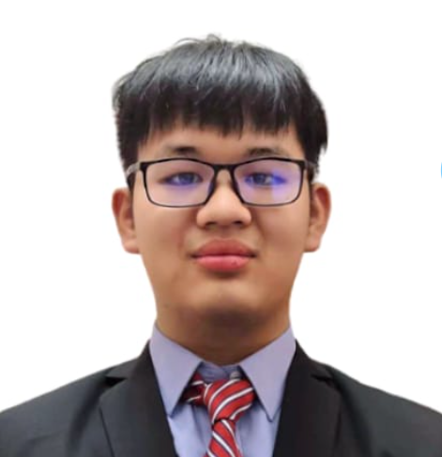

- Sik Zhi Xuan
Undergraduate in Physics, Faculty of Science, UTM JB
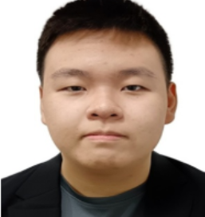

- Asser Abdelnabby
Master in Electrical Engineering, UTM JB
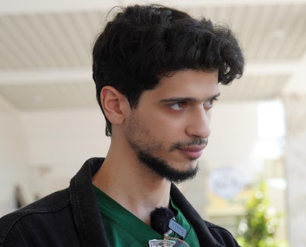

- Mouhab Nawfal Idrees
Master in Physics, Faculty of Science, UTM JB
