Lab2

**Code No1: Structural Coding**

**Without Correction**

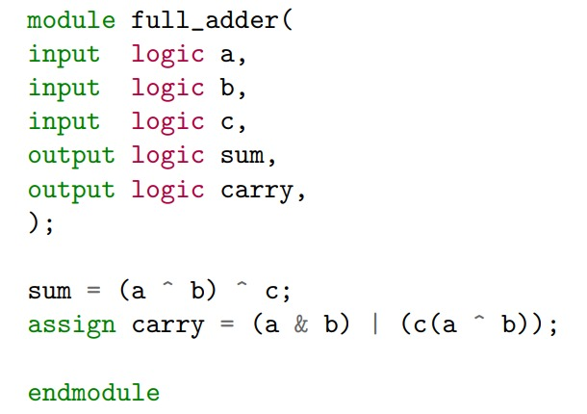

**After Correction**

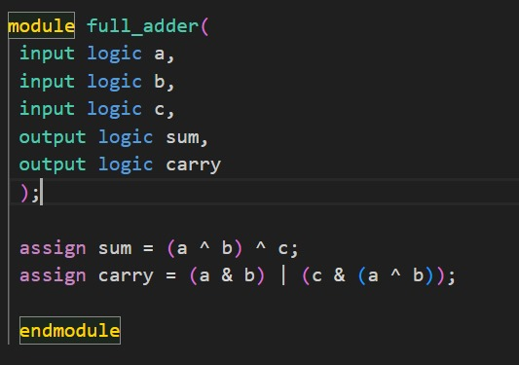

**Problems**

1. In line number 6, no need of comma after ‘carry’
2. In line number 6, assign statement is missing before ‘sum’
3. In line number 10, wrong equation, the correct equation is (a & b) | (c & (a ^ b)).

Code No2: Part (b)

Before Correction

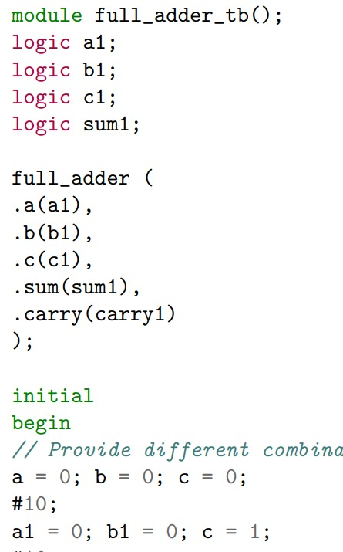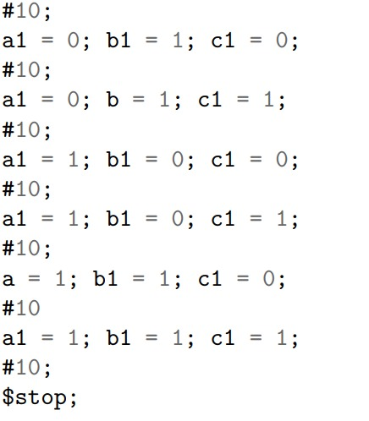

After Correction

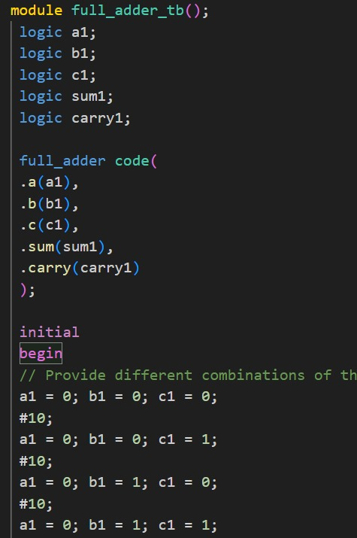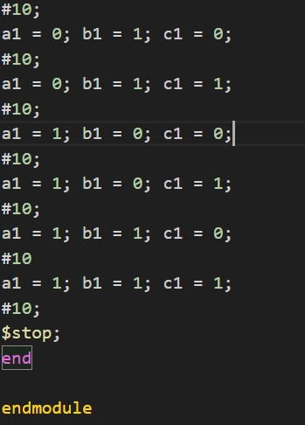

Problems

In line number 6, ‘logic carry 1’ is missing

In line number 7, ‘name of copy’ is missing

In line number 18, a, b, c should be a1, b1, c1

In line number 20, c should be c1

In line number 24, b should be b1

In line number 30, a should be a1

In line number 31, ; is missing

In line number 35, ‘end’ statement is missing

Graph

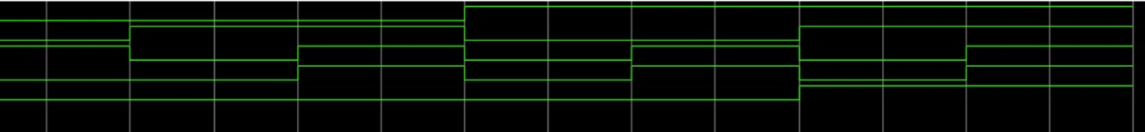

Diagram

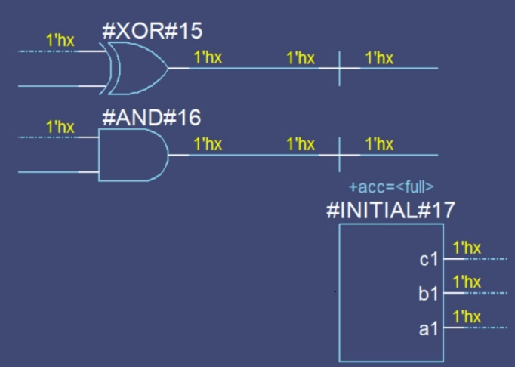

Truth Table

|  |  |  |  |  |  |  |  |  |
| --- | --- | --- | --- | --- | --- | --- | --- | --- |
|  |  |  | A1 | A2,a4 | A3 | B1 | x | y |
| a | b | c | NOT c | a OR b | a NAND b | A3 XOR a2 | A1 XOR A2 | A2 AND B1 |
| 0 | 0 | 0 | 1 | 0 | 1 | 1 | 1 | 0 |
| 0 | 0 | 1 | 0 | 0 | 1 | 1 | 0 | 0 |
| 0 | 1 | 0 | 1 | 1 | 1 | 0 | 0 | 0 |
| 0 | 1 | 1 | 0 | 1 | 1 | 0 | 1 | 0 |
| 1 | 0 | 0 | 1 | 1 | 1 | 0 | 0 | 0 |
| 1 | 0 | 1 | 0 | 1 | 1 | 0 | 1 | 0 |
| 1 | 1 | 0 | 1 | 1 | 0 | 1 | 0 | 1 |
| 1 | 1 | 1 | 0 | 1 | 0 | 1 | 1 | 1 |