TEKUN Corporation Integrated Collection Growth Partnership
A TEKUN Corporation-owned collection platform, authorised managed operations and an evidence-led path to scale
Document control | Detail
Status | Discussion proposal — not a contract or final implementation commitment
Prospective client | TEKUN Corporation Sdn Bhd
Prepared by | Sifututor capability team; proposing legal entity and authorised contact to be confirmed before circulation
Document owner | Hafiz / designated proposal owner
Version | Draft 1.0
Date | 31 August 2026
Classification | Confidential — controlled stakeholder use
Legal position | Portfolio applicability, authorisation and legal responsibilities require confirmation
Commercial position | No price, guaranteed result or final commercial commitment is made

This proposal is intended to support a structured decision on discovery and pilot co-design. It respects TEKUN Corporation as an established collection operator and does not assume that its present operation, systems or service partners are deficient.

Contents
Part | Sections
Strategic case | 1. Executive summary · 2. Opportunity · 3. Why now
Partnership and authority | 4. Partnership model · 5. Ownership, authority and accountability · 6. Collection lifecycle
Platform solution | 7. Platform in plain language · 8. Role-based workspaces · 9. Customer treatment · 10. Payment and reconciliation · 11. Data, integration, security and resilience · 12. Reporting and assistance
Managed service | 13. Managed collection service · 14. Training, competency and quality · 15. Service management and improvement
Proof and value | 16. Why our experience is relevant · 17. Business impact · 18. Balanced scorecard · 19. Bounded pilot · 20. Commercial principles
Direction and decision | 21. Milestones and roadmap · 22. Long-term value, assurance and transition readiness · 23. Discovery agenda · 24. Recommended next decision

Reading guide: Executive and board readers may prioritise Sections 1–5 and 17–24. Operations, compliance, finance and technology teams should also review Sections 6–16.

1. Executive summary
TEKUN Corporation already has collection experience, client relationships and an established operating identity. TCorp states that its debt-collection customer call centre has operated since 2015, that it is registered with the Ministry of Finance under field code 221105 and that approximately 30 organisations have appointed it. Its official 2026 announcements also describe continuing collection or recovery appointments. The opportunity is therefore not to start a collection business from zero. It is to connect and strengthen an existing capability.
We propose a partnership with two integrated components:
- a dedicated collection platform owned and governed by TEKUN Corporation, designed, built, operated, maintained and continuously improved by our team; and
- an authorised managed collection operation, performed or coordinated by our team within confirmed policy, contractual and legal boundaries.
Together, these components create one operating spine across portfolio intake, segmentation, assignments, controlled contact, promises, protected cases, payment evidence, reconciliation, cessation, reporting and improvement. TEKUN Corporation retains governance, policy and consequential authority. Our team supplies platform engineering, service operations, evidence, support and improvement.
The recommended decision is deliberately bounded: authorise discovery and pilot co-design, then commit to implementation only when authority, evidence, customer-treatment, technical and commercial gates are satisfied.

What this creates
- clearer case ownership and authorised next actions;
- consistent and provable customer treatment;
- payment outcomes tied to reconciled evidence rather than unverified reports;
- segregated reporting for each principal and an enterprise view for TEKUN Corporation;
- a repeatable way to onboard additional portfolios and appointing organisations;
- platform health, service management and improvement disciplines around daily collection work.
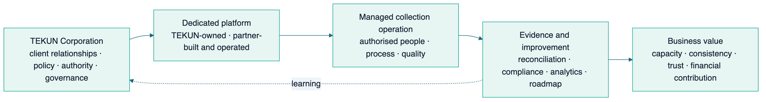

2. The opportunity: strengthen an established operator
The proposal begins with a respectful fact: TEKUN Corporation is already active in credit management and recovery. TCorp's own public materials state corporate registration in 2014 and establishment of its debt-collection customer call centre in 2015; its dated announcements describe new collection or recovery activity in 2026.
This history matters because the partnership should preserve TEKUN Corporation's identity, principal relationships and operating knowledge. The platform and managed service are intended to make that capability easier to govern, measure and scale.
Existing foundation | Partnership contribution
Collection experience and organisational standing | A connected digital operating model and evidence trail
Principal and stakeholder relationships | Segregated portfolios, reports and repeatable onboarding
Policy and authority | Configurable controls, approvals and auditable exceptions
Collection teams and practical knowledge | Guided workspaces, quality systems and operational analytics
Business-growth mandate | A measurable path from capacity to sustainable contribution

Public information does not disclose TEKUN Corporation's current platform, detailed performance baseline, portfolio volumes, commission model or any current third-party arrangement. This proposal makes no assumption about those matters. They form part of discovery.

3. Why now
Malaysia's consumer-credit environment places greater emphasis on authorisation, conduct, evidence and complaints handling. Published expectations translate directly into operating requirements: controlled contact, identity verification, notices, non-disclosure, payment handling, hardship and complaint pathways, representative competency and information security.
Actual applicability must be determined portfolio by portfolio. A multi-principal operator may serve products and organisations that follow different legal pathways. The practical answer is not a single blanket rule; it is a policy-controlled platform that can apply the correct approved treatment to each portfolio and retain evidence of what happened.

4. Proposed partnership model

TEKUN Corporation governs
- client and principal relationships;
- platform ownership and strategic direction;
- portfolio acceptance, policy and risk appetite;
- authority limits, settlement, write-off and legal escalation decisions as agreed;
- regulatory, compliance and customer-treatment oversight;
- approval of expansion to further portfolios or principals.

Our team delivers
- platform discovery, design, implementation and integration;
- secure operation, monitoring, maintenance and recovery;
- authorised collection execution or coordination;
- operating procedures, training support, supervision and quality tools;
- reporting, analytics and evidence;
- continuous improvement and transition support.

Jointly governed
- baseline and KPI definitions;
- pilot scope and success gates;
- service levels and escalation paths;
- incidents, material changes and lessons;
- roadmap priorities and expansion decisions.
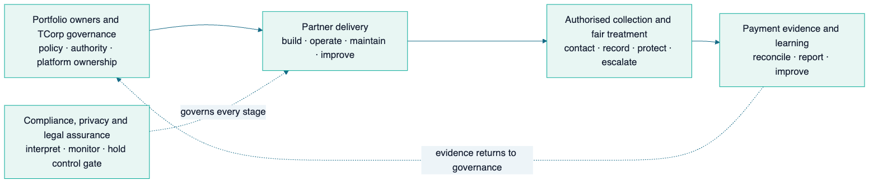
The relationship should remain durable because it continues to create measurable value—not because TEKUN Corporation cannot leave. Data, configuration, operating records and documentation should therefore remain usable and exportable from the beginning.

5. Ownership, authority and accountability
The platform must preserve the difference between owning a portfolio, governing collection, performing work, receiving money, verifying payment and making consequential decisions.
Decision or activity | Proposed accountable party | Delivery or support
Principal relationship and portfolio acceptance | TEKUN Corporation | Portfolio owner consulted; partner supports
Collection policy and treatment strategy | TEKUN Corporation within principal authority | Partner configures and operates approved rules
Platform build and operation | Partner delivery team | TEKUN Corporation governs priorities and acceptance
Daily case work | Authorised collection operation | Platform guides and records work
Receipt of customer money | Approved official channel, to be confirmed | Representatives never receive customer money
Payment reconciliation | Named finance authority, to be confirmed | Platform imports, matches and exposes exceptions
Settlement, write-off and legal action | TEKUN Corporation or portfolio owner as agreed | Operation recommends or escalates only
Complaints, dispute and hardship | Named TEKUN/portfolio authority | Specialist operation and platform hold controls
Regulatory submission | Accountable entity to be confirmed | Platform supplies controlled evidence and export

No system permission should imply authority that has not been explicitly granted. Overrides, approvals and policy changes must be attributable, time-stamped and auditable.

6. End-to-end collection lifecycle
The solution is a complete operating loop rather than a stand-alone dialler, messaging tool or dashboard.
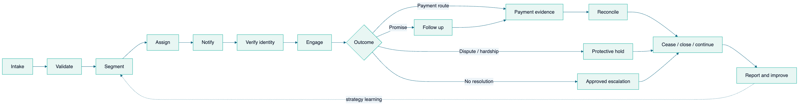
Stage | Core purpose | Required evidence or control
Intake | Establish an authoritative portfolio population | Source, schema, balance, history, duplication and withdrawal checks
Segment | Apply an approved strategy to the correct cohort | Product, arrears, risk, exclusions and strategy version
Assign | Give each case a responsible owner | Team, competency, authority, language and workload
Notify | Issue required approved communication | Template, version, timing, mandatory information and delivery evidence
Verify | Confirm the correct person before disclosure | Verification outcome without unnecessary exposure
Engage | Perform controlled contact and record outcome | Time, frequency, channel, script, conduct and complete interaction history
Promise | Record a specific commitment accurately | Amount, date, method, tolerance and follow-up
Protect | Divert disputes, hardship, vulnerability and legal holds | Immediate hold, specialist owner and release/closure decision
Pay | Direct the customer to an approved channel | No agent receipt of funds; official instruction retained
Reconcile | Match payment evidence to the correct account | Source evidence, allocation, reversal and unmatched exceptions
Cease/close | Stop or adjust treatment when authority changes | Authoritative event, time-to-stop and post-stop exception
Report/improve | Turn events into management and principal insight | Governed definitions, portfolio segregation and approved learning

7. Platform solution in plain language
The platform is organised into five connected layers:
- Experience layer — the right workspace for agents, supervisors, management, compliance, finance and each principal.
- Authoritative portfolio layer — principals, portfolios, customers/accounts, cases, agreements, balances and policy versions.
- Controlled interaction layer — queues, notices, identity steps, contacts, promises, complaints and holds.
- Evidence and money layer — payment evidence, reconciliation, reversals, cessation and outcome history.
- Enterprise intelligence layer — service health, performance, customer treatment, risk, financial contribution and roadmap insight.
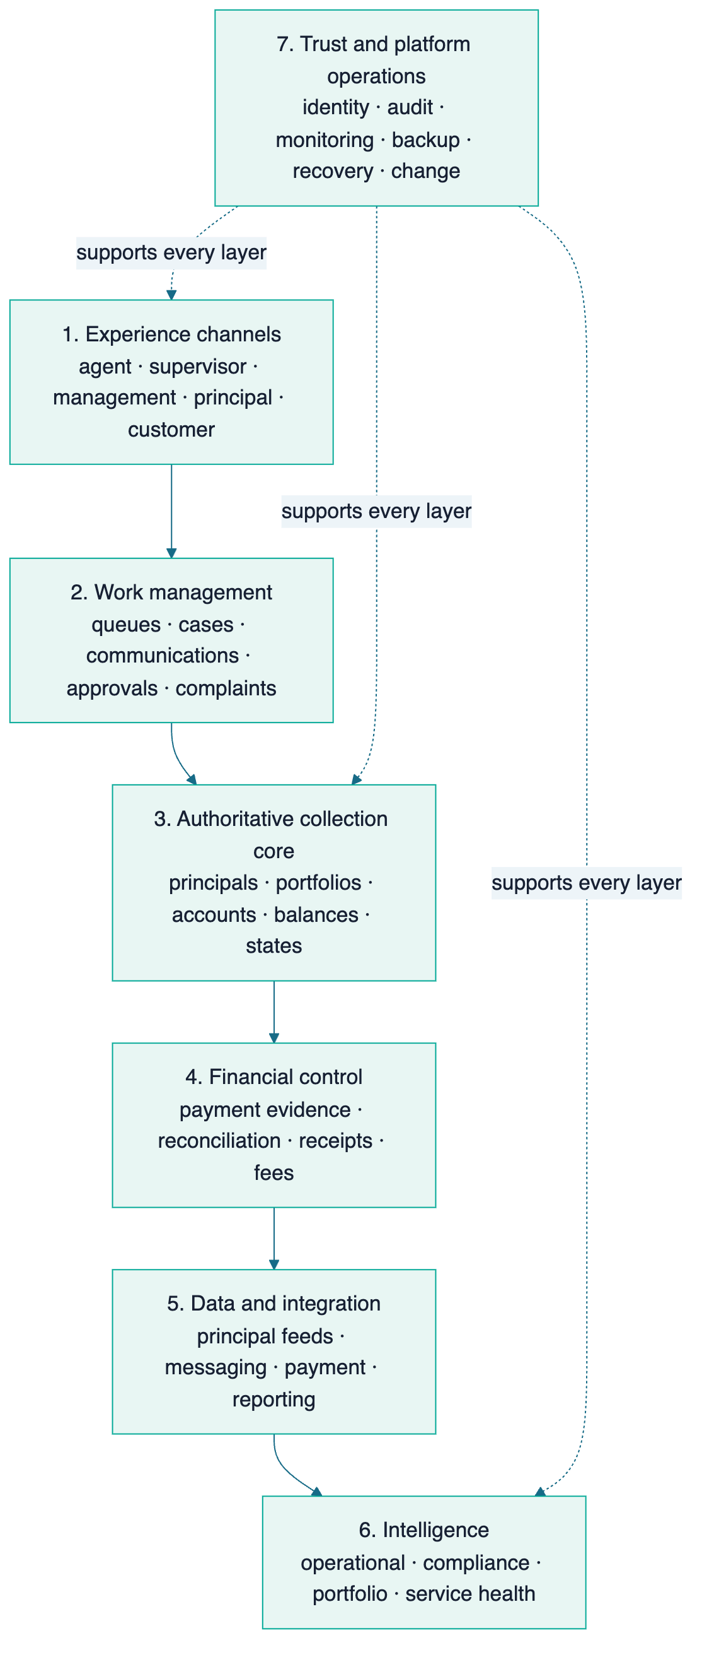
Each principal should see only its authorised portfolio. TEKUN Corporation retains the governed enterprise view across principals, policies, service health and strategic outcomes.

8. Role-based workspaces

Agent workspace
An authorised representative sees prioritised cases, verified context, the permitted next action, approved communication, identity requirements, contact history, promises and escalation routes. The system blocks or redirects actions that are outside policy.

Supervisor workspace
A supervisor sees workload, ageing, unreachable accounts, promises due, quality results, exceptions, complaints, holds, staffing and capacity. Supervisors can coach and rebalance work within approved authority, but cannot silently override customer-treatment controls.

Management and principal views
Management sees outcomes, cost, service health, risks and improvement. Each principal sees its own accepted definitions and portfolio evidence. Compliance and finance receive independent exception views appropriate to their responsibilities.

9. Customer treatment by design
Customer treatment is part of the operating system, not a separate policy document. The proposed design supports:
- identity verification before account discussion;
- approved contact windows, frequency and channels;
- controlled notices, scripts and versions;
- prevention of disclosure to unauthorised third parties;
- immediate holds and specialist routing for disputes, complaints, hardship, vulnerability and legal conditions;
- cessation or treatment change following authoritative settlement or arrangement events;
- an accessible complaint record and resolution trail;
- representative appointment, training and competency evidence;
- human authority for consequential outcomes.
Final controls must be approved against the applicable portfolio, governing agreements and qualified Malaysian legal advice. The platform can enforce and prove an approved rule; it cannot itself decide what the law means.

10. Payment evidence and reconciliation
A reported promise or claimed payment is not yet a verified collection result. The platform should distinguish:
- promise made;
- payment reported by a customer;
- payment evidence received;
- payment matched and reconciled;
- reversal or adjustment;
- case treatment changed or ceased.
Representatives direct customers to approved payment routes and do not receive money. The final payment recipient, receipt issuer, evidence source, reconciliation owner and service timing must be agreed during discovery.
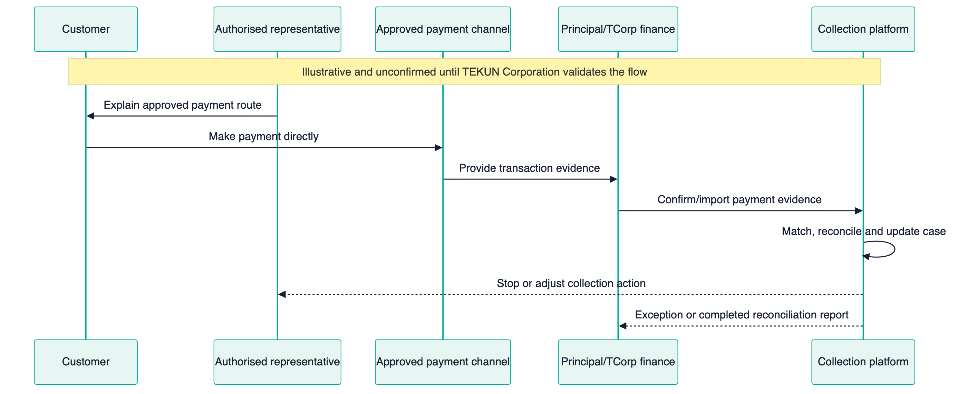
Financial reporting and any future commercial fee logic should use agreed reconciled evidence, not agent-entered outcomes alone.

11. Data, integration, security and resilience
The platform will handle sensitive identity, financial and communication information. Trust therefore depends on explicit data purpose, source, access, change history and recovery.
Control family | Proposed approach
Identity and access | Strong authentication, least privilege and principal/role boundaries
Data authority | Named source systems, validated interfaces and immutable provenance
Sensitive-data protection | Encryption, minimisation, controlled download/export and endpoint policy
Audit | Tamper-evident history for material actions, approvals and changes
Integration safety | Schema validation, duplicate/reversal handling, retry and exception visibility
Monitoring | Availability, errors, feed failures, queue health and unusual access
Incident response | Severity, ownership, containment, communication and learning
Backup and recovery | Protected backups, recovery objectives and tested restoration
Secure change | Review, testing, controlled release, rollback and post-release monitoring

Privacy roles—controller, processor, sub-processor or other applicable role—are a discovery and contracting outcome. The technical design should follow the confirmed data-flow and responsibility map.

12. Reporting and explainable assistance
Different stakeholders need different views of the same governed truth:
- agents need today's safe actions;
- supervisors need workload, quality and exceptions;
- finance needs payment and reconciliation evidence;
- compliance needs conduct, complaints, holds and access events;
- management needs portfolio, cost, service and platform health;
- each principal needs only its own accepted portfolio results;
- TEKUN Corporation governance needs value, risk, growth and roadmap insight.
Advanced assistance should progress from descriptive reporting to diagnostic insight, then guided work and only later predictive or assisted capabilities. Any AI-supported summary, quality sampling or recommendation must remain explainable, auditable and subject to human authority.

13. Managed collection service
The technology and operating service are designed together.
Operating role | Primary responsibility | Boundary
TEKUN service owner | Principal relationship, policy, authority and outcomes | Retains governance
Collection manager | Strategy, allocation, performance and escalation | Cannot bypass independent controls
Supervisor | Queue health, coaching, daily exceptions and capacity | Acts within approved limits
Authorised representative | Verify, contact, understand, record, follow up and escalate | No money receipt or unapproved consequential decision
Complaints/hardship specialist | Protected-case assessment and coordination | Protected from target pressure where required
Finance/reconciliation | Validate payment evidence, allocation and reversals | Reconciled evidence is outcome authority
Compliance/privacy | Interpret obligations and monitor conduct/data | Independent oversight line
Platform operations | Availability, integrations, incidents and recovery | Does not redefine business policy
Product/improvement | Convert evidence into governed improvements | Roadmap jointly prioritised

Headcount, employment model, location, channels and service hours remain discovery and costing decisions.

14. Training, competency and quality
The representative lifecycle is: screen and verify → train → assess → authorise → observe and sample → coach or remediate → reassess. A material concern may suspend or revoke authorisation.
Training covers portfolio policy, identity, confidential communication, permitted contact, notices, payment routes, promises, disputes, complaints, hardship, prohibited conduct, evidence quality, privacy, security and escalation.
Quality scoring should balance outcome, accuracy, conduct, documentation and customer treatment. Recovery alone is not a complete measure of quality.

15. Service management and continuous improvement
A healthy platform detects issues, responds, recovers and learns. The operating partnership should use the same evidence discipline for software, integrations, workforce and collection processes.
The service model includes:
- availability, response and recovery objectives;
- application, integration, data-feed and queue monitoring;
- incident severity, communication and post-incident learning;
- change review, testing, release and rollback;
- backup and restoration exercises;
- operating playbooks, configuration history and data definitions;
- a visible improvement backlog jointly prioritised with TEKUN Corporation;
- feedback translated into measurable changes.

16. Why our experience is relevant
Sifututor has operated a live education service since 2018 and moved its new SIMS generation into production in May 2025. Its ecosystem coordinates multiple participant groups, operational states, financial evidence, mobile and staff channels, communications, analytics, permissions, monitoring and recovery.
That operating history demonstrates relevant patterns:
- connected identities and multi-participant workflows;
- financially sensitive records and reconciliation disciplines;
- specialised staff workspaces and governed decisions;
- multi-organisation separation;
- communications ownership and customer service operations;
- analytics, monitoring, incident response and recovery;
- controlled change with human accountability.
This is evidence of platform-operating capability, not a claim of prior debt-collection performance. Collection strategy, controls, training and proof must be designed and validated with TEKUN Corporation.

17. Business impact and measurement
The platform can influence financial contribution through a causal chain, not a guarantee.
Capability | Leading signal | Outcome signal | Possible contribution
Better portfolio data | Completeness and intake acceptance | Contactability and throughput | Faster onboarding
Guided work | Queue coverage and right-party contact | Kept promises and time to payment | More effective capacity
Payment integration | Match rate and reconciliation age | Verified collection/recovery | Clearer revenue or fee basis
Customer-treatment controls | Conduct and complaint exceptions | Service consistency | Trust and readiness
Supervisor and quality tools | Coaching closure and competency | Stable team performance | Scalable operations
Principal reporting | Timeliness and acceptance | Renewal or referral opportunity | More appointing organisations
Platform health | Availability and failed-feed rate | Fewer interrupted workflows | Revenue protection

Recovery outcomes are influenced by portfolio age, balance, product, customer circumstances, data quality, contactability, policy, legal state and economic conditions. A fair assessment uses a frozen or controlled cohort, written definitions and agreed adjustment events.

18. Balanced scorecard
“Collection rate” is not complete until the parties agree its numerator, denominator, population, period, exclusions and source.
Lens | Illustrative governed indicators
Operations | Time to first action, contact coverage, right-party contact, promises and cases per agent
Financial | Reconciled amount, collection/recovery rate, cost-to-collect and net recovery
Portfolio | Ageing, roll rate, cure rate and write-off context
Customer treatment | Complaints, resolution time, hardship outcomes, disputes and cessation
Controls | Contact, notice, identity, disclosure, payment-handling and data exceptions
Platform health | Availability, incidents, restore evidence, failed feeds and reconciliation age
Strategic growth | Active principals, onboarding time, capacity headroom and contribution

The discovery team should produce a KPI dictionary naming formula, source, owner, frequency, exclusions and misinterpretation risk.

19. Bounded pilot
The pilot should cover one principal, product or arrears cohort that is large enough to measure and bounded enough to govern.
Pilot element | Proposed rule
Baseline | Written comparable history, quality limits and known changes
Cohort | Frozen or controlled population with clear inclusions/exclusions
Authority | Approved policy, representatives, channels and escalation
Technical scope | Minimum complete lifecycle, evidence, reporting and monitoring
Evaluation | Operations, financial outcomes, customer treatment, controls and platform health
Governance | Weekly operating review and monthly decision forum
Gate | Expand, adjust, re-baseline or stop based on agreed evidence

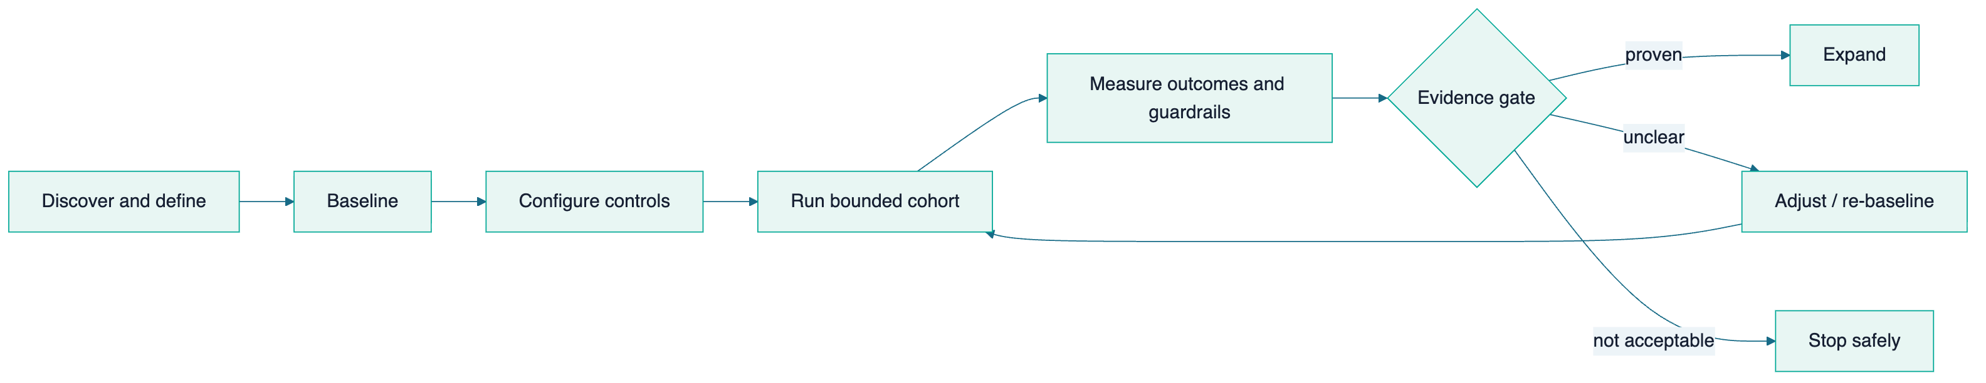
The pilot succeeds only when performance, conduct, reconciliation and platform-health evidence are acceptable together. No result should be presented without its cohort and definition.

20. Commercial principles
Pricing cannot be responsibly set before portfolio volume, channels, service hours, staffing, integrations, risk allocation and performance definitions are known.
The recommended commercial design principles are:
- separate one-time mobilisation from recurring platform and service cost;
- connect any outcome-based element only to reconciled qualifying evidence;
- avoid incentives that reward recovery while weakening customer treatment;
- define pass-through communication or integration costs transparently;
- use service credits or remedies only against agreed measurable obligations;
- preserve export and transition support;
- review economics after a controlled pilot rather than pricing from assumptions.
No commercial archetype is selected in this proposal.

21. Milestones and roadmap

Evidence to date
Period | TEKUN Corporation track | Our platform-operating track
2014–2015 | Corporate registration and stated collection call-centre establishment | —
2018–2024 | Collection service continues | Live multi-stakeholder service and finance operations mature
May 2025 | — | New SIMS goes live in production
2025–2026 | — | Specialist staff tools, analytics, operations and monitoring deepen
2026 | Public collection/recovery appointments continue | Connected operating capability continues to mature
Proposed next | Evaluate integrated platform and managed service partnership | Apply proven platform disciplines to a dedicated collection domain

Partnership horizons
Horizon | Purpose | Evidence gate
H0 — Align and baseline | Confirm authority, portfolio map, current lifecycle, sources and KPI definitions | Signed discovery outputs and decision ownership
H1 — Trusted operating foundation | Establish one bounded portfolio, identity, roles, intake, audit, queues and health | Data accepted, access tested and core journey proven
H2 — Controlled pilot | Operate authorised work with customer-treatment, payment and reporting controls | Balanced pilot evidence and reconciled outcomes
H3 — Integrated performance scale | Automate feeds, reconciliation, reporting and capacity planning | Reliable interfaces, service levels and stable definitions
H4 — Multi-principal growth | Replicate policies, segregation, onboarding and accepted reporting | New principal onboarded without uncontrolled reinvention
H5 — Governed intelligence | Add explainable assistance and evidence-led strategy | Clean history, bias/control review, human authority and measurable value

Expansion should occur only after the evidence gate for the preceding horizon is met. The roadmap shows sequence, not promised dates.

22. Long-term partnership value, assurance and transition readiness
Value deepens through four layers:
- Foundation value — a governed platform, baseline and control model.
- Operating value — trained teams, reliable service, integrations and evidence.
- Growth value — faster onboarding, more principals and accepted reporting.
- Compounding value — portfolio knowledge, trusted governance and a jointly governed roadmap.
TEKUN Corporation should retain complete export, configuration, operating records and transition support from day one. This protects institutional control while giving the operating partner a reason to remain useful through expertise and continuing improvement.

Assurance evidence
Assurance question | Evidence expected
Are only authorised people acting? | Identity, role, competency and authorisation records
Are actions permitted now? | Notice, contact, consent, hold and authority-gate evidence
Was the customer treated fairly? | Interaction history, quality sample and protected-case record
Is a collection result real? | Reconciled payment evidence and governed cohort definition
Did payment stop action correctly? | Cessation timestamp and post-stop exception report
Is each principal separated? | Access/isolation tests and principal-scoped reporting
Can an incident be understood and service recovered? | Monitoring, audit, incident, backup and restore evidence
Can TEKUN Corporation govern or transition? | Documentation, export and tested transition exercise

Transition-ready asset inventory
From mobilisation onward, the governed asset set should include usable data export; configuration and policy versions; a data dictionary; interface specifications; operating and incident runbooks; representative and competency records; open complaint, hardship, dispute and legal-hold registers; permitted interaction and reconciliation history; change and release logs; access/isolation evidence; backup and restoration proof; cessation evidence; and a tested transition plan with named owners.

23. Discovery agenda
Before an implementation or commercial commitment, the joint team should confirm:
- legal entity, portfolio and principal relationships;
- current service providers, systems, processes and pain points;
- authorisation or registration status relevant to each portfolio;
- account volumes, products, arrears, channels and historical outcomes;
- policy, notices, scripts, settlements, complaints and hardship pathways;
- customer payment route, reconciliation and fee evidence;
- data sources, roles, retention, security and integration constraints;
- workforce model, hours, languages, competency and supervision;
- baseline, KPI dictionary, pilot cohort and guardrails;
- procurement, commercial inputs, transition expectations and decision process.
These questions are not weaknesses. They are the information required to produce a responsible design and a fair business case.

24. Recommended next decision
Authorise a governed discovery and pilot co-design programme.
The joint working group should produce:
- a current-state lifecycle and stakeholder map;
- principal and portfolio segmentation;
- authority, regulatory and privacy responsibility maps;
- system, provider, data and money-flow architecture;
- baseline, KPI and guardrail definitions;
- a bounded pilot cohort and evidence gate;
- solution scope, transition approach and implementation sequence;
- commercial inputs without premature pricing.
Full implementation should be considered only after the evidence, authority, customer-treatment, technical and commercial gates are satisfied.

Evidence note
This proposal is governed by the TEKUN Corporation Integrated Collection Growth Partnership Sourcebook v1.0, reviewed 31 August 2026. Public factual statements remain attributed to TEKUN Corporation, TEKUN Nasional, the Consumer Credit Commission or other named primary sources in that sourcebook. Volatile regulatory information must be reverified before external circulation. Proposed capabilities describe a future design, not a current TEKUN Corporation implementation.

Selected public sources
The links below allow a controlled proposal reader to verify the principal public statements without access to the internal claim register. They were last reviewed on 31 August 2026 and must be checked again before circulation.
- TEKUN Corporation official home page — corporate identity and history.
- TCorp credit management and recovery page — call-centre date, MOF field-code statement and appointing-organisation statement.
- TCorp — Awqaf Education appointment — 7 May 2026.
- TCorp — MOCCIS service contract — 23 July 2026.
- SKP/MOF commencement release — commencement and authorisation timeline.
- SKP Conduct Standards v1.0 — collection, hardship, complaints, competency and information management.
- SKP debt-collection guidance — authorised collection and official payment channels.

